Changemakers – Assignment 1
I confirm that all work done is mine unless stated otherwise or referenced – Ruben Bhatia
E-Portfolio Link & Screenshots - https://rchangemakers.weebly.com
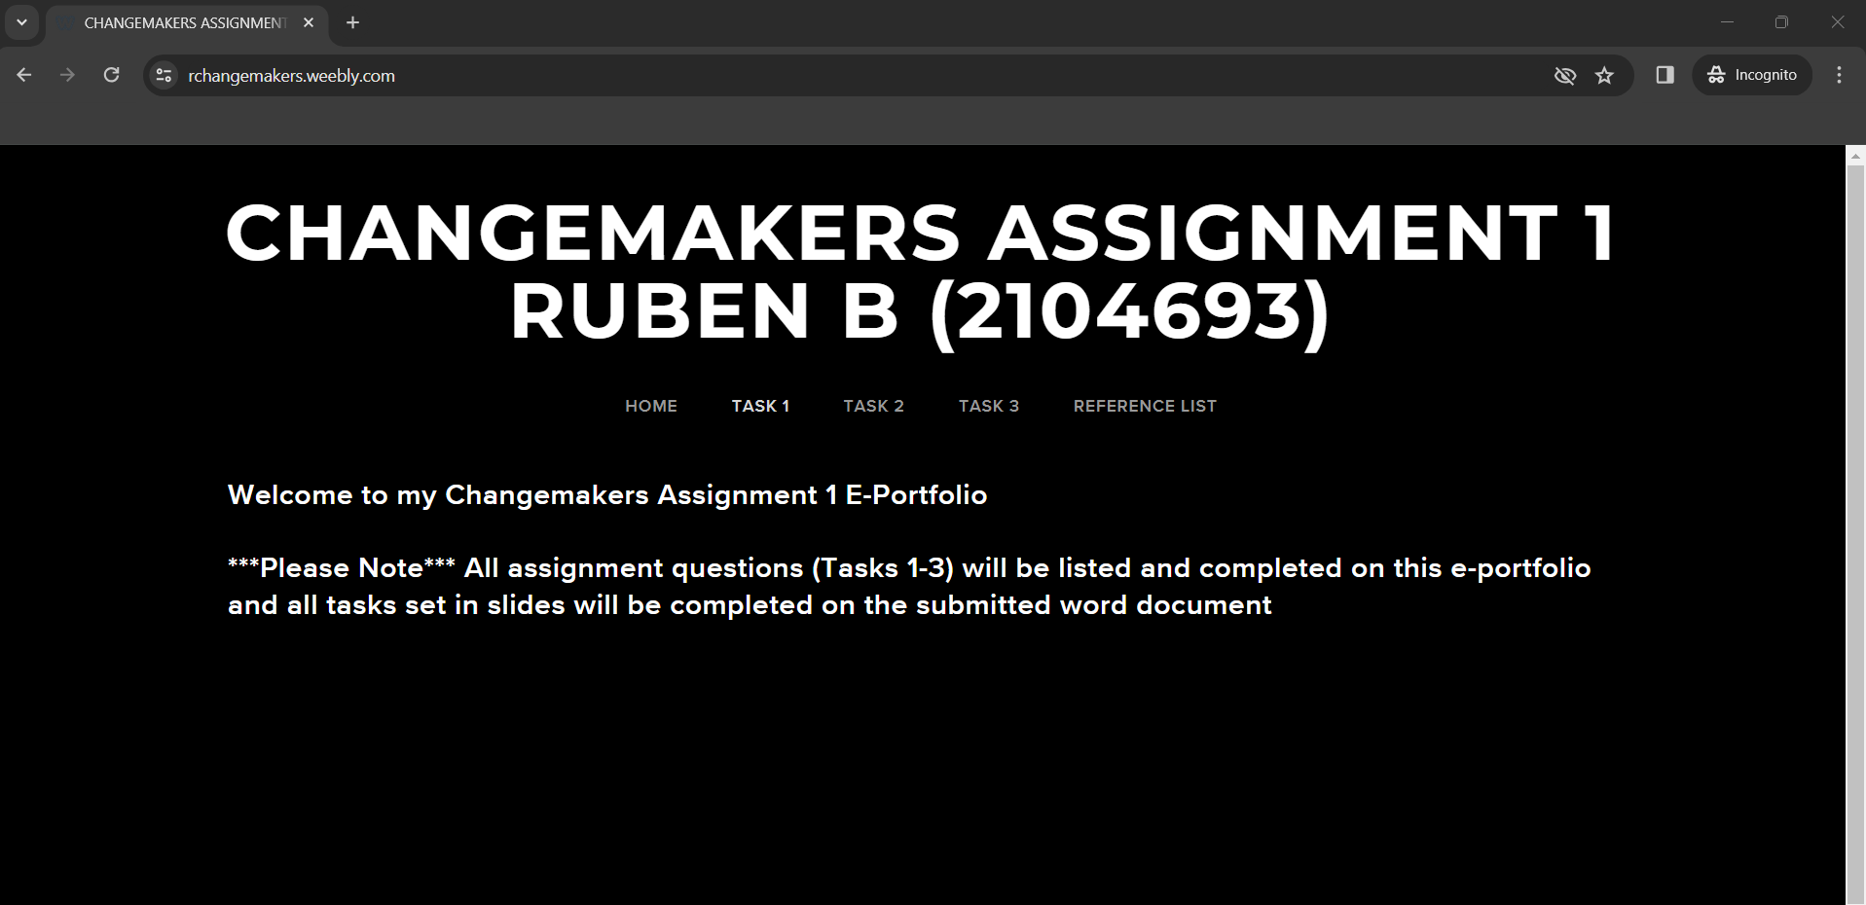
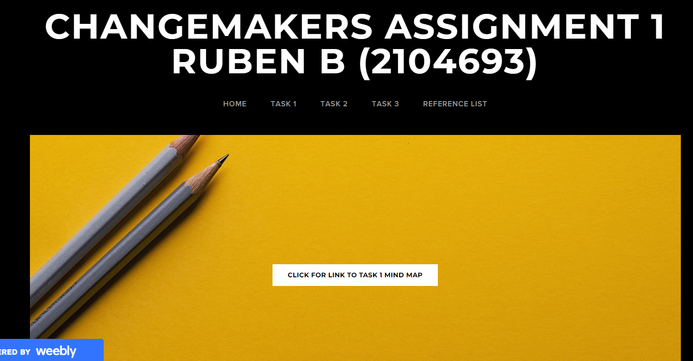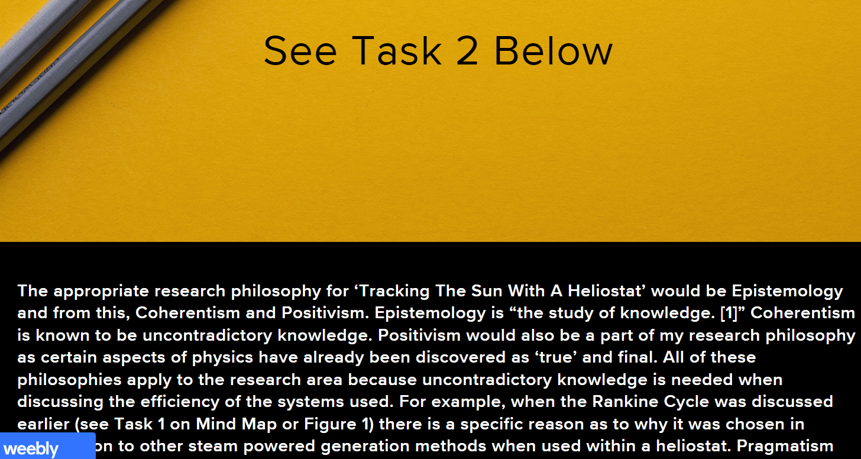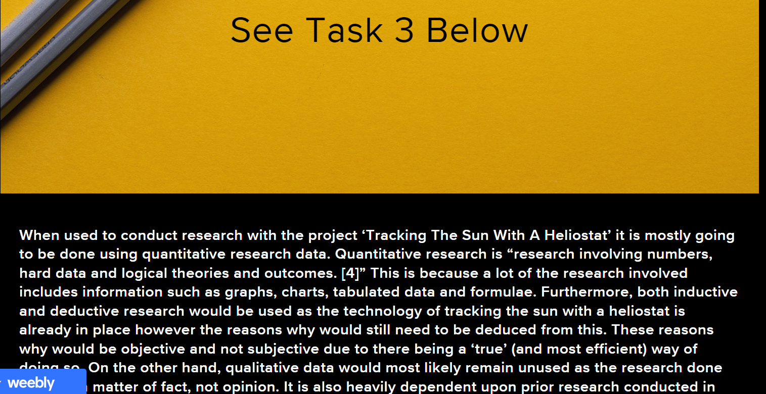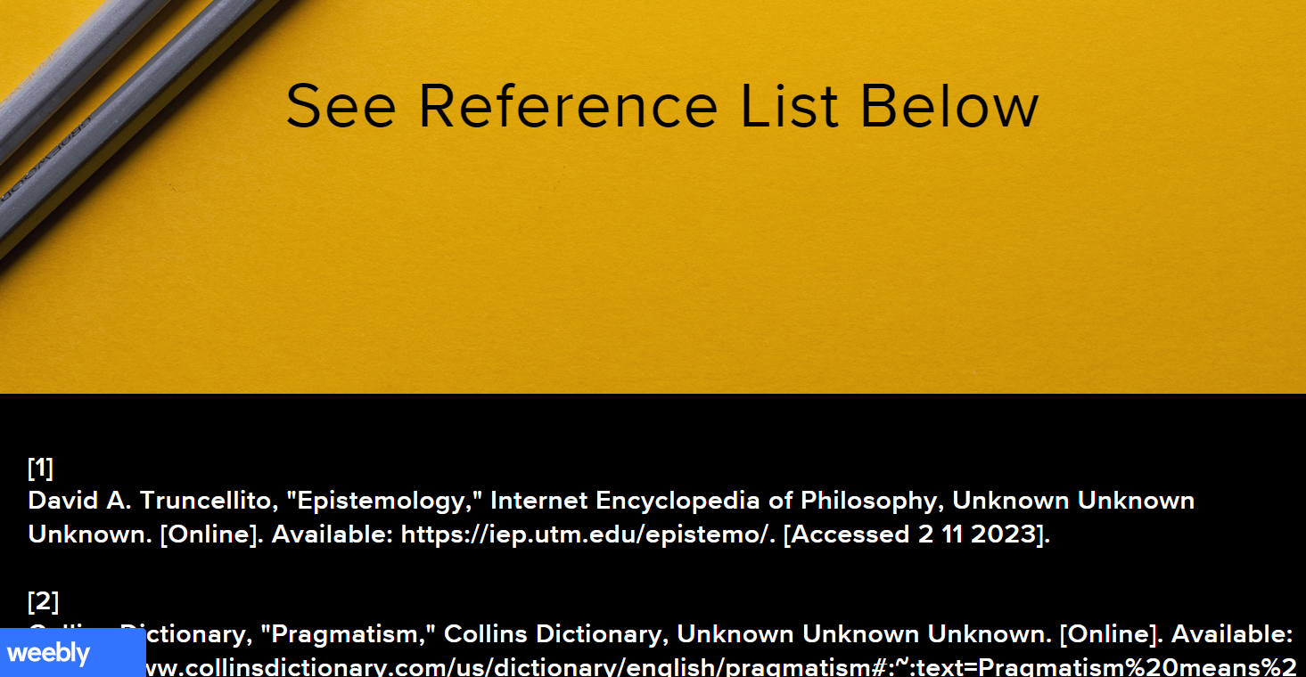

Task 1 Mind Map - https://mm.tt/app/map/3041378363?t=JdsrjKZHI5
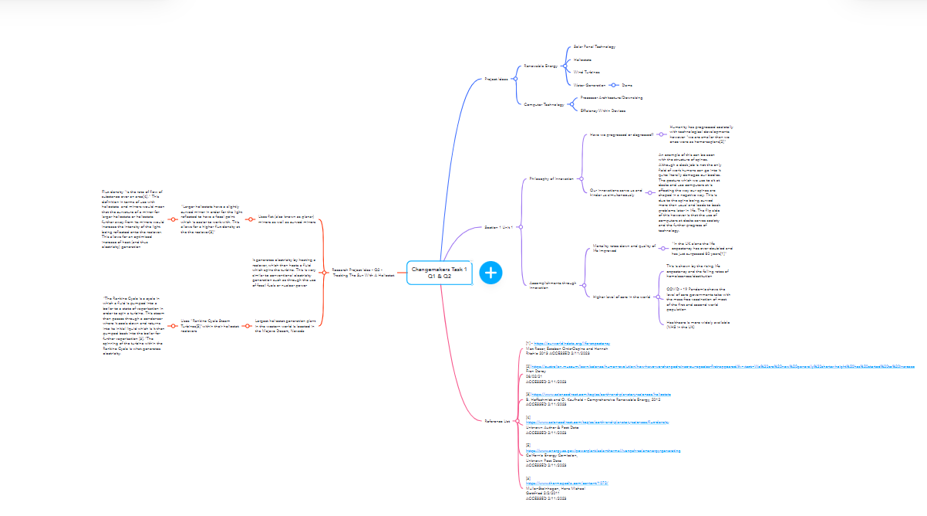
Figure 1

Unit 1
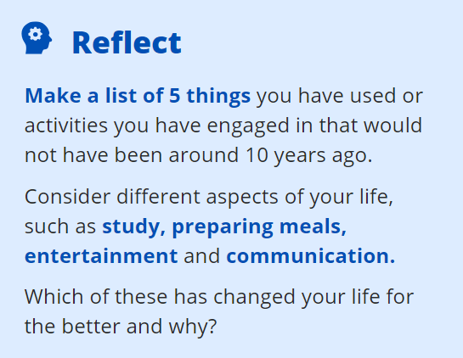
Touchscreen Phones – Communication – Quality of life using apps or other communication methods greatly improved
Air Fryer – Meal Prep – Allows for faster cooking which increases time spent elsewhere
FireStick – Entertainment – Allows for easier browsing and use of various entertainment apps
Wireless Earphones – Communication – Allows for seamless access to mobile devices for calls and entertainment purposes without wire interference
AI – Study – Although not 100% useful, AI tools such as ChatGPT allow for faster access of information compared to that of an internet search

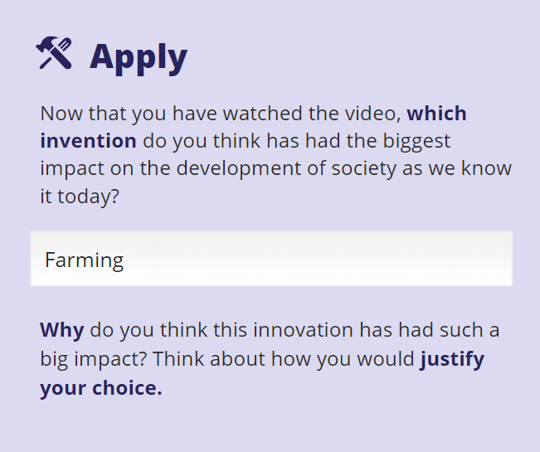
Farming was humanities first step towards what we have today. Without it the need for society and developments in all fields of life would be non-existent. Furthermore, we as a species would have perhaps stagnated without this. 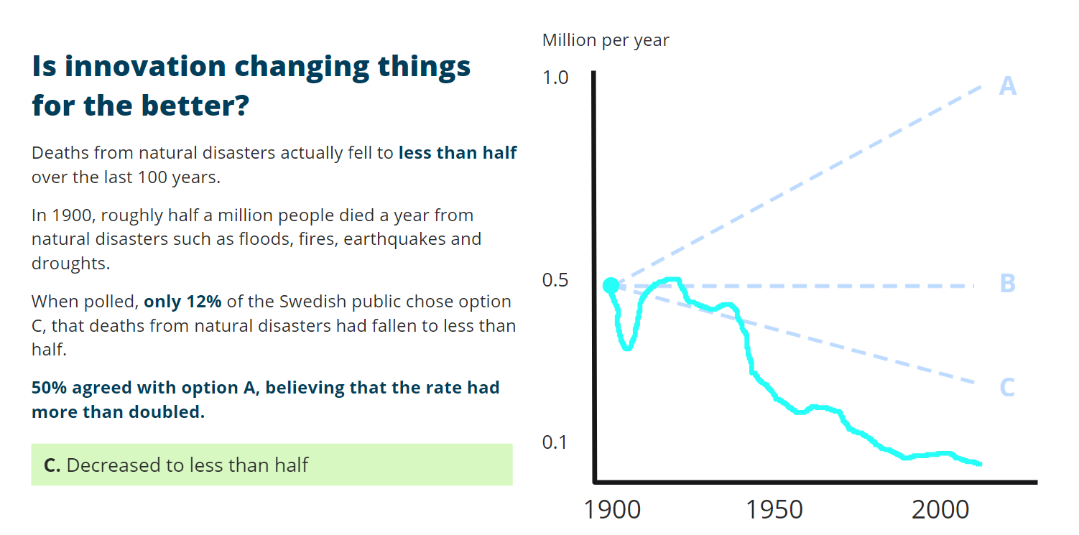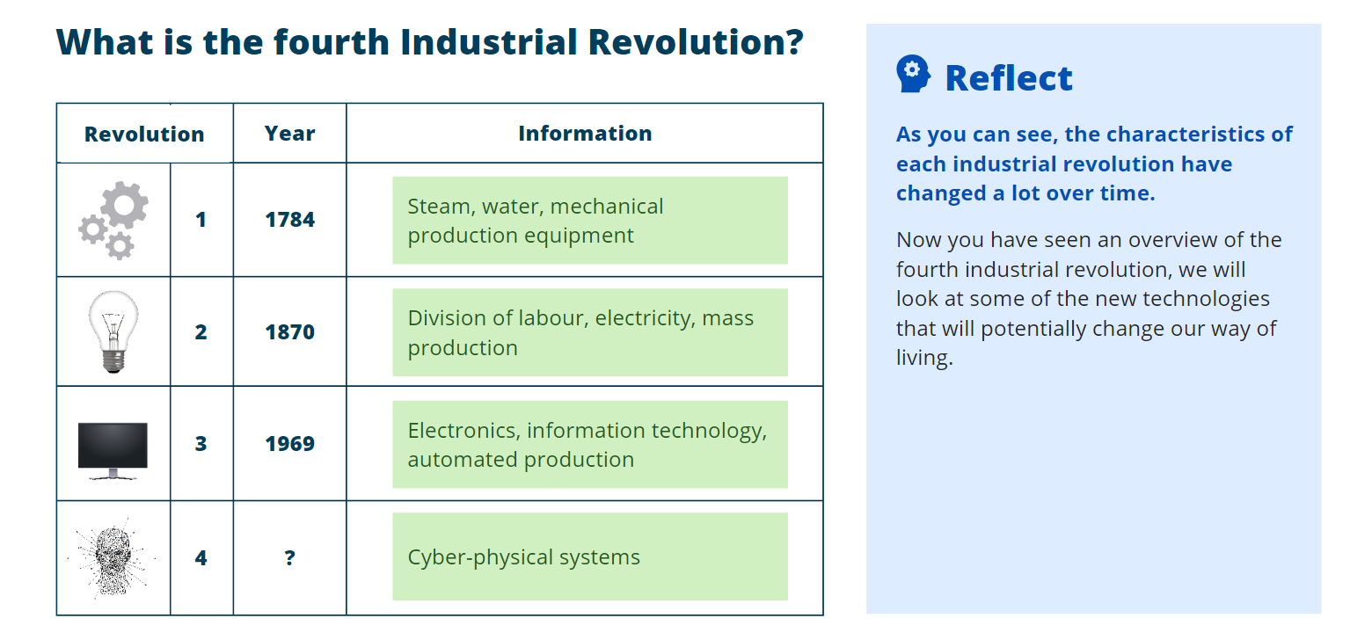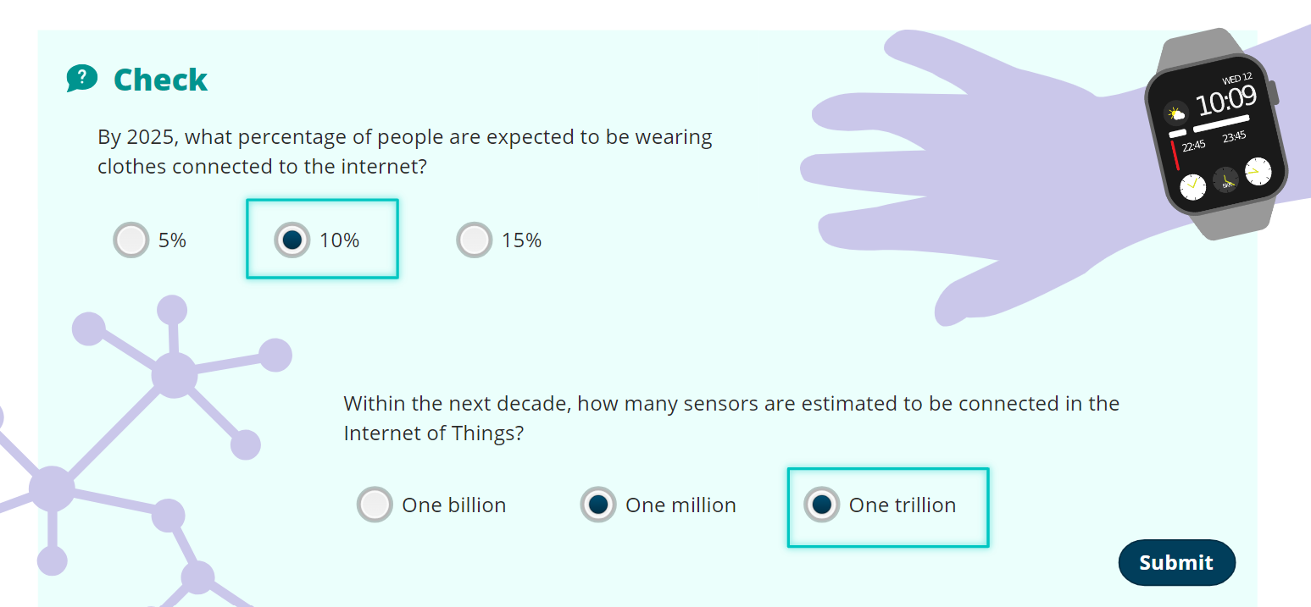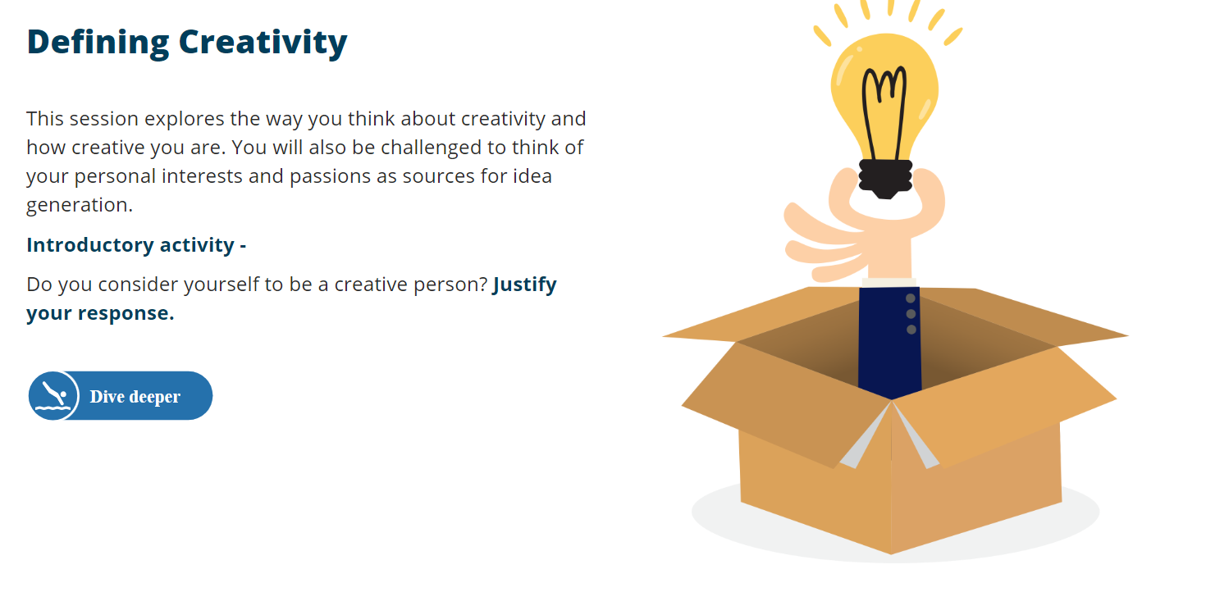No I don’t consider myself as a creative person. This is because I believe my brain leans towards logic and mathematics rather than art. *Side Note – From watching the video later on in slide 44 I see that I may be wrong about my percieved definition of creativity*
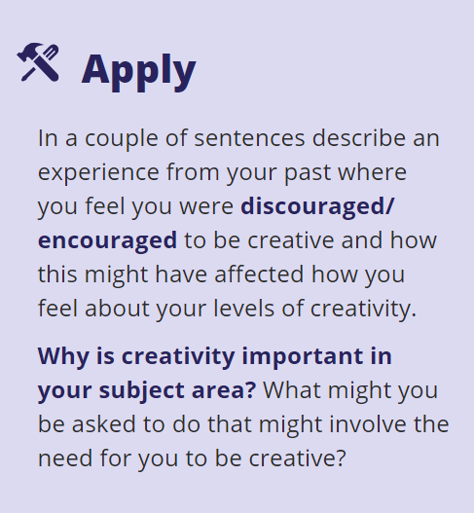
I submitted a painting in high school for my art class. My art teacher laughed and told me to not take art as a GCSE. I laughed and agreed because I truly did agree but in retrospect I have definitely not taken an interest in art since that point.
Creativity is important in Electrical Engineering because it requires creativity from time to time to solve maths problems or to think of improvements to further the field.

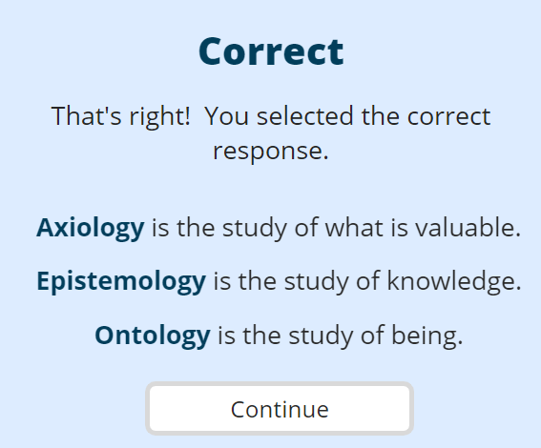
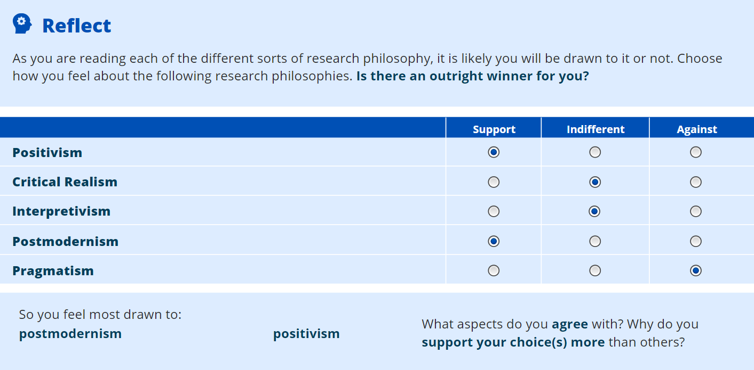
I agree with positivism due to the aspect of understanding a full truth and not just assuming certain answers are so.
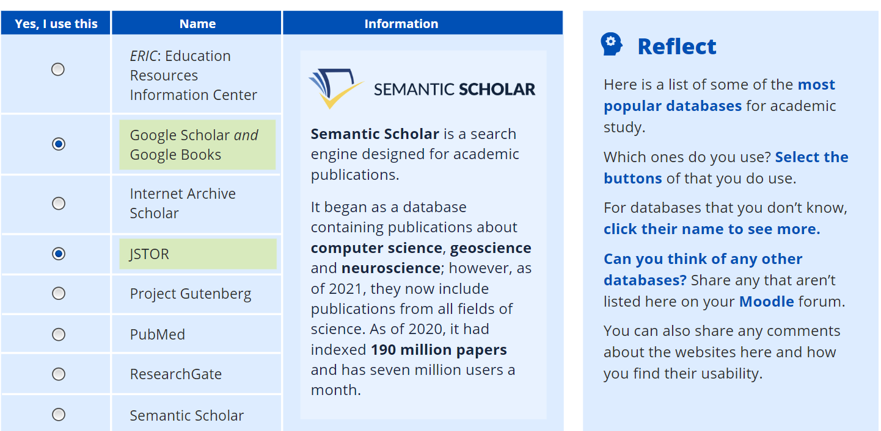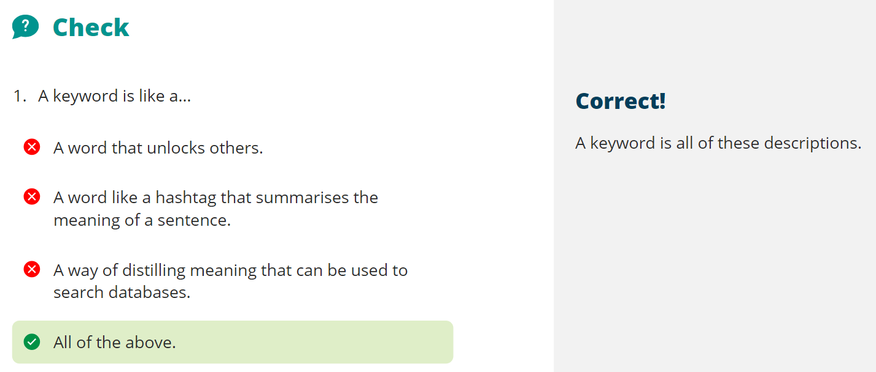
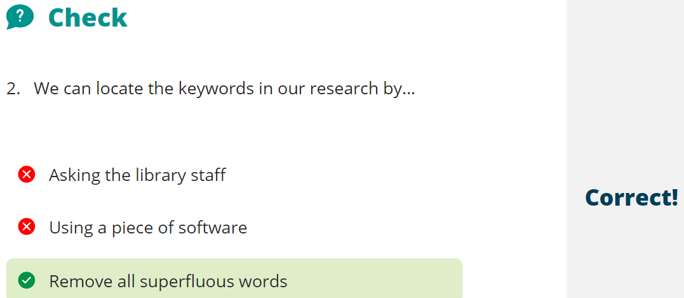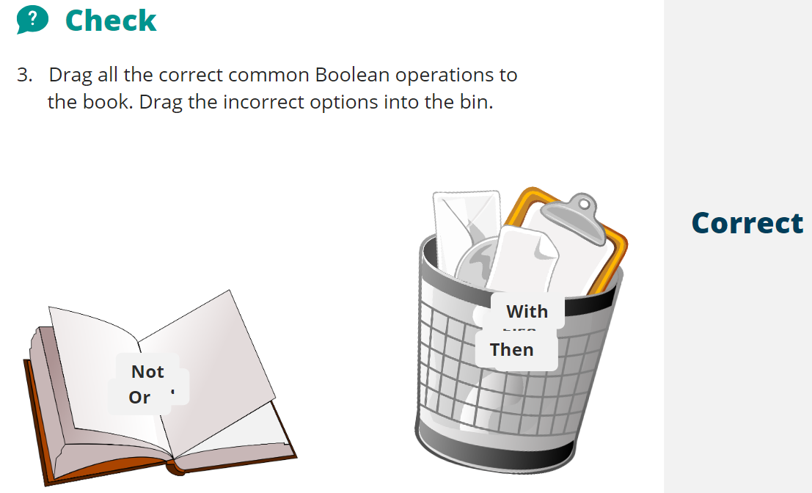
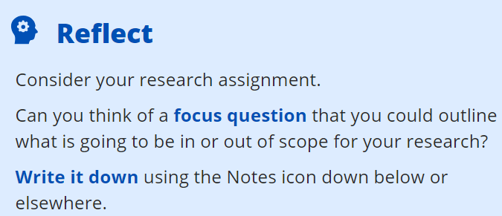
What is the most optimal method for tracking a sun with a heliostat and how can it be improved upon?
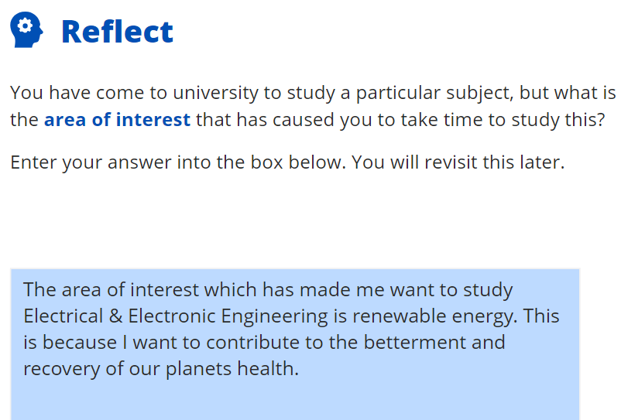
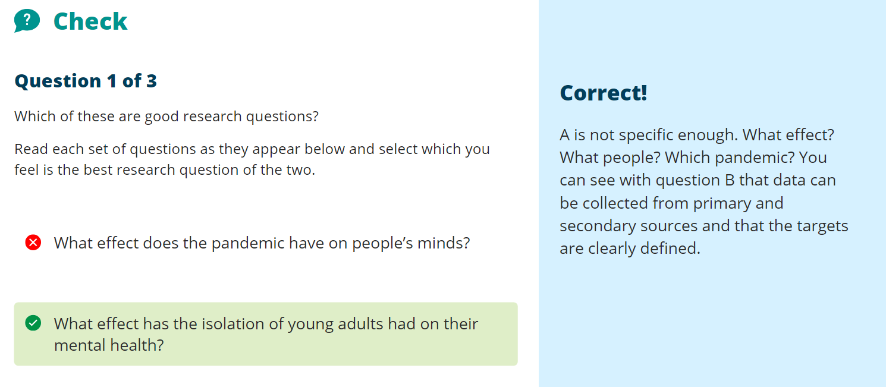Unit 2
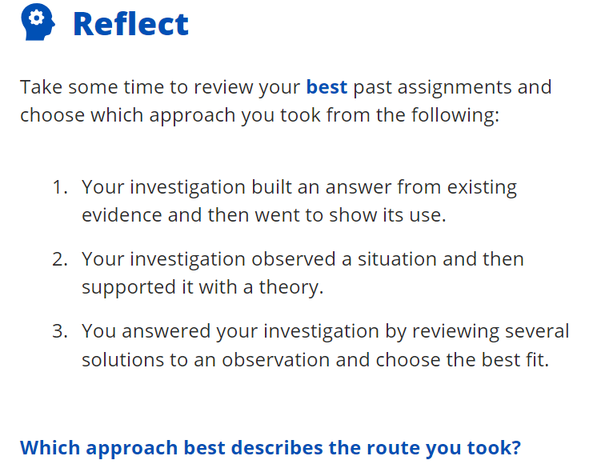
I would choose answer 3
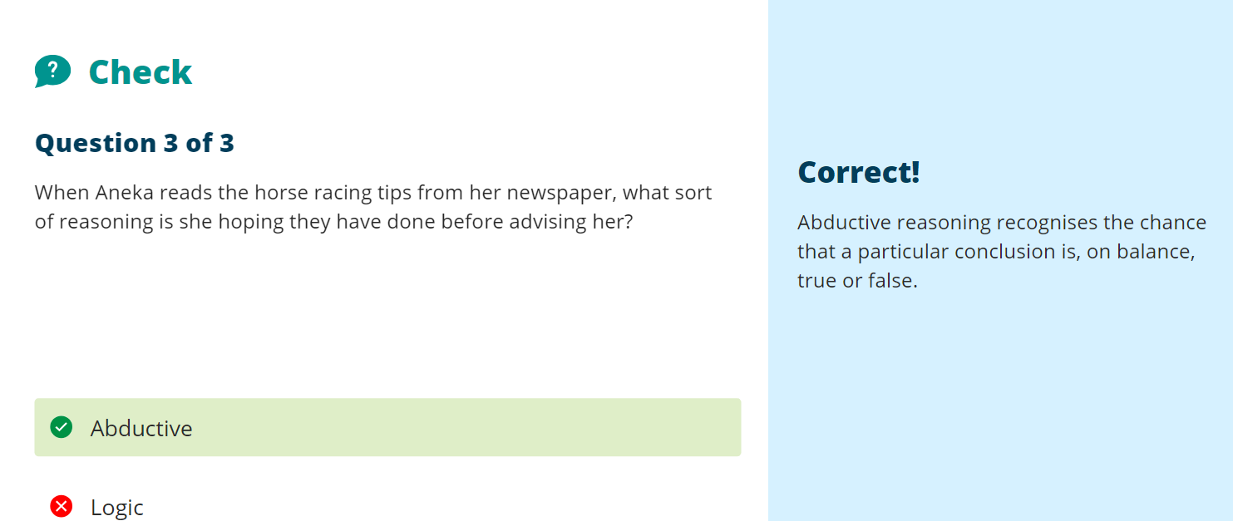
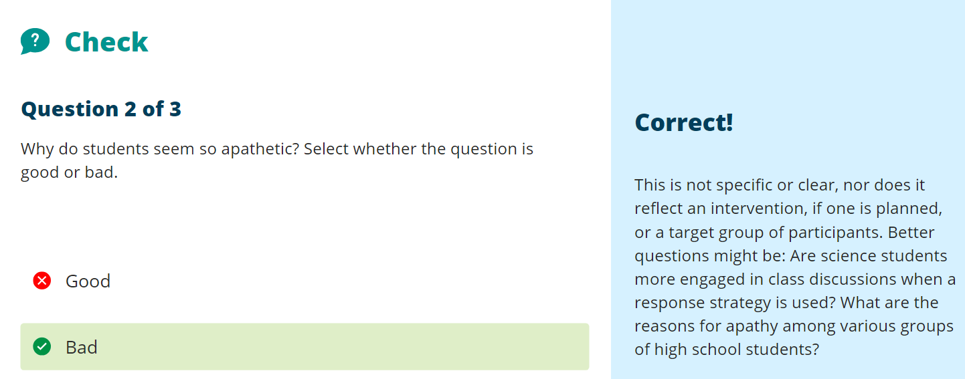
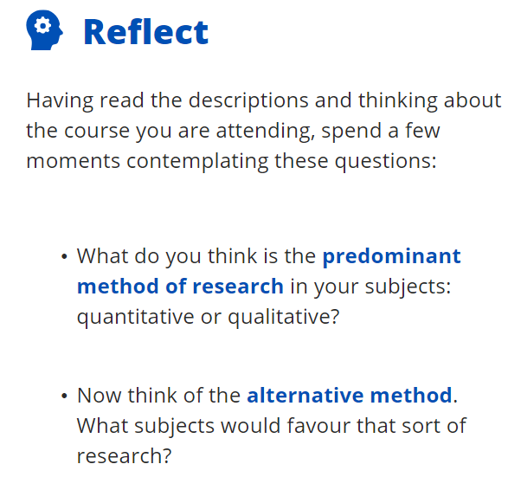
The predominant method of research in my subject of work would be quantitative as it is heavily maths based. Qualitative research would be most likely to be best utilised by subjects such as English, philosophy and art.
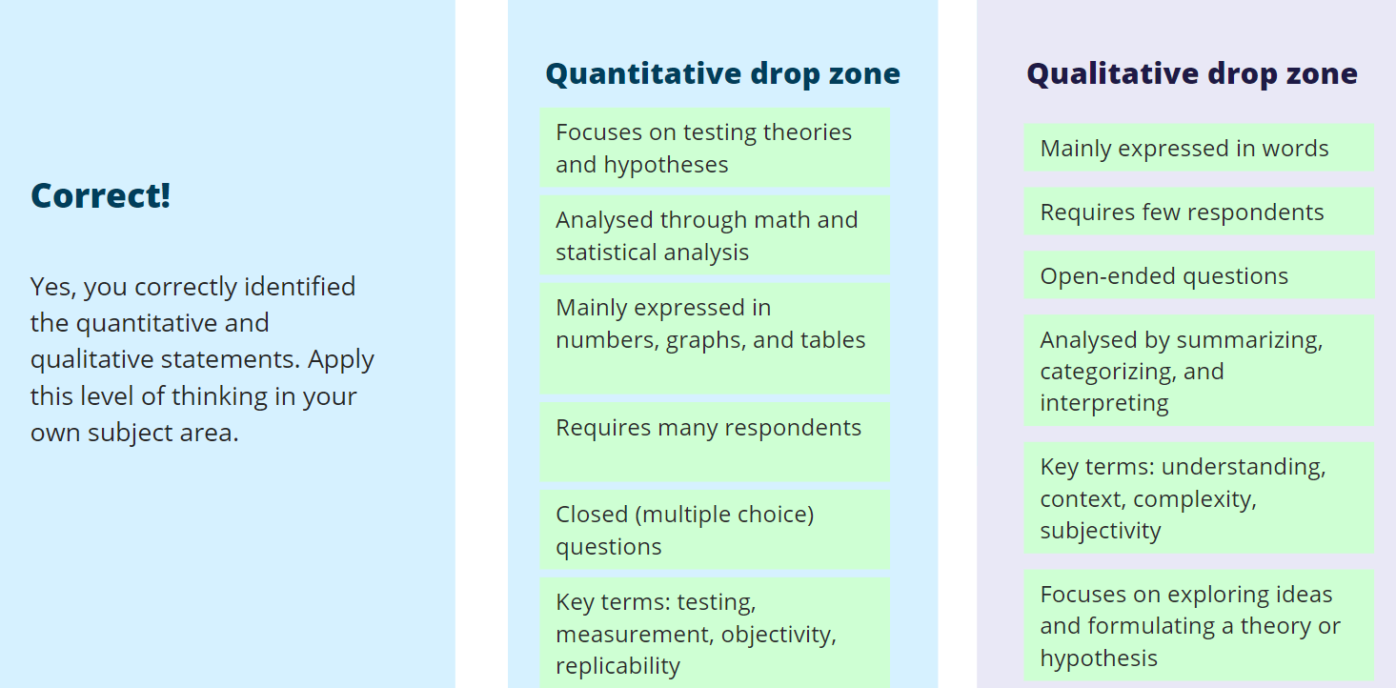
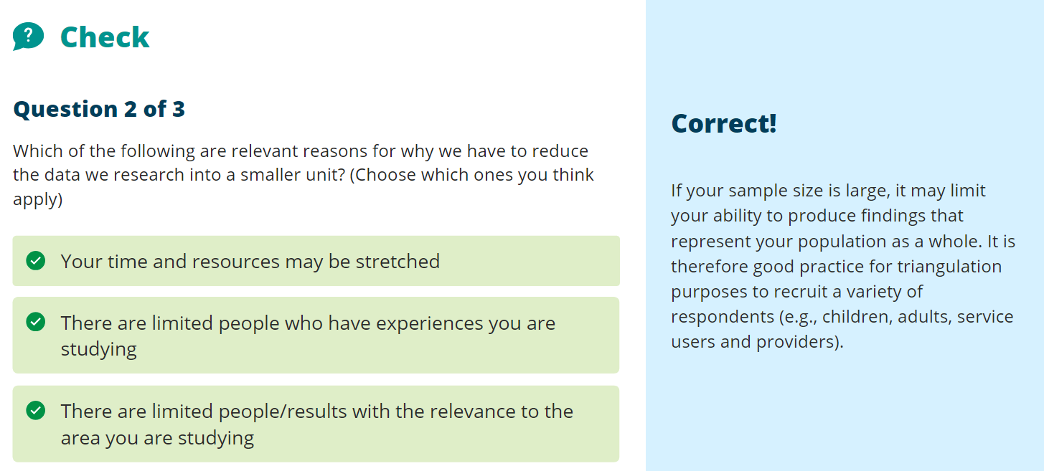

Task 2 Writeup Backup
The appropriate research philosophy for ‘Tracking The Sun With A Heliostat’ would be Epistemology and from this, Coherentism and Positivism. Epistemology is “the study of knowledge. [1]” Coherentism is known to be uncontradictory knowledge. Positivism would also be a part of my research philosophy as certain aspects of physics have already been discovered as ‘true’ and final. All of these philosophies apply to the research area because uncontradictory knowledge is needed when discussing the efficiency of the systems used. For example, when the Rankine Cycle was discussed earlier (see Task 1 on Mind Map or Figure 1) there is a specific reason as to why it was chosen in comparison to other steam powered generation methods when used within a heliostat. Pragmatism (“solving problems in a practical manner rather than the most logical one [2]”) states that if something works then let it be, however, if applied to this research area the efficiency of other generation methods would be less efficient and thus pale in comparison in terms of electricity production. This would mean that a combination of the chosen research philosophies would be optimal when conducting research.
Appropriate databases to use when conducting research for the research project would be:
- Articles from academic journals
- Market reports (seeing what methods of generation the highest profiting companies use)
- Images & Videos
- Books
- Government Reports
- Case Studies
- Government Body Reports
Appropriate methods of search should also be conducted when researching using various databases. These methods would be the use of keywords and Boolean searches, both together and apart. Boolean searches are “the use of the words AND, OR and NOT when searching. The use of AND would mean both subjects searched and include both in the result. The use of OR would mean either of the subjects searched and include one of two in the result. The use of NOT would include any subjects searched placed before to the NOT and would not include the subject placed after the use of NOT (in terms of word syntax) for the result. [3]” The use of keywords would be highly specific to the subject material and would be best utilised with a few, very descriptive words. Using both methods to conduct research for ‘Tracking The Sun With A Heliostat’ would use words and phrases such as ‘heliostat tracking’ or ‘tracking sun mirrors’ to obtain more specific results. This compared to searches such as the title of the research project itself would result in a yield which has a broader spectrum of results.
Research strategies to use when conducting research for the project would be to formulate a valid set of hypotheses. This would be done by framing it in a way in which a question is asked or stated. For example the question ‘does x equal y because of z?’ would have three (or more supposed outcomes). The first outcome would be that there is no correlation between x and y. The second outcome would be x does equal y because of z. The third outcome would the opposite of the second outcome. Feedback would also be useful when conducting research. This can be done by asking peers or field experts on opinions or facts. However depending on the validity of the knowledge from these people may not always be a good idea as they might not have a grasp of the subject at hand.

Task 3 Writeup Backup
When used to conduct research with the project ‘Tracking The Sun With A Heliostat’ it is mostly going to be done using quantitative research data. Quantitative research is “research involving numbers, hard data and logical theories and outcomes. [4]” This is because a lot of the research involved includes information such as graphs, charts, tabulated data and formulae. Furthermore, both inductive and deductive research would be used as the technology of tracking the sun with a heliostat is already in place however the reasons why would still need to be deduced from this. These reasons why would be objective and not subjective due to there being a ‘true’ (and most efficient) way of doing so. On the other hand, qualitative data would most likely remain unused as the research done must be a matter of fact, not opinion. It is also heavily dependent upon prior research conducted in both fields of mathematics and physics. Qualitative research is “research which explores real world and more subjective matters. [5]” That being said, one may argue that something as simple as the weather would (and will) effect how well a heliostat will function as it solely relies on the sun to work therefore discussing what the weather could be like may provide use to the research project in a qualitative manner. This however would not be the case as we can predict what the weather will be like at any given time days, if not weeks into the future, and thus predict the functionality of the heliostat at any given time. This is also conducted via the use of quantitative research which is why it will be prioritised over qualitative research throughout the research project.
The best methods to improve validity, reliability and generalisability of research and results would be to use methods such as the CRAAP test, observations, surveys and secondary data. Surveys of multiple heliostat data such as the fluid used, number of mirrors and location could all provide valuable information as to which is the best way to track the sun with a heliostat. These surveys would most likely include secondary data due to the location of the research project itself. The use of the CRAAP test would improve validity and generalisability of the project as it serves as a ‘double check’ for the acquired information. The CRAAP test “serves as a list to check the Currency, Relevance, Authority, Accuracy and Purpose of and information included in research. It acts as a self-imposed barrier of entry in order to prevent false, useless and old information from being used. [6]”

Bibliography

[1] | David A. Truncellito, "Epistemology," Internet Encyclopedia of Philosophy, Unknown Unknown Unknown. [Online]. Available: https://iep.utm.edu/epistemo/. [Accessed 2 11 2023].
[2] | Collins Dictionary, "Pragmatism," Collins Dictionary, Unknown Unknown Unknown. [Online]. Available: https://www.collinsdictionary.com/us/dictionary/english/pragmatism#:~:text=Pragmatism%20means%20thinking%20of%20or,%5Bformal%5D. [Accessed 2 11 2023].
[3] | Shauntee Burns, "What is Boolean Search?," New York Public Library, 22 2 2011. [Online]. Available: https://www.nypl.org/blog/2011/02/22/what-boolean-search. [Accessed 2 11 2023].
[4] | Babbie, Earl R, "Quantitative Methods," USC Libraries, Unknown Unknown 2010. [Online]. Available: https://libguides.usc.edu/writingguide/quantitative#:~:text=Quantitative%20research%20deals%20in%20numbers,%2C%20free%2Dflowing%20manner%5D.. [Accessed 2 11 2023].
[5] | Steven Tenny; Janelle M. Brannan; Grace D. Brannan., "Qualitative Study," National Library of Medicine, 18 9 2022. [Online]. Available: https://www.ncbi.nlm.nih.gov/books/NBK470395/#:~:text=Qualitative%20research%20is%20a%20type,well%20as%20further%20investigate%20and. [Accessed 2 11 2023].
[6] | Libraries Central Michigan University, "Online Research: CRAAP Test," Libraries Central Michigan University, 30 8 2023. [Online]. Available: https://libguides.cmich.edu/web_research/craap#:~:text=The%20test%20provides%20a%20list,more%20information%2C%20please%20see%20below.. [Accessed 2 11 2023].

