

Module Name: Managing Enterprise
Module Code: (BMSW4011_CARD)
Assignment Name: Business plan, and reflection
Student Name: Roqia haji haidar
Student Number:2422002
Lecturer: Melanie Squire
Deadline:28/11/2025

Wordcount: 1269
AI Acknowledgement
Examples of statements If you have not used AI
I confirm that I have not presented any AI generated materials as my own work.
I confirm that I have copies of my drafts, notes, and other resources I used, which I may be asked to provide in evidence.
Examples of AI statements if you have used AI
Example 1:
I acknowledge the use of Grammarly (https://www.grammarly.com/) on Date to check my work using the prompt(s):
1. Please check the following text for readability, grammar and syntax.
I confirm that I have not presented any AI generated text as my own work. I confirm that I have copies of my drafts, notes, and other resources I used before, and after the use of AI tools which I may be asked to provide in evidence.
Example 2:
I acknowledge the use of SciSpace (https://typeset.io/) on 7 March 2024 to support my research using the prompt(s):
1. Please provide me with materials on the biology of the liver.
2. Please provide me with materials on liver cells.
I confirm that I have not presented any AI generated text as my own work. I confirm that I have copies of my drafts, notes, and other resources I used before, and after the use of AI tools which I may be asked to provide in evidence.
Example 3:
I acknowledge the use of ChatGPT (https://chatgpt.com/) on 13 April 2024 to write my notes into submission format using the prompt(s):
1. Please write up these bullet points as an essay paragraph at university level.
I confirm that I have not presented any AI generated text as my own work. I confirm that I have copies of my drafts, notes, and other resources I used before, and after the use of AI tools which I may be asked to provide in evidence.
Example 4 - acknowledgement of the use of multiple AI tools:
I acknowledge the use of SciSpace (https://typeset.io/) on 28 June 2024 to support my research using the prompt(s):
1. Please provide me with materials on the American Civil War.
2. Please provide me with materials on the reception of Gone with the Wind.
I confirm that I have not presented any AI generated text as my own work. I confirm that I have copies of my drafts, notes, and other resources I used before, and after the use of AI tools which I may be asked to provide in evidence.
I acknowledge the use of Adobe Express (https://www.adobe.com/express/) on 24 June 2024 to edit photographic material:
1. Remove background from Figure 1.
I confirm that I have not presented any AI generated materials as my own work. I confirm that I have copies of my drafts, notes, and other resources I used before and after the use of AI tools which I may be asked to provide in evidence.

Table of Contents
- Overview of Lash Aura
- Background and Business Idea
- Business Ownership
3.1 Rationale
3.2 Advantages and Disadvantages
- Mission, Objectives, and Unique Selling Proposition (USP)
- Location
- Human Resources
- Market Analysis and Marketing Strategy
7.1 Market Segmentation
7.2 Marketing Mix (4Ps)
- Risk Management
- Financial Planning and Cash Flow
- PESTLE and SWOT Analysis
- Conclusion
- References
- Appendices

Business Plan – Lash Aura
1.Overview of Lash Aura
Lash Aura is a beauty business that provides eyelash extensions, lash lifts, and tinting services for women living in cities across the UK. The goal of the business is to deliver high-quality, safe, and personalised treatments at prices that are accessible (Slávik et al., 2022). Demand for eyelash extensions continues to grow as more people look for beauty services that boost confidence and enhance their overall appearance (Atiqa Radhi, Hamdan and Muneer Al Mubarak, 2024).
All treatments will take place in a small studio or home-based salon, using professional techniques and maintaining strict hygiene and safety procedures. To attract a younger, urban audience, the business will make use of platforms like Instagram and TikTok. Customer loyalty will be encouraged through repeat-visit incentives and referral programmes that reward clients for recommending the service to others (Lupo and Stroman, 2020; Fu and Pang, 2018).

2. Background and Business Idea
The idea for Lash Aura came from noticing how quickly the beauty industry is growing in the UK, especially the increasing demand for eyelash services among women (Atiqa Radhi, Hamdan and Muneer Al Mubarak, 2024). Many clients want beauty services that are personal, convenient, and help them feel more confident, while fitting into their busy lives.
Home-based and small boutique salons are becoming more common because they offer a cheaper alternative to expensive studios, while keeping good quality and hygiene standards (Sadiq, Ahmad and Khan, 2021). This type of business allows the owner to start with a small budget, test the market, and slowly expand the services over time.

3. Business Ownership
Lash Aura will operate as a sole trader. This model is chosen due to its simplicity, flexibility, and cost effectiveness for small start-ups (Rye, 2020). Operating as a sole trader allows full control over business decisions, faster implementation of strategies, and simplified accounting.
3.1 Rationale
With a modest £2,000 start-up budget, the sole trader structure is ideal for minimizing overheads and maintaining operational flexibility (Moschella, Boulianne and Magnan, 2022). It is suitable for a business testing new market trends and refining its service offerings based on client feedback (Slávik et al., 2022).
3.2 Advantages and Disadvantages
Advantages:
- Full control over the business
- Simplified accounting
- Quick decision making
Disadvantages:
- Unlimited personal liability
- Limited access to finance
- Growth may be constrained
(Rye, 2020; Slávik et al., 2022)

4. Mission, Objectives, and Unique Selling Proposition (USP)
Mission Statement:
To enhance confidence and beauty through premium eyelash services delivered safely, professionally, and affordably.
SMART Objectives:
- Launch Lash Aura by January 2025 and gain at least 50 clients by the end of March 2025.
- Maintain a client retention rate of at least 90% throughout 2025.
- Expand services to include lash lifts and tints by December 2026.
Unique Selling Proposition (USP):
Lash Aura combines high hygiene standards, professional techniques, and customized lash designs at affordable prices, ensuring a safe and exceptional client experience (Mewoh, Lapian and Gunawan, 2023; Chonyitree Sangwijit, Fatima Ibrahim Abdulsalam and Nitikorn Phoosuwan, 2024).

5. Location
The business will operate from a home-based studio in Cardiff, offering clients a convenient urban location. This choice reduces initial overhead costs while providing a professional environment for beauty treatments (Sadiq, Ahmad and Khan, 2021; Yakiv Baytelman and Viktoriya Voropayeva, 2025). Accessibility, safety, and compliance with local health regulations are priorities to ensure both customer satisfaction and legal compliance.

6. Human Resources
Initially, Lash Aura will be operated solely by the owner. Staff may be added as demand grows, with training focused on eyelash application, client care, and hygiene practices Maintaining high standards in service delivery is crucial to building brand reputation and loyalty. (Chonyitree Sangwijit, Fatima Ibrahim Abdulsalam and Nitikorn Phoosuwan, 2024).

7. Market Analysis and Marketing Strategy
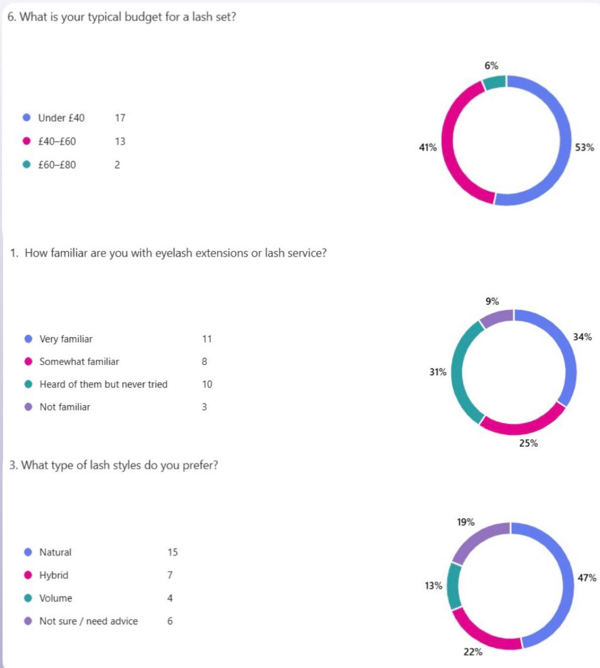
7.1 Market Segmentation
Based on the questionnaire results, the three most common responses indicate that Lash Aura primarily targets women of all ages in urban areas who value beauty, self-care, and convenience. Among these, students and young professionals showed the highest interest in home-based lash services, highlighting a demand for flexible and accessible beauty solutions. (ieeexplore.ieee.org, n.d.; Atiqa Radhi, Hamdan, & Muneer Al Mubarak, 2024).
- Experience: 34% are very familiar with lash services.
- Style: 47% prefer a natural look.
- Budget: 53% spend under £40.
- Lifestyle: Customers value self-care and follow beauty trends.
- Location: Urban areas make home services easy and convenient.
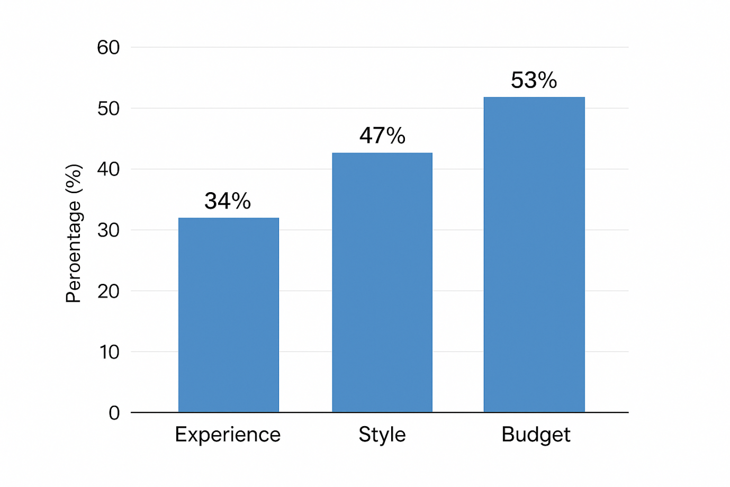

7.2 Marketing Mix (4Ps)
Product:
Eyelash extensions, lash lifts, lash tints, and aftercare advice.
Price:
Mid-range pricing to offer an affordable but premium service.
Place:
Home-based studio with an online booking system for easy access.
Promotion:
Instagram, TikTok, referrals, and loyalty programmes to attract and retain clients (Lupo and Stroman, 2020; Fu and Pang, 2018
Strong visual branding and consistent online presence will enhance brand identity and attract potential clients (Sumelius, 2022).

8. Risk Management
Lash Aura may face risks such as competition from other beauty businesses, not following regulations, and financial difficulties. To reduce these risks, the business will make sure it has all the necessary licenses and insurance, maintain high standards of hygiene, and carefully track income and expenses (Moschella, Boulianne and Magnan, 2022). In addition, Lash Aura will have plans in place to keep the business running during unexpected problems and will regularly check client satisfaction to make sure customers are happy. These steps will help the business operate safely and successfully over time.
9. Financial Planning and Cash Flow
Item and Cost:
- Lash kit and materials – £500
- Marketing (social media) – £300
- Studio setup / home salon – £700
- Licences and insurance – £300
- Miscellaneous – £200
Total Start-up Cost: £2,000
Effective financial management will ensure that cash flow remains positive, and expenses are covered while maximizing profitability (Williams, Yehezkeil Hasudungan and Nur Azizah, 2025).

MONTH | REVENUE | VARIABLE COSTS | FIXED COSTS | MARKETING | NET CASH FLOW | CUMULATIVE CASH
JAN | 800 | 100 | 200 | 50 | 450 | 2,450
FEB | 1,000 | 125 | 200 | 50 | 625 | 3,075
MAR | 1,200 | 150 | 200 | 50 | 800 | 3,875
APR | 1,400 | 175 | 200 | 50 | 975 | 4,850
MAY | 1,600 | 200 | 200 | 5O | 1.150 | 6,000
JUN | 1,800 | 225 | 200 | 50 | 1,325 | 7,325
JULY | 2,000 | 275 | 200 | 50 | 1,500 | 8.825
AUG | 2,200 | 275 | 200 | 50 | 1,675 | 10,500
SEP | 2,400 | 300 | 200 | 50 | 1,850 | 12,350
OCT | 2,600 | 325 | 200 | 50 | 2,025 | 14,375
NOV | 2,800 | 350 | 200 | 50 | 2,200 | 16,575
DEC | 3,000 | 375 | 200 | 50 | 2,375 | 18.950

Revenue steadily grows as the client base increases.
Net Cash Flow shows monthly profit after deducting costs.
Cumulative Cash reflects the total cash available over time, including the initial £2,000 start-up.

10. PESTLE and SWOT Analysis
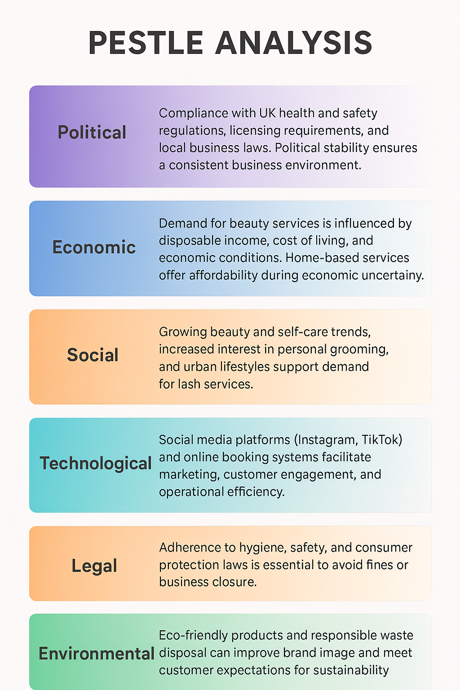
PESTLE Analysis
- Political: Compliance with UK health and safety regulations, licensing requirements, and local business laws. Political stability ensures a consistent business environment.
- Economic: Demand for beauty services is influenced by disposable income, cost of living, and economic conditions. Home-based services offer affordability during economic uncertainty.
- Social: Growing beauty and self-care trends, increased interest in personal grooming, and urban lifestyles support demand for lash services.
- Technological: Social media platforms (Instagram, TikTok) and online booking systems facilitate marketing, customer engagement, and operational efficiency.
- Legal: Adherence to hygiene, safety, and consumer protection laws is essential to avoid fines or business closure.
- Environmental: Eco-friendly products and responsible waste disposal can improve brand image and meet customer expectations for sustainability

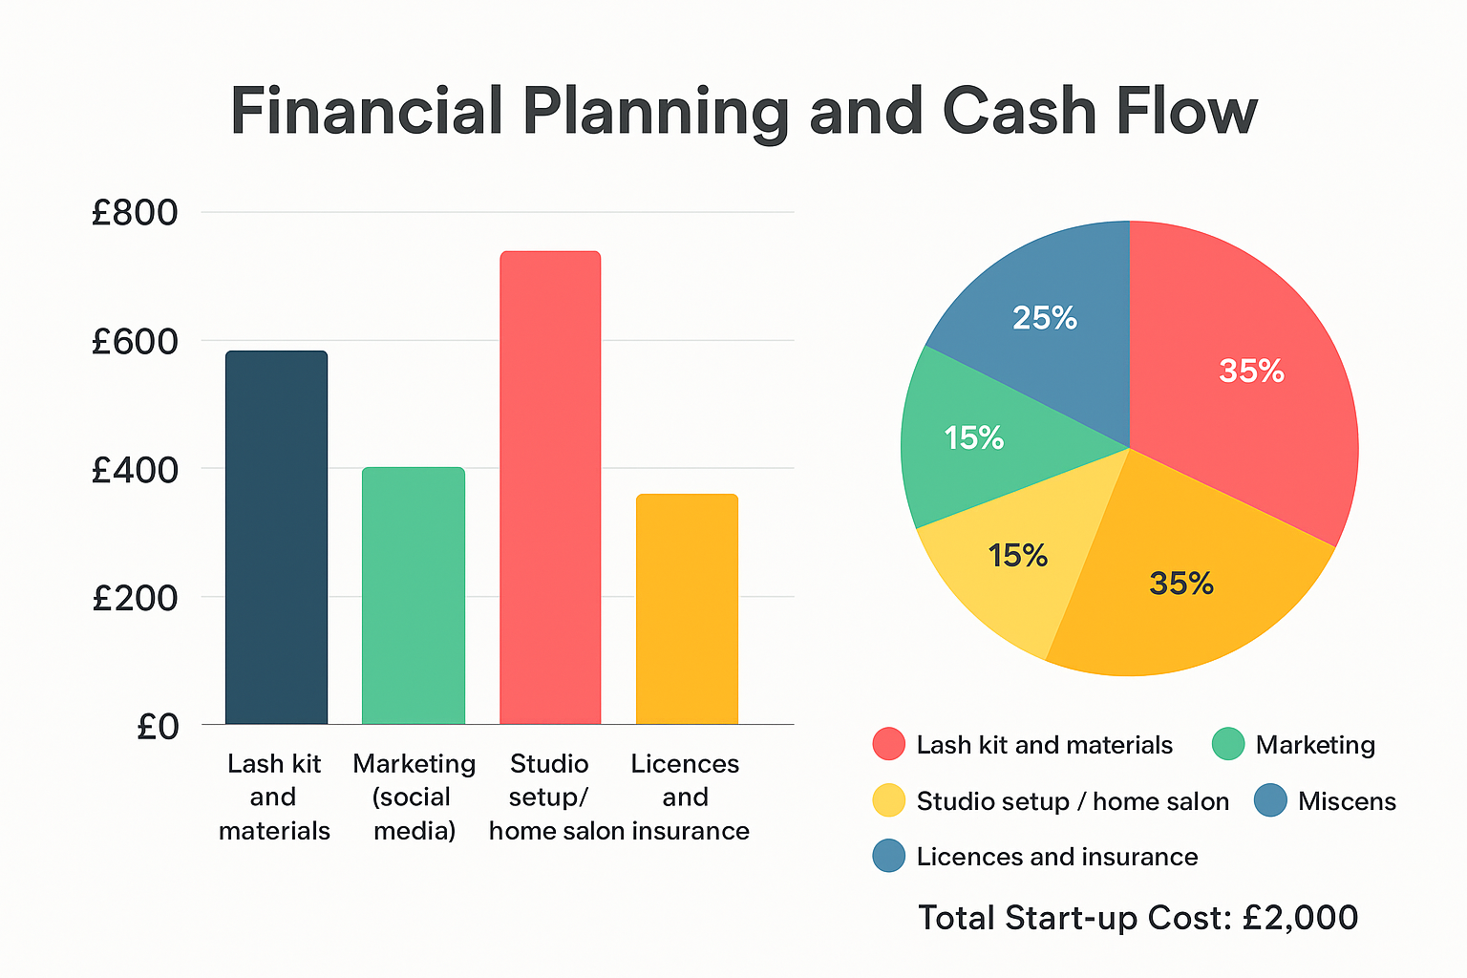

11. Conclusion
Lash Aura is positioned to capitalize on the growing beauty services market in the UK, particularly eyelash extensions. By combining affordable high-quality services, strong branding, careful financial planning, and effective marketing, the business is set to achieve sustainable growth. Compliance with health and safety standards, attention to customer preferences, and a clear USP will help differentiate the business in a competitive market (Slávik et al., 2022; Dehghan Bejarkenari et al., n.d.; Yakiv Baytelman and Viktoriya Voropayeva, 2025).
12. References
- Slávik, Š., Hudáková, I.M., Procházková, K. and Zagoršek, B. (2022). Strategic Background of the Start-Up—Qualitative Analysis. Administrative Sciences, 12(1), p.17. doi:https://doi.org/10.3390/admsci12010017.
- Rye, J. (2020). What is the difference between a sole trader and a limited company? Setting Up and Running a Therapy Business, pp.132–134. doi:https://doi.org/10.4324/9781003096320-38.
- Dehghan Bejarkenari, Z., Farzpourmachiani, M., Fojlaley, M. and Rajacic, S. (n.d.). Entrepreneurship in Women’s Beauty Sciences. [online] 3, p.2024. Available at: https://dl.tubittumjournal.com/articles/2024/issue3/652-660.pdf.
- Yakiv Baytelman and Viktoriya Voropayeva (2025). A Start-Up for Business Development of Start-Ups. Lecture notes in networks and systems, pp.195–202. doi:https://doi.org/10.1007/978-3-031-83523-0_18.
- Moschella, J., Boulianne, E. and Magnan, M. (2022). Risk Management in Small‐ and Medium‐Sized Businesses and How Accountants Contribute†. Contemporary Accounting Research. doi:https://doi.org/10.1111/1911-3846.12819.
- Business development of eyelash extension salon A Case Study for Brows & Lashes Bar. (n.d.). Available at: https://www.theseus.fi/bitstream/handle/10024/894859/Saarik_Elizaveta.pdf?sequence=2.
- Atiqa Radhi, Hamdan, A. and Muneer Al Mubarak (2024). Factors Influencing Consumer Buying Behavior of Beauty and Personal Care. Studies in systems, decision and control, pp.409–424. doi:https://doi.org/10.1007/978-3-031-62106-2_32.
- Mewoh, I.A., Lapian, S.L.H.V.J. and Gunawan, E.M. (2023). THE INFLUENCE OF BRAND IMAGE, PRODUCT VARIETY, AND PRICING STRATEGY ON PURCHASE DECISION OF EYELASH EXTENSION AT LASHTHETIQUE MANADO (STUDY ON LASHTHETIQUE CUSTOMERS). Jurnal EMBA : Jurnal Riset Ekonomi, Manajemen, Bisnis dan Akuntansi, [online] 11(3), pp.359–370. doi:https://doi.org/10.35794/emba.v11i3.49619.
- Chonyitree Sangwijit, Fatima Ibrahim Abdulsalam and Nitikorn Phoosuwan (2024). Health and safety in hair salons during the Covid-19 situation: A cross-sectional study in a semi-urban district in Thailand. Public Health in Practice, [online] pp.100472–100472. doi:https://doi.org/10.1016/j.puhip.2024.100472.
- Sadiq, S., Ahmad, A. and Khan, I.U. (2021). Analyzing the impact of Women-Owned Home-based Businesses on Income Generation and Household Livelihood in Khyber Pakhtunkhwa Pakistan. VFAST Transactions on Education and Social Sciences, [online] 9(2), pp.19–29. doi:https://doi.org/10.21015/vtess.v9i2.782.
- Lupo, C. and Stroman, J.R. (2020). Social Media Marketing Adoption Strategies: An Exploratory Multiple Case Study of Landscape Industry Small Businesses. Journal of Social, Behavioral, and Health Sciences, 14(1), pp.211–220. doi:https://doi.org/10.5590/jsbhs.2020.14.1.15.
- ieeexplore.ieee.org. (n.d.). Cosmetic Products Customisation and Customer Segmentation | IEEE Conference Publication | IEEE Xplore. [online] Available at: https://ieeexplore.ieee.org/abstract/document/10200286.
- Sumelius, J. (2022). How visual identities influence the performance and success of start-ups. [online] Aalto.fi. Available at: https://aaltodoc.aalto.fi/items/5a9a4d80-90cb-415a-9be6-c6165f3e5ae4.
- Fu, X. and Pang, J. (2018). Effect of e-referral incentive programs on referrer loyalty on social platforms. The Service Industries Journal, pp.1–22. doi:https://doi.org/10.1080/02642069.2018.1505872.
- Williams, A., Yehezkeil Hasudungan and Nur Azizah (2025). The Implementation of Effective Financial Management to Increase the Profitability of Startups. Startupreneur Business Digital (SABDA Journal), [online] 4(1), p.-. doi:https://doi.org/10.33050/sabda.v4i1.714

13. Appendices
WEBSITE :
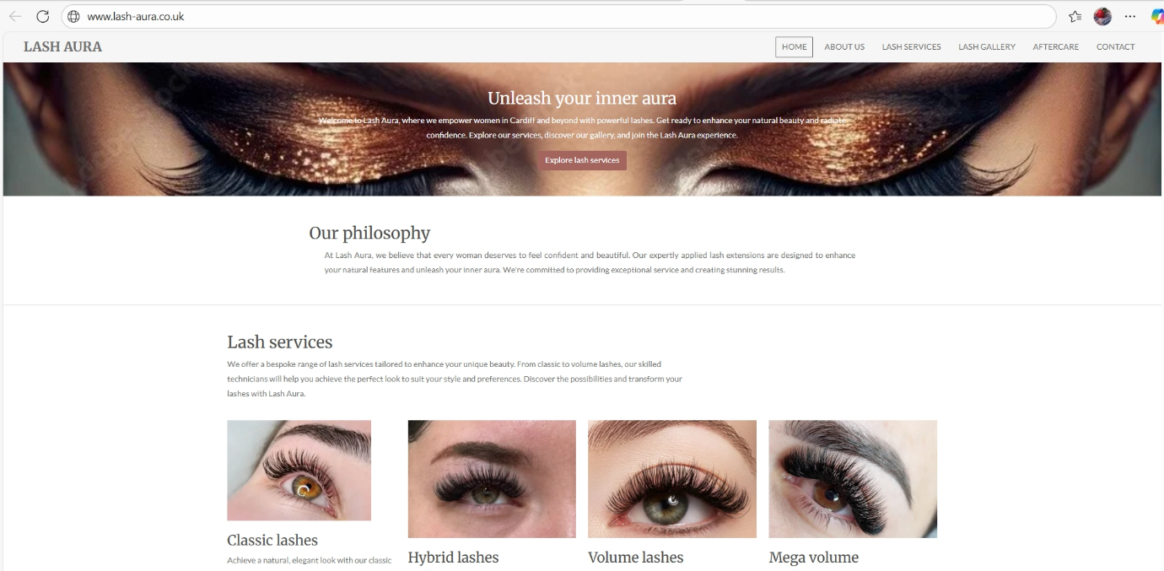
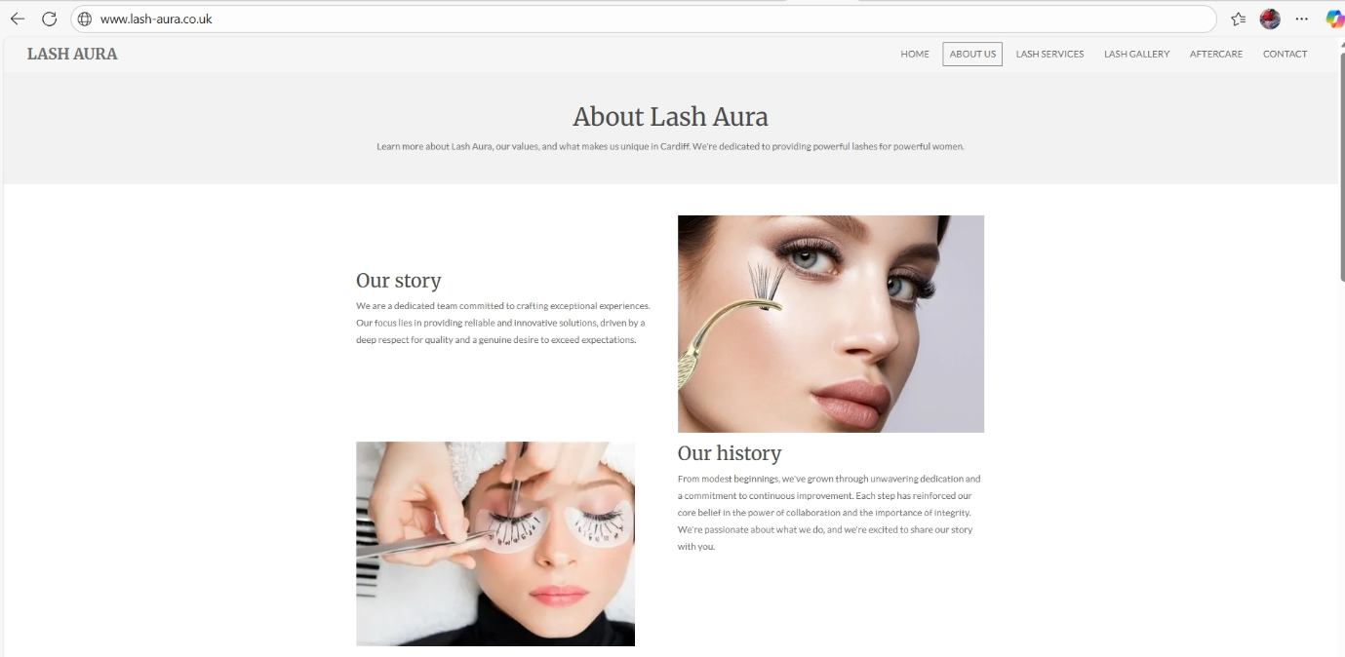
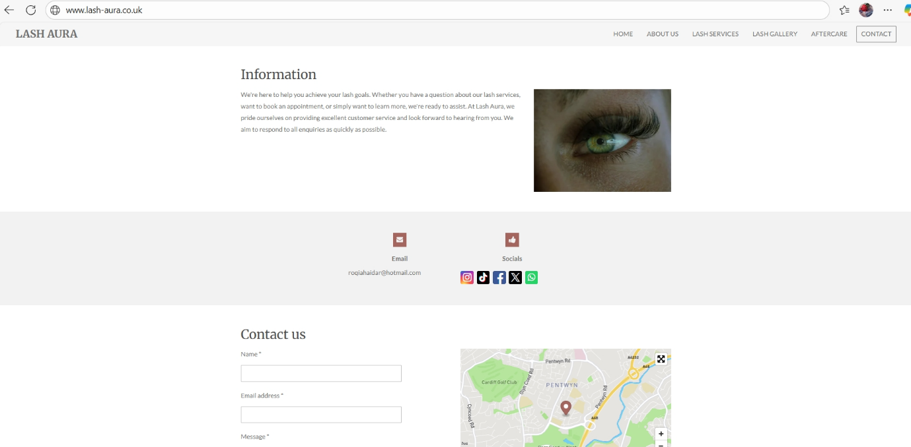

BUISNESS CARD
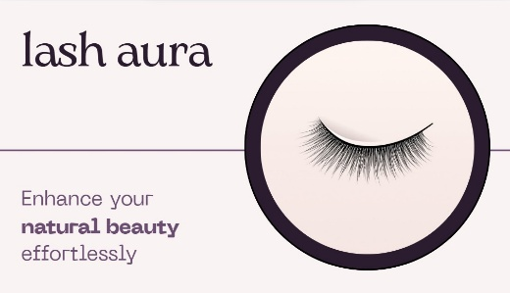
BUISNESS FLYER
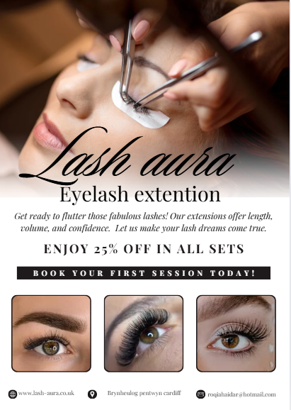

Module Name: Managing Enterprise
Module Code: (BMSW4011)
Assignment Name: Individual Reflection
Student Name: Roqia haji haidar
Student Number:2422002
Lecturer: Melanie Squire
Deadline:28/11/2025

Wordcount: 525
AI Acknowledgement
Examples of statements If you have not used AI
I confirm that I have not presented any AI generated materials as my own work.
I confirm that I have copies of my drafts, notes, and other resources I used, which I may be asked to provide in evidence.
Examples of AI statements if you have used AI
Example 1:
I acknowledge the use of Grammarly (https://www.grammarly.com/) on Date to check my work using the prompt(s):
1. Please check the following text for readability, grammar and syntax.
I confirm that I have not presented any AI generated text as my own work. I confirm that I have copies of my drafts, notes, and other resources I used before, and after the use of AI tools which I may be asked to provide in evidence.
Example 2:
I acknowledge the use of SciSpace (https://typeset.io/) on 7 March 2024 to support my research using the prompt(s):
1. Please provide me with materials on the biology of the liver.
2. Please provide me with materials on liver cells.
I confirm that I have not presented any AI generated text as my own work. I confirm that I have copies of my drafts, notes, and other resources I used before, and after the use of AI tools which I may be asked to provide in evidence.
Example 3:
I acknowledge the use of ChatGPT (https://chatgpt.com/) on 13 April 2024 to write my notes into submission format using the prompt(s):
1. Please write up these bullet points as an essay paragraph at university level.
I confirm that I have not presented any AI generated text as my own work. I confirm that I have copies of my drafts, notes, and other resources I used before, and after the use of AI tools which I may be asked to provide in evidence.
Example 4 - acknowledgement of the use of multiple AI tools:
I acknowledge the use of SciSpace (https://typeset.io/) on 28 June 2024 to support my research using the prompt(s):
1. Please provide me with materials on the American Civil War.
2. Please provide me with materials on the reception of Gone with the Wind.
I confirm that I have not presented any AI generated text as my own work. I confirm that I have copies of my drafts, notes, and other resources I used before, and after the use of AI tools which I may be asked to provide in evidence.
I acknowledge the use of Adobe Express (https://www.adobe.com/express/) on 24 June 2024 to edit photographic material:
1. Remove background from Figure 1.
I confirm that I have not presented any AI generated materials as my own work. I confirm that I have copies of my drafts, notes, and other resources I used before and after the use of AI tools which I may be asked to provide in evidence.

Individual Reflection
Table of Contents
- Development of New Business Skills
- Improvement of Financial Skills
- Strategic Planning and Business Analysis
- Entrepreneurial Traits and Personal Development
- Realistic Potential of My Business Idea

1. Development of New Business Skills
Creating my business plan for Lash Aura allowed me to strengthen skills that were new to me. One of the most important skills I learned was how to do proper market research. Before this module, I had never created a questionnaire or looked closely at people’s answers. By collecting feedback and spotting common patterns, I began to understand what customers really want, how much they are happy to pay, and which lash services interest them the most.
This helped me shape my business idea based on real customer needs instead of guesses, which made my plan more accurate and realistic.
2. Improvement of Financial Skills
Throughout this process, my financial understanding also improved. Preparing the cash flow forecast, identifying start-up costs, and estimating how many clients I might see each month helped me realise how important proper financial planning is. Even a small beauty business needs careful budgeting to stay stable at the beginning.
Learning how to work out expenses, profit, and the break-even point gave me more confidence in managing the money side of Lash Aura and understanding what the business needs to stay financially healthy.

3. Strategic Planning and Business Analysis
I also strengthened my strategic thinking skills. Completing tools like the SWOT and PESTLE analysis helped me understand how different outside factors such as economic changes, local competitors, and new beauty trends can impact my business. This made me think more clearly about where Lash Aura fits in the market, what makes it stand out, and how I can attract clients.
Using the marketing mix (4Ps) also helped me plan out important areas such as pricing, how I will promote my services, the quality of what I offer, and how I want my brand to be presented.

4. Entrepreneurial Traits and Personal Development
During this project, I realised that one area I need to work on is my self-confidence. In the beauty industry, confidence matters because clients want someone who appears skilled and trustworthy. I sometimes doubt myself or hesitate when making decisions, which can hold me back.
To improve this, I plan to keep practising, do more trial sets, and ask for honest feedback. I also want to attend workshops, follow experienced lash artists, and keep learning new techniques. With more experience and support, I hope to become more confident in promoting my services and taking new steps in my business.

5. Realistic Potential of My Business Idea
From my research, I believe that Lash Aura is a realistic and achievable business idea. The beauty industry continues to grow in the UK, and lash treatments ike extensions and lash lifts are becoming more popular. My questionnaire also showed that many people prefer home based services because they are more private and flexible.
The start-up costs for Lash Aura are low, and I already own most of the equipment and training needed, which reduces the risk. As I gain more practice and confidence, I can slowly build my client base and develop the business further.
Overall, the high demand, low costs, and the skills I am building show that Lash Aura has strong potential for success.

