Title: A Critical Analysis of External Factors impacting High Street retailers in the UK
Module code: BMSW4014
Module Title: Problem Solving and Innovation
Student name: RAMONA ELENA MIRON
Student number:2421212
S
Table of Contents
1 Introduction 3
2 Findings 3
2.1 Overview of External Challenges 3
2.2 PESTLE Analysis 3
2.2.1 Political Factors 3
2.2.2 Economic Factors 4
2.2.3 Social Factors 5
2.2.4 Technological Factors 6
2.2.5 Legal Factors 7
2.2.6 Environmental Factors 7
2.3 SWOT Analysis 7
2.4 Conclusion 8
3 Recommendations 8
4 Reference 10

Introduction
The UK high street retail industry is experiencing a major change, as the trend of increasing cost, evolving consumer behavior, and digital disruption has posed immense challenges never faced before. Traditional retailers are at risk, and once vibrant town centers are recording higher rates of vacancy and lower footfall. This report examines critically the external forces that affect the high street retailers with specific strategic instruments like PESTLE and SWOT analysis. The models allow systematizing the discovery of strategic positioning and macro-environmental impact (CIPD, 2024). These dynamics are crucial to providing well-informed decisions and sustainable solutions. In this analysis, the report will attempt to criticize the external pressure on the sector and suggest a feasible bargain to facilitate resilience and innovation in the sector. Through the contextual introduction, the use of analytical tools, conclusion of findings, and strategic recommendations, the structure helps in improving the problem-solving power in the current dynamic retailing world (Hallo, 2022).

Findings

Overview of External Challenges
The UK looks like a country with many external challenges for high street retailers. The shift in customer behavior is one of them. There are more shoppers using the web because it is convenient and faster. In the COVID-19 pandemic, an even greater number of people began purchasing on the sites. Therefore, less customer traffic is hitting actual stores. Online competition is another big challenge. Online retailers such as Amazon have low product prices, delivery within 24 hours, and a wide variety of products (Ratchford et al., 2022). This is challenging for the small and medium-sized high street shops. Various shops are losing their customers and revenue, and that is pressuring their existence (Proctor, 2019). Such transformations imply that the high street business should be able to think in different ways and engage in new strategies for attracting and retaining customers.

PESTLE Analysis

Political Factors
The retail enterprises can be influenced by government decisions and rules. As an illustration, business rates and other local taxes are sometimes high, and it costs a lot to operate a shop on the high street. These costs have been attempted to be mitigated by local councils, which haven't been able to decrease them; nonetheless, several stores are having trouble. There is also the issue of the supply of European goods, which is also affected by other Brexit factors, which cost more and cause delays (Marmol, 2015). The 20 leading cities and towns in the UK where the decline of high streets is the highest (Orr et al., 2022). Such locations as Poole, Blackpool, and Wigan have experienced steep declines in the performance of retail outlets, as political and economic choices have a localized effect on the high streets.
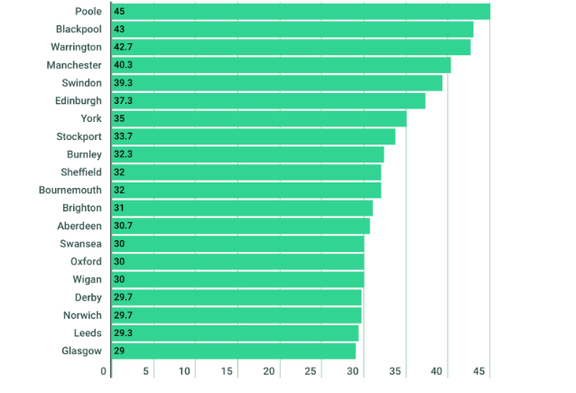
Figure 1 High Streets in the UK
Source: (Orr et al., 2022)

Economic Factors
The UK is experiencing some financial issues, such as inflation and the cost-of-living crisis. An increase in the price means that individuals become strained with little money to spend on other unnecessary products. This is detrimental to high street retailers such as clothing and gift shops. Greater energy bills are also a factor that adds to the cost of operating physical stores (Marchau, 2019). Web shops will invariably have less overhead, and they will be at an advantage. The inflation in the UK increased remarkably to reach an excessive value of 11.1 % in October 2022, which inflated the cost of consumer goods and services for retailers (Greenwood and Hanke, 2022). The result of high inflation has fallen to 2.0% as of May 2024, but its extensive duration has cut the power of spending among households and increased the cost of operations by high street firms.
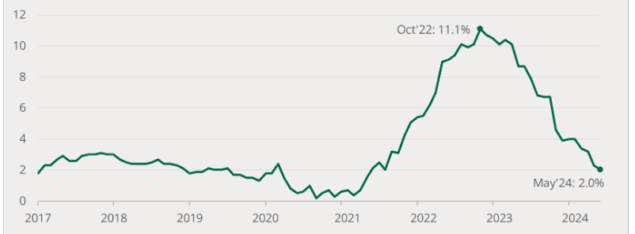
Figure 2 Annual change in UK consumer prices
Source: (Greenwood and Hanke, 2022).

Social Factors
The way of life and preferences of the customers have changed. The number of those who prefer convenience and online offers is large. The younger generations are shopping online via mobile applications and social media. This implies that even the conventional stores will have to create an online presence to remain relevant (Proctor, 2019). Meanwhile, certain customers would want to experience and test products physically, which is why it is still necessary to provide a positive in-store experience. There is some support for this instance courtesy of, which indicates that even in 2024, a massive percentage of UK consumers remained keen to use physical stores to acquire their basic commodities, whose high rates include snacks (85%), beverages (84%), and groceries (83%) (Statista, 2024). These evolving behaviors lead to the fact that high street retailers will need to provide a physical as well as digital shopping experience to remain competitive.
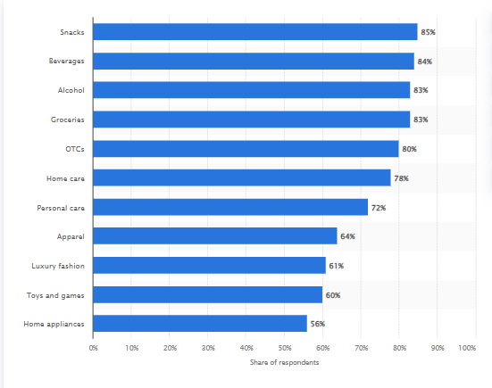
Figure 3 Consumers pick a physical store over an online store
Source: (Statista, 2024)

Technological Factors
Technology is revolutionizing shopping and doing business in retail. The non-use of modern digital tools by high street retailers threatens to lag. Click-and-collect, online payment, and personalized promotions are becoming expected traits in many consumers. Online applications also assist enterprises in stock management and customer trends, as well as enhancing marketing. The UK digital transformation market is likely to expand, in the period of 2023-2033, by a factor of 10, i.e., from $36.03 billion to $365.2 billion (Spherical Insights, 2024). Such high-speed growth indicates the level of investment in digital systems. Retailers are compelled to respond to this trend by enhancing their online platforms and utilizing technology to generate an improved customer experience. Companies that fail to respect these changes can find it difficult to keep up with more technologically advanced competitors.
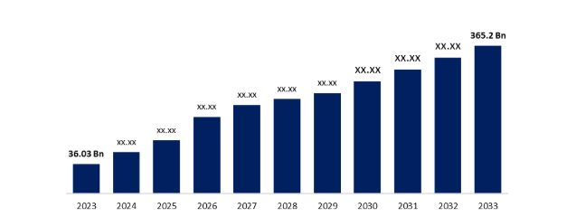
Figure 4 UK Digital Transformation Market
Source: (Spherical Insights, 2024)

Legal Factors
Retailers must conform to the employment acts, regulations regarding health and safety, and regulations governing data protection. Not complying may incur legal fines and even the downfall of the business. The security of customer data has become one of the primary concerns of UK GDPR rules (Keough, 2019).

Environmental Factors
The retailers face an increase in demand to be more sustainable. Lots of customers would like to serve companies that utilize recyclable packaging, cut waste, and use ethical sources. When stores fail to consider the environment, they risk losing the trust of the client. The reference to going green is also able to develop a better brand image and enhance long-term success (Keough, 2019).

SWOT Analysis
Strengths | Weaknesses
The most established reputation in society. | An expensive town center rent and business rates.
In-store customer service, Personal. | The small use of technology in small shops, Helms and Nixon (2010).
The ability of customers to physically observe and have the chance to test products. | Certain retailers have been too slow to change to online platforms.
The dominant supply chains (by UK-based retailers). | The shortage of staff or training.
Opportunities | Threats
The marketing and the increase in e-commerce to cover more customers. | The heavy competition with giant online sites.
To provide experiences in stores that are not available in online shops, Madecraft (2021). | Inflation and energy prices are causing an increase in operational costs.
The collaboration with domestic brands or suppliers. | The constant fluctuations in customer expectations.
The integration of online and in-store sales with the help of click-and-collect. | Economic insecurity is lowering the overall consumer expenditure.

Conclusion
In the analysis, it was clear that there are severe issues confronting the UK high street retailers, notably, the economic forces, accelerated technological revolution, and changing consumer behavior. Consumer spending has plummeted due to high inflation rates and the costs of doing business, and the online and convenience trends are greatly in demand. PESTLE and SWOT analyses illustrate how the retailers are affected by external forces and how they have weaknesses internally, such as poor adoption of digital aspects. Nonetheless, there are opportunities available, including click-and-collect services and digital marketing. The high street retailers will have to be fast to adjust due to innovation and informed decision-making (Adair, 2019), which can be done with the use of tools such as PESTLE and SWOT.

Recommendations
Recommendations are based on the results of the PESTLE and SWOT analysis to provide high street retailers with the opportunity to resist the existing external pressure and be competitive:
The main task of the high street retailers is to develop powerful online stores along with enhancing the shopping experience in the stores. Many customers have been using websites, mobile apps, and social media sites to do their shopping (Vinu Sunderaraj and Rejeesh, 2020). Meanwhile, there are people who still prefer going to physical stores to get necessary products. The retailers can integrate the two by integrating click and collect, contactless payments, and personal online services. The strategy gives them the opportunity to respond to evolving customer requirements and rival online giants.
The customers are increasingly becoming environmentally friendly. The retailers must employ the use of sustainable packaging, minimize wastage, and procure/produce ethically. All this serves to establish customer confidence and enhance brand reputation (Keough, 2019). Moreover, local brands and suppliers can be used to attract local customers loyal to their communities. There are other ways to increase footfalls and customer loyalty, such as hosting events or providing in-store experiences, that cannot be had online.

Reference
Adair, J.E. (2019) Decision making and problem solving: break through barriers and banish uncertainty at work. Fourth edition. London: Kogan Page.
CIPD (2024) PESTLE analysis. Available at: PESTLE analysis | CIPD
Greenwood, J. and Hanke, S.H. (2022). On monetary growth and inflation in leading economies, 2021–22: Relative prices and the overall price level. Economic Affairs, [online] 42(2), pp.288–306. doi: https://doi.org/10.1111/ecaf.12536.
Hallo, L. (2022) Holistic view of intuition and analysis in leadership decision-making and problem-solving. Administrative sciences. 12 (1), 1–25. doi:10.3390/admsci12010004
Helms, M.M. & Nixon, J. (2010) Exploring SWOT analysis - where are we now? A review of academic research from the last decade. Journal of strategy and management. 3 (3), 215-. doi:10.1108/17554251011064837.
Keough, P.D. (2019) Ethical problem-solving and decision-making for positive and conclusive outcomes. Hershey, Pennsylvania: IGI Global. doi:10.4018/978-1-5225-7582-5.
Madecraft (2021) Conducting a SWOT Analysis. J. Belfiore (ed.). Conducting a SWOT Analysis.
Marchau, V.A.W.J. (2019) Decision Making under Deep Uncertainty [electronic resource]: From Theory to Practice. 1st ed. 2019. Cham; Cham:, Springer Nature; Springer International Publishing; Imprint Springer. doi:10.1007/978-3-030-05252-2.
Marmol, T. del (2015) PESTLE analysis. Namur: Lemaitre Publishing.
Orr, A.M., Stewart, J.L., Jackson, C. and White, J.T. (2022). Not quite the ‘death of the high street’ in UK city centres: Rising vacancy rates and the shift in property use richness and diversity. Cities, [online] 133, pp.104124–104124. doi:https://doi.org/10.1016/j.cities.2022.104124.
Proctor, T. (2019) Creative problem solving for managers: developing skills for decision making and innovation. Fifth edition. New York: Routledge.
Ratchford, B., Soysal, G., Zentner, A. and Gauri, D.K. (2022). Online and offline retailing: What we know and directions for future research. Journal of Retailing, [online] 98(1), pp.152–177. doi:https://doi.org/10.1016/j.jretai.2022.02.007.
Spherical Insights. (2024). United Kingdom Digital Transformation Market Size, Share, Forecasts to 2033. [online] Available at: https://www.sphericalinsights.com/reports/united-kingdom-digital-transformation-market [Accessed 17 Jun. 2025].
Statista. (2024). UK: Preference of physical stores, by category 2024| Statista. [online] Available at: https://www.statista.com/statistics/1500509/physical-store-preference-categories-uk/ [Accessed 17 Jun. 2025].
Vinu Sundararaj and Rejeesh, M.R. (2020). A detailed behavioral analysis on consumer and customer changing behavior with respect to social networking sites. Journal of Retailing and Consumer Services, [online] 58, pp.102190–102190. doi:https://doi.org/10.1016/j.jretconser.2020.102190.

