
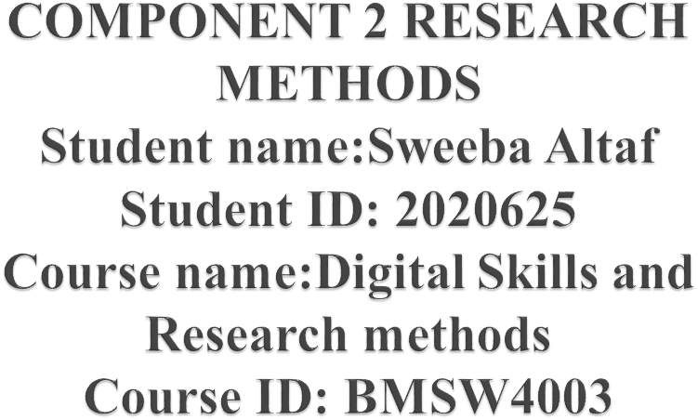

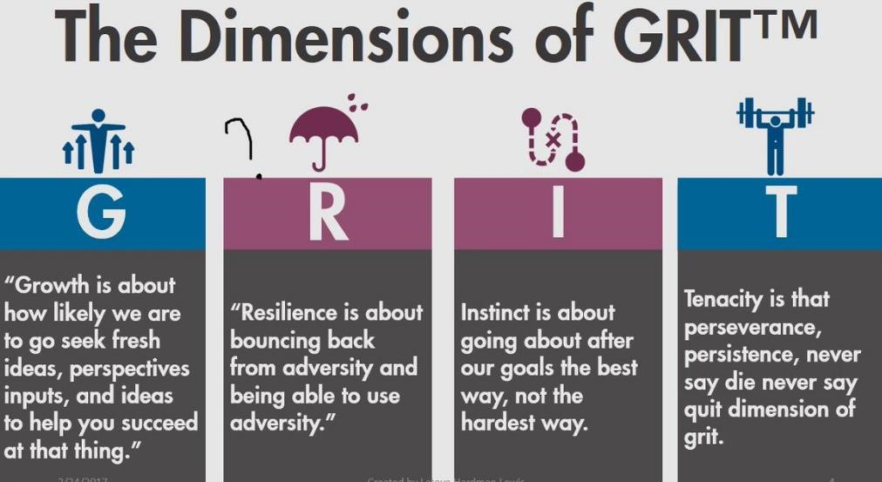
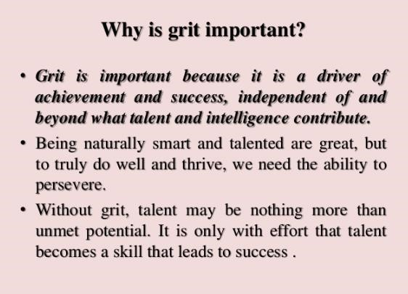

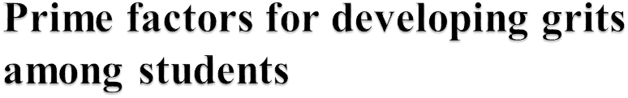
passion and
perseverance
Acknowledging
higher
confidence
skill
development
effective
communication
Managerial
prosperity


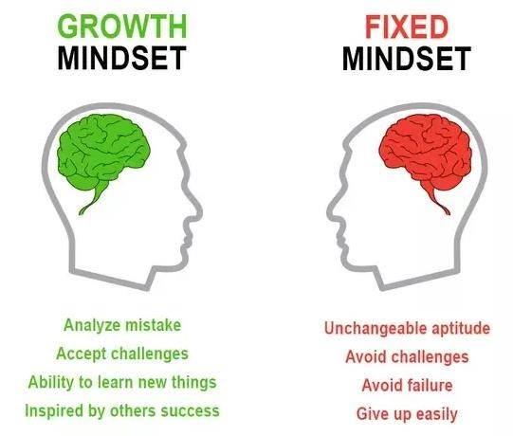
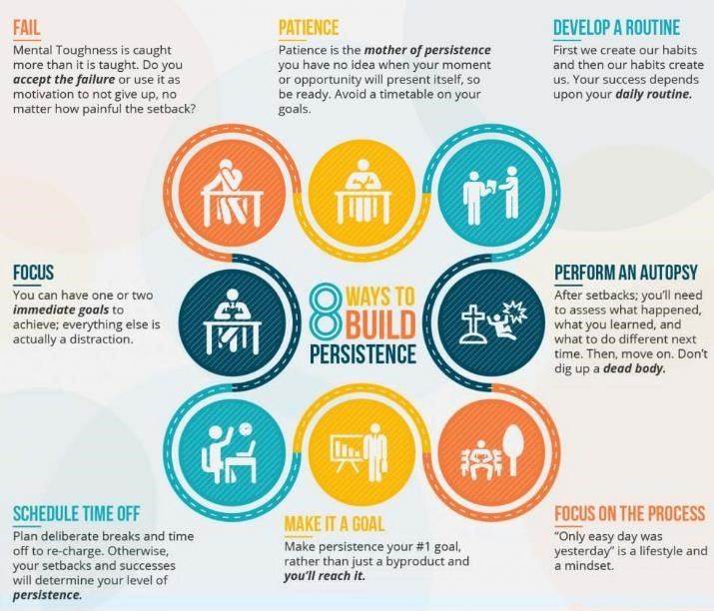


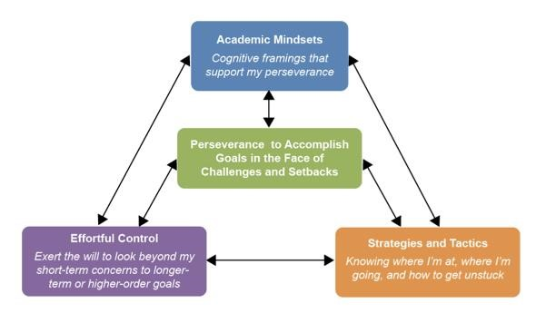



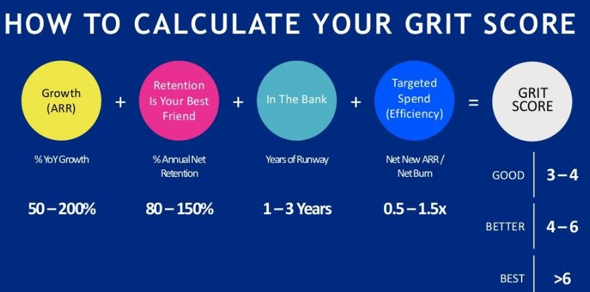
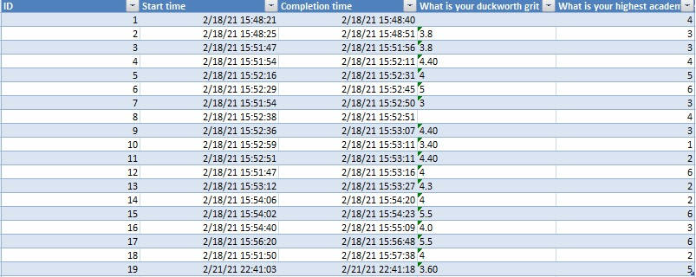
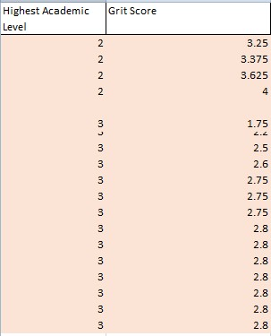




- Allen, R.E., Kannangara, C. and Carson, J., 2021. True Grit: How Important is the Concept of Grit for Education? A Narrative Literature Review. International Journal of Educational Psychology, 10(1), pp.73-87.
- Bazelais, P., Lemay, D.J., Doleck, T., Hu, X.S., Vu, A. and Yao, J., 2018. Grit, mindset, and academic performance: A study of pre-university science students. EURASIA Journal of Mathematics, Science and Technology Education, 14(12), pp.1-10
- Castillo, L.A.M. and Cazarini, E.W., 2019. Knowledge management practices in technology parks: case study-Technology Park TECNOPUC. Gestão & Produção, 26(3).pp.1-14
- Fabelico, F. and Afalla, B., 2020. Perseverance and Passion in the Teaching Profession: Teachers' Grit, Self-Efficacy, Burnout, and Performance. Journal of Critical Reviews.7(11), pp.108-120
- Gov.uk, (2020), UKTI trade and investment, available at: https://www.gov.uk/ukti, [accessed on; 10/03/2021]
- Ibrahima, B.B., Mohamadb, N.H.B., Bin, A., Abd Azizc, M.B.K. and Abd Hamide, Z.B., (2020) A Look at Grit: A Study about Malaysian Technical Instructors’ Performance Retention.11(2), pp.620-637
- Jeonga, H., (2020), Resilience and Grit of Pre-Service Kindergarten and Elementary School Teachers. 13(4), pp.223-235
- Jumat, M.R., Chow, P.K.H., Allen, J.C., Lai, S.H., Hwang, N.C., Iqbal, J., Mok, M.U.S., Rapisarda, A., Velkey, J.M., Engle, D.L. and Compton, S., 2020. Grit protects medical students from burnout: a longitudinal study. BMC Medical Education, 20(1), pp.1-9.
- Kisby, B., 2017. 'Politics is ethics done in public': exploring linkages and disjunctions between citizenship education and character education in England. Journal of Social Science Education, 16(3), pp.7-20.
- Miguel, A.F. and Duval, L., 2019. Fintech and the Socialization of the Financial Industry. Fintech and the socialization of the financial industry, 10(9), pp.35-45.
- Murphy, N.A., Yuan, M. and Elias, M.J., 2020. Youth leadership programming in high-poverty minority students. Evaluation and program planning, 79(C).pp.1-11
- Sharkey, C.M., Bakula, D.M., Gamwell, K.L., Mullins, A.J., Chaney, J.M. and Mullins, L.L., 2017. The role of grit in college student health care management skills and health-related quality of life. Journal of pediatric psychology, 42(9), pp.952-961.
- Sigmundsson, H., Haga, M. and Hermundsdottir, F., 2020. Passion, grit and mindset in young adults: Exploring the relationship and gender differences. New Ideas in Psychology, 59, p.100795.
- Stoffel, J.M. and Cain, J., 2018. Review of grit and resilience literature within health professions education. American Journal of Pharmaceutical Education, 82(2).pp.124-136
- Wang, X., Xiao, X., Zhang, X. and Meng, J., 2017, October. Analysis on UK Robotics and Autonomous Systems Research Development. In
2017 International Conference on Education Science and Economic Management (ICESEM 2017), 106(68), pp. 510-514




