

Student Name: Mohammad Abdul Bathen

Student Number: 2212002

Module Title: Operating Hotel Facilities

(Rework of Component 2 and 3)

Module Code: BMIH4006

Lecturer: Natalie Brailsford

Component Two:
Contribution to Overall Module Assessment: 25%
In this scenario – You have just been promoted to team leader for a floor within the hotel. A guest complained that on their arrival, their room had not been thoroughly cleaned. Create an action plan and answer the following questions.

Problem | Why did it happen? | What are you going to do? | How will you prevent this from happening in the future? | What measures would you introduce to improve team effectiveness?
Poor dusting of surfaces within the guest’s room. | Inadequate supplies to complete tasks and poor planning when conducting supply checks. | Apologies to the guest for the inconvenience caused, show empathy, and tell them the issues is going to be addressed.  Investigate the issues and find out who was the staff involved and examine the room. Do not assign blame and approach this objectively.  Rectify the issues and request housekeeping to attend to the room again and dust all surfaces. Also do a quality inspection on other areas to ensure nothing else has been missed.  Once it has been resolved, ensure to ask if the guests would require any additional services to make them feel more comfortable. | Analyse the root cause of the problem and identify any underlying issues or gaps in the housekeeping. Consider whether additional training, revised procedures, or enhanced communication protocols are needed to prevent similar incidents in the future. | Following the incident Share any findings and recommendations with the housekeeping team to ensure collective growth and development.
Failure in bed making and decorating the room. | Insufficient training of how to make the bed properly and decorate the room to be aesthetically pleasing. | Offer a solution to the guests such as assigning a different  housekeeper with more experience to clean the room properly. | Encourage more open communication between housekeeping staff so they can share best practices and address any shortcomings collectively. | Implement a recognition program which will acknowledge and reward exceptional performance and work to motivate the team to consistently delivery high quality services.
Some cleaning tasks in the room were left incomplete such as disposal of waste in room bins. | Poor time management of housekeeping staff. | Apologise to the guests and assure them that this issue will be addressed promptly.  Speak with the housekeeping staff and gather information to see what caused poor time management such as if it was overload of tasks or lateness.  Offer the guest compensation and ensure the room is cleaned again. | Explore the use of technology to support with time management such as housekeeping management software to help streamline and monitor the cleaning processes more effectively. | Invest in ongoing training to enhance this skill and keep the staff up to date with the best practices to support with providing good customer service.
Final decorative cleaning on the schedule was not completed and not inspected correctly. | Oversight in the room inspection procedures | Apologies to the guest and address the issue immediately.  Communicate with the housekeeping team to understand the challenges they faced which caused poor performance. | Review and strengthen the room inspection protocols and procedure to ensure that each of the rooms meet the standard before all guest check ins. | Establish a feedback process where team members can provide input on the processes and how it can be improved or if they have any concerns or recommendations.
Improper sanitation of the guest toilet and bathroom | Potentially no PPE available or supplies to clean. Housekeeper forgot to attend to this area of the guest room due to busy season or due to handling other tasks. | Address the guest complaint seriously and be sure to be empathetic and reassure the guest that this issue will be resolved. Check with housekeeping supervisor if there is efficient number of PPE available to complete the task. Request for housekeepers to rectify the issues and ensure quality check is completed once cleaned.  Again, apologies to the guests and inquire about their overall experience and confirm that their concerns were addressed. | Conduct proper training or online training for housekeeping staff who are responsible for cleaning toilets and bathrooms. | Provide cross training for housekeeping staff so in events of busy hotel periods other staff can support with housekeeping tasks.

Word count 648
Component Three:
Contribution to Overall Module Assessment: 50%
Your task is to create and prepare a presentation following the detailed scenario provided below.

As the floor housekeeping manager and given the recent guest complaints you need to put together a basic training presentation for your colleagues within the housekeeping team to get the best out of them, ensure that brand standard is being achieved and that Health and Safety procedures are also being followed.



Training Notes:

Hello everyone, following recent guest complaints this training is being delivered to talk about the importance of enhancing and maintaining Housekeeping Excellence at Hotel Trinity.

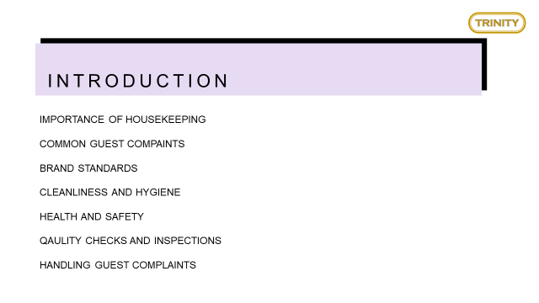
Training Notes:

The topics we will be discussing today are the importance of housekeeping, common guest complaints, Hotel Trinity’s brand standards, the cleaning and maintenance procedures, Health and Safety procedures, Quality Checks and Inspection and Handling Guest Complaints.
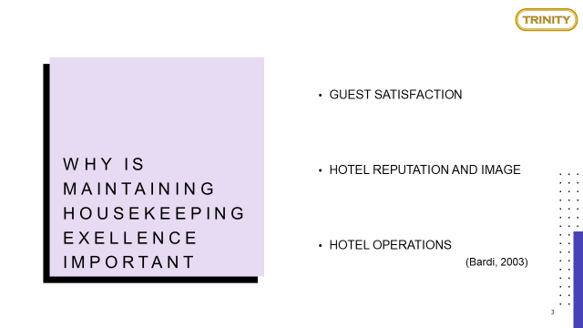
Training Notes:
Housekeeping plays a huge role in the way guest services are provided, one of the main reasons a guest will choose a hotel is based upon its level of cleanliness. It is important housekeeping staff provide a satisfactory level of cleanliness as it creates a positive atmosphere and encourages guests to choose Hotel Trinity for their holiday or business stays. If this is maintained guests are more likely to share positive reviews online and thus positively highlighting the brand image.
Housekeeping is also an essential part of hotel operations; all departments have a role and function to ensure smooth flow of operations. Housekeeping forms the foundation of all operations (Bardi, 2003) .

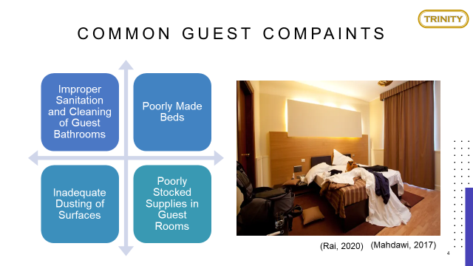
Training Notes:
It is important to note the most common types of guest complaints for example, improper sanitation and cleaning of guest bathrooms, poorly made beds, inadequate dusting of surfaces and poorly stocked rooms.
By knowing the cause and problem for complaints it is easier to find the solution and address why this takes place to begin with. This could be either a lack of preparation or poor time management, all of which can be easily rectified through proper training.
Having guest complaints can negatively impact upon the hotel’s reputation and overall success, therefore it’s essential we promptly resolve complaints (Rai, 2020).

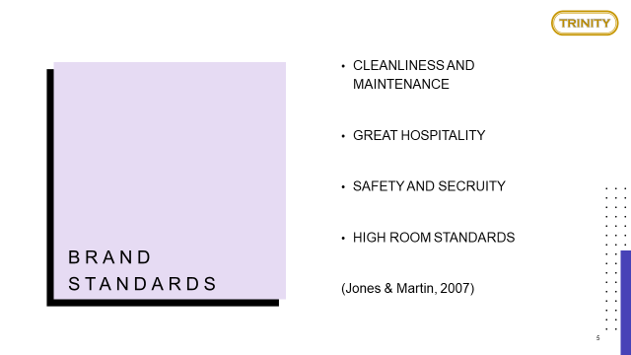
Training Notes:
To deliver great forms of housekeeping it is important to keep in mind the following brand standards.
- Cleanliness and maintenance
- Great hospitality
- Safety and security
- High room standards
By maintaining and adhering to each it will help with delivering excellent housekeeping. For example, ensuring the rooms are visually attractive and clean will satisfy guests and produce high room standards (Jones & Martin, 2007).

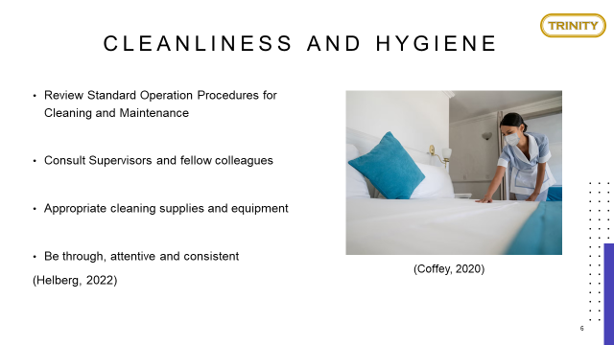
Training Notes:

To help improve or revising cleaning and maintenance skills, colleagues can review the standard operation procedures available for all the different types of cleaning and maintenance tasks such as properly dusting surfaces, how to organise bedding etc.
Housekeeping staff can also consult other team members or supervisors for support and advice regarding certain tasks to understand if they are in line with regulation.
It is also important that the proper cleaning supplies and equipment are used to avoid improper practices and safety concerns (Helberg, 2022).
When cleaning it is important to pay close attention to details to avoid mistakes and be consistent with techniques (Coffey, 2020).

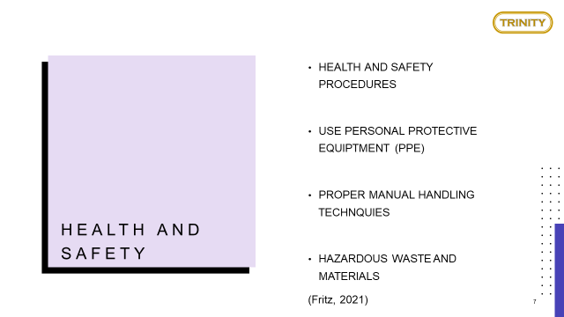
Training Notes:

All employees at Hotel Trinity must follow health and safety regulations when conducting any task that can pose a potential risk to one's health or others.
This will ensure that the working environment is safe for fellow colleagues as well as for guests who are staying within the facilities.
It is important to use PPE where necessary, this will ensure there is no cross contamination or risks of spreading infections or diseases. Since COVID-19 there has been a higher emphasis on using PPE in professional settings to protect the public from diseases therefore, it is essential to recognise its importance (Fritz, 2021) .

Working within the housekeeping team requires being physically active for long periods of time, therefore it is important to follow proper ergonomic and lifting techniques to ensure your personal safety is always protected.
Housekeeping also requires frequent use of chemical products and equipment's; therefore, it is necessary to have proper training on how to dispose of hazardous waste and materials. There are resources available online for Hotel Trinity employees to learn more on hazardous waste and materials and the correct procedures to follow for its disposal.

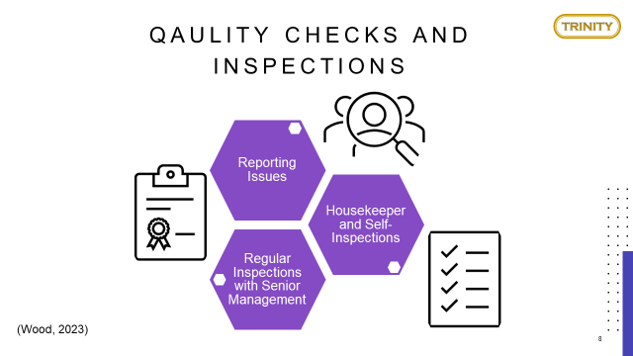
Training Notes:
It is important that supervisors and managers conduct regular quality inspections with all team members present, this will ensure that the proper methods and techniques are being followed.
Furthermore, it will ensure that the high standards are being maintained and can be used to support and develop areas that are problematic or have become causes for guest complaints (Wood, 2023)
Housekeepers can also conduct self-inspections and utilise checklist daily to ensure they are on track with all tasks. It is also vital to report issues with any housekeeping tasks to ensure the correct resolution can be attained. Planning should be done regularly to ensure that staff are remaining organised and are being time efficient.

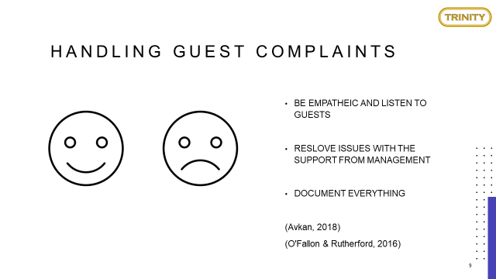
Training Notes:
Regardless of maintaining excellence, guest complaints can still happen, therefore it is important to be empathetic and listen to the guest to understand how you can resolve the issue.
Firstly, always assure the guest that their concerns are being addressed, staff should then follow the proper guidelines of handling guest complaints and seek support from management. (O'Fallon & Rutherford, 2016).
It is vital that all matters are documented appropriately to protect both staff and guests (Avkan, 2018). Lastly, staff should ensure that before closing the matter that the guests are satisfied with the resolution.

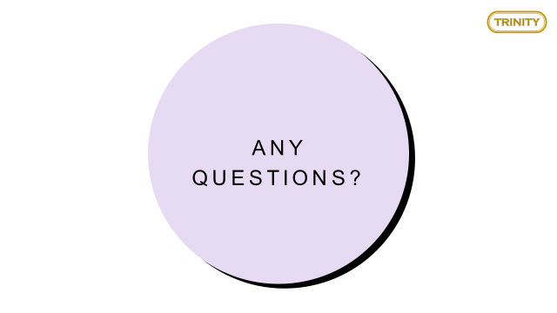

Training Notes:
That concludes the end of this training, any questions?

References
Avkan, O., 2018. 101 ways to guest satisfaction. 1st ed. s.l.:Beyaz Publishing.
Bardi, J., 2003. Hotel Front Office Management. 3rd ed. New York: John Wiley & Sons.
Bender, A., 2012. Americans' Biggest Complaints About Hotels. [Online]
Available at: https://www.forbes.com/sites/andrewbender/2012/07/27/americans-biggest-complaints-about-hotels/
[Accessed 03 June 2023].
Brody, D., 2016. Housekeeping by Design: Hotels and Labor. Illustarted ed. s.l.:University of Chicago Press.
Coffey, H., 2020. What are UK hotels doing behind the scenes to tackle coronavirus?. [Online]
Available at: https://www.independent.co.uk/travel/uk/uk-hotels-coronavirus-safe-a9655806.html
[Accessed 02 June 2023].
Fritz, A., 2021. 5 Surprising Ways Hotels Can Make You Sick. [Online]
Available at: https://www.everydayhealth.com/cold-and-flu/surprising-ways-hotels-can-make-you-sick.aspx
[Accessed 02 June 2023].
Helberg, P., 2022. Hotel Housekeeping: Operations and Management. s.l.:Murphy & Moore Publishing.
Indeed Editorial Team, 2022. Guide to Housekeeping Skills (With Tips and Examples). [Online]
Available at: https://www.indeed.com/career-advice/career-development/housekeeping-skills
[Accessed 02 June 2023].
Jones, T. & Martin, R., 2007. Professional Management of Housekeeping Operations. 5th ed. s.l.:John Wiley and Sons.
Levere, J., 2020. Hotels Tout Cleaning, But Guests Say, ‘My Room Was Dirty’. [Online]
Available at: https://www.nytimes.com/2020/08/26/travel/virus-hotels-cleaning.html
[Accessed 02 June 2023].
Mahdawi, A., 2017. Should you make your bed when staying at a hotel, like Margaret Thatcher?. [Online]
Available at: https://www.theguardian.com/travel/shortcuts/2017/jun/28/make-your-bed-staying-at-hotel-like-margaret-thatcher
[Accessed 03 June 2023].
O'Fallon, M. & Rutherford, D., 2016. Hotel Management and Operations. 5th ed. s.l.:Wiley.
Raghubalan, G. & Raghubalan, S., 2009. Hotel Housekeeping Operations and Management. 2nd ed. New Delhi: Oxford University Press.
Rai, S., 2020. Hotel Housekeeping Operations. 1st ed. Smriti Nagar: Orangebooks Publication.
USA Today, 2023. How do hotels deal with problems? Common issues and what guests can expect in exchange. [Online]
Available at: https://eu.usatoday.com/story/travel/hotels/2023/01/25/hotel-common-guest-complaints-compensation/10883679002/
[Accessed 03 June 2023].
Wood, M., 2023. 11 Hotel Secrets from a Former Hotel Inspector. [Online]
Available at: https://www.rd.com/list/11-hotel-secrets-from-a-former-hotel-inspector/
[Accessed 02 June 2023].
Zaldivar, G., 2017. Hotel Guests' Most Common Complaints. [Online]
Available at: https://www.travelpulse.com/News/Hotels-and-Resorts/Hotel-Guests-Most-Common-Complaints
[Accessed 02 June 2023].

