A critical analysis, using the FITT framework, of the benefits and limitations of the Welsh Immunisation System in supporting the provision of COVID-19 vaccinations at a Health Board in Wales
Introduction
During December 2020, Health Boards in Wales rolled out the Welsh Immunisation System (WIS) to support the delivery of the COVID-19 Vaccination programme (Welsh Government, 2021). Beginning in December 2021, Health Boards managed this delivery in Mass Vaccination Centres (MVCs) before expanding to include delivery through hospitals, GP surgeries, pharmacies, and mobile vaccination units. (Welsh Government, 2021). National strategy for the rollout of the vaccination programme focused on three elements, each to be supported by a single, central digital system. These elements included delivery of vaccines according to the Joint Committee for Vaccination and Immunisation (JCVI) priority list, appointments and vaccination outcomes are recorded digitally and that national data could be routinely released to the public and policy makers (Welsh Government, 2021).
NHS Wales Informatics Service (NWIS) (now Digital Health and Care Wales) built WIS from an existing system, the Children and Young person Integrated System (CYPRiS); CYPRiS already performs a similar function for the storage of vaccination outcomes and other statutory data regarding children and young persons in Wales (Digital Health and Care Wales, 2021; Health Tech Newspaper, 2020; NHS Wales Informatics Service, n.d.; Welsh Government, 2021). WIS comprises of two software programs that enable the accurate and standardised recording of vaccination data, appointment scheduling, patient demographic storage and retrieval, adverse effects recording and vaccine stock management (Digital Health and Care Wales, 2021; Digital Health and Care Wales, 2022; Health Tech Newspaper, 2020; NHS Wales Informatics Service, n.d.; Welsh Government, 2021). WIS Web is a web-based application that facilitates most functions required by those delivering vaccinations in a mass vaccination centre or other immunisation location. These include retrieving a vaccination record, demographic editing, eligibility questioning, vaccine recording, booking appointments, vaccine stock and fridge temperature recording. WIS Core is a desktop-based application that provides additional features to manage the setup of vaccination sessions, retrieve and edit demographic details not editable in WIS Web, perform user interface (UI) integrated reporting, manage the delivery of letters and SMS and user management. Additionally, the program can also automatically populate vaccination sessions, but this feature is still restricted to staff in Digital Health and Care Wales (DHCW) due to a lack of a UI that can support criteria used to manage this process.
The Health Board implemented WIS upon the release of WIS Web and implementation of WIS Core occurred a week later Monday 7th December 2020. Mass Vaccination Centre (MVC), based at a hospital site, began vaccinations on Tuesday 8th December 2020. In January 2021 the Welsh Government Vaccination strategy was released and directed Health Boards to offer a vaccination to every individual in the first four cohorts by mid-February 2021 (Perry, et al., 2021; Welsh Government, 2021). It should be noted the author was involved in the implementation of WIS as the Product Specialist to the Health Board and continued to be so for several months afterwards.
Within six weeks two MVC sites were delivering vaccinations to a significant proportion of identified health and care staff within the region. Initially clinicians were recording vaccinations on paper to then be processed into WIS Web via a non-clinical administrator.
The Mass Vaccination programme within the Health Board currently encompasses three MVCs (a hospital venue, a sports centre and showground), several community hospitals, GP surgeries and has also utilised temporary venues across the region. A “booking hub” manages the creation, population and management of vaccination sessions using WIS Core. It also manages the invitation of individuals to these sessions using both the automatic booking system and manually for those who have unique needs i.e., immunocompromised patients. In the MVCs there are three key teams using WIS: the pharmacy team, vaccinators, and administrators. The Medicine Management teams’ role is to manage vaccine stock in accordance with regulations and provide medical advice to the vaccinators if required. The administrators principally manage the flow of those arriving for vaccination into and out of the MVC. Vaccinators and healthcare assistants will administer vaccines to individuals and monitor for any adverse effects. WIS Web plays an important role in each team capturing activity at the MVC but also informing clinical delivery. At the time of writing the programme had offered and administered first and second doses to all age groups and was in the final stages of offering booster doses to those aged 5 to 11 years old. A programme for further doses has also been confirmed for those clinically vulnerable in March 2022 for those who received a vaccine more than 6 months prior. (Welsh Government, 2022) For clarity, WIS Web and WIS Core and the underlying database will be collectively referred to as WIS unless making a distinction.
Method
To arrive at a conclusion of how well WIS has been adopted and how it provides functionality for the Mass Vaccination programme an analysis will be conducted using the FITT framework (Fit between Individuals, Task and Technology). Only the delivery at a MVC was included as provision at GP surgeries or within a hospital require alternative staffing arrangements and processes. The FITT framework was proposed by Ammenwerth et al. in 2006 with this novel framework analysing how IT adoption within a clinical environment was dependent on three factors: the individuals, the task, and the technology present.
Alternatives do exist, such as the Task-Technology-Fit (TTF) model by Goodhue & Thompson (1995). The framework includes the notion that IT adoption was reliant on a quality fit between various factors. This included technology, the user, and clinical task complexity and their interactions with each other as factors affecting the fit between technology functionality and individual ability. Their framework also reconciled the fact that system adoption was gradually becoming non-voluntary and research focusing on attitudes and behaviours to motivate utilisation did not address this or explicitly recognise that higher utilisation does not necessarily mean improved performance. However, models that focus solely on a fit require the system to be utilised first before conclusions can be drawn and therefore lacks a predictive quality. Ammenwerth et al., 2006 however argue that the TTF model fails to include the interaction between the user and the task being undertaken.
The FITT model proposes that the quality of fit between the task, individual and technology impacts the success of IT adoptions. The individual elements include the users or user groups. The Technology element describes any tools provided to accomplish a given task which can include computer-based components (e.g., hardware, software, network infrastructure) and non-computer-based components (e.g., paper forms). The task element includes any task or process that the user completes and is supported by the provided technology (Ammenwerth, et al., 2006).

Figure 1 - The FITT framework by Ammenwerth (2006)
For each of the elements there are various factors that will affect the quality of fit and the presence or absence of these factors is context dependent. It is the role of those managing the adoption of IT systems to influence these factors to improve the quality of the fit. (Ammenwerth, et al., 2006)
The below table, based on the work of Ammenwerth et al. (2006) identifies factors affecting each FITT element and possible interventions that could be employed to resolve them.
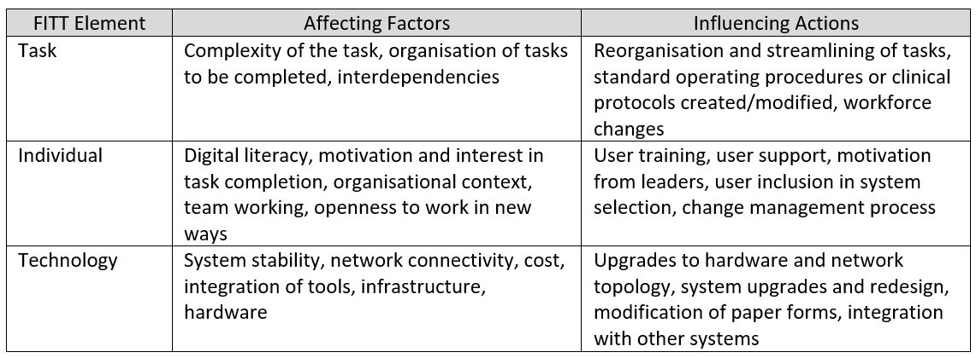
Table 1 - Factors affecting FITT elements and actions that could be employed to influence the quality of fit (Ammenwerth, et al., 2006)
Included in the framework are the external influencing factors that can influence the fit whilst not being in the direct control of the management team. For example, staff turnover, changes in strategy/clinical direction, changes in the software compatibility with existing hardware (Ammenwerth, et al., 2006). These create a dynamic environment where these factors will affect the fit at any given moment in time. Prgomet et al. (2019) goes as far as to add an additional element, environment, to FITT (FITTE) which addressed issues more permanent external factors that could be controlled by adoption managers. These included temporal rhythms (drug rounds), space limitation, infection control and battery issues.
Measuring the fit in the FITT framework is a qualitative assessment that can be arrived at by various means. Work by Tsiknakis and Kouroubali (2009) employed the use of system usage data, interviews, field observation and document reviews with medical professionals over an 8-year period. Nilsson et al. (2020) conducted semi structured interviews with 15 men who had undergone radical prostatectomy surgery for prostate cancer loosely based on the System Usability Scale (SUS). The SUS has also been used by other literature assessing the suitability of IT systems in the health and care sector. A similar approach to data collection was used by Bloom et al. (2021). In their study they collected data via an online survey to assess the usability of the electronic health records (EHR) systems across the United Kingdom.
John Brooke, in 1995, first proposed the System Usability Scale (SUS) application at an engineering firm in the 1980s. The SUS consists of 10 questions which are answered using a 5-point Likert scale ranging from Strongly Disagree (1) to Strongly Agree (5). Odd numbered questions focus on positive attributes of the system (“I like using the system”) and even numbered focus on negative attributes of the system (“I find the system unnecessarily complex”) (Brooke, 1995). Systems are scored out of 100, with systems gaining a score higher than 70 being deemed as good (Bloom, et al., 2021; Hägglund & Scandurra, 2021). Systems with scores between 50 and 70 warrant further investigation into the usability of the system (Bloom, et al., 2021; Hägglund & Scandurra, 2021). As a baseline, operating systems such as Microsoft Windows have scores around 75 (Bloom, et al., 2021). Google Search has a score of 92 (Lewis, 2018). This scale is now widely used as an international standard to assess the usability of a system (Bloom, et al., 2021; Lewis, 2018). Evidence also shows that there is a close correlation with task success and usability of a system (Kortum & Peres, 2014).
An online survey, created using Microsoft Forms, was shared with senior leaders to communicate to their staff within the Mass Vaccination Programme. This survey could be completed from any location, was device neutral and required the participant to be a member of staff in the Health Board. Staff members were also told that surveys could be completed over the course of their shift. The survey was open from 16th February 2022 to 28th February 2022. Roles were defined as MVC Administrator, Bookings Hub Administrator, Business Manager/Business Support Manager/MVC Manager, Pharmacist and Vaccinator. An “Other” option was also allowed. This allowed for trends in fit and usability to be mapped to specific roles. Participants also highlighted the program they primarily used and the purpose of the use. Further questions followed that were necessary to calculate a system usability score. These questions were presented in a Likert fashion as per the design of John Brooke (1995). Finally, participants were asked to identify how WIS enables and disrupts their ability to perform their role. Guidance was provided to encourage responses that discussed themes that could be matched to the FITT framework. For example, “How you interact with WIS” could be matched to the Individual element of FITT. All responses were anonymous; however, participants were asked if they would be willing to engage with further discussions about WIS. Where they were willing the anonymity was removed by including a contact email address. Results were stored in an Excel document stored securely within the OneDrive of the author. Analysis was conducted using Microsoft PowerBI.
A discussion was conducted with the Mass Vaccination Business Manager responsible for the booking hub. This discussion determined a baseline for how information currently runs through WIS and the touchpoints with various staff groups. A single view was taken due to time afforded, standard operating procedures direct the use of WIS in multiple settings and the downstream impacts of data quality issues are resolved by the booking hub. This process map could then be used to identify any shadow processes or workarounds being employed that would highlight areas of poor fit.
The personal experience of the author during the implementation of WIS, supporting staff during the adoption and on-site support at a “pop up” vaccination centre has also been included.
Further discussions were not undertaken due to time constraints present and a lack of capacity to avoid issues with the Hawthorne effect. Because the author was heavily involved in the implementation of the WIS and subsequent systems since, there was a risk that responses may be biased to provide a commentary expected/hoped for by the author.
Results
Process Map
A discussion was held with the Business Manager responsible for the Booking Hub to identify existing expected processes. Additionally, the discussion looked to identify areas of process that were not occurring or consume significant time as possible areas of poor fit. Below are maps for key processes that occur to provide seamless care to citizens requiring a vaccination.
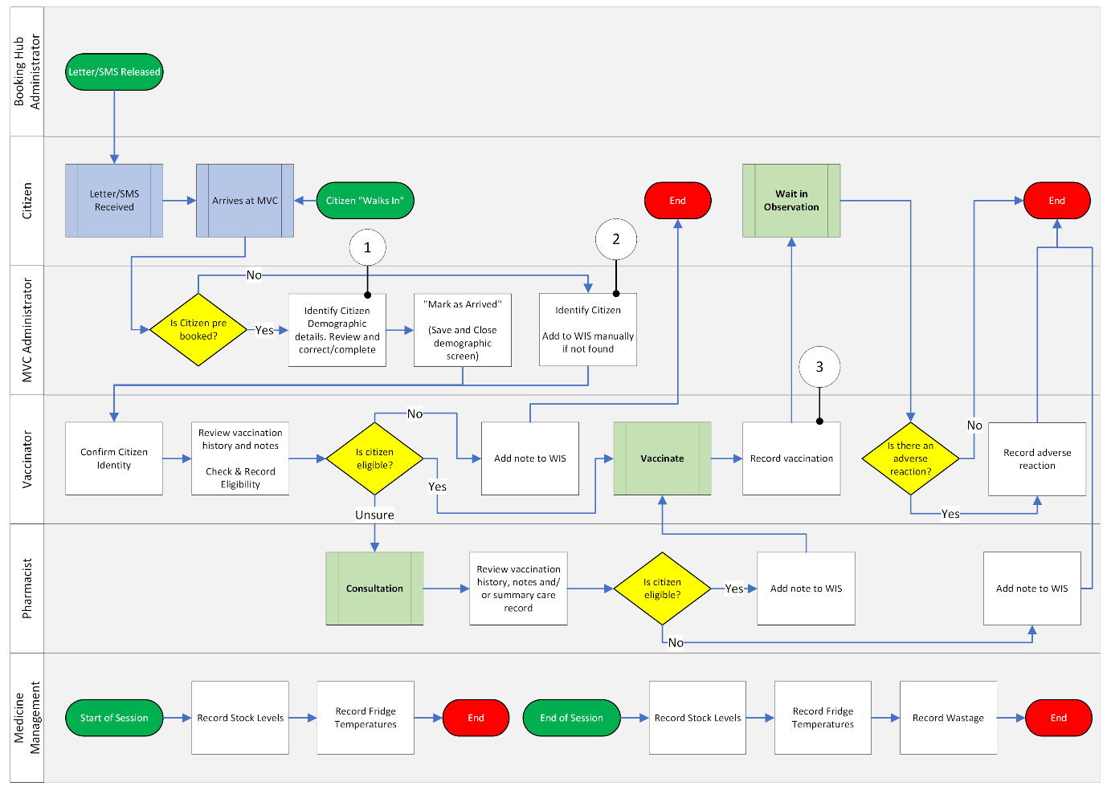
Figure 2 - Process map of activities related to a citizen being vaccinated in an MVC using WIS Web
In figure 2 the process map for vaccination being administered in an MVC is detailed. It is expected that all these processes utilise WIS Web. There are three key areas where issues occur and require resolution. At point 1, it is found that demographic data is not always fully up to date and data is missing despite an individual having been vaccinated. At point 2 there have been occurrences where a citizen has not been correctly identified as not within WIS and registered manually or the details of another citizen overwritten. At point 3 the vaccination is not always stored within WIS successfully. This is detected by a paper process that compares names of citizens having received vaccination and those recorded in WIS.
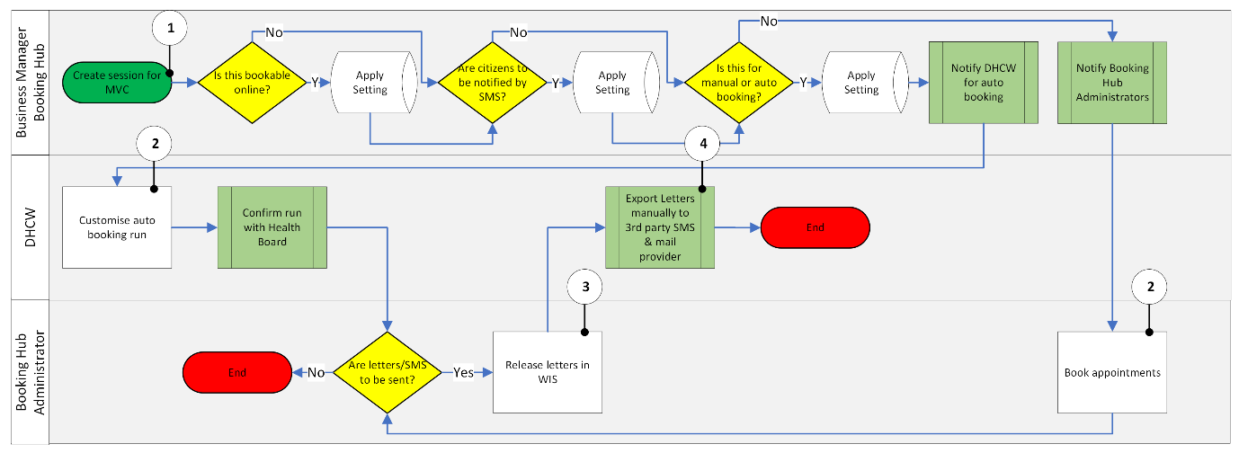
Figure 3 - Process map of activities related to scheduling clinics and booking appointments using WIS Core
In figure 3, the process for generating appointments is detailed. This can only be completed using WIS Core and involves communication with the application team in DHCW. This is because the full functionality for generating appointments is still retained by this team. Several points of issue were identified. In point 1 it was identified that the interface has limited ability to manually manage slots, instead relying on a rigid creation system. This does not allow for the creation of breaks through direct manipulation of appointment slots. Further, sessions must be created for each MVC separately and cannot be applied across several sites. In point 2 it was discussed that once a booking is made, the session enters a locked state in the database and configuration is no longer possible without deleting clinic. This also impacts recurrences. Therefore, any changes to a session cannot be made with cancelling all the appointments and reappointing. In point 3 the functionality to identify letters/SMS for release is limited. Therefore, if an appointment is booked manually the letter must be released by the Booking Hub Administrator at the time of booking else the letter will stay on hold. Finally, in point 4, the process of managing letter templates is still controlled by DHCW and the Health Board cannot customise this process at short notice. Therefore, any short notice appointing must be communicated via SMS message or via an online booking tool not integrated into WIS.
In all, these issues are more frustrations and only on occasion to they stop the provision of seamless care to citizens. For example, an incomplete demographic record may mean a citizen is not notified a session is cancelled.
Online Survey Participants
43 individuals responded to the online survey with 6 respondents being corrected as they identified the incorrect program and 1 excluded from the final analysis as the survey had not been fully completed. Corrections were made where it was identified the discussions responses and job role did not meet the expected values. For example, Booking Hub Administrators do not routinely use WIS Web to schedule and change appointments, Vaccinators are not able to record vaccinations in WIS Core. 57.14% (24) of participants identified as “Vaccinators”, 14.29% (6) identified as “Business Manager/Business Support Manager/MVC Manager”, 14.29% (6) identified as “MVC Administrator”, 7.14% (3) identified as “Bookings Hub Administrator”, 4.76% (2) identified as “Pharmacist” and 2.38% (1) identified as “Assistant Technical Officer”.
73.80% of users said they primarily used WIS Web in their role with the remaining use WIS Core.
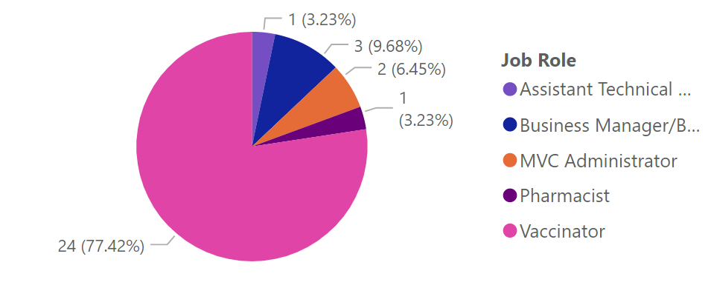
Figure 4 - Distribution of job roles primarily using WIS Web
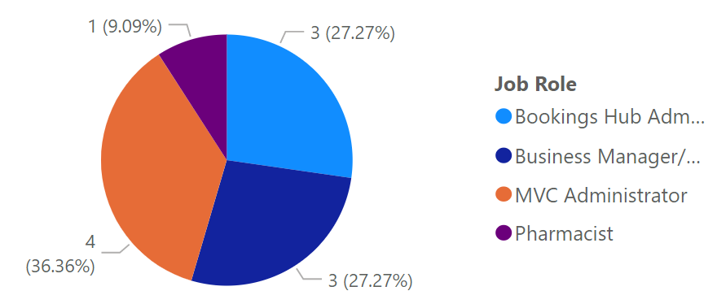
Figure 5 - Distribution of job roles primarily using WIS Core
System Usability Scale
The SUS score for both programs was above the threshold of 70 for an acceptable system with good usability. The average score for WIS Core was 83.00 and for WIS Web it was 74.39. The median scores were 81.27 for WIS Core and 78.00 for WIS Web. Figure 4 shows a violin chart of SUS scores for all participants split across both systems. The violin chart has been restricted to show the true range of scores. A box and whisker plot are overlayed on a plot representing frequency and size of SUS score. The thicker the plot, the greater the frequency of the score. WIS Core shows a more restricted range of scores with the overall range being 52 points. WIS Web, whilst having a similar median SUS score, has a much larger range of 73 points which would explain the difference in averages. However, this difference is less than 5%.
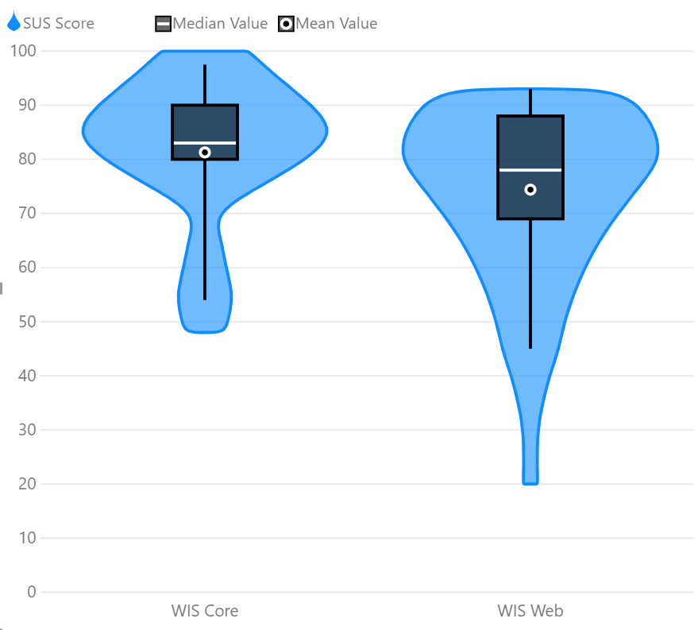
Figure 6 - Violin chart of SUS scores for WIS Core and WIS Web
The SUS score can also be broken down according to the program being used by job role. WIS Core shows a larger consensus between the Booking Hub Administrators found the system more usable, on average, than other job roles with an average score of 90.00. Whilst the range in results was the same for Booking Hub administrators, the Business Managers returned a slightly lower average SUS score of 83.33. Only 1 Pharmacist reported using WIS Core and the score was 83.00 and within the range of the scores reported by the Business Managers. MVC Administrators showed a larger range (100.00 to 48.00) in SUS score with the average score being 72.75. The lowest score in this case was 48.00.
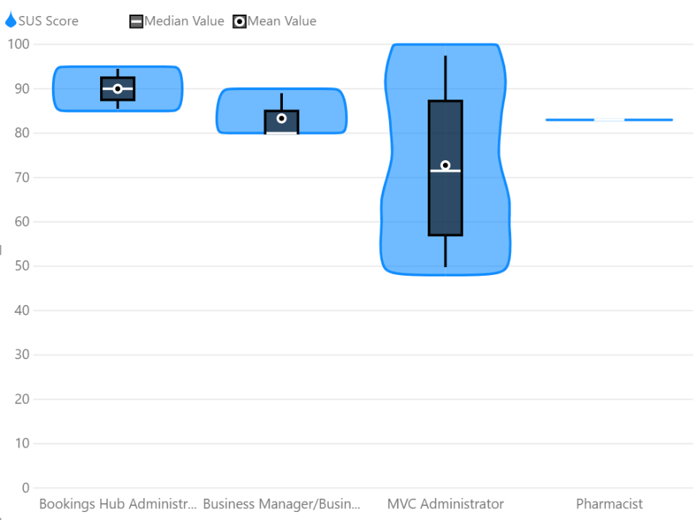
Figure 7 - SUS Score by Job Role for WIS Core
For WIS Web the larger range of score is contributed to by several different job roles. Only one Assistant Technical Officer and one Pharmacist submitted a response about WIS Web. However, in the context of WIS Web both job roles will be performing similar functions within the medicines management team. Both were within the acceptable usage score with a range between 70.00 and 90.00. Responses were received from three Business Managers/Business Support Managers/MVC Managers with a range of scores from 93.00 to 45.00. However, both the average (71.00) and median (75.00) are above the threshold of good usability. Similar is also true for Vaccinators. Although the range in responses is 73 points, the average (74.08) and median (79.00) are above the threshold of good usability. SUS Scores for the two MVC Administrators exist were 70.00 and 85.00 and in the range of good usability.
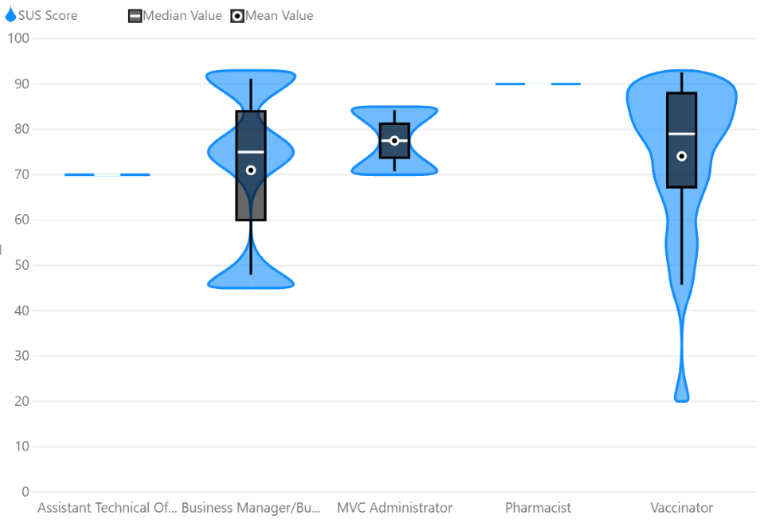
Figure 8 - SUS Score by Job Role for WIS Web
Overall, the results indicate a good level of usability but that there are outliers which warrants individual intervention with users to explore issues their experience. This is especially true amongst Vaccinators where there is a significant range in response as well as being the primary source of clinical information being inputted into WIS. Additionally, responses from Business Manager/Business Support Manager/MVC Managers and MVC Administrators are also polarised, tending to favour a lower SUS for the former. This coincides with feedback from the process mapping discussion with the Business Manager where it is noted that tasks by MVC Administrators are not always being completed despite the functionality being present in WIS.
It was found that average scores in the question response breakdown were mostly similar for odd numbered questions and for the even numbered questions.
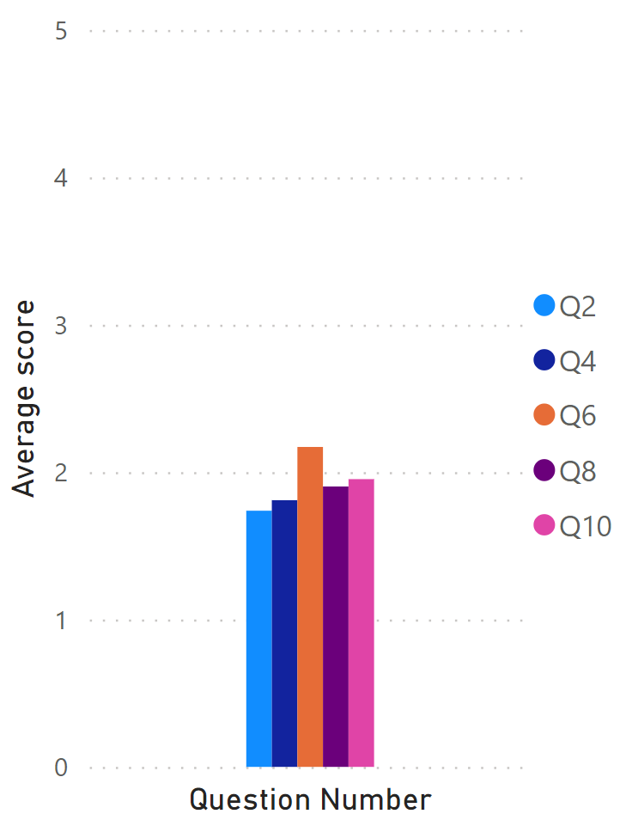  Figure 9 - Average scores for Even numbered questions (negative themes) | 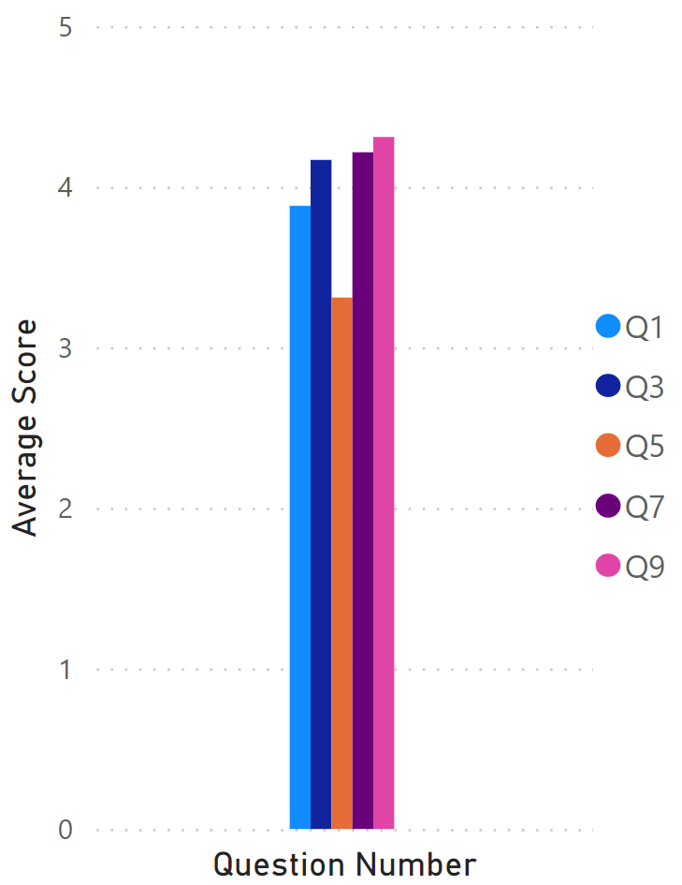  Figure 10 - Average scores for Odd numbered questions (positive themes)
For the negative themes, the lowest average score was for “I find the system unnecessarily complex”. The highest score was for “I think there is too much inconsistency in the system”.
For the positive themes, the lowest average score was for “I find the various functions in the system are well integrated”. The highest was “I feel very confident using the system”.
Enabling/Disrupting Themes
All participants were asked to “Please describe how using WIS enables you to complete your job” and “Please describe how using WIS disrupts you in completing your job”. Additional guidance was provided to help structure and inspire responses without guiding participants to a particular response. Responses were then reviewed and grouped into recurring and unique concepts.
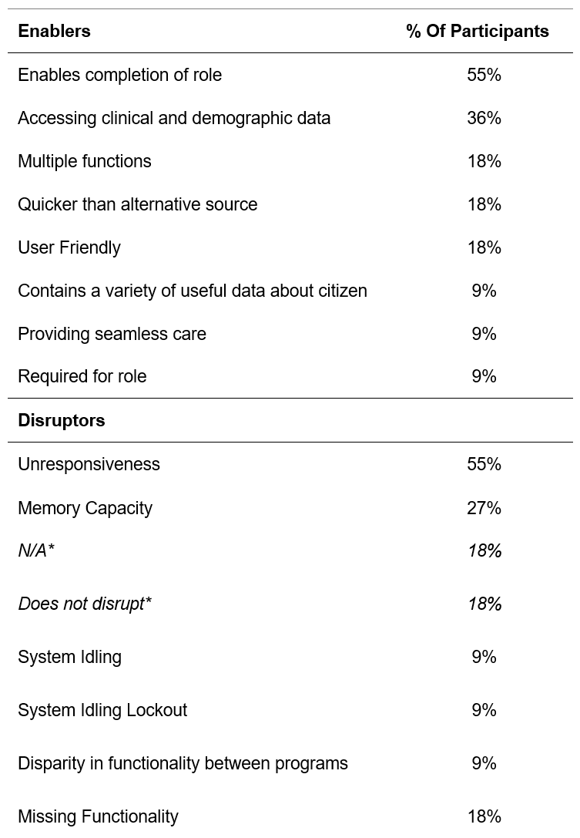
Table 2 - Themes identified within WIS Core, *Responses still included as survey fully completed
For WIS Core, most participants identified that the program enabled them to discharge their role with 36% of participants identifying that the ability to access clinical and demographic data enabled them to complete tasks. Several issues with the program and/or supporting technology were identified, although it is not always clear which is the root cause of the issue. 55% described issues with unresponsiveness with 27% respondents reporting error warning involving memory capacity. For others the unresponsiveness was characterised as “can be slow loading on times” and “…when it gets slow and glitchy”.
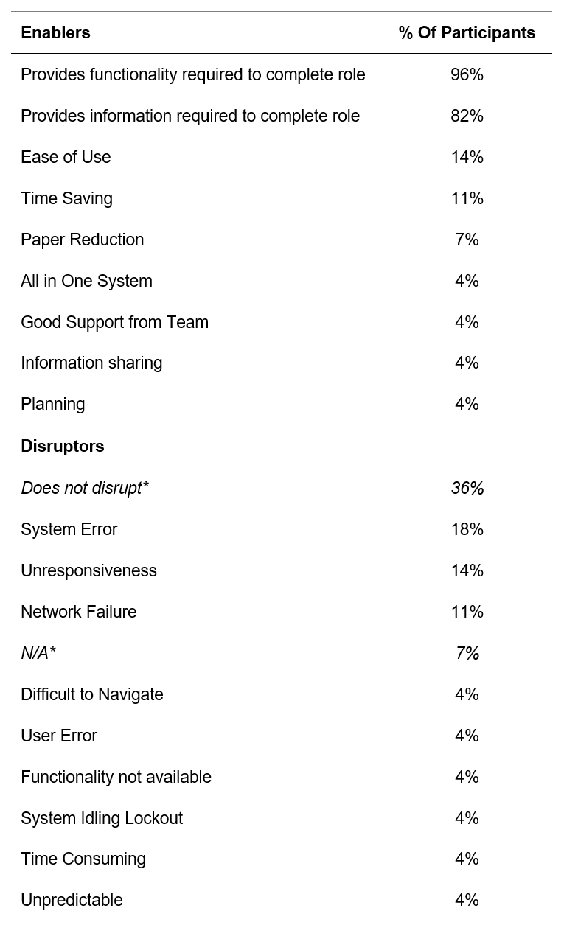
Table 3 - Themes identified within WIS Web, *Responses still included as survey fully completed
Nearly all respondents highlighted that WIS Web provided functionality that was necessary for them to complete their role. Further, 82% of respondents highlighted that they were provided the information they required to be able to complete their role. In the disrupting themes, 36% of respondents highlighted that WIS Web does not disrupt them in completing their role. The next highest disruptors focused on issues regarding errors created by the system, unresponsiveness and specific issues created by the local area network.
Discussion
Individual to Task Fit
For all roles within the programme the fit between the individual and the task was always going to be good. In the case of the vaccinators, they will always need to check demographics of the patient in front of them and document the care given into a set of notes. For administrators they will already be experienced in retrieving and inputting information and negotiating future appointments. The Medicines Management team already have a routine of fridge temperature and medicine stock management. These processes can be completed to a high quality in the presence of an ICT system or a paper-based system. In terms of WIS, Public Health Wales provided paper forms that matched the values being collected by WIS. Therefore, the addition of WIS to replace these paper forms to collect and store this data would’ve maintained this level of fit and support the provision of seamless care.
During the initial adoption of WIS, this notion of replacing a good non-digital process with an equally good digital process was especially true. Initially, clinical managers and clinicians were reluctant to adopt WIS because it was felt that adopting the system and a new clinical protocol would be too much for users. This reluctance for adoption can be, in part, rationalised by Information Value Chain Theory. Information Value Chain Theory is based on decision theory and can be used to quantify a value placed on the receipt of new information by an individual user. This is known as the Value of Information (VOI) (Coiera, 2019).
Where a system merely substitutes a high-quality process (recording vaccination on paper) with one that does not improve the quality of care we can expect the VOI score for data in the system to be low (Coiera, 2019). Because the task to individual fit was high this was likely to occur. WIS Web, at the time, did not hold any relevant clinical information and the eligibility questions were already part of the clinical protocol. Therefore, the probability of WIS Web informing a clinician of something they did not know or helping to provide an outcome different to vaccinating or not vaccinating was low. Thus, it held a VOI of close to zero and it was seen as an additional element of workload for the clinician as it did not inform the clinical process (Coiera, 2019). Additionally, reluctance was also attributed to the ability to provision training in an environment which itself was novel, lacked a test environment for the program, subject to ICT access restrictions, vulnerable to continual changes to clinical protocol and high pressured.
Task to Technology Fit
The fit between the task and technology is good but has opportunities to be strengthened. Most participants highlight that WIS allows them to complete their role. One member of the Medicines Management team highlights
“Quick and easy way of recording temperature readings with the overview of recent readings visible…”
This is highlighted in the high average SUS scores from participants and indicates the program is very usable. In fact, the system is more usable than other clinical systems that vaccinators may also have used within the Health Board. One study places the SUS for the Welsh Patient Administration System and Welsh Clinical Portal at 31-59. (Bloom, et al., 2021)
However, this fit can be further strengthened. At least 18% of participants noted that the system experiences unexpected behaviours. In the main this related to WIS Core with several participants highlighting a recurring issue with memory:
“…WIS crashes after you have accessed X number of citizens records as there is "not enough memory” …"
Comments were also made about WIS Web and included:
“Occasional glitches require support from admin or tech, this can be time consuming”
These errors could be the result of issues in the central architecture, the technology provided or the network infrastructure within the MVCs. Therefore, a review of the ICT infrastructure at MVCs as well as raising the issue of memory errors with the application team would be recommended. In many cases users have adapted to understand the triggers for these events, understand how to reattempt the entry of data or escalate issues for resolution by the Booking Hub. The main disruption to seamless care will be the experience of the citizen in the vaccination booth but occasionally a lack of data may result in them being called for further vaccination.
Technology to Individual Fit
The fit here is also good to strong. This is evidenced by the high SUS scores that participants have reported. However, this is not an opinion shared by all. 23.8% of participants scored WIS below 70, with one Participant scoring it 20. One of these respondents felt:
“It is slow/badly written old-fashioned software”
However, this participant also identified the system incorrectly. Therefore, there are some potential issues with the users understanding of the programs they are using or hold elevated expectations.
When reviewing average responses to individual questions, two distinct themes do not match other responses. The average score for “I find the various functions in the system are well integrated” was closer to 3 than 4, unlike other odd numbered questions. However, there are few responses that explain what is being suggested. One participant highlighted:
“Having to switch between WIS Web/WIS Core for functions such as entering a vaccine (we don't do this very often) but would be easier if it was incorporated into one system”
This would also agree with the discussion with the Business Manager where it was identified that the WIS Core program currently still does not allow for the processing for automatic bookings or management of letters being sent without having to negotiate with DHCW over email. Having this integrated into the program would likely improve the fit here and the SUS responses.
The second theme was “I think there is too much inconsistency in the system” and this may allude to the system issues that are experienced by users, poor data quality of users. However, the responses from participants do not speak in detail to this issue.
The fitness of FITT and SUS
The FITT framework is an appropriate framework to use because it not only identifies issues that other frameworks such as the Technology Acceptance Model (TAM), Task-Technology Fit (TTF) model and Information Systems Success model it draws in the experience of the individual and the external settings (Schnall, et al., 2012).
However, Prgomet et al. (2019) assert that the framework should be Fit to Individual, Task, Technology and Environment (FITTE) to allow the consideration of the context in which the IT adoption is operating. For example, they show that the adoption of hardware in a ward environment can be impacted by factors such as the timing of drug administration, infection control restrictions and space availability. In the case of WIS and the COVID-19 pandemic the framework has not necessarily encouraged a discussion regarding the adherence to COVID control measures, the built space used, and the political pressure to vaccinate at pace. An example is highlighted in the feedback from the Business Manager who said, “the PPE screens at the front desk make it especially hard to hear patients confirm demographic details and may explain why this step is not always completed well”. To counter this, Ammenwerth et al. (2009) does acknowledge that external factors do have a role in FITT and the planning of intervention to improve a fit. Instead, the suggestion of a FITTE framework as suggested maybe more suitable in forward planning for adoption and the FITT framework better suited at review stages after adoption has begun.
The SUS is a widely used tool and evidence does show that even with low numbers of responses a valid score can be gained (Bloom, et al., 2021; Lewis, 2018). However, some of the questions appear to be ambiguous and do not lend themselves to identifying specific issues with a system without further interrogation. For example, the interpretation of “I find the various functions in the system are well integrated” may not be consistent amongst users with low digital literacy. A future review of WIS would be better served by combining data from this tool with direct observation and semi-structured interviews. A methodology like Prgomet et al. (2019), Nilsson L, Hellström A, Wennerberg C, et al. (2020) or Lærum & Faxvaag (2004) may bring about a more detailed analysis of the use of WIS as a tool for seamless care provision.
Conclusion
The Welsh Immunisation System is now a well adopted information system within the Mass Vaccination Programme. It is difficult to suggest a better system for the management of vaccination data and administration of appointments. This is reflected in the nomination of WIS for an award and lack of a similar unified system elsewhere in the world (Digital Health and Care Wales, 2022).
Though the adoption of WIS was not without its issues. Data shows that confidence in the system is high and that it provides a useful function to users in carrying out their job roles in providing care to citizens. However, it must be noted that for clinicians the system replaces a process that can be achieved using paper or lacks functionality that could be beneficial to administration of appointments. Alongside this are the issues with resilience and that unexpected behaviour can impact the task at hand which reduces motivation to adopt the system. Further, if the now high confidence in the system through usage over time is an inevitability, adoption may have been hastened and improved further by reaching this confidence level sooner. Future system adoptions should bear this in mind and both system and clinical managers should consider reluctance to adopt the system through the lens of the FITT (or FITTE) framework. This will allow system managers to better design adoption methods and provide clinical managers assurance to encourage adoption within their team.

References
Ammenwerth, E., Iller, C. & Mahler, C., 2006. IT-adoption and the interaction of task, technology and individuals: a fit framework and a case study. BMC Medical Informatics and Decision Making, 6(3).
Bloom, B. M. et al., 2021. Usability of electronic health record systems in UK EDs. Emerg.Med.J., 38(6), pp. 410-415.
Brooke, J., 1995. SUS: A “quick and dirty” usability scale. In: P. W. Jordan, B. Thomas, B. A. Weerdmeester & I. L. McLelland, eds. SUS: A “quick and dirty” usability scale. London: Taylor & Francis, pp. 189-194.
Coiera, E., 2019. Assessing Technology Success and Failure Using Information Value Chain Theory. In: P. Scott, N. de Keizer & A. Georgiou, eds. Applied Interdisciplinary Theory in Health Informatics. s.l.:IOS Press, pp. 35-48.
Digital Health and Care Wales, 2021. Child Health. [Online]
Available at: https://nwis.nhs.wales/systems-and-services/in-the-community/child-health/
[Accessed 25 February 2022].
Digital Health and Care Wales, 2021. Welsh Immunisation System. [Online]
Available at: https://dhcw.nhs.wales/coronavirus/digital-support-updates-for-healthcare-professionals/primary-care/welsh-immunisation-system/
[Accessed 25 February 2022].
Digital Health and Care Wales, 2022. Welsh Immunisation System finalist in Impact Awards. [Online]
Available at: https://nwis.nhs.wales/news/latest-news/welsh-immunisation-system-finalist-in-impact-awards/
[Accessed 25 February 2022].
Faxvaag, H. L. &. A., 2004. Task-oriented evaluation of electronic medical records systems: development and validation of a questionnaire for physicians. BMC Medical Informatics and Decision Making, 4(1).
Goodhue, D. L. & Thompson, R. L., 1995. Task-Technology Fit and Individual Performance. MIS Quarterly, 19(2), pp. 213-236.
Hägglund, M. & Scandurra, I., 2021. User Evaluation of the Swedish Patient Accessible Electronic Health Record: System Usability Scale. JMIR Human Factors, 8(3).
Health Tech Newspaper, 2020. National system introduced in Wales to support COVID-19 vaccine roll out. [Online]
Available at: https://htn.co.uk/2020/12/09/national-system-introduced-in-wales-to-support-covid-19-vaccine-roll-out/
[Accessed 25 February 2022].
Kortum, P. & Peres, S. C., 2014. The Relationship Between System Effectiveness and Subjective Usability Scores Using the System Usability Scale.. International Journal of Human-Computer Interaction, 30(7), pp. 575-584.
Lærum, H. &. F. A., 2004. Task-oriented evaluation of electronic medical records systems: development and validation of a questionnaire for physicians. BMC Medical Informatics and Decision Making, 4(1).
Lewis, J. R., 2018. The System Usability Scale: Past, Present, and Future.. International Journal of Human-Computer Interaction, 34(7), pp. 577-590.
NHS Wales Informatics Service, n.d. Protect - Privacy and Data Protection Information. [Online]
Available at: http://www.wales.nhs.uk/protectprivacyanddataprotectioninformation
[Accessed 25 February 2022].
Nilsson, L. et al., 2020. Patients’ experiences of using an e-Health tool for self-management support after prostate cancer surgery: a deductive interview study explained through the FITT framework. BMJ Open, 10(e035024).
Perry, M. et al., 2021. Inequalities in coverage of COVID-19 vaccination: A population register based cross-sectional study in Wales, UK. Vaccine, 39(42), pp. 6256-6261.
Prgomet, M., Georgiou, A., Callen, J. & Westbrook, J., 2019. Fit Between Individuals, Tasks, Technology, and Environment (FITTE) Framework: A Proposed Extension of FITT to Evaluate and Optimise Health Information Technology Use. In: L. Ohno-Machado & B. Séroussi, eds. MEDINFO 2019: Health and Wellbeing e-Networks for All. Amsterdam: International Medical Informatics Association (IMIA) and IOS Press, pp. 744-748.
Schnall, R. et al., 2012. Employing the FITT framework to explore HIV case managers’ perceptions of two electronic clinical data (ECD) summary systems. International Journal of Medical Informatics, 81(10), pp. e56-e62.
Tsiknakis, M. & Kouroubali, A., 2009. Organizational factors affecting successful adoption of innovative eHealth services: A case study employing the FITT framework. International Journal of Medical Informatics, 78(1), pp. 39-52.
Welsh Government, 2021. Vaccination Strategy for Wales. [Online]
Available at: https://gov.wales/sites/default/files/publications/2021-01/vaccination-strategy-for-wales_3.pdf
[Accessed 25 February 2022].
Welsh Government, 2022. COVID-19 Vaccination Strategy for 2022. [Online]
Available at: https://gov.wales/sites/default/files/publications/2022-02/covid-19-vaccination-strategy-for-2022.pdf
[Accessed 25 February 2022].

