

Marketing Plan

Student Name: Maria Andrei
Student ID:2243878
Course Name: Marketing Essential BMIH4005
Lecturer’s Name: Scott James
Word count:1553

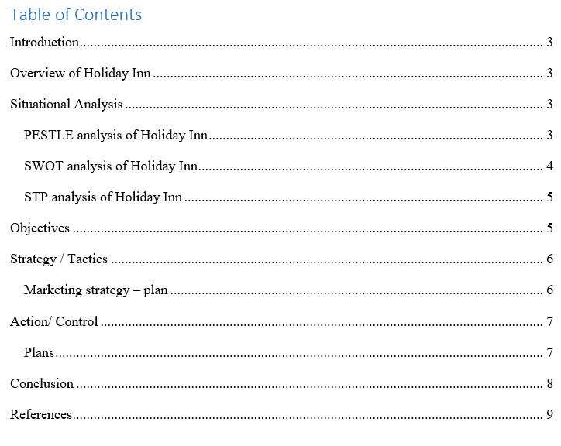

Introduction
The Holiday Inn now offers a service to help guests arrange transportation. Their hotel staff is here to provide a trouble-free arrival and departure no matter how you're travelling to us. Their punctual and courteous drivers will get them where they need to go quickly and safely. Make use of Holiday Inn's shuttle services and relax throughout the time they're there. This introduction is direct, succinct, and eye-catching (Drucker, 2014). It emphasises the most salient features of the new service, such as its reliability, security, and ease of use. It also features an urgent call to action that prompts readers to arrange for transport help immediately. The remainder of the marketing strategy would elaborate on the service by discussing its specifics, such as the available modes of transportation, pricing, and how reservations can be made.

Overview of Holiday Inn
Holiday Inn is a famous hotel chain that has been around for quite some time. It caters to business travellers, vacationers, and families with children by providing several accommodation configurations and convenient services. The hotel's handy and low-cost locations in well-known tourist hotspots across the world are further selling points. Different accommodation kinds, from ordinary to suite, are available to meet guests' demands and budgets (Bryson, 2018). Locations that are central to or near major transportation hubs or other points of interest are also desirable. Prices that are reasonable and within reach of most vacationers. Staff members who genuinely care about satisfying customers. Well-maintained, spotless, and comfy accommodations. Internet access throughout the stay is provided at no cost to the visitor.

Situational Analysis

PESTLE analysis of Holiday Inn
PESTLE | Analysis
Political factors | The political environment can have a significant impact on the hotel industry. For example, changes in visa regulations or tax laws can make it more or less difficult for tourists to visit a particular country. The political stability of a country can also affect the demand for hotel rooms (Rangkuti, 2019). For example, if a country introduces new visa regulations that make it more difficult for tourists to visit, Holiday Inn can adjust its marketing and pricing strategies to attract more domestic travellers.
Economic factors | Economic uncertainty may have a significant impact on the hotel industry. When times are tough, fewer people travel, which might mean less business for hotels.
Social factors | Changes in consumer preferences, lifestyle, and population structure might have an effect on the Hotel Inn. For instance, hotels geared towards the elderly are in high demand (Porter, 2020).
Technological factors | Another major factor influencing the hotel industry is the rise of online travel agencies and smartphone booking applications. These innovations have the potential to reduce hotel prices by making the booking and administration procedures more efficient.
Legal factors | Regulatory uncertainty is an additional threat to the hotel industry. A hotel's operations may be influenced by zoning laws, labour statutes, and safety mandates (Mintzberg & Quinn, 2013).
Environmental factors | The hospitality sector is vulnerable to external influences, such as climate change and natural catastrophes. Hotels in hurricane- or flood-prone locations, for instance, can see occupancy rates drop when natural disasters strike.

SWOT analysis of Holiday Inn
Strengths  Holiday Inn can use its well-known name and worldwide footprint to enter new areas and grow its business. The hotel's variety of hotels and room types allows it to cater to the demands of a wide spectrum of guests. | Weaknesses  Holiday Inn may repair its ageing infrastructure by spending money on improvements and restorations (Hill and Jones, 2019). Hotel workers can benefit from more training, and a customer feedback system would do wonders for the hotel's standing with guests.
Opportunities  Holiday Inn may take advantage of the rising demand for tourism by establishing more of its hotels in high-traffic areas (Grant, 2016). More customers can be attracted to the hotel by creating innovative new services and goods like loyalty programmes and mobile booking applications. | Threats  Holiday Inn can prepare for and weather economic downturns by keeping a healthy financial buffer and adopting alternative strategies. Investing in other hotels in countries with more stable governments is another way for the hotel to shield itself from the effects of political unrest.

STP analysis of Holiday Inn
Segmentation: Holiday Inn may leverage demographics to its advantage by focusing on hotels in key business areas, where business travellers are likely to be staying. The hotel can also exploit locations to attract vacationers by specialising in lodgings in major tourist hubs.
Targeting: In order to attract families, Holiday Inn can provide services aimed specifically towards them, such as a children's club and a swimming pool. The hotel may provide special rates for families with several kids (Drucker, 2014).
Positioning: Holiday Inn may differentiate itself from other hotel chains by providing a wide range of accommodation types at reasonable rates. If the hotel consistently delivers high-quality service, it may market itself as part of a larger hotel chain known for its emphasis on visitor satisfaction.

Objectives
- To properly categorise the market, essential commercial locations and significant tourism hotspots should be identified.
- To provide specialised services and marketing in order to target and draw in families.
- To promote Holiday Inn as a trustworthy, reasonably priced hotel business with a high emphasis on guest service.
- To use social media, search engine marketing, and word-of-mouth as well as traditional marketing methods in order to reach marketing objectives.
- To use marketing to raise brand recognition, bring in new customers, and keep current ones.
- To include feedback methods and customer service training into the operating strategy.

Strategy / Tactics

Marketing strategy – plan
Holiday Inn marketing strategy:
- Target market: Business travellers, leisure travellers, and families.
- Positioning: Reliable and affordable hotel chain with a focus on customer service.
- Marketing mix: Competitive prices, variety of room types, convenient locations, and excellent customer service.
- Marketing channels: Online and offline channels, such as social media, search engine marketing, and word-of-mouth.
- Marketing goals: Increase brand awareness, attract new guests, and retain existing guests.
Online marketing: social media presents opportunities for audience engagement, online advertising, and search engine optimisation for Holiday Inn (Daft, 2019).
Offline marketing: Advertisements, billboards, and conventions are just a few of the ways Holiday Inn might potentially reach its target audience.
Word-of-mouth marketing: If visitors to Holiday Inn enjoyed their stays, they could consider telling others about it.

Action/ Control

Plans
HR plan  Holiday Inn can recruit and retain top employees by offering competitive salaries, sign-on bonuses, and tuition reimbursement schemes. The hotel should invest in its employees' careers by providing opportunities for them to learn and improve, such as tuition reimbursement and mentoring programmes (Bryson, 2018).  Holiday Inn was able to manage staff performance by providing clear goals, regular feedback, and prompt resolution of difficulties. As an added bonus, the hotel may use the results of these evaluations to assist its best employees in moving through the ranks. | Operational Plan  Methods to better serve customers, such as providing staff with customer service training, establishing a system for gathering and analysing client feedback, and fostering a welcoming atmosphere (Bryson, 2018).  Cost-cutting measures, such as improved supplier negotiations, less wasteful operations, and increased productivity, might all be part of such a plan.
Financial Plan  Cost reduction, stock and bond investment, and retirement savings are all part of a retirement savings plan (Barney, 2011).  Debt repayment strategy: In this strategy, they might think about budgeting, consolidating their debt, and making larger payments. | Controlling plan  Expansion into untapped markets: This technique can be used to increase market share, revenue, and/or profits. The plan may also incorporate mechanisms for monitoring development and soliciting end-user feedback.  Efforts to raise morale among workers: Indicators for this tactic may include polls of employees, turnover rates, and absence management plans.

Conclusion
As a result, it's clear that a controlling strategy is crucial to the on-time and effective completion of projects and procedures. A controlling plan is necessary to ensure that Holiday Inn's efforts and processes are effective and on track (Aaker et al., 2019). With the help of a well-thought-out control plan prepared in line with the aforementioned recommendations, Holiday Inn may increase customer satisfaction, reduce costs, expand into new areas, and enhance morale.

References
Aaker, D. A., Kumar, V., & Day, G. S. (2019). Marketing research. 12th edition. New York, NY: McGraw-Hill Education.
Barney, J. (2011). Firm resources and sustained competitive advantage.** Journal of Management, 17(1), 99-120.
Bryson, J. M. (2018). Strategic planning for public and nonprofit organizations: A guide to strengthening and sustaining organizational performance.** 5th edition. San Francisco, CA: Jossey-Bass.
Daft, R. L. (2019). The leadership experience.** 8th edition. New York, NY: McGraw-Hill Education.
Drucker, P. F. (2014). The practice of management.** New York, NY: Harper & Row.
Grant, R. M. (2016). Contemporary strategy analysis: Text and cases.** 12th edition. New York, NY: Wiley.
Hill, C. W. L., & Jones, G. R. (2019). Strategic management: An integrated approach.** 14th edition. Boston, MA: Pearson.
Mintzberg, H., & Quinn, J. B. (2013). The strategy process: Concepts, contexts, cases.** 6th edition. Upper Saddle River, NJ: Pearson.
Porter, M. E. (2020). Competitive strategy: Techniques for analyzing industries and competitors.** New York, NY: Free Press.
Rangkuti, F. (2019). The power of strategic management: Techniques for analyzing and formulating business strategies.** 2nd edition. Jakarta, Indonesia: Gramedia Pustaka Utama.

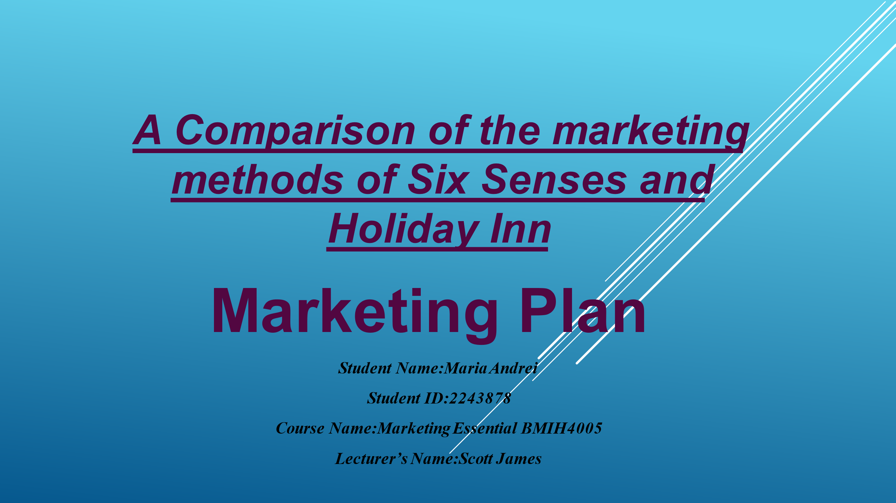
Slide 1
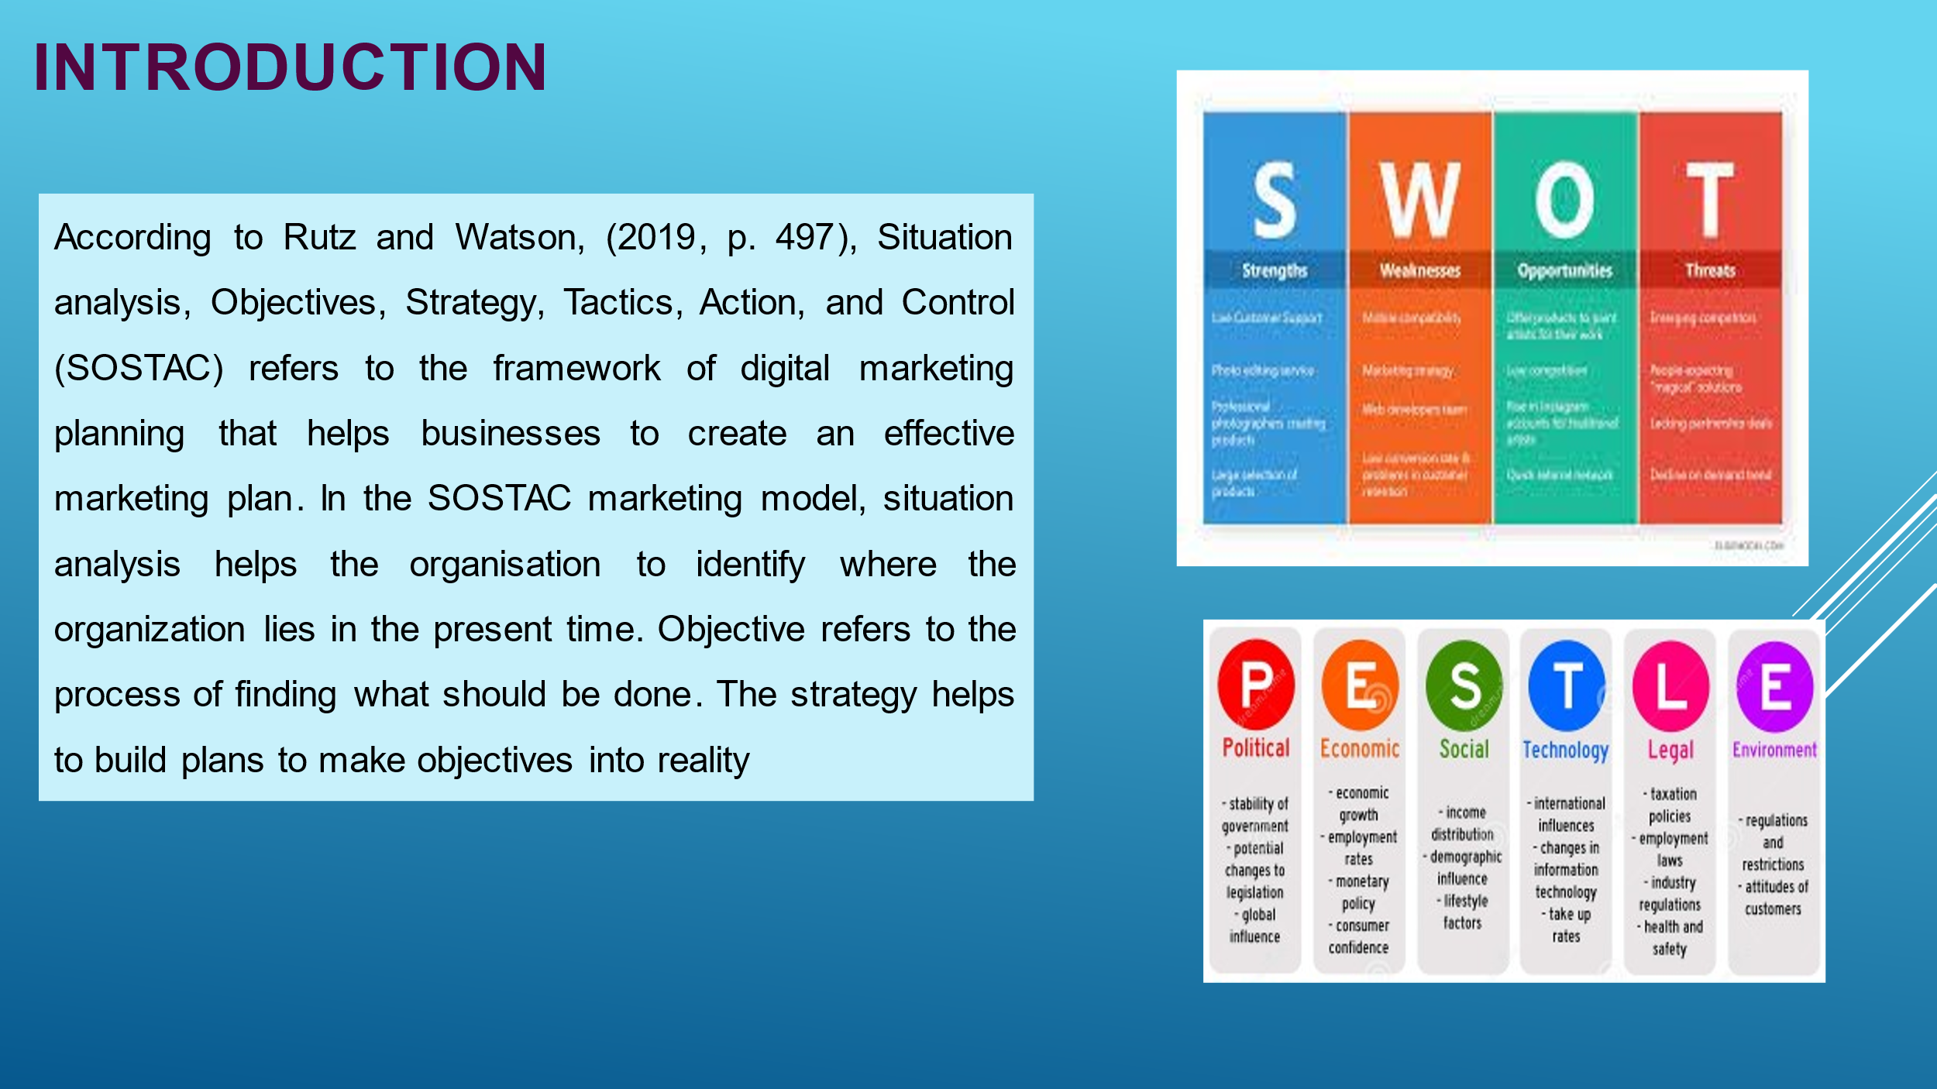
Slide 2
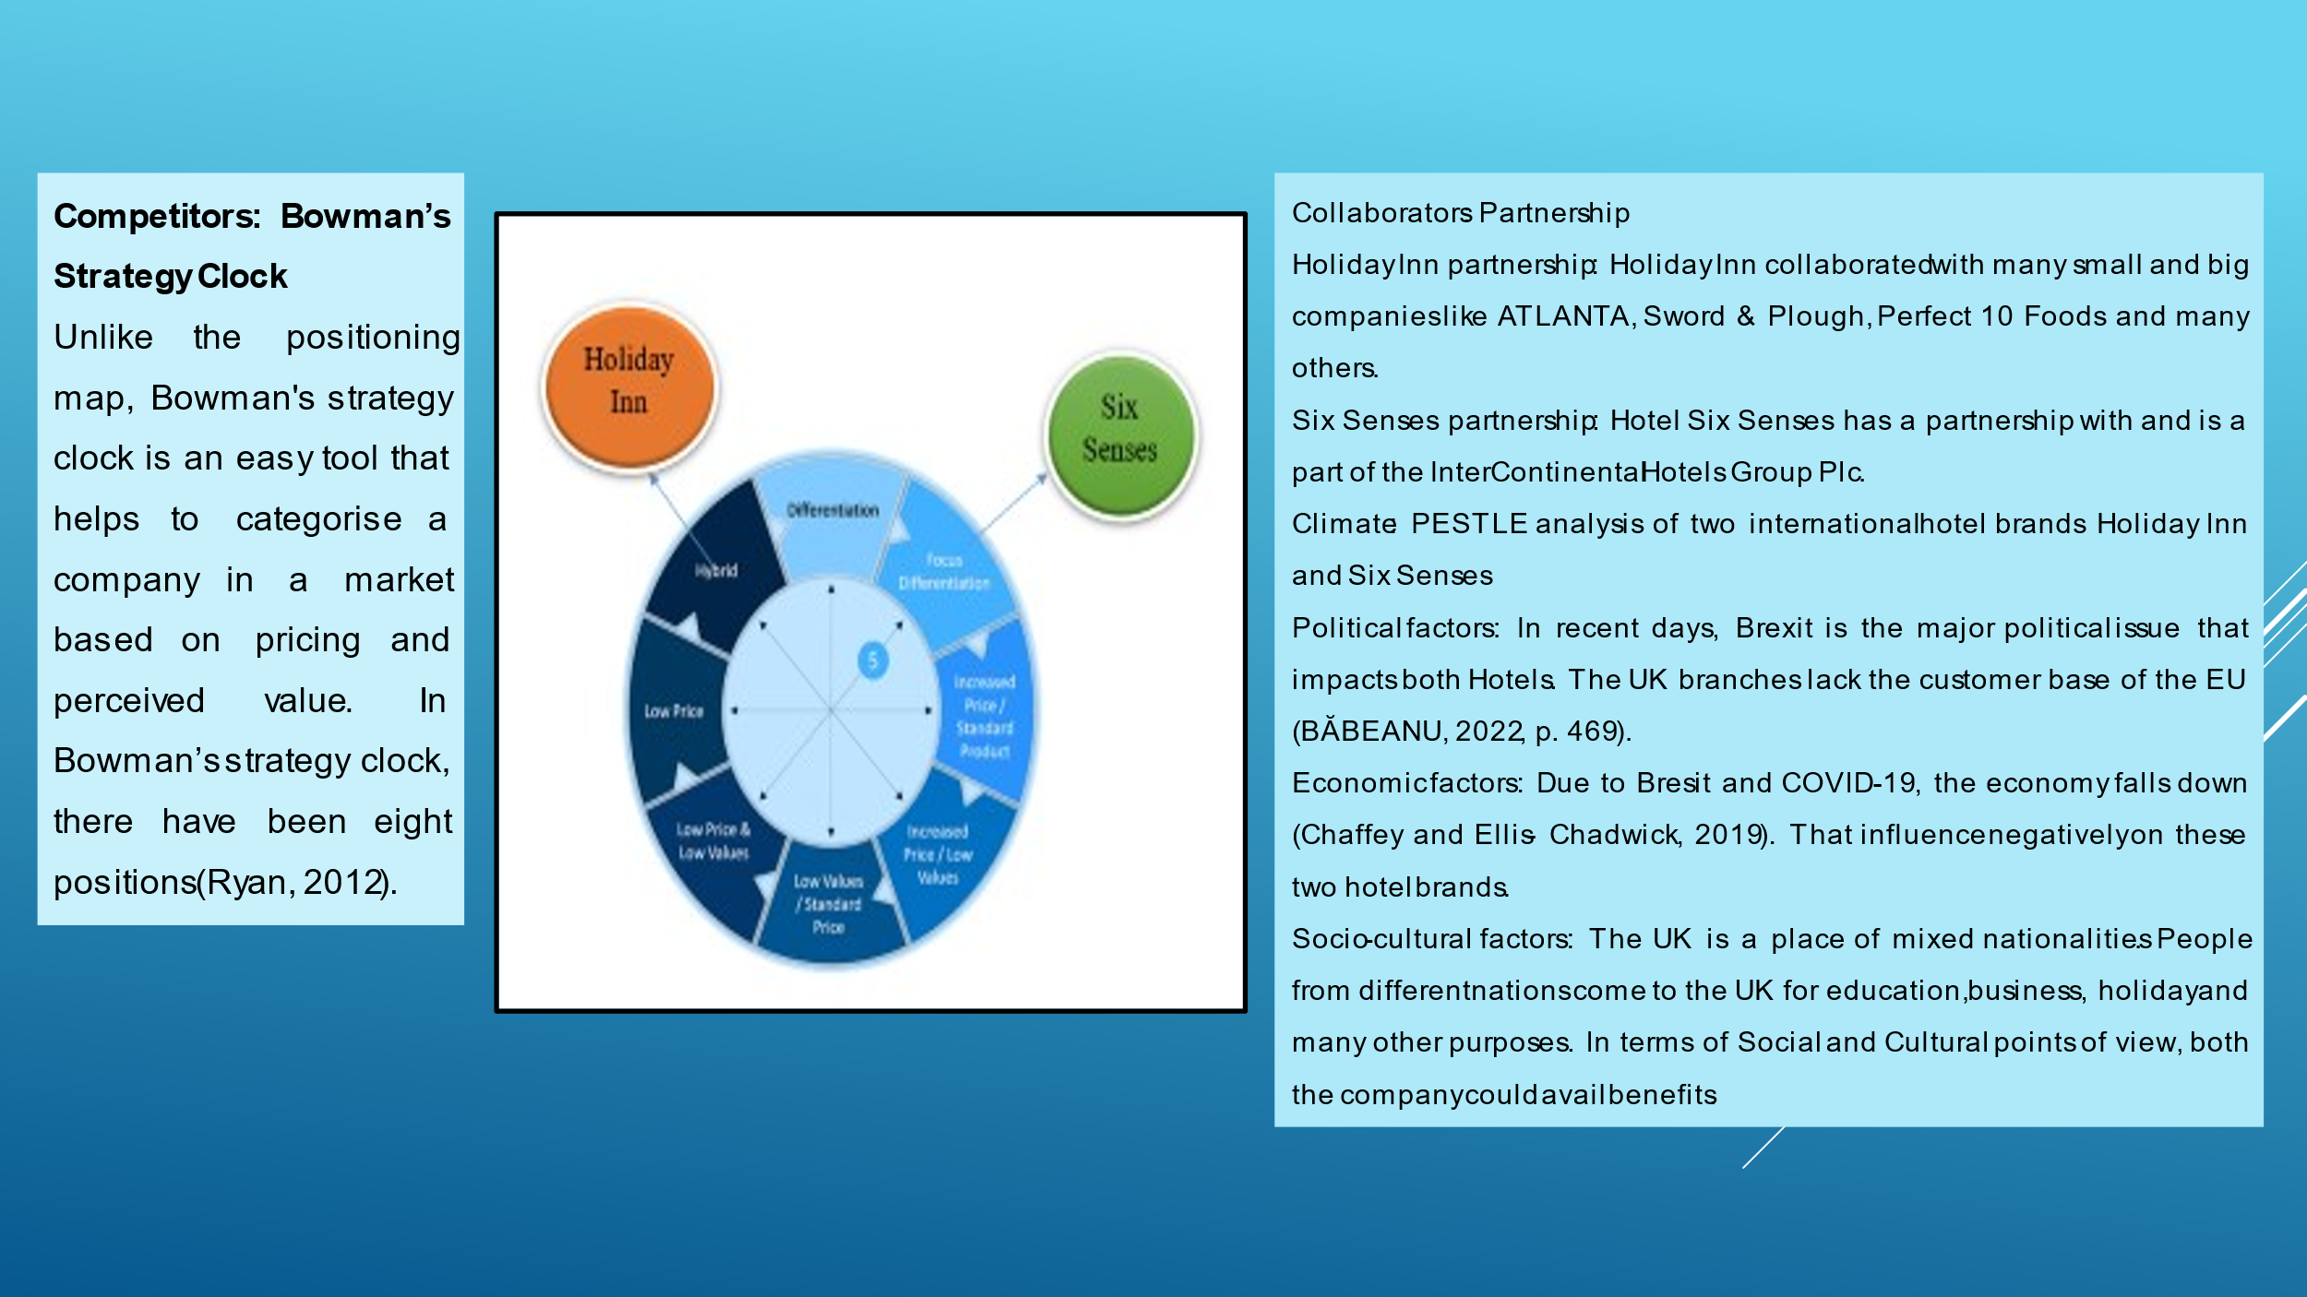
Slide 3
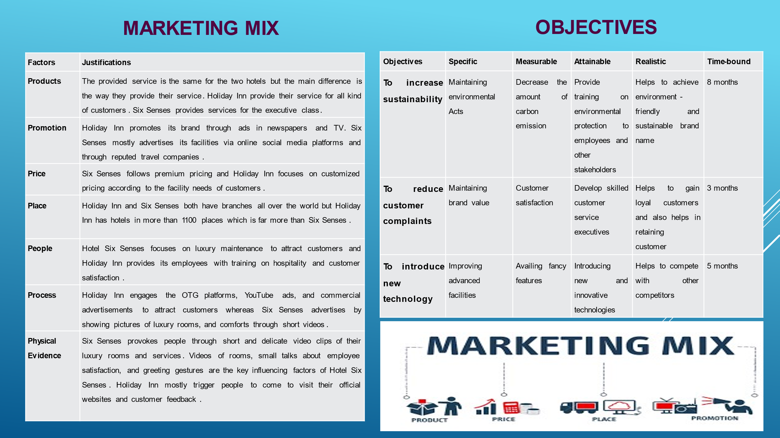
Slide 4
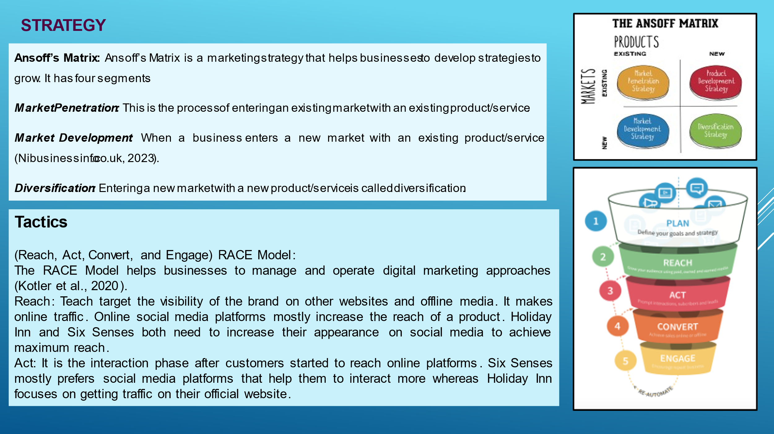
Slide 5
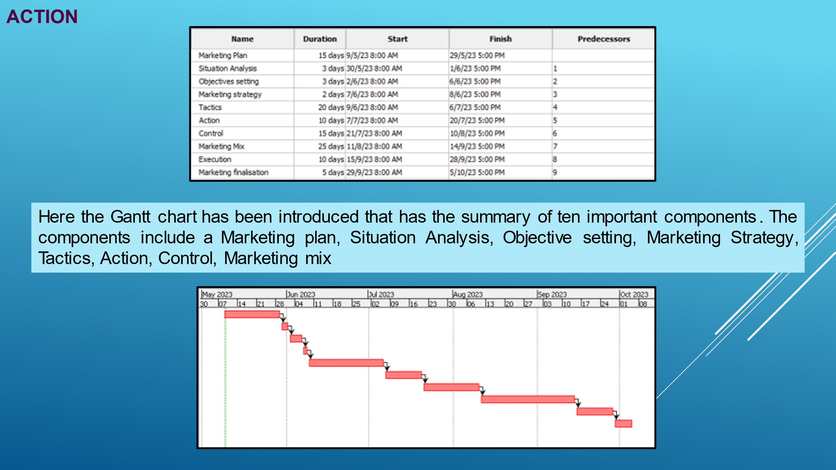
Slide 6
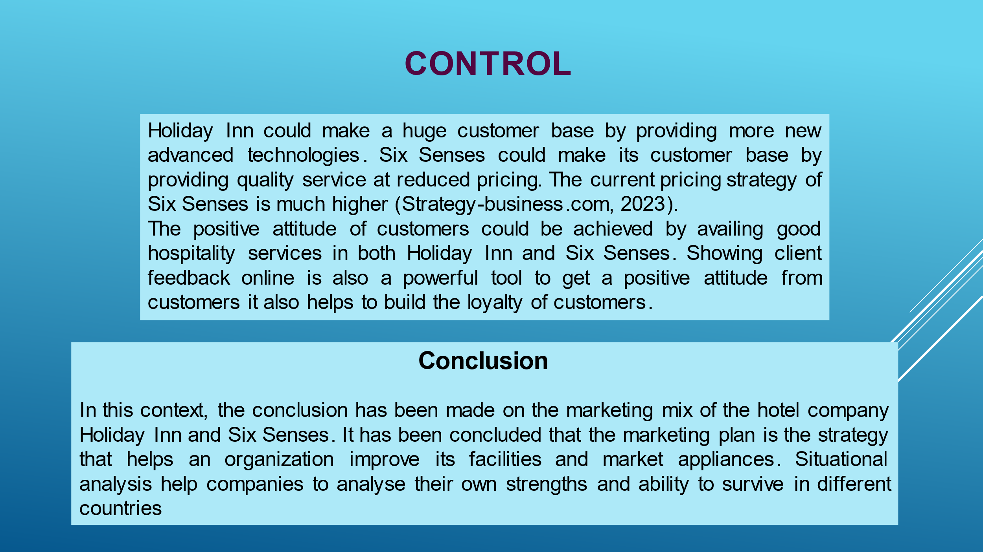
Slide 7
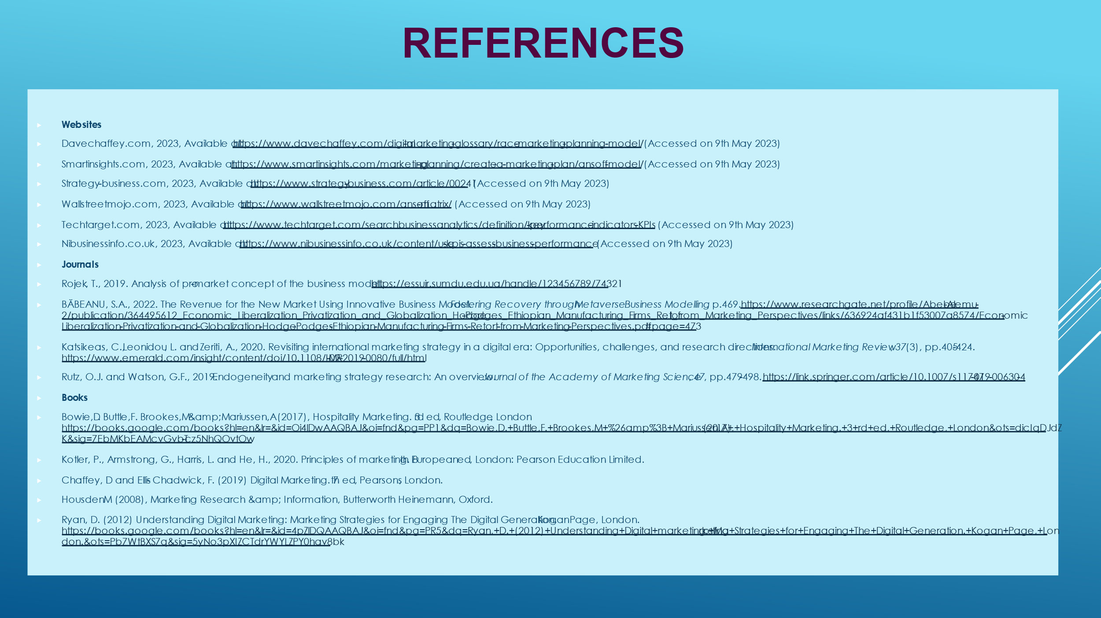
Slide 8

