
Master of Business Administration
LCMB7034 - International Business Concepts
Assignment Title: “Report on the Internationalisation Strategy of FedEx in India”
Student Name: Manish verma
Student ID : 2433117
Word Count: 5000
Table of Contents
1. Introduction 3
2. Benefits and challenges of International operations 3
2.1 Justification as an MNC 3
2.2 Global Value Chain of FedEx 6
2.3 Entry modes used by FedEx 8
2.3 Entry modes used by FedEx 8
2.4 Key Benefits of Internationalisation 9
2.5 Challenges of Internationalisation 10
3. OLI Eclectic Paradigm Analysis 11
3.1 Ownership Advantages (O) 11
3.2 Location Advantages (L) 12
3.3 Internalisation Advantages (I) 13
3.4 Resulting Entry Mode Decision 14
4. Cultural Distance & Its Implications 15
4.1 Cultural Profile Comparison 15
4.2 Impact on Entry Strategy 18
4.3 Impact on Success Potential 19
5. Recommendations and Strategic Adjustments for FedEx in India 19
5.1 Strengthen Local Partnerships 19
5.2 Sustainability and Cost Management 20
5.3 Digital Innovation for Efficiency 21
6. Conclusion 22
7. References 23

1. Introduction
FedEx Corp. is a global transportation and e-commerce Organisation, with its headquarters located in Little Rock, Arkansas, USA. The company has a vast portfolio of services that include air and ground delivery, freight, supply chain, and business services. The core business aspect ofthis company is to deliver packages and freight globally, with the help of overnight express, in both ground and air. The strategy includes operational excellence along with attaining innovation and a competitive advantage in the logistics sector (FedEx, 2023). It operates as one of the world's largest cargo airlines, with major hubs like Memphis (US) and international hubs in Asia, Europe, and the Middle East. This company engages in the provision of a portfolio of transportation, e-commerce, and logistics services (Forbes, 2025). It has various segments in which it operates its business, including FedEx Express, FedEx Ground, FedEx Freight, FedEx Services, and Corporate, Other, and Eliminations.
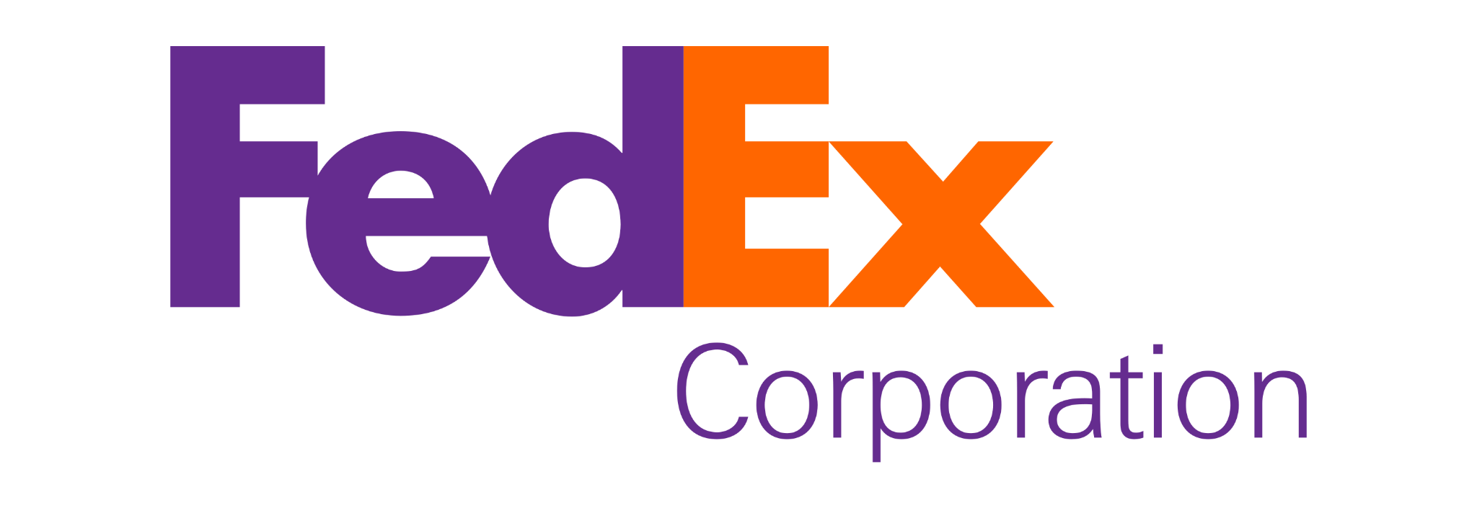
Figure 1: Logo of FedEx
(Source: PNG Mart, 2024).

2. Benefits and challenges of International operations

2.1 Justification as an MNC
A multi-national company refers to a company that has robust operations in more than one country. FedEx is considered one of the most influential multinational companies, due to its robust management and operational excellence in various countries. Based on th USA, the company operates in over 220 countries, along with having over 500,000 employees worldwide. FedEx's multinational status comes from its expansive physical network, diverse service portfolio, massive global workforce, and strategic focus on facilitating international commerce and e-commerce (FedEx, 2023). The mission of the company is to provide a high-value-added logistics and transportation service, while opting for a fully integrated digital and physical network worldwide to gain financial returns for its shareholders.
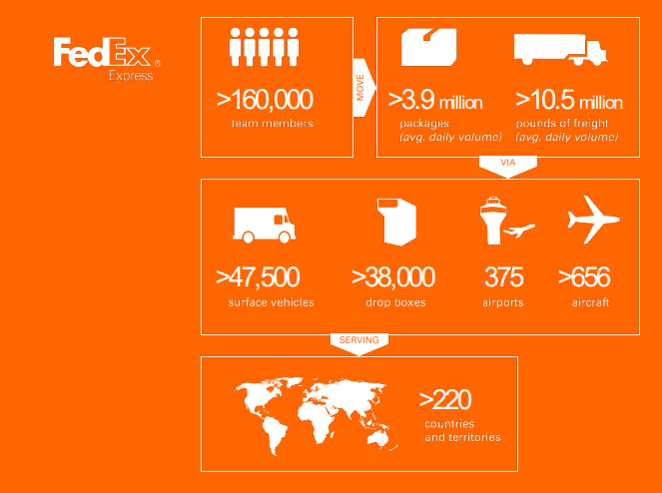
Figure 2: Supply Chain of FedEx
(Source: SNTIC.org, 2025)
For its internal operations, it primarily focuses on several aspects such as global reach, comprehensive services, economic integration, strategic adaptation, corporate structure, and a global workforce. The company is known for using leading-edge IT for its logistics and tracking processes to adapt to different regulatory environments. With its global operations, the company has successfully attained over 99% of the world's GDP. In the full fiscal year of 2025, the annual revenue of the company stands at $87.9 billion, facing a 0,27% increase from 2024.
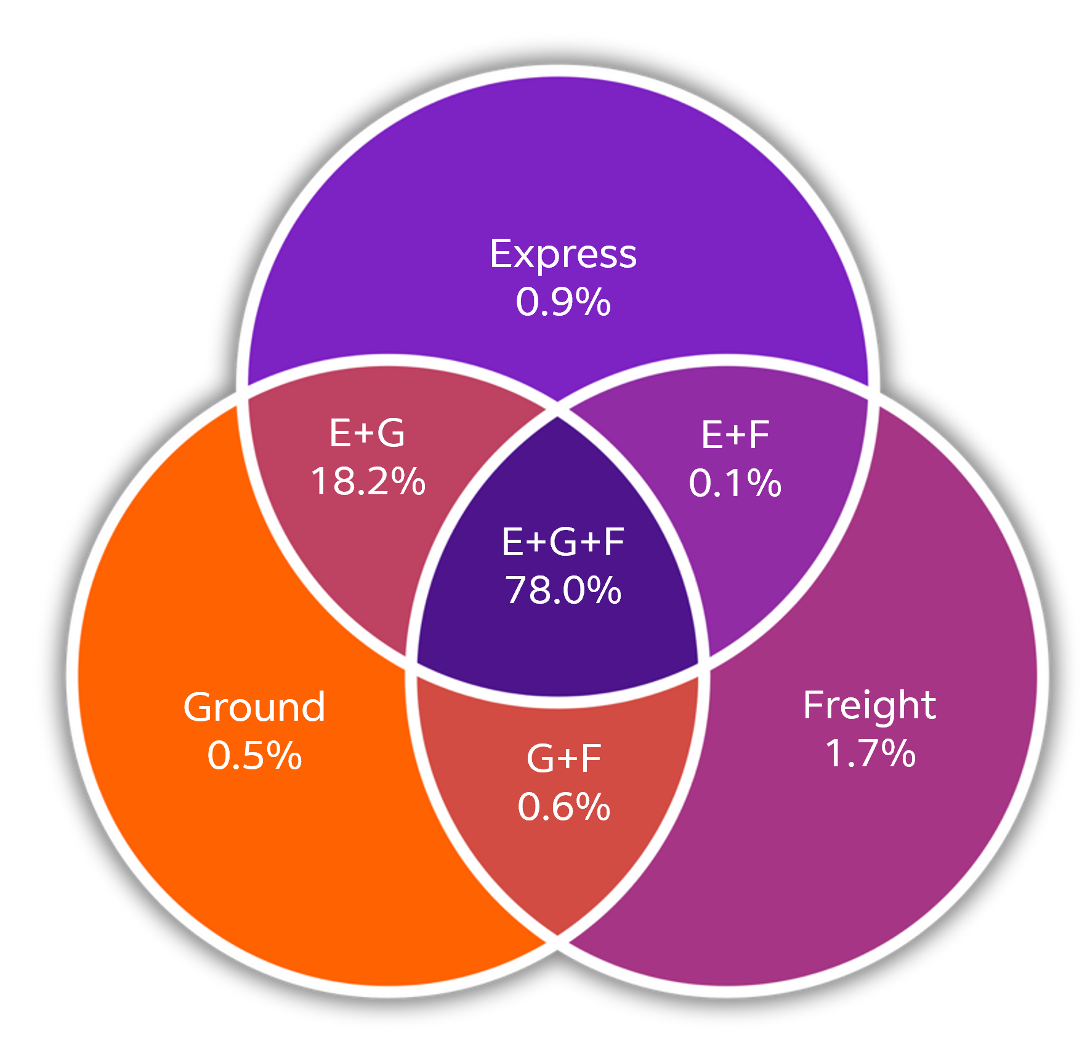
Figure 3: Revenue Percentage of FedEx
(Source: FedEx, 2023)

2.2 Global Value Chain of FedEx
The global value chain of the company primarily focuses on its integrated network, that is comprised of transport, e-commerce, and business services. With its vast infrastructure, it integrates an air-ground network for express delivery, leveraging hubs, planes, and trucks globally. This vast infrastructure also caters to the revenue stream of the company. The figure below depicts the revenue of each service of FedEx, such as the ground service with $33.9 billion, express services with $41.4 billon, freight with $8.9 billion, and other services with 3.7 billion in revenue (FedEx, 2023). 2022 was the year with the highest revenue for the company, increasing to $93.51 billion in that year, facing 11.38% increase. However, in 2023, the company faced a 3.59% decline, bringing its revenue down to $90.2 billion
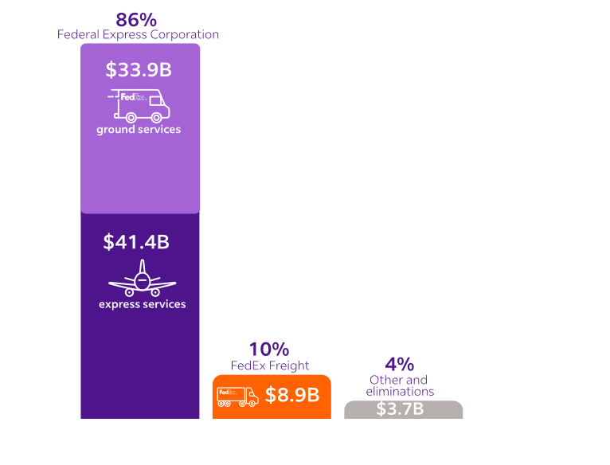
Figure 4: Revenue of FedEx
(Source: FedEx, 2023)
The company also attains a strong and prominent value chain that primarily focuses on integrated inbound and outbound logistics, powered by the digital network and automation. The inbound logistics help the company to receive packages and sort them using automation, while outbound logistics help them with final delivery and real-time tracking using various technologies (FedEx, 2025). The trade networks of the company also significantly impact its management of the global value chain. As mentioned before, the company uses its inbound and outbound logistics to create a seamless channel for managing and delivering its products.
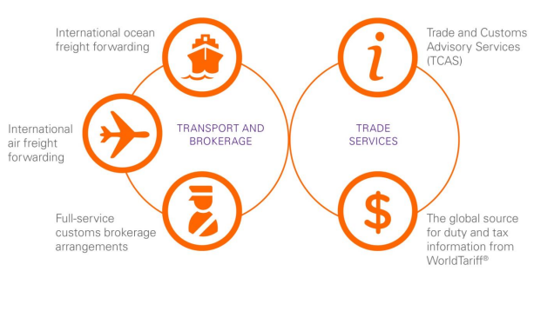
Figure 5: FedEx Trade Networks
(Source: SNTIC.org, 2025)

2.3 Entry modes used by FedEx

2.3 Entry modes used by FedEx
There is a plethora of traditional entry modes used by other logistics companies in the global market. However, FedEx is known for not using any kind of traditional entry modes, but rather, uses its global logistics network to help other businesses collaborate with it, and help other businesses enter a country through integrated services. Therefore, before entering a market in India, it needs to conduct in-depth research to understand its diverse culture, local demands, regulatory laws, competition, and more (Wortham, 2025). Its own entry modes focus on three primary factors. Firstly, and most importantly, it uses direct or indirect exporting of services globally and uses its vast network as a base for its production. Secondly, it uses strategic acquisitions and partnerships with other companies to form alliances and expand its network through exporting (Ahmed, 2020). Thirdly, it uses greenfield investment for its network expansion to build new hubs in countries and enable direct investment with its own infrastructure.
For other companies, however, it uses different entry modes not only for collaboration but also for exporting. It uses exporting, integrated logistics, and various technologies in its e-commerce infrastructure to facilitate proper and robust international operations for its shipments. This allows the companies to export goods with the help of FedEx, while facing a low level of risk and control (Gaikwad, 2025). Export and import help the other companies to enable international shipping, integrated logistics help with warehousing, distribution, and returns, and technology helps to implement digital platforms for online businesses, which also works as a digital market for FedEx. In essence, FedEx provides the platform for businesses to choose their preferred market entry strategy, such as exporting, FDI, and others, offering services that reduce the cost and complexity of international operations.

2.4 Key Benefits of Internationalisation
Internationalisation refers to the process by which a company’s products or services are circulated internationally. FedEx uses this strategy to gain a significant advantage in the global market, along with fostering innovation and economic excellence. The most significant benefit for FedEx is its global competitive advantage, that opts for utilising its massive global supply chain (FedEx, 2025). It operates the world's largest all-cargo airline and a massive global network, which is difficult for competitors to replicate. This infrastructure allows it to offer time-definite, reliable services to the countries it operates in and territories, connecting to nearly 99% of the world's GDP.
It also opts for significantly high operational efficiency by owning and integrating its air and ground networks. This helps FedEx to gain a higher level of control over its supply chain as well as its logistics processes. This also minimises its reliance on third-party companies and provides an equal and consistent service worldwide. In markets such as Asia and Europe, it diversifies its revenue streams to gather strategic growth, while also highlighting its financial success in the global market (FedEx, 2025). FedEx has a Robust and prominent focus on its technological advancements, as it opts for technological leadership to manage its internal operations, and uses technologies for real-time tracking, predictive analysis, and optimisation of the shortest route for delivery.
It also provides a diversified global network that helps build supply chain resilience, allowing the company to adapt quickly to changing market conditions, regulations, or regional disruptions. It is known for providing benefits to its customers and the global trade by providing access to the global market, simplifying customer clearance, and improving customer experience, opting for cost and time saving, and significantly impacting the economy of the country (sarahrudge, 2025). For its entry in India, FedEx has a significant impact on the economy due to its robust operational efficiency and management.

2.5 Challenges of Internationalisation
Even though FedEx has a robust management for its internationalisation strategies, it still faces challenges in several aspects, hindering its operations in the global market. One of the major challenges for its international operations is regulatory challenges. Since each country have different approach to its regulatory laws and customs, it can cause a significant hindrance in creating a diverse culture in the company. This also confuses various requirements, such as trade rules, tariffs, and data privacy in different countries (FedEx, 2025). Geopolitical tensions during trades are another major issue the company faces, since fluctuating international relations and sudden changes in trade policies, such as the uncertainty surrounding US-China tariffs, can rapidly alter market dynamics, disrupt supply chains, and make long-term forecasting difficult. The volatility and risks of the global supply chain are another issue, since it can become susceptible to various disruptions, including extreme weather events driven by climate change, physical cargo damage, and theft (Frerichs, 2024). Therefore, FedEx needs to manage such risks to manage its vast network and robust system.

3. OLI Eclectic Paradigm Analysis
According to Cruz and Floriani (2020), OLI framework is also considered as Eclectic Paradigm which is a key framework in international business. This Framework is developed by John Dunning. This framework discussed that the reason of multinational enterprises engages in foreign direct investment (FDI) by evaluating its three core advantages such as ownership, location and internalization.
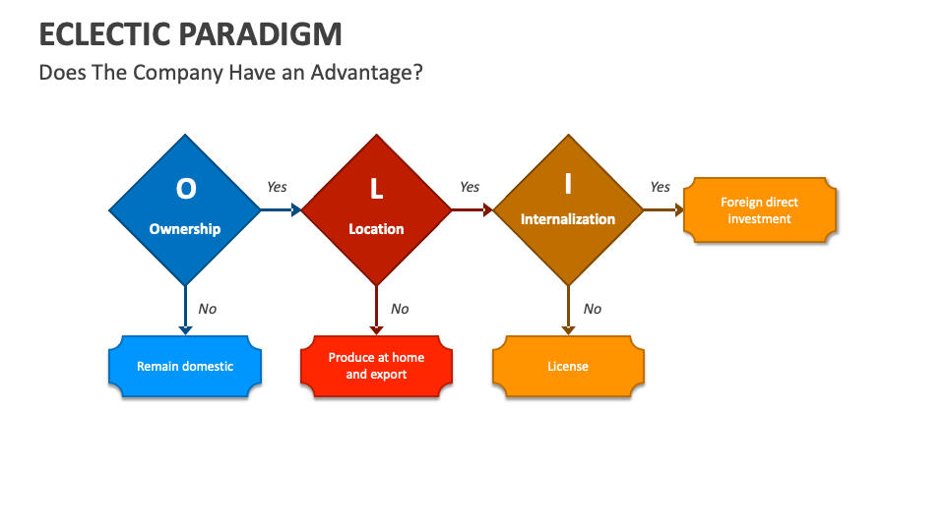
Figure 6: OLI Framework
(Source: Collidu, 2023)

3.1 Ownership Advantages (O)
The ownership advantages of FedEx in India can be derived from its unique proprietary assets in competitive edge over the local rivals (Sridharan, 2021). These primary intangible assets foster its global brand, advanced technology and operation process.
Strong Brand Equity and Reputation - FedEx fosters its strong brand reputation and equity with synonymous speed. In the Indian market its strong brand reputation and image enhances trust for this company (Aithor, 2024). It also helps offset the "liability of foreignness".
Advanced Information Technology (IT) Systems - Another core advantage of FedEx can be highlighted the continuous investment in IT sectors which includes its proprietary shipment tracking system, AI-driven route optimisation and data analytics as well (Harumi, 2024).
Globally Integrated Network and Infrastructure - FedEx also operates an integrated global air and ground network by using a "hub-and-spoke" system. This helps the company to own an aircraft fleet rather than relying on a third party carrier to maintain control over transportation operations (Dunning et al., 2003). This offers time definite International delivery services which the local companies struggle to match.
Operation And Excellence and Managerial Expertise - this company builds a decades of specialised operational research (OR) in terms of managing complex logistics on a massive and international scale. In this field, this company highlights its expertise in the areas such as custom clearance, supply chain management and risk management (Scribd, 2025). It helps to guide the limitations of cross border trade in India significantly.

3.2 Location Advantages (L)
FedEx's location advantages in India fosters a combination of the country's strategic position in global trade with specific infrastructure development and partnerships which enhances the operational efficiency (CFI, 2022).
Strategic Geographic Position - India's location can be a vital hub in Southeast Asia and Asia with the Middle-East and other global markets. This position offers FedEx to grow faster international trade routes (ANI Press Release, 2025).
Extensive Domestic Reach through Partnership - The partnership with Indian logistics provider, Delhivery can highlight the strategic alliance and investment which helps to foster FedEx with unparalleled access (Construction Week India, 2021). This company covers more than eighteen thousand and seven hundred pincodes.
Growing Market Demand - The blooming economic growth, large population and E-commerce market of India offers a high demand for the efficient domestic and international logistic services (Chowdhury, 2024). It emphasizes local demand for this company’s long term growth.
Development of Advanced Logistics Infrastructure - this company invests in building advanced facilities involving the new automatic hub in Bangalore by fostering the merchandise conveyors with the bonded custom capabilities (Thomas, 2021). This location specific investment of this company helps to improve the speed efficiency and supply chain management in the high value industries such as health-care sectors, automotive and electronic sectors.

3.3 Internalisation Advantages (I)
The internalisation advantages of FedEx in India highlights its robust global network, enhanced operational capabilities and specialised services for E-Commerce and SMEs. This helps Indian businesses access the international markets significantly (FedEx Newsroom, 2024).
Extensive Global Connectivity - This company accesses more than two hundreds and twenty countries and territories with its global air and ground network. Some of the key trade centres of this company may involve the USA, Europe and AMEA region with its improved and faster transit times (Manufacturing Today India, 2024).
Faster Transit Times - FedEx International priority fosters a shipment from India which can reach the major market in the USA within two to three business days and Europe within two business days with a significant improvement in the speed of this company (FedEx Newsroom, 2023b).
Integrated End-to-End Solutions - FedEx offers comprehensive logistic solutions in India by integrating the domestic operations which includes International and domestic air express services, ground services, warehousing and supply chain management (FedEx Newsroom, 2014).
Support for SMEs and E-commerce - FedEx supports various Indian small and medium enterprises and e-commerce platforms by providing advanced solutions. This includes the cost effective FedEx International Connect Plus (FICP) service for The e-commerce platforms and digital tools such as FedEx Ship Manager (FSM) (FedEx Newsroom, 2023a). This company also collaborates with the E-Commerce platforms like Shopify and Woocommerce.

3.4 Resulting Entry Mode Decision
FedEx’s primary entry and expansion mode in India highlight a combination of various strategies. This may include direct investment in infrastructure and a strategic partnership or alliance with the Indian logistics company. In terms of strategic alliance and minority stake acquisition, FedEx Express introduced a strategic partnership with Delhivery which is a leading logistics and supply chain services company in India (FedEx Newsroom, 2021). Delhivery was allowed to operate the assets of FedEx India and TNT India Private Limited as well. The goal of this strategic partnership fosters Delhivery's extensive domestic network and technology-driven platform with FedEx's global network in terms of international shipping (Fedex, 2020). This helps to enhance e-commerce growth for Indian businesses.
In terms of direct investment and infrastructure expansion, FedEx invested in its own infrastructure within India to function effectively. It constitutes a form of Foreign Direct Investment (FDI) and direct operations. This company expands its gateways in the key cities like Delhi, Bangalore, Mumbai and others. This company also launched a state-of-the-art 60,000 sq. ft. integrated air hub at the Kempegowda International Airport in Bengaluru (FedEx Newsroom, 2025).
FedEx also adopts franchising or authorised service partners in India for its limited operations. This may include local pickups and delivery by enabling a wider reach without any full direct ownership of every local center (Cargo, 2022). On the other hand this company also collaborates with the government initiatives in India by supporting the government's “One District One Product" (ODOP) initiative by focusing on the" Make in India” vision (Chowdhury, 2024).

4. Cultural Distance & Its Implications

4.1 Cultural Profile Comparison
Hofstede's Cultural Dimensions is considered as a framework which helps to analyse the cultural differences that affect the values and behaviours related to different cultures. This framework involves six dimensions and these are Power Distance, Individualism v/s Collectivism, Masculinity v/s Femininity, Uncertainty Avoidance, Long-Term v/s Short-Term Orientation and lastly Indulgence v/s Restraint (Piotrowska and Piotrowski, 2023).
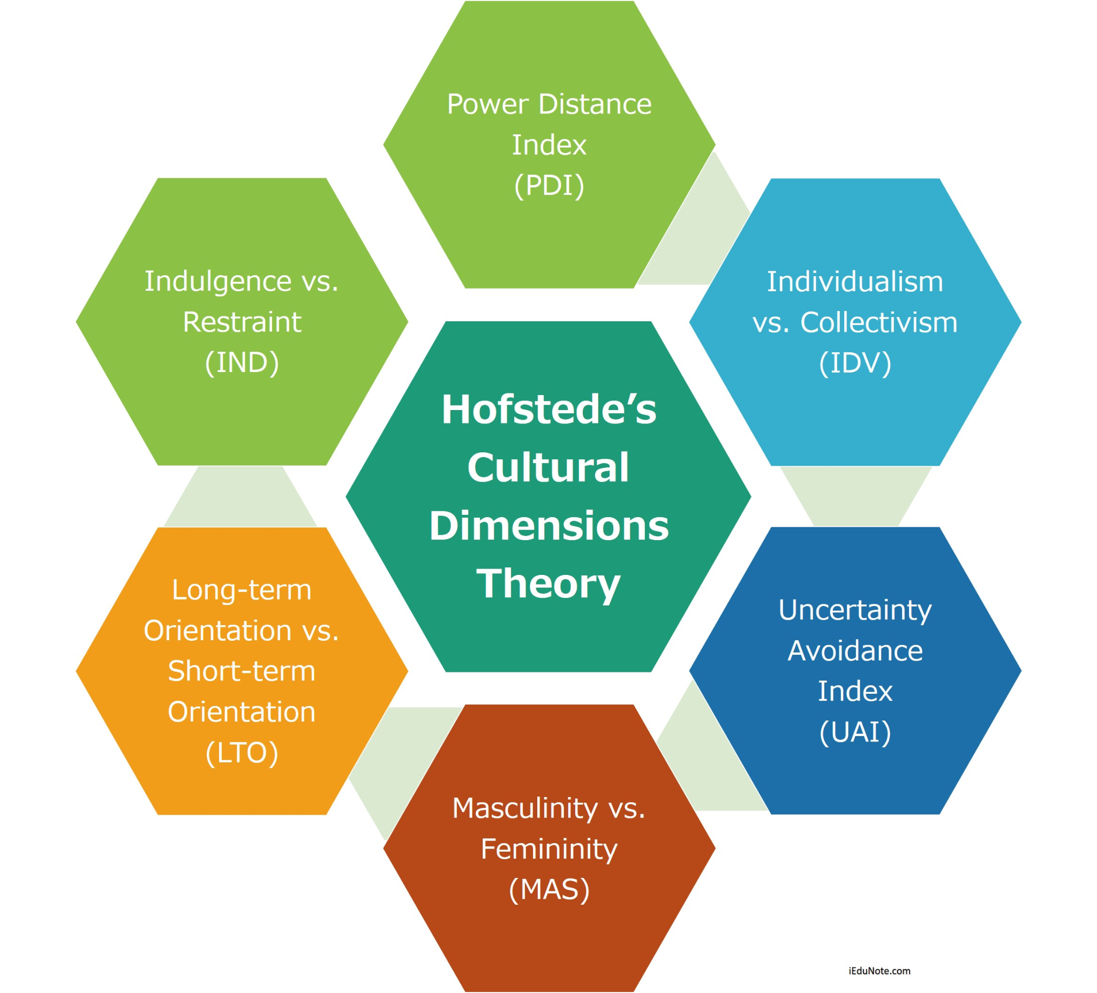
Figure 7: Hofstede’s Cultural Dimensions
(Source: Muntasir, 2019)
Dimensions | USA | India
Power Distance | The USA's power distance score is 40. It means the USA focuses on equal rights in different aspects of society and government. | India’s power distance score is 77. It indicates that India believes in acceptance of people with inequality.
Individualism v/s Collectivism | The USA’s score in individualization is 60. It presents an individualistic culture in the USA. The country promotes the independent degree in society with “I’ or " We”. | India fosters collectivist society with a score of 24 in individualism. It means the group is prioritized too much over the individuals in India.
Motivation Towards Achievement and Success | The USA also promotes high motivation towards achievement and success with a score of 62. | India scores 56 in this domain which indicates low scores in this domain highlights the decisive society which shows visual display about the success and power.
Uncertainty Avoidance | The USA also presents a low score of 46. It believes that their behaviour plays pivotal rather than its culture. The society of the USA promotes new ideas and innovation. | India scored 40 which indicates low. India is considered as India accepts the imperfections and believes that “nothing has to be perfect.”
Long-Term v/s Short-Term Orientation | The USA scores 50 in the dimension of long-term orientation. This country measures its performance on a short-term basis where the USA also promotes a society with very practical mindsets. | India scored 51 in this dimension of long-term orientation. This country measures its performance on a short-term basis. India also has a great tolerance for its religious views.
Indulgence v/s Restraint | The USA scores 68 in the dimension of Indulgence. The society of the USA represents lack of control in the impulses and desires as the UK. | A score of 26 in the dimension of the Indulgence which indicates corruption. religious culture with various languages. The society of India does not promote leisure time and controls its needs and impulses.
Table 1: Comparison between USA v/s India
(Source: The Culture Factor, 2025)
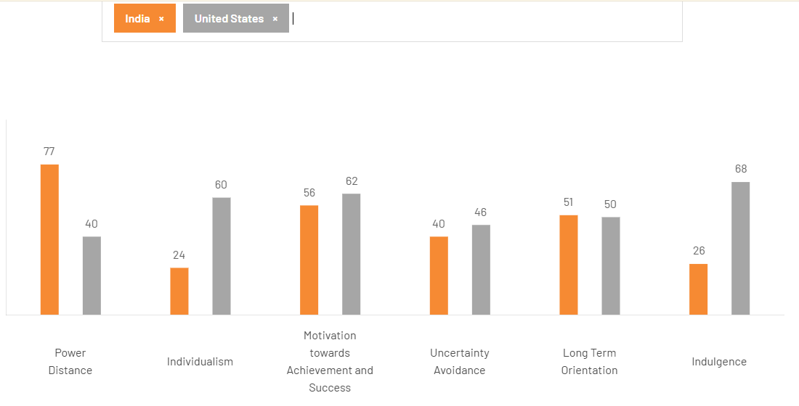
Figure 8: USA v/s India
(Source : The Culture Factor, 2025)
According to The Culture Factor (2025), India’s power distance score is 77 which is high. It indicates that India believes in the acceptance of people with inequality. This comparison emphasises that India fosters collectivist society with a score of 24 in individualism which is low but high in collectivism. It means the group is prioritized too much over the individuals in India. This country scores 56 in motivation towards achievement and success which indicates low scores in this domain highlights the decisive society which shows visual display about the success and power. According to this comparison between the USA and India, India scored 40 which indicates low in uncertainty avoidance. India is considered as India accepts the imperfections and believes that “nothing has to be perfect”. India also scored low with 51 in the dimension of long-term orientation. This country measures its performance on a short-term basis. India also has a great tolerance for its religious views (The Culture Factor, 2025). A score of 26 in the dimension of the Indulgence which indicates corruption, religious culture with various languages which highlights a low score. The society of India does not promote leisure time and controls its needs and impulses.

4.2 Impact on Entry Strategy
The entry strategy of FedEx in India can be highlighted by focusing on the growing GDP of India, various talent pools, digitization of strategic alliances such as Delhivery (Maritime Gateway, 2021). It also focuses on the infrastructure by enhancing and investing in digital tools. This helps this company to gain the cross border E-Commerce platforms by serving the growing businesses and building local take capabilities. FedEx also adopts the Global brand strength with its localized marketing for reliability with the speed in a dynamic market of India. According to FedEx Newsroom (2024), it also contributed 0.1% to the net economic output in the transportation, storage and communication sectors of India directly. This company indirectly contributed approximately USD 280 million in FY 2024. This company also focuses on partnership with Delhivery and builds local capabilities by investing at Bombay IIT for supply chain Innovation (Edunuri, 2024). In terms of Technology and digital integration FedEx introduces platform slide FedEx Import Tool (FiT) and innovation hubs such as Hyderabad's Advanced Capability Community (ACC) by focusing on digital innovation. FedEx’s overall strategy highlights its pure service provision by fostering a deep integration in the digital and economic ecosystem of India which focuses on local innovation, talent and synergies (Chowdhury, 2024). This helps this company to become a key enabler of India's global trade ambitions.

4.3 Impact on Success Potential
The blooming eCommerce market of India offers strong and growing strategic investments of FedEx with technology development of the company by playing a role as a global innovation hub (NewsVoir, 2024). This company fosters strategic partnership with Delhivery with $100 million investment (FedEx, 2020). The FedEx Innovation Lab (FIL) of India also collaborates with various local startups such as Mad Street Den and various top institutions such as IIT Bombay and IIT Madras (Vaitheeswaran B, 2024). On the other hand FedEx emphasizes on the needs of small and medium enterprises and e-tailers by introducing its digital tool called FedEx Import Tool (FIT).
FedEx also faces some challenges such as intense competition, operational complexity and economic headwinds. It operates in a highly competitive environment where there are established rivals (Senniappan, 2023). Despite of various operational complexity, it navigates custom regulations and managers the peak season demands.

5. Recommendations and Strategic Adjustments for FedEx in India

5.1 Strengthen Local Partnerships
In India, FedEx can strengthen its local partnership by collaborating with local logistics companies, such as Delhivery and Invest India. By fostering a strategic collaboration with such companies, FedEx can leverage its image in the global market by increasing its revenue streams in India. Its partnership with Delhivery can significantly improve the global network of the company by improving “Last-Mile Connectivity” with the help of the extensive pan-India network of Delhivery (Sidharth, 2024). FedEx can also collaborate with the corner stores of the countries gain an insight into the local businesses in the country. Collaborating with the local corner stores can improve the accessibility of the services provided by the company, as well as create brand visibility.
FedEx can also successfully collaborate with the government initiative of India. Programs such as the “One District, One Product” program, “Make in India” program, and the “Vocal for Local” Movement are some of the most successful programs and movements for leveraging the local businesses of the country (Fedex.com, 2025). All these can help the company to expand the scope of the current collaboration with Invest India to provide more comprehensive support, including specialised packaging solutions, inventory management training, and access to the SME Connect platform for over 750 districts.
Another significant factor that can strengthen its partnership and collaboration with the company is investing in localised infrastructure and innovation in India. The company needs to increase its investment in the FedEx Innovation Lab (FIL) in India to focus on developing and implementing AI-related technologies to opt for a stronger supply chain management in the country. It can also differentiate services based on regional demands. For instance, developing robust cold chain logistics solutions could cater to specific industries like pharmaceuticals or perishable goods in relevant industrial clusters (Agarwal, 2025). Other improvements can include tailored training for employees, digital tool adoption, region-specific offerings, CSR initiatives, and localised sports sponsorship. This can help it to expand its operations locally while also engaging in community-level training and integration.

5.2 Sustainability and Cost Management
One of the most important factors that the company needs to consider for its operations in India is its awareness of sustainability and cost management. In various sectors of India, sustainability has become amajor factor for gaming operational efficiency in its management. The most important factor the company needs to look for is its fleet electrification to reduce emissions and fuel costs. If the company can deploy the use of Electric Vehicles or EVs for its deliveries, it can create an enhanced sustainable facility design for both green impact and long-term cost-savings, while also aligning with its vision of carbon-neutrality by 2040 (FedEx, 2025). The company needs to increase EV adoption for owned fleets in India to beat the global target of 50% new purchase of EVs by 2025, and 100% by 2030. This can help to lower the costs of fuel, maintenance, and government subsidies in India.
It can also opt for sustainable facilities and energies for reducing its operational costs and increasing efficiency. For example, the application of solar panels on all suitable gateways, along with advanced VRF cooling, can facilitate a significant energy-efficient system. FedEx needs to replicate the Delhi Hub Model with advanced HVAC in all facilities to decrease energy costs for its operations. It can also implement sensors for automated lighting and climate control to minimise waste (3blmedia.com, 2025). Waste reduction and circularity are significant for the company since promoting recyclable packaging for SMEs can integrate a seamless and paperless management system for its shipments. Through encouragement, it can allow the customers to consolidate shipments through better online tools to reduce overall trips.
As mentioned in the previous recommendation, partnering or collaborating with local companies can provide several scopes for improvement for the company; similarly, partnership and collaboration can also allow the company to opt for sustainability and cost management in India. FedEx also needs to bring a cultural shift in its management by looking after its employees. Employee engagement is a crucial factor in any company and sector; therefore, if the company can opt for eco-friendly operations, it can reduce resource wastage and foster a culture of efficiency in the company (FedEx, 2024). India is a diverse Country with a variety of cultures, religions, and beliefs; thus, FedEx needs to have prior knowledge about the factors to bring out efficiency and foster a sustainable culture. With “Green Delivery”, it can integrate a positive influence on both the planet and profit, while also educating the employees.

5.3 Digital Innovation for Efficiency
Digital innovation is a primary driving factor for FedEx in India, as it needs to focus on expanding the use of various technologies, such as AI, ML, and predictive logistics, to nurture a new and prominent platform for deep integration. AI has become a crucial integration for achieving technological advancements in a sector or a company, as various technologies can be used with AI to foster an end-to-end connection among SMEs and implement robust cybersecurity (Mitra, 2024). Advanced AI and predictive analytics can use a more advanced sensor and AI-driven insights for real-time tracking, disruption alerts, and an enhanced cold chain for its Indian consumers. The company can also implement AI technologies to optimise routes dynamically, especially in the most congested and over-crowded cities in India.
FedEx needs to focus on providing more tailored and end-to-end e-commerce solutions to fully leverage its “fdx" platform. This leverage helps the company with connecting to the supply chain, foster growth, and create seamless logistics for delivery aggregators. Developing deeper API integrations with local Indian e-commerce platforms, marketplaces, and delivery aggregators can bring out more seamless logistics (Iru.org, 2025). For future operations in the country, the company needs to focus on adopting autonomous technologies, such as continuous testing and researching autonomous vehicles for long-term journeys for delivery, both fast and long deliveries.
Cybersecurity is another factor that every company in the logistics sector needs to focus on due to the growing demand for international shipping. Therefore, as previously mentioned, green logistics can be useful for adapting EV usage and minimising carbon footprints for attaining sustainable strategies in India (Bora, 2025). The other factors that can be recommended for digital innovation in the country are real-time digital twin, SME-centric tools, personalised solutions, and strengthening the local ecosystem. integration, and leveraging IoT awareness. By focusing on these areas, FedEx can solidify its leadership in India's dynamic logistics market, delivering superior efficiency, customer experience, and security through digital innovation, particularly for the vital SME segment. Finally, it can be said that FedEx should focus on expanding AI-driven FedEx Surround for predictive analytics, leveraging its Digital Twin network for real-time simulations to prevent delays, enhancing the new fdx platform for SME e-commerce integration, integrating SenseAware ID for granular tracking, and prioritising secure, sustainable tech to build on its core efficiency, especially for India's booming SMEs.

6. Conclusion
To conclude, it can be said that this study has successfully analysed the international business operations of FedEx, while comparing its management in its home country and in India. The company has a vast portfolio of services that include air and ground delivery, freight, supply chain, and business services. The core business aspect ofthis company is to deliver packages and freight globally, with the help of overnight express, in both ground and air. FedEx is considered one of the most influential multinational companies, due to its robust management and operational excellence in various countries. FedEx's multinational status comes from its expansive physical network, diverse service portfolio, massive global workforce, and strategic focus on facilitating international commerce and e-commerce.
The global value chain of the company primarily focuses on its integrated network, that is comprised of transport, e-commerce, and business services. With its vast infrastructure, it integrates an air-ground network for express delivery, leveraging hubs, planes, and trucks globally. The most important factor is that this company does not follow any traditional entry mode, and thus, uses its global logistics network to help other businesses collaborate with it. It also opt sfor significantly high operational efficiency, by owning and integrating its air and ground networks. However, it also faces challenges, such as regulatory laws, geopolitical affairs, and other kinds of disruption.
The OLI factor focuses on the three factors and provides a deeper understanding of its operations and positioning in the world. Its ownership advantage focuses on a strong brand equity and reputation, an advanced IT system, a globally integrated network, and operational and managerial excellence. Its location advantage focuses on strategic geographic position, extensive domestic reach, growing market demand, and development of advanced logistics. Its internationalisation focuses on global connectivity, faster transit time, integrated solutions, and e-commerce support. Hofstede’s cultural factor provides a robust comparison of the company in the USA and India. The recommendations provide a deeper understanding of its factors for strengthening its local partnerships, managing sustainability and cost, and opting for digital innovation and efficiency.

7. References
3blmedia.com. (2025). Driving Sustainability: FedEx’s Commitment to Carbon. [online] Available at: https://www.3blmedia.com/news/driving-sustainability-fedexs-commitment-carbon-neutral-operations-and-greener-global-supply [Accessed 11 Dec. 2025].
Agarwal, M. (2025). Quick Commerce Is Forcing Logistics Providers To Rethink Their Networks: FedEX Exec. [online] Inc42 Media. Available at: https://inc42.com/features/quick-commerce-is-forcing-logistics-providers-to-rethink-their-networks-says-fedex-vp-meisa-nitin-navneet-tatiwala/ [Accessed 11 Dec. 2025].
Ahmed, S.E.S. (2020). Critical Reflections on the Strategic Management of FedEx Corporation. [online] ResearchGate. Available at: https://www.researchgate.net/publication/343679017_Critical_Reflections_on_the_Strategic_Management_of_FedEx_Corporation [Accessed 11 Dec. 2025].
Aithor (2024). An Analysis of FedEx Global Strategy Essay. [online] aithor.com. Available at: https://aithor.com/essay-examples/an-analysis-of-fedex-global-strategy-essay [Accessed 11 Dec. 2025].
ANI Press Release (2025). FedEx Powers India’s Small and Medium Enterprises to Think Big, Ship Smart. [online] @bsindia. Available at: https://www.business-standard.com/content/press-releases-ani/fedex-powers-india-s-small-and-medium-enterprises-to-think-big-ship-smart-125051701004_1.html [Accessed 11 Dec. 2025].
Bora, G. (2025). SMEs central to FedEx’s innovation story in India, says Vishal Talwar of FedEx. [online] The Economic Times. Available at: https://m.economictimes.com/small-biz/sme-sector/smes-central-to-fedexs-innovation-story-in-india-says-vishal-talwar-of-fedex/articleshow/124985352.cms [Accessed 11 Dec. 2025].
Cargo, D. (2022). Apace Digital Cargo. [online] Apacedigitalcargo.com. Available at: https://apacedigitalcargo.com/fedex-invest-india-in-pact-to-elevate-indian-craftsmanship-from-local-to-global/ [Accessed 11 Dec. 2025].
CFI (2022). Eclectic Paradigm. [online] Corporate Finance Institute. Available at: https://corporatefinanceinstitute.com/resources/management/eclectic-paradigm/ [Accessed 11 Dec. 2025].
Chowdhury, A. (2024). ‘India key market, will deliver the goods for FedEx’: Global CEO Raj Subramaniam. [online] The Economic Times. Available at: https://economictimes.indiatimes.com/industry/transportation/shipping-/-transport/india-key-mkt-will-deliver-the-goods-for-fedex/articleshow/108147736.cms?from=mdr [Accessed 11 Dec. 2025].
Collidu (2023). Eclectic Paradigm. [online] Collidu.com. Available at: https://www.collidu.com/presentation-eclectic-paradigm [Accessed 11 Dec. 2025].
Construction Week India (2021). FedEx, Delhivery enter into alliance - Construction Week India. [online] Construction Week India. Available at: https://www.constructionweekonline.in/business/18698-fedex-delhivery-enter-into-alliance [Accessed 11 Dec. 2025].
Cruz, C. and Floriani, D.E. (2020). (PDF) The OLI Paradigm as a comprehensive model of FDI determinants: a sub-national approach Dinor a Eliete Floriani. [online] ResearchGate. Available at: https://www.researchgate.net/publication/344373722_The_OLI_Paradigm_as_a_comprehensive_model_of_FDI_determinants_a_sub-national_approach_Dinor_a_Eliete_Floriani [Accessed 11 Dec. 2025].
Dunning, H., Guisinger, S., Cantwell, J., Ozawa, T., Benito, G., Oxelheim, L., Narula, R., Devinney, T. and Madhok-Examine, A. (2003). International Business and the Eclectic Paradigm. [online] Available at: http://ndl.ethernet.edu.et/bitstream/123456789/35706/1/107.John%20Cantwell.pdf [Accessed 11 Dec. 2025].
Edunuri, P. (2024). Case Study - Marketing Strategy Of FedEx 2024 | Best Digital Marketing Training Institutes In Bangalore. Digital Marketing Training In Bangalore. [online] Digital Marketing Training Institute in Bangalore with Live Projects & Placement Assistance. Available at: https://www.webmarketingacademy.in/digital-marketing-blogs/case-study-marketing-strategy-of-fedex-2024/ [Accessed 11 Dec. 2025].
FedEx. (2025). FedEx International Economy | FedEx India. [online] Available at: https://www.fedex.com/en-in/shipping/services/international-economy.html [Accessed 11 Dec. 2025].
FedEx. (2025). International Trade Solutions. [online] Available at: https://www.fedex.com/en-us/logistics/trade-solutions.html [Accessed 11 Dec. 2025].
FedEx. (2025). Small Business International Shipping Challenges. [online] Available at: https://www.fedex.com/en-us/small-business/peer-insights/international-shipping-challenges.html [Accessed 11 Dec. 2025].
FedEx. (2025). Sustainability and Carbon Neutrality. [online] Available at: https://www.fedex.com/en-in/about/sustainability.html [Accessed 11 Dec. 2025].
FedEx. (2025). Sustainable Supply Chains | FedEx India. [online] Available at: https://www.fedex.com/en-in/small-business/adapt-innovate/sustainable-supply-chain.html [Accessed 11 Dec. 2025].
Fedex.com. (2025). Tapping into the cross-border e-commerce in India. [online] Available at: https://www.fedex.com/content/dam/fedex/meisa-middle-east/downloads/fedex-ecommerce-ebook-en-in.pdf [Accessed 11 Dec. 2025].
Fedex (2020). FedEx Express and Delhivery Announce Completion of Transaction Unlocking Cross-Border Potential in India. [online] Fedex.com. Available at: https://investors.fedex.com/news-and-events/investor-news/investor-news-details/2021/FedEx-Express-and-Delhivery-Announce-Completion-of-Transaction-Unlocking-Cross-Border-Potential-in-India/default.aspx [Accessed 11 Dec. 2025].
FedEx (2020). FedEx Express and Delhivery Announce Completion of Transaction Unlocking Cross-Border Potential in India. [online] Fedex.com. Available at: https://investors.fedex.com/news-and-events/investor-news/investor-news-details/2021/FedEx-Express-and-Delhivery-Announce-Completion-of-Transaction-Unlocking-Cross-Border-Potential-in-India/default.aspx [Accessed 11 Dec. 2025].
FedEx (2023). FedEx - FedEx - Mission & Goals. [online] investors.fedex.com. Available at: https://investors.fedex.com/company-overview/mission-and-goals/default.aspx [Accessed 11 Dec. 2025].
FedEx (2023). Overview of company | FedEx. [online] investors.fedex.com. Available at: https://investors.fedex.com/company-overview/overview-of-company/default.aspx [Accessed 11 Dec. 2025].
FedEx (2024). FedEx | ESG Report 2024. [online] Fedex.com. Available at: https://www.fedex.com/content/dam/fedex/us-united-states/sustainability/gcrs/FedEx_2024_ESG_Report.pdf [Accessed 11 Dec. 2025].
FedEx Newsroom (2014). FedEx strengthens its domestic ground and supply chain services in India following successful integration. [online] FedEx Newsroom. Available at: https://newsroom.fedex.com/newsroom/middle-east-indian-subcontinent-and-africa/fedex-strengthens-its-domestic-ground-and-supply-chain-services-in-india-following-successful-integration [Accessed 11 Dec. 2025].
FedEx Newsroom (2021). FedEx Express and Delhivery Come Together to Unlock Cross-Border Potential in India. [online] FedEx Newsroom. Available at: https://newsroom.fedex.com/newsroom/united-states/fedex-express-and-delhivery-come-together-to-unlock-cross-border-potential-in-india.
FedEx Newsroom (2023a). FedEx Enhances International Priority® Service in India. [online] FedEx Newsroom. Available at: https://newsroom.fedex.com/newsroom/amea/fedex-enhances-international-priority-service-in-india [Accessed 11 Dec. 2025].
FedEx Newsroom (2023b). FedEx Enhances Shipping Experience for E-tailers in India. [online] FedEx Newsroom. Available at: https://newsroom.fedex.com/newsroom/amea/fedex-enhances-shipping-experience-for-e-tailers-in-india [Accessed 11 Dec. 2025].
FedEx Newsroom (2024). FedEx and Invest India Collaborates to Elevate Indian Craftsmanship from Local to Global. [online] FedEx Newsroom. Available at: https://newsroom.fedex.com/newsroom/amea/fedex-and-invest-india-collaborates-to-elevate-indian-craftsmanship-from-local-to-global [Accessed 11 Dec. 2025].
FedEx Newsroom (2024). FedEx Economic Impact Report Showcases ‘FedEx Effect’ on Driving India’s Growth and Commitment to Sustainabil. [online] FedEx Newsroom. Available at: https://newsroom.fedex.com/fedex-economic-impact-report-showcases-fedex-effect-on-driving-indias-growth-and-commitment-to-sustainability [Accessed 11 Dec. 2025].
FedEx Newsroom (2025). FedEx Strengthens India’s Export Corridors with New Integrated Hub in Bengaluru. [online] FedEx Newsroom. Available at: https://newsroom.fedex.com/newsroom/meisa-english/fedex-strengthens-indias-export-corridors-with-new-integrated-hub-in-bengaluru [Accessed 11 Dec. 2025].
Forbes (2025). FedEx | FDX Stock Price, Company Overview & News. [online] Forbes. Available at: https://www.forbes.com/companies/fedex/ [Accessed 11 Dec. 2025].
Frerichs, P. (2024). FedEx Restructuring - Technological and Personnel Challenges Prove Sticky. [online] Global Trade Magazine. Available at: https://www.globaltrademag.com/fedex-restructuring-technological-and-personnel-challenges-prove-sticky/ [Accessed 11 Dec. 2025].
Gaikwad, R. (2025). Business Model of FedEx: Complete Strategy Breakdown 2025. [online] Miracuves Solutions. Available at: https://miracuves.com/blog/business-model-of-fedex/ [Accessed 11 Dec. 2025].
Harumi (2024). [online] Harumi.io. Available at: https://harumi.io/blog/fedex [Accessed 11 Dec. 2025].
Iru.org. (2025). FedEx: In the midst of a digital revolution. [online] Available at: https://www.iru.org/news-resources/newsroom/fedex-midst-digital-revolution [Accessed 11 Dec. 2025].
Manufacturing Today India (2024). FedEx expands operations to boost India’s global trade and connectivity - Manufacturing Today India. [online] Manufacturing Today India. Available at: https://www.manufacturingtodayindia.com/fedex-expands-operations-to-boost-indias-global-trade-and-connectivity.
Maritime Gateway (2021). FedEx Express and Delhivery unlock cross-border potential in India. [online] Maritime Gateway - South Asia’s Premier Shipping and Logistics News Portal | Maritime Gateway covers, analyses, comments on wide-ranging news on Ports, Shipping, Logistics that drive South Asian Maritime Industry. Available at: https://www.maritimegateway.com/fedex-express-and-delhivery-unlock-cross-border-potential-in-india/ [Accessed 11 Dec. 2025].
Mitra, T. (2024). FedEx leverages advanced technology to make smarter and more sustainable supply chains - ET Edge Insights. [online] ET Edge Insights - The New Paradigm of Business Intelligence. Available at: https://etedge-insights.com/industry/logistics/fedex-leverages-advanced-technology-to-make-smarter-and-more-sustainable-supply-chains/ [Accessed 11 Dec. 2025].
Muntasir (2019). Hofstede’s Cultural Dimensions Theory - iEduNote.com. [online] iEduNote.com. Available at: https://www.iedunote.com/hofstedes-cultural-dimensions-theory/ [Accessed 11 Dec. 2025].
NewsVoir (2024). NewsVoir. [online] Newsvoir.com. Available at: https://www.newsvoir.com/release/fedex-economic-impact-report-showcases-fedex-effect-on-driving-india-s-growth-and-commitment-to-sustainability-30210.html [Accessed 11 Dec. 2025].
Piotrowska, M. and Piotrowski, J. (2023). Hofstede’s Cultural Dimensions Theory. [online] ResearchGate. Available at: https://www.researchgate.net/publication/371822907_Hofstede [Accessed 11 Dec. 2025].
PNG Mart. (2024). Fedex Logo, Typography, Delivery, Recognition, Branding PNG. [online] Available at: https://www.pngmart.com/image/231883 [Accessed 11 Dec. 2025].
sarahrudge (2025). Supply Chain World. [online] Supply Chain World magazine. Available at: https://scw-mag.com/news/fedexs-bold-strategy-and-investments-to-lead-in-global-markets/ [Accessed 11 Dec. 2025].
Scribd (2025). Supply Chain Management at Fedex India. [online] Scribd. Available at: https://www.scribd.com/document/2165098/Supply-Chain-Management-at-Fedex-India [Accessed 11 Dec. 2025].
Senniappan, N. (2023). FedEx Corporation Success Story: Delivering Excellence. [online] StartupTalky. Available at: https://startuptalky.com/fedex-success-story/ [Accessed 11 Dec. 2025].
Sidharth, R. (2024). FedEx Partners with Invest India to Elevate India’s One District One Product Initiative, Boosting Market Reach for Local Artisans. [online] Logistics Insider. Available at: https://www.logisticsinsider.in/fedex-partners-with-invest-india-to-elevate-indias-one-district-one-product-initiative-boosting-market-reach-for-local-artisans/ [Accessed 11 Dec. 2025].
SNTIC.org (2025). FedEx Express Overview. [online] Available at: http://www.sntic.org/meeting/02/mccarran/chamberlain/SNTIC%20Federal%20Express%20Presentation.pdf [Accessed 11 Dec. 2025].
Sridharan, M.A. (2021). OLI | Think Insights. [online] Think Insights. Available at: https://thinkinsights.net/strategy/oli [Accessed 11 Dec. 2025].
The Culture Factor (2025). Country Comparison Tool. [online] Theculturefactor.com. Available at: https://www.theculturefactor.com/country-comparison-tool?countries=india%2Cunited+states [Accessed 11 Dec. 2025].
Thomas, R. (2021). FedEx Invests $100m in Indian Logistics Startup Delhivery. [online] Supplychaindigital.com. Available at: https://supplychaindigital.com/logistics/fedex-invests-dollar100m-indian-logistics-startup-delhivery [Accessed 11 Dec. 2025].
Vaitheeswaran B (2024). Fedex committed to make significant investments in India: COO. [online] The Times of India. Available at: https://timesofindia.indiatimes.com/business/india-business/fedex-committed-to-make-significant-investments-in-india-coo/articleshow/116477472.cms [Accessed 11 Dec. 2025].
Wortham, J. (2025). FedEx: Entry Strategy-Navigating Global Markets with Precision (Chapter 8). [online] Jeremy Wortham - Strategic Management. Available at: https://jwortham25.wordpress.com/2025/03/16/fedex-entry-strategy-navigating-global-markets-with-precision-chapter-8/ [Accessed 11 Dec. 2025].

