University of Wales Trinity Saint David

Wales institute of Science and Arts



Structural Design and Fluid Analysis
Application of Computer Aided Engineering Processes
ACHA6010
Kieran Dellow
2102899
17/12/2023

Contents
1.0 – Introduction 3
2.0 – Literature review 4
3.0 – Validation 5
3.1 – Bimetallic strip simulation 5
3.1.1 – Comparison with analytical solution 6
3.2 – Independent Mesh Study 7
4.0 – First iteration analysis 8
4.1 – Rigid Dynamics simulation 9
4.2 – Steady-State Thermal simulation 10
4.3 – Static Structural simulation 11
4.3.1 – Total Deformation 12
4.3.2 – Stress 13
5.0 – Second iteration analysis 14
5.1 – Rigid Dynamics simulation 14
5.2 – Steady-State Thermal simulation 14
5.3 – Static Structural simulation 15
5.3.1 – Total Deformation 16
5.3.2 – Stress 16
6.0 – Third iteration analysis 18
6.1 – Rigid Dynamics simulation 18
6.2 – Steady-State Thermal simulation 18
6.3 – Static Structural simulation 19
6.3.1 – Total Deformation 19
6.3.2 – Stress 20
7.0 – Conclusion / Limitations and benefits of Ansys Workbench 21
References 22

– Introduction
This study uses Ansys Workbench to comprehensively assess a piston's response, including motion, displacement, and thermal effects.
A validation study examines a bimetallic strip subjected to loads, rigorously testing the software's precision and reliability in predicting structural deformations under varying conditions.
Three structural analysis stages will be conducted:
- Rigid Dynamics Study: Simulating piston motion within its contextual system, e.g., connected to the crankshaft via a connecting rod and gudgeon pin, this stage provides information on forces experienced during piston translation.
- Steady-State Thermal Study: Analysing thermal behaviour under preset temperatures for specific model faces, results from this simulation, along with the Rigid Dynamics Study, feed into the next stage.
- Static Structural Study: Temperature distribution and force results from the Rigid Dynamics Study are used to calculate (Von-Mises) stresses and piston deformation in this stage.
These results will allow the piston model to be improved, looking at removing unnecessary material from the design, while keeping the structural properties of the original model.

2.0 – Literature review
This analysis of a piston requires an understanding of stress/strain, as well as thermal conductivity and expansion, in order to redesign a model with superior strength, as well as better heat rejection.
The root of the analysis described above is Hooke’s Law, which can be stated as the following:
σ=E⋅ε
Where:
σ is the stress (force per unit area) applied to the material.
E is the modulus of elasticity or Young's modulus, which is a material property representing its stiffness.
ε is the resulting strain, a measure of the material's deformation.
This law states describes the linear relationship between stress and strain in elastic materials. Finite element analysis also takes into consideration inertial forces when calculating dynamic stresses,
Piston design will be an important factor in the performance of the simulation, and the iterations made must be designed with the hopes of reducing levels of deformation, equivalent stress, as well as temperature.
“Recent study has shown that the amount of stress and temperature are affected by the shape of the piston crown” - (Lee and Ku, 2021)
The chosen material was 6061 Aluminium alloy T6, as pistons are commonly made out of this material. This material has very desirable thermal conductivity properties and performs well under heat, as well as stress. This material will be read-in from Ansys Granta, a material database.
Thermal conductivity is a material property that describes its ability to conduct heat. It represents the rate at which heat is transferred through a material in response to a temperature difference. The thermal conductivity (k) is measured in watts per meter-kelvin
W/mK

3.0 – Validation
The first simulation stage involved validating Ansys Workbench results for a simple case, such as a bimetallic strip, through cross-referencing with an analytical solution.
An independent mesh study determined the optimal mesh size for the simulation, using varying sizes to identify a suitable mesh for further analyses.

3.1 – Bimetallic strip simulation
The first validation case undertaken was a bimetallic strip made from invar, as well as copper, under a thermal load of 122°C. This could then be compared to an analytical solution, to prove Ansys’ solving accuracy. This analytical solution result is shown in Figure 3.1 below:
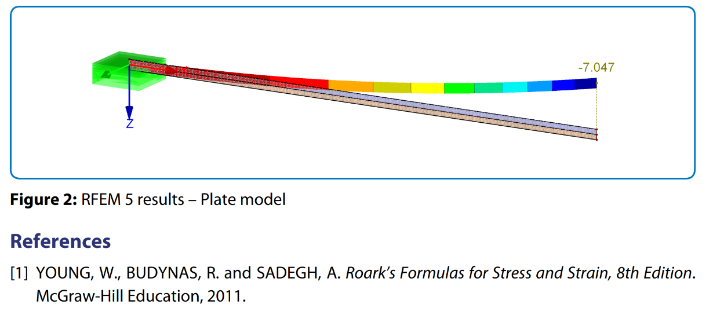
Figure 3.1 - Analytical solution to bimetallic strip under a thermal load of 122°C
One end of the bimetallic strip was fixed, as in the worked example, so that only the free end could deform under load. A deflection value of 7.047mm was calculated in the analytical solution, caused by the two different metals having different thermal expansion values, causing different expansion.
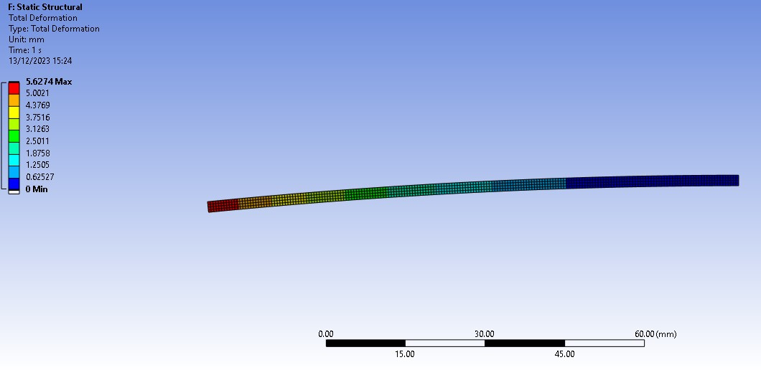
Figure 3.2 – Bimetallic strip Total Deflection (0.5mm mesh sizing) results.
Figure 3.2 shows the total deflection of the bimetallic strip, when a convection load of 122°C is applied to the body, following the analytical solution.
This figure shows a value of 5.6274mm of deflection, which is clearly incorrect when comparing to the analytical solution, an inaccuracy of over 25%. This is most likely due to the mesh size being inappropriate for the model size.
Changing the mesh size could alleviate these inaccuracies, giving a closer result to the analytical solution.
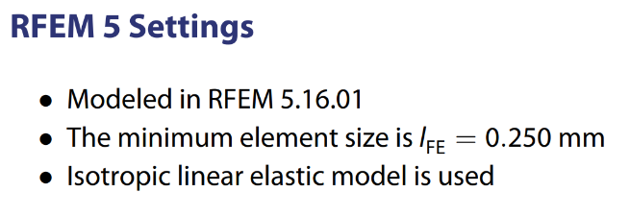
Figure 3.3 – Mesh sizing within analytical solution.
Figure 3.3 states that the mesh size used during the analytical solution was 0.250mm, half that of the ANSYS simulation. This is the most likely cause of the inaccuracy.

3.1.1 – Comparison with analytical solution
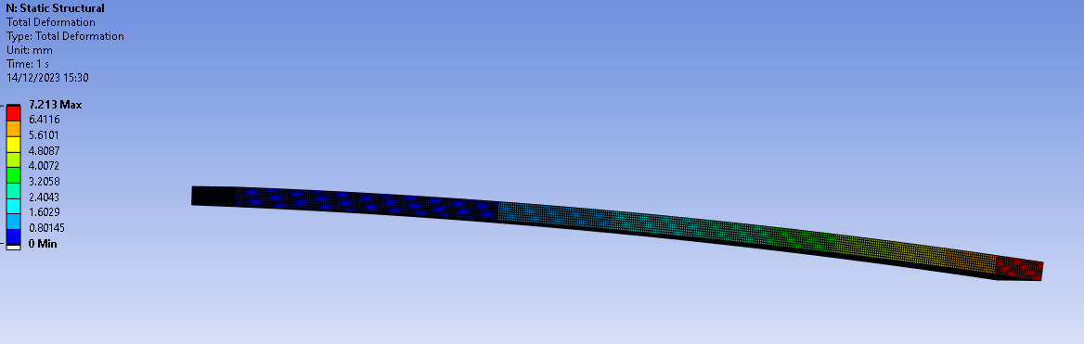
Figure 3.4 – Bimetallic strip Total Deflection (0.25mm mesh sizing) results.
Halving the mesh size within the ANSYS simulation gives a much closer result to that of the analytical solution, proving that both mesh sizing can make a major difference to results, and that ANSYS Workbench can adequately solve these scenarios with accurate results.
Dividing the ANSYS result by the analytical solution result (7.047/7.213) , an accuracy of 2.3% can be observed, which is adequate for further case studies that will be simulated.

3.2 – Independent Mesh Study
An independent mesh study involves systematically varying mesh sizing, to assess their impact on the accuracy and efficiency of a simulation. The goal is to determine the optimal mesh settings that provide reliable results while balancing computational cost, as smaller mesh sizing can become extremely demanding even for more powerful machines.
Using the correct mesh sizing is extremely important as demonstrated in section 3.1, and this can be further investigated by doing an Independent Mesh Study.
This will consist of a standard unchanged case, which will have the mesh sizing gradually changed, and results compared. Change in percentage differences, in the result values for each mesh, can be used to determine where the most suitable mesh sizing is.
The case used was the first iteration of the piston, with a force of 100N applied to the crown faces. These parameters will be kept constant throughout the entirety of the study, so that the only variable that could affect results is mesh sizing.
Results were gathered for mesh sizing of 0.00125mm, 0.0025mm, 0.005mm, 0.0075mm, and 0.00875mm. These results could then be plotted, which gave a “dip” in the data, where results became their lowest value.
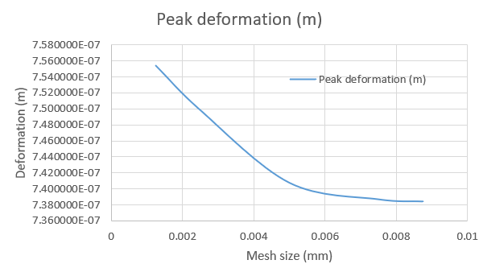
Figure 3.5 – IMS value graph.
The above graph suggests that an appropriate mesh size to move forward with would be between 0.005mm and 0.01mm, as the differences in values for these mesh sizes are negligible.

4.0 – First iteration analysis
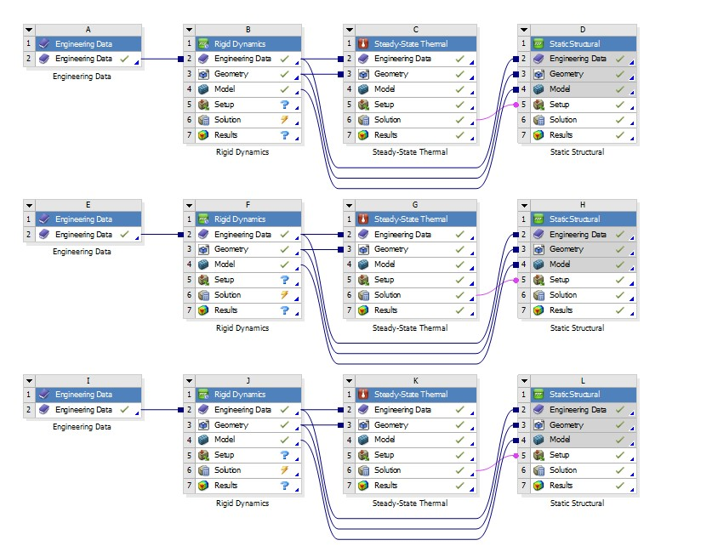
Figure 4.1 – Data flow through rigid dynamics, steady-state thermal, and static structural simulations.
The above figure visualises the sequence in which simulations are undertaken, as each simulation uses sections of the previous simulation.
Rigid dynamics simulation will be used to simulate the motion of the piston within its used environment, e.g. connected to a crankshaft through a gudgeon pin and connecting rod.
Steady-state thermal will emulate the thermal loads that a piston would experience during combustion. These will vary across the piston, with different temperatures and heat transfer coefficients as seen below in figure 4.2.
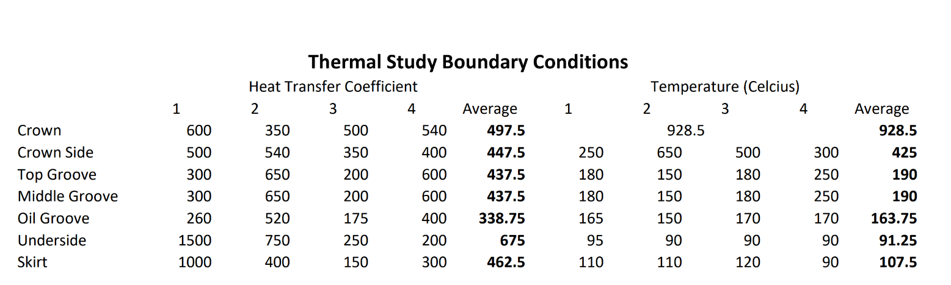
Figure 4.2 – Thermal study boundary conditions for a piston.
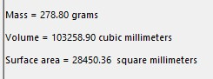
In the static structural simulation, thermal load and motion forces from the rigid dynamics simulation are combined to calculate total piston deformation and stress. This informs the redesign of the piston to reduce weight while maintaining or reducing deformation and stress, leading to an improved design with reduced inertial forces, potentially enhancing engine response time and combustion efficiency.
Figure 4.3 – First piston iteration weight.
The weight of the first piston was recorded at 278 grams, using 6061 aluminium T6 as a material selection in solidworks after the first iteration had been finalised.

4.1 – Rigid Dynamics simulation
Once an assembly of each part mentioned in section 4.0 had been imported as a .STEP file into Ansys, joints between each component had to be established, as show in figure 4.3 below:
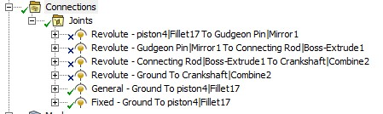
Figure 4.4 – Joints constraining components’ degrees of freedom.
Revolute joints were used to constrain the translation of the components, and the general joint to constrain every degree of freedom apart from a singular translational movement. This allowed the piston to move up and down, as if it were encased in the cylinder walls, while all other components were rotating as expected in an engine.
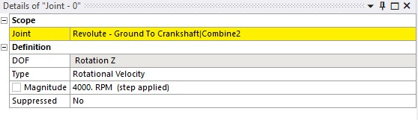
Figure 4.5 – Rotational velocity applied to crankshaft.
A joint load shown in figure 4.5 was applied to the joint fixing the crankshaft, a “Body-ground” joint, at 4000 RPM.
This load would in turn apply loads to the piston, which could be recorded though a joint probe, shown in figure 4.6 below:
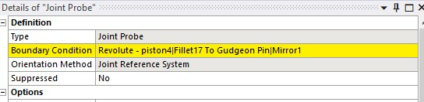
Figure 4.6. – joint probe assigned to the piston/gudgeon pin joint.
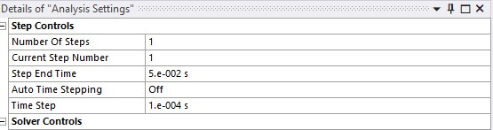
Figure 4.7 – Analysis recording configuration.
Figure 4.7 shows the rate at which data is recorded during the motion of the piston under the rotational load. The total run time was 0.05 seconds, with data being recorded every 0.0001 seconds.
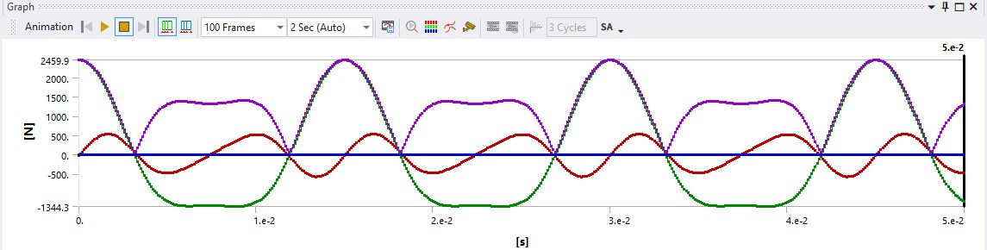
Figure 4.8 – Motion simulation force results for the piston during an engine cycle.
The results were exported for further analysis, featuring peak values around 2500 newtons shown in figure 4.8. The exported data will be divided into component forces, including moments in both directions and remote forces. Notably, all components, except the piston, were assigned structural steel material for result simplification. The piston's material, Aluminium 6061 T6, was chosen from Ansys Granta for its relevance to mass production vehicles.

4.2 – Steady-State Thermal simulation
A thermal analysis was also conducted on the piston, to simulate how it would deform under thermal load. Figure 4.2 shown previously, shows the temperatures applied to each of the areas of the piston, as well as the heat transfer coefficient of each area. Convective heat transfers were applied to each of the faces, with their respective temperatures and heat transfer coefficients.
Mesh sizing shown in figure 4.9 below, was generated on the entire body of the piston, in order to accurately simulate temperature across its entirety. 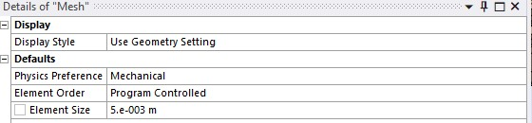
Figure 4.9 – Mesh sizing (0.005m) for piston simulations.
Once the mesh had been generated, the simulation was run, and results gathered could then be fed into the next section, as seen in figure 4.1.
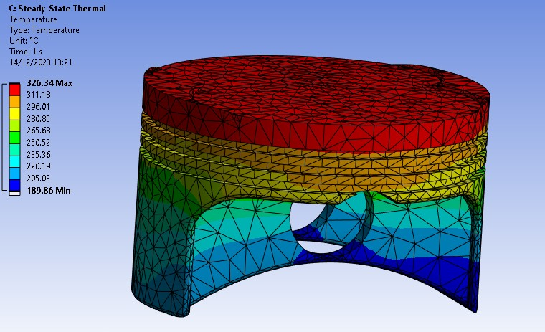
Figure 4.10 – Temperature (degrees) distribution for first piston iteration.
Figure 4.10 visualises the temperature spread across the piston, and it is as expected, with a steady gradient from the hottest face to the coolest face, without any major heat spots where they aren’t expected.
A peak temperature of 326.34 Celsius can be observed, which can later be compared to further iterations. This temperature could be reduced by removing unnecessary material, increasing the surface area, therefore giving the piston greater cooling ability.

4.3 – Static Structural simulation
Data was exported from the Rigid Dynamics testing, and imported into the Static Structural simulation, as well as temperature data being fed in directly from the Steady-State Thermal analysis, as mentioned before.
An additional joint was added to the piston, to fix it in place, as without it, the imported forces would just send the piston in whatever direction the forces were applied.

4.3.1 – Total Deformation
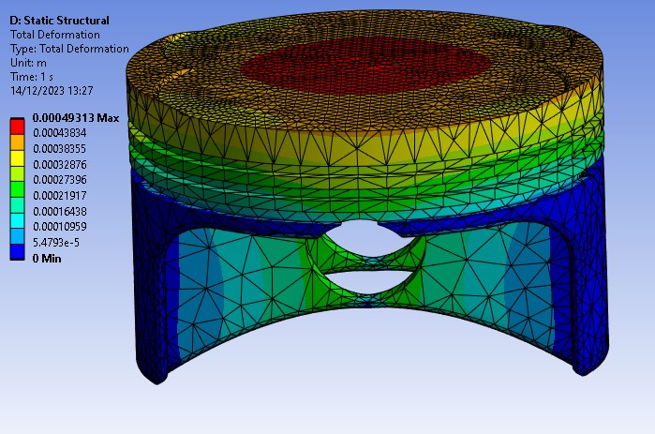
Figure 4.11 – Total deformation (m) under thermal and motion loads for first piston iteration.
The above solution shows a peak deformation of 0.493mm in the centre of the crown, which could be improved in further iterations.
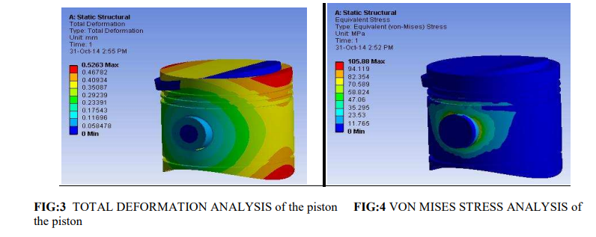
Figure 4.12 – Total deformation, and Von Mises equivalent stress - (Journals Invention and Dilip, 2015)
The above graph proves that the solution in figure 4.11 was correctly calculated and can therefore be replicated with different piston designs to see improvements.

4.3.2 – Stress
As before with the deformation, the equivalent stress (Von mises) was calculated for the first iteration, as seen below in figure 4.11.
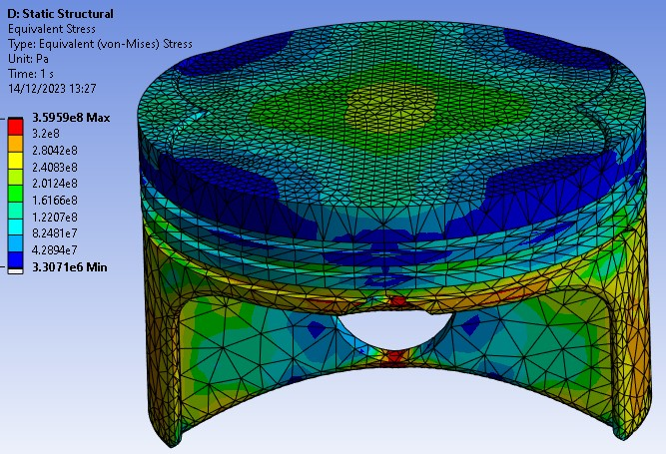
Figure 4.13 – Equivalent (Von-mises) stress (Pa) for first piston iteration.
Comparing the values of stress in figure 4.13 to that of 4.12, the peak stress is almost 3 times as large, though this is most likely because the gudgeon pin has also been included in the solve for figure 4.10.
This can lead to potentially catastrophic cracks within the piston, as seen in figure 4.14 below.
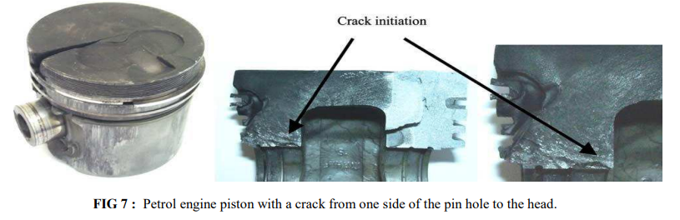
Figure 4.14 – Crack initiation due to high stresses in concentrated areas. - (Journals Invention and Dilip, 2015)

5.0 – Second iteration analysis
For the second iteration of the piston, the focus was on removing unnecessary material, while keeping the same values for stress and deformation, under exactly the same load conditions.
The crown's ridges on either side were filleted using solidworks, in order to reduce weight of the component, and additionally reducing the deformation around the sharp edges of the previous piston’s crown.
Sections of material were also removed from the gudgeon pin supports, as they showed little to no stress in the first iteration solution. Additional material was also removed from the underside, directly beneath the piston crown.
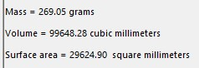
Figure 5.1 – Piston second iteration weight.
The revised piston design had a new weight of 269.05 grams, a reduction of almost ten grams over the first iteration.
After a second design had been finalised, the exact same process as before was carried out, just with a new piston swapped out in the assembly that was read into Ansys.

5.1 – Rigid Dynamics simulation
The same as before, motion loads were exported to a file, which would then be read-in to the Static Structural Simulation in a later stage.
The loads should be very similar to the first iteration’s, the only difference stemming from the new weight of the piston.

5.2 – Steady-State Thermal simulation
As before, the exact same temperatures and heat transfer coefficients were applied to their respective faces on the new design through convection thermal loads.
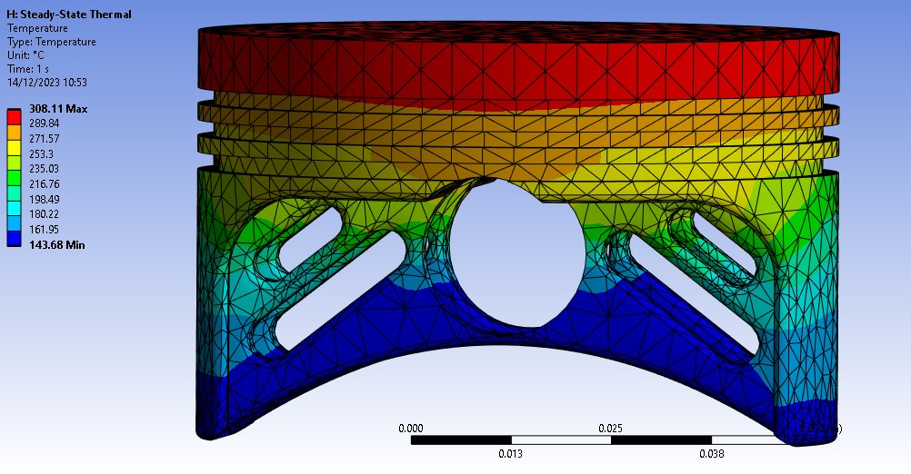
Figure 5.2 – Temperature (degrees) distribution for second piston iteration.
Comparing figure 5.2 to figure 4.10, there has been a clear decrease in maximum temperature on the crown, as well as a majorly decreased minimum temperature, which will in turn improve performance in the static structural simulation.
The cutouts directly beneath the crown, as well as the gudgeon pin supports, contribute to two major factors decreasing the temperature:
- Increase in surface area, which in turn increases cooling capabilities.
- Decrease in total volume seen in figure 5.1, reducing the pistons total heat storing capacity.

5.3 – Static Structural simulation
The static structural simulation, as explained before, drew results from the imported motion loads from the rigid dynamics simulation, as well as the Steady-State Thermal temperatures for the second iteration.

5.3.1 – Total Deformation
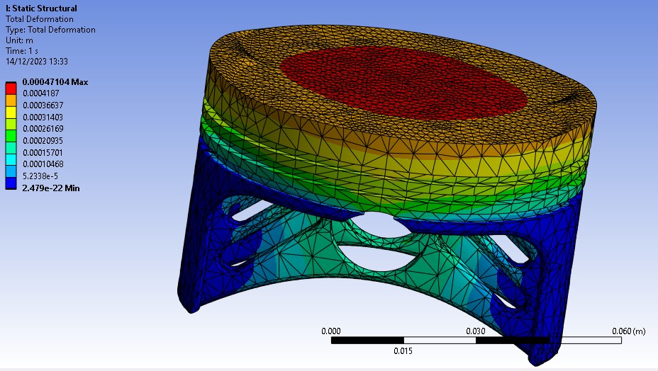
Figure 5.3 – Total deformation (m) for second piston iteration.
Figure 5.3 visualises a small reduction in peak deformation over the first iteration, as well as reduced values around the gudgeon pin hole and supports. This result supports the argument that the piston has been improved thus far, reducing both weight, and deformation across the pistons entirety.

5.3.2 – Stress
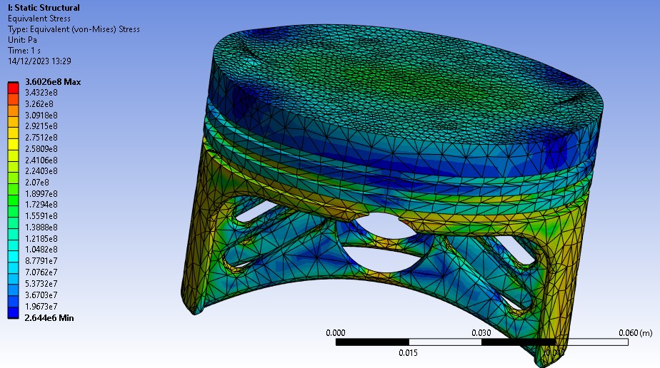
Figure 5.4 – Equivalent (Von-Mises) Stress for second piston iteration.
The above figure shows a very slight increase in stress, though this is to be expected, as reducing the amount of material to spread the load across can increase stress in nodes. The second iteration does however, reduce the minimum stress experienced, by over 5x10^5 Pascals, which could be the difference between a working piston, and a completely non-functional engine. The peak stress seems to be around the oil groove, though this is most likely because of the lack of supporting material in that area.

6.0 – Third iteration analysis
Analysing the second iteration, it is clear that there is nearly no deformation within the piston skirts, which are still untouched through the different iterations. There is lots of potentially unnecessary material in these areas, only increasing the weight of the piston, without making a difference to any of the measured values.
The crown showed slightly higher levels of stress in the second iteration, so small amounts of material was added back to the cuts beneath the crown on the underside.
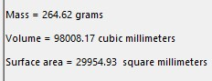
Figure 6.1 – Weight of third piston iteration.
Removing sections of material from the piston skirt, as well as re-adding a millimetre of depth to the cuts taken beneath the crown, reduced the weight by another 5 grams, and the volume by around 1600 cubic millimetres, which may lower the motion/thermal loads even more.

6.1 – Rigid Dynamics simulation
As before, the piston was swapped out for the new iteration in the assembly and re-read into Ansys rigid dynamics simulation. With a slightly lower total weight, it can be assumed that motion loads will again be reduced, though this will be confirmed within the static structural simulation results.

6.2 – Steady-State Thermal simulation
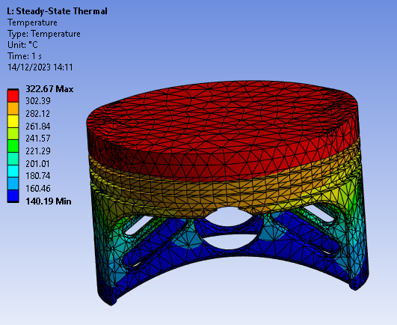
Figure 6.2 – Temperature (degrees) distribution across third piston iteration.
Figure 6.2 shows similar distribution to the second iteration’s, though peak temperatures similar to the first iteration are being demonstrated. This is most likely due to the material added underneath the piston crown, increasing the volume at the top of the piston, and decreasing the piston’s ability to dissipate heat from that area.
The minimum temperature seen during the simulation has again been decreased by around 3 degrees, which may allow for better performance during combustion.

6.3 – Static Structural simulation
Again, these results from the steady state thermal study, as well as the rigid dynamics study should decrease both the deformation and the equivalent stress of the new iteration.

6.3.1 – Total Deformation
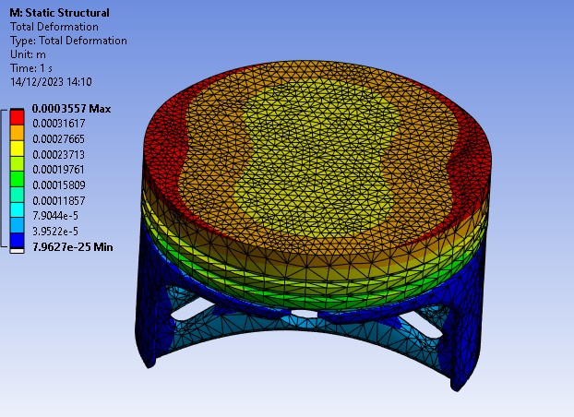
Figure 6.3 – Total Deformation (m) for third piston iteration.
Figure 6.3 shows significantly less deformation that that of the second iteration, and also a more evenly spread deformation with regard to the crown shape. Deformation has also decreased to a large degree around the gudgeon pin supports and piston skirts, most likely due to the extra material added beneath the crown, further strengthening it.
This iteration shows a respectable decrease in deformation of over 38% when compared with the initial design, suggesting the redesign has been successful.

6.3.2 – Stress
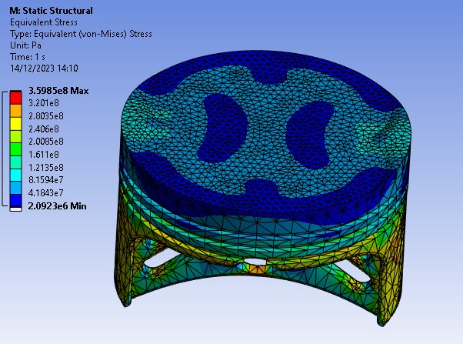
Figure 6.4 – Equivalent (Von-Mises) Stress for third piston deformation
Peak stresses have also been very minorly decreased, when compared to the first iteration, though it can be noted that the minimum stresses calculated have been decreased by over 58% in comparison to the first iteration.
These decreases could prolong life within the engine, as decreased stresses could make a large difference over the span of say 1 million combustion cycles.
The final weight of the third iteration is around 5% less than that of the first iteration. This reduction, as well as the reduction of both deformation and stress contribute to a superior piston design, hopefully with a longer fatigue life.

7.0 – Conclusion / Limitations and benefits of Ansys Workbench
Ansys Workbench, like any simulation tool, relies on assumptions and simplifications for computational feasibility, necessitating awareness of these limitations and validation against experimental data.
Some benefits of Ansys Workbench are stated as follows:
- Multi-simulation capabilities: Workbench has the ability to simulate a very wide range of scenarios, through different solve models, which is a huge benefit in the example of a piston, where multiple models need to be used to accurately simulate.
- Optimization: Ansys allows for simple design changes to integrate into a previous simulation workflow almost seamlessly, only needing to reassign faces and materials.
- Solver accuracy: Ansys is widely know for its accurate solvers, allowing for reliable results, giving engineers clear directions to take in order to improve a part.
Ansys Workbench also has its fair share of drawbacks and limitations: as stated below:
- Computational resources: High-fidelity simulations can be extremely resource-demanding, cutting into valuable development time, so lower quality simulations may be favourable. Balancing these two can be difficult, as a lower quality simulation may give an incorrect result.
- Validity of results: Careful consideration must be taken when using workbench, as an analytical solution or experimental data must be used in comparison, in order to ensure accuracy and reliability of results.
- Cost: Ansys workbench is a costly software to acquire a license for, therefore smaller companies may be at a significant advantage, having no choice but to prototype and test in a controlled environment.
Ansys Workbench has successfully modelled various scenarios, proving its feasibility over real-life prototyping, potentially saving costs compared to expensive equipment, such as accurate thermal imaging tools.
The rapid and cost-effective simulations provided by Ansys Workbench can be particularly beneficial in scenarios requiring multiple studies in a prototyping environment.

References
Lee, Z.R. and Ku, P.X. (2021). Geometry design and optimization of piston by using finite element method. Journal of Physics: Conference Series, 2120(1), p.012013.
doi:https://doi.org/10.1088/1742-6596/2120/1/012013.
Journals Invention and Dilip (2015). Theoretical Analysis of Stress and Design of Piston Head using CATIA & ANSYS.
doi:https://doi.org/10.6084/m9.figshare.1472852.v1.

‌

