
Student name: Mariatu Bangura
Student ID :2328124
Module name: Changemakers: Building Your Personal Brand for Sustainable Employment
Module code: BMHP5015
Lecturer name: Christopher Mafuva
Submission Date: 13th April 2026 14:00 (2PM)
Component 1: Assignment (Portfolio)

Table of Contents
Introduction
Reflection on Unit 1: Brand You
Who I am and what I stand for
Ambition and motivation
Skills and practise and evidence
Reflection on Unit 2: It’s a small world
Understanding network and culture
Building external links
Digital presence and professional conduct
Reflection on Unit 3: Opportunity Knocks
Seeing and creating Opportunities
Stretch goals and planning
Presenting value
Reflection on Unit 4: The pursuit of Happiness
Resilience and mindset
Handling setbacks and change
Mentors and role models
Conclusion
References
Introduction
This assignment provides a fresh perspective on four units from the Changemakers module and outlines their influence on my personal brand as I aspire to be a Social Prescribing Link Worker. This position involves helping individuals enhance their daily lives by connecting them with local activities, advice services, and practical support. It aligns with my strengths in patient listening, clear communication, and efficient planning. Below, I will detail my insights on ambition and motivation, adaptable careers and skills, community networks, and habits that foster wellbeing. I emphasise actionable ideas and maintain a conversational tone throughout.

Reflection on Unit 1: Brand You
Defining Myself and My Values
Unit 1 guided me in drafting a concise and genuine portrayal of the professional I aim to become. I prioritise dignity, inclusion, and patience, believing that small, effective actions can foster significant change. My demeanour is calm, my approach friendly, and my notes are organised. I recognise areas for improvement, such as my tendency to hesitate with unclear tasks and to take on excessive responsibilities to please others (Melam, 2024). To address this, I request clear outcomes, set achievable deadlines, and provide regular progress updates, thus reducing stress and building trust.
Ambition and Motivation
My goal is to empower individuals to take charge of their social health. I aspire to assist someone in joining a walking group, consulting a debt advisor, or locating a safe space to connect with others. While these may seem modest, they can significantly impact feelings, routines, and hope (World Health Organization, 2022). To translate my passion into action, I developed a SMART goal: within a year, I aim to secure a Social Prescribing Link Worker position or a training role within a primary care network. I will track my monthly progress through applications, interviews, shadowing experiences, and acquired skills. This goal is realistic as I am developing the necessary habits and evidence (Bertotti, 2024) and is aligned with my values, formatted for timely reviews.
Skills Development and Evidence Gathering
I have identified three skills to practice for twenty minutes each weekday. First, I focus on active listening, summarizing key points at the end of calls. Second, I employ motivational questioning that honors individuals' choices and pacing. Lastly, I ensure that record-keeping is factual, empathetic, and useful for future reference. To refine these skills, I engage in role-plays covering common scenarios like initial calls, follow-ups, and case closures. I continually revise my notes for clarity and specificity and request feedback by having others repeat back what they heard to assess my summaries (Oster et al., 2023). I also track my progress through peer feedback, completion checklists, and reflections on my changes and reasoning.
Evidence from online activates
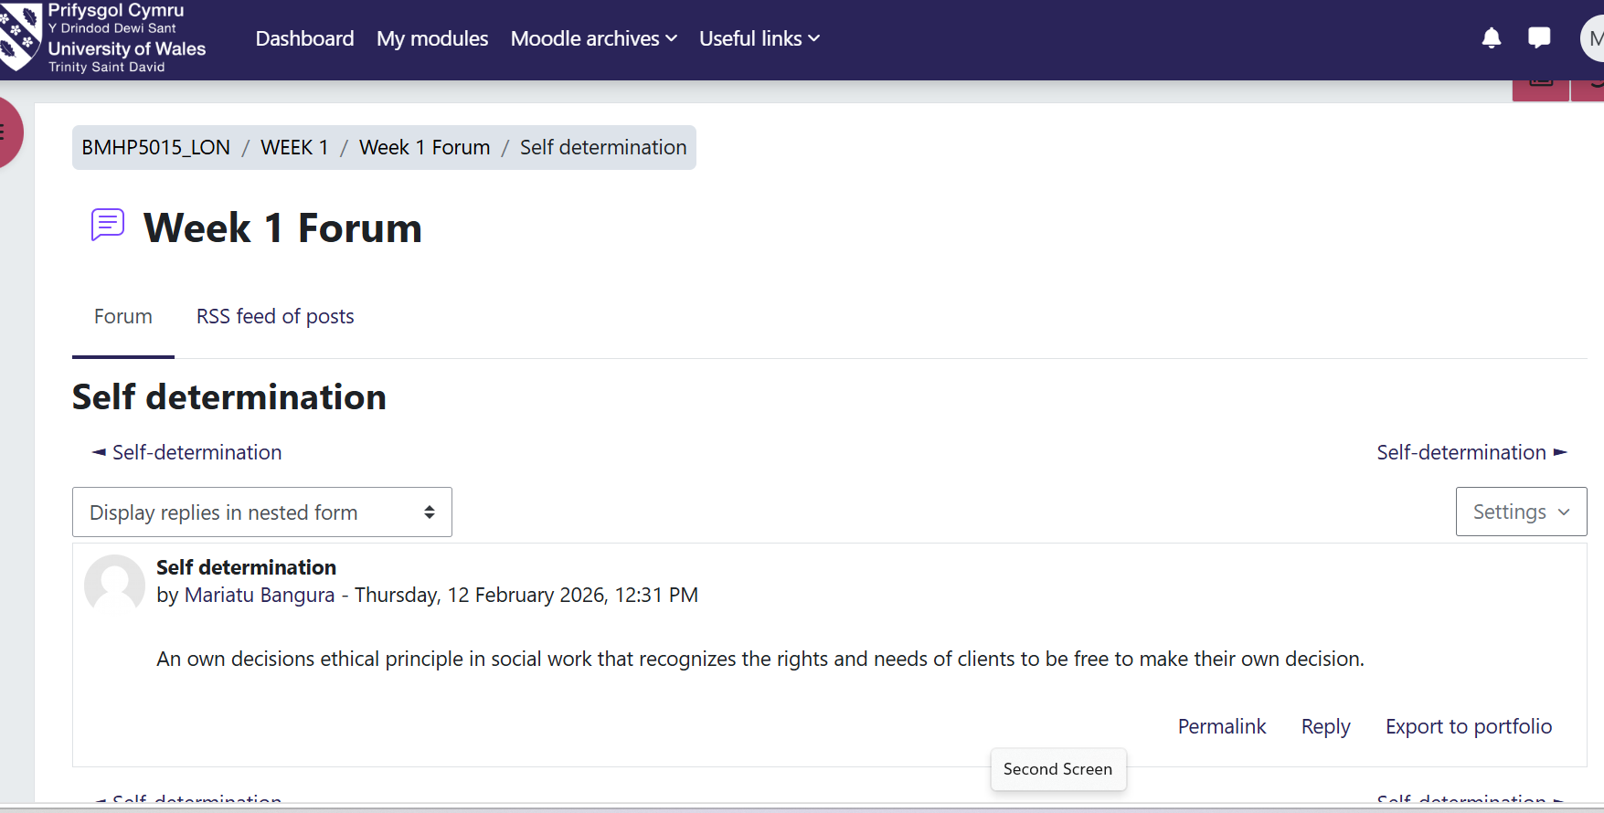
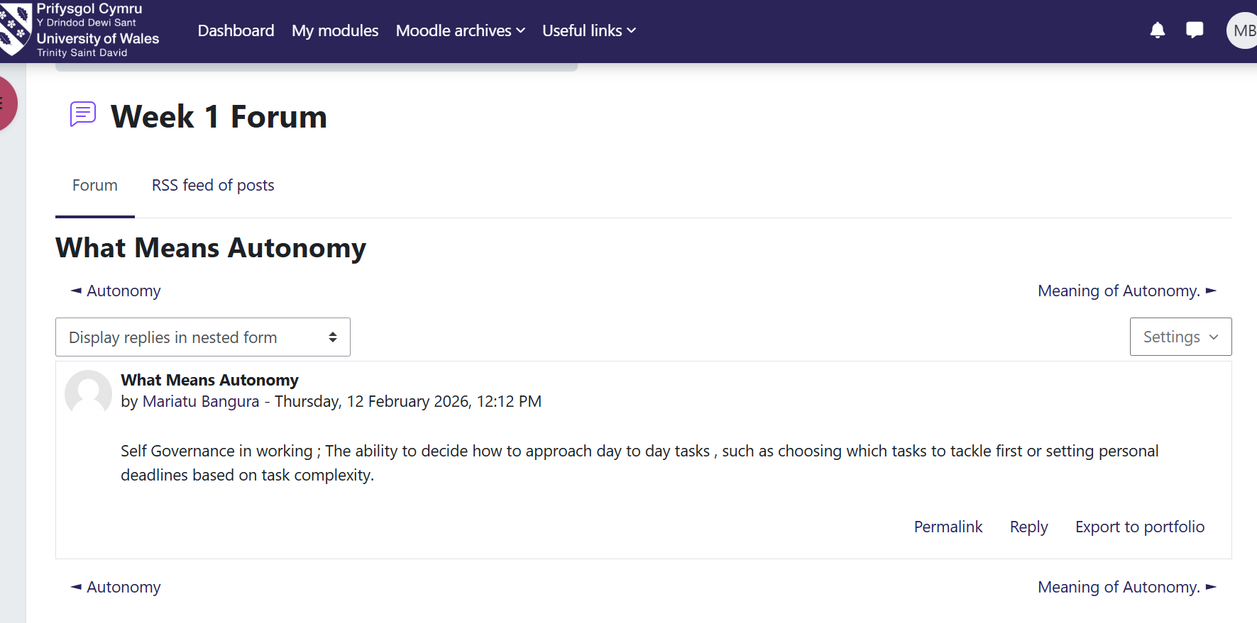
Reflection on Unit 2: It’s a Small World
Evidence from online activities

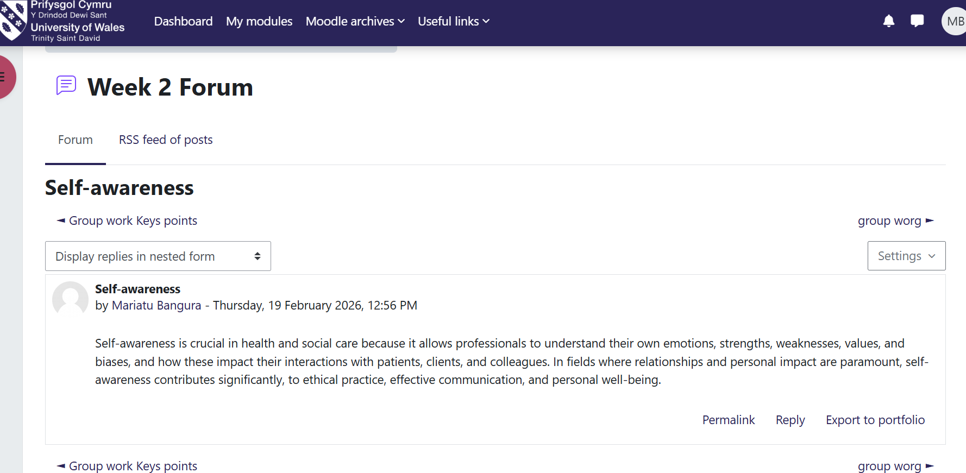

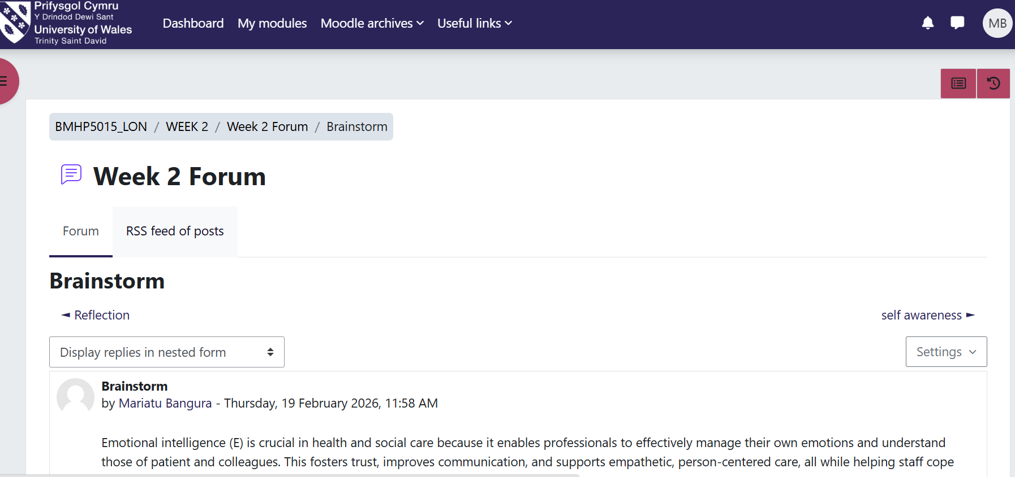
Networking and Cultural Understanding
Unit 2 shifted my perspective on networking. I now see it as a dynamic web of relationships built on service and trust rather than a mere contact list. I mapped out possible contacts and groups I may collaborate with locally (Dacre-Pool, 2020), including GPs, care coordinators, community nurses, social workers, and various community organisations. I considered how language, identity, and culture influence access and practiced using open-ended questions. I learned to confirm understanding and utilize interpreters or advocates when necessary, emphasising the importance of making individuals feel safe to take their first steps (NHS England, 2023).
Establishing External Connections
To build local ties, I created a weekly outreach strategy, where I research one local service and engage with a specific contact each week. I document what services they offer, who they serve, referral processes, and any accessibility issues. I also track transportation options and barriers like digital sign-ups and wait times, developing alternative solutions. I prepare individuals before referrals to set expectations, gradually creating a repository of practical options (Ghosh et al., 2021). This routine increases my confidence in conversations as I can suggest suitable choices based on needs, budget, and location.
Digital Presence and Professionalism
Recognising the importance of online networking, I updated my profile for clarity, respectfulness, and usefulness. I included a summary of my aims and values, along with relevant skills like conversation techniques, data management, partnership building, and safeguarding awareness. I also removed content that could be misunderstood or harmful. I adhere to a simple principle (NHS England, 2020): I won't post anything online that I wouldn't say in a clinical or community setting to maintain trust and a consistent professional image.
Reflection on Unit 3: Opportunity Knocks
Evidence from line activities
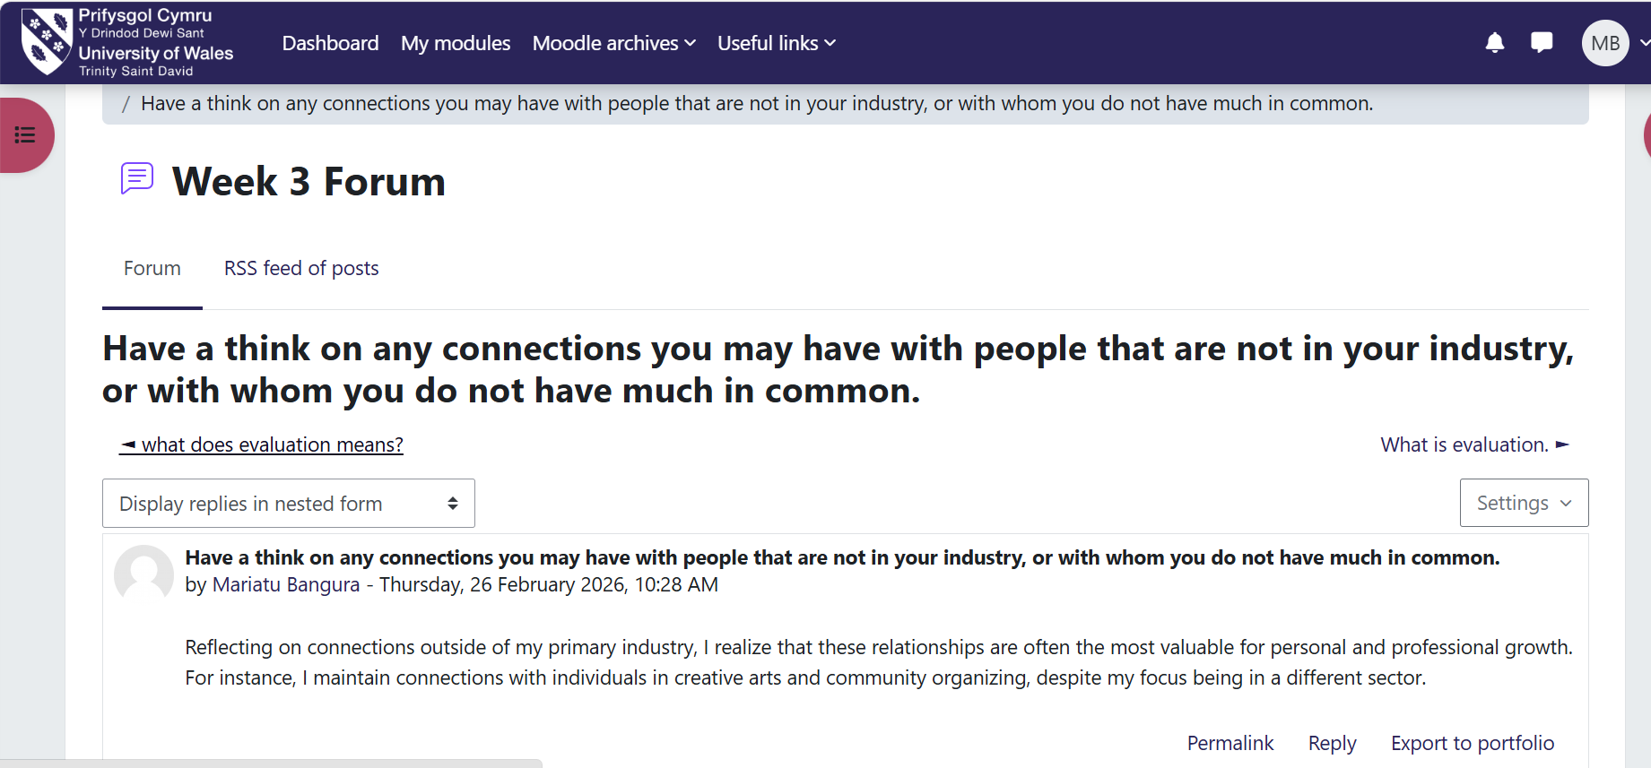
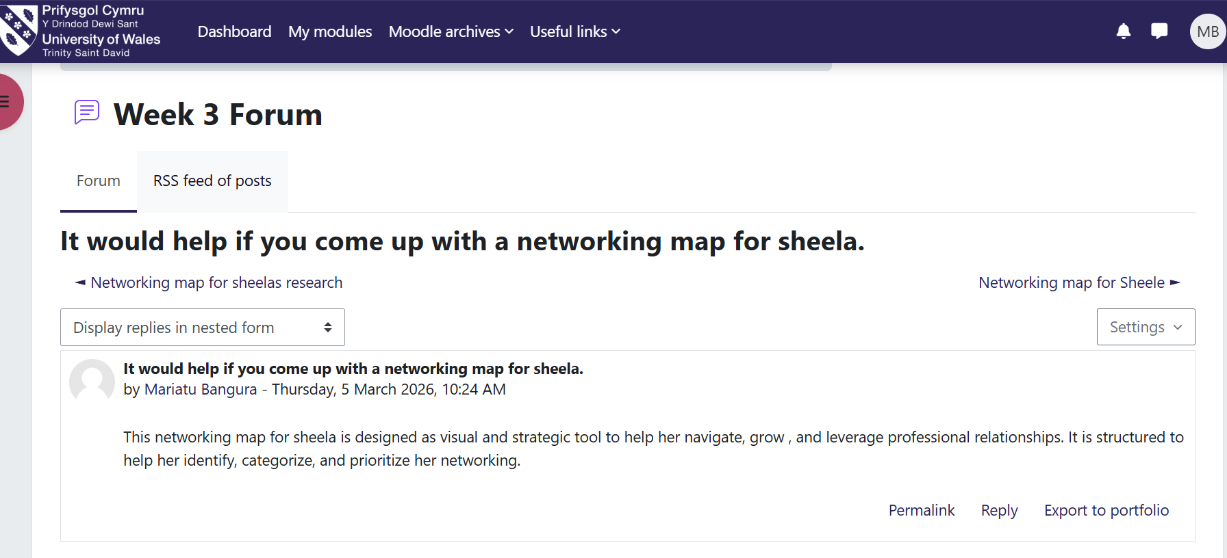

Identifying and Creating Opportunities
Unit 3 taught me to recognise small opportunities and take proactive steps. I organised a weekly schedule to balance study, outreach, job searching, and rest. I keep a card with prompts that facilitate engaging conversations, asking what helps individuals feel heard or which local groups they trust. These queries enhance brief meetings into meaningful learning moments (Ivziku et al., 2021). I also crafted three messages requesting shadowing opportunities, leading me to spend a morning with a community team where I observed initial calls, consent documentation, and case closure procedures.
Setting Stretch Goals and Planning
I established a stretch goal to prepare a ten-minute presentation on social prescribing for a student group, focusing on clarifying the role's scope. I identified three key points and prepared one illustrative story demonstrating a safe and ethical approach. Thorough practice ensured smooth delivery. Seeking feedback boosted my confidence and improved my message (Weller et al., 2024). Additionally, I refined my study routine to include dedicated time for policy research, script practice, and rest, promoting high energy and focus.
Presenting Worth
We examined how to convey value without over-promising. I revised my CV and created a one-page profile featuring a personal statement, a skills list, a couple of impactful examples, and a brief values section (Mulfiyanti and Satriana, 2022). I selected examples relevant to the Link Worker role, such as a project linking a student with a peer group to reduce isolation and a resource sheet developed for a financially stressed family that directed them to the appropriate advisor. I also articulated my core work values and their practical manifestations (Kolb, 2015), demonstrating respect through careful listening and clarity, ensuring safety through transparent consent and organized notes, and exemplifying reliability through follow-through on commitments.
Reflection on Unit 4: The Pursuit of Happiness
Building Resilience and Mindset
Unit 4 emphasised resilience and the establishment of healthy routines. I began by identifying limiting beliefs, such as the idea that I needed to solve every problem immediately (Min et al., 2021), which caused stress and fatigue. I reformed this thought to acknowledge my role as a listener and guide, emphasizing that individuals are responsible for their choices, relieving pressure and enhancing the quality of our interactions (Tortosa-Alted et al., 2021). I established a daily routine to safeguard my energy, ensuring regular sleep patterns, meal preparation, hydration, and brief walks. I utilise checklists to responsibly start and conclude my study sessions.
Navigating Setbacks and Change
I developed a three-step strategy for difficult days: first, pausing to acknowledge my feelings; second, articulating what occurred clearly (Miller and Rollnick, 2013); and third, identifying a lesson and an action to take. I applied this plan after a practice call where I rushed a summary. After reflecting on my notes and pacing myself, my subsequent calls improved significantly. Additionally, I prepare for changes that arise frequently, setting aside weekly time to learn about new processes or services (McCormack and McCance, 2017), and maintaining a simple index of my learning for easy sharing with colleagues, keeping my practice current.
Seeking Mentorship and Role Models
Mentorship accelerates growth. I compiled a list of individuals I admire and their strengths and reached out to two contacts for insights on initial roles and training. One provided a short call that covered aspects like setting boundaries, ensuring safety, and avoiding unrealistic promises. They encouraged me to keep a folder documenting my learning and reflections after challenging conversations (Rapo et al., 2023). Now, I conduct monthly reviews to evaluate what worked, what was challenging, and my next steps, sharing insights with a peer to facilitate mutual improvement.

Conclusion
Through these four units, I developed a personal brand that aligns with the role of a Social Prescribing Link Worker. Unit 1 aided in defining my identity, establishing a SMART goal, and forming daily practices. Unit 2 expanded my network mapping skills and cultural awareness, alongside refining my online presence. Unit 3 emphasized transforming small openings into actionable steps, creating a stretch goal that empowered my voice, and presenting my value effectively. Unit 4 focused on maintaining energy, addressing setbacks with a clear strategy, and seeking guidance when necessary. Collectively, these lessons form a simple commitment I aim to uphold in practice: I will listen with respect, act with care, record clearly, and keep my promises. As I move forward, my plans include completing my program, conducting weekly outreach, and applying for Link Worker or trainee positions in local networks. I intend to participate in community meetings to gain insights into barriers and opportunities while maintaining my daily routine and monthly evaluations to ensure steady progress. Thus, my personal brand is more than a catchphrase; it's a consistent pattern of actions that others can recognize and rely on.

References
Bertotti, M. (2024).Social Prescribing Policy, Research and Practice. Springer Nature.
Christiana Melam MBE (2024).The Social Prescribing Link Worker Model. Class Professional Publishing.
Dacre-Pool, L. (2020). Revisiting the CareerEDGE model of graduate employability.Journal of the National Institute for Career Education and Counselling, [online] 44(1), pp.51–56. doi:https://knowledge.lancashire.ac.uk/id/eprint/33178/10/33178%20NICEC%20CareerEDGE%20article%20April%202020%20%28FINAL%29.pdf.
Ghosh, S., Ramamoorthy, L. and Pottakat, B. (2021). Impact of structured clinical handover protocol on communication and patient satisfaction.Journal of Patient Experience, 8(1), pp.1–6. doi:https://doi.org/10.1177/2374373521997733.
Ivziku, D., Ferramosca, F.M.P., Filomeno, L., Gualandi, R., De Maria, M. and Tartaglini, D. (2021). Defining nursing workload predictors: A pilot study.Journal of Nursing Management, 30(2), pp.473–481. doi:https://doi.org/10.1111/jonm.13523.
Kolb, D. (2015).Experiential learning: Experience as the source of learning and development. 2nd ed. Upper Saddle River, New Jersey: Pearson Education, Inc.
McCormack, B. and McCance, T. (2017).Person-centred Practice in Nursing and Health Care: Theory and Practice. 2nd ed. Wiley Blackwell.
Miller, W.R. and Rollnick, S. (2013).Motivational interviewing: Helping people change. 3rd ed. London ; New York: The Guilford Press.
Min, A., Hong, H.C. and Kim, Y.M. (2021). Work schedule characteristics and occupational fatigue/recovery among rotating‐shift nurses: A cross‐ sectional study.Journal of Nursing Management, 30(2). doi:https://doi.org/10.1111/jonm.13511.
Mulfiyanti, D. and Satriana, A. (2022). The Correlation between the Use of the SBAR Effective Communication Method and the Handover Implementation of Nurses on Patient Safety.International Journal of Public Health Excellence (IJPHE), 2(1), pp.376–380. doi:https://doi.org/10.55299/ijphe.v2i1.275.
Rapo, E., Johansson, E., Jönsson, F., Åsa Hörnsten, Anna Sofia Lundgren and Nilsson, I. (2023). Critical components of social prescribing programmes with a focus on older adults - a systematic review.Scandinavian Journal of Primary Health Care, 41(3), pp.326–342. doi:https://doi.org/10.1080/02813432.2023.2237078.
Tortosa-Alted, R., Reverté-Villarroya, S., Martínez-Segura, E., López-Pablo, C. and Berenguer-Poblet, M. (2021). Emergency handover of critical patients. A systematic review.International Emergency Nursing, 56(1), p.100997. doi:https://doi.org/10.1016/j.ienj.2021.100997.
Weller, J.M., Mahajan, R., Williams, K.F. and Webster, C.S. (2024). Teamwork matters: Team situation awareness to build high-performing healthcare teams, a narrative review.British Journal of Anaesthesia, 132(4), pp.771–778. doi:https://doi.org/10.1016/j.bja.2023.12.035.
NHS England (2020).Personalised Care Social prescribing and community-based support Summary guide. [online] Available at: https://www.england.nhs.uk/wp-content/uploads/2020/06/social-prescribing-summary-guide-updated-june-20.pdf?utm.
NHS England (2023).NHS England» Workforce development framework: social prescribing link workers. [online] England.nhs.uk. Available at: https://www.england.nhs.uk/publication/workforce-development-framework-social-prescribing-link-workers/?utm.
Oster, C., Skelton, C., Leibbrandt, R., Hines, S. and Bonevski, B. (2023). Models of social prescribing to address non-medical needs in adults: A scoping review.BMC Health Services Research, [online] 23(1). doi:https://doi.org/10.1186/s12913-023-09650-x.
World Health Organization (2022).A Toolkit on How to Implement Social Prescribing. [online] World Health Organisation. Available at: https://www.who.int/publications/i/item/9789290619765.

