changemakers: creativity and value creation (ACCa5033)
NHS Future Workforce Simulator: A Recruitment Scenario and Workforce Forecasting Tool

Edward Lloyd
2511559

Contents
1 – Introduction 4
2 – Task 1: Practical Development & Implementation 4
2.1 – Question 1: Initial Feedback 4
2.1.1 – Survey Design & Theory 4
2.1.2 – Survey Results Analysis 5
2.1.3 – Project Changes from Feedback 7
2.2 – Question 2: Implementation 7
2.2.1 – Minimum Viable Product 7
2.2.2 – NMR Model Specifications 8
2.2.3 – A&C Model Specifications 12
2.2.4 – User Dashboard Visualisation 13
3 – Task 2: Innovation 18
3.1 – Question 1: DevOps 18
3.1.1 – Project Development 19
3.1.2 – Project Deployment 19
3.1.3 – Project Monitoring 19
3.1.4 – Project Maintenance 19
3.2 – Question 2: PEST Analysis 19
4 – Task 3: Project Reflection 20
4.1 – Question 1: Practical Feedback 20
4.1.1 – Survey Results Analysis 20
4.1.2 – Project Changes from Feedback 22
4.2 – Question 2: Project Process Diary 22
4.2.1 – Project Management Tools 22
4.2.2 – Project Success 22
4.2.3 – Project Challenges 23
4.2.4 – Future Project Improvements 23
4.3 – Question 3: Knowledge and Skills 23
4.3.1 – Project Management Knowledge and Skills 23
4.3.2 – Technical Knowledge and Skills 23
4.4 – Positive Social Impact 23
5 – Conclusion 23
References 25
Appendix 1 – Weekly Progress Sheets 27
Appendix 2 – CPD Evidence 29
LinkedIn Learning 29
Appendix 3 – Design Stage Survey 30
Creating Survey 30
Designing Data Collection Method 31
Piloting Survey 31
Collecting Survey Results 32
Appendix 4 – PESTLE-SWOT Analysis Table 34
Appendix 5 – Prototype Stage Survey 36
Creating Survey 36
Designing Data Collection Method 38
Piloting Survey 38
Collecting Survey Results 38
Appendix 6 – Example of p Value Testing 40
Residuals 40
Autocorrelation Diagnostic 41
Normality Diagnostic 42
Homoscedasticity Diagnostic 43
Diagnostics Conclusion 44
Troubleshooting Failed Diagnostic 44
Appendix 7 – Administrative & Clerical Model Specifications 45
Administrative and Clerical Model Specifications 45
Model Parameters Selection 45
Model Validity Diagnostics 46
Forecast Accuracy Metrics 47
Model Selection 49
Appendix 8 – Recorded Simulation of Dashboard Interaction 50

Word Count: 2,189 (excluding direct quotations, images, image captions, text within tables, and appendices)

1 – Introduction
This assignment explores practical software development through interconnected tasks in which stakeholder feedback is gathered throughout development, practical implementation is evidenced, the viability of long-term project development methods is considered, along with a critical reflection of project progress. The completion of these tasks will serve to demonstrate both technical proficiency and adherence to professional development standards.

2 – Task 1: Practical Development & Implementation

2.1 – Question 1: Initial Feedback

2.1.1 – Survey Design & Theory
A design stage survey was created using Microsoft Forms and recipients were also provided with a Project Design Overview.
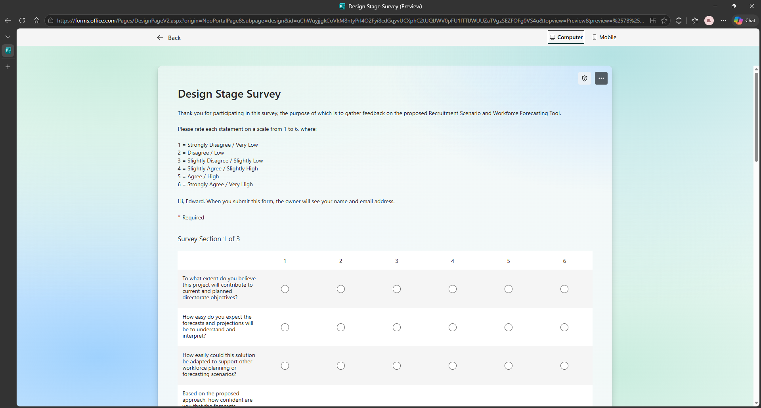
Figure 1: screenshot of Design Stage feedback survey created in Microsoft Forms.
Five metrics were selected to provide focus for the questions which could be measured across the Design and Prototype stages:
Metric | Question Focus
Value | Project alignment with organisational goals and support existing initiatives.
Usability | User accessibility and ease of interpretation for different stakeholder groups.
Scalability | Potential for project expansion beyond the immediate scope or team.
Accuracy | Model performance and reliability of forecasting outputs to inform staffing decisions.
Feasibility | Readiness to implement the solution within the Health Board.

The survey was completed by the following Survey Respondents (SR):
Survey Respondent | Job Role | Knowledge Background
SR1 | Business Intelligence Officer | Non-technical
SR2 | Business Intelligence Officer | Non-technical but statistical
SR3 | Very Senior Data Systems Manager | Technical
SR4 | Data Systems Supervisor | Non-technical
SR5 | Workforce Planning Project Manager | Theoretical

2.1.2 – Survey Results Analysis
By maintaining the metrics across both surveys, the results will be compared to gauge any changes in respondent opinion, visualised specifically with radar charts. Radar charts are “one of the most popular methods for comprehensive performance evaluation” due to their intuitive visualisation [1]. They are “particularly useful” for “comparing performance across different categories” and “analysing variations in data” by “looking at two series on the same graph and comparing ‘shape’” [2]. Compared with traditional bar charts, radar charts also have “a stronger visual impact and can more intuitively display the characteristics of one object that is particularly prominent in an attribute” [1].
Design Stage Survey Results
Respondent | Value | Usability | Scalability | Accuracy | Feasibility | Total
DSR1 | 4.7 | 3.0 | 3.0 | 2.0 | 3.3 | 3.2
DSR2 | 4.7 | 4.7 | 4.0 | 4.0 | 4.3 | 4.3
DSR3 | 6.0 | 3.3 | 2.7 | 4.7 | 3.7 | 4.1
DSR4 | 4.0 | 3.3 | 3.7 | 4.0 | 4.0 | 3.8
DSR5 | 5.3 | 4.7 | 4.7 | 4.7 | 4.7 | 4.8
Total | 4.9 | 3.8 | 3.6 | 3.9 | 4.0 | 4.0

Respondent confidence varied significantly by role and expertise: DSR1 reported lowest confidence in the project’s Accuracy, while DSR3 and DSR5 demonstrated highest confidence.
The results were then used to display individual responses in a radar chart:
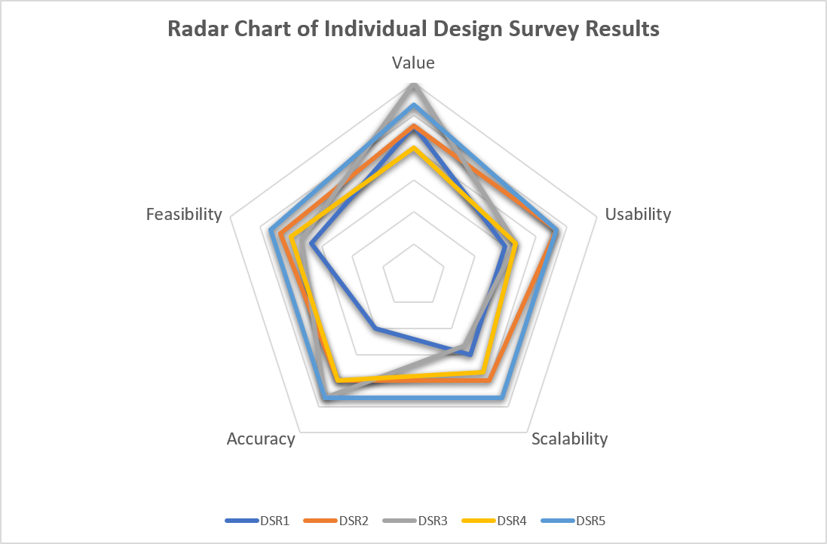
Figure 2: radar chart of averaged individual responses to Design Stage Survey.
The radar chart visually demonstrates stakeholder consensus on the project's Value, alongside shared apprehension regarding the tool's Usability.
The average results were then summed and divided by the number of participants to generate an overall average in a radar chart:
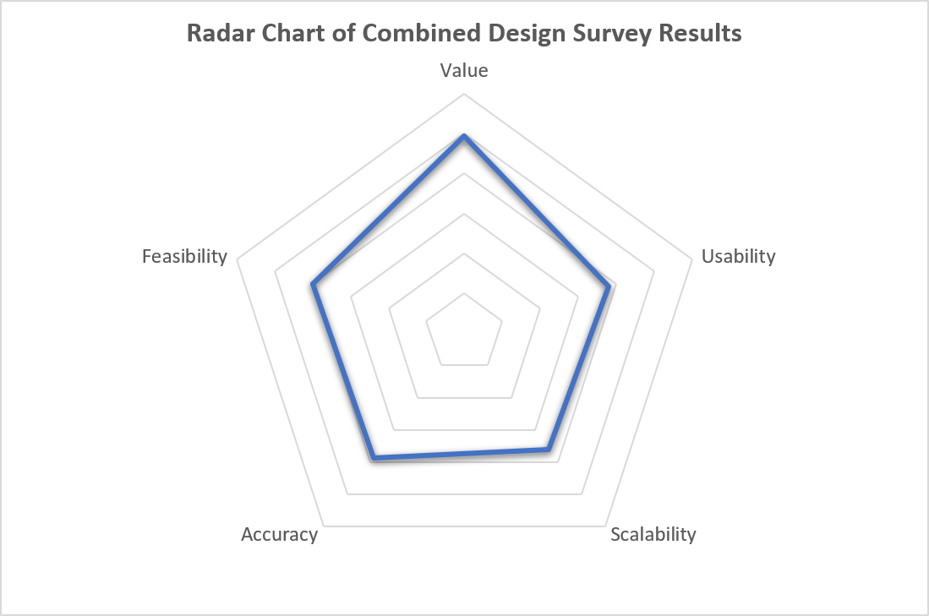
Figure 3: radar chart of combined responses to Design Stage Survey.
The radar chart visually confirmed respondent consensus on the project's strategic Value, while identifying Scalability as the predominant shared concern.

2.1.3 – Project Changes from Feedback
The following changes were made to the project from the survey respondents’ written feedback:
- Ensure Tool Usability: create a functional prototype user dashboard to address Usability concerns directly.
- Demonstrate Forecast Accuracy: include robust evidence of the forecasting reliability in the implementation evidence.

2.2 – Question 2: Implementation
Jesus Lopez’s course ‘Python for Time Series Forecasting’ acted as a guide for building ARIMA models and the AI assistant Lumo was used to adapt Python code to fit the chosen dataset and conform to the Python library limitations of Excel which would be used for final visualisation [3, 4].

2.2.1 – Minimum Viable Product
Initial ARIMA testing indicated that each Staff Group would require individual model specifications. Due to the project time constraints, it was decided to produce a Minimum Viable Product (MVP) that ensured accuracy validation for only two Staff Groups. NMR was selected due to its seasonal pattern, while ‘Administrative and Clerical’ (A&C) was chosen as a contrasting case with no seasonality and demonstrating a consistent downward trend since January 2025, enabling validation across diverse staffing patterns.
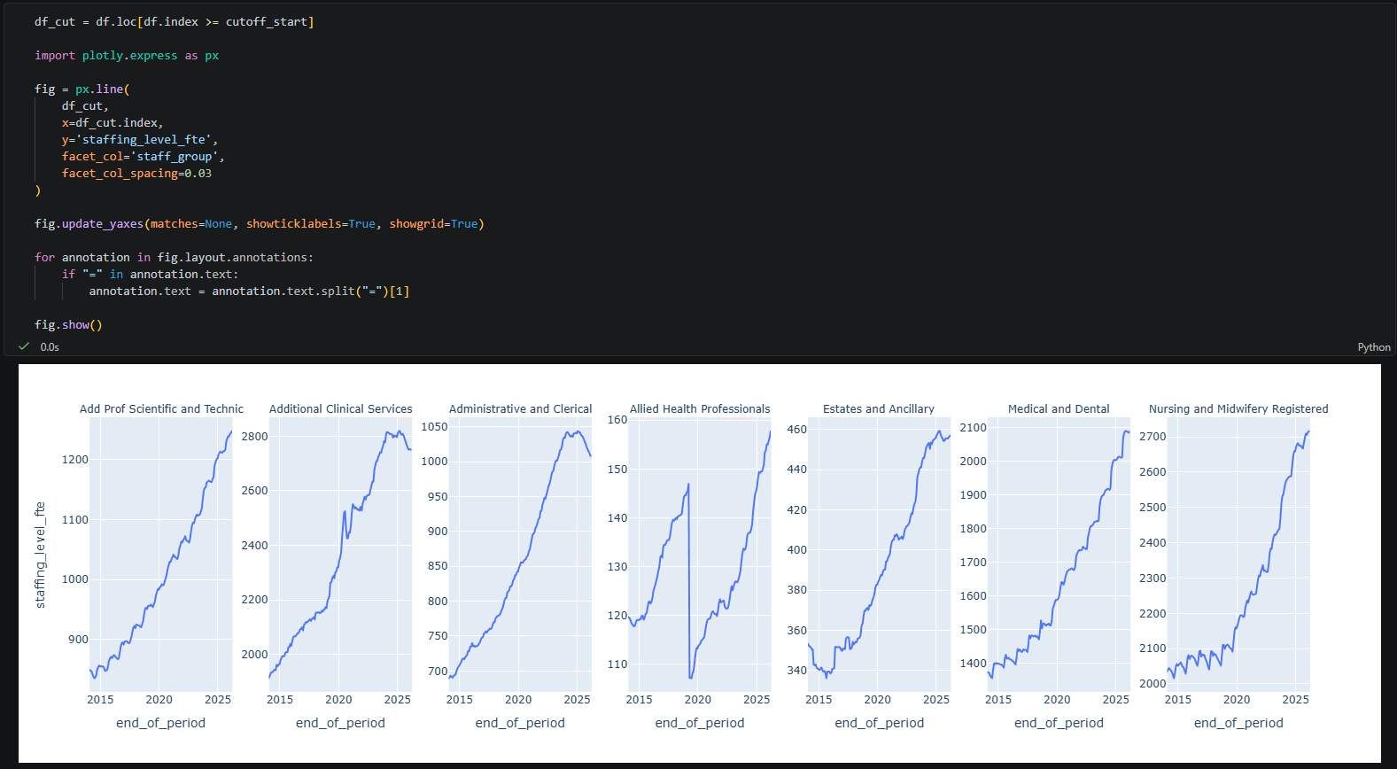
Figure 4: screenshot of code and output to visualise historical data trend of each staff group.

2.2.2 – NMR Model Specifications

2.2.2.1 – Model Parameters Selection
Lopez notes that the process of determining the parameters for ARIMA is “somewhat subjective”, as there is a requirement “to balance selecting enough parameters to capture patterns without adding noise”, however the techniques below were used to validate the model specifications [3]. Lopez identifies the ARIMA model parameters as follows:
Parameter | Name | What it does
p | AR (AutoRegressive) part | How many lagged values of the time series are used (past observations).
d | I (Integrated) part | How many times we difference the data to make it stationary.
q | MA (Moving Average) part | How many lagged forecast errors (residuals) are used to model the next step.

Once differencing was completed, a Partial Autocorrelation Function (PACF) plot was used to determine the p value by looking for lags above the confidence band, of which the most significant were 7 and 15:
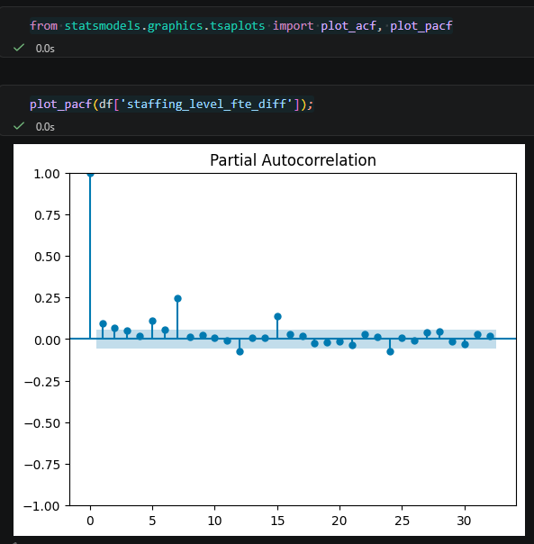
Figure 5: screenshot of code and output for Partial Autocorrelation testing.
An Autocorrelation Function (ACF) plot was also generated, with significant spikes also at 7 and 15:
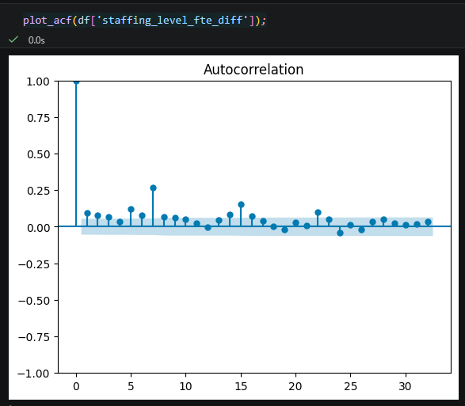
Figure 6: screenshot of code and output for Autocorrelation testing.
Both PACF and ACF demonstrated spikes at lag 15 indicating significant behaviour.

2.2.2.2 – Model Validity Diagnostics
Once model parameters had been determined to ensure “the series had a constant mean, variance over time, and the coefficients are significant”, the assumptions of the model were then explored, such as “the autocorrelation, normality, and homoscedasticity of the residuals” [3]. If these diagnostics are not fulfilled, then “the significant values and coefficients in the model summary may be biased” [3].
ARIMA Model | Diagnostic | p Value | Outcome
1,1,1 | AR Lag | 0.197 | Failed
1,1,1 | Autocorrelation | 0.000 | Failed
1,1,1 | Normality | 0.000 | Failed
1,1,1 | Homoscedasticity | 0.015 | Failed
7,1,1 | AR Lag | 0.707 | Failed
7,1,1 | Autocorrelation | 0.114 | Passed
7,1,1 | Normality | 0.009 | Failed
7,1,1 | Homoscedasticity | 0.364 | Passed
12,1,1 | AR Lag | 0.000 | Passed
12,1,1 | Autocorrelation | 0.318 | Passed
12,1,1 | Normality | 0.281 | Passed
12,1,1 | Homoscedasticity | 0.068 | Passed
15,1,1 | AR Lag | 0.011 | Passed
15,1,1 | Autocorrelation | 0.978 | Passed
15,1,1 | Normality | 0.034 | Failed
15,1,1 | Homoscedasticity | 0.065 | Passed

ARIMA(12,1,1) was the only model to satisfy all diagnostics.
The viability of the models was then tested by using the Akaike Information Criterion (AIC) to determine how well the model predicts future data and the Bayesian Information Criterion (BIC) to determine how simple the model is while still fitting well [3]:
ARIMA Model | AIC | BIC
1,1,1 | 1083.191 | 1092.080
7,1,1 | 1051.904 | 1078.570
12,1,1 | 890.726 | 932.206
15,1,1 | 886.345 | 954.490

ARIMA(15,1,1) had slightly more accurate predictions than ARIMA(12,1,1) which had the simplest model fit for the data.

2.2.2.3 – Forecast Accuracy Metrics
The following statistical error metrics were used to test the accuracy of the forecasts compared to historical data, based on learning from ‘Learn Time Series Forecasting in Python’ by Marco Peixeiro [5]:

Statistical Error Metric | Abbreviation | Explanation
Mean Absolute Error | MAE | Measures how many units (FTE) on average the model deviates from the actual data.
Root Mean Square Error | RMSE | Also measures FTE but gives extra weight to larger mistakes and is useful for gauging when a model makes a large error.
Mean Absolute Percentage Error | MAPE | Measures the prediction error and expresses it as a percentage of the actual unit (FTE) level at each point then averaged.

Historical date ranges were selected to test model accuracy before, during, and after COVID pandemic recruitment increases:
ARIMA Forecast vs Actual Data (01/02/2016 to 31/12/2019)
ARIMA Model | MAE | RMSE | MAPE
1,1,1 | 27.629 | 35.897 | 1.312%
7,1,1 | 29.505 | 37.450 | 1.402%
12,1,1 | 14.008 | 19.028 | 0.668%
15,1,1 | 13.555 | 17.289 | 0.650%

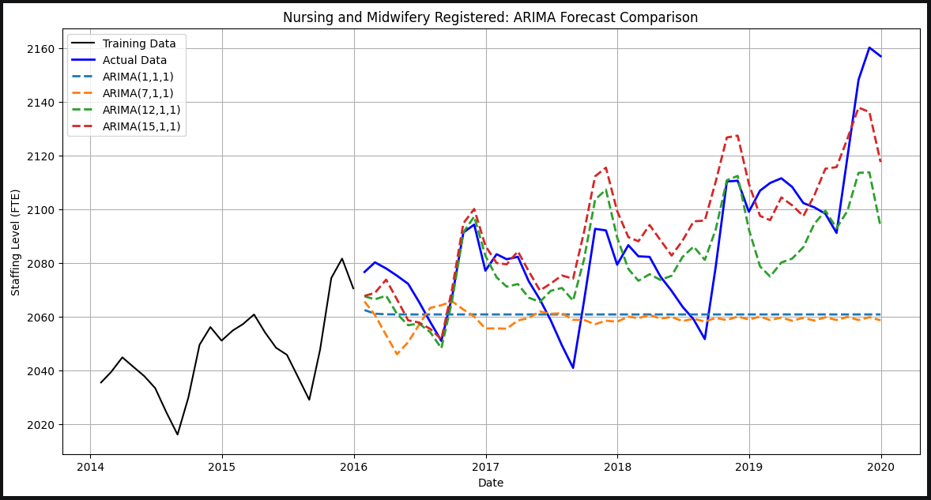
Figure 7: screenshot of ARIMA Forecasts by model vs Actual Data for ‘Nursing and Midwifery Registered’ from 01/01/2016 to 31/12/2019.

ARIMA Forecast vs Actual Data (01/01/2020 to 31/03/2026)
ARIMA Model | MAE | RMSE | MAPE
1,1,1 | 270.299 | 322.613 | 10.687%
7,1,1 | 287.658 | 337.314 | 11.407%
12,1,1 | 132.021 | 165.748 | 5.184%
15,1,1 | 126.830 | 164.565 | 4.956%

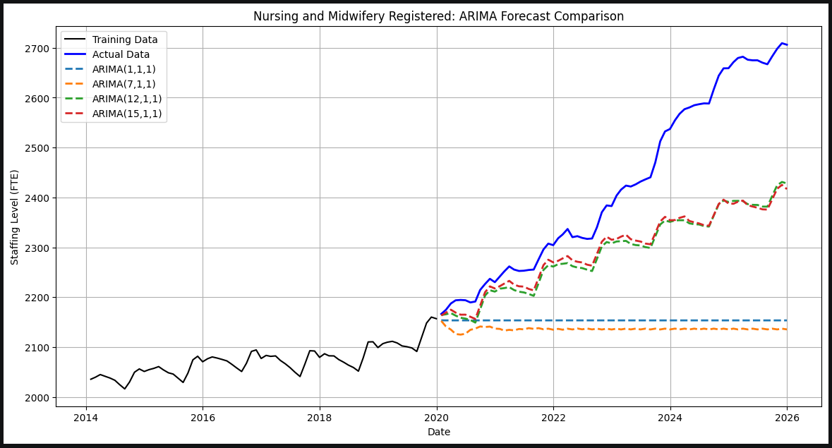
Figure 8: screenshot of ARIMA Forecasts by model vs Actual Data for ‘Nursing and Midwifery Registered’ from 01/01/2020 to 31/03/2026.

ARIMA Forecast vs Actual Data (01/01/2022 to 31/12/2023)
ARIMA Model | MAE | RMSE | MAPE
1,1,1 | 95.325 | 117.529 | 3.900%
7,1,1 | 94.826 | 117.315 | 3.879%
12,1,1 | 27.625 | 40.083 | 1.122%
15,1,1 | 26.332 | 38.370 | 1.071%

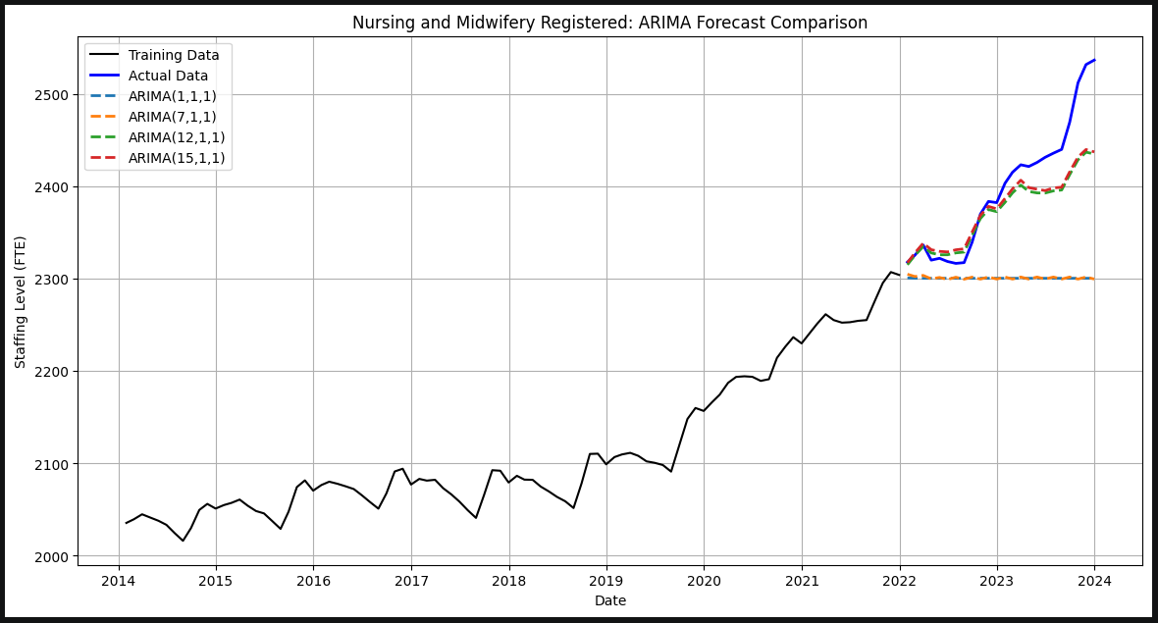
Figure 9: screenshot of ARIMA Forecasts by model vs Actual Data for ‘Nursing and Midwifery Registered’ from 01/01/2022 to 31/12/2023.
ARIMA(15,1,1) scored the lowest error metrics for all three selected date ranges.

2.2.2.4 – Model Selection
While the AIC test and forecast accuracy metrics indicate ARIMA(15,1,1) produces marginally more accurate predictions, ARIMA(12,1,1) is the most defensible model because it is the only specification that is statistically valid across the entire dataset, passes all p value checks and residual diagnostics, and achieved the best BIC score. ARIMA(12,1,1) remained highly competitive in its accuracy, scoring only 4.381 higher in AIC and average errors differing by just 2.312 for MAE, 1.545 for RMSE, and 0.099% for MAPE.

2.2.3 – A&C Model Specifications
ARIMA(12,1,1) was again the most defensible model, and for evidence of the same testing methodology applied to A&C model specifications, see Appendix .

2.2.4 – User Dashboard Visualisation
Based on the wireframe design, a prototype dashboard was created in Excel due to its support of model-appropriate Python libraries and its accessibility throughout the Health Board. The workbook was separated into four sheets:
Sheet Name | Function
Data | Contained the Power Query table which was linked to the prepared dataset.
Python | Contained the structured programme to generate the forecasting model, accept user inputs, and output a forecasting plot and associated summaries.
Inputs | Contained inputs selected from the Dashboard which were stored and/or converted for use in Python.
Dashboard | Interface for the proposed solution where users can amend parameters to adjust their view of historical data and create forecasting predictions of future workforce levels.

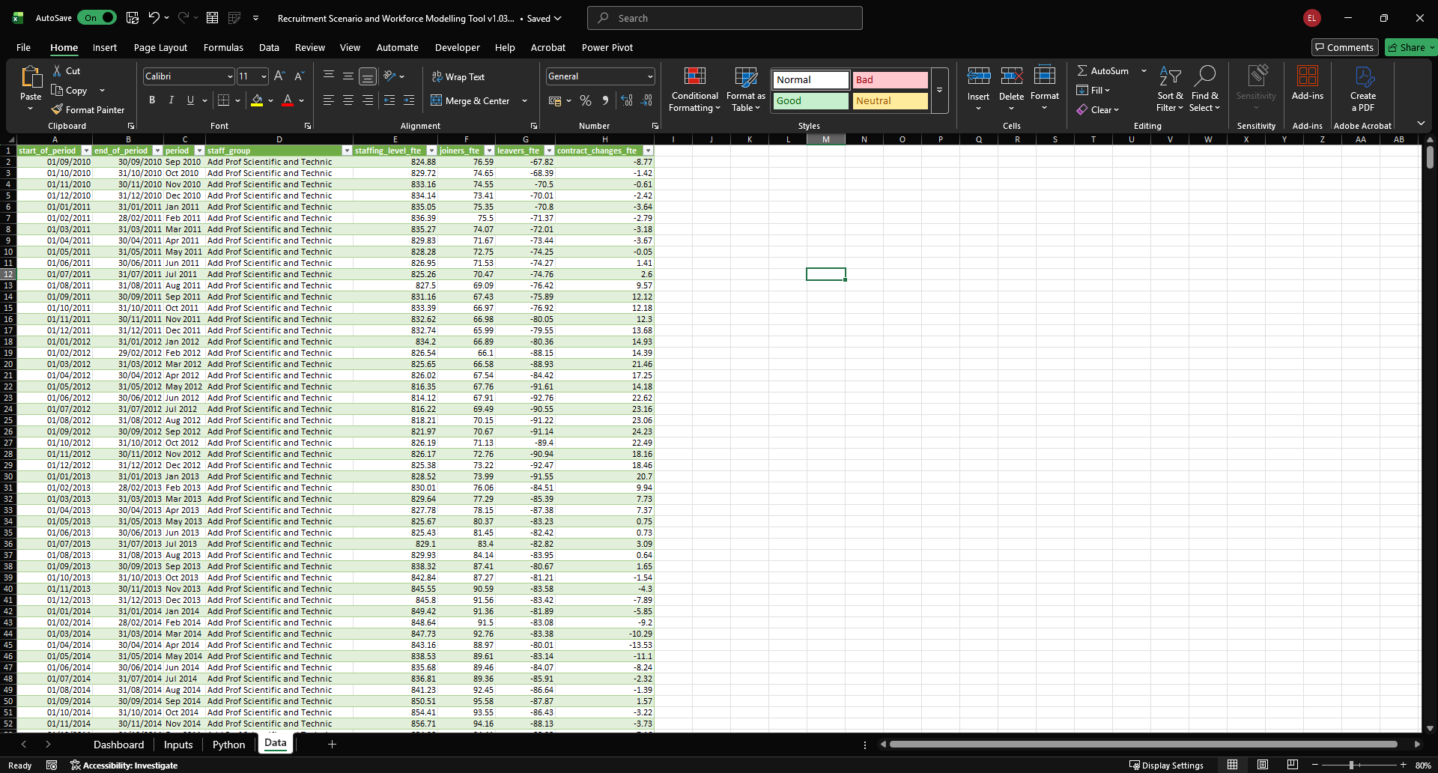
Figure 10: screenshot of Data sheet in the 'Recruitment Scenario and Workforce Forecasting Tool' Excel workbook.
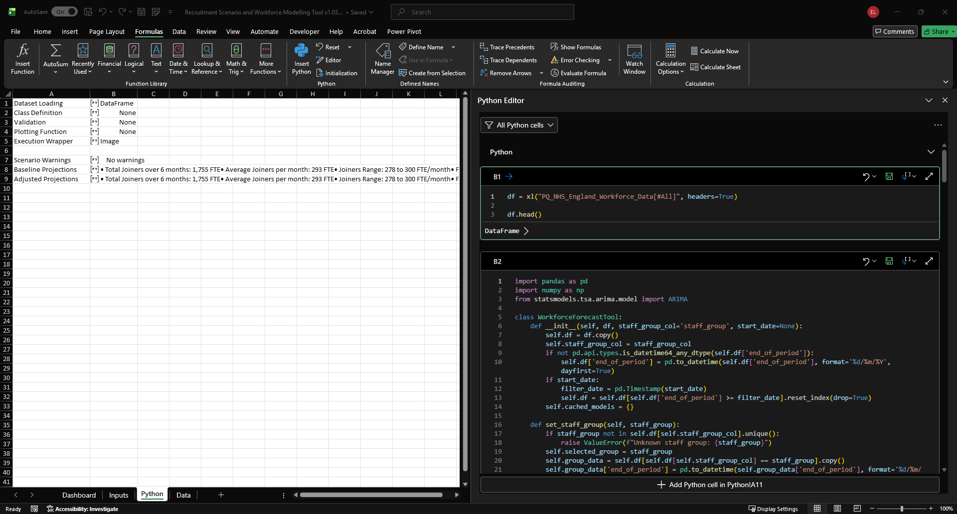
Figure 11: screenshot of Python sheet in the 'Recruitment Scenario and Workforce Forecasting Tool' Excel workbook.
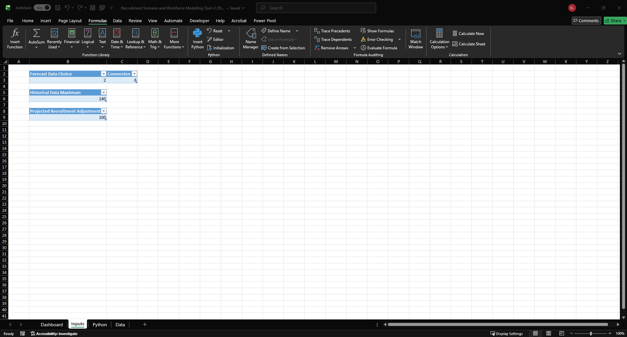
Figure 12: screenshot of Inputs sheet in the 'Recruitment Scenario and Workforce Forecasting Tool' Excel workbook.
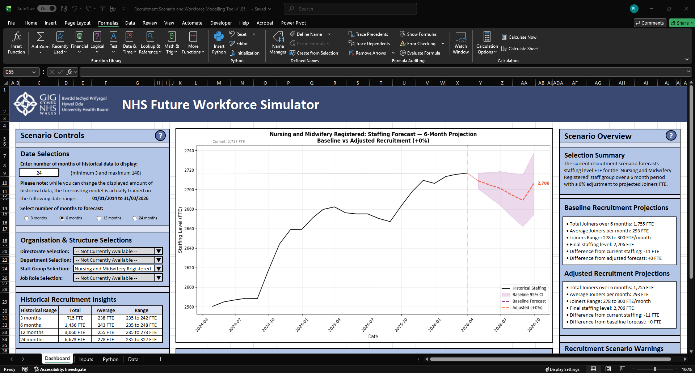
Figure 13: screenshot of Dashboard sheet in the 'Recruitment Scenario and Workforce Forecasting Tool' Excel workbook.
The screen view was adjusted to emulate a Power BI dashboard, and user-friendly interface elements were included such as functioning buttons, dropdown lists, and sliders. Some of the data fields could not be populated due to the inherent limitations of the publicly available dataset.
During the model evaluation stage, it was determined that SARIMAX models would need to be used to properly incorporate seasonality and treat Joiners, Leavers, and Contract Changes as exogenous features which influence Staffing Level. Due to the time constraints of the project, ARIMA(12,1,1) was maintained and the AI assistant Lumo was used to develop a placeholder solution where “seasonal recruitment averages were calculated separately and, once the adjustment multiplier was applied, the cumulative staffing impact was added to the model baseline to generate diverging forecast lines” [4].
The below screenshots simulate user interactions with the dashboard and how adjusting the stored variables changes the output plot and projected summaries (see also Appendix 8 – Recorded Simulation of Dashboard Interaction):
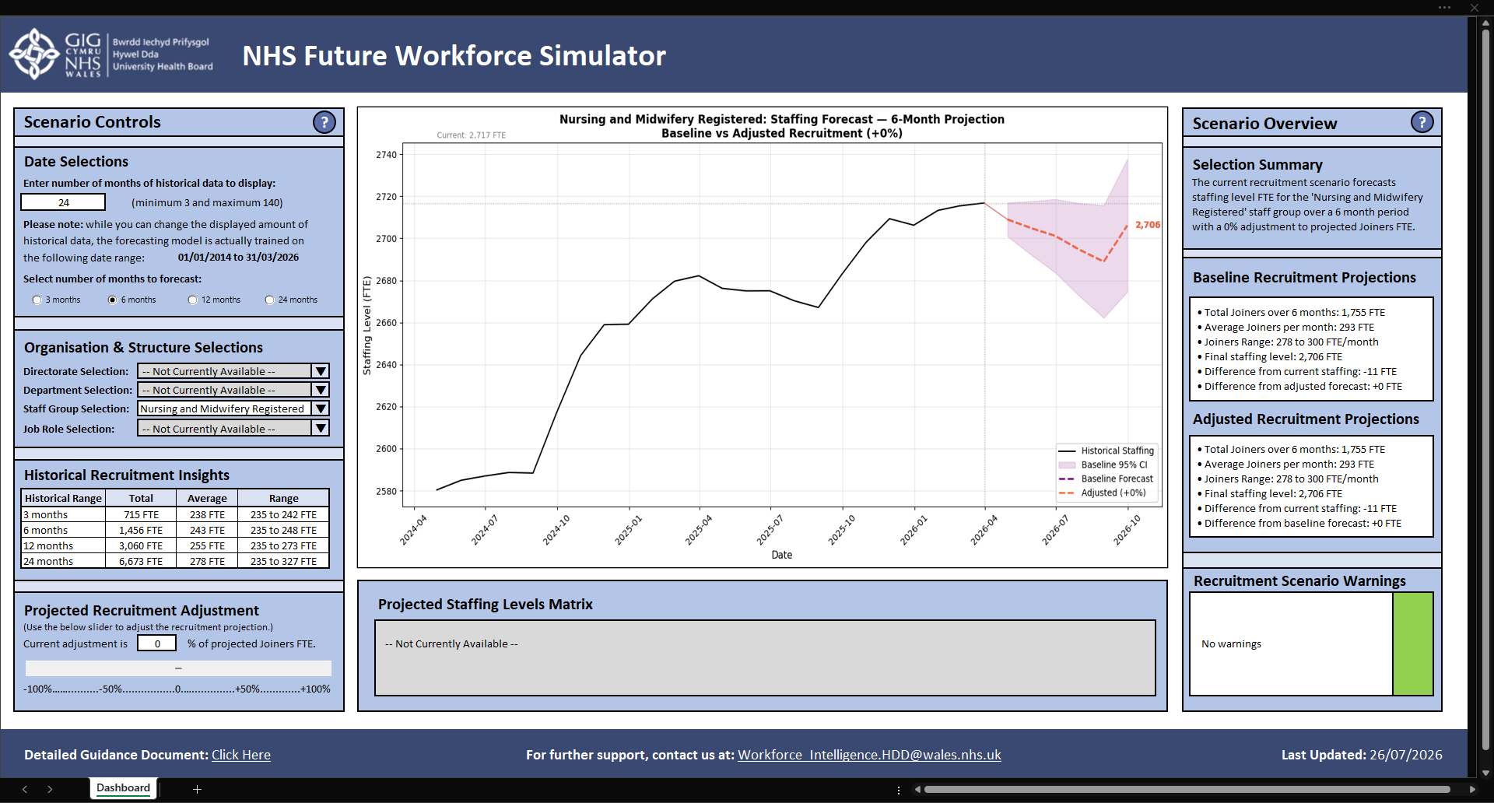
Figure 14: screenshot of the user dashboard adjusted to emulate Power BI view and all filters set to default.
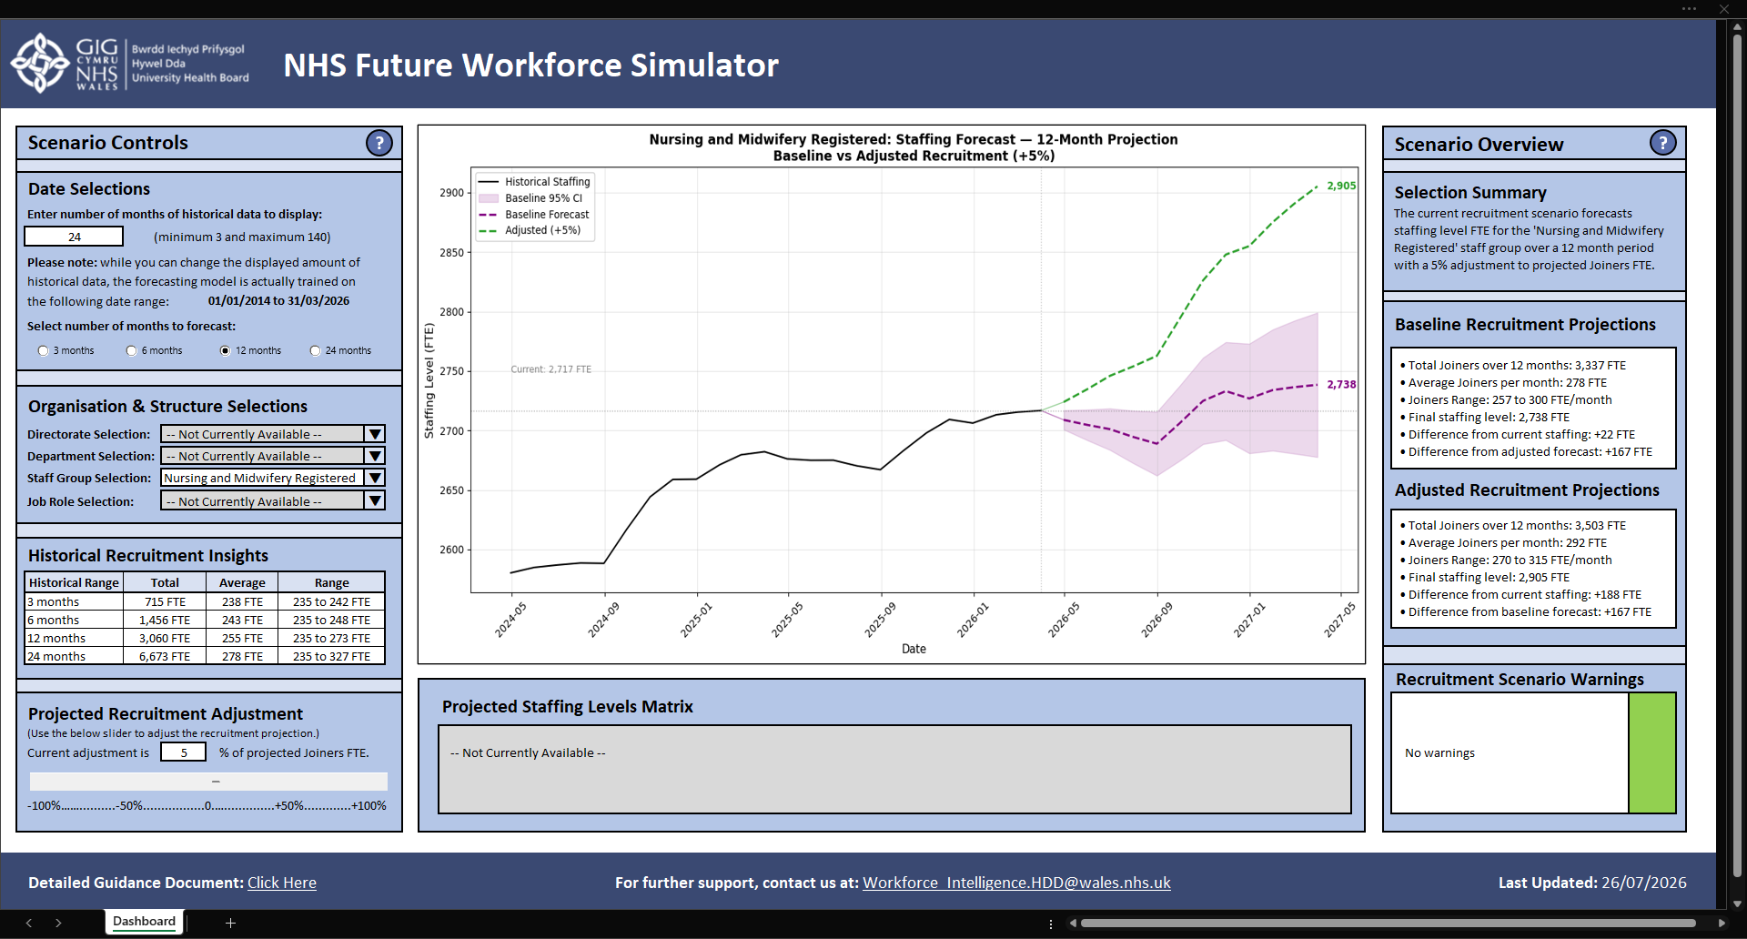
Figure 15: screenshot demonstrating user adjusted parameters to increase both forecast window and percentage of projected Joiners.
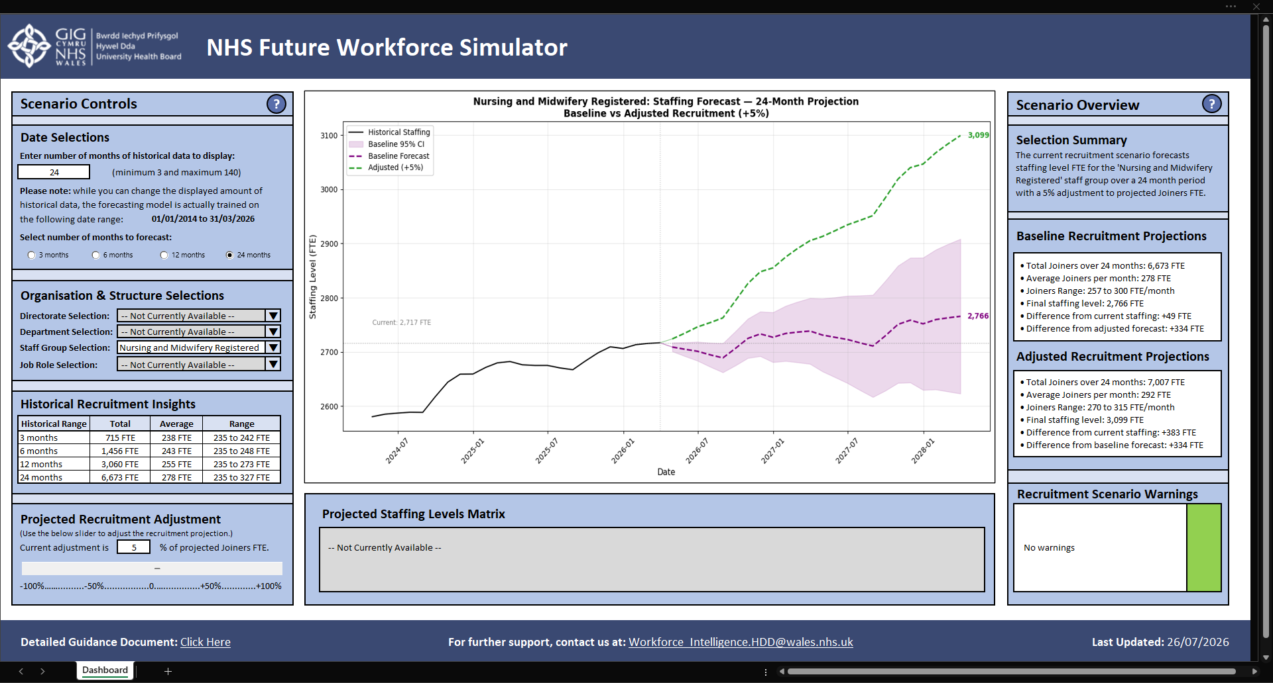
Figure 16: screenshot demonstrating increase of forecasting window from previous Figure with adjustments in projection summaries.
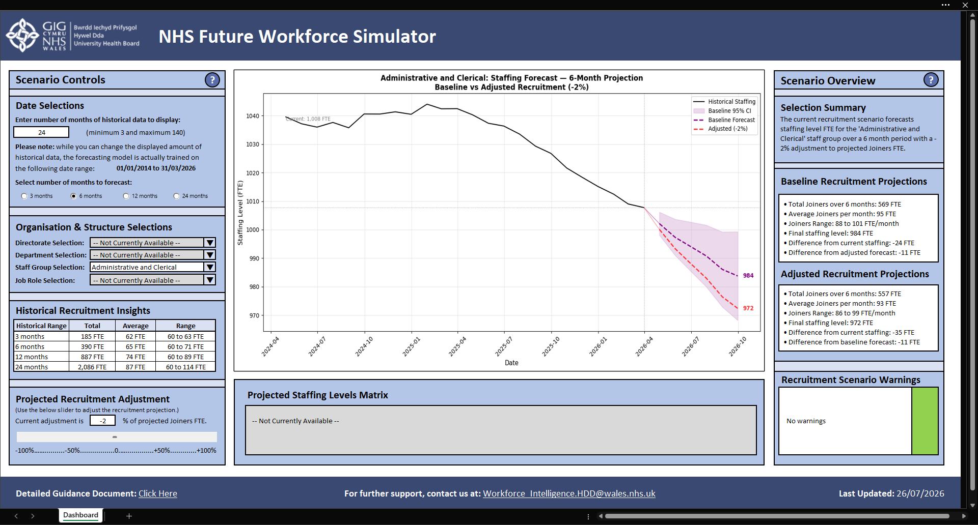
Figure 17: screenshot demonstrating change of Staff Group to ‘Administrative and Clerical’ with reduction in percentage of projected Joiners.
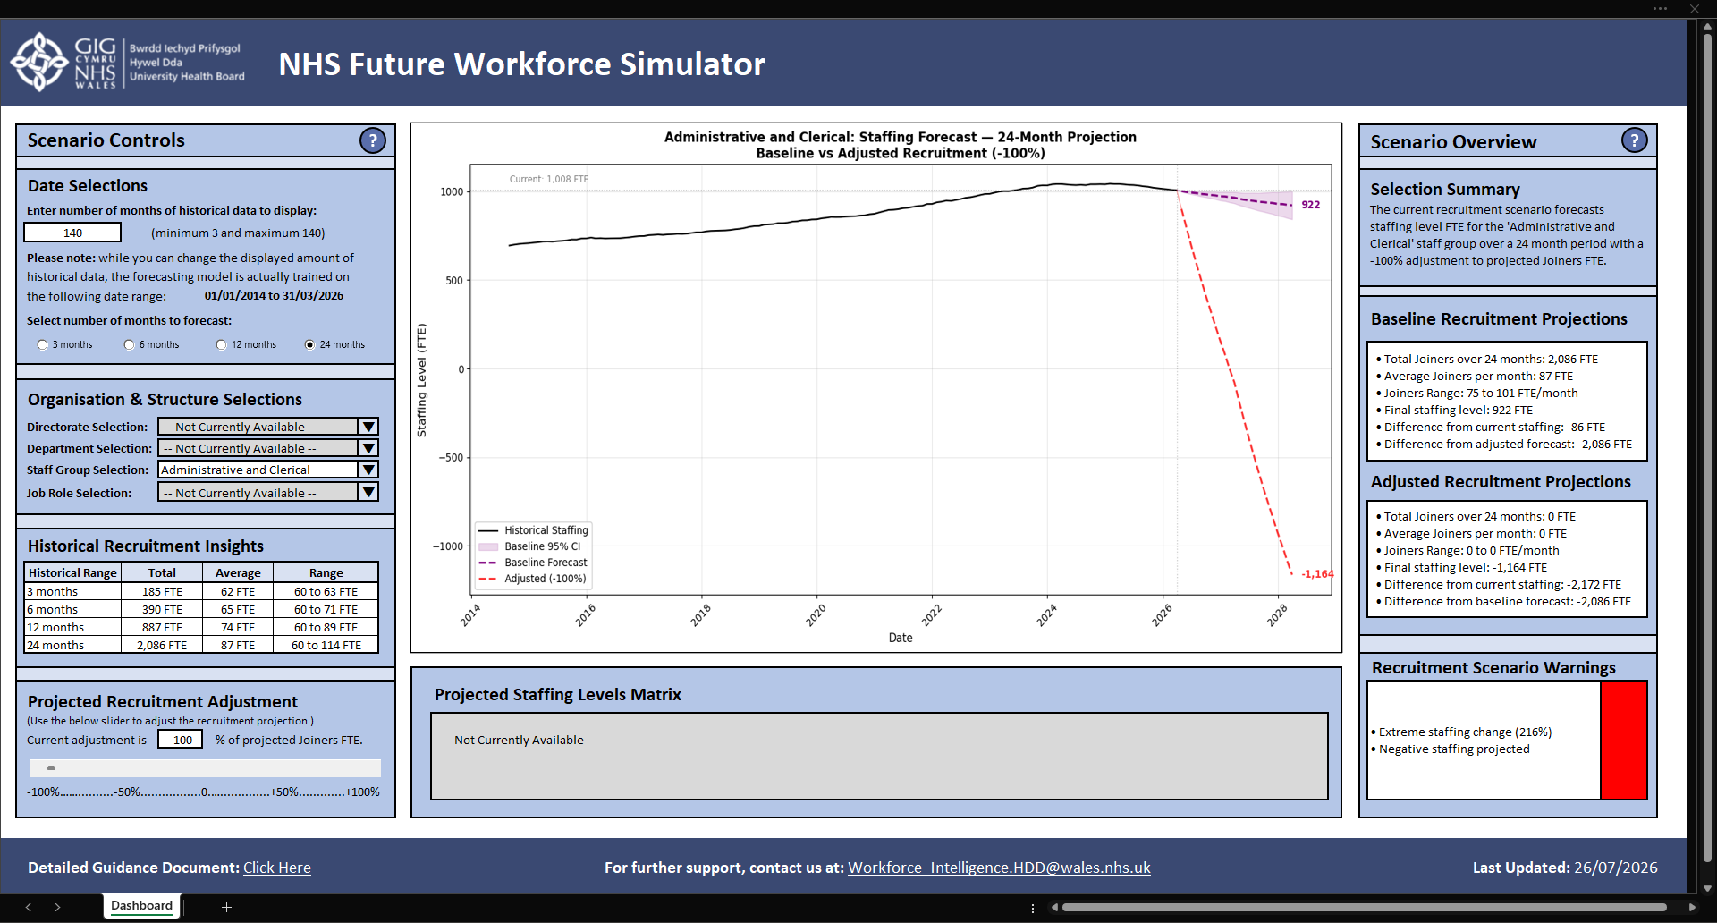
Figure 18: screenshot of Dashboard demonstrating user input variables which exceed expected scenario modelling and triggering Recruitment Scenario Warnings.

3 – Task 2: Innovation

3.1 – Question 1: DevOps
The project has been designed for deployment within the large organisation ‘Hywel Dda University Health Board’, which, with over 13,000 employees, is the local health board responsible for “planning and providing NHS services in Carmarthenshire, Ceredigion and Pembrokeshire” for almost 400,000 people [6].
DevOps is an organisational shift and “evolution of the agile movement” that integrates development and operations away from “distributed siloed groups performing functions separately” [7, 8]. While there is an element of individual assessment required to ensure project and company fit, it will benefit most developers by “better connecting development and operations” and “using automated runtime monitoring for improving software runtime properties” [8, 7]. As an approach, its strengths are in ensuring “fewer requirements changes [and] focused testing and quality assurance” with the potential to “improve [delivery] cycle time by 10 to 30 percent and reduce costs up to 20 percent” [8].
DevOps is suitable for the long-term development, deployment, maintenance, and evolution of this project within the Health Board because it aligns with strategic objectives to reduce siloed working and improve project delivery times. In line with the DevOps stages, the following technologies have been identified for future project development.

3.1.1 – Project Development
- Development environment: Microsoft’s Visual Studio Code (VSC) would be the IDE of choice for Python programming.
- Data storage: Microsoft SharePoint would maintain cloud storage while Microsoft Power Query would prepare the data for modelling.
- Version control: Microsoft SharePoint supports file versions for rollback, and GitHub is now owned by Microsoft so programme version control could be maintained within VSC.

3.1.2 – Project Deployment
- Deployment tools: Excel 365 initially then move to more complex but secure Power BI hosting solution.
- Cloud-based service: Microsoft Azure, currently used to host Power BI dashboards which will form part of the long-term distribution.

3.1.3 – Project Monitoring
- Monitoring Dashboard: to monitor model validity diagnostics and forecast accuracy metrics as new data is uploaded, allowing the team to adjust the model to prevent under/overfitting.
- Power Automate: flows to alert Workforce Intelligence of any unplanned downtime of the user dashboard.

3.1.4 – Project Maintenance
- Workspace management: with the transition to Power BI, workspaces would be used to separately develop and test the solution, while controlling which staff members have access to the final product.

3.2 – Question 2: PEST Analysis
The PEST analysis framework is relied upon heavily for strategic company planning because it provides “a holistic view of the many macro-environmental elements impacting a company” [9]. PEST analysis considers the extraneous influences on the business, specifically Political, Economic, Social, and Technological [9]. The additional variables Legal and Environmental were later added resulting in the PESTLE model which is the most widely accepted version of the framework today [10].
While PESTLE is suitable for examining a company’s external environment, it does not provide an actionable strategy for project managers to respond to those extraneous influences [11]. A related approach to business analysis is SWOT which is a “strategic planning tool that involves evaluating Strengths, Weaknesses, Opportunities, and Threats” [12]. While the frameworks can be conducted separately to understand the internal and external factors affecting a project, by combining PESTLE and SWOT frameworks, project managers can simultaneously understand the external environment and develop an action plan [13].
A PESTLE-SWOT analysis table was created (see Appendix 3) which, in summary, demonstrated that the project’s strengths and opportunities included:
- Strong Strategic Alignment: with key Health Board and Welsh Government strategic priorities, providing the project with a strong policy foundation to secure organisational support and wider adoption.
- Financial Value: through the reduction of agency and bank staff expenditure with improved recruitment investment decisions, with long-term cost savings made through proactive workforce management.
- Technological Opportunity: the first project outside of Data Science to demonstrate how advanced forecasting and simulation techniques can be used with both existing NHS data and widely available Health Board technology.
Project weaknesses and threats were also identified:
- Data Quality and Reliability: one of the most significant challenges is ensuring forecast accuracy which can be affected by inconsistent data and unexpected workforce shocks.
- Skills Requirements: despite using NHS data and widely available resources, the project depends on specialist technical skills to ensure ongoing model maintenance and calibration.
- Legal and Ethical Risks: the project would need to carefully manage equality and bias considerations, and trade union resistance to workforce redeployment recommendations.

4 – Task 3: Project Reflection

4.1 – Question 1: Practical Feedback
To capture feedback on prototype work, a Microsoft Forms survey was emailed to the previous respondents with a Prototype Overview Pack.

4.1.1 – Survey Results Analysis
Prototype Design Stage Survey Results
Respondent | Value | Usability | Scalability | Accuracy | Feasibility | Total
SR1 | 4.3 | 4.3 | 4.7 | 4.7 | 4.7 | 4.5
SR2 | 4.7 | 5.0 | 4.0 | 5.0 | 5.0 | 4.7
SR3 | 5.3 | 4.3 | 3.0 | 4.3 | 2.7 | 3.9
SR4 | 5.0 | 4.3 | 5.0 | 4.7 | 4.3 | 4.7
SR5 | 5.7 | 4.7 | 4.7 | 5.0 | 4.0 | 4.8
Total | 5.0 | 4.5 | 4.3 | 4.7 | 4.1 | 4.5

Design and Prototype Stage Surveys responses were compared to identify where opinion had changed:
Differences from Design to Prototype Stage Survey Results
Respondent | Value | Usability | Scalability | Accuracy | Feasibility | Total
SR1 | -0.3 | 1.3 | 1.7 | 2.7 | 1.3 | 1.3
SR2 | 0.0 | 0.3 | 0.0 | 1.0 | 0.7 | 0.4
SR3 | -0.7 | 1.0 | 0.3 | -0.3 | -1.0 | -0.1
SR4 | 1.0 | 1.0 | 1.3 | 0.7 | 0.3 | 0.9
SR5 | 0.3 | 0.0 | 0.0 | 0.3 | -0.7 | 0.0
Total | 0.1 | 0.7 | 0.7 | 0.9 | 0.1 | 0.5

Results demonstrated overall improved confidence in Accuracy, shifting from Somewhat Positive to Positive on average. However, given their senior management status and technical/theoretical expertise, addressing the decreased confidence of SR3 and SR5 about Feasibility will be critical for securing resource investment approval.
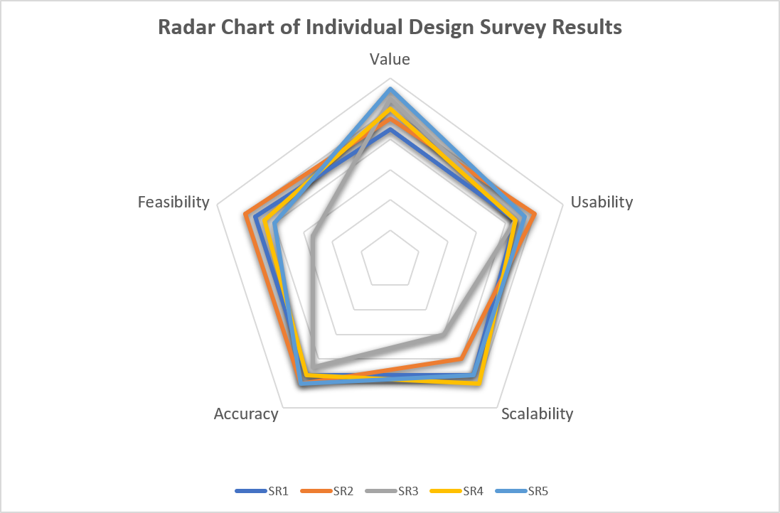
Figure 19: radar chart of averaged individual responses to Prototype Stage Survey.
The radar chart shows respondent consensus across all metrics at Positive levels, with two notable deviations: SR2 maintained Somewhat Positive sentiment on Scalability, while SR3 expressed lowest confidence regarding Feasibility.
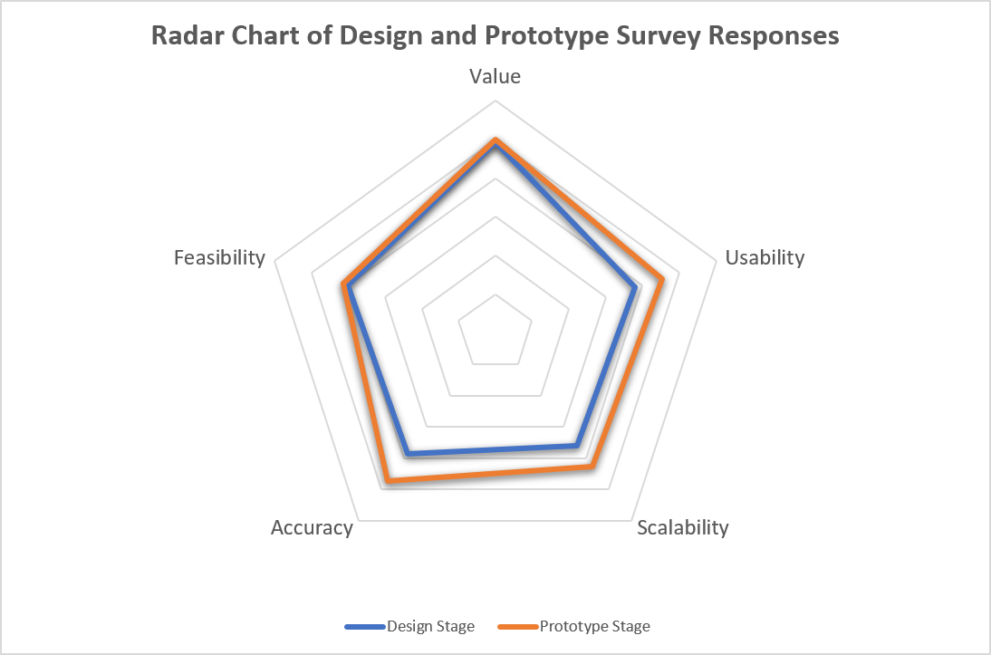
Figure 20: radar chart of overlaid combined responses to Design Stage and Prototype Stage Surveys.
The overlaid radar chart confirms improved consensus on Usability and Scalability, and Accuracy now rivals Value as the highest-rated metric.

4.1.2 – Project Changes from Feedback
Expanded modelling capabilities and supporting user documentation could be considered for future project work based on the qualitive feedback.

4.2 – Question 2: Project Process Diary
The following sections evaluate the use of project management tools, along with a project success, challenge, and future improvement:

4.2.1 – Project Management Tools
- Gantt Chart: visually engaging high-level overview of the main tasks whilst affording granular views of sub-tasks.
- Kanban Boards: separated with an SDLC framework, this was a particularly effective way of monitoring project progression.
- Weekly Progress Sheets: although a basic monitoring method, these ensured short-term targets were set and achieved.

4.2.2 – Project Success
A functioning prototype was demonstrated to survey respondents which gained significant project buy-in.

4.2.3 – Project Challenges
Despite using Excel-compatible Python libraries, an unexpected 8,415-character function limit necessitated a time-consuming separation of the code across multiple cells.

4.2.4 – Future Project Improvements
Further research into interactive Python visuals within Microsoft applications will be required to address respondent Feasibility concerns.

4.3 – Question 3: Knowledge and Skills Developed

4.3.1 – Project Management Knowledge and Skills
- Project Development Methodologies: a hybrid methodology provided the necessary project structure while affording flexibility as new insights were gained.
- Project Task Management: the use of Gantt Charts and Kanban boards were used to appropriately manage project tasks.

4.3.2 – Technical Knowledge and Skills
- Time-Series Forecasting: existing Python skills were extended to understand the principles underlying the ARIMA time-series forecasting model.
- Microsoft Forms: an online tutorial was used to create surveys and collect participant feedback.

4.4 – Positive Social Impact
In line with Welsh Government’s long-term plan for health and social care, the ability to more accurately forecast workforce levels under different recruitment scenarios will be used to support sustainable workforce development, utilising clinical apprenticeship pipelines to attract local talent into healthcare sectors whilst fulfilling projected staffing shortages. Ultimately, the continued development of this project will strengthen rural workforce sustainability, ensuring underserved communities receive safe and accessible care, which will deliver lasting societal value beyond immediate operational benefits.

5 – Conclusion
This assignment has culminated in the development of the ‘NHS Future Workforce Simulator’, a validated ARIMA forecasting tool with recruitment scenario abilities, which addressed key stakeholder concerns through iterative feedback cycles. Through extensive research, practical implementation, and reflective practice, expertise was developed in time-series forecasting, DevOps-aligned deployment strategies, and NHS-compliant Data Science solution design. The project has demonstrated both technical competency and a commitment to Welsh health workforce sustainability.

References

[1] | W. Peng, Y. Li, Y. Fang, Y. Wu and Q. Li, “Radar Chart for Estimation Performance Evaluation,” IEEE Access, vol. 7, pp. 113880-113888, 2019.
[2] | Improvement Cymru Academy, “Radar Charts Tool Kit,” 1 November 2023. [Online]. Available: https://performanceandimprovement.nhs.wales/functions/quality-safety-and-improvement/improvement/improvement-cymru-academy/resource-library/academy-toolkit-guides/radar-charts-toolkit/. [Accessed 30 June 2026].
[3] | J. Lopez, “Python for Time Series Forecasting,” LinkedIn Learning, 17 July 2025. [Online]. Available: https://www.linkedin.com/learning/python-for-time-series-forecasting/. [Accessed 26 May 2026].
[4] | Lumo, Adapting Guidance from 'Python for Time Series Forecasting' Tutorial to suit NHS England Workforce Dataset, Geneva: Proton AG, 2026.
[5] | M. Peixeiro, “Learn Time Series Forecasting in Python,” freecodecamp, 7 August 2025. [Online]. Available: https://www.freecodecamp.org/news/learn-time-series-forecasting-in-python/. [Accessed 26 May 2026].
[6] | Welsh Government, “Hywel Dda University Health Board,” Welsh Government, 27 October 2021. [Online]. Available: https://www.gov.wales/hywel-dda-university-health-board. [Accessed 18 July 2026].
[7] | L. Leite, C. Rocha, F. Kon, D. Milojicic and P. Meirelles, “A Survey of DevOps Concepts and Challenges,” ACM Computing Surveys (CSUR), vol. 52, no. 6, pp. 1-35, 2020.
[8] | C. Ebert, G. Gallardo, J. Hernantes and N. Serrano, “DevOps,” IEEE Software, vol. 33, no. 3, pp. 94-100, 2016.
[9] | A. Waqar, N. Shafiq, I. Othman, F. K. Alqahtani, A. M. Alshehri, M. A. Sherif and H. R. Almujibah, “Examining the impact of BIM implementation on external environment of AEC industry: a PEST analysis perspective,” Developments in the Built Environment, vol. 17, p. 100347, 2024.
[10] | B. Feys, PESTLE Analysis, Mont-Saint-Guibert: Lemaitre Publishing, 2015.
[11] | D. Tang, “How Can PESTLE Analysis Be Integrated With SWOT and Porter’s 5 Forces? [Complete Guide],” Flevy, 24 June 2024. [Online]. Available: https://flevy.com/topic/pestle/question/maximizing-competitive-advantage-integrating-pestle-analysis-strategic-tools. [Accessed 14 July 2026].
[12] | A. Bullock, C. Jennings and N. Timbrell, “SWOT/PEST Analysis,” Oxford Reference, 2019. [Online]. Available: https://www-oxfordreference-com.uwtsd.idm.oclc.org/display/10.1093/acref/9780191863592.001.0001/acref-9780191863592-e-229. [Accessed 7 July 2026].
[13] | Y. Li and M. Zhao, “Focus on the investment of Waste Incineration in China - Based on PEST-SWOT analysis,” IOP Conference Series. Earth and Environmental Science, vol. 358, no. 2, p. 22038, 2019.
[14] | Microsoft Support, “Microsoft Forms help & learning,” Microsoft, 2016. [Online]. Available: https://support.microsoft.com/en-us/forms/. [Accessed 16 July 2026].
[15] | Lumo, PESTLE-SWOT Analysis for Workforce Forecasting Tool, Geneva: Proton AG, 2026.
[16] | R. W. Emerson, “Likert Scales,” Journal of Visual Impairment & Blindness, vol. 111, no. 5, p. 488, 2017.
[17] | J. Lewis and J. Sauro, “Does Removing the Neutral Response Option Affect Rating Behavior?,” MeasuringU, 8 August 2023. [Online]. Available: https://measuringu.com/removing-the-neutral-response-option/. [Accessed 30 June 2026].

Appendix 1 – Weekly Progress Sheets
Below are copies of the weekly progress sheets used to support this assignment.
Name: Edward Lloyd (2511559)
Programme: Changemakers: Creativity and Value Creation (ACCA5033)

Project Aim: To model and forecast NHS workforce levels under various recruitment scenarios.
Project Objectives:
- Source Publicly Available Data and Prepare for Modelling
- Develop Python Modelling Skills
- Build Initial Forecasting Model
- Add Scenario Testing Ability
- Produce Proof-of-Concept (MVP) and Supporting Documentation
Weekly Project progress forms:

Week 1

Date: 30/06/2026 to 06/07/2026

Progress:
- Create data collection form to acquire feedback on initial project design work.

Actions:
State priority actions to undertake over the next week below.
- Finish writing questions for feedback questionnaire.
- Collect feedback from managers and colleagues.
- Summarise feedback results for Radar Chart visualisation and analysis.

Next review date: 07/07/2026

Week 2
Date: 07/07/2026 to 13/07/2026

Progress:
- Practical implementation, adding recruitment scenario testing ability.

Actions:
State priority actions to undertake over the next week below.
- Complete tutorial on ARIMA models.
- Connect forecasting models to NHS dataset.
- Test accuracy of different forecasting model specifications.
- Start testing Joiners adjustment variable to alter projections.

Next review date: 14/07/2026

Week 3
Date: 14/07/2026 to 20/07/2026

Progress:
- ITSM and ITIL practices explained by guest lecturers.
- Complete a PEST analysis table for the project.

Actions:
State priority actions to undertake over the next week below.
- Research and evaluate DevOps fit with current project.
- Complete PEST analysis and research complimentary approaches.

Next review date: 21/07/2026

Week 4
Date: 21/07/2026 to 27/07/2026

Progress:
- Finish forecasting model accuracy testing and produce supporting document.
- Finalise interactive user dashboard to demonstrate to survey respondents.
- Create data collection form to acquire feedback on prototype work.

Actions:
State priority actions to undertake over the next week below.
- Produce supporting document for Prototype Stage Survey to provide evidence of forecasting accuracy.
- Complete interactive user dashboard and implement into workplace system for live demonstrations.
- Finish writing questions for feedback questionnaire.
- Collect feedback from managers and colleagues.
- Summarise feedback results for Radar Chart visualisation and analysis.

Next review date: 28/07/2026

Appendix 2 – CPD Evidence
Below is CPD evidence of the completion of an online certified course related to the assignment.

LinkedIn Learning
The online certified course ‘Python for Time Series Forecasting’ by Jesus Lopez, hosted by LinkedIn Learning, was started for Assignment 1 and completed for Assignment 2 [3].
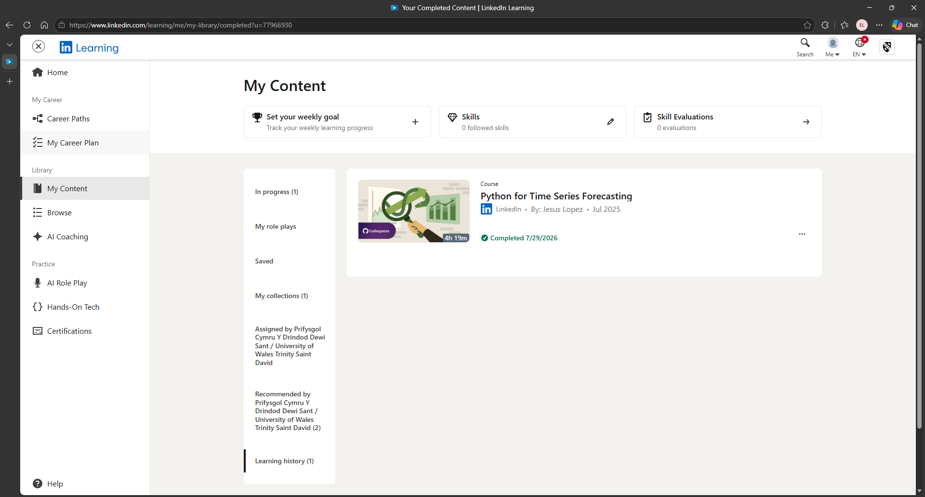
Figure 21: screenshot confirming completion of online certified course ‘Python for Time Series Forecasting’.

Appendix 3 – Design Stage Survey
Below is documented the process for creating, piloting, and releasing the Design Stage Survey and the collection of responses.

Creating Survey
The following list of questions were designed to capture survey responses for five different metrics. The three questions per metric were separated into three separate sections to decrease the likelihood of the respondent choosing the same response for each metric question.
A Likert scale was used to capture responses with the following key:
1 = Strongly Disagree / Very Low
2 = Disagree / Low
3 = Slightly Disagree / Slightly Low
4 = Slightly Agree / Slightly High
5 = Agree / High
6 = Strongly Agree / Very High
Design Stage Survey
Measure 1: Value
Focus: project alignment with organisational objectives and support existing initiatives.
- To what extent do you believe this project will contribute to current and planned directorate objectives?
- How effectively do you believe this solution will support existing Health Board projects and strategic priorities?
- To what extent do you believe this solution will improve workforce planning and decision-making within the organisation?
Measure 2: Usability
Focus: user accessibility and ease of interpretation for different stakeholder groups.
- How easy do you expect the forecasts and projections will be to understand and interpret?
- How intuitive does the dashboard design appear for users with varying levels of technical expertise?
- To what extent do you believe the solution will reduce the time required for workforce analysis and reporting?
Measure 3: Scalability
Focus: potential for project expansion beyond the immediate scope or team.
- To what extent could this solution be adapted to support other workforce planning or forecasting scenarios?
- How likely is it that this solution could be implemented and maintained outside of the Workforce Intelligence team?
- How scalable do you believe this solution would be if deployed across additional directorates or departments?
Measure 4: Accuracy
Focus: model performance and reliability of forecasting outputs to inform staffing decisions.
- Based on the proposed approach, how confident are you that the forecasts generated by this solution will be sufficiently reliable for workforce planning purposes?
- To what extent do you believe the forecast output will provide adequate evidence to support staffing and recruitment decisions?
- How confident are you that the model will accurately reflect the impact of recruitment changes on future workforce levels?
Measure 5: Feasibility
Focus: readiness to implement the solution within the Health Board.
- How confident are you that this solution can be delivered using existing technical resources and infrastructure?
- To what extent do you believe the solution aligns with information governance and data security requirements?
- How feasible is the long-term implementation and maintenance of this solution within current budget and staffing constraints?

Designing Data Collection Method
Microsoft Forms was used to host the survey and distribute it to respondents within the Health Board. This method was chosen due to respondents’ familiarity with the platform and for its ability to collect and summarise responses in a clear manner. Official support documents were utilised from Microsoft to aid in the design and release of this chosen data collection method [14].

Piloting Survey
Initial feedback of the survey was piloted with a non-technical, non-connected team member whose responses were excluded from the final survey. When initial design work was shown to the wider team, a team member recommended the removal of a true neutral answer to discourage users from hiding their opinions within neutrality.

Collecting Survey Results
Survey Respondents (SR) were identified and contacted for their responses:
Survey Respondent | Job Role | Knowledge Background
SR1 | Business Intelligence Officer | Non-technical
SR2 | Business Intelligence Officer | Non-technical but statistical
SR3 | Very Senior Data Systems Manager | Technical
SR4 | Data Systems Supervisor | Non-technical
SR5 | Workforce Planning Project Manager | Theoretical

Microsoft Forms collected their responses and presented overview statistics:
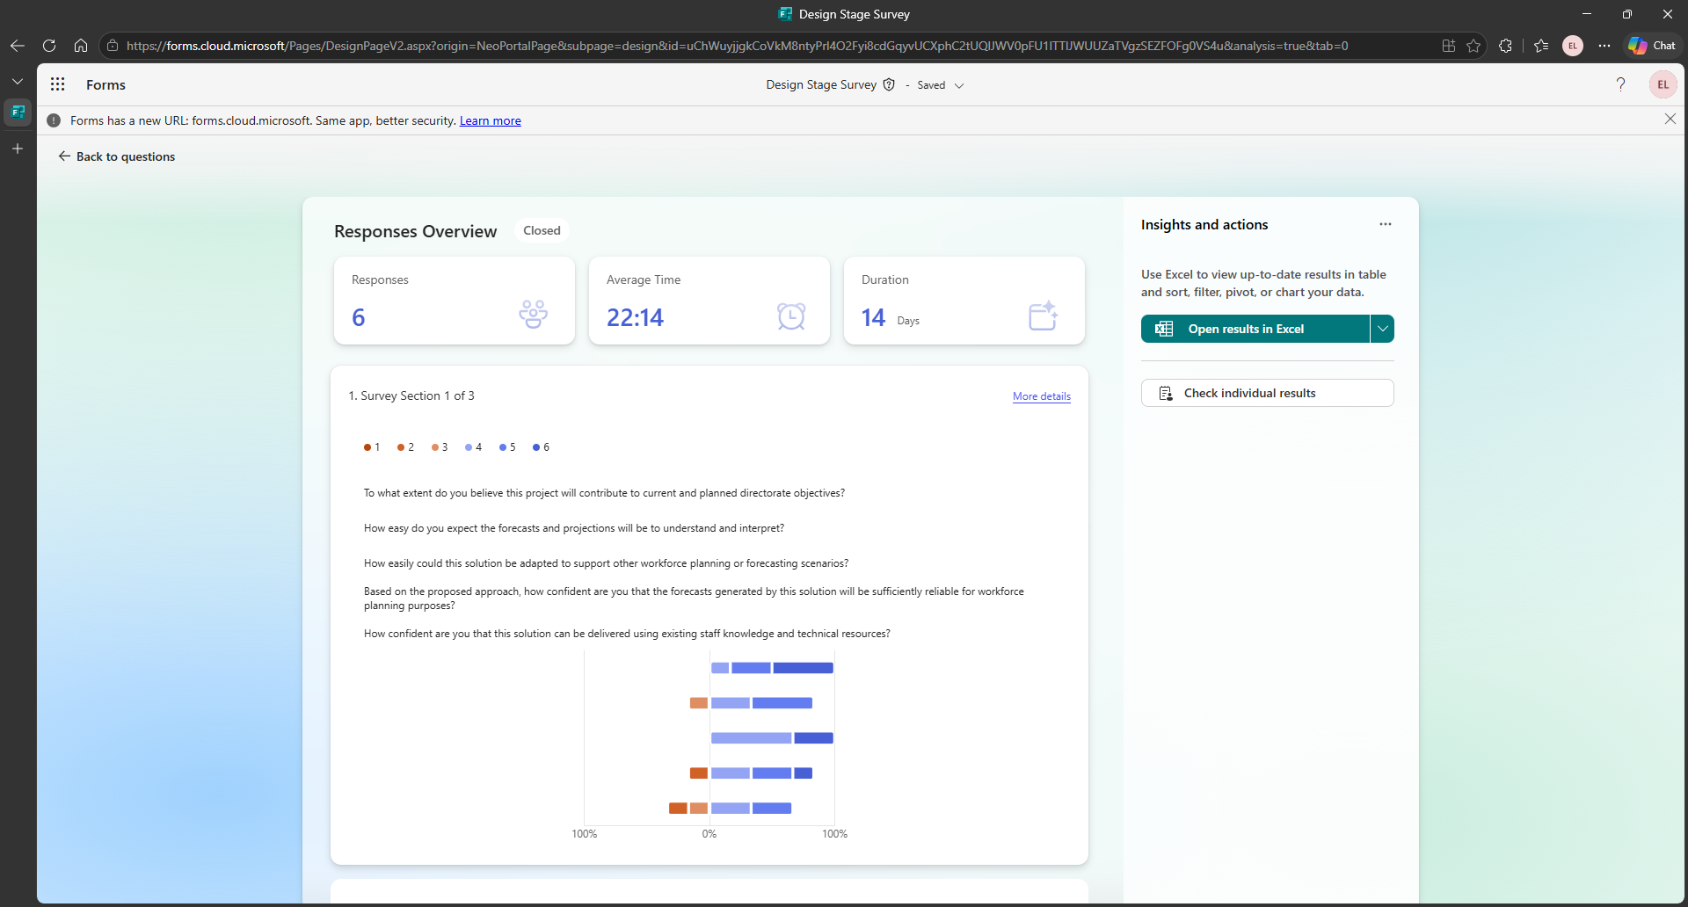
Figure 22: screenshot of Responses Overview within Microsoft Forms for the Design Stage Survey.
Below are tables detailing the responses according to the Likert scale for each question by section, with a RAG rating applied to determine particularly strong and weak project areas according to survey responses:
Section 1 of 3
Respondent | Value | Usability | Scalability | Accuracy | Feasibility | Total
DSR1 | 5 | 3 | 4 | 2 | 4 | 18
DSR2 | 5 | 4 | 4 | 4 | 5 | 22
DSR3 | 6 | 5 | 4 | 5 | 2 | 22
DSR4 | 4 | 4 | 4 | 4 | 3 | 19
DSR5 | 6 | 5 | 6 | 5 | 5 | 27
Total | 26 | 21 | 22 | 20 | 19 | 22
Section 2 of 3
Respondent | Value | Usability | Scalability | Accuracy | Feasibility | Total
DSR1 | 5 | 3 | 3 | 2 | 3 | 16
DSR2 | 5 | 5 | 3 | 4 | 4 | 21
DSR3 | 6 | 3 | 2 | 4 | 5 | 20
DSR4 | 4 | 3 | 4 | 4 | 5 | 20
DSR5 | 5 | 4 | 2 | 5 | 5 | 21
Total | 25 | 18 | 14 | 19 | 22 | 20
Section 3 of 3
Respondent | Value | Usability | Scalability | Accuracy | Feasibility | Total
DSR1 | 4 | 3 | 2 | 2 | 3 | 14
DSR2 | 4 | 5 | 5 | 4 | 4 | 22
DSR3 | 6 | 2 | 2 | 5 | 4 | 19
DSR4 | 4 | 3 | 3 | 4 | 4 | 18
DSR5 | 5 | 5 | 6 | 4 | 4 | 24
Total | 23 | 18 | 18 | 19 | 19 | 19

Sum of All Survey Sections
Respondent | Value | Usability | Scalability | Accuracy | Feasibility | Total
DSR1 | 14 | 9 | 9 | 6 | 10 | 48
DSR2 | 14 | 14 | 12 | 12 | 13 | 65
DSR3 | 18 | 10 | 8 | 14 | 11 | 61
DSR4 | 12 | 10 | 11 | 12 | 12 | 57
DSR5 | 16 | 14 | 14 | 14 | 14 | 72
Total | 74 | 57 | 54 | 58 | 60 | 61

Analysis of the Design Stage Survey results can be found at the assignment section 2.1.2 – Survey Results Analysis.

Appendix 4 – PESTLE-SWOT Analysis Table
Below is the PESTLE-SWOT analysis table based upon the model by Yun Li and Min Zhao and ideation for its content was supported by the AI assistant Lumo [13, 15]:
PESTLE-SWOT |  | P  Political | E  Economic | S  Social | T  Technological | L  Legal | E  Environmental
Internal Factors | S  Strengths | PS1: Strong alignment with Welsh Government's A Healthier Wales strategy and national workforce planning priorities, giving the project political backing. | ES1: Potential for significant cost savings through reduced reliance on agency/bank staff via better forward planning. | SS1: The model's focus on identifying low-retention areas and redeploying staff demonstrates a commitment to employee wellbeing and job satisfaction. | TS1: Leveraging modern simulation and forecasting techniques provides robust, repeatable scenario testing. | LS1: The model can be designed to ensure all redeployment recommendations comply with NHS terms and conditions and employment law. | ES1: Model could be developed to incorporate remote/ hybrid working scenarios, supporting greener commuting patterns and reduced travel.
Internal Factors | W  Weaknesses | PW1: Dependence on sustained political and executive buy-in; a change in senior leadership or ministerial priorities could deprioritise the project.  PW2: Limited prior experience within the team of developing workforce simulation models may slow initial progress. | EW1: Upfront development and validation costs, including specialist software licences and staff time, may strain already limited directorate budget.  EW2: Ongoing maintenance, data updates, and model recalibration require recurring funding that is not guaranteed year-to-year. | SW1: Staff and trade unions may resist data-driven redeployment recommendations, perceiving them as imposed rather than consultative. | TW1: Data quality and completeness across legacy systems may be inconsistent, undermining model reliability.  TW2: Dependency on IT infrastructure and specialised analytical skills; if key personnel leave, institutional knowledge of the model is at risk. | LW1: Employment law around redeployment is nuanced; the model may oversimplify legal constraints.  LW2: Risk of unintended bias in algorithmic recommendations raising equality-law compliance concerns. | EW1: The model does not currently account for environmental disruptions that can significantly affect rural staff attendance and service delivery.
External Factors | O  Opportunities | PO1: Alignment with the A Healthier Wales strategy provides a policy mandate for wider adoption across other health boards. | EO1: Demonstrable benefits through reduced agency spend could attract additional investment and enable scaling to other NHS Wales organisations. | SO1: Ageing population in the Hywel Dda region increases demand for healthcare services, making proactive workforce forecasting more urgent and valued. | TO1: Advances in machine learning could be incorporated to enhance forecasting accuracy over time. | LO1: Increasing regulatory requirements for NHS workforce reporting and planning create a pull for standardised, defensible modelling tools. | EO1: NHS Wales’s commitment to becoming a net-zero health service creates opportunity to model environmentally sustainable workforce patterns.
External Factors | T  Threats | PT1: Competing national workforce initiatives could render a locally developed tool redundant. | ET1: Departmental budget pressures may reduce available funding for tool development and maintenance. | ST1: Industrial action and ongoing disputes over NHS pay and conditions create volatile workforce dynamics that are difficult to model reliably. | TT1: Rapid evolution of workforce analytics technology may outpace the model's development cycle, making it quickly appear outdated. | LT1: Post-Brexit changes to immigration and professional registration rules may affect the availability of internationally recruited staff, complicating model assumptions. | ET1: Increasing environment-related health burdens may increase service use unpredictably, skewing workforce demand.

Appendix 5 – Prototype Stage Survey
Below is documented the process for creating, piloting, and releasing the Prototype Stage Survey and the collection of responses.

Creating Survey
Based on respondent feedback from the first survey, the following changes were made:
- The questions were changed to statements to which respondents would declare the degree of their agreement or disagreement.
- The three survey question sections and free text section were separated into separate pages based on respondent feedback.
- A true neutral option was requested but, as it was not included in the Design Stage Survey, it was not included in this survey to ensure survey responses remained consistent between the two surveys. Further research identified that “well-constructed Likert items generally have an odd number of response categories” because it provides respondents with a “neutral middle response” [16]. Jim Lewis and Jeff Sauro identified that “the absence of a middle option in rating scales tends to increase the magnitude of ratings by a small amount”, their estimate of the effect size is 1.5% for the means [17]. They also identify that there is “less incentive to hide beliefs” in a neutral response when answering questions “about usability or general satisfaction with a system” or application, than compared with “responding to social or political questions” [17].
The following list of questions were designed to capture survey responses for five different metrics. The three questions per metric were separated into three separate sections to decrease the likelihood of the respondent choosing the same response for each metric question.
A Likert scale was used to capture responses with the following key:
- 1 = Strongly Disagree
- 2 = Disagree
- 3 = Slightly Disagree
- 4 = Slightly Agree
- 5 = Agree
- 6 = Strongly Agree
Prototype Stage Survey
Measure 1: Value
Focus: project alignment with organisational objectives and support existing initiatives.
- The project will contribute to current and planned directorate objectives.
- This solution will effectively support existing Health Board projects and strategic priorities.
- This solution will improve workforce planning and decision-making within the Health Board.
Measure 2: Usability
Focus: user accessibility and ease of interpretation for different stakeholder groups.
- The forecasts and projections are easy to understand and interpret.
- The dashboard design is intuitive for users with varying levels of technical expertise.
- This solution will reduce the time required for analysis and reporting on workforce planning.
Measure 3: Scalability
Focus: potential for project expansion beyond the immediate scope or team.
- This solution could be adapted to support other workforce planning or forecasting scenarios.
- The solution could be implemented and maintained outside of the Workforce Intelligence team.
- This solution will be scalable if deployed across additional directorates or departments.
Measure 4: Accuracy
Focus: model performance and reliability of forecasting outputs to inform staffing decisions.
- The forecasts generated by this solution will be sufficiently reliable for workforce planning purposes.
- The forecast output provides adequate evidence to support staffing and recruitment decisions.
- The model will accurately reflect the impact of recruitment changes on future workforce levels.
Measure 5: Feasibility
Focus: readiness to implement the solution within the Health Board.
- The solution can be delivered using existing staff knowledge and technical resources.
- The solution aligns with information governance and data security requirements.
- The long-term implementation and maintenance of this solution is feasible within current budget and staffing constraints.

Designing Data Collection Method
Microsoft Forms was once again used to host the survey and distribute it to respondents within the Health Board.

Piloting Survey
Initial feedback of the survey was received by the same non-technical, non-connected team member whose responses were excluded from the final survey.

Collecting Survey Results
Survey Respondents (SR) which had been identified for the Design Stage Survey were re-contacted for their feedback on the Prototype Stage:
Survey Respondent | Job Role | Knowledge Background
SR1 | Business Intelligence Officer | Non-technical
SR2 | Business Intelligence Officer | Non-technical but statistical
SR3 | Very Senior Data Systems Manager | Technical
SR4 | Data Systems Supervisor | Non-technical
SR5 | Workforce Planning Project Manager | Theoretical

Microsoft Forms collected their responses and presented overview statistics:
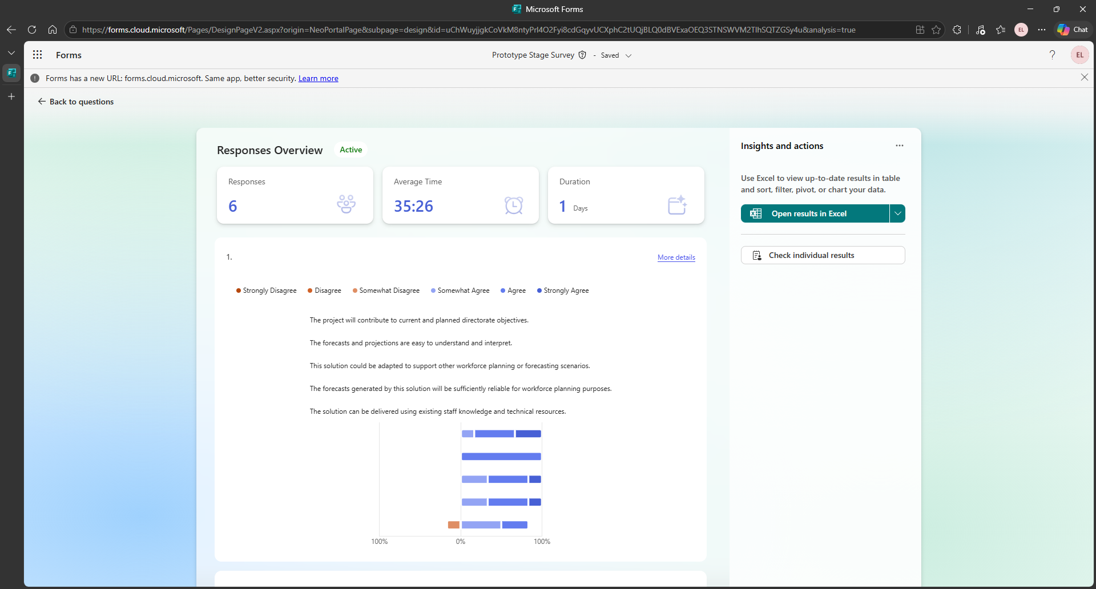
Figure 23: screenshot of Responses Overview within Microsoft Forms for the Prototype Stage Survey.
Below are tables detailing the responses according to the Likert scale for each question by section, with a RAG rating applied to determine particularly strong and weak project areas according to survey responses:

Section 1 of 3
Respondent | Value | Usability | Scalability | Accuracy | Feasibility | Total
SR1 | 4 | 5 | 5 | 5 | 4 | 23
SR2 | 5 | 5 | 4 | 5 | 5 | 24
SR3 | 6 | 5 | 5 | 4 | 2 | 22
SR4 | 5 | 5 | 5 | 4 | 4 | 23
SR5 | 6 | 5 | 6 | 6 | 5 | 28
Total | 26 | 25 | 25 | 24 | 20 | 24
Section 2 of 3
Respondent | Value | Usability | Scalability | Accuracy | Feasibility | Total
SR1 | 5 | 4 | 4 | 4 | 5 | 22
SR2 | 5 | 6 | 3 | 5 | 5 | 24
SR3 | 5 | 4 | 2 | 4 | 4 | 19
SR4 | 5 | 4 | 5 | 5 | 5 | 24
SR5 | 6 | 4 | 2 | 4 | 4 | 20
Total | 26 | 22 | 16 | 22 | 23 | 22
Section 3 of 3
Respondent | Value | Usability | Scalability | Accuracy | Feasibility | Total
SR1 | 4 | 4 | 5 | 5 | 5 | 23
SR2 | 4 | 4 | 5 | 5 | 5 | 23
SR3 | 5 | 4 | 2 | 5 | 2 | 18
SR4 | 5 | 4 | 5 | 5 | 4 | 23
SR5 | 5 | 5 | 6 | 5 | 3 | 24
Total | 23 | 21 | 23 | 25 | 19 | 22
Sum of 3 Sections
Respondent | Value | Usability | Scalability | Accuracy | Feasibility | Total
SR1 | 13 | 13 | 14 | 14 | 14 | 68
SR2 | 14 | 15 | 12 | 15 | 15 | 71
SR3 | 16 | 13 | 9 | 13 | 8 | 59
SR4 | 15 | 13 | 15 | 14 | 13 | 70
SR5 | 17 | 14 | 14 | 15 | 12 | 72
Total | 75 | 68 | 64 | 71 | 62 | 68

Analysis of the Design Stage Survey results can be found at the assignment section 4.1.1 – Survey Results Analysis.

Appendix 6 – Example of p Value Testing
The following appendix documents an example of p value testing of ARIMA(15,1,1) for the ‘Nursing and Midwifery Registered’ staff group based on learning from Jesus Lopez’s certified course ‘Python for Time Series Forecasting’ [3].

Residuals
The first value of the series is an outlier and is not representative because it is not forecasted correctly (with no historic data of its own to use) [3]:
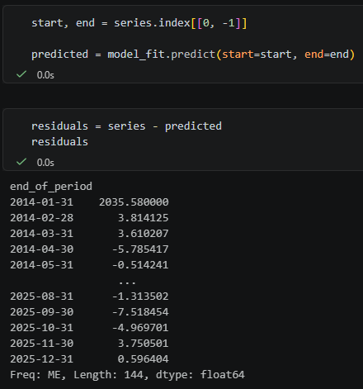
Figure 24: screenshot of code and output for residuals.
Therefore, the residuals were adjusted to begin from the second value, and the histogram below demonstrates that the remaining residuals are all within range:
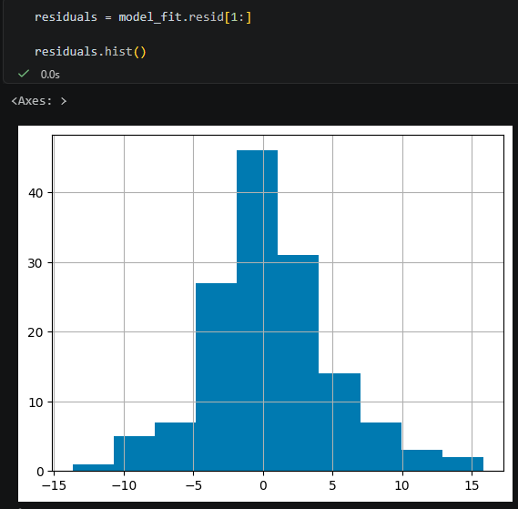
Figure 25: screenshot of code and output for plotting residuals with a histogram.

Autocorrelation Diagnostic
ACF was used to plot the residual distribution, which demonstrated there were no values outside of the confidence box and that there was no pattern in their distribution:
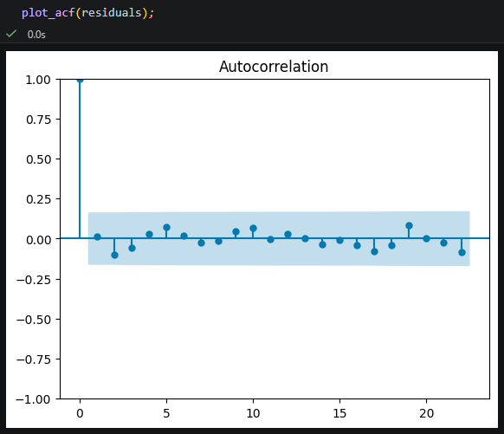
Figure 26: screenshot of code and output of ACF chart to determine if any residual lags fall outside of the confidence box.
The Ljung-Box test was applied at lag intervals of 10, 20, and 30 to verify that residual errors contained no remaining autocorrelation:
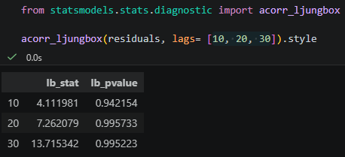
Since all the p values are above 0.05, we cannot reject the null hypothesis, which means there is no autocorrelation between the residuals [3]. While a p value below 0.05 is measured in previous parameter tests, in the diagnostics stage the inverse is true as there must be no significant values on the test which thereby indicates that everything in the residuals is normal [3]. Significant values in the diagnostic stage would indicate that the model is not correctly fitting the data [3].

Normality Diagnostic
To determine the normality of the residuals, at the plotting stage, the line appeared to be properly adjusted to the residuals:
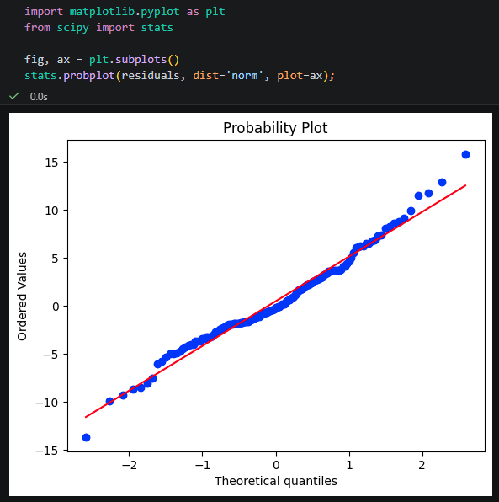
However, during the test stage, a Jarque Bera test was used to determine the p value was 0.03 which is below 0.05, therefore the null hypothesis must be rejected therefore it can be determined that the distribution of residuals does not follow a normal distribution [3].
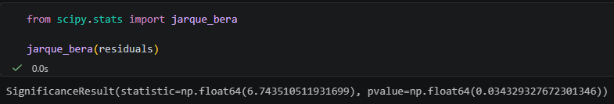

Homoscedasticity Diagnostic
The raw residuals were plotted, indicating some variance at the end (2024-2026):
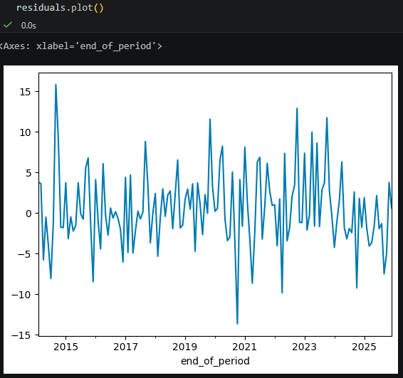
The plot was tested with a ARVH test:
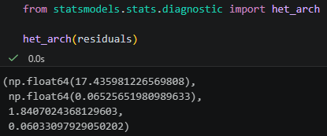
The p value was 0.06 which is greater than 0.05, therefore the null hypothesis cannot be rejected therefore it can be determined that there are no significant differences in the variance of the residuals [3].

Diagnostics Conclusion
While the ARIMA(15,1,1) model for ‘Nursing and Midwifery Registered’ was deemed feasible on the parameter checking, the diagnostics indicated the following:
Diagnostic | Testing Focus | p Value | Outcome
Autocorrelation | Significance of residuals | 0.99 | Passed
Normality | Distribution of residuals | 0.03 | Failed
Homoscedasticity | Variance of residuals | 0.06 | Passed

While the model met the Autocorrelation and Homoscedasticity assumptions, it failed to meet the Normality assumption, and troubleshooting would be required to determine if there is something wrong with the model that can be resolved. As Lopez explains, it is important to ensure correct assumptions “because if all the assumptions are not fulfilled, the solutions you get from the model in the model fit summary’s coefficients are biased and may be indicating a wrong forecast” [3].

Troubleshooting Failed Diagnostic
The ARIMA(15,1,1) is a feasible fit based on the model fit summary which demonstrates a meaningful lag, the model had the lowest AIC/BIC scores, the diagnostic results indicate the residuals are uncorrelated and homoscedastic and have a mean zero. However, according to Lopez, if the data demonstrates seasonality and fails its diagnostics, then a better model must be found, which he suggests is SARIMA; this is because if the diagnostics fail but the parameters testing is successful, then there is an issue with the data or the chosen model (not with the specifications) [3].

Appendix 7 – Administrative & Clerical Model Specifications
The following appendix provides evidence of the model specification testing that was undertaken for the Administrative and Clerical staff group in line with the process used for Nursing and Midwifery Registered, as documented in section 2.2.2 – NMR Model Specifications.

Administrative and Clerical Model Specifications

Model Parameters Selection
The baseline p value was used along with 7 and 15 from analysing PACF and ACF plots, and 12 due to the success with ‘Nursing and Midwifery Registered’. Once again, increasing the q value did not add any significant value so remained as 1.
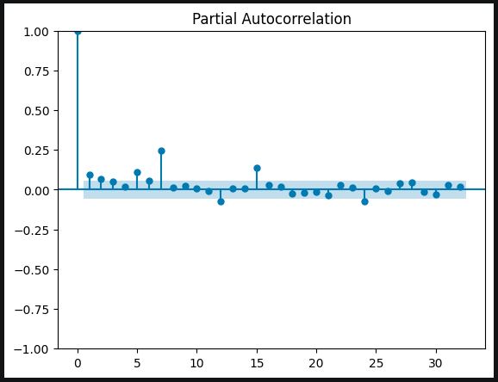
Figure 27: screenshot of Partial Autocorrelation plot for Administrative & Clerical differentiated data.
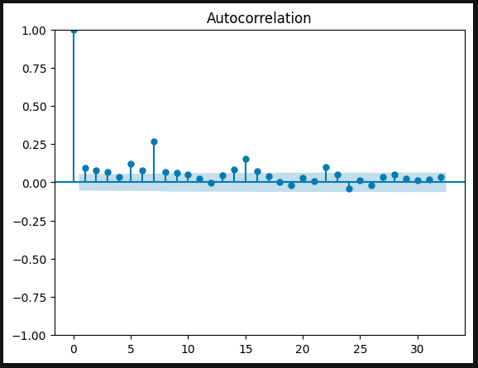
Figure 28: screenshot of Autocorrelation plot for Administrative & Clerical differentiated data.

Model Validity Diagnostics
The table below summarises the diagnostics for each ARIMA model to determine feasibility:
ARIMA Model | Diagnostic | p Value | Outcome
1,1,1 | AR Lag | 0.475 | Failed
1,1,1 | Autocorrelation | 0.001 | Failed
1,1,1 | Normality | 0.661 | Passed
1,1,1 | Homoscedasticity | 0.477 | Passed
7,1,1 | AR Lag | 0.166 | Failed
7,1,1 | Autocorrelation | 0.074 | Passed
7,1,1 | Normality | 0.665 | Passed
7,1,1 | Homoscedasticity | 0.633 | Passed
12,1,1 | AR Lag | 0.000 | Passed
12,1,1 | Autocorrelation | 0.881 | Passed
12,1,1 | Normality | 0.484 | Passed
12,1,1 | Homoscedasticity | 0.999 | Passed
15,1,1 | AR Lag | 0.422 | Failed
15,1,1 | Autocorrelation | 0.988 | Passed
15,1,1 | Normality | 0.422 | Passed
15,1,1 | Homoscedasticity | 0.984 | Passed

ARIMA(12,1,1) was the only model to satisfy all diagnostics.
The table below summarises the results of the AIC and BIC tests to determine model prediction accuracy and simplicity of fit:
ARIMA Model | AIC | BIC
1,1,1 | 684.898 | 693.786
7,1,1 | 674.750 | 701.416
12,1,1 | 647.792 | 689.272
15,1,1 | 647.816 | 715.961

ARIMA(12,1,1) scored the best for both AIC and BIC tests indicating the feasibility of its model compared to the others based on accuracy of predictions and simplicity of fit.

Forecast Accuracy Metrics
The tables and charts below demonstrate the accuracy of each model where the forecast is compared to actual data within a historical period:
ARIMA Forecast vs Actual Data (01/02/2016 to 31/12/2019)
ARIMA Model | MAE | RMSE | MAPE
1,1,1 | 9.708 | 10.598 | 1.240%
7,1,1 | 8.426 | 9.119 | 1.083
12,1,1 | 9.135 | 10.014 | 1.183%
15,1,1 | 68.018 | 84.301 | 8.479%

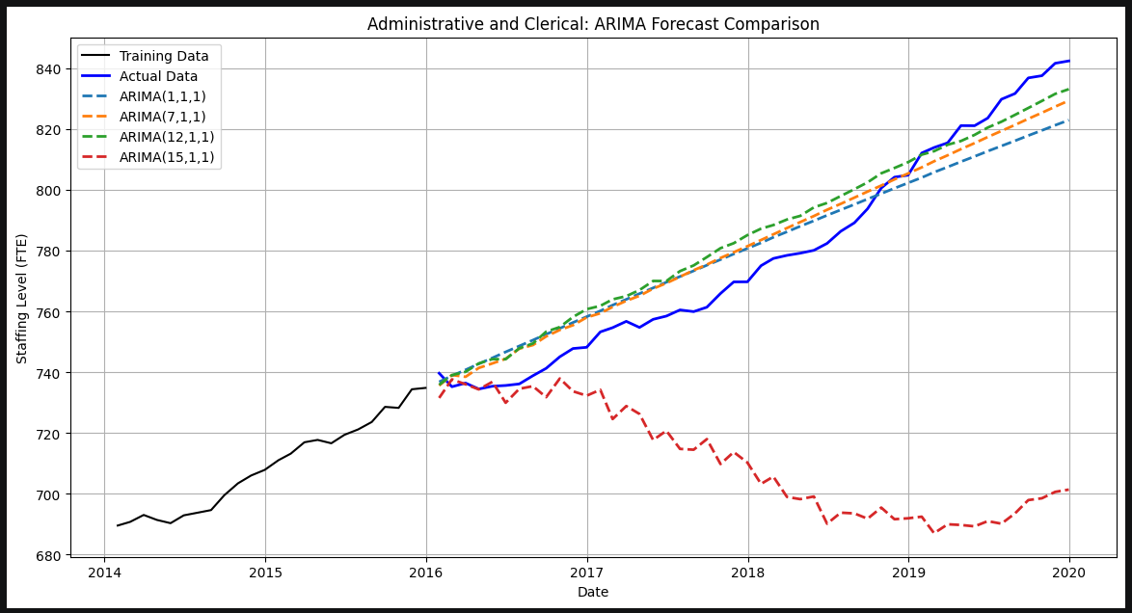
Figure 29: screenshot of ARIMA Forecasts by model vs Actual Data for ‘Administrative and Clerical’ from 01/01/2016 to 31/12/2019.

ARIMA Forecast vs Actual Data (01/01/2020 to 31/03/2026)
ARIMA Model | MAE | RMSE | MAPE
1,1,1 | 34.607 | 42.087 | 3.448%
7,1,1 | 31.331 | 38.241 | 3.124%
12,1,1 | 36.682 | 44.254 | 3.647%
15,1,1 | 33.872 | 41.236 | 3.370%

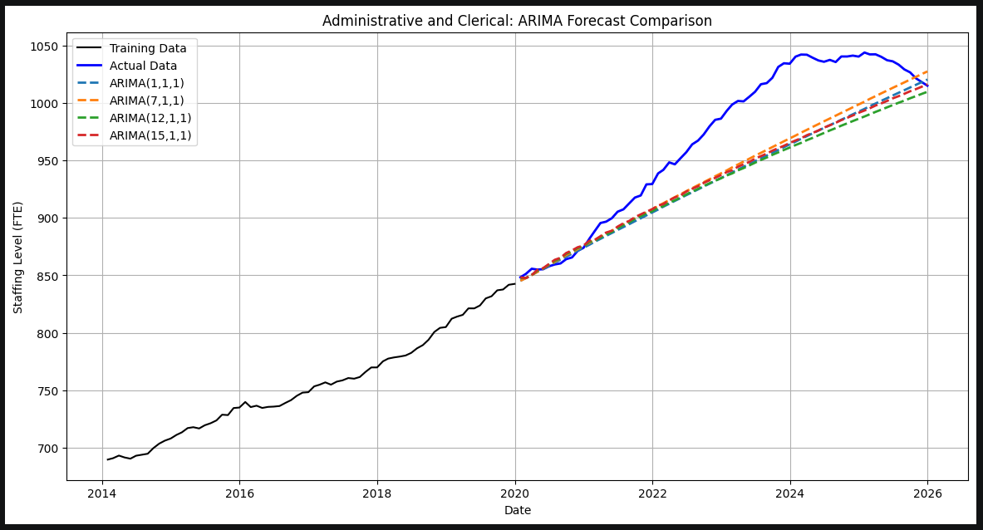
Figure 30: ARIMA Forecast by model vs Actual Data for ‘Administrative and Clerical’ from 01/01/2020 to 31/03/2026.

ARIMA Forecast vs Actual Data (01/01/2022 to 31/12/2023)
ARIMA Model | MAE | RMSE | MAPE
1,1,1 | 13.521 | 14.751 | 1.353%
7,1,1 | 11.291 | 12.425 | 1.129%
12,1,1 | 4.399 | 5.058 | 0.440%
15,1,1 | 4.255 | 4.955 | 0.426%

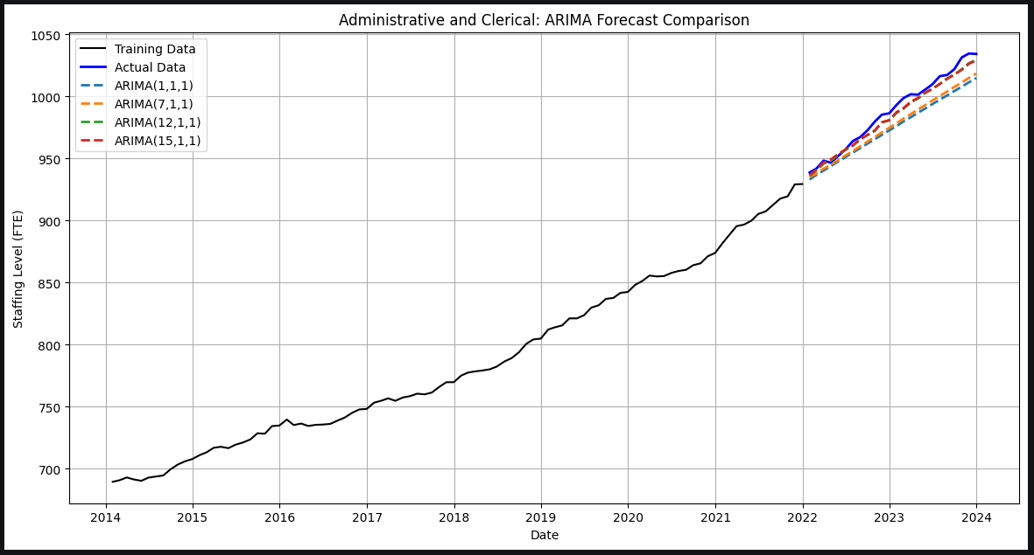
Figure 31: screenshot of ARIMA Forecasts by model vs Actual Data for ‘Administrative and Clerical’ from 01/01/2022 to 31/12/2023.
ARIMA(1,1,1) with its short-range memory was the most accurate pre-2020 with stable growth, ARIMA(7,1,1) with its medium-range memory was the most accurate post-2020 with sudden increase, plateau, and decline, and ARIMA(15,1,1) with the longest-range memory was the most accurate for recent return to stable growth.

Model Selection
Although the forecast accuracy metrics demonstrate how well each model matches historical data within a specific period, it is the p value testing, residual diagnostics, and AIC/BIC tests which indicate whether a model is structurally correct and will behave reliably in the future [3].
ARIMA(12,1,1) is again the most defensible model because statistical validity ensures long-term reliability better than forecast accuracy metrics [3]. It is the only specification that is statistically valid across the entire dataset, passes all p value checks and residual diagnostics, and has the best AIC/BIC scores. This means it is the most reliable model for future forecasting, even if other models appear more accurate in isolated periods.
However, for perspective it is worth recognising that ARIMA(12,1,1) is still competitive in its accuracy, scoring on average only 2.068 FTE higher than the highest scoring models for MAE, 2.337 FTE for RMSE, and 0.212% for MAPE.

Appendix 8 – Recorded Simulation of Dashboard Interaction
The below YouTube link is for an unlisted recording of the simulated user choices made for section 2.2.4 – User Dashboard Visualisation:
https://youtu.be/eec5LYK6Sfg
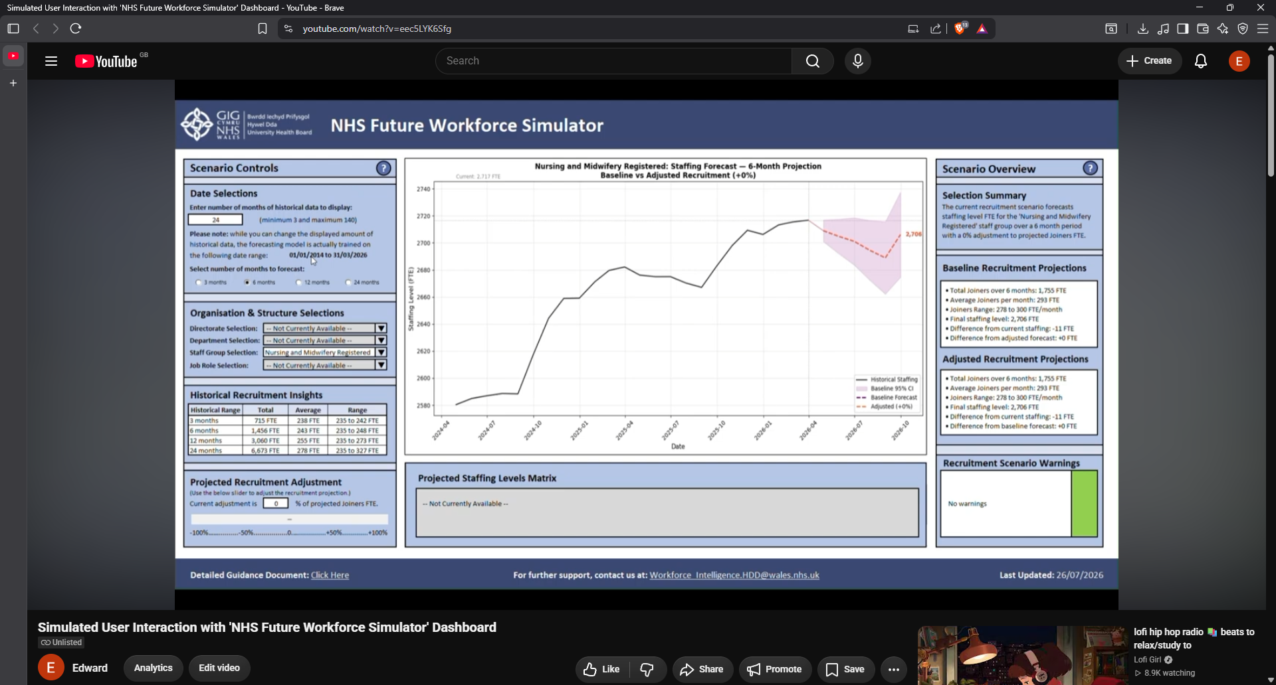
Figure 32: screenshot of unlisted YouTube video of simulated user interaction with prototype dashboard.

