Keren Godson-Cofie

1809329

BSKM4003

Digital Skills and
Research Methods

Anupam Mazumdar

This essay will evaluate the effectiveness of modern technologies in the health and social care setting while exploring social media as a marketing tool. Over the years, modern technology developments have affected the quality of care for patients, practices of health care workers and improved services across the healthcare sector. There are various innovations that have impacted benefits of modern technology.
Electronic Health Records has shifted the way health care professionals provide care for service users. Healthcare roles such as nurses and health care practitioners have the responsibility for inputting patient data such as medical records, care plans, scheduling appointments, updating patient into a digitalised system. They provide data to clinical researchers which advances the development of new treatments. In addition, the technology makes it easier to discover illness and develop treatment plans, which makes it efficient. Entering data into a computerised system is much time-efficient than written methods. This can help to reduce the risk of forthcoming errors in patient data and details. This will create an efficient base for confidentiality and productivity.
‘Big data’ is the term used for data collected from various sources that are then processed for analysing. Healthcare naturally collects and stores huge amounts of data. This information has benefits such as:
- Decrease in healthcare costs
- Avoiding preventing deaths
- Improving quality of life
- Reducing healthcare consumption
- Improving efficiency
- Developing new treatments and medication
This is perhaps one of the innovative products in healthcare technology. The cloud uses software and hardware in order to distribute services through the internet. In this case, both health professionals and service users can have admission to records and information and be able to use various applications. Cloud computer technology allows various information to be stored cost-effectively. It also includes many recovery services with strong backup systems. The cloud is a invaluable tool that can widely be used for the research of medical information and the analysation of data. Having the ability to share this type of data can help the development of new and better medication with in health care. Health professionals can share information such as medical records, diagnosis and patient details more time-effectively using smartphones, emails, telemonitoring and telemedicine systems.
Telemedicine can be used for the transmission of health care data and can be used in various fields such as radiology screening. It can also monitor symptoms and risks of many health illnesses. It is known to improve the quality of care as there will be minimum waiting time and more access for service users; improved efficiency of working cooperation and collaboration amongst health care staff.
There are various mobile health apps that are flexible and give both health professionals and service users cheap and quick access to useful information. Health professionals may use health apps to contribute with diagnostics, mental and physical health records, weight and fitness, treatments, management of medication and management of chronic care.
Communication technology allows health care professionals to complete tasks. For example, my role as health care assistant, if a patient needs new medication, I would be able to access their medical history to see which medication will be suitable for them to take. In terms of cloud storage, health professionals can store and save data files safely without misplacing or forget where they have placed them as there are many systems to back up files. Health care facilities are able to reach out to service users who may be unable to physically attend the facility through the use of social media. Health professionals are able to discuss with the patient about their diagnosis, treatments and medications suggested and how they can help themselves on a daily basis. In terms of better treatment and rapid changes in preventing disease, new medicines, new machines and new treatments can reduce the levels of mortality and improve the services health professionals provide. To the fact that electronical databases consume large amounts of information used for medical methods, it makes patient care safe and reliable as service users will also be able to have access to their details and information so they can understand their level of quality of care. It has enabled health professionals. There are various databases online that can analyse health trends. An example is the Google search engine that can foresee health trends in the rising level of obesity nationally and internationally. Not only is this beneficial for health professionals but it will also benefit medical experts to take precautionary trials.
Despite the advantages of medical technology, there are also many disadvantages and dangers that link into health care. Firstly, bandwidth allowance may exceed, which will result into high-costs of electronical medical care. Secondly, there may be times where power cuts occur, which means having no internet access to any data and files, hence the importance of saving all data regularly. This may cause issues specially amongst multi-displinary teams as they may have been relying on information to progress in their team goal. To managers, this may be lack of organisation and lack of competence which will affect each health worker in the group. Another disadvantage is that there may be risk of medical information being hacked. Within health and social care there has been many data thefts as medical records were being stolen. This may put into question how safe records and medical information is amongst patients and health professionals. Having secure data security in the workplace is essential in order to maintain confidentiality. Lack of security can result to internet viruses and harmful software/hardware. Medical technology also requires time to adapt as they are constantly evolving. There may also be over-dependency. As many health professionals will be using the same or similar health systems, there is likely to be a rundown on the computer system. This can be a major issue especially in the emergency department as there needs to be rapid care constantly. This influences how procedures need to be followed as the system will be delayed. This will also influence how patients are cared for. According to Hospitals and Health Networks (2009) ‘Hospitals with high percentage of poor patients that fall behind in developing digital technology than hospitals with a low percentage of poor patients that is difficult for administrators to change their system to become more digital’. This could lead to health care inequalities.
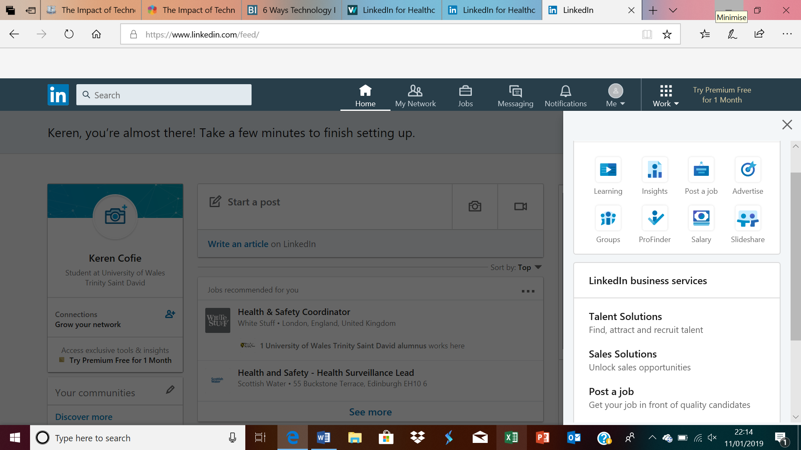
LinkedIn for Healthcare

Linkedin is a valuable social media tool that is widely used by healthcare professionals with over 1.5 million healthcare professionals registered for personal and professional development. Health professionals can use LinkedIn to learn about other companies and organisations that branch outside health and social care. In order to start a network, an online profile has to be created which outlines your job role, experience, education, achievements and goals. Once the profile is created, you are then able to connect with other health professionals. the more health professionals linked to your network, the more your network will grow and develop into a bigger network, as you are continually making yourself accessible to other health professionals. It can also help to introduce new heath professionals, new treatments, and new medical technologies and new innovations your workplace may have never come across. Being socially active on LinkedIn allows healthcare professionals to share important information.

References
Banova, B. (2018). The Impact of Technology on Healthcare | AIMS EDUCATION. [online] AIMS EDUCATION. Available at: https://www.aimseducation.edu/blog/the-impact-of-technology-on-healthcare/.
Honigman, B. (2019). 24 Outstanding Statistics on How Social Media has Impacted Health Care. [online] ReferralMD. Available at: https://getreferralmd.com/2013/09/healthcare-social-media-statistics/
Linkedin.com. (2019). LinkedIn. [online] Available at: https://www.linkedin.com/feed/ [Accessed 11 Jan. 2019].
Rauv, S. (2017). The Impact of Technology in Healthcare: Trends and Examples | elcom. [online] Elcomcms.com. Available at: https://www.elcomcms.com/resources/blog/the-impact-of-technology-in-healthcare-trends-benefits-examples.
Russell, J. (2017). Social Media in Health Care: Benefits, Challenges, and Opportunities. [online] Hootsuite Social Media Management. Available at: https://blog.hootsuite.com/social-media-health-care/.
The University of Scranton Online. (2019). Top 5 Ways Social Media is Used by Healthcare Professionals. [online] Available at: https://elearning.scranton.edu/resource/business-leadership/top-5-ways-social-media-is-used-by-healthcare-professionals

