Simon Fudge
1904006
Photography in the Arts
ADAD4018, Ways of Thinking
Lecturer, Ryan Moule

Task 1: Observational writing.
548 words
According to Barker (2004) Ferdinand de Saussure (1857-1913) is described as the founding theorist of Semiology. A fundamental concept of Semiotics is that language signs achieve meaning only when they have connections with other signs and are placed into meaningful combinations. Saussure suggested that the signifier is the combination of sounds of the language, and the signified is the idea or concept behind the sign. It is the science of signs in social life and related to Structuralism.
Barker (2004, p.189) tells us that ‘…a structuralist understanding of culture is concerned with the ‘system of relations’…’
Nicholas (2017) argues the study of signs suggest that something stands in for something else. In nature for example the appearance of a line of seaweed on a beach suggests that the tide has come in and out. There is an inherent link between the seaweed and the ocean. He goes on to explain that words, written or spoken can also be signs.
I take this to mean for example, that the word cat conveys the idea of a particular animal. Similarly, a photograph of a cat communicates the idea of a cat without it being a cat. However, there is no inherent link between the word cat and the physical animal. It is a societal construct, in this case an English societal invention. To a non-English speaker the spoken noise ‘cat’ signifies nothing.
An understanding of how communication is made and recognising how signs are often purely constructed is surely an important concept for artists.
During the 1970’s the company who make the alcoholic drink Martini made several television adverts.
https://www.youtube.com/watch?v=6AfYoXxtZLU
The opening scene shows two skiers descending the snow-covered slopes. This is the signifier or as Levi (2006) points out, how Barthes might suggest the denoted sign. The signified or connoted meaning is intertextual with the following two scenes. One, where two people, a young adult man and woman appear on boats speeding through a marshland and smiling. This image is then immediately followed by the image of the bottle of Martini alcohol.
The literal images come quickly. Next there is a luxury boat. At the helm is a man and at his side a young woman. Then the Martini is poured into a glass full of ice just to reinforce the message. Drink this and the underlying, metaphoric meaning is that you will be happy.
This was at the time when the international package holiday would be a thing of the future for most people.
There follow further rapid images of horse riding in the countryside and scuba diving in a crystal-clear ocean. The people are always young, beautiful and happy.
One scene depicts the couple hugging closely while the music tells us that there is a ‘wonderful world you can share in the bright taste of Martini’.
The advert concludes with a couple kissing at sunset on a beach.
The advertising campaign represents the personification of the exotic and the sophisticated and is seeking to create a metonym between the drinking of martini with a suave, jet set existence, fun filled with beautiful happy people.
Having made a semiotic analysis of this advert I am drawn to Berger (1972, p.149) where he suggests that advertising usurps democracy. It diverts peoples’ attention from the lack of democracy withing society.

Bibliography
Barker, C., (2004). The Sage Dictionary of Cultural Studies., London: Sage Publications.
Berger, J. (1972) Ways of Seeing. London, Penguin.
Levy, L. (2009). The Question of Photographic meaning in Roland Barthes’ Camera Lucida. Philosophy Today, 53(4), pp. 395-406.
Nicholas, T., (2017). Semiotics: WTF? Introduction to Saussure, the Signifier and Signified [video]. Available at: https://www.youtube.com/watch?v=0JtJu9HdQVM. (Accessed: 2 December 2020).

Simon Fudge 1904006
ADAD4018
Manifestos
Lecturer: Ryan Moule
522 words

Task 2. What Do I Believe in as a student artist?

Listen and Learn
Experiment
Place and Time
Creativity

Practice, practice
Now and Then
Light and Dark
Environment

Environment
I want to practice my art outdoors as much as possible. I believe that being sat in front of a computer is not healthy for the body, mind nor spirit.
Macfarlane (2016) describes the manifesto of the West Coast f64 group as rejecting a prevailing pictorial approach in favour of a more direct presentation. The group included Edward Weston, Ansel Adams and Imogen Cunningham.
I can appreciate the amazing clarity and composition of many of their images but what I am most drawn to is the time they spent communing with their natural environments. As we lose the wilderness and species, I want to savour what is left.
Liz Wells (2004 p.267) describes their style as ‘American Formalism’. She writes about how Ansel Adams drew the analogy between the creating of a photographic image and the making of a piece of music. Many of their images are magnificent and I aspire to the creative and technical abilities of their makers but equally I feel the producing of art is as important as the result.
Place and Time
I was born in Britton Ferry within an industrialised, working class environment. Heavy industry was all about and during the 1960’s one could often taste the Welsh coal and grit in the smoke-filled air. I witnessed the declines of these ways of life and I feel pulled towards the bones and scars of its memories.
I lament the passing to some extent of the dignity of the urban working class who found identity, pride, fellowship and status within their labour and communities. I also remember the exploitation, pollution and appalling dangers associated with heavy industry and try to avoid the ‘rose tinted’ spectacles.
In Smith (2019) the urban landscape photographer John Davies says “…the most important influence on my work has been my background and the places where I lived.”
I think the work of John Davies and other British artists such as John Kippin, John Blakemore and Jem Southam as awe inspiring and a celebration of creativity and of our British landscapes.
Now and Then
Sontag (2005 p.5) pointed out that ‘…photography has become almost as widely practiced an amusement as sex and dancing – ‘
If this were true almost four decades ago then I wonder what she might make of our societies today. Virtually every person on the planet now carries with them a camera in their mobile phone.
The ubiquity of the photographic image is undeniable and self-evident. It seems almost too easy to take and distribute via the internet these images due to their digital format.
Sontag (2005 p.7) argues that the speed and ease of taking photographs back then somehow diminished the meaning of the events they depicted. Perhaps her point is even more valid today.
I feel that I want to slow down the process and I am interested in using film as a medium.
I suspect the pace of life has also speeded up and I want to slow it down. I want to have time to think carefully about what I am doing, to ponder, reflect, experiment, and explore. I want to play with light.

Bibliography
Macfarlane, E. (2016). Group f.64, Rocks and the Limits of the Political Photograph’, American Art, 30(3), 26-53. Doi:10.1086/690265
Smith, O., (2019). The Reality of the Place Where We Live. Photographies, 12(2), pp.143-153
Sontag, S., (2005). On Photography, Rosetta Books
Wells & Wells, Liz, 2004. Photography: A Critical Introduction 3rd ed., New York: Routledge

Practice-based writing
536 words
When I was a child, I was taken by my parents to an art gallery. I cannot remember where it was but I do remember that the oil paintings hanging in there were old and were mainly portraits of posh, rich people from hundreds of years ago. Many were surrounded with fancy, ornate golden coloured frames. Perhaps I was quite young as I remember I had to crane my neck to see them properly. I remember it was crowded with people and that it was hot and stifling.
I also remember that I felt that I should be appreciating these images but that they had no positive emotional effect upon me whatsoever. Rather, I felt an indifference to them and even a dislike. I remember feeling sick, hot and sweaty and my head was spinning. It was a relief to get back outside and away from that place.

Berger (1972, p21) talks about the false sense of ‘religiosity’ that surrounds many works of art and this resonates with me. He explains that objects have a market value and how they are talked up by a social and self-interested elite.
A person feels as if they must appreciate these things or they might be considered uncultured. Berger, (p.29) goes on to suggest that the establishment’s cultural system supports unequal social hierarchies.

Moving on some decades later I saw several large paintings by Mark Rothko at the Tate Modern. They were in a dimly lit room to themselves and there was a calm, pensive and immersive atmosphere. In (Bourriaud et al 2002 p.79), it is suggested that the intention is to place and surround the viewer in a colourful experience.
The images did not act alone but were part of a group and in a particular setting. I was able to sit down and situate myself directly in front of these paintings. It was quiet and the room seemed to hum with vibrations that could not be heard.
According to the Tate.org.uk (2020) it was Rothko’s intention and design that the works should be exhibited in this way.
Rothko shows how artists might enhance the viewer’s experience by not only considering the work piece itself but also the setting within which it will be seen.
I contrast that approach with the example of Richard Billingham’s 1996 work ‘Ray’s a Laugh’. Cotton (2004) suggests that when making these images the artist had no intention that they be seen by a viewer at all but were made merely as sketches in preparation for paintings. However, they are powerful, moving and intriguing.
A few years ago, I saw David Nash’s exhibition at Cardiff Museum and I was able to appreciate and admire not just the pieces themselves but the way they had been curated and displayed.
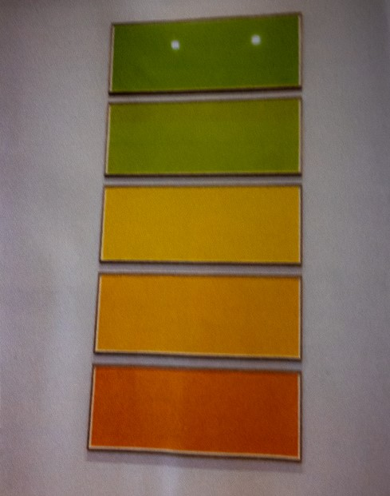 Fig 1

The works were widely spaced in a white wall setting. The ceilings were high and the rooms very quiet and well lit. There were hardly any other visitors and I was able to peruse and contemplate the work at my leisure.
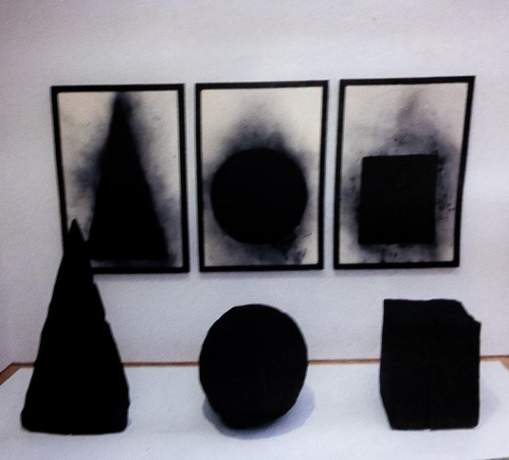fig 2

I was inspired by Nash’s video piece, Wooden Boulder (2019). During my Foundation studies I went on to create a video, drawing on some of his themes and motifs.

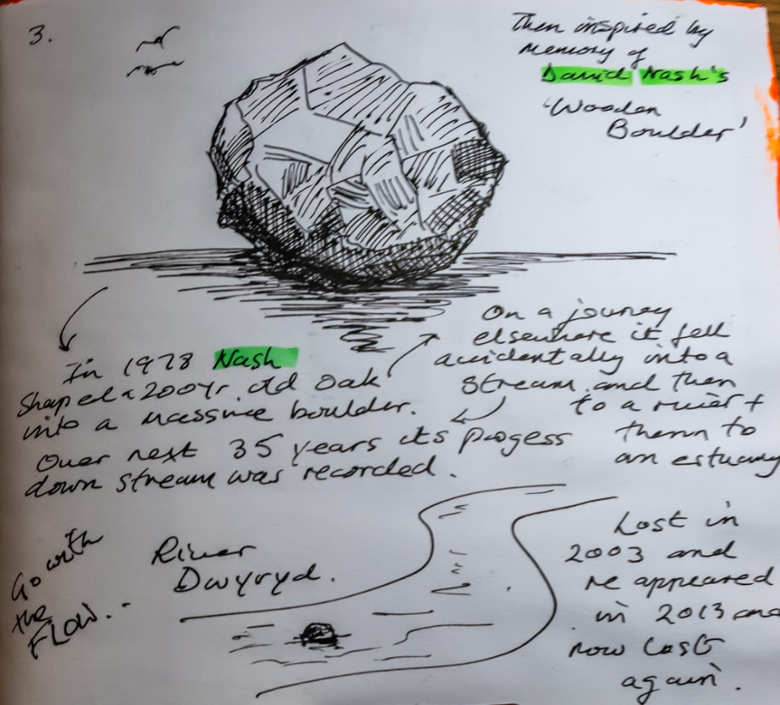

Fig 3 notes
As a result of these experiences, I carefully consider the viewer when deciding about the creation and viewing of my work. For example, I use a blog where I can upload high definition, large file images; https://wordpress.com/view/simonfudge.art.blog

Bibliography
Berger, J. (1972) Ways of Seeing. London, Penguin
Bourriaud, N. Pleasance, S., Woods, F. & Copeland, M. (2002). Relational Aesthetics. Presses de Reel.
Cotton, C. (2004). The Photograph as Contemporary Art. Thames & Hudson.
Fudge, S. (2019) Fig 1 & 2, 3.
Nash, D. (2019), Sculpture Through the Seasons. Cardiff Museum, Cardiff, 3 May – 1 September 2019.
Tate.org.uk (2020), Mark Rothko. Available at https://www.tate.org.uk/visit/tate-modern/display/in-the-studio/mark-rothko. (Accessed 7.12.20)

