

Strategic Festivals and Events Management

Feasibility Study

Executive Summary

In July 2018, the Village of Mumbles hosted the first White Lady Festival. With all aspects of the event being organised by the Mumbles Community Council. This is a weekend long family and community-based festival.

This study investigates whether or not running the local festival on an annual basis this a feasible option for the village or not. Due to the failure of the event in 2019 this is an extremely important document that if at the end results in the conclusion of the festival being a viable option it could aid in gaining funding and support from stakeholders. This is stated below in the Purpose part of the document.

This report provides a clear background for the event along with background into Mumbles which is the destination for the festival. It states what the area is like and how much it has grown from a little fishing village into a busy diverse village. The festival as a whole is examined, putting forward what type of festival this is going to be. The White Lady Festival is very community based, using local suppliers to provide the food and beverages for the event. This festival is being hosted in order to try and give something back to the local community by also providing entertainment and games.

A further point which is evaluated is the current market and demographic of the Mumbles area. After conducting research, it is apparent that this little village is home to people of all ages however most of which are fairly affluent with disposable income available to use in events like this. After taking this into consideration it is apparent that this festival will need to cater for young children, the older generation in the area and every age category in between. By being aware of the target market within the area, the organisers can also implement the appropriate trends. The main trend for events at the moment is that they are becoming more activity based. The White Lady Festival has already stated that they look to include different activities in the festival to help encourage people to attend. A massive part of researching the market around the festival is including a PESTEL analysis as this has determined any political, economic, social, technological, environmental and legal factors that have the potential to affect the festival and people attending.

Oystermouth Castle is the chosen venue for this event and has been analysed to ensure appropriateness for this event. As this venue has hosted successful events in the past, it is considered to be a great fit for this community festival. However, by conducting research into the destination, the festival is being held in this report has been able to identify any areas that will need to be looked at before hosting the festival. For example, people coming and going from the festival will need to be well monitored and controlled as there is only one main entrance, so it is vital that the efficiency of ticketing system is well thought through. Linked with the destination analysis is a SWOT analysis that states a few strengths, weaknesses, opportunities and threats that the festival will encounter. After evaluating this it is apparent that the strengths and opportunities for the festival and local community massively outweigh the weaknesses and threats that may be encountered.

Furthermore, stakeholders have been identified and analysed, these include the local community, the community council, local businesses, support services for the event and many, many more. It has been identified that a lot of the stakeholders involved in this festival have the potential to aid in the planning and running of the event.

This feasibility study additionally provides a critical evaluation of the operational and strategic issues which could arise from the staging of The White Lady Festival. By reviewing the operations included in this festival it is apparent that a massive issue this festival faces and should look into is timing for the entire festival as it is not sustainable for the festival to continue operating as it is due to timing not suiting the targeted market. The report will look into potential impacts of the event and how these can be turned in positive or eradicated for the future sustainability of the festival. As this is a community based festival, there are many potential positive social impacts that could arise from holding this festival which could include increasing community pride and bringing people together that may not usually socialise. However, as this is an outdoor event there are also huge negative environmental impacts that will need to be reviewed as they could not only be an issue for the duration of the festival but could result in long lasting issues for the host destination.

This report concludes by offering recommendations that the festival could benefit from trying out. These include the festival to maintain as a local one, as this event has put such an emphasis one being a community-based festival, however they have used musicians that are not local and are extremely expensive. A further recommendation for this festival is to cut down the days to just the Saturday and Sunday as this could result in higher ticket sales. Furthermore, as previously suggested, the festival may benefit from adjusting their timings from 2018 and possibly having a constant flow of musicians. Lastly, it is apparent that no contingency plan was put in place for the 2018 festival so this a recommendation that is imperative that if looked at for following festivals.

Content Page

  - Purpose 6
  - Background 6
    - The Festival in Context 7
  - Market Analysis/Demand 8
1.2.1 PESTEL 9
  - Destination Analysis 9
    - SWOT 10
  - Stakeholder Analysis 11
  - Operational Analysis 12
  - Impact Analysis 13
  - Conclusion & Recommendations 14
  - References 15
  - Appendices 17
1.10.1. – Steam Summary 2017 – City and County of Swansea 17
1.10.2. – Male to Female Ration in Mumbles 18
1.10.3. – Age Distribution in Mumbles 18
1.10.4. – Age Groups in Mumbles 18
1.10.5. – PESTEL 19
1.10.6. – Map of Oystermouth Castle 21
1.10.7. – SWOT 22
1.10.8. – Stakeholders 24
1.10.9. – Event Timings 25
1.10.10. – Operations 26
1.10.11. - Financial Summary 27
  - Purpose

The purpose of this feasibility study is to provide the Village of Mumbles with the information required to make an informed decision about whether or not to continue to plan, host and run the family friendly festival that is ‘The White Lady Festival’. Allen et al., 2014, suggest that in order for any kind of event to be a success, a feasibility study must be undertaken in order to examine and overcome any weaknesses the event may face. Specifically, this study will analyse the current market in the area and any demand for this type of festival. In addition, the event project tasks, timing, capability, recourse requirements and any stakeholders will be determined and outlined. The potential for any social/cultural, economic/developmental political and environmental management and leverage will be taken into account through strategic analysis of the potential impact. The study identifies opportunities for collaboration with existing community events and businesses.

  - Background

The little old fishing village of Mumbles marks the beginning of the coastline along the Gower Peninsula. Visit Swansea Bay, 2019, suggest that although Mumbles is only a village there is something for everyone here with plenty of thing to do, see and explore. On the quaint streets there are many different high-end shops, independent boutiques or much-loved galleries showing off work based on the area. With outstanding views across Swansea, Mumbles is well known for walkers as it can lead them all around Gower. Bellis, 2017, continues and looks at other attractions in the area, including Oystermouth Castle, Mumbles lighthouse and the Mumbles lifeboat station. This village is home to a number of local businesses, not only including the shopping, but restaurants, cafes, bars and many more.

1.2.1. The Festival in Context
It is suggested by Long and Robinson, 2004 that festivals as a whole are a way of bringing people together through their love of the same thing. In this case if would relate to the community, music, food and drink.

Ramsey, 2018 states that the festival is organised by the Mumbles Community Council. The name for the festival comes from the resident ghost of Oystermouth Castle, The White Lady. Williams, 2018, adds to this by explaining what the festival is about as it combines local food, drinks, music and games in order to create an event and atmosphere that will provide entertainment for the whole family for a weekend. The festival in 2018 played host to a number of variations of Music, including rock, classical, blue, pop and flamenco jazz.

Williams, 2018, states that “the aim of The White Lady Festival is to put on something for the locals and also to encourage visitors to come down for the weekend to enjoy a festival atmosphere in the beautiful grounds of the castle.” This aim suggests that this festival is trying to raise the profile of the village and the local businesses that operate within it. As shown in the appendices under the heading 1.10.1. the tourism report for Swansea as a whole. Swansea.gov.uk, 2019 state that in 2017 the total economic impact based on tourism was a huge £417.85M. by reviewing these figures it is apparent that there is already enough tourism within the city as a whole to keep festivals like The White Lady Festival running. However, as this festival is trying to put its focus on the local community it may attract some tourism depending on size and marketing. Even if this is the case, according to citypopulation.com, the population of Mumbles in 2017 was 16,603 so even if the festival struggles to attract tourist it should be a great way to bring the local community together through a fun day out for the whole family.

Another aim sated by Ramsey, 2018, is that one of the main reasons of hosting this festival as a locally based one is in order to try and give back to the local community. This is why that festival is trying to only host local businesses to source to food and beverages, as well as keeping trying to only employ local artists and bands to perform at the festival.
  - Market Analysis/Demand
Robinson, Wale and Dickson, 2013. Suggest that in order to create and run a successful event a feasibility study must be put together and in order to successfully do this, market analysis needs to take place. This includes gathering data regarding the market being targeted, in the case, the Mumbles area. As previously stated, this festival aims to target all generations by ensuring that they are able to provide activities, entertainment, food or drink for each person attending. Under the headings 1.10.2., 1.10.3. and 1.10.4. in the appendices are graphs showing the demographic in Mumbles. The graphs sourced from citypopulation.de, 2019, show the male to female ratio in the village which are very similar at 52.3% female and 47.7% male. By having a near 50/50 split it will mean that the festival really has to ensure that they are catering for both genders equally. In addition to this, another graph shows the age ranges for the local people. This is split in 10-year groups, 0-9, 10-19, 20-29 and so on. Each of these categories equally vary from between 1,289 which is the age category 20-29, to 2,444 which is the 60-69 age category. By now knowing the age demographic within the area the festival is going to be held, it will aid the event organiser in knowing what to include in the event. By also knowing the age ranges it is apparent that the aim of this festival, to make it a family friendly on can be achieved as a lot of families live in Mumbles. Shone and Parry, 2015, suggest that by researching and knowing the demographic being targeted it can lead to many benefits. It is evident that the festival has already done research into this as their main aim is to produce a festival that will include the whole of the community. Local, 2017 suggests that by staging an event that has the potential to include to entire community will allow an increase in local tourism which will lead to benefiting local businesses. Furthermore, if the festival is run well and becomes well known it could aid in reinforcing the identity of Mumbles. Lastly, it will bring the local community together and create a stronger bond within Mumbles and allow people to get together and have fun.

Booker, 2018, suggests that the events industry in 2018 had twenty-two main trends that most events ranging from festivals, corporate events would follow. The main trend that The White Lady Festival follows is that “more activity-based festivals will launch.” This is something that this festival will look at, as this is not just going to be an average festival but one that will engage with its audience in more ways than just through musical acts. By becoming more activity based it could also attract more people to the festival by appealing to a wider demographic.

    - PESTEL
Worthington and Britton, 2018, state that a PESTEL analysis is extremely beneficial to businesses and events. It incorporates political, economic, social, technological, environmental and legal factors that have the potential to affect a business or event. In the appendices under the heading 1.10.5. is a PESTEL analysis for The White Lady Festival outlining factor that could affect it.

  - Destination Analysis

The destination that will be used to host The While Lady Festival will be the grounds of Oystermouth Castle, situated in the heart of Mumbles. In the appendices under the heading of 1.10.6., I have inserted a map to show what is around the castle and grounds. As seen in the image sourced from Google Maps, 2019, the location is right next to the main road in and out of Mumbles. This will allow for easy access for any tourists who would be attending the event. In addition to this, Visit Swansea Bay, 2019 confirm that the castle has disabled access if needed, parking and toilet facilities nearby, is a dog friendly venue that also aims to attract children and families. However, as stated by Kluge, 2018, this space is open air, due to this, last year’s festival was unable to run some of the activities as the weather was so bad. Moreover, the grounds of this Castle are uneven so could pose problems for visitors. In addition to this, the village has numerous hotels, B and B’s and rooms to accommodate any tourists looking to stay for the weekend. Furthermore, Mumbles as a host destination itself has the ability to cater or a potentially massive event. The village successfully hosts a number of events throughout the year, such as the RNLI Raft Race. This is also a community-based event that brings together local businesses to build their own raft in order to raise money for the Mumbles RNLI and compete in the race. Perkins and Dalling, 2018 have suggested that thousands of people gathered along the Mumbles promenade to watch the race. Another successful event that is organised by the local council and held in Mumbles, is the ‘Mumbles Here Comes Summer’ event. This is to celebrate schools going on holiday and the beginning of the summer period. It is stated by Dalling, 2018, that this festival brings together the local community but putting on a mini street festival, including children’s rides, stalls, food and beverage stalls and live music. This is also done at Christmas time where they close the street and again have children’s rides, stalls, food and beverage stalls and live music. Williams, 2018 goes on to explain that this event is based around turning on the Christmas lights for the village, because of this, the RNLI team get together and ride down the street with Santa. Focusing specifically on Oystermouth castle, according to Kluge, 2018, the last successful event that was held at Oystermouth Castle was a ‘Halloween Spooktacular”. Williams, 2018, explains that this event was a Halloween themed one aimed at all ages 8+. This event was marketed more as an experience over event which included atmospheric lighting, theatrical effects including audio and visual and actors. Oystermouth Castle was the chosen destination due to its 12th century vaults, ancient corridors and the ghost of the White Lady. Due to the fact that Mumbles Community Council and the selected destination have successfully hosted events in the previous years, it suggests that if The White Lady festival is properly organised it has massive potential to be a huge success for the local community.

    - SWOT
As stated by Shone and Parry, 2013, a SWOT analysis is a useful tool for events as it is used in order to determine the strengths, weaknesses, opportunities and threats that the event may face. In the appendices under the heading of 1.10.7. is a SWOT analysis focusing of The White Lady Festival.

  - Stakeholder Analysis

Stakeholders are a person, group or organisation that have an interest in this case it would be The White Lady Festival. They might possibly benefit from the festival, or it may affect them in other ways. This is suggested by Foley, McGillivary and Mc Pherson, 2012. Stakeholders can be internal or external parties with direct or indirect interests. The main stakeholder for The White Lady Festival will be the Mumbles Community Council as this group of people will have a massive interest in the event and will have the most to gain or lose during and after the festival, this will also be due to the fact that the council will be organising and running the whole event. There are a group of major stakeholders for this event that will come under the category of ‘Support Services’ for event. A major stakeholder and supporting service for this event will include the local businesses that will be involved by having stalls at the event. According to Williams, 2018, local pubs ran a beer tent last year alongside Cheers Wine Merchants running a Gin Bar. There were also food stalls at the event which also featured local businesses including Chai and Gower Ice Cream. All of the businesses would be stakeholders in this event as they have masses of interest in this event as it has potential to make money for them. There are many more stakeholders that come under the support services umbrella including and companies including in providing any A/V equipment needed. For example, staging, lighting, sound and power. A further support service that will be utilised during this event will be first aid and security services. There will be a vital service for this event as it is anticipated to be an extremely busy event security will be needed on the bars and both are required for this type of event. Lastly, a waste management service will be required for during the event to keep on top of waste and post event in order to dispose of all general waste and recycling. On top of having all of these support services as stakeholders another huge stakeholder for this festival will be the local community in Mumbles. As this festival is being marketed as a community-based festival it is imperative that the local community is actually considered and their needs are taken into account. As the festival was not as successful as once thought last year, the organisers must ensure that they include food and beverage stalls, musical acts and stalls that the community would like to see at an event like this. In the appendices under the heading 1.10.8. is a table listing numerous other stakeholders for this event.

  - Operational Analysis
Whitford, Dunn and Cooper, 2013, suggest that operational analysis relates to the study of the operational systems being use for an event with the aim of identifying opportunities for improvement. A key factor that needs to be investigated is the timings of the event. In the appendices under the heading 1.10.9., sourced from Mumbles.gov.uk, 2019, are the timings used for the festival held in 2018. On Friday, the first day of the festival, the site opens at 6:45 with no closing time states. Masterman, 2014 suggests that in order to ensure event success the timings of the event must flow well. Apart from the Friday, as there isn’t much on, the festival has ensured that the Saturday and Sunday part of the event flow smoothly, starting with activities during the day time until 5:45pm on Saturday and 6:00pm on Sunday. This ensures that families attending the event with young children are able to bring them at times that suit them. Moreover, the location of the event and available infrastructure will need to be taken into consideration alongside any equipment needed. This will all need to be evaluated in order to ensure the correct pieces are being sourced, the equipment is in good condition and the price is competitive. It is apparent from viewing ‘The White Lady Festival 2018 Review’ that this was not done before running the 2018 festival. By looking at the table in the appendices under the heading of 1.10.11., the amount paid for all of this equipment was outrageously expensive. By conducting in depth research, the festival will be able to correct this mistake for the 2019 festival. Additionally, all operations involved in running the event will need to be analysed, this will include looking at the job roles of all of the staff involved and ensuring that they are working to the best of their abilities, along with doing their jobs well and efficiently. O’Toole, 2011, offers four important aspects to consider when looking at operations of an event. These include having a detailed map of the venue in order to visualise the running of the event and entry flow of attendees. Coordination of staff and any volunteers used to ensure effectiveness, having the right equipment to keep track of people attending the event and finally to have a contingency plan that covers all eventualities of the event. Reviewing the festival held in 2018 it seems apparent that no contingency plan was put in place regarding weather as the festival had to shut until 3:30pm on the Saturday. In the appendices under the heading 1.10.10. is a table listing all of the resources required for this event and potential suppliers.

  - Impact Analysis
Jones, 2010, recommends that in order to achieve event sustainability it is imperative to analyse any potential impacts of the event. These impacts can be measured using the ‘Triple Bottom Line’ tool. Slaper and Hall, n.d., propose that this tool incorporates three aspects of event impact including social, economic and environmental. As this is an event with massive focus on the local community this event should have positive social impacts. This event has a main aim of bringing together the community in the Mumbles area, which does have potential of becoming a reality. Wood, 2017, puts forward the idea that more and more events are putting a focus on the wellbeing of the people attending. Considering this, if The White Lady Festival is successful in achieving its aim of bringing together the local community, they would be improving the wellbeing of the guests. As well as this, if the festival is a success it could have an impact on participation throughout the community and boost community pride. This festival does have the potential to impact the skills of the people working the event and any volunteers, this is due to the fact that as there is nothing similar to this event being held in the surrounding area it will allow for people to learn new skills to implement in future employment. Additionally, the local economy is likely to be positively impacted. This is done by the local people attending the event, and by doing so putting money back into the community by purchasing food and beverages from the local business stalls and even attending the festival in the first place, as it is a council run event. In addition to the social and economic impacts created by this festival, there will also be impacts to the local environment. These impacts could be negative, as a result of this it needs to be ensured that these impacts are appropriately assessed and prevented. For example, as this is an event that is held outside it is imperative that all waste generate in well managed as if not it could have detrimental impacts for not only the landscape and venue itself but also for any local wildlife.

  - Conclusion & Recommendations
To conclude there is plenty of evidence to suggest that this festival is able to become a successful annual event. However, in order to achieve this there are some recommended changes to be made. Firstly, for the festival to remain as a local event, it has put such an emphasis one being a community-based festival, however they have used musicians that are not local and are extremely expensive. This can be done further down the line as the festival grows, but for now, local musicians will aid the festival by bringing their follows and keeping costs down. Additionally, it could be argued that the festival would sell more tickets if it was only held on the Saturday and Sunday. By doing this, the festival would make savings as Friday only had music on with no other attractions so this may have deterred people from coming. Moreover, the festival may benefit from adjusting their timings from 2018 and possibly having a constant flow of musicians. Lastly, it is apparent that no contingency plan was put in place for the 2018 festival so this a recommendation that is imperative that if looked at for following festivals.

  - References
Allen, J., O'Toole, W., McDonnel, I. and Harris, R. (2014). Festival and special event management. Vancouver, B.C.: Langara College.
Bellis, K. (2017). This is what it's really like to live in Mumbles. [online] walesonline. Available at: https://www.walesonline.co.uk/news/local-news/what-its-really-like-live-13214419 [Accessed 15 Jan. 2019].
Booker, B. (2018). 22 Event Trends for 2018 - Eventbrite UK Blog. [online] Eventbrite UK Blog. Available at: https://www.eventbrite.co.uk/blog/event-trends-for-2018-ds00/ [Accessed 16 Jan. 2019].
Citypopulation.de. (2019). Mumbles (Community, United Kingdom) - Population Statistics, Charts, Map and Location. [online] Available at: https://www.citypopulation.de/php/uk-parishes-wales.php?adm2id=W04000583 [Accessed 15 Jan. 2019].
Dalling, R. (2018). Major road to be shut in rush hour for festival and samba parade. [online] walesonline. Available at: https://www.walesonline.co.uk/news/wales-news/major-swansea-road-shut-during-14953759 [Accessed 16 Jan. 2019].
Foley, M., McGillivray, D. and McPherson, G. (2012). Event policy. London: Routledge.
Google Maps. (2019). Google Maps. [online] Available at: https://www.google.com/maps/search/oystermouth+castle+grounds+size/@51.5771398,-4.0048398,16z [Accessed 16 Jan. 2019].
Jones, M. (2010). Sustainable event management. London: Earthscan.
Kluge, E. (2018). .
Local, R. (2017). The Importance of Festivals Within Your Community. [online] Houston Party Rental. Available at: https://www.houstonparty.com/importance-festivals-within-community/ [Accessed 16 Jan. 2019].
Long, P. and Robinson, M. (2004). Festivals and Tourism: Marketing, Management and Evaluation.
Masterman, G. (2014). Strategic sports event management. London: Routledge.
Mumbles.gov.uk. (2019). [online] Available at: https://www.mumbles.gov.uk/wp-content/uploads/2018/10/The-White-Lady-Festival-Review-2018-FINAL-Edited-SH.pdf [Accessed 17 Jan. 2019].
O'Toole, W. (2011). Events Feasibility and development: from strategy to operations. Amsterdam: Butterworth-Heinneman.
Perkins, L. and Dalling, R. (2018). The colourful and creative vessels at the 2018 Mumbles Raft Race. [online] walesonline. Available at: https://www.walesonline.co.uk/news/wales-news/gallery/mumbles-raft-race-2018-pictures-14993545 [Accessed 16 Jan. 2019].
Ramsey, M. (2018). [online] Mumbles.gov.uk. Available at: https://www.mumbles.gov.uk/wp-content/uploads/2018/10/The-White-Lady-Festival-Review-2018-FINAL-Edited-SH.pdf [Accessed 15 Jan. 2019].
Robinson, P., Wale, D. and Dickson, G. (2013). Events Management. 1st ed. Cabi Tourism Texts.
Shone, A. and Parry, B. (2013). Successful event management. Andover, Hampshire: Cengage Learning.
Shone, A. and Parry, B. (2015). Successful event management. Andover, Hampshire: Cengage learning.
Slaper, T. and Hall, T. (n.d.). The Triple Bottom Line. [online] Ibrc.indiana.edu. Available at: http://www.ibrc.indiana.edu/ibr/2011/spring/article2.html [Accessed 17 Jan. 2019].
Swansea.gov.uk. (2019). Swansea - Tourism research and statistics. [online] Available at: https://www.swansea.gov.uk/article/6406/Tourism-research-and-statistics [Accessed 15 Jan. 2019].
Visit Swansea Bay. (2019). Mumbles. [online] Available at: https://www.visitswanseabay.com/destinations/mumbles/ [Accessed 15 Jan. 2019].
Visit Swansea Bay. (2019). Oystermouth Castle. [online] Available at: https://www.visitswanseabay.com/listings/oystermouth-castle/ [Accessed 16 Jan. 2019].
Whitford, M., Dunn, A. and Cooper, C. (2013). Event Management. Oxford: Goodfellow Publishers Ltd.
Williams, C. (2018). Haunted Castle of Horrors – Enjoy Swansea Bay. [online] Enjoy Swansea Bay. Available at: http://www.enjoyswanseabay.com/events/haunted-castle-of-horrors/ [Accessed 17 Jan. 2019].
Williams, C. (2018). The White Lady Festival – Enjoy Swansea Bay. [online] Enjoy Swansea Bay. Available at: http://www.enjoyswanseabay.com/the-white-lady-festival/ [Accessed 15 Jan. 2019].
Williams, N. (2018). Christmas lights switch ons in and around Swansea 2018. [online] walesonline. Available at: https://www.walesonline.co.uk/whats-on/whats-on-news/christmas-lights-switched-around-swansea-15413553 [Accessed 16 Jan. 2019].
Wood, S. (2017). Focus on wellness for Event Wellbeing Week | Conference News. [online] Conference-news.co.uk. Available at: http://www.conference-news.co.uk/news/focus-wellness-event-wellbeing-week [Accessed 17 Jan. 2019].
Worthington, I. and Britton, C. (2018). The Business Environment. Harlow, United Kingdom: Pearson Education Limited.

  - Appendices
1.10.1 Steam Summary 2017 – City and County of Swansea (Swansea.gov.uk, 2019)
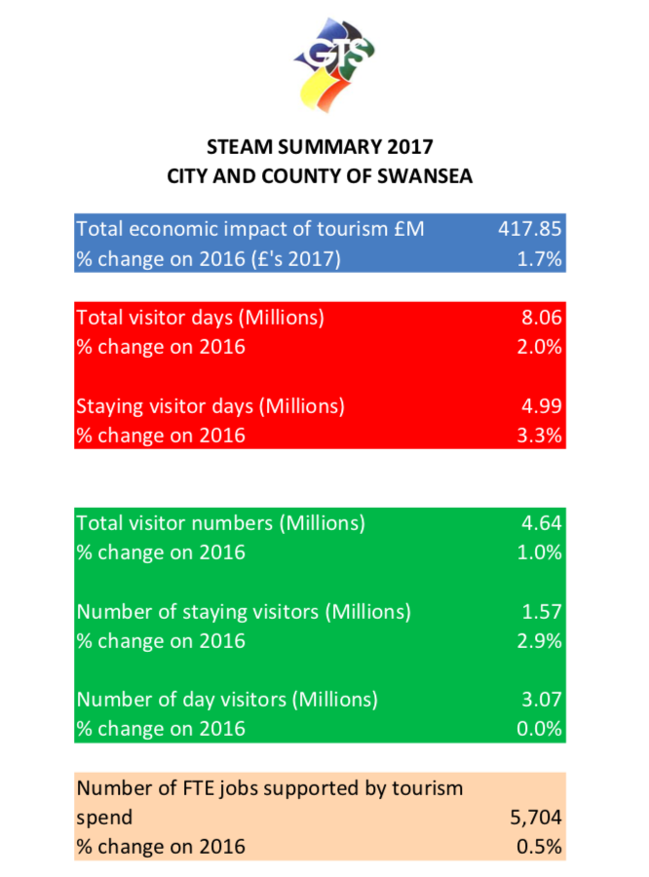
1.10.2. – Male to Female Ratio in Mumbles (Citypopulation.de, 2019)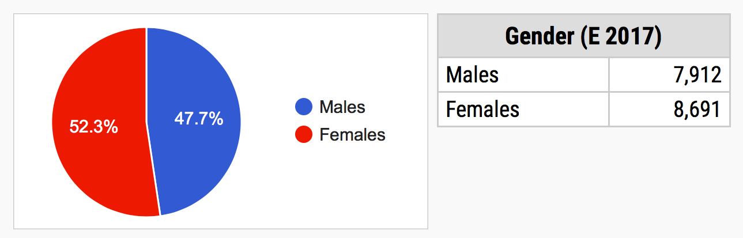
1.10.3. – Age Distribution in Mumbles (Citypopulation.de, 2019)
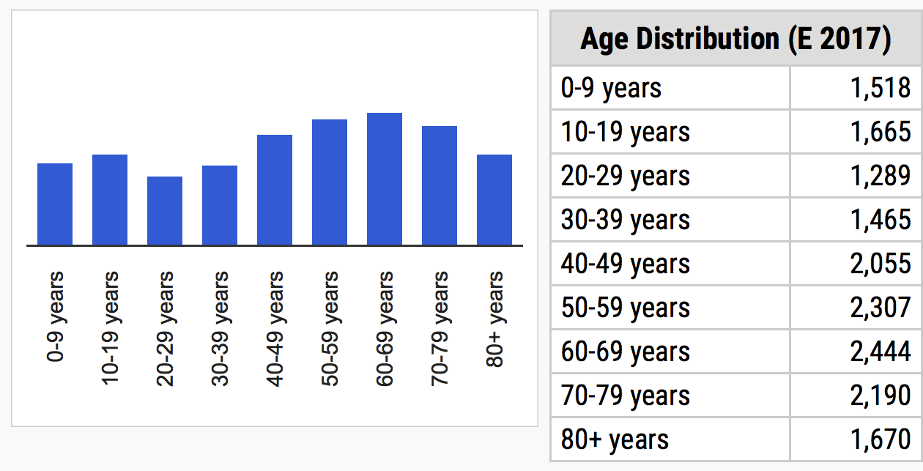
1.10.4. – Age Groups in Mumbles (Citypopulation.de, 2019)
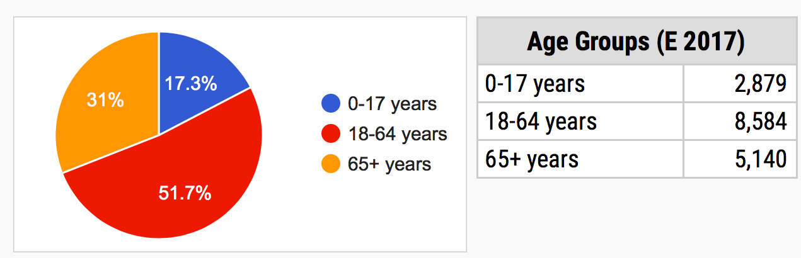

1.10.5. – PESTEL
Political | A massive political factor that will be present for this festival is the availability of government/council funding. As this is a council run festival, this will be a massive factor to consider. Furthermore, there will be a number of government regulations that will need to be followed additionally, labour law and trade restrictions will need to be considered.
Economic | An economic factor that will need to be considered by the festival is the amount of disposable income available in Mumbles. However, this may not be such a big problem as Mumbles is quite an affluent area where the most residents do have disposable income readily available to spend at events like this. The unemployment rates will need to be evaluated and will relate to the amount of disposable income in the village.
Social | Social factors for the festival to look at will include things like;  - population size  - age distribution  - wealth distribution  - social classes  - family size and structure  - lifestyle  - buying habits  - current trends  - crime levels  - education levels
Technological | This event will use a large amount of technology as they will need to cater for musicians and all of their equipment, along with lighting and any other A/V needs. However, in order to accommodate these aspects of the festivals a technician with experience and knowledge in this field may need to employed to ensure a smooth running of the festival. Another way technology will be used is through ticketing, as a result of this, staff may need training on how to use the ticketing devices.
Environmental | As this event is held outside there will be environmental factors that will need to be considered. A massive one will be waste management, this is something that needs to be highly considered and planned before the festival takes place. Furthermore, the weather will need to be considered to ensure all eventualities are covered for the festival to go ahead. Also, any risk of potential pollution will need to be evaluated and overcome.
Legal | Legal factors could include changes in the law. Regarding the White Lady Festival, this could relate to the sale of alcohol at the event as all ID’s will need to be checked to ensure no on under age is attempting to purchase alcohol. In addition to this, any legislations laid out by Oystermouth castle itself will need to be adhered to. There are number of laws that will also need to be followed, including data protection laws for when customers are purchasing tickets and health and safety laws throughout the entire event.

1.10.6. – Map of Oystermouth Castle (Google Maps, 2019)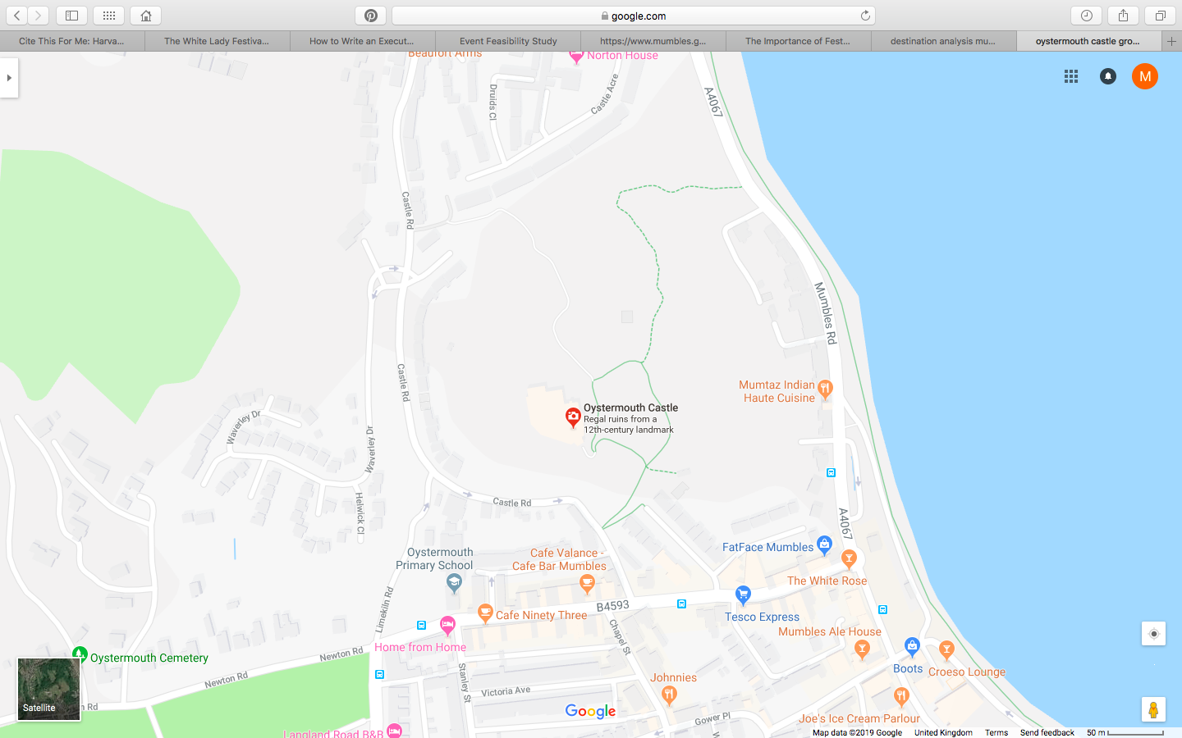

1.10.7. – SWOT
Strengths | Weaknesses
- One strength that The White Lady Festival has is that this a unique festival to the Mumbles area, the village has nothing similar to this and with this in mind, the festival should in theory be a success.  - In addition to this, a massive strength for this festival is that it should work well with the local community by interacting with the local people and increasing community pride.  - The festival itself will be in a great location for the local community as it is central and has great transport links for any tourists wanting to attend.  - This festival will offer a variety of entertainment that has the ability to cater for people of all ages. | - A massive weakness for this festival is that at the moment, they don’t seem to actually know what they want for this festival. This is a massive issue as without a clear concept of the event the success of the festival its self is up in the air.  - The festival doesn’t have solid and reliable events manager at the moment.  - Lack of experience within the team planning and running the festival.  - Limited time to prepare and ensure all resources are sourced before the festival takes place.
Opportunities | Threats
- The opportunity to boost the local economy for Mumbles as a whole.  - By hosting a successful festival, it gives potential to increase community pride and strengthen any relationships or allowing for new ones to take place.  - As this is a new festival it provides the community to learn new skills if they are involved in the planning or running of the event. | - Not enough volunteers prepared to help out with the planning and running of the event.  - Weather issues could be a massive threat for this event as it is an outdoor one.  - Losing the ability to attract enough of the local community to ensure festival success.

1.10.8. – Stakeholders
Primary Stakeholders | How to Contact
- Mumbles Community Council  - Local Businesses  - A/V Suppliers  - First Aid support  - Security  - Bands  - Workers/Volunteers  - Oystermouth Castle  - Local Community  - Waste Management Services  - Marketing Personnel  - Staging Company  - Swansea City Council  - Local Schools  - Local Hotels/B and B’s  - Traders Association | - Face to Face  - Email  - Email  - Email  - Email  - Email/Phone  - Face to face/Email/Phone  - Face to face/Email/Phone  - Flyers  - Email  - Face to face/Email  - Email  - Email  - Flyers  - Flyers  - Email

1.10.9. – Event Timings (Mumbles.gov.uk, 2019)
Friday July 27th
6.45pm Site Opens
7.00pm Rumblestrutters
8.15pm ABBA’s Angels
Saturday July 28th
12:00pm Site Opens
12:30pm It’s a Knockout
5.45pm Site closes (for non-ticket holders)
6.45pm Site opens (ticket holders only – £10, concessions *£8 ) 7:00pm Jango Haze
9:00pm The Curious
Sunday July 29th
(*Cancelled due to the Weather)
11.45am Site Opens – Delayed to 3.30pm
*12:00pm Tug of War
*1:00pm Children’s stories with popular local author Spencer Davieson *3:00pm Tug of war
3.30pm City of Swansea Concert Band – SITE RE-OPENED
5:00pm Dan Stockton
6.00pm Site Closes (for non-ticket holders)
6.45pm Site Opens (ticket holders only – £7, concessions *£5)
7.00pm Siwan Howells
7.45pm Festival Orchestra of Wales

1.10.10 – Operations
Resources Required | Sourced From
A/V | Outsourced
Marketing | Internal
Social Media | Internal
Volunteers | Outsourced – University Students
Marquee | Outsourced – Same as staging?
Security | Outsourced – Same as first aid?
First Aiders | Outsourced – or internal if qualified?
Bands | Outsourced – Mumbles own acts
Staging and Seating | Outsourced – same as Marque?
Food and Beverage Stalls | Outsourced – local businesses
Games (bouncy Castle) | Outsourced
Waste Management | Outsourced – potential volunteers form university?
Ticketing | Internal

1.10.11. – Financial Summary (Mumbles.gov.uk, 2019)
 | Financial Summary
 | Anticipated | Actual
Income:
Ticket Sales | £8,250.00 | £1,755.00
Food Vendors | £500.00 | £300.00
Bar | £1,000.00 | £0.00
Total | £9,750.00 | £2,055.00
Expenditure:
Festival Services | £17,683.00 | £14,541.29
Musical Acts | £9,400.00 | £8,904.00
Additional Services | £0.00 | £4,892.50
Total | £27,083.00 | £28,337.79
Cost of Festival | £17,333.00 | £26,282.79

