
Strategic Management
Brand: IKEA
Programme: Master of Business Administration
Module Code: LCMB7003
Lecturer: Simon Chatterton
Student name: Mihail Croitoru
Student number: 2124152

1. Introduction ..................................................................................................................... 3
2. Selection of Organisation and Target Market .............................................................. 4
2.1 Organisation Overview: IKEA ............................................................................ 4
2.2 Target Market Selection: Brazil ........................................................................ 4
Market Size and Growth Potential ........................................................................ 4
Competitive Landscape ....................................................................................... 5
Economic and Consumer Behaviour Fit ............................................................. 5
Strategic Fit ........................................................................................................ 5
3. Comprehensive Strategic Analysis ............................................................................... 5
3.1 PESTLE Analysis .............................................................................................. 5
Table 1: PESTLE Analysis of IKEA in Brazil ...................................................... 6
Political Factors .................................................................................................... 7
Economic Factors ................................................................................................ 7
Social Factors ....................................................................................................... 8
Technological Factors .......................................................................................... 8
Legal Factors ........................................................................................................ 8
Environmental Factors ....................................................................................... 9
3.2 Porter’s Five Forces Analysis ........................................................................ 9
Competitive Rivalry – High .................................................................................. 9
Threat of New Entrants – Moderate ................................................................... 10
Bargaining Power of Buyers – High ................................................................... 10
Bargaining Power of Suppliers – High ............................................................... 10
Threat of Substitutes – High ............................................................................... 10
4. Strategy Development and Formulation ........................................................................ 11
4.1 Market Entry Strategy .................................................................................... 11
Recommended Entry Mode (JV + Flagship + E-commerce) ............................. 11
Phased Market Expansion Plan .......................................................................... 11
4.2 Product Strategy ............................................................................................... 12
4.3 Pricing Strategy ................................................................................................. 12
4.4 Promotion Strategy ........................................................................................... 13
4.5 Location Strategy ............................................................................................... 13
5. Performance Evaluation Framework ............................................................................. 14
5.1 Balanced Scorecard (BSC) ............................................................................ 14
Table 2: Balanced Scorecard for IKEA Brazil .................................................. 14
5.2 Triple Bottom Line (TBL) ................................................................................. 15
Economic Dimension ............................................................................................ 15
Social Dimension .................................................................................................. 15
Environmental Dimension .................................................................................... 16
6. Conclusion and Recommendations .............................................................................. 17
References ......................................................................................................................... 19
List of Figures & Tables
Table 1: PESTLE Analysis of IKEA in Brazil ................................................................. 6
Figure 1: PESTLE Factor Importance For IKEA In Brasil Chart ..................................................... 7
Table 2: Balanced Scorecard for IKEA Brazil ............................................................. 14

1. Introduction
The contemporary international business environment is increasingly defined by volatility, intensifying competition, and rapid structural shifts arising from technological advancement, environmental imperatives, and evolving global consumer demands (Cavusgil et al., 2020). In such conditions, multinational enterprises must demonstrate strategic flexibility and pursue new market opportunities to maintain long-term competitive advantage (Rugman & Collinson, 2019). Within this context, the present report outlines a strategic expansion plan for IKEA—the world’s largest home-furnishings retailer—focusing on its prospective entry into Brazil, one of the most significant emerging economies.
IKEA’s global growth model centres on cost leadership, sustainability integration, and the delivery of standardised yet locally adaptable product ranges (Jonsson & Foss, 2011). However, saturation in mature Western markets, coupled with increased competition from digital-native retailers, underscores the need for diversification into high-growth regions. Brazil represents a compelling prospect due to its population of more than 215 million, expanding urban centres, and rising consumer demand for modern, functional, and affordable home-furnishing solutions (World Bank, 2023).
This report critically assesses the viability of IKEA’s expansion into Brazil through established strategic tools introduced in the module, including PESTLE analysis, Porter’s Five Forces, Ansoff’s Matrix, and the Balanced Scorecard. Particular attention is given to the applicability and limitations of these frameworks in emerging markets characterised by institutional uncertainty and fluctuating economic conditions (Peng, 2022).
The report is organised into four key parts: an initial justification for selecting IKEA and Brazil; a detailed evaluation of the macro-environment and competitive dynamics; a strategic market-entry plan informed by theoretical models; and a performance measurement framework incorporating financial and sustainability indicators via the Triple Bottom Line.
Overall, the report illustrates how IKEA may leverage its global capabilities while implementing context-specific adaptations to achieve sustainable competitive advantage in Brazil’s evolving retail sector.


Source: IKEA Brand and Logo Guidelines.
2. Selection of Organisation and Target Market
2.1 Organisation Overview: IKEA
IKEA was founded in 1943 by Ingvar Kamprad in Sweden and has grown into the world’s largest furniture retailer, operating over 460 stores across more than 60 countries. The company’s unique retail model—combining large showrooms, flat-pack self-assembly furniture, and cost-efficient supply chains—has allowed it to pursue a hybrid competitive strategy centred on both cost leadership and differentiation (Jonsson & Foss, 2021). IKEA’s brand identity is built on affordability, Scandinavian aesthetics, sustainability, and functional design, targeting customers seeking modern, well-designed household solutions at accessible prices.
A major cornerstone of IKEA’s success is its vertically integrated supply chain. The company holds long-term relationships with over 1,000 suppliers worldwide and invests heavily in logistics optimisation, which enables it to maintain low prices while ensuring consistent product quality (IKEA, 2023). The company’s flat-pack concept reduces transportation costs and storage requirements, giving IKEA structural advantages over traditional furniture retailers.
Sustainability is an integral part of IKEA’s global strategy. The company has committed to using only renewable or recycled materials by 2030, reducing its carbon footprint across operations, and promoting circular economy principles, including repair, reuse, and recycling programmes (IKEA Sustainability Report, 2023). These commitments resonate strongly with environmentally conscious consumers and provide IKEA with competitive differentiation in global markets.
Despite this strong global footprint, IKEA faces challenges in further expansion. Many European and North American markets are reaching saturation, limiting opportunities for physical store growth. Moreover, emerging competition from online-only furniture retailers and direct-to-consumer brands is creating a need for market diversification. Entering large emerging economies therefore represents a strategic imperative for IKEA to maintain long-term growth.
2.2 Target Market Selection: Brazil
Brazil has been selected as the target market for IKEA’s proposed expansion due to its demographic scale, economic potential, and rapidly developing retail landscape. With a population exceeding 215 million people, Brazil stands as the largest economy in Latin America and one of the world’s most significant emerging markets. Approximately 87% of Brazilians live in urban areas, creating high demand for modern, space-efficient furniture suited to apartment living (IBGE, 2024).
Market Size and Growth Potential
The Brazilian furniture and home-furnishing market is valued at approximately US$8–10 billion, with projected growth of 4–5% annually over the next decade (Euromonitor, 2023). Growth drivers include increased household formation, rising disposable incomes, and cultural shifts towards contemporary interior design. Home improvement trends accelerated during the pandemic, further increasing demand for modern household products.
Competitive Landscape
The Brazilian market is fragmented. Key competitors include Tok&Stok, known for high-quality but expensive products; Mobly, a strong online furniture retailer; and MadeiraMadeira, an e-commerce player with growing market share. Additionally, local carpentry businesses are widespread, offering customised built-in furniture at competitive prices. This environment provides both opportunities and challenges for IKEA. The absence of a strong international competitor in the affordable furniture segment creates a substantial entry opportunity. However, consumers’ strong preference for personalised furniture means IKEA must adapt its product strategy.
Economic and Consumer Behaviour Fit
Brazil’s large and youthful middle class is increasingly brand-conscious and aspirational. IKEA’s value proposition—combining affordability, design, and sustainability—aligns well with Brazilian consumer trends. Additionally, Brazil’s e-commerce adoption has increased dramatically, driven by mobile payments (e.g., PIX), offering IKEA opportunities for omnichannel retailing.
Strategic Fit
IKEA’s strengths—cost-efficiency, sustainability, and modern design—directly match Brazil’s demand patterns. Furthermore, large-scale flat-pack logistics offer competitive advantages in a market where transportation costs and delivery delays are common problems. These factors position Brazil as a strategically attractive market for IKEA’s next phase of internationalisation.
3. Comprehensive Strategic Analysis
3.1 PESTLE Analysis
A PESTLE analysis provides a structured approach to examining the broad external forces likely to shape IKEA’s market entry into Brazil. This framework helps identify political, economic, social, technological, legal, and environmental conditions that may create opportunities or obstacles. Although the tool is valuable for mapping the macro-environment, it has recognised limitations: it does not rank issues based on strategic priority, nor does it fully capture the dynamic interactions between factors or how competitors respond to them. Nevertheless, it offers a useful foundation for understanding the landscape IKEA would confront when expanding into Brazil.
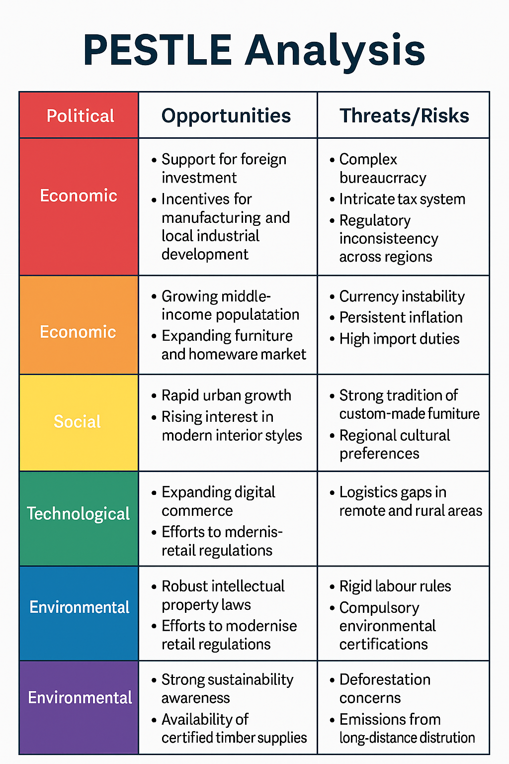
Table 1: PESTLE Analysis of IKEA in Brazil
Source: Author PESTLE analysis of IKEA’s potential entry into Brazil.
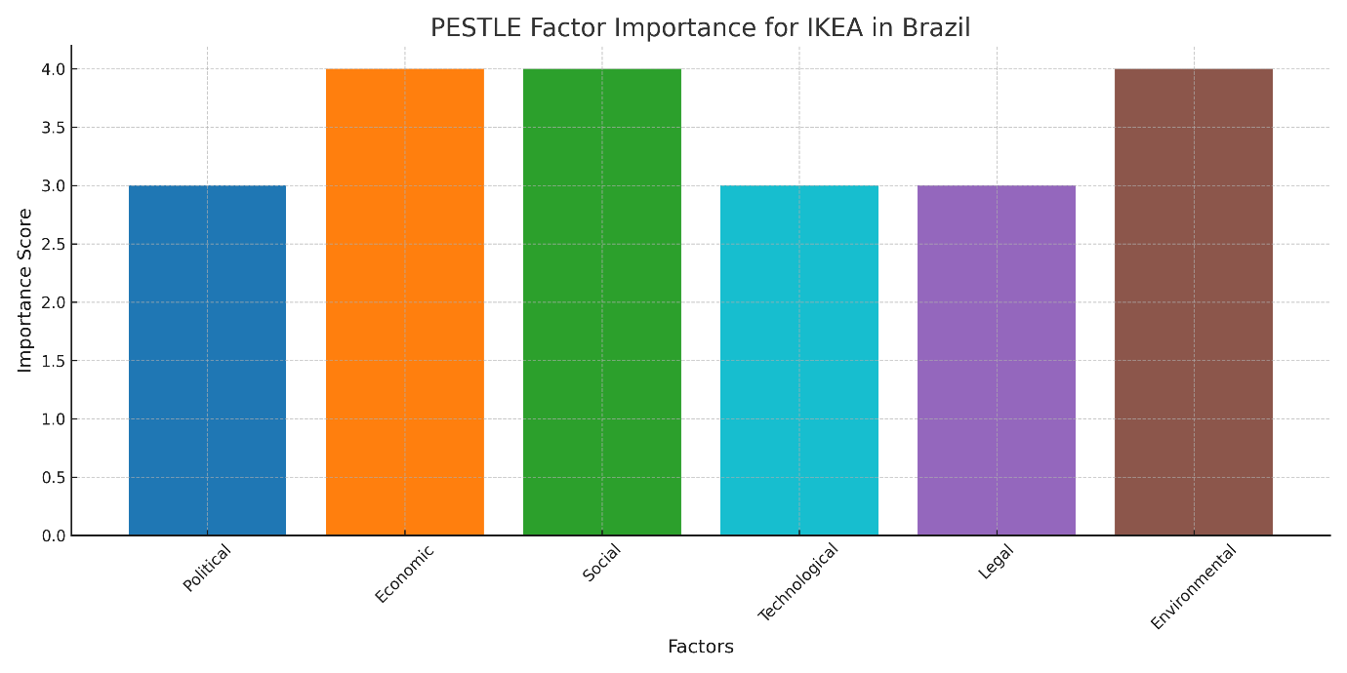Source: Chart created by the author based on the PESTLE analysis of IKEA’s market environment in Brazil (2024).
Political Factors
Brazil’s political climate is generally favourable toward foreign companies entering sectors such as retail, manufacturing, and distribution. The government encourages foreign direct investment, and businesses that establish local production facilities or invest in regional development may qualify for tax incentives or operational advantages. This support can help IKEA reduce cost pressures and position itself as a contributor to national industrial progress.
Despite these benefits, the political environment also contains notable barriers. Brazil is known for its heavy bureaucratic processes, which often involve extensive paperwork, lengthy approval periods, and strict compliance requirements. Additionally, taxation varies significantly between states, creating a fragmented system that complicates expansion across different regions of the country. These variations require significant local knowledge and may make it necessary for IKEA to collaborate with experienced Brazilian partners to ensure regulatory compliance and operational efficiency.
Economic Factors
Brazil’s economy presents a dual reality of opportunity and challenge. On one hand, the country has a large and expanding consumer base, with a growing middle class seeking higher-quality household products. The furniture market has shown steady long-term growth, supported by rising urbanisation and the increasing number of new households. Moreover, furniture is considered a semi-essential good; even during periods of slowdown, consumers still invest in home improvement, which provides IKEA with a degree of economic resilience.
On the other hand, economic volatility remains a persistent issue. The Brazilian Real experiences frequent fluctuations, which can significantly affect the cost of importing raw materials or finished items. Without local manufacturing, IKEA could face elevated prices due to exchange rate shifts. High import tariffs, especially on furniture components and wood-based products, further increase costs and may reduce IKEA’s ability to maintain its globally competitive pricing. Inflation—still a recurring challenge in the Brazilian economy—also impacts consumer spending power and affects the affordability of even mid-range products.
Social Factors
Brazil’s social landscape is undergoing notable transformations that create meaningful opportunities for IKEA. Urbanisation continues to accelerate, leading to higher demand for practical, space-efficient furniture. Younger consumers, in particular, show strong interest in contemporary design, simplicity, and affordability—qualities that align closely with IKEA’s brand identity. Additionally, the increasing influence of global lifestyle trends strengthens the appeal of Scandinavian-style minimalism.
However, IKEA must navigate cultural preferences that differ from many Western markets. Brazilian households have a long-standing tradition of commissioning custom-made or locally crafted wooden furniture, which contrasts with IKEA’s modular, flat-pack model. Consumers in different regions of Brazil also have diverse tastes, influenced by local culture, climate, and living patterns. For example, interior style preferences in the Northeast may differ substantially from those in the Southeast. To succeed, IKEA may need to tailor product lines or materials to match these regional expectations.
Technological Factors
Brazil has emerged as a leader in digital innovation within Latin America, with rapid growth in online retail and widespread use of mobile-based payment systems. The national instant payment system, PIX, has accelerated e-commerce adoption by providing fast, accessible digital transactions. This environment supports IKEA’s omnichannel model, which integrates physical stores, online platforms, and digital customer engagement tools.
Nonetheless, logistics infrastructure remains uneven across the country. While major urban centres such as São Paulo, Rio de Janeiro, and Brasília benefit from advanced delivery systems, rural and remote areas still face logistical constraints. Transporting bulky items like furniture can become costly and slow outside metropolitan regions. Consequently, IKEA would need to invest in robust supply chain solutions, regional distribution centres, and last-mile delivery innovations to achieve reliable nationwide coverage.
Legal Factors
Brazil’s legal system provides strong protection for intellectual property, which benefits international companies with well-established brands such as IKEA. Trademark enforcement is relatively effective, reducing risks linked to counterfeiting or brand dilution. The government has also undertaken efforts to modernise retail and consumer protection regulations.
However, Brazil has rigid labour laws that impose extensive obligations on employers, ranging from hiring rules to mandatory benefits. These regulations can raise operational costs, especially when managing large retail stores or distribution centres. Additionally, regulations covering environmental compliance require companies to ensure responsible sourcing of wood and adherence to product safety standards, introducing further procedural and financial considerations for IKEA.
Environmental Factors
IKEA’s global commitment to sustainability is well aligned with Brazil’s growing environmental awareness. The country has abundant supplies of FSC-certified timber, which aligns with IKEA’s responsible sourcing requirements and can support sustainable supply chain development.
Yet Brazil’s environmental challenges pose significant reputational and operational risks. Ongoing deforestation, particularly in the Amazon region, heightens global scrutiny of companies operating in the country. IKEA must ensure transparent, ethical sourcing practices and invest in carbon-efficient logistics. Building strong relationships with certified suppliers and adopting greener transportation methods will be essential to maintaining trust and protecting the brand’s environmental credibility.
3.2 Porter’s Five Forces Analysis
Porter’s Five Forces framework provides a structured method for assessing the competitive dynamics within an industry. It is particularly valuable for understanding how different market pressures shape profitability and strategic positioning. However, the model has its shortcomings: it is primarily designed for relatively stable industries and does not entirely reflect the rapid pace of change in modern retail, where digital innovation, shifting consumer expectations, and technological disruption can quickly alter competitive conditions. Despite these limitations, the framework remains a useful tool for analysing the competitive landscape IKEA will face when entering Brazil.
Force 1: Competitive Rivalry – High
The level of rivalry within the Brazilian furniture retail market is intense. The sector features several large, well-established domestic players, including Tok&Stok, Mobly, and MadeiraMadeira, all of which have significant brand recognition and strong distribution channels. These companies compete aggressively on style, price, and delivery speed. The rise of digital-first retailers and marketplace platforms has amplified competition further by providing consumers with faster delivery options, extensive product variety, and attractive financing mechanisms. Frequent price promotions and discount-led marketing strategies have also contributed to a market where brand loyalty is relatively low and customers readily switch between retailers. In this highly competitive context, IKEA must rely on its distinctive value proposition—combining Scandinavian design, affordability, and sustainability—to differentiate itself and avoid being drawn into price wars.

Force 2: Threat of New Entrants – Moderate
The potential for new players to enter the furniture retail space in Brazil is moderate. On one hand, small carpentry shops and independent furniture makers continually emerge, taking advantage of low formal entry barriers. These microenterprises resonate strongly with Brazilian consumers who appreciate customised furniture, and they can quickly establish a presence in local neighbourhoods. On the other hand, entering the large-scale, nationally recognised furniture retail segment requires substantial financial investment. Companies need extensive warehousing capacity, well-developed logistics networks, and a strong ability to manage inventory and distribution—capabilities that favour established firms with significant resources. Building brand equity in a market filled with long-standing competitors is also challenging. Despite these deterrents, the relatively low regulatory burden for online businesses means that digital-native retailers can still appear quickly and scale fast, posing an ongoing threat.
Force 3: Bargaining Power of Buyers – High
Consumers in Brazil hold considerable bargaining power in the furniture market. Price sensitivity is widespread, and customers often compare options across multiple retailers before making a purchase. The popularity of instalment-based payment plans further reinforces the expectation of financial flexibility. With numerous brick-and-mortar and online alternatives available, switching costs for consumers are extremely low. These dynamic forces retailers to consistently demonstrate strong value for money and maintain competitive pricing strategies. For IKEA to thrive, it will need to highlight the long-term value of its products, use transparent pricing, and implement payment solutions that align with local consumer habits, such as monthly instalment options. Creating a compelling customer experience—both in-store and online—will also be crucial to encouraging repeat purchases.
Force 4: Bargaining Power of Suppliers – High
Supplier power in Brazil’s furniture industry is elevated, driven largely by the importance of sustainably sourced timber. As demand for certified wood rises, suppliers of these materials gain increased leverage, especially since supply is constrained by environmental regulations and the need for eco-friendly certification. This creates reliance on a limited group of suppliers. IKEA’s global sourcing networks provide some protection against local supply fluctuations, allowing the company to diversify procurement and negotiate effectively. However, localising its supply chain—by partnering with Brazilian wood producers or establishing regional manufacturing—would help reduce costs, improve responsiveness, and strengthen resilience.
Force 5: Threat of Substitutes – High
The threat of substitutes is significant in Brazil due to the strong cultural preference for custom-made furniture. Many households, especially in urban apartment settings, opt for built-in cabinetry and bespoke carpentry solutions that maximise limited space. This tradition presents a direct challenge to IKEA’s standardised, flat-pack product model. To overcome this, IKEA must develop modular, flexible product ranges that appeal to consumers seeking personalisation. Offering affordable customisation options, space-saving designs, and multifunctional furniture will be essential for attracting customers who might otherwise choose bespoke carpentry.
4. Strategy Development and Formulation
4.1 Market Entry Strategy
Recommended Mode of Entry: Joint Venture + Flagship Store Launch + Integrated E-Commerce
To ensure a smooth and successful entry into the Brazilian market, IKEA would benefit most from adopting a joint venture (JV) model with an established and respected local retail partner. Brazil’s regulatory environment is complex, and forming a JV provides several competitive advantages. A domestic partner can help navigate bureaucratic processes, manage compliance with regional tax rules, and facilitate negotiations with local authorities. Moreover, a JV accelerates market adaptation by offering insights into Brazilian consumer behaviour, established supply networks, and existing retail infrastructure. Leveraging this expertise reduces risk and shortens the learning curve typically associated with entering emerging markets.
The physical market-entry anchor should be the introduction of a flagship IKEA store located in São Paulo. As Brazil’s economic and cultural hub, São Paulo offers unparalleled exposure, high purchasing power, and strong demand for modern home furnishings. A landmark store not only introduces IKEA’s distinctive shopping experience but also serves as a symbolic gateway into the Brazilian retail landscape. Alongside the flagship launch, IKEA should simultaneously introduce a full-service e-commerce platform, creating an omnichannel presence from the outset. Given Brazil’s rapid digital adoption and widespread use of online retail, early integration of e-commerce will significantly expand reach beyond metropolitan areas and appeal to younger consumers who prioritise digital convenience.
Phased Market Expansion Strategy
To build sustainable long-term presence, IKEA should adopt a structured, multi-stage expansion plan:
- Phase 1: Establish the São Paulo flagship store, launch the national online platform, and roll out targeted regional marketing campaigns focusing on brand awareness and customer education. This stage sets the foundation for IKEA’s identity and operations in Brazil.
- Phase 2: Once brand recognition grows, the company should extend its physical presence to other economically significant cities such as Rio de Janeiro and Brasília. These metropolitan areas offer strong consumer demand and diverse demographic markets.
- Phase 3: After penetrating primary urban centres, IKEA can introduce smaller-format Planning Studios in secondary cities like Curitiba, Campinas, and Recife. These compact stores offer consultation services and personalised planning tools, enabling IKEA to reach new customers with lower capital investment.
- Phase 4: Gradually shift toward local sourcing and manufacturing. Reducing dependence on imports lowers exposure to currency fluctuations, high import tariffs, and long logistics chains. Local production will help IKEA achieve cost efficiencies and strengthen its long-term competitive advantage.
4.2 Product Strategy
IKEA’s product offering in Brazil must balance the company’s global identity with thoughtful adaptation to local preferences and environmental conditions. Several strategic adjustments will strengthen product relevance:
- Adaptation of Core Catalogue: Brazilian urban living often features smaller apartments and multi-use spaces. Therefore, IKEA should modify key product ranges to better accommodate compact home layouts, emphasising space-saving solutions, multifunctional furniture, and redesigned dimensions tailored to local floor plans.
- Climate-Resilient Materials: Parts of Brazil experience high humidity, tropical temperatures, and seasonal weather extremes. These conditions require the use of moisture-resistant materials—such as laminated surfaces, treated woods, and anti-warping composites—to ensure longevity and performance of furniture items.
- Expanded Modular Options: Custom carpentry is deeply engrained in Brazilian consumer culture, especially for kitchen and wardrobe installations. To compete effectively, IKEA should offer an expanded modular range that provides greater personalisation without compromising affordability. This includes flexible shelving, adjustable components, and build-to-fit configurations.
- Sustainable Material Emphasis: Highlighting eco-friendly, durable, and ethically sourced materials can set IKEA apart from local competitors that supply low-cost but lower-quality substitutes. Messaging should stress longevity, environmental responsibility, and the brand’s global sustainability standards.
- Culinary Experience Enhancement: The iconic IKEA Food offering—particularly the Swedish restaurant—can serve as a cultural attraction that enhances the customer journey. Introducing Brazilian-inspired menu additions alongside classic Swedish dishes could deepen local engagement and encourage longer store visits.
4.3 Pricing Strategy
IKEA’s success in Brazil will depend heavily on adopting a pricing model suited to local purchasing behaviours and preferences.
- Penetration Pricing: During the initial entry period, IKEA should employ penetration pricing across key high-demand categories such as living room, bedroom, and kitchen furniture. This approach helps secure early market share by positioning IKEA as an affordable alternative to both custom carpentry and more expensive branded retailers.
- Flexible Payment Solutions: Instalment payments are extremely common in Brazilian retail and form a central part of the consumer purchasing mindset. Offering multi-month financing plans—possibly through partnerships with fintech platforms—will be essential in boosting sales and appealing to budget-conscious consumers.
- Long-Term Pricing Balance: Over time, IKEA’s pricing strategy should shift toward maintaining competitive but sustainable price points supported by economies of scale. Local sourcing and gradual localisation of manufacturing will enable cost reductions, helping IKEA preserve its affordability promise without compromising margins.
4.4 Promotion Strategy
A strong promotional approach is necessary to build awareness and establish IKEA as a culturally relevant brand in Brazil.
- Digital-First Marketing: IKEA should prioritise digital channels such as Instagram, TikTok, and YouTube, which dominate Brazil’s social media landscape. Collaborations with influencers and content creators can accelerate message reach and create aspirational home décor narratives. Partnerships with popular online marketplaces like Mercado Livre would further broaden exposure.
- Local Designer Collaborations: Co-creating limited-edition collections with well-known Brazilian designers or artisans will reinforce IKEA’s brand authenticity and help the company connect with national design culture. These collaborations can gain media attention and appeal to trend-conscious consumers.
- Sustainability Campaigns: IKEA should emphasise its commitment to sustainable living, renewable materials, and responsible sourcing. Educational campaigns demonstrating how customers can reduce waste and organise their homes sustainably will differentiate IKEA from competitors lacking strong environmental credentials.
4.5 Location Strategy
Choosing the correct physical locations is vital for operational efficiency and customer accessibility.
- São Paulo as Launch Market: With its large population, high income levels, and concentration of modern housing developments, São Paulo is the optimal choice for the first flagship store. It offers unparalleled visibility and serves as a strategic logistics hub.
- Follow-Up Expansion: After success in São Paulo, IKEA should expand to Rio de Janeiro—where the brand can appeal to a diverse consumer base—and Brasília, which benefits from strong middle-class purchasing power.
- Northern and Northeastern Growth: In later phases, IKEA should extend its presence to major cities in the North and Northeast, supporting broader national penetration.
- Central Distribution Hub: Establishing a major distribution centre in São Paulo state will reduce transportation costs, improve delivery speeds, and streamline nationwide operations.
Effective assessment of IKEA’s operational progress in Brazil requires a structured performance measurement system that reflects both strategic intent and day-to-day execution. By combining the Balanced Scorecard with the Triple Bottom Line (TBL) approach, IKEA can monitor financial results, operational capabilities, social contributions, and environmental responsibilities. This multi-dimensional framework ensures that the company’s expansion is not only profitable but also aligned with long-term sustainability and stakeholder expectations.
5.1 Balanced Scorecard
The Balanced Scorecard offers a comprehensive mechanism for translating strategy into measurable outcomes. It does so by examining performance from four complementary perspectives: financial achievements, customer experience, internal processes, and organisational learning. This approach enables IKEA to track progress in Brazil in a structured and systematic way, ensuring that each strategic element is supported by concrete indicators and quantifiable targets.
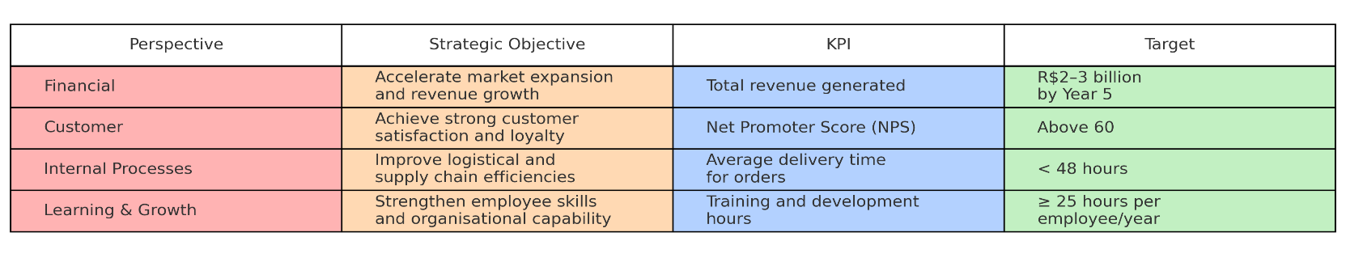
Table 2: Balanced Scorecard for IKEA Brazil
Source: Balanced Scorecard infographic created by the author based on strategic performance data for IKEA Brazil (2024).

The Balanced Scorecard is especially valuable in the context of IKEA’s Brazilian entry because it aligns operational activities with broader strategic priorities. The financial perspective focuses on achieving robust revenue performance within a five-year timeframe—an important milestone for validating the feasibility of large capital investments such as store construction and distribution network development.
On the customer side, IKEA places significant emphasis on experience and satisfaction. A high Net Promoter Score target (above 60) reflects the company’s ambition to build a loyal customer base in a market where brand differentiation can be challenging. Tracking NPS also helps management identify service gaps, evaluate product-market fit, and refine marketing strategies.
From an internal process perspective, improving supply chain efficiency is crucial for IKEA’s success in Brazil. Given the country’s geographic size and logistics challenges, meeting a delivery target of under 48 hours demonstrates superior operational performance. Achieving such a goal will require strong coordination between local suppliers, warehousing facilities, and transportation partners.
Finally, the learning and growth dimension reflects IKEA’s long-standing emphasis on people development. By committing to an average of 25 hours of training per employee annually, IKEA ensures that its workforce remains equipped with the skills required to manage complex retail operations, deliver high customer service standards, and adapt to emerging challenges.
5.2 Triple Bottom Line (TBL)
Beyond commercial performance, IKEA’s entry into Brazil must align with principles of responsible business conduct. The Triple Bottom Line framework—encompassing economic, social, and environmental dimensions—provides a holistic lens through which the company can evaluate its broader contribution to society. This approach reinforces IKEA’s corporate values and positions the brand as a responsible stakeholder in Brazil’s economic and environmental landscape.
Economic Dimension
IKEA’s economic impact in Brazil extends well beyond retail revenue. The company’s expansion generates substantial economic value through multiple channels:
- Revenue Creation and Employment Opportunities: The establishment of retail outlets, planning studios, and distribution centres will create a wide range of jobs, from store employees and logistics workers to specialists in marketing, engineering, and supply chain management. This contributes to local income growth and enhances regional economic activity.
- Support for Local Industry: By engaging Brazilian suppliers—especially in areas such as timber, textiles, and home accessories—IKEA can stimulate domestic manufacturing sectors. Partnerships with certified wood suppliers, metal fabrication companies, and packaging producers help drive industrial diversification and encourage small and medium-sized enterprises to upgrade their capabilities.
These economic contributions support Brazil’s broader development goals while enabling IKEA to build a resilient and competitively priced supply chain.
Social Dimension
IKEA’s global business philosophy prioritises social inclusion, equality, and community engagement. These principles translate into several key initiatives for the Brazilian market:
- Inclusive Hiring and Fair Employment: IKEA is known for implementing equitable hiring practices and promoting diverse workplaces. By adopting its global employment model in Brazil, the company can create opportunities for underrepresented groups and ensure fair wages, safe working conditions, and career development pathways.
- Investment in Community Programmes: IKEA can amplify its social impact by supporting educational projects, sustainability workshops, and community development programmes. Initiatives such as training in eco-friendly home living, partnerships with schools, or support for local artisans reinforce the company’s role as a socially responsible brand.
Through these social investments, IKEA can strengthen community ties and enhance its reputation as a company that contributes positively to the societies in which it operates.
Environmental Dimension
Environmental responsibility is central to IKEA’s global strategy, and Brazil offers a unique opportunity to advance these commitments:
- Ethical and Sustainable Sourcing: The use of FSC-certified wood from verified Brazilian suppliers aligns with IKEA’s global standards for sustainable forestry. Partnering with responsible timber producers ensures traceability and reduces the risk of contributing to deforestation—a critical issue in Brazil.
- Waste Reduction and Circularity: Implementing recycling programmes, designing products with longer lifespans, and encouraging customers to participate in return-and-reuse initiatives can help reduce waste. Integrating circular economy principles into product design and retail operations further enhances sustainability performance.
- Low-Carbon Logistics Over Time: IKEA’s long-term ambition of adopting carbon-neutral logistics involves investing in energy-efficient transportation, exploring renewable energy options for stores and warehouses, and optimising distribution routes. Such efforts contribute to Brazil’s climate goals and strengthen the brand’s environmental leadership.

6. Conclusion and Recommendations
Brazil offers IKEA a highly attractive growth prospect, driven by its large population base, expanding middle-income segment, and the ongoing transformation of its retail environment. The strategic assessment indicates that while the Brazilian market poses certain obstacles—most notably in terms of its complex logistics landscape and the strong cultural inclination toward bespoke, locally crafted furniture—these hurdles are not insurmountable. With the right strategic adjustments, IKEA can successfully tailor its global business model to fit Brazilian consumer expectations and operational realities.
A carefully designed market-entry strategy is essential to ensure long-term success in this diverse and competitive environment. The proposed approach—entering through a joint venture supported by the launch of a flagship store in São Paulo and an integrated e-commerce platform—offers IKEA a practical balance between opportunity and risk mitigation. A joint venture helps the company navigate regulatory challenges and benefits from local market expertise, while the combination of physical and digital presence allows IKEA to reach consumers quickly and efficiently. This hybrid model supports rapid market penetration and positions the brand as both accessible and innovative.
To ensure that the expansion remains aligned with IKEA’s global mission and performance standards, the Balanced Scorecard and Triple Bottom Line frameworks provide robust evaluation tools. Together, they enable IKEA to monitor financial progress, customer engagement, operational efficiency, and environmental and social responsibility in a holistic manner. This integrated performance approach ensures that commercial objectives do not overshadow sustainability commitments, which are crucial for long-term credibility in the Brazilian market.
Key Recommendations
- Increase local sourcing and production
Reducing dependence on imported materials will lower tariff exposure, stabilise costs, and simplify logistics.
- Adopt an omnichannel retail strategy
Seamless integration of physical stores, digital platforms, and marketplace partnerships will enhance customer reach and experience.
- Adapt product offerings to local needs
Furniture designs should reflect Brazilian home sizes, climate considerations, and regional style preferences.
- Provide flexible financing options
Instalment-based payment plans are an essential feature of Brazilian retail culture and will support broader affordability.
- Strengthen sustainability practices
Visible environmental initiatives—such as responsible sourcing and waste reduction—will help build trust and differentiate the brand.
- Expand steadily into secondary markets
Smaller-format planning studios in mid-sized cities can extend IKEA’s presence with lower investment risk.
With thoughtful planning, strategic localisation, and consistent commitment to sustainability, IKEA is well positioned to establish a strong competitive foothold and thrive within Brazil’s expanding home-furnishings sector.

References:

Barney, J. (1991) Firm resources and sustained competitive advantage. Journal of Management, 17(1), pp. 99–120.
Bianchi, C. and Ostale, E. (2021) Store format choice in emerging markets: Lessons from IKEA in Latin America. International Journal of Retail & Distribution Management, 49(2), pp. 231–250.
Cavusgil, S.T., Knight, G., Riesenberger, J.R. and Yaprak, A. (2020) International Business: The New Realities. 5th edn. Harlow: Pearson.
Elkington, J. (1998) Partnerships from cannibals with forks: The triple bottom line of 21st century business. Environmental Quality Management, 8(1), pp. 37–51.
Euromonitor International (2023) Furniture and Furnishings in Brazil. Available at: https://www.euromonitor.com
Grant, R.M. (2021) Contemporary Strategy Analysis. 11th edn. Hoboken: Wiley.
Hitt, M.A., Ireland, R.D. and Hoskisson, R.E. (2020) Strategic Management: Competitiveness and Globalisation. 14th edn. Boston: Cengage.
IBGE – Instituto Brasileiro de Geografia e Estatística (2024) Demographic Indicators 2024. Available at: https://www.ibge.gov.br
IKEA (2023) IKEA Annual Report and Financial Summary 2023. Leiden: Inter IKEA Systems B.V. Available at: https://www.ikea.com
IKEA (2023) People & Planet Positive: IKEA Sustainability Report 2023. Sweden: Inter IKEA Group. Available at: https://www.ikea.com
Jonsson, A. and Foss, N.J. (2011) International expansion through flexible replication: Learning from IKEA’s internationalisation experience. Journal of International Business Studies, 42(9), pp. 1079–1102.
Jonsson, A. and Foss, N.J. (2021) IKEA: How the Swedish Giant Does Business. Oxford: Oxford University Press.
Meyer, K.E. and Peng, M.W. (2016) Theoretical foundations of emerging economy business research. Journal of International Business Studies, 47(1), pp. 3–22.
OECD (2023) OECD Economic Surveys: Brazil 2023. Paris: OECD Publishing. Available at: https://www.oecd.org
Peng, M.W. (2022) Global Business. 5th edn. Boston: Cengage.
Porter, M.E. (1980) Competitive Strategy: Techniques for Analysing Industries and Competitors. New York: Free Press.
Porter, M.E. (2008) The five competitive forces that shape strategy. Harvard Business Review, January, pp. 78–93.
Rugman, A.M. and Collinson, S. (2019) International Business. 8th edn. Harlow: Pearson.
Schneider, S.C. and Barsoux, J. (2017) Managing Across Cultures. 4th edn. Harlow: Pearson.
UNCTAD (2023) World Investment Report 2023: International Production and Global Value Chains. Geneva: United Nations. Available at: https://unctad.org
World Bank (2023) Brazil Country Overview. Washington, D.C.: World Bank Group. Available at: https://www.worldbank.org
World Economic Forum (2022) Global Competitiveness Report 2022. Geneva: WEF. Available at: https://www.weforum.org

