
Student Name: | Rizwana Adeel
Student ID Number: | 2504702
Programme: | Certificate of Higher Education Skills for the Workplace (Health and Social Care)
Module Title: | Professional Development within Health and Social Care
Module Code: | LCHS4009
Lecturer: | Wafa Nasir

Table of Contents
Task 1: Curriculum Vitae (CV) .................................................................................................. 3
Task 2: Personal Statement ...................................................................................................... 5
Task 3a: SWOT Analysis ........................................................................................................... 6
Task 3b: Personal Development Plan (PDP) ........................................................................... 7
Task 4: Critical Reflection (Gibbs Model) ................................................................................ 8
References ............................................................................................................................... 12

RIZWANA
rizwana@gmail.com

PERSONAL PROFILE
Caring and conscientious individual currently studying towards a Level 4 Diploma in Health and Social Care at the University of Wales, Birmingham, and now seeking to apply this knowledge in a Care Assistant role. Brings a solid foundation of workplace experience across retail and warehouse settings, where accuracy, reliability and teamwork were essential every day. Known for a steady, considerate manner and a genuine desire to support others, with the drive to put developing care knowledge into practical, hands-on support for individuals who need it.
KEY SKILLS
• Considerate and supportive manner  • Accuracy and attention to detail  • Dependable team player  • Clear, confident communicator | • Works well under time pressure  • Follows procedures correctly  • Punctual and consistent  • Willing and fast learner
WORK EXPERIENCE
Warehouse Operative – Argos Warehouse (2014 – 2015)
• Handled returned items with care, following clear procedures to assess and process stock
• Worked reliably and accurately within a fast-paced team environment
Customer Service Assistant – Sharif and Sons' Supermarket (2011 – 2013)
• Operated the till and served customers directly, building strong everyday communication skills
• Completed product training to ensure accurate and confident customer service
VOLUNTARY EXPERIENCE
Befriending Volunteer
• Visited isolated older people at home on a weekly basis to offer company and conversation
• Reported any concerns about wellbeing promptly and appropriately to the coordinating team
EDUCATION
Level 4 Diploma in Health and Social Care (In Progress)
University of Wales, Birmingham
ACHIEVEMENTS
• Progressing steadily through a Level 4 Diploma in Health and Social Care while balancing other commitments
• Consistently met accuracy and dispatch targets across warehouse roles
• Built confident customer-facing skills through direct till and service experience
HOBBIES AND INTERESTS
I enjoy reading, walking and spending time outdoors, as well as cooking and trying new recipes. I also enjoy spending quality time with family and friends, which I find helps me stay grounded, patient and positive in everyday life.
REFERENCES
w.nasir@uwtsd.ac.uk

Task 2: Personal Statement
I am an empathic person looking for a Care Assistant role wherein I will be able to utilize my acquired skills and knowledge in relation to health and social care along with my hands-on work experience in order to offer compassionate and personalized assistance. The ultimate objective of my professional life is to create a productive career in the health and social care field through offering excellent quality care in terms of promoting respect, dignity, independence and wellbeing.
I am now enrolled in a level four diploma in health and social care programme at the University of Wales, Birmingham. The course has reinforced my knowledge of such topics as safeguarding, person-centered care, communication, equality, diversity, infection control, and the professional aspects of being a healthcare practitioner. It has also helped me become a better reflective practitioner, better understand the needs of the individual and the significance of providing safe and evidence-based care. According to research, continuous education is an effective method for increasing the quality of care provided by healthcare practitioners through increased competence and confidence (Mlambo et al., 2021).
My past experience has provided me with the opportunity to gain some transferable skills which have helped me acquire skills that apply to the position of Care Assistant. Being a Warehouse Operative involved working with accuracy, organisational skills, team work and adhering to procedures with efficiency in performance. Being attentive while processing returns enhanced my sense of responsibility and consistency. In my previous job as a Customer Services Assistant, I gained communication skills as I was dealing with customers from varied cultural backgrounds. Through product training, I gained self-confidence and an attitude to learn and adapt to new situations, which are important while working with people who require different care needs.
The voluntary work I did as a Befriending Volunteer was a good indication of how much I am passionate about working with vulnerable individuals. The weekly visits to older adults who are living on their own helped me realize the need to have empathy, good listening skills and good communication. By providing companionship to these individuals and reporting any issues raised by them helped me realize the role of safeguarding in healthcare. Compassionate communication and interaction can significantly increase the health and well-being of elderly individuals (Shorey et al., 2023).
Patience, reliability, attention to detail and being an effective team player are my personal strengths. I am timely, flexible and ready to learn from my more experienced co-workers in order to enhance my professional practice. I am aware of the significance of confidentiality, diversity awareness and organisational policies for the delivery of safe and effective care. I think that my combination of academic education, professional work experience and volunteering at community level have enabled me to be a suitable candidate for a Care Assistant position. I believe that my positive attitude, dedication to person-centered care and professional approach will allow me to become a valuable member of your organisation and simultaneously acquire the necessary knowledge, skills and experience to make my career in health and social care a success.

Task 3A: SWOT Analysis
SWOT analysis has provided me with an opportunity to assess how prepared I am to take on the Care Assistant position based on my present skill set, experience, and education. Reflective self-assessment is crucial for personal growth in one’s career path since it helps professionals identify the need for learning and develop practice (Nursing and Midwifery Council, 2023).
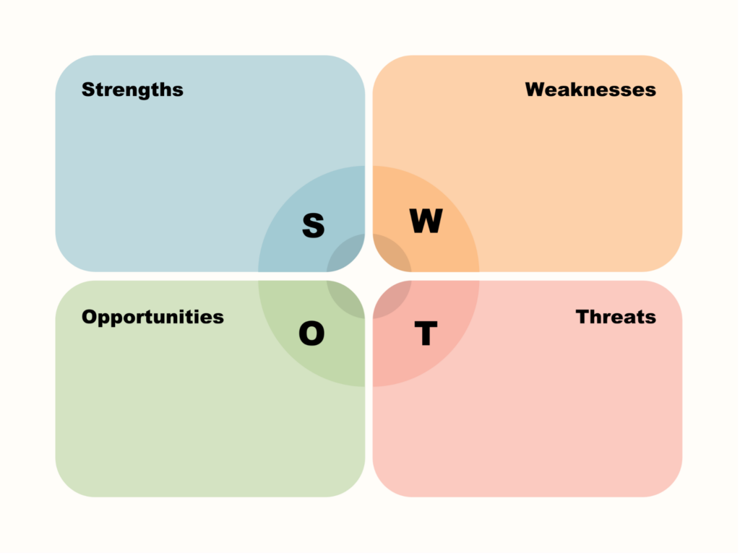
(BNI, 2023)
Strengths
Having worked before in customer services has helped me to improve my communication, patience, and positive interaction with people from various cultures. Moreover, I was working as a Befriending Volunteer that allowed me to improve my listening skills, empathy, and understanding about the significance of reducing the social isolation of older people. Also, my studies at the Level 4 Diploma have contributed to enhancing my knowledge about such issues as safeguarding, person-centred approach, and professional values. (Social Care Institute for Excellence, 2024).
Weaknesses
Despite my strong interpersonal skills, I lack hands-on experience in administering personal care to those who require assistance in mobility and other basic activities. I am not yet very confident in documenting and recording care practices in the workplace.
Opportunities
The acquisition of my diploma qualification, gaining the Care Certificate and undertaking required work-based training will improve my practical skills and help me progress in my career path. Gaining experience from more experienced colleagues through supervision and feedback will aid my professional development (Skills for Care, 2024).
Threats
The physical requirements of providing care, stress and coping with various clients’ needs can be considered threats. But by remaining resilient and learning all the time, I will manage these challenges and give clients my best care.

Task 3B: Personal Development Plan
As part of preparation for work as a Care Assistant, I have made up the following Personal Development Plan (PDP). Setting goals and evaluating the progress will allow me to enhance my theoretical knowledge and practical skills along with gaining more confidence (Nursing and Midwifery Council, 2023).
Development Goal | Actions | Timescale | Monitoring and Evaluation
Develop confidence in delivering personal care. | Work alongside experienced Care Assistants, complete workplace induction and practise personal care skills safely under supervision (Skills for Care, 2024). | 6–12 months | Supervisor competency assessments, reflective diary and monthly feedback meetings.
Improve safeguarding and safe working knowledge. | Complete safeguarding, infection prevention and moving and handling training and apply learning in practice (Social Care Institute for Excellence, 2024). | 12–18 months | Training certificates, workplace observations and discussions with senior staff.
Strengthen professional communication and teamwork. | Attend communication workshops, continue befriending activities and actively participate in multidisciplinary team discussions (Nursing and Midwifery Council, 2023). | Within 24 months | Mentor feedback, self-reflection, annual appraisal and achievement of personal learning objectives.

I shall evaluate this plan every six months through comparison of my progress to the objectives set out and any other learning requirements. Reflections on feedback provided by my supervisor, and experienced colleagues along with competency assessment will help me evaluate my own progress objectively. In case of any improvement needed, I shall update my objectives and pursue more learning activities. Through adherence to this planned route, I am sure that I shall be able to make a successful transition to my profession as a confident, caring, and competent Care Assistant (Skills for Care, 2024).

Task 4: Critical Reflection Using Gibbs’ Reflective Cycle
The following reflection use Gibbs' Reflective Cycle (Gibbs, 1988) as an approach to assess my presentation on Problem Solving: Supporting Safe and Effective Practice in Health and Social Care within the context of LCHS4009 Component 1. It highlights the significance of problem solving and illustrates how it is applied in real life by means of a case study concerning a dementia patient refusing personal care. Through such reflection I have evaluated my performance and identified my strengths and weaknesses.

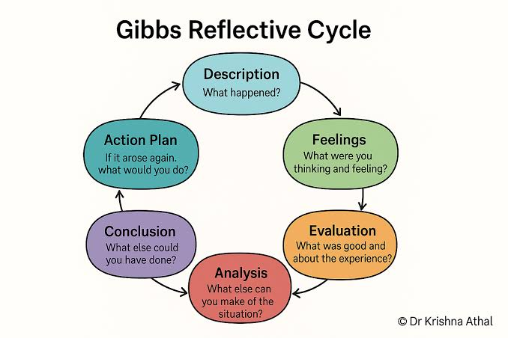
(Athal, 2025)
Description
My presentation lasted five minutes and was about the importance of problem solving in health and social care. I highlighted how Healthcare Assistants can detect problems, collect information, assess the options, take necessary action and conduct evaluation. I used an example where the client had dementia and did not want to be attended to. I spent enough time researching the topic before delivering the presentation and also rehearsing in order to be confident and keep the presentation within five minutes. According to my lecturer, I was able to explain the topic well, maintained good eye contact and had done well in preparation for the presentation.
Feelings
Prior to giving the presentation, I was quite anxious as I was afraid of forgetting the information and presenting it in front of the class. While I was familiar with the topic, I lacked confidence while introducing the presentation. However, as I continued with the slides, especially the one on dementia, I gained confidence and started focusing on delivering the information. It made me feel less anxious seeing the audience engaged in what I had to say. I felt proud of myself upon completing the presentation and was encouraged to develop my skills as a presenter. According to Manninen et al. (2023), confidence builds with preparation and practice (Manninen et al., 2023).
Evaluation
Overall, I find that my presentation was a success since I was able to deliver all the concepts in an efficient manner through proper structure and time allocation. Using the case study of dementia enabled me to link the theories into real-world experiences in the field of healthcare. The feedback from my lecturer on the effectiveness of my explanations and eye contact suggests that my communication skills were effective. I found that the fear affected my vocal projection especially when introducing my topic. Another thing that I found would be that engaging the audience through a question or example would have been more interactive (Rosenbek Minet, Hansen and Pedersen, 2021).
Analysis
This experience made me realize that a good presentation requires proper preparation, confidence, and proper communication along with subject knowledge. My ability to describe the case of dementia reinforced my understanding about how problem solving helps in delivering safe person-centered care and professional decision making. Self-reflection on my presentation has allowed me to see how preparation played an important role in my success while I realized that I needed to overcome my nervousness. Self-reflection allows students to critically evaluate their experiences, enhance professional competency, and apply learning in the future scenarios (Manninen et al., 2023).
Conclusion
To deliver the presentation was a worthwhile learning process as it helped me build confidence and improve my knowledge of problem solving in the health and social care sector. Despite being nervous at the beginning of the presentation, I managed to concentrate, give a clear explanation of the topic and receive positive remarks from my lecturer about my preparation, eye contact, and explanations.
Action Plan
For future presentations, I shall ensure that I practice enough to boost my confidence and minimize the levels of pre-presentation anxiety. I shall practice my speed of speech, voice projection, and body language, incorporating more healthcare examples in the process. In addition, I shall ensure that I record my practice presentations and receive feedback on my work from lecturers and other students. It is evidenced that reflecting and incorporating constructive feedback enhances the communication abilities, presentation confidence, and professional growth in healthcare education (Manninen et al., 2023; Wei et al., 2022).

REFERENCES
Gibbs, G. (1988) Learning by Doing: A Guide to Teaching and Learning Methods. Oxford: Oxford Polytechnic.
Manninen, K., Henriksson, E.W., Scheja, M. and Silén, C. (2023) ‘Reflective learning in healthcare education: Promoting professional competence through structured reflection’, BMC Medical Education, 23(1), 611.
Mlambo, M., Silén, C. and McGrath, C. (2021) ‘Lifelong learning and nurses’ continuing professional development, a metasynthesis of the literature’, BMC Nursing, 20(1), 62.
Nursing and Midwifery Council (2023) Standards for Education and Training: Supporting Learning and Assessment in Practice. London: NMC.
Rosenbek Minet, L.K., Hansen, T.B. and Pedersen, C.D. (2021) ‘Developing presentation and communication competence in healthcare education: A qualitative study’, Nurse Education in Practice, 56, 103190.
Shorey, S., Ang, E., Lau, Y. and Ng, E.D. (2023) ‘The effectiveness of befriending interventions on social isolation, loneliness and wellbeing among older adults: A systematic review and meta-analysis’, International Journal of Nursing Studies, 141, 104476.
Skills for Care (2024) The State of the Adult Social Care Sector and Workforce in England 2024. Leeds: Skills for Care.
Social Care Institute for Excellence (2024) Person-centred Care: Supporting Good Practice in Adult Social Care. London: SCIE.
Wei, H., Sewell, K.A., Woody, G. and Rose, M.A. (2022) ‘The state of the science of nurse communication: A scoping review’, International Journal of Nursing Sciences, 9(4), pp. 545–554.

