Hotel Placement - Hotel Administration and Front Office
~ BMIH5010~

Module lead: Daniel Payne
Tutor name: Lisa-Marie Bassler

Student name: Simona-Marilena Patrascu
Student id:2123259

Table of Contents
Part 1: Reflective Writing Using Gibbs’ Model 3
Introduction 3
Description 3
Feelings 4
Evaluation 4
Analysis 5
Conclusion 6
Action Plan 6
Conclusion 7
Part 2: Hotel Mentor Feedback 9
Part 3: Academic Tutor Feedback 15
Part 4: Reflection on Hotel and Academic Tutor Feedback 18
Introduction 18
Understanding the Feedback 18
Impact of the Feedback 19
Action Steps for Growth 19
Conclusion 20
Part 5: Placement Presentation Summary 21
Part 6: Q&A 27
Reference List 28

Part 1: Reflective Writing Using Gibbs’ Model

Introduction
This reflection uses Gibbs’ Reflective Cycle to explore my internship at Leonardo Hotels in Wales, where I worked in the Hotel Administration and Front Office (HAFO) department. As a Romanian student living in Wales, studying for a BA in Hospitality and Hotel Management, I aimed to learn front office skills like check-in, check-out, and guest relations. Despite challenges, such as poor management and unfair workloads, I focused on developing communication, problem-solving, and operational skills. This reflection examines my experiences, feelings, and lessons, linking them to hospitality theories and practices. These learnings motivate me to excel in hospitality and ensure future interns receive better support (Bassot, 2024).

Description
During my internship at Leonardo Hotels, I worked in the HAFO department, primarily at the reception desk. My responsibilities included to assist my former colleagues performing check-in and check-out procedures, managing guest inquiries about hotel services, and discussing front office operations with the manager to understand systems like reservation software and guest databases. I learned how to process payments, issue room keys, and address special requests, such as room upgrades or late check-outs. I also assisted at various hotel events, including corporate meetings, weddings, and networking receptions. My tasks involved greeting guests, coordinating seating arrangements, ensuring audio-visual equipment was ready, and consulting with event organizers to maintain smooth operations. One event was notably well-staffed to impress a key client, demonstrating the hotel’s professionalism and attention to detail. However, larger events, such as multi-day conferences, often had insufficient staff, which placed significant pressure on me due to my limited experience. My Romanian-Welsh background enabled me to connect with diverse guests, offering personalized greetings and assistance that made their check-in experience welcoming.
The internship presented several challenges. The hotel manager treated me like a full-time employee, expecting me to work extended hours and manage full responsibilities without compensation or structured training. I was frequently required to cover for absent staff, taking on additional shifts or event tasks with little notice. Strict appearance rules, such as cutting my nails and prohibiting nail polish, felt overly restrictive and unnecessary. During a large conference, a guest verbally mistreated me over an insignificant issue, but the manager provided no support, leaving me to resolve the situation alone. Despite these difficulties, I remained dedicated, prioritizing guest satisfaction and learning front office skills to build my hospitality expertise. My commitment allowed me to contribute to the hotel’s operations and gain valuable experience, even in a challenging environment (Vallen and Vallen, 2014).

Feelings
I began the internship with enthusiasm, eager to work in a professional hotel and develop front office skills. Welcoming guests at reception was a highlight, as my bilingual background helped me connect with people from various cultures, making me feel confident and valued. Successfully managing check-ins during peak hours or coordinating event coordination, like ensuring a wedding reception ran smoothly, gave me a sense of accomplishment. These moments reinforced my passion for hospitality and my belief that I could succeed in the industry.
However, the manager’s unfair treatment made me feel undervalued. Working long hours without training was exhausting, particularly as a Romanian student adapting to life in Wales. The guest mistreatment incident during the conference was deeply upsetting, and the manager’s failure to intervene left me feeling exposed and unsupported. I also felt isolated from other staff, who were sometimes distant or dismissive, which heightened my sense of being an outsider. These experiences were discouraging, but positive feedback from guests, such as compliments on my friendly service, kept me motivated. Small achievements, like resolving a guest’s billing issue during a busy check-out, boosted my morale. Reflecting now, I feel proud of my resilience and ability to stay professional, and I am inspired to create better workplace experiences for others in hospitality (Uglanova, 2024).

Evaluation
The internship yielded significant positive outcomes that enhanced my hospitality skills. Even though I did not do the check-in and check-out procedures myself, I learned from my colleagues how to them. I also assisted them to process transactions efficiently and handle guest requests with professionalism which again helped me to learn new things. My cultural background allowed me to build rapport with guests, creating warm interactions that improved their experience, such as assisting international guests in their native language. Assisting at events, even when understaffed, taught me to stay composed and manage multiple tasks, such as coordinating with my colleagues and guests simultaneously. These experiences built my confidence and prepared me for future front office roles, demonstrating my potential to excel in hospitality. One negative aspect of this experience in front office is that I did not have the chance to manage those process myself because of limitations imposed by hotel manager. I was only allowed to assist and learn by observation, not by practice. However, in other departments where physical work was needed, I was asked to work and cover for absent staff. I did not find this fair. The manager’s poor treatment was a notable challenge. Poor relations with other staff made the workplace feel unwelcoming, contributing to feelings of isolation. Despite these challenges, my achievements were substantial. My ability to learn quickly, maintain professionalism, and prioritize guest satisfaction were key strengths. The skills and resilience I developed outweigh the difficulties, as they equip me with valuable tools for a successful hospitality career (Bardi, 2011).

Analysis
My Romanian-Welsh background enhanced guest communication, as cultural competence improves service quality (Roshid and Kankaanranta, 2025). Event coordination, like managing guest arrivals, developed organizational skills, as event management boosts guest perceptions. These supported guest experiences, as staff performance drives loyalty (Hogreve, 2022). Service quality theory highlights how employee interactions shape guest satisfaction, which my personalized greetings achieved despite challenges (Martin, 2021).
Challenges reflected industry issues. Lack of training and support during the guest incident caused frustration, as workplace bullying leads to exhaustion (Said, 2022). Understaffed events showed poor resource allocation, impacting service. These align with intern exploitation, driving turnover. Maslow’s hierarchy explains reduced motivation from unmet respect needs (Rojas, 2023). Herzberg’s two-factor theory suggests poor management, like lack of support, lowers job satisfaction, while positive guest feedback functioned as a motivator. Emotional intelligence theory underscores managing stress during guest conflicts, which I developed through resilience. These theories highlight training and leadership needs. Overcoming obstacles-built skills to deliver excellent service and advocate for better practices, ensuring staff are valued (Dawson, 2024).

Conclusion

This placement taught me resilience, communication, and the harsh realities of the hospitality industry. I learned to perform front office tasks and use my Romanian-Welsh background to connect with guests, boosting my self-confidence (Uglanova, 2024). However, the mistreatment, lack of training, and unsupportive environment showed the importance of fair management and structured training for employee retention. These experiences reflect industry challenges, where poor treatment leads to high turnover, as seen in reports of intern exploitation (Ahmed, 2025). Maslow’s theory explains how unmet needs for respect caused my dissatisfaction, while customer relationship management principles highlight the impact of staff welfare on service quality. I realized that effective communication and organizational skills require supportive leadership to thrive. Despite the challenges, I remained professional and focused on learning, which strengthened my resolve. This experience has motivated me to advocate for better working conditions in hospitality, ensuring future interns receive the support I lacked. I am determined to be the change I wanted to see when I started this internship.

Action Plan

To grow as a hospitality professional, I will take targeted steps. I will enrol in an online course on property management systems like OPERA to boost front office efficiency, enhancing technical skills for guest service. I will practice active listening to improve guest interactions, ensuring clear communication and conflict resolution (Roshid and Kankaanranta, 2025). I will volunteer at university events to refine coordination skills, mastering coordination for seamless guest experiences. To manage stress from past challenges, I will adopt mindfulness techniques to maintain resilience, supporting my emotional well-being (Dawson, 2024). I will join the Institute of Hospitality to learn best practices and network with professionals who prioritize staff welfare, gaining insights into fair management. In future roles, I will advocate for intern training and support, sharing my experiences to push for structured onboarding and fair workloads, creating positive workplaces that benefit staff and guests. These steps will prepare me to deliver outstanding service and contribute to a supportive hospitality industry, ensuring future interns receive the guidance and respect I sought during my internship.

Conclusion
This reflection, using Gibbs’ Cycle, highlights my growth at Leonardo Hotels. I developed front office skills, including check-in, check-out, and event coordination, and used my Romanian-Welsh background for welcoming guest experiences. Despite poor management and unfair workloads, I stayed professional, learning resilience and efficiency. These showed the need for better training and support in hospitality. My learnings fuel my passion to excel, delivering excellent service and advocating for fair treatment. By improving technical, communication, and organizational skills, I aim for environments where staff and guests thrive. This internship, though difficult, strengthened my commitment to hospitality and my goal to ensure future interns receive the respect and support I sought.

Part 2: Hotel Mentor Feedback
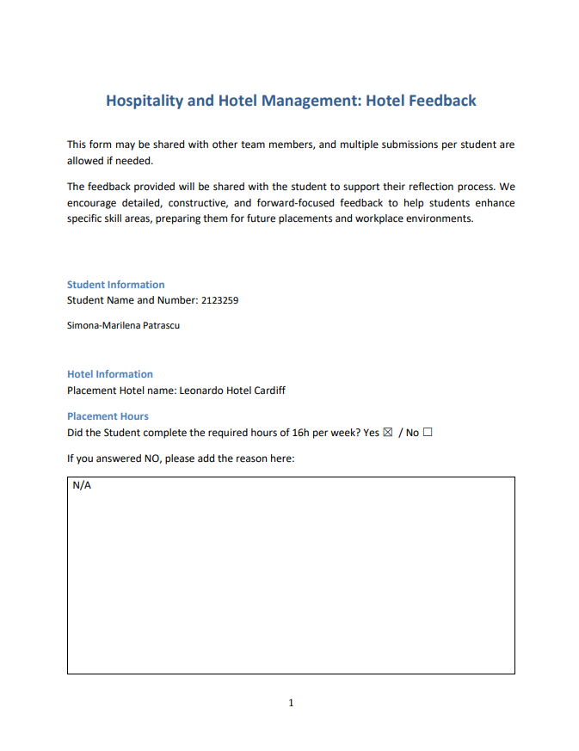
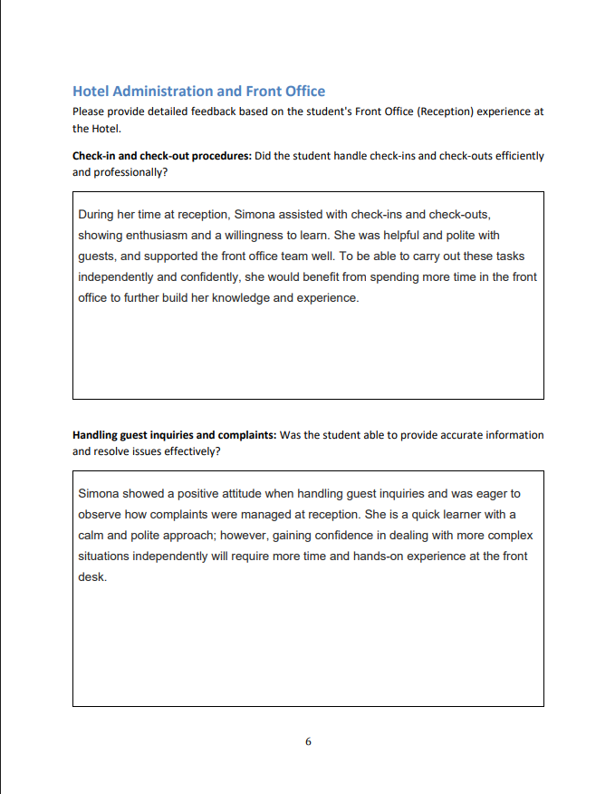
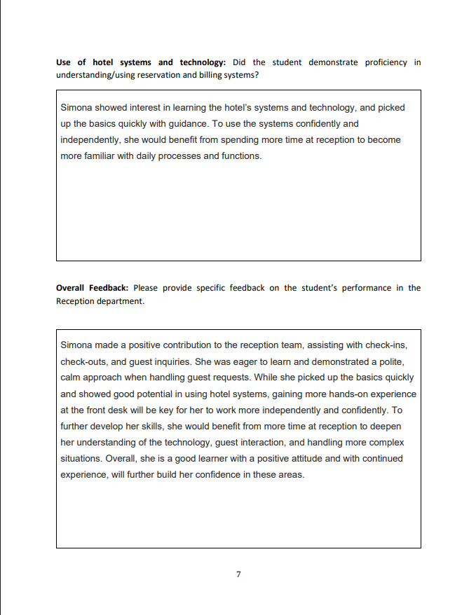

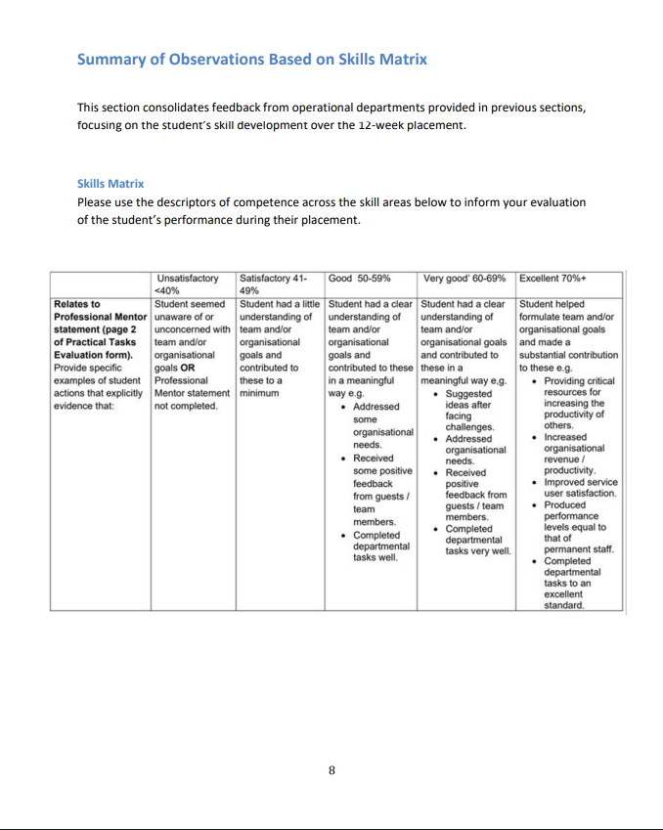
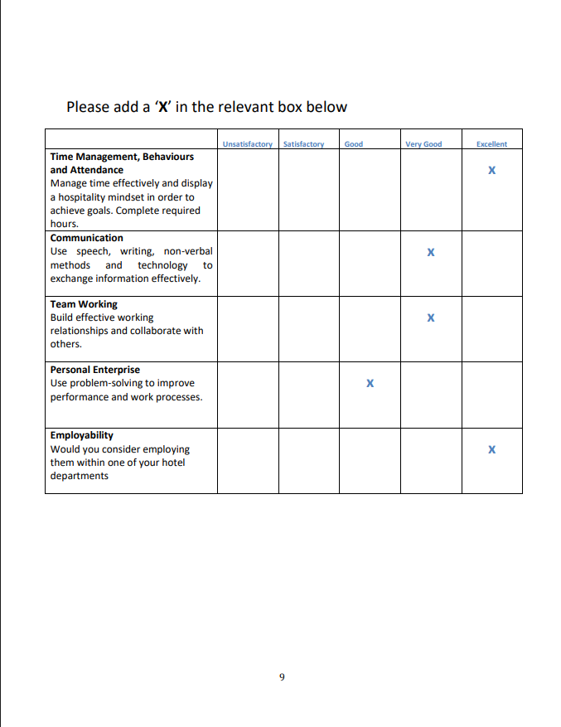
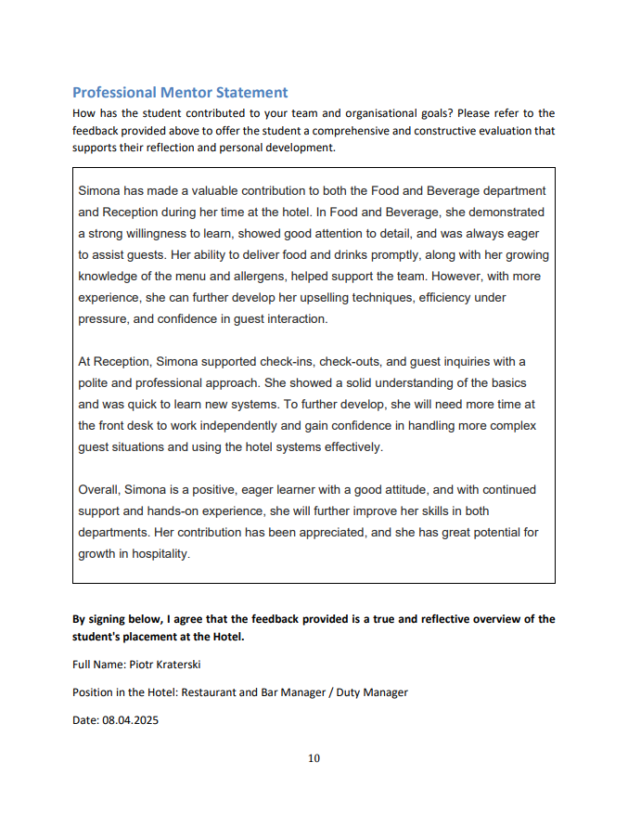

Part 3: Academic Tutor Feedback
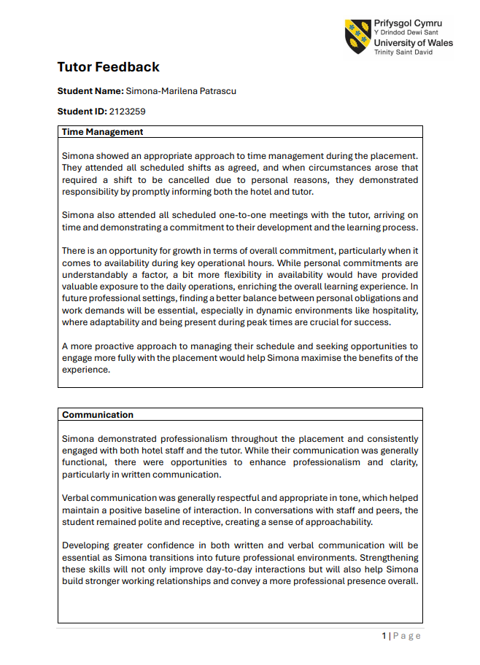
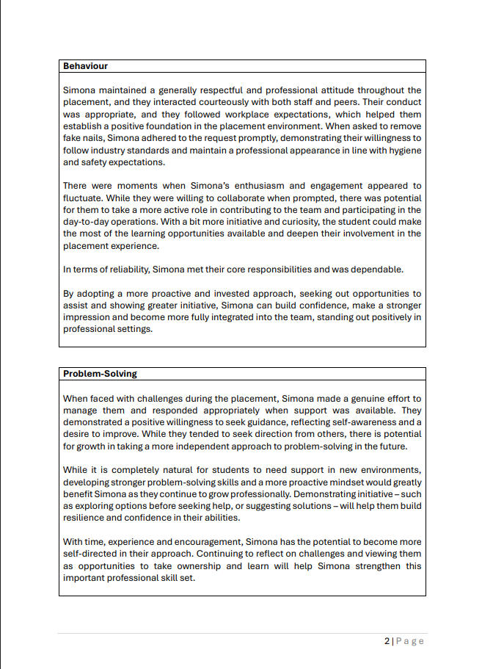
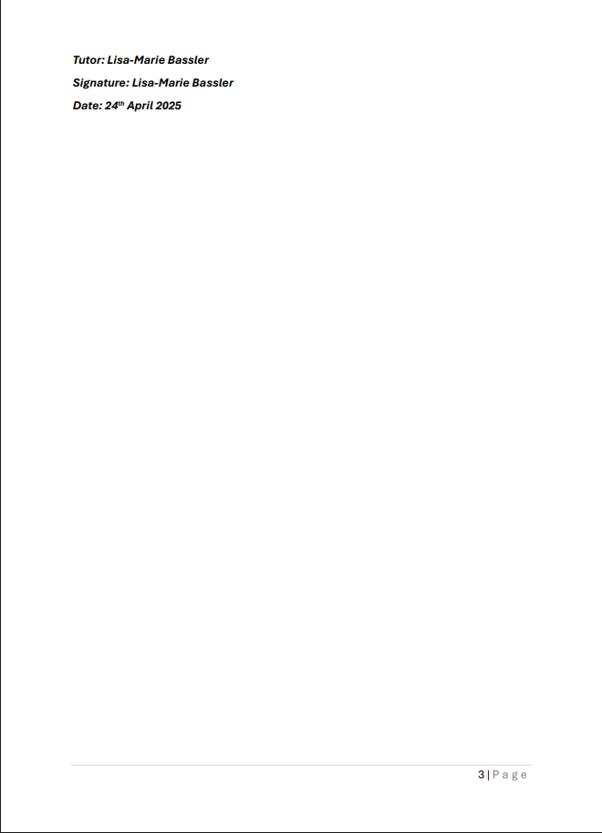

Part 4: Reflection on Hotel and Academic Tutor Feedback

Introduction
This reflection analyses feedback from my hotel mentor and academic tutor regarding my performance in the Hotel Administration and Front Office (HAFO) department at Leonardo Hotels. As a student pursuing a BA in Hospitality and Hotel Management, I aimed to develop front office skills like check-in, check-out, and guest relations. The feedback highlights my strengths, such as professionalism and enthusiasm, and areas for improvement, like confidence in handling complex inquiries. Reflecting on this feedback is crucial for identifying my abilities, addressing weaknesses, and guiding my growth in guest-facing and administrative roles. This process motivates me to enhance my skills and contribute to hospitality with excellence (Bassot, 2024).

Understanding the Feedback
The hotel mentor’s feedback praised my contribution to the reception team, noting my enthusiasm and willingness to learn during check-in and check-out tasks. I assisted with guest inquiries, demonstrating a polite and calm approach, and showed quick learning of hotel systems like reservation and billing software. However, the mentor suggested I need more front desk time to work independently and gain confidence in handling complex situations, such as challenging guest inquiries or complaints, and to become proficient with hotel technology. This indicates my potential but highlights limited experience as a barrier.
The hotel mentor’s feedback also focused on my time management, communication, behaviour, and problem-solving in the HAFO department. I attended all scheduled shifts and meetings punctually, showing commitment and professionalism. My verbal communication was respectful and appropriate, fostering approachability, but my written communication lacked clarity and confidence. The tutor noted my responsible behaviour, such as promptly removing fake nails to meet appearance standards, but suggested I show more initiative in engaging with tasks. In problem-solving, I sought guidance appropriately but relied on others, needing a more independent approach. The tutor also recommended greater flexibility in availability to gain more exposure to front office operations.
Common themes include my professionalism and eagerness to learn, as both praised my positive attitude. Unique insights include the hotel’s focus on technical and guest-handling skills and the tutor’s emphasis on communication clarity and initiative. Both agree I need more experience to build confidence and independence (Bardi, 2011).

Impact of the Feedback
The feedback has clarified my strengths in the front office, particularly my ability to engage guests politely and learn quickly. The hotel’s recognition of my calm approach during check-ins helped me realize my potential to create positive guest experiences, as seen when I assisted an international guest with a room change, using my Romanian-Welsh background for rapport. The tutor’s praise for punctuality and respectful communication reinforced my reliability, evident when I managed check-out tasks during busy mornings without delays. These strengths align with hospitality’s focus on guest satisfaction and operational efficiency (Vallen and Vallen, 2014).
The feedback also highlighted weaknesses that reshaped my perspective. The hotel’s note about needing more front desk time made me reflect on a time when I struggled with a complex billing inquiry, relying on a colleague due to unfamiliarity with the system. The tutor’s comment on limited availability linked to missing peak-hour shifts, reducing my exposure to high-pressure situations. This showed me the importance of adaptability in hospitality, where peak times test multitasking skills (Pyo, 2013). The tutor’s observation about lacking confidence in written communication, prompted me to see how clear communication builds trust. These insights emphasize the need for technical proficiency, initiative, and flexibility to excel in front office roles (Hogreve, 2022).

Action Steps for Growth
To address the feedback, I will take specific actions to enhance my front office skills. First, I will enrol in an online course on property management systems like OPERA to master hotel technology, improving my ability to manage check-ins and billing independently (Bardi, 2011). Second, I will attend communication workshops to strengthen written clarity, ensuring professional emails and reports, addressing the tutor’s feedback (Roshid and Kankaanranta, 2025). Third, I will practice problem-solving by role-playing complex guest scenarios, building confidence to manage complaints without guidance (Said, 2022). Fourth, I will adjust my schedule in future placements to ensure availability during peak hours, gaining exposure to high-pressure situations and improving multitasking (Vallen and Vallen, 2014). Finally, I will join the Institute of Hospitality to learn best practices and network with mentors who can guide my initiative (Luu, 2021). These steps will prepare me for front office roles by enhancing technical, communication, and problem-solving skills. By applying these actions, I aim to become a confident hospitality professional, delivering exceptional guest service and operational efficiency, aligning with my career goal of leading front office teams (Martin, 2021).

Conclusion
This reflection on hotel and tutor feedback highlights my growth in the HAFO department at Leonardo Hotels. My professionalism, enthusiasm, and quick learning were strengths, while limited experience and confidence need improvement. These insights emphasize the importance of technical proficiency, initiative, and adaptability in front office roles. By addressing these areas, I am committed to enhancing my skills for future placements. This process has strengthened my resolve to excel in hospitality, delivering outstanding guest service and advocating for supportive intern environments, ensuring continuous improvement and professional excellence in the industry.

Part 5: Placement Presentation Summary
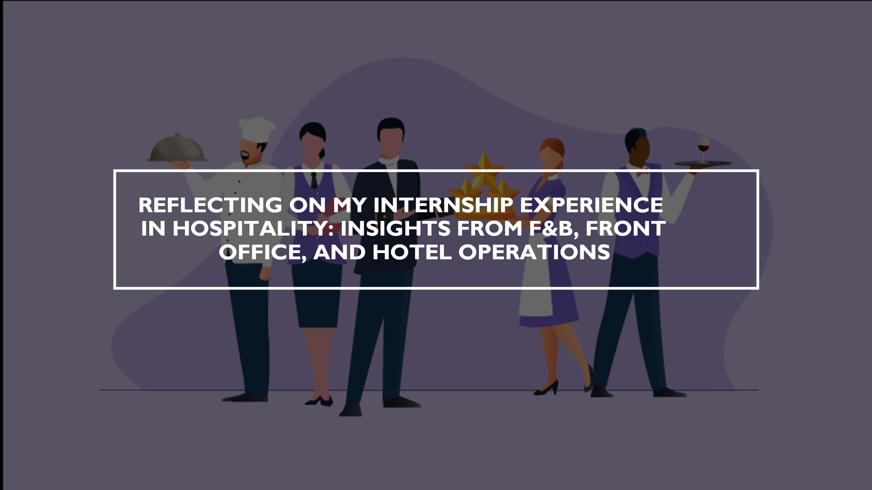
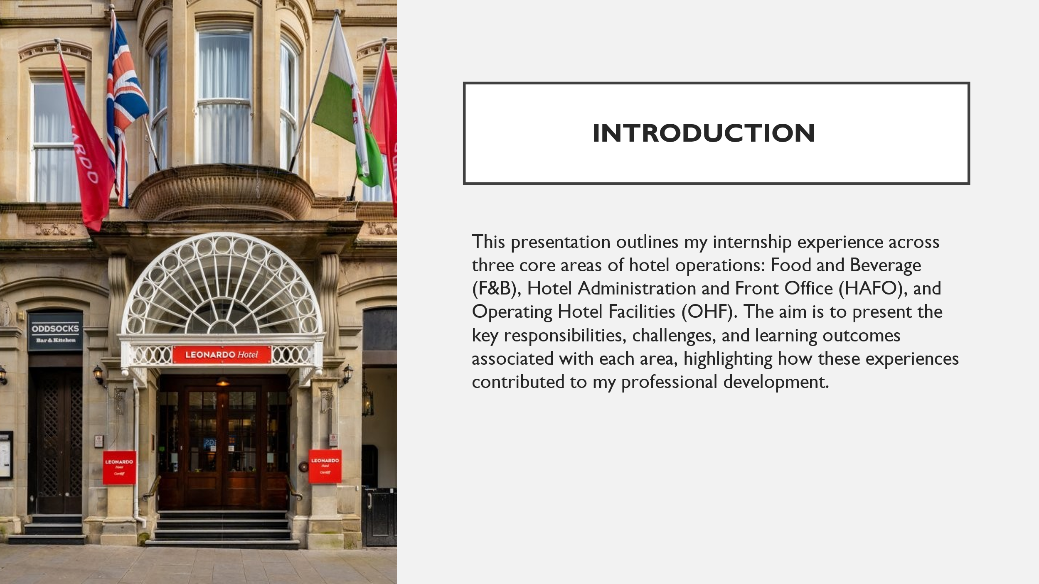
Notes: Nevertheless, in face of a lot of challenges, for instance, dealing with mistreatment and no support, I kept up my momentum in learning, growing my skills and getting a sense of what the operational reality in the hospitality industry is (Thompson et al., 2021). By going through this experience, I have solidified that I would like to be a responsible leader that takes the health of their staff and the ethics behind work settings very seriously.
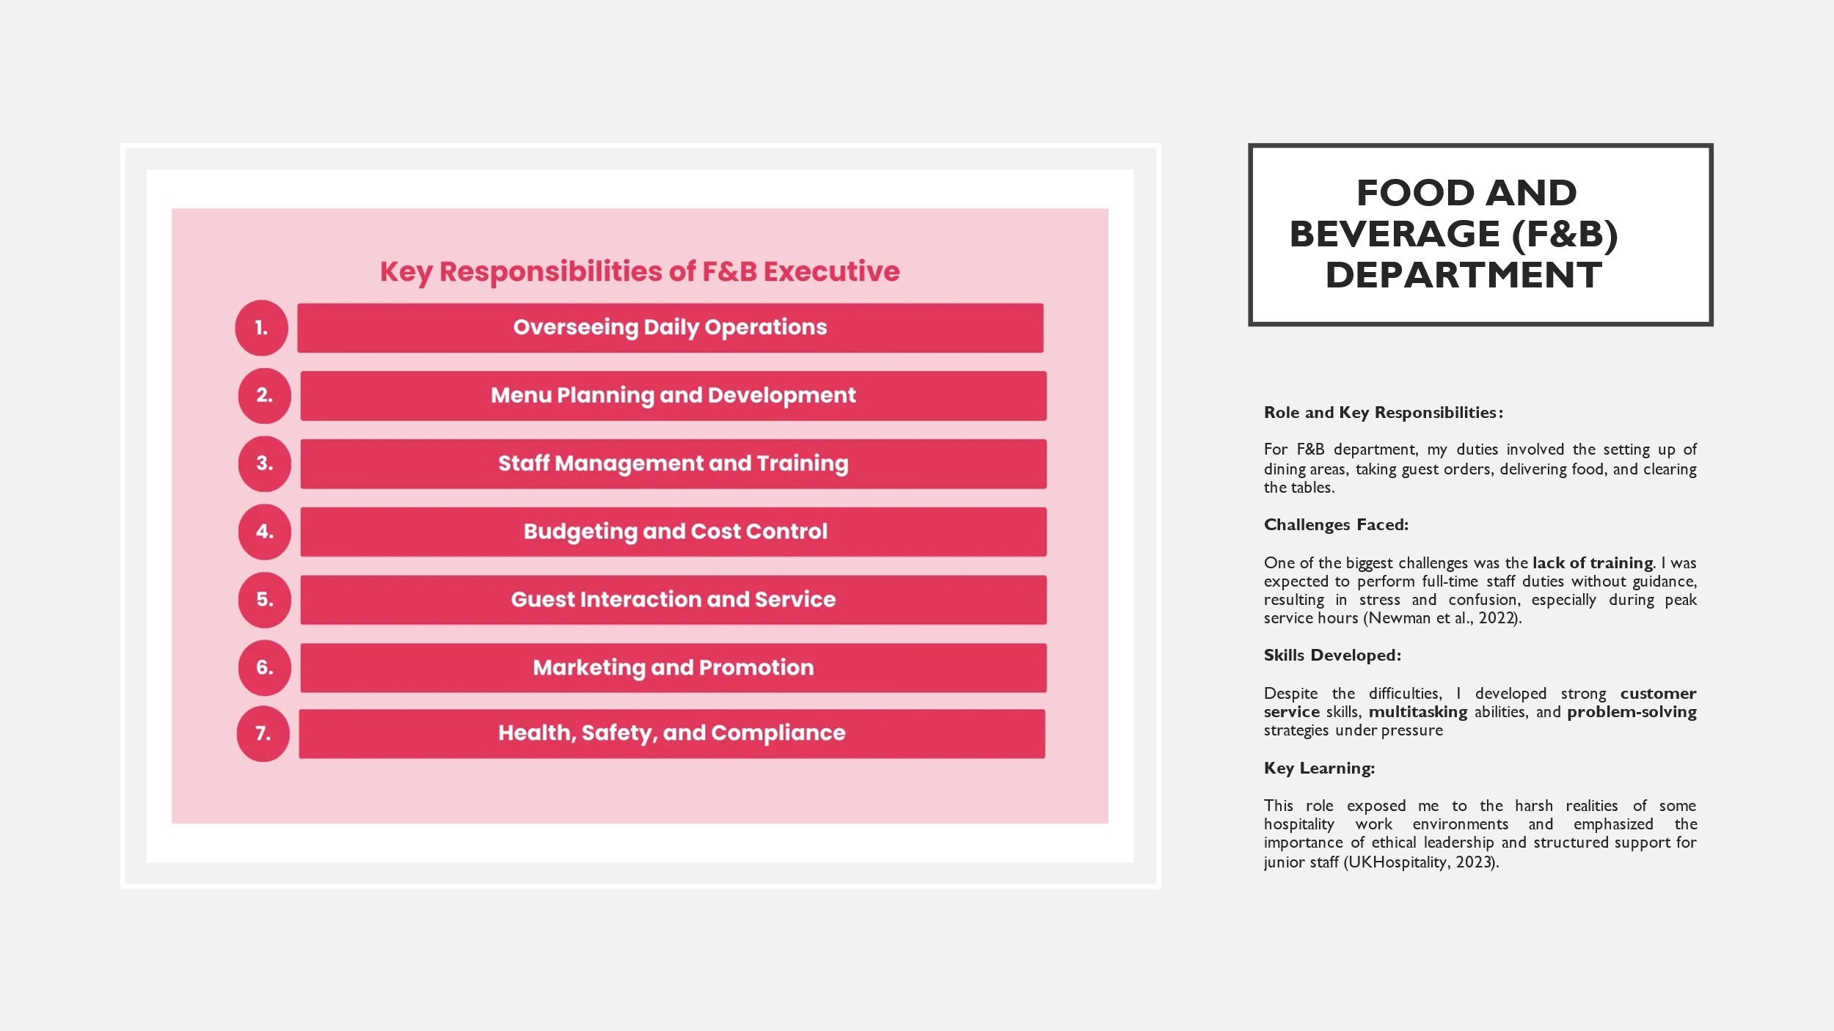
Notes: Role and Key Responsibilities:
I was also expected to support food preparation and event setup during large events, with very little supervision.
Challenges Faced:
On multiple occasions, I was left alone to manage operations when others were sent home. Additionally, I encountered mistreatment from both guests and management. For example, during a major event, a guest verbally mistreated me, and the manager did not intervene or support me, which significantly affected my morale.
Skills Developed:
I learned to adapt quickly, manage difficult guests professionally, and maintain composure during stressful service periods. This resilience will benefit me in future roles where quick thinking and professionalism are essential.

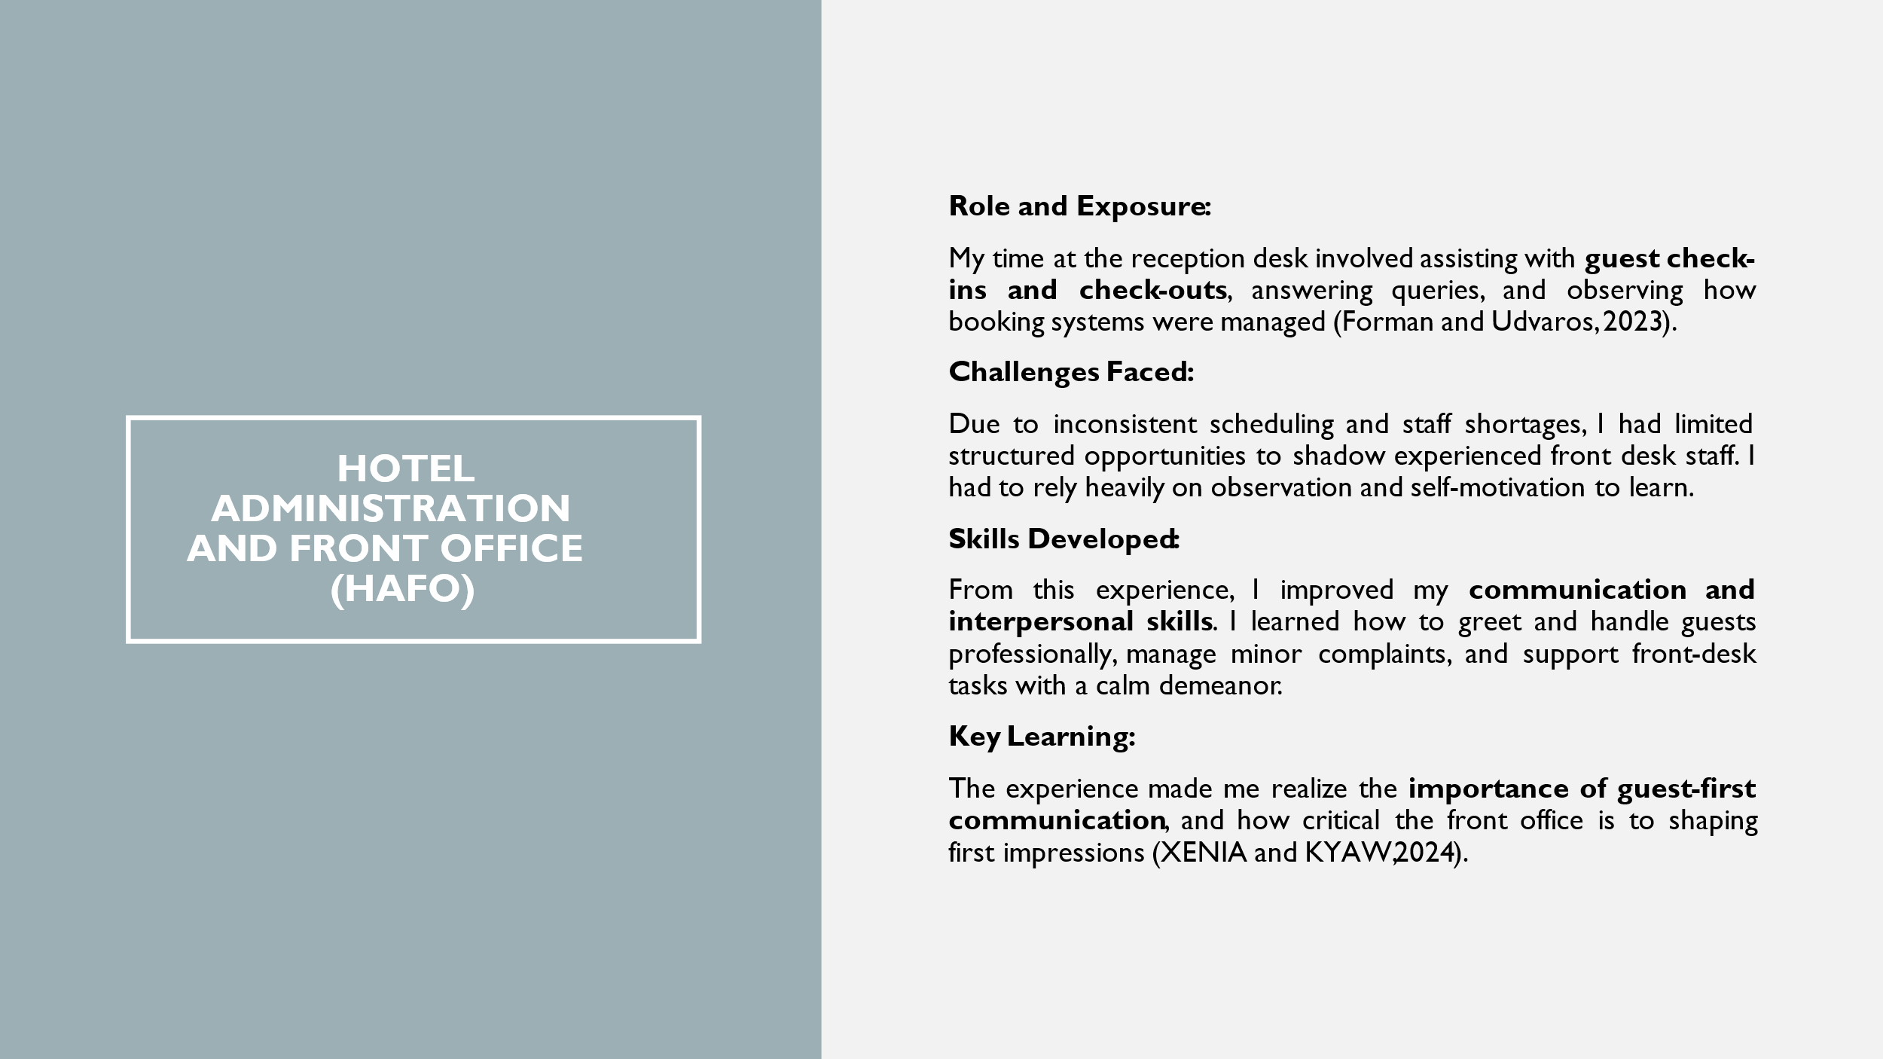
Notes: Role and Exposure:
I also had several conversations with the front office manager about administrative procedures and the hotel’s operating systems.
Challenges Faced:
Although I was not given login access to booking systems, I was able to understand the workflow by watching and asking questions.
Skills Developed:
Observing the administrative process also gave me a better understanding of front office coordination, room allocation, and guest records management.
Key Learning:
It also highlighted the need for cross-departmental communication between F&B, housekeeping, and front office for a seamless guest experience (Hayes, 2014).
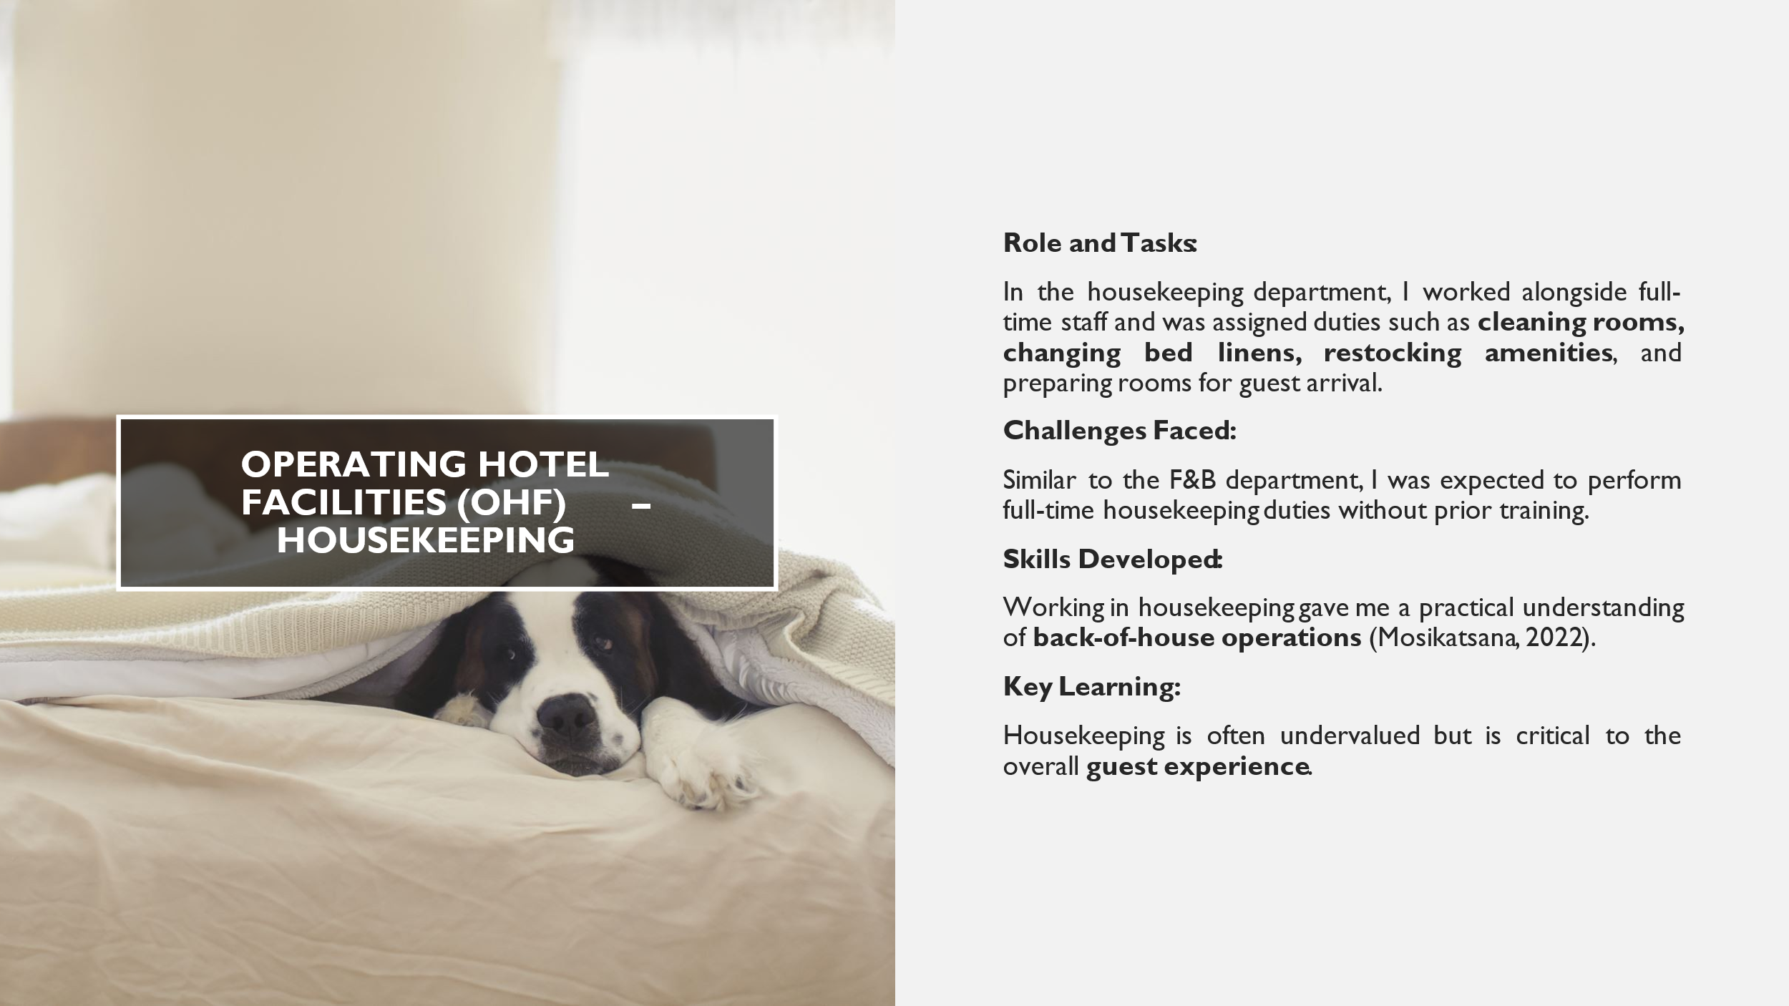
Notes: Challenges Faced:
The work was physically demanding, especially during busy days when I had to clean multiple rooms without sufficient breaks or rotation. The lack of team cohesion also made it harder to seek support or guidance from permanent staff.
Skills Developed:
I developed time management skills, attention to detail, and an appreciation for how cleanliness standards impact guest satisfaction. I also gained empathy for frontline housekeeping staff, whose efforts often go unnoticed despite being essential to hotel operations.
Key Learning:
A clean and well-maintained room significantly shapes guest perception, highlighting the importance of teamwork, communication, and appreciation across departments (Dwyer, 2023).

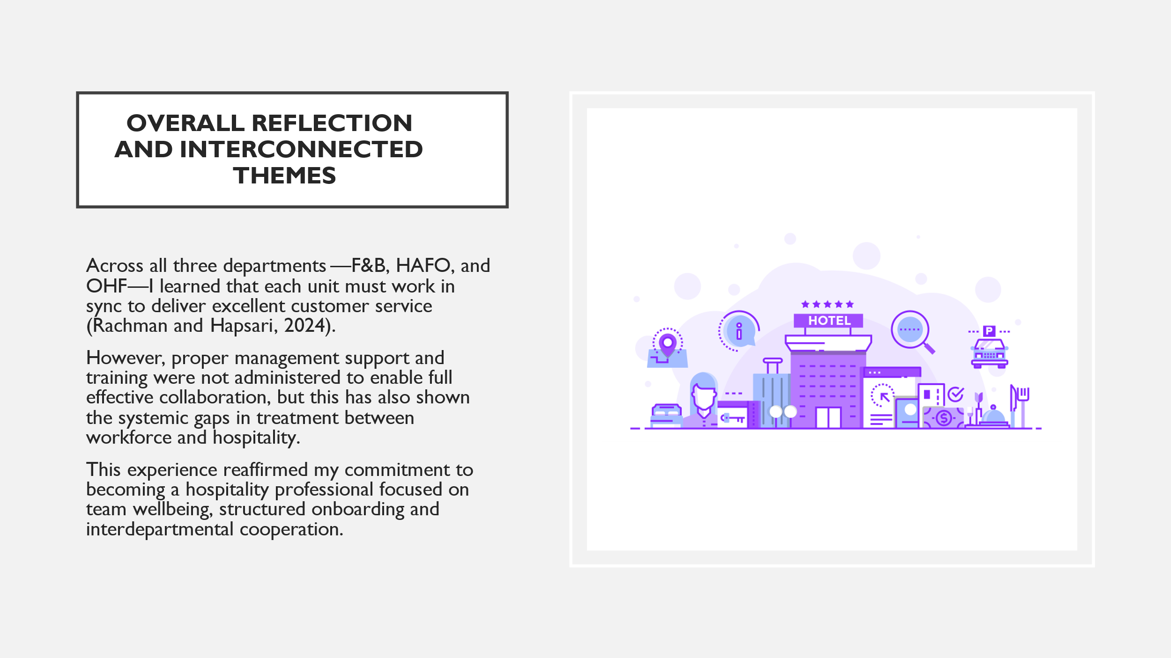
Notes: But I now know, first hand, just how critical ethical leadership and honest communication is to staff retention, morale, and guest satisfaction.

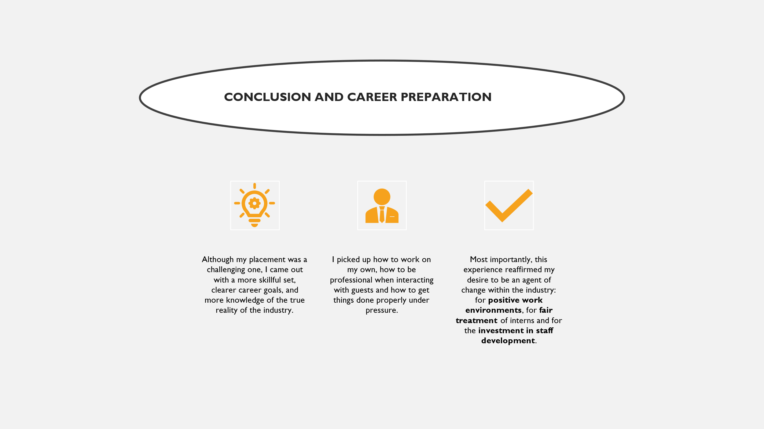
Notes: Established, I am eager to carry these lessons forward, in any future placement, and in my professional roles to be a part of creating a more inclusive and respectful culture in the hospitality sector.
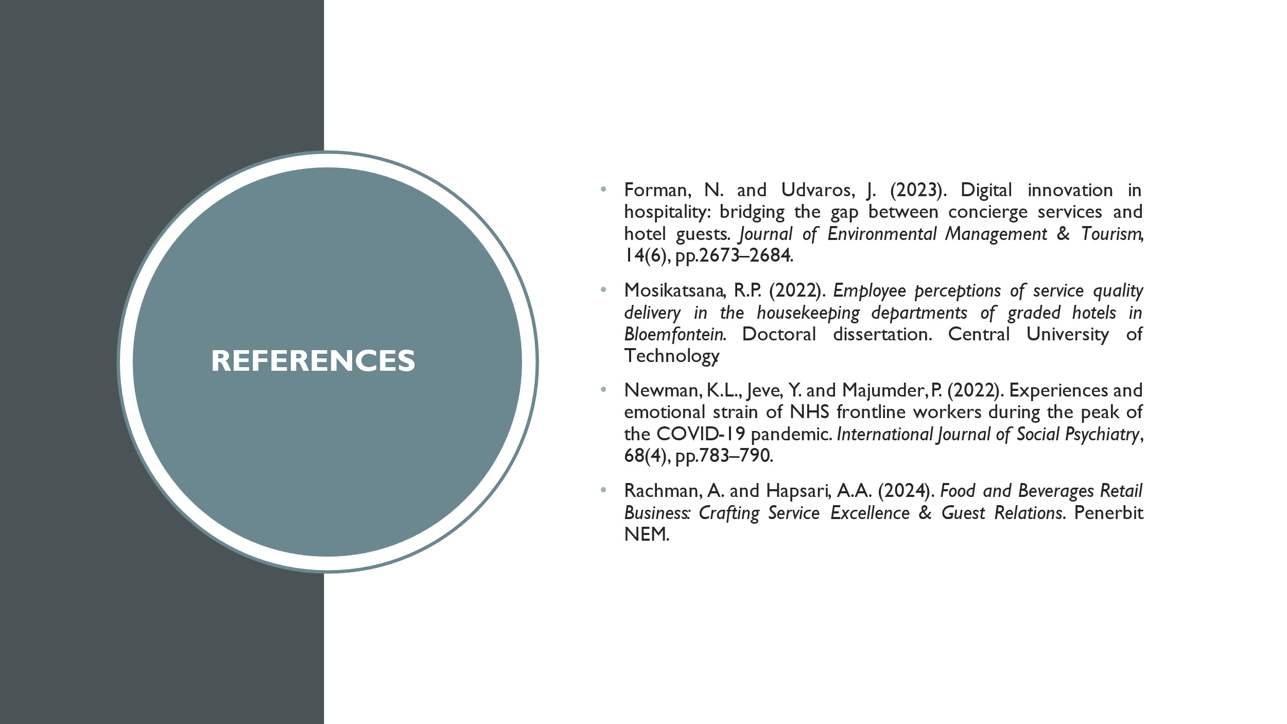
Notes:
Thompson, M.N., Perez-Chavez, J. and Fetter, A. (2021). Internship experiences among college students attending an HBC: A longitudinal grounded theory exploration. Journal of Career Assessment, 29(4), pp.589–607.
Xenia, L. and Kyaw, A.K. (2024). The effect of marketing mix on customer satisfaction and loyalty of Sunshine Princess Hotel in Yangon. Unpublished manuscript.

Part 6: Q&A

Reference List
Ahmed, T. (2025) Department of Tourism and Hospitality Management. Doctoral dissertation, Department of Tourism and Hospitality Management, Noakhali Science and Technology University.
Asyhari, A. and Sifa’i, M. (2021) 'Problem-Based Learning to Improve Problem-Solving Skill: Is It Effective Enough?', Indonesian Journal of Science and Mathematics Education, 4(1), pp. 78–88.
Badriyah, N., Sulaeman, M.M., Wibowo, S.N. and Anggapratama, R. (2024) 'The role of constructive conflict management in fostering team collaboration and innovation: A perspective of transformational leadership', Journal of Contemporary Administration and Management (ADMAN), 2(1), pp. 402–408.
Bardi, J.A. (2011) Hotel Front Office Management. 5th edn. Hoboken, NJ: Wiley.
Bassot, B. (2024) The Reflective Journal. London: Bloomsbury Publishing.
Dawson, P., Yan, Z., Lipnevich, A., Tai, J., Boud, D. and Mahoney, P. (2024) 'Measuring what learners do in feedback: The feedback literacy behaviour scale', Assessment & Evaluation in Higher Education, 49(3), pp. 348–362.
Hogreve, J., Iseke, A. and Derfuss, K. (2022) 'The service-profit chain: Reflections, revisions, and reimaginations', Journal of Service Research, 25(3), pp. 460–477.
Kuzmina, K. and Moran, J. (2025) 'Reflection by Design: Embedding Reflective Practice into the Student Learning Journey', in Transforming Higher Education With Human-Centred Design. London: Routledge, pp. 218–229.
Luu, T.T. (2021) 'Can human resource flexibility disentangle innovative work behavior among hospitality employees? The roles of harmonious passion and regulatory foci', International Journal of Contemporary Hospitality Management, 33(12), pp. 4258–4285.
Martin, J.W. (2021) Lean Six Sigma for the Office: Integrating Customer Experience for Enhanced Productivity. New York: Productivity Press.
Pyo, S. (2013) Benchmarks in Hospitality and Tourism. 1st edn. Oxford: Taylor and Francis. Available at: https://doi.org/10.4324/9780203827116.
Rojas, M., Méndez, A. and Watkins-Fassler, K. (2023) 'The hierarchy of needs: Empirical examination of Maslow’s theory and lessons for development', World Development, 165, p. 106185.
Roshid, M.M. and Kankaanranta, A. (2025) 'English communication skills in international business: Industry expectations versus university preparation', Business and Professional Communication Quarterly, 88(1), pp. 100–125.
Said, H.K. (2022) 'Effects of Workplace Bullying on Employee Emotional Exhaustion in Hospitality Industry Zanzibar'.
Trimasse, N. (2025) 'The use of reflective reports in higher education', Reflective Practice, 26(1), pp. 154–171.
Uglanova, E. (2024) 'Self-confidence', in Encyclopedia of Quality of Life and Well-Being Research. Cham: Springer International Publishing, pp. 6226–6229.
Vallen, G.K. and Vallen, J.J. (2014) Check-in Check-out: Managing Hotel Operations. 9th edn. Harlow: Pearson.

