Abstract
Comparing the digital modulation types of amplitude shift keying (ASK), binary phase shift keying (BPSK) and quadrature phase shift keying (QPSK), by changing the quantity of additive white Gaussian noise (AWGN) in Simulink models in MATLAB.
modelling digital modulation types in simulink
Comparing the effectiveness of ASK, BPSK and QPSK digital modulation types in Simulink
Freya Jaleh Vafadari
S2112275@student.uwtsd.ac.uk

Introduction
The purpose of the Digital Signal Processing & Communications module assignment is to compare the digital modulation types of amplitude shift keying (ASK), binary phase shift keying (BPSK) and quadrature phase shift keying (QPSK), by changing the quantity of additive white Gaussian noise (AWGN) in Simulink models in MATLAB. Figure 1 shows the general block diagram of the communication system being modelled in Simulink for the three types of digital modulation – ASK, BPSK and QPSK.
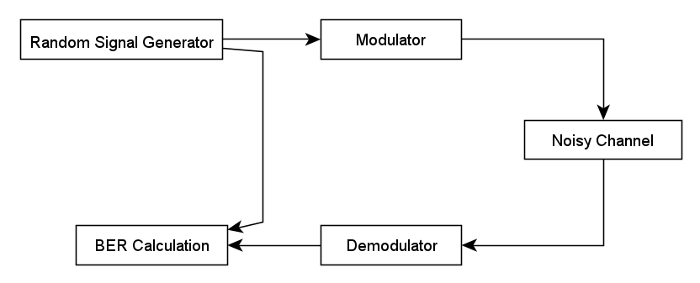
Figure 1 Communication system

List of figures
- Figure 1 Communication system
- Figure 2 Amplitude shift keying modulations waveforms
- Figure 3 Binary phase shift keying modulations waveforms
- Figure 4 Quadrature phase shift keying modulations waveforms
- Figure 5 ASK Simulink model
- Figure 6 ASK Simulink model with the constellation diagram block
- Figure 7 Modulated and demodulated waves of an ASK Simulink model
- Figure 8 Graph of the bit error rate for changing levels of white Gaussian noise in amplitude shift keying modulation
- Figure 9 Graph of the bit error rate for changing levels of white Gaussian noise in amplitude shift keying modulation with error bars at 1 standard deviation
- Figure 10 BPSK Simulink model
- Figure 11 RF output signals on channels connected to the first oscilloscope
- Figure 12 RF output signals on channels connected to the second oscilloscope
- Figure 13 Graph of the bit error rate for changing levels of white Gaussian noise in binary phase shift keying modulation

- Figure 14 Graph of the bit error rate for changing levels of white Gaussian noise in binary phase shift keying modulation with error bars at 1 standard deviation
- Figure 15 QPSK Simulink model
- Figure 16 RF output signals on channels connected to the first oscilloscope
- Figure 17 RF output signals on channels connected to the second oscilloscope
- Figure 18 Graph of the bit error rate for changing levels of white Gaussian noise in quadrature phase shift keying modulation
- Figure 19 Graph of the bit error rate for changing levels of white Gaussian noise in quadrature phase shift keying modulation with error bars at 1 standard deviation
- Figure 20 Constellation diagram for ASK modulation when the signal noise ratio is 1000dB
- Figure 21 Constellation diagram for ASK modulation when the signal noise ratio is -20dB
- Figure 22 Constellation diagram for BPSK modulation when the signal noise ratio is 1000dB
- Figure 23 Constellation diagram for BPSK modulation when the signal noise ratio is -20dB
- Figure 24 Constellation diagram for QPSK modulation when the signal noise ratio is 1000dB
- Figure 20 Constellation diagram for QPSK modulation when the signal noise ratio is -20dB

Background information
Digital modulation is the process of changing properties like amplitude and frequency of a periodic time-based waveform called the carrier signal with an independent signal called the modulation signal that contains the information to be transmitted. A modulator is a device that performs modulation. The lowest modulation frequency is called the baseband and the highest modulated carrier frequency is called the passband. Digital modulation is a digital signal formed of a sequence of binary digits on the carrier by mapping bits to elements from a discrete alphabet to be transmitted and the alphabet consists of a set of real or complex numbers. Demodulation is to extract the original message signal from the modulated carrier wave. Noise is unwanted random radio frequency electrical signals and fluctuating voltages in the filter and modem, which are always present in a radio receiver in addition to the radio signal being transmitted. [4] R. Hu, RF Fundamentals Pages 24 - 26. 2019. The radio frequency source in the system is a random Bernoulli binary generator. A signal generator is a class of electronic devices that generates electrical signals with predetermined properties of amplitude, frequency and wave shape. The Bernoulli Binary Generator block generates sequences of binary numbers using a Bernoulli distribution and the Simulink block can be modelled to form random data bits to simulate digital communication systems and calculate performance of systems like bit error rate. The Bernoulli distribution with parameter $p$ produces zero with probability $p$ and one with probability $(1-p).$ The Bernoulli distribution has mean value $\left(1-p\right)$ and variance$p(1-p)$. The Probability of zero parameter specifies $p$ and can be a real number in the range $[0, 1].$ The Simulink model has a digital low pass filter to demodulate the signal and decode the message signal from the carrier signal. A low-pass filter is a filter that passes signals with a frequency lower than a predetermined cutoff frequency and attenuates signals with frequencies higher than the frequency response point. It’s a circuit that allows the most efficient route for low-frequency signals and a difficult path with high impedance for high-frequency signal. Filters can be divided into two types: active and passive. Active filters contain amplifying devices to increase signal strength while passive filters contain components like resistors and capacitors and can only dissipate or store energy and their output can’t be changed using a power supply. The output of passive filters changes with the load current unlike active filters which maintain constant a performance regardless of the load current. In the frequency domain, the sine wave and the noise are separate frequency components that are always present in the signal but are present on different points of the wave if the signal’s frequency-domain representation. Therefore, the signal can filter out the noise by directing the signal through a circuit that passes low frequencies and impedes high frequencies. The range of frequencies for which a filter does not result in attenuation is called the passband, and the range of frequencies for which the filter does cause significant attenuation is called the stopband. Low-pass filters are rated at a specific cutoff frequency, which is the frequency above which the output voltage falls below $70.7\%$ of the input voltage.
ASK ([1] – Amplitude shift keying) is a form of modulation that shows digital data as changes in the amplitude carrier wave. In ASK systems, the binary symbol 1 is shown by transmitting a constant amplitude carrier wave and constant frequency for a bitstream of T seconds. If the signal is value is “1/HIGH” then the carrier signal is transmitted, otherwise the signal has a value of “0/LOW” isn’t transmitted. The simplest form of ASK operates as a single pole single throw switch so in the presence of a carrier wave the value is binary “1” and with no carrier wave its binary “0”, this type of modulation is called on-off keying. ASK modulation is implemented to transmit digital data over optical fibre and for LED transmitters, “1” is represented by a short pulse of light and “0” by no light. Figure 2 shows the carrier and message signals and result after ASK modulation waveforms. Figure 2 shows an example of ASK modulation with both waveforms and the output signal. [4] R. Hu, RF Fundamentals Pages 24 - 26. 2019.
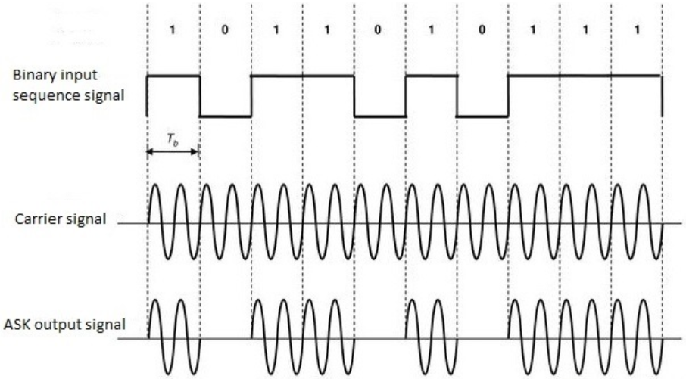
Figure 2 Amplitude shift keying modulations waveforms
Binary phase shift keying (BPSK) ([2] – Phase shift keying) is a type of modulation where the phase of the carrier signal is changed to show binary data and typically has two phases $0$ and $180°$ to encode binary bits and is shown in Figure 3. When transmitting with BPSK modulation, the binary information is changed into a series of symbols where each symbol represents a collection of data bits. The symbols are then mapped onto the carrier signal’s phase where one phase is binary “0” and one phase is binary “1”. At the receiver, the receiver is demodulated to retrieve the original binary data and the receiver compares the phase of the received signal to a reference signal to find the transmitted bits. If the phase is in phase with the reference signal so it’s decoded as binary “0” and if it’s $180°$ out of phase its decoded as binary “1”. In BPSK modulation, binary data is represented by changing the phase of the carrier signal. The carrier signal is a high-frequency sinusoidal waves which is the medium for transmitting binary data. If the binary bit is “0” the phase of the carrier is unchanged and if it’s “1” then the phase of the carrier is shifted by 180°.
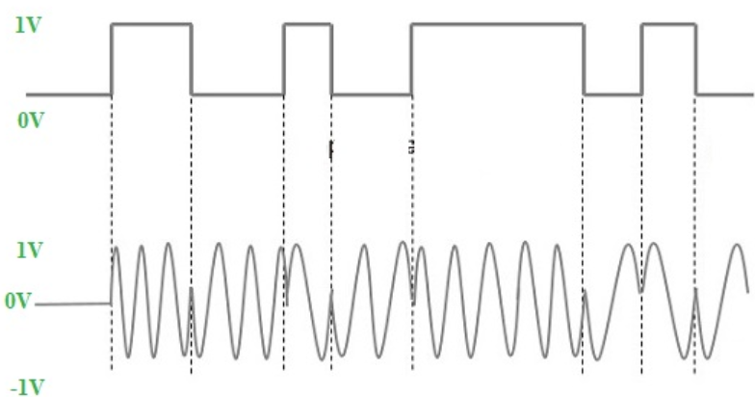
Figure 3 Binary phase shift keying modulations waveforms
Quadrature phase shift keying (QPSK) ([3] – Quadrature phase shift keying) is a digital modulation type that encodes data into the phase of a carrier signal by changing the phase and can transmit multiple bits of information simultaneously and is shown in Figure 4. The phase of the carrier wave is change to represent the binary data and the term ‘quadrature’ refers to the two carrier waves that are $90°$ out of phase. In QPSK, each symbol represents two bits of information, and the four possible phase shifts are $0°, 90°, 180° \& 270°$ and these phase shifts are utilised to encode the binary values $00, 01, 10 \& 11.$
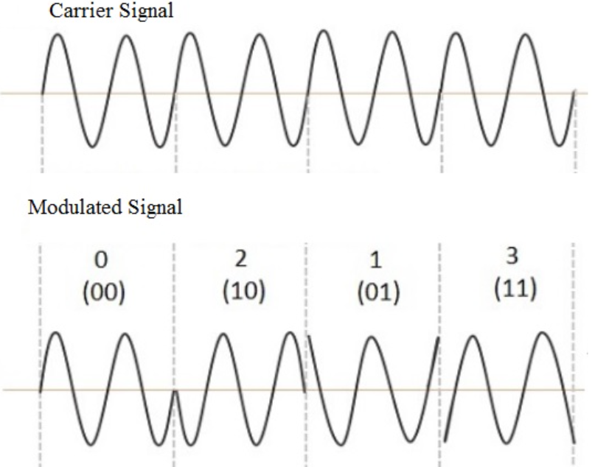
Figure 4 Quadrature phase shift keying modulation waveforms
ASK is implemented digital data through an optical fibre cable is transmitted using ASK technique. BPSK is implemented in Bluetooth and LoRWaN wireless networks. QPSK is implemented in digital communication systems which require high bandwidth like digital television broadcasting. AWGN is a simple noise model that simulates the random transmission of RF signals. The ‘W’ letter stands for white because the AWGN model has a uniform power spectral density which is the distribution of average power of a signal $x(t)$ in the frequency domain. The letter ‘G’ stands for Gaussian noise distribution is a signal noise that has a probability density function equal to the normal distribution and the probability density function $p$ of a Gaussian random variable $z$ is:
$$φ\left(z\right)= \frac{1}{σ\sqrt{2π}}e^{-\frac{{\left(z-μ\right)}^{2}}{2σ^{2}}}$$
Where $z$ is the Gaussian variable, $μ$ the mean Gaussian variable and $σ$ the standard deviation. White Gaussian noise is when the values at two points in time are distributed identically and are statistically independent so not correlated. Communication systems can be affected by wideband white Gaussian noise from the thermal vibrations of atoms in electrolytic conductors referred to as Johnson-Nyguist noise. In digital transmission, the number of bit errors is the quantity of received data bits from a bitstream over a communication channel that have been changed to noise, distortion, bit synchronisation or distortion errors. The bit error rate is the number of bit errors divided by the total number of transferred bits in a period. Signal to noise ratio is the ratio between the desired signal or the power of a signal and the undesired information or the power of the background noise. Therefore, SNR is the ratio of signal power to the noise power and has a unit of decibels, $dB$. A ratio, a greater than $0dB$ or higher than 1:1 shows more signal than noise is in the system. The equation for SNR in $dB$ is:
$${SNR}_{dB}=10log⁡\left(\frac{P_{signal}}{P_{noise}}\right)$$
A constellation diagram is a graphical representation of a signal modulated by three different types of phase shift keying digital modulations. It displays the signal as a two-dimensional point on an xy scatter plane where the points are separated by uniform time intervals in the sample period. The angle point of a point measured counterclockwise from the x axis is the phase shift of the carrier wave from a reference phase. The distance of a point from the origin shows the amplitude or power of the signal.

Simulation Models

ASK modulation
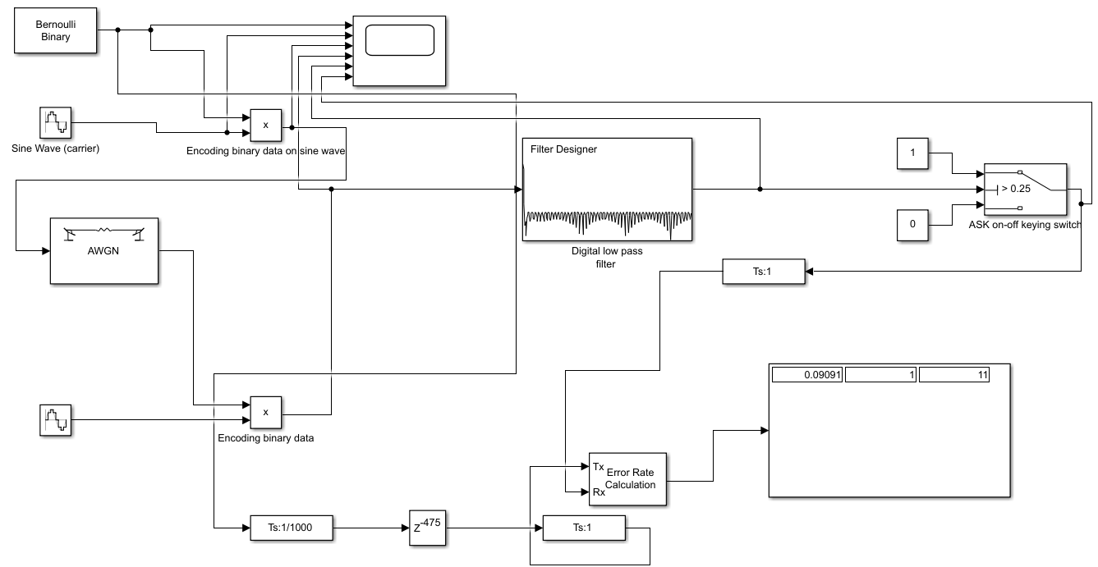
Figure 5 ASK Simulink model
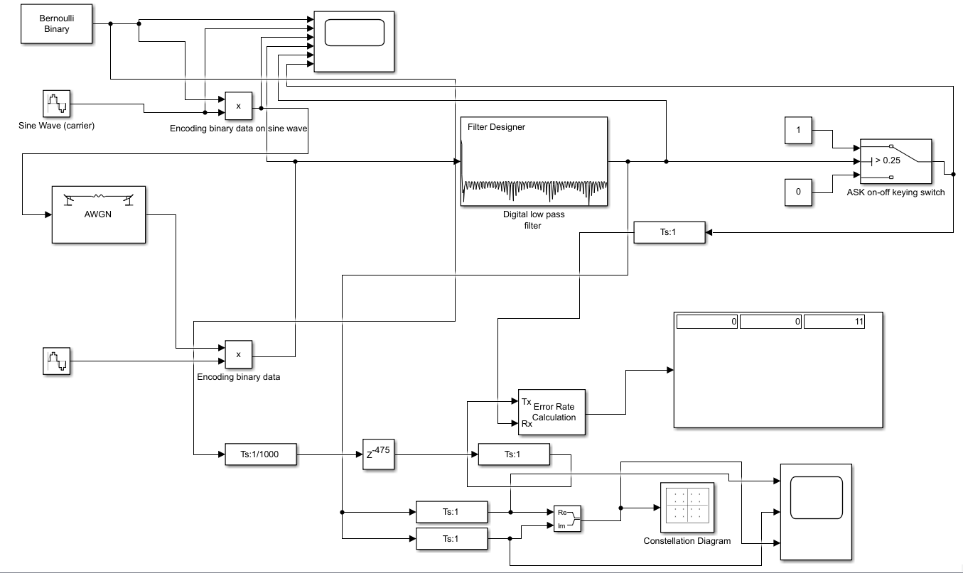
Figure 6 ASK Simulink model with the constellation diagram block
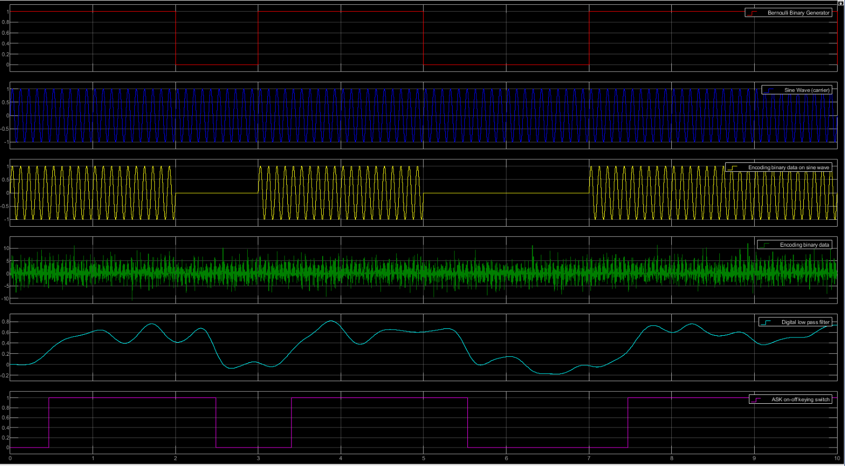
Figure 7 Modulated and demodulated waves of an ASK Simulink model
Figure 8 Graph of the bit error rate for changing levels of white Gaussian noise in amplitude shift keying modulation

Figure 9 Graph of the bit error rate for changing levels of white Gaussian noise in amplitude shift keying modulation with error bars at 1 standard deviation

BPSK modulation
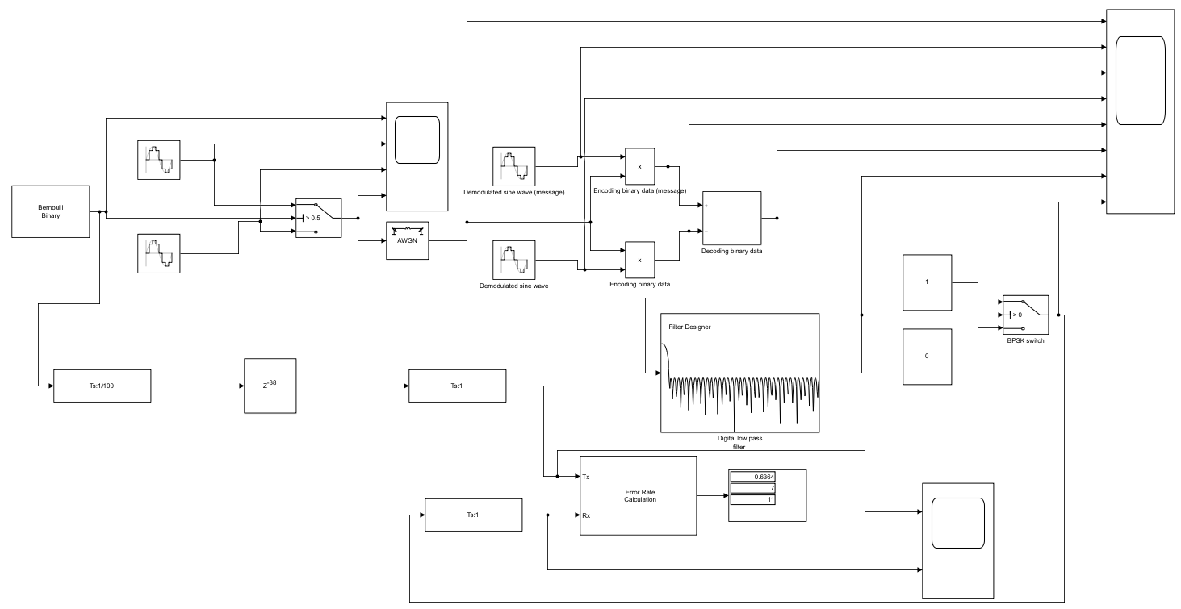
Figure 10 BPSK Simulink model
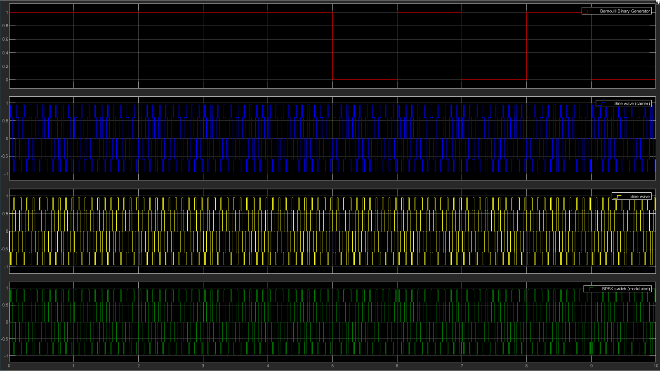
Figure 11 RF output signals on channels connected to the first oscilloscope

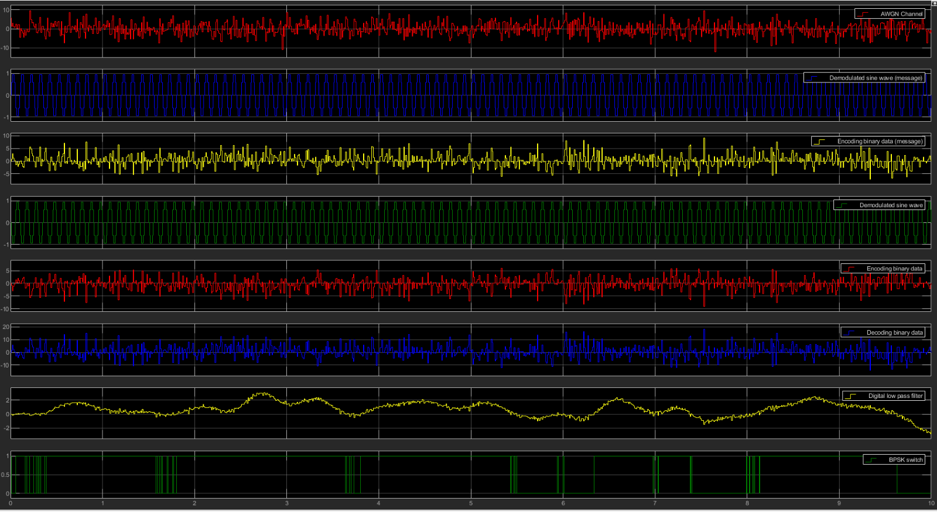
Figure 12 RF output signals on channels connected to the second oscilloscope
Figure 13 Graph of the bit error rate for changing levels of white Gaussian noise in binary phase shift keying modulation

Figure 14 Graph of the bit error rate for changing levels of white Gaussian noise in binary phase shift keying modulation with error bars at 1 standard deviation

QPSK modulation
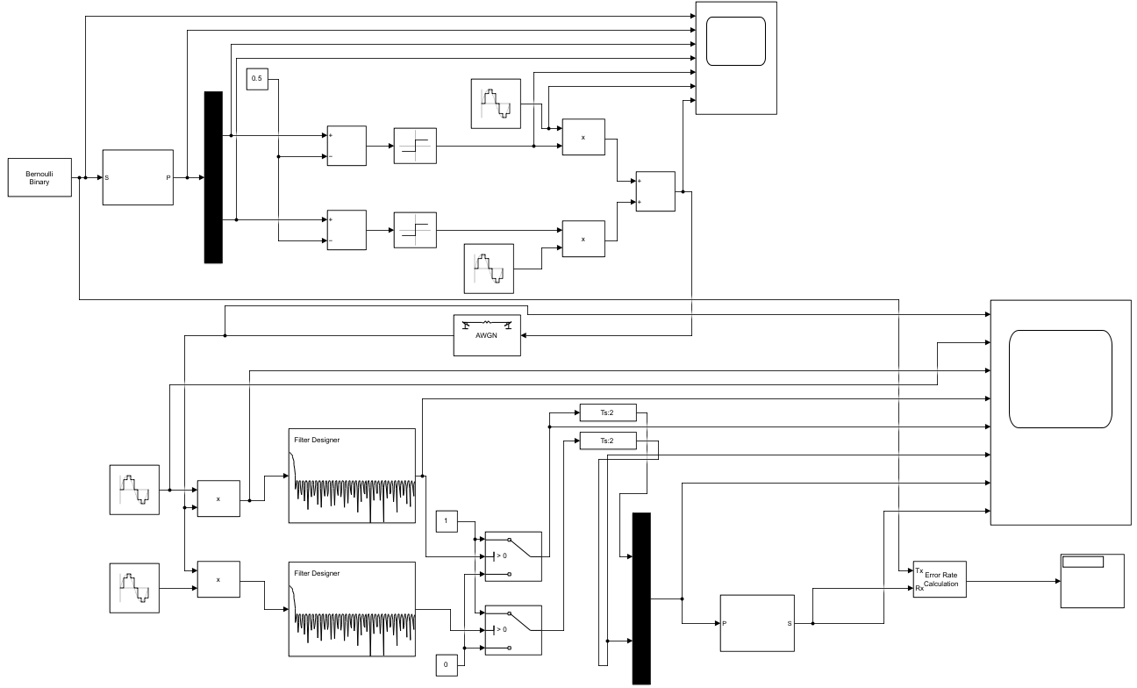
Figure 15 QPSK Simulink model
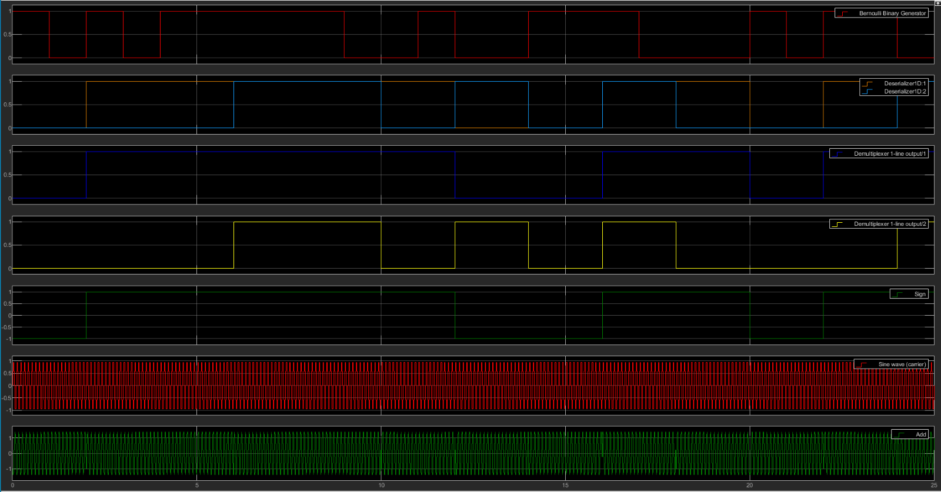
Figure 16 RF output signals on channels connected to the first oscilloscope

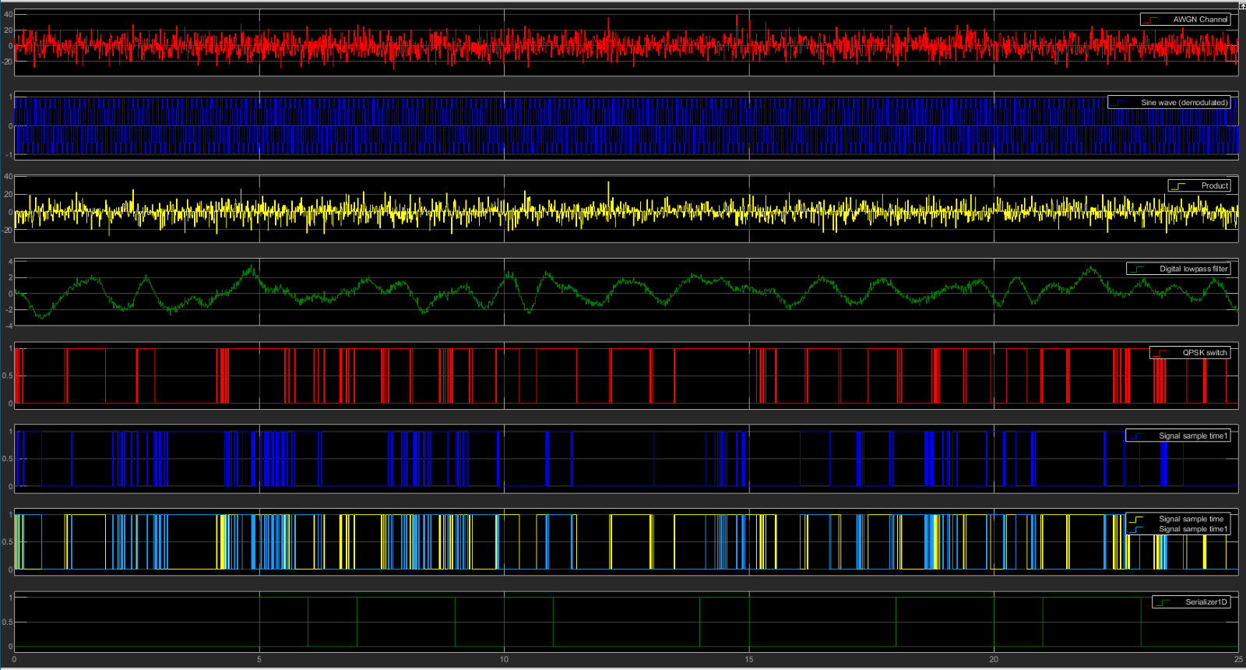
Figure 18 Graph of the bit error rate for changing levels of white Gaussian noise in quadrature phase shift keying modulation
Figure 17 RF output signals on channels connected to the second oscilloscope

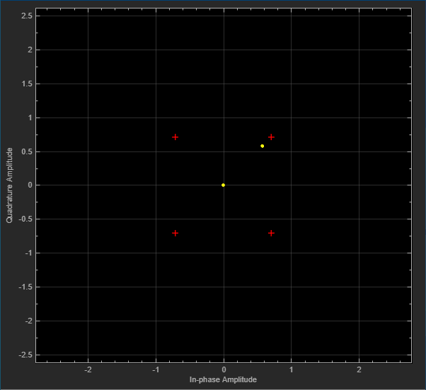
Figure 19 Graph of the bit error rate for changing levels of white Gaussian noise in quadrature phase shift keying modulation with error bars at 1 standard deviation
Figure 20 Constellation diagram for ASK modulation when the signal noise ratio is 1000dB
Figure 20 shows the constellation diagram for ASK modulation when the SNR is $1000dB$which is the closest approximation possible to an ideal system with no noise.
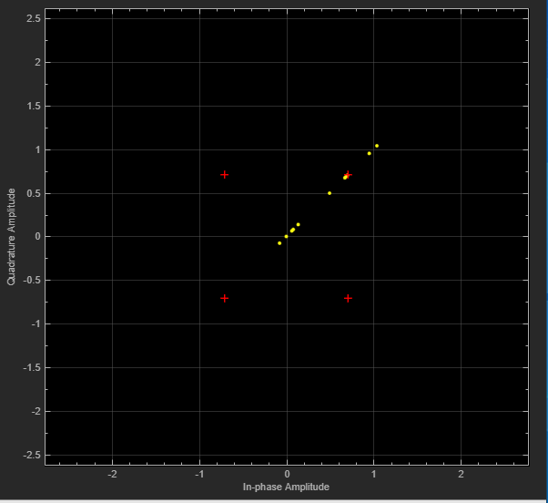
Figure 21 Constellation diagram for ASK modulation when the signal noise ratio is -20dB
Figure 21 shows the constellation diagram for ASK modulation when the SNR is $-20dB$.
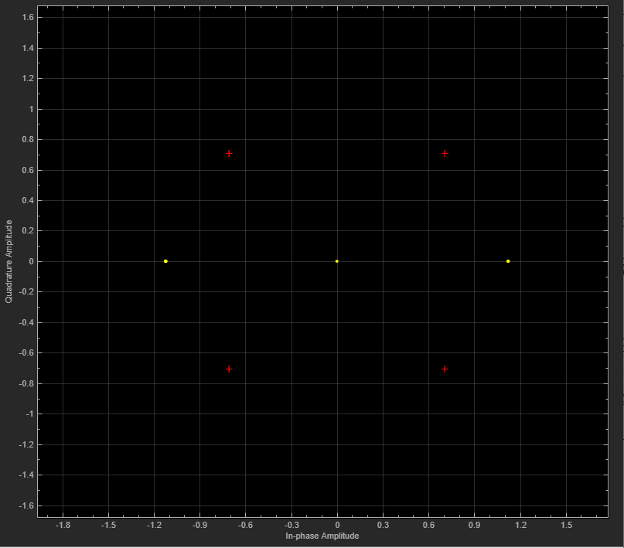
Figure 22 Constellation diagram for BPSK modulation when the signal noise ratio is 1000dB
Figure 22 shows the constellation diagram for BPSK modulation when the SNR is 1000dB which is nearest to an ideal system with no noise because a SNR $>0 dB$ and the signal to noise ratio has an inverse logarithmic relationship so the higher the ratio, the less distortion in the system. This indicates that the signal power is greater than the noise so the higher the ratio, the better the signal quality and the less interference from noise in the AWGN model. Distortion is the changing of the original waveform, and for a linear device, the input and output frequencies are equal and there is a single constant frequency. The output signal only has amplitude and phase change. The output from nonlinear devices, the output may have a frequency shift in the frequency domain or additional frequencies. ([5] - Bit Error Rate (BER) Comparison of AWGN Channels for Digital Modulation)
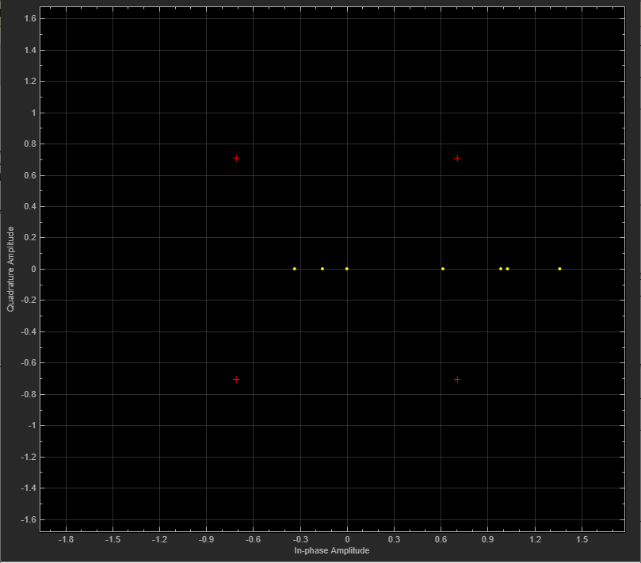
Figure 24 Constellation diagram for BPSK modulation when the signal noise ratio is -20dB
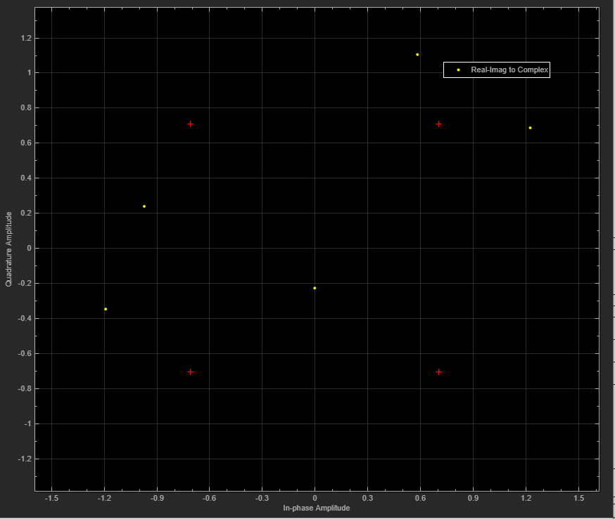
Figure 24 Constellation diagram for QPSK modulation when the signal noise ratio is 1000dB
Figure 24 shows the constellation diagram for QPSK modulation when the SNR is 1000dB which is the closest approximation possible to an ideal system with no noise.

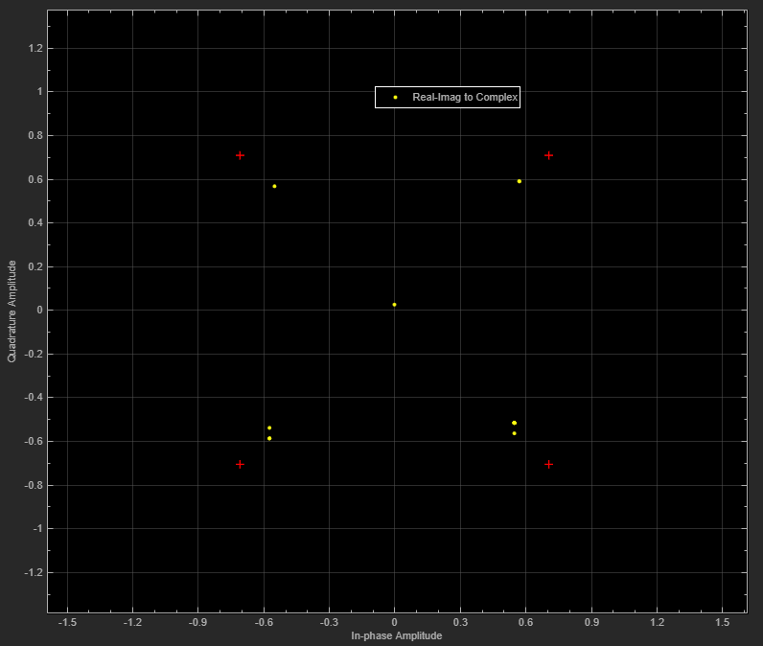
Figure 25 Constellation diagram for QPSK modulation when the signal noise ratio is -20dB

Discussion
Figure 9 shows the changing bit error rate as AWGN is changed in the system for ASK modulation and has the largest error bars one standard deviation away from the mean average bit error rate for different SNR compared to BPSK and QPSK modulations. The error bars on Figure 9 are the longest out of the three modulation types in the x and y directions. The error bars show the variation in the bit error rate as more noise is added into the modulation system and therefore changes the SNR. The variation is highest in ASK because randomised data can be added to the carrier signal at different points and changes the amplitude adding random noise into the system. Figure 19 shows the QPSK modulation and has shortest error bars in the x and y directions, so the bit error rate is consistently similar of several simulations adding randomised binary data to the carrier wave to be modulated as the SNR increases. QPSK has the lowest probability error because it’s got a high noise immunity as its not effected by a changing amplitude and for the same bit error rate, the bandwidth needed by QPSK is half that of BPSK and therefore the information transmission rate of QPSK is higher.

Conclusion
In conclusion, QPSK is the most effective type over digital modulation over ASK and BPSK types because a disadvantage of ASK is that it’s effected by noise interference because unintentional voltages can be introduced onto the carrier wave through the electromagnetic induction effect from other voltage sources and these unintentional voltages combine with the carrier signal and change the amplitude. QPSK is unaffected by amplitude change because it’s constant. One advantage of BPSK over ASK is that its less effected by data transmission errors because it’s not dependent on the amplitude of the carrier and has a higher power efficiency than AKS. One advantage of QPSK over BPSK is that although both are phase shift keying modulations, BPSK encodes binary data in two different phases in comparison to QPSK which encodes data with four different phases. Therefore, this allows QPSK to transmit the double the binary data in the same bandwidth as BPSK. One disadvantage of QPSK is that is it’s not power efficient because the more power is needed to transmit two bits.

References
[1] “What is Amplitude Shift Keying (ASK)? ASK modulation, ASK demodulation, advantages, disadvantages and applications of ASK,” Electronics Coach, Oct. 03, 2018. https://electronicscoach.com/amplitude-shift-keying.html
[2] “What is Phase Shift Keying (PSK)? BPSK modulation, BPSK demodulation, advantages, disadvantages and applications of PSK,” Electronics Coach, Oct. 03, 2018. https://electronicscoach.com/phase-shift-keying.html
[3] “What is QPSK Shift Keying (QPSK)? QPSK modulation, QPSK demodulation, advantages, disadvantages and applications of QPSK,” Electronics Coach, Oct. 03, 2018. https://electronicscoach.com/quadrature-phase-shift-keying.html
[4] R. Hu, RF Fundamentals – Definitions, Building Blocks and Components ASK, FSK and PSK Pages 24 - 26. 2019.

[5] M. Sadeque, “Bit Error Rate (BER) Comparison of AWGN Channels for Different Type’s Digital Modulation Using MATLAB Simulink.” Available: https://core.ac.uk/download/pdf/235049678.pdf

Appendices

Amplitude shift keying modulation data
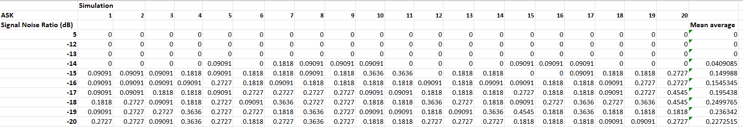
Binary phase shift keying modulation data
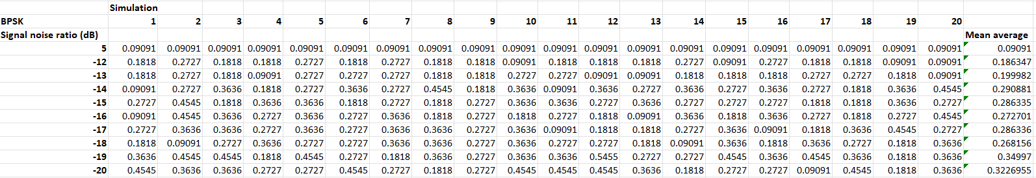
Quadrature phase shift keying modulation data


