communication in the workplace
Marina Ciubotariu (2209175)
date: 16.06.2023
word count:1067
Effective teamworking and communication BMSW40009_CARD

2023
Contents
Terms of reference 2
Procedure 3
Introduction 4
Main findings 5
1. The Shannon-Weaver communication model 1949 5
2. Schramm’s communication model 1954 6
3. David Berlo communication model 1960 7
Communication issue in the workplace 8
Conclusion 8
Reference list 9
Appendices 11

Terms of reference

This report was requested by the lecturer Melanie Squire as part of the assignment for the Effective Team Working and Communication module, level 4 qualification ‘Skills for the Workplace’ at University of Wales Trinity Saint David.
Submission date is 16th June 2023.

Procedure
To create this assignment, the procedures used were academic journals, websites, and lecture resources.

Introduction

Effective workplace communication involves ensuring that messages are clear, accurate, and understood by others. It has positive impacts on teamwork, collaboration, and the effectiveness of internal processes (Team, 2023).
Simply sending messages back and forth is not enough. It's crucial to confirm that the intended recipients comprehend the information being conveyed. To achieve clear communication, active listening, observation of nonverbal cues, soliciting feedback, and addressing misunderstandings are important practises. Establishing a respectful and empathetic environment that values diverse perspectives is essential. (Simpson, 2023)
For effective workplace communication, selecting the appropriate communication method, defining the purpose, adhering to schedules, and adapting to different communication styles are crucial. Instead of engaging in personal attacks during conflicts, individuals should focus on finding solutions (Adu-Oppong & Agyin-Birikorang, 2014).
Communication acts as ripples in a pool, starting internally and influencing people's thoughts, emotions, and actions. The effectiveness of communication depends on factors such as word choice, tone, and the context of the situation (Perkins, 2008). When communication is clear, thoughtful, and purposeful, it yields significant positive effects.
Poor workplace communication leads to conflicts among employees, damaging trust, motivation, and job satisfaction.
The main causes of conflicts are:
- inadequate management,
- unclear tasks and goals
- unequal opportunities,
- harassment
- unfair treatment
- personality clashes
- increased workload
- unrealistic expectations
- unhealthy competition
- conflicting values
(Mazowiecki, 2020).
To address these issues, organizations should prioritize clear communication channels, provide training in communication skills, foster a respectful culture, and address underlying problems. By improving communication, organizations can create a positive and harmonious work environment.

Main findings

The Shannon-Weaver communication model 1949

The 1949 Shannon-Weaver Model of Communication ‘’the mother of all models’’ by Claude Shannon and Warren Weaver has made significant contributions to communication theory.

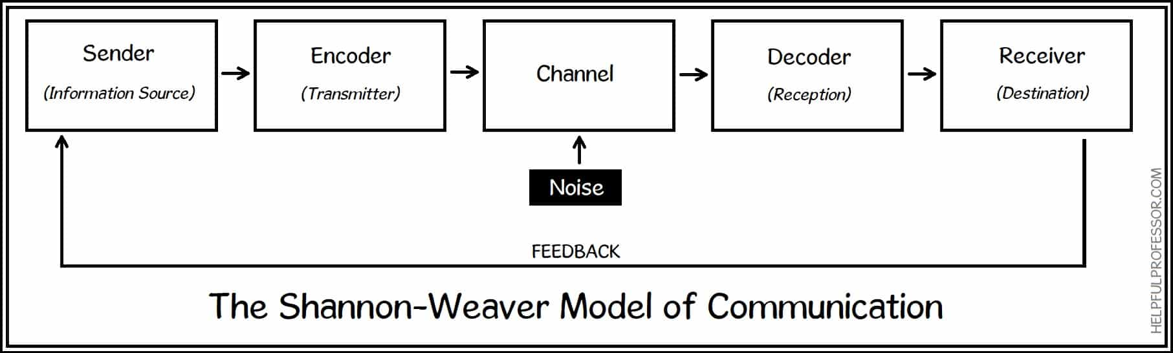

The Shannon-Weaver model illustrates the six essential steps of communication: sender, encoder, channel, noise, decoder, and receiver. The sender originates the message, which is then encoded into signals or language. The channel serves as the medium for message transmission, and the receiver decodes and comprehends the message (Shannon & Weaver, 1949).
However, the Shannon-Weaver model has faced criticism for its simplicity and linear depiction of communication. It was Norbert Wiener who introduced the concept of "feedback," transforming the model into a cyclical representation. The model lacks comprehensive consideration of human factors, such as varying interpretations, and may not fully accommodate modern multimedia communication with diverse mass audiences. Furthermore, contextual factors, including the situation, society, institutions, politics, culture, and history, play significant roles in message reception.
Despite these limitations, the fundamental principles of the Shannon-Weaver model have influenced the development of other communication models and theories that seek to capture the complexity of human interaction (Dickinson, 2022).

2. Schramm’s communication model 1954

Schramm published in 1954 a model of communication that includes two processes between the initiator and receiver, followed by the exchange of information and feedback and contains all the essential communication elements.

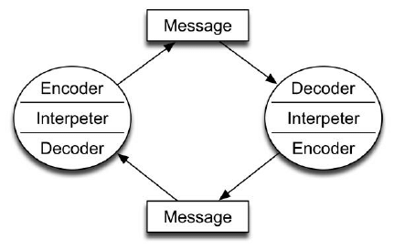

Schramm’s Model focuses on the reciprocal nature of communication.
The four guiding principles of the model are:
- There is no such thing as a one-way conversation.
- Usually, conversations are two-way streets.
- Messages need to be understood.
- There are three stages to any communication process: encoding, decoding, and interpretation (Drew, 2023).
It highlights the importance of the sender and receiver mutually influencing each other through the process of encoding and decoding messages. The model recognizes the dynamic and interactive nature of communication, emphasizing the role of feedback and the interpretation of messages within the social context. However, Schramm's model has been criticized for its limited consideration of external factors such as noise and contextual influences (Chakravarty, 2016).
Communication is considered incomplete without feedback from the recipient.

3. David Berlo communication model 1960

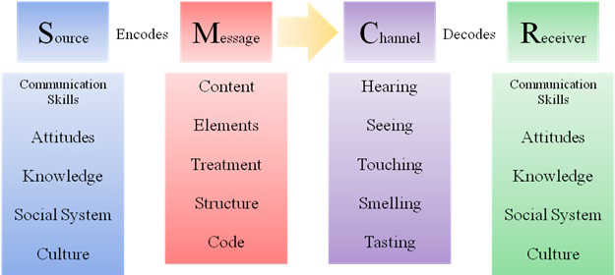
Berlo's Model of Communication is highlighting the sender, message, channel, receiver, and feedback as crucial components of communication.
Berlo's SMCR model has several drawbacks:
- Few comments: The model ignores feedback's impact on communication.
- Neglecting barriers: Cultural differences and distractions can hinder communication.
- Noise: The model ignores noise, which can impair communication.
- Complexity: Some say the model is too complicated for practical use.
- Linearity: It ignores communication's interactive and dynamic nature.
- The model's assumption of shared understanding is unrealistic in diverse settings.
- The model ignores intuition and critical thinking as communication channels.
- The SMCR model provides a framework, but it doesn't capture communication's complexity and dynamics (in Communication Models, 2019).
The model is basic but has limitations. It ignores noise, context, and communication dynamics.
It also ignores culture, interpersonal relationships, and nonverbal communication, which are crucial to communication.
Berlo's model helps explain communication's fundamentals despite its limitations. (Businesstopia, 2018).

Communication issue in the workplace

One communication issue I encountered while working as a care assistant in a dementia care home was a lack of communication. My team leader assigned me to assist a new resident to his room, whom I was not familiar with. However, because my team leader was occupied with other tasks and I didn't think to ask for additional information or inform her that I was unfamiliar with the resident, I proceeded without seeking further clarification.
As I approached the resident in the corridor, he was walking and being somewhat loud. I began asking him if he was okay, but suddenly, he started yelling and running towards me. Startled and frightened, I instinctively ran away from him, this incident caused me to panic, and I soon began feeling unwell.
I recognize that both my team leader and I could have improved our communication to ensure a smoother and safer experience. While my team leader should have provided me with necessary information about the new resident, I also bear responsibility for not actively seeking clarification or expressing my concerns. This incident has taught me the importance of proactive communication and taking personal responsibility in ensuring clear understanding and mutual support within the workplace.
From this experience, I learned the importance of effective communication and seeking clarification when faced with unfamiliar situations. It is crucial to openly communicate with team members, ask necessary questions, and seek guidance to ensure the safety and well-being of both residents and staff. Additionally, taking ownership of one's actions and learning from mistakes is essential for personal and professional growth in the workplace.

Conclusion

- Effective workplace communication is enhanced by models like Berlo's, Schramm's, and Shannon-Weaver's.
- Applying these models improves communication skills and creates a productive environment.Berlo's focuses on sender-receiver dynamics and feedback.
- Shannon-Weaver addresses noise but has limitations. Schramm's emphasizes feedback but may overlook external factors.
- Understanding these models and using active listening and clear feedback fosters effective communication in the workplace.

Reference list
- Adu-Oppong, A.A. and Agyin-Birikorang, E. (2014) ResearchGate. Available at: https://www.researchgate.net/publication/304782482_COMMUNICATION_IN_THE_WORKPLACE_GUIDELINES_FOR_IMPROVING_EFFECTIVENESS/link/57a8550108ae73e6e132670b/download full text available (Accessed: 13 June 2023).
- Businesstopia (2018) Berlo’s SMCR model of communication, Businesstopia. Available at: https://www.businesstopia.net/communication/berlo-model-communication?utm_content=cmp-true (Accessed: 16 June 2023).
- Chakravarty, B. (2016) Schramm’s model of Communication, Academia.edu. Available at: https://www.academia.edu/26534964/Schramms_Model_of_Communication (Accessed: 15 June 2023).
- Dickinson, G. (2022) Take online courses. earn college credit. Research Schools, Degrees & Careers, Study.com | Take Online Courses. Earn College Credit. Research Schools, Degrees & Careers. Available at: https://study.com/learn/lesson/shannon-weaver-model-communication-theory-parts-transmission-model.html (Accessed: 15 June 2023).
- Drew, C. (2023) Osgood-Schramm Model of Communication - Pros & Cons, Helpful Professor. Available at: https://helpfulprofessor.com/osgood-schramm/ (Accessed: 15 June 2023).
- in Communication Models, I.C. (2019) Berlo’s SMCR model of communication, Communication Theory. Available at: https://www.communicationtheory.org/berlos-smcr-model-of-communication/#:~:text=Criticism%20of%20Berlo’s%20SMCR%20model%20of%20communication%3A&text=There%20is%20no%20room%20for,for%20effective%20communication%20to%20happen. (Accessed: 15 June 2023).
- Mazowiecki, G. (2020) How important is good communication in the workplace?, G2A.COM - Official Corporate Website. Available at: https://www.g2a.co/how-important-is-good-communication-in-the-workplace/ (Accessed: 14 June 2023).
- Perkins, P.S. (2088) The art and science of communication, Google Books. Available at: https://books.google.co.uk/books?hl=en&lr=&id=PEzKCQAAQBAJ&oi=fnd&pg=PR11&dq=what%2Bmakes%2Beffective%2Bcommunication%2Bin%2Bthe%2Bworkplace%3F&ots=7RsvINurW3&sig=s6YenIwIcljCslbHThKSWAy8rlk#v=onepage&q=what%20makes%20effective%20communication%20in%20the%20workplace%3F&f=false (Accessed: 13 June 2023).
- Schramm’s model of Communication (2023) Wikipedia. Available at: https://en.wikipedia.org/wiki/Schramm%27s_model_of_communication (Accessed: 15 June 2023).
- Shannon, C.E. and Weaver, W. (1949) UC Santa Barbara. Available at: https://raley.english.ucsb.edu/wp-content/Engl800/Shannon-Weaver.pdf (Accessed: 15 June 2023).
- Simpson, O. (2023) Why Communications Skills are management’s most important quality, Digital Marketing & Strategy Training Programmes. Available at: https://www.ascento.co.uk/blog/why-communications-skills-are-a-managers-most-important-quality (Accessed: 14 June 2023).
- Team, R. (2023) 5 tips [and 5 tools] for effective communication in the workplace, RingCentral. Available at: https://www.ringcentral.com/us/en/blog/the-importance-of-effective-communication-in-the-workplace/ (Accessed: 14 June 2023).

Appendices

https://www.youtube.com/shorts/UQbR3m79bNw

