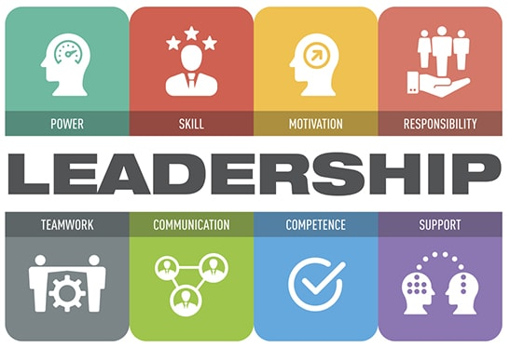

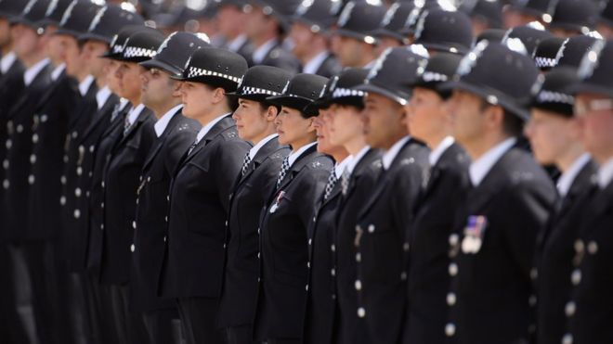

Development doesn’t come to you,
You have to seek it out.

The AIM of this session is

To enable you to gain
an understanding of the
concepts, styles and dimensions of
Leadership & Teamwork

TO

BECOME A MORE EFFECTIVE LEADER

OBJECTIVES

- Explain the professional importance of self-evaluation, self-improvement & reflective practice.

- Understand the nature of effective team working.

Leadership Styles

During the course you will discuss a variety of Leadership models:

1. Autocratic Leadership is when a leader makes a decision alone. The leader conveys the decision to staff and they have to work within the scope of that decision. As a result, decisions will reflect the opinions and personality of the manager, which in turn can project an image of a confident, well managed business. On the other hand, strong and competent team members may find this limit on decision-making freedom.

2. Democratic Leadership encompasses discussion, debate and sharing of ideas. The democratic style encompasses the notion that everyone should play a part in the group's decisions. However, the democratic style of leadership still requires guidance and control by a specific leader. The democratic style demands the leader to make decisions on who should be called upon within the group and who is given the right to participate in, make and vote on decisions.

3. Laissez-faire Leadership (derived from the French meaning 'leave alone') is a loose leadership style. It allows employees to carry out activities freely within broad limits. It differs from the democratic style in that individuals are able to behave independently and make their own decisions, rather than coming together on an agreed course of action.
4. Transactional Leadership starts with the idea that team members agree to obey their leader when they accept a job. The "transaction" usually involves an organisation paying team members in return for their effort and compliance. The leader has a right to "punish" team members if their work doesn't meet an appropriate standard.
Although this might sound controlling, transactional leadership offers some benefits. For one, this leadership style clarifies everyone's roles and responsibilities. Another benefit is that, because transactional leadership judges team members on performance, people who are ambitious or who are motivated by external rewards – including compensation – often thrive. The downside is that team members may feel they have little control of job satisfaction which in turn can lead to high staff turnover.
5. Transformational Leadership is often seen as the opposite to transactional leadership style. Transformational leadership aims to change and transform people. It influences followers to want to achieve more than what is usually expected of them and is based on attaining follower commitment opposed to follower compliance. It creates a desire for people to work as a team in an enjoyable and non-threatening culture. The Transformational Leader may use social networking to create a direct link to team members. This theory is based on the ability of the leader to inspire the work force to perform at their best by using personal characteristics to inspire others to achieve goals.
6. Situational Leadership dictates that different situations demand different styles of leadership. Therefore an effective leader must be able to adapt their leadership style according to the situation. The model is based on the leader assessing development level toward a specific task and matching the most appropriate leadership style.

7. Adaptive Leadership “mobilises people to tackle tough problems” Heifetz (1996) rather than relying upon the leader trying to drive change from the top down. It recognises leadership is complex and that future leaders need to be self-aware and adaptable. Adaptive leadership recognises there are basically two kinds of problems that people confuse when trying to find solutions:

- “Technical problems” where an adequate response has been developed; there are one or more experts with general credibility and an established procedure or protocol will suffice. For example, a critical incident; although the situation may be complex, there is an established procedure to follow, etc.
- “Adaptive problems” where procedures don’t exist, there are no recognised experts, and no adequate responses developed such as organisational change. The problem definition is not clear cut and technical fixes are unavailable. It calls for Adaptive leadership where the leader does not have the answers. Instead, the leader has to find a way of mobilising and motivating people to work together to find new solutions that will succeed.
Adaptive leadership is about first recognising what kind of challenge or situation is being dealt with, then deciding on a course of action that utilises either a management style or a range of leadership qualities to mobilise people in order to find an appropriate way forward.

8. Supportive Leadership Supportive leadership is a naturally organic and emotionally sensitive style; like other styles, it is especially useful in certain circumstances, but the organisation must adopt a culture that encourages such styles for them to be effective.
In supportive leadership, the manager is not so interested in giving orders and managing every detail as in giving employees the tools they need to work themselves. While delegation is a vital part of supportive leadership, managers do not simply assign tasks and then receive the results. Instead, they work through the tasks with employees to improve skills and talent until the manager does not need to worry about a task being done correctly and the employee is fully empowered in a particular area.
Supportive leadership styles are defined by their approach to emotions, training and time. Supportive leaders listen carefully to their employees and help them deal with stress and the conflicting personalities of other employees. This requires empathy and a degree of sensitivity that is difficult for some managers to achieve. Supportive leaders then train employees to deal with issues themselves, as they arise, relying on the manager when necessary but dealing with the problems themselves as much as possible. This requires significant time investment by the leader.
Supportive leadership helps to build and maintain effective interpersonal relationships. A manager who is considerate and friendly toward people is more likely to win their friendship and loyalty. The emotional ties that are formed make it easier to gain cooperation and support from people on whom the manager must rely to get the work done. It is more satisfying to work with someone who is friendly, cooperative, and supportive than with someone who is cold and impersonal, or worse, hostile and uncooperative. (Yukl, 2010)
If you practice supportive leadership, your people will likely be more satisfied with you and with their jobs. The research on the relationship between supportive leadership and employee performance is not well established, but there is some evidence suggesting that supportive leadership can enhance performance.
Here are some behaviors that supportive leaders should work on (Yukl, 2010):-
- Show acceptance and positive regard for others.
- Be polite and considerate, not arrogant and rude.
- Treat each employee as an individual.
- Remember important details about the person (like their name!).
- Be patient and helpful when giving instructions or explanations.
- Provide sympathy and support when the person is anxious or upset.
- Express confidence in the person when there is a difficult task.
- Provide assistance with the work when it is needed.
- Be willing to help with personal problems.
- Listen more than you talk, that’s why you have two ears and only one mouth.
- Develop others by giving praise
- Allow others to take the lead in order to grow and gain some insights on what it takes to be a leader.
Supportive Leadership can also be referred to as Participative Leadership.



Finding the appropriate leadership style

Each leadership style has benefits and weaknesses. Leadership is not a "one size fits all" thing; often, you must adapt your style to fit a situation or a specific group. This is why it's useful to gain a thorough understanding of leadership styles; after all, the more approaches you're familiar with, the more you can shape your approach to the situation.
How do you know which leadership style you should use? There are a number of things that determine this. For example, does the work have scope for creativity, or does it need to be completed in a specific way? Would close management be best, or should you encourage your people to work independently and deliver a finished product?
Different people and different areas of business need different leadership styles. But how do you know which approach is best for each project, person, or situation? For example, when assessing delegation of work, a leader must first assess the developmental level of each follower and use the most appropriate leadership style to achieve that goal. Questions asked may include:

- What does the task or project involve?
- How difficult is it?
- Does the team/team member have skills, knowledge and appropriate experience?
- Are they motivated to complete the task?

In other words, leaders,
through whom they are and the way they behave,
inspire others to perform well and develop.

Leadership

Leadership definitions and descriptions vary enormously. Examples of Leadership can be extremely diverse too. We can find Leadership in every sort of work and play, regardless of scale and financial or official authority. Given the many ways in which Leadership operates, it is no surprise that Leadership is difficult to define.
The practical aspects of leadership are not as easy as theoretical explanations that exist in the many publications on this subject matter. It could be argued that leadership is about behaviour first and skill second. There are natural leaders and others who need a little more guidance in regards to the leadership process. Qualities such as confidence and charisma will continue to grow from experience within a leadership role, and individuals will become better leaders as a result of this experience.
Good leadership, supervision and management are not an exact science. They are the product of many factors including; circumstances, deadlines, individuals, team dynamics, cooperation, skills availability.

What does Leadership mean to you?

Record information regarding points 3 & 4 that is relevant to you.

How does a Leader behave?

How does a good leader inspire those around them? We all respond to different leaders in different ways. Think of leaders who you have worked for, what attributes did they have?

Bad Attributes Good Attributes

Personal SWOT Analysis

Name: Date:

Strengths  (What are my leadership strengths?) | Weaknesses  (What are my leadership weaknesses?)
Opportunities  (What are my leadership opportunities?) | Threats  (What are my leadership threats?)

COMMUNICATION

Do we really mean what we say when we say it? Often not! Again, the situation, circumstances and various other imponderables will determine how we communicate with others. Communication is key to personal leadership and successful interactions. You communicate with others every day on many levels. However you may not always take time to analyse how your natural ways of interacting affect others. Understanding, appreciating, and accommodating individual differences in communication style can enhance your ability to communicate.

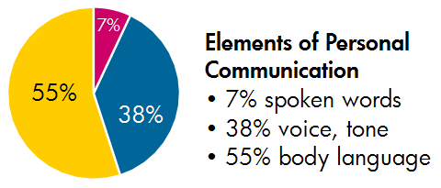

In 1971, American psychologist Albert Mehrabian published his most famous but often misquoted research on communication. This research, which is still relevant today, emphasised the importance of non-verbal communication, referring to the signals that we give another person and the way we interpret the signals given by them. We do not have to be experts in body language to ‘get the picture’ and it is worth remembering that while we may form an impression of someone before they even speak, they are also forming a first impression of us. Remember your body langauge can present a picture that is different from what is actually being said or what is intended to be said.

John Adair's action centred leadership

(a model for team leadership and management)
John Adair, born 1934, British, developed his Action Centred Leadership model while lecturing at Sandhurst Royal Military Academy and as assistant director and head of leadership department at The Industrial Society during the 1960s and 70s.
Adair was probably the first to demonstrate that leadership is a trainable, transferable skill, rather than it being an exclusively inborn ability. He helped change perception of management to encompass leadership, to include associated abilities of decision-making, communication and time-management. As well as developing the Action Centred Leadership model, Adair wrote over 40 books on management and leadership, including Effective Leadership, Not Bosses but Leaders, and Great Leaders.
Leadership is different to management. All leaders are not necessarily great managers, but the best leaders will possess good management skills. One skill-set does not automatically imply the other will be present. Adair used the original word meanings to emphasise this: Leadership is an ancient ability about deciding direction, from an Anglo-Saxon word meaning the road or path ahead; knowing the next step and then taking others with you to it. Managing is a later concept, from Latin 'manus', meaning hand, and more associated with handling a system or machine of some kind. The original concept of managing began in the 19th century when engineers and accountants started to become entrepreneurs.
There are valuable elements of management not necessarily found in leadership, e.g. administration and managing resources. Leadership on the other hand contains elements not necessarily found in management, e.g., inspiring others through the leader's own enthusiasm and commitment. The three elements - Achieving the Task, Developing the Team and Developing Individuals - are mutually dependent, as well as being separately essential to the overall leadership role.
Adair set out these core functions of leadership and says they are vital to the Action Centred Leadership model:
Planning - seeking information, defining tasks, setting aims
Initiating - briefing, task allocation, setting standards
Controlling - maintaining standards, ensuring progress, ongoing decision-making
Supporting - individuals' contributions, encouraging, team spirit, reconciling, morale
Informing - clarifying tasks and plans, updating, receiving feedback and interpreting
Evaluating - feasibility of ideas, performance, enabling self-assessment

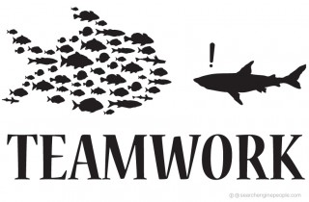
John Adair's simple Action-Centred Leadership model (provides a great blueprint for leadership and the management of any team, group or organisation. Action Centred Leadership is also a simple leadership and management model, which makes it easy to remember and apply, and to adapt for your own situation.
Good managers and leaders should have full command of the three main areas of the Action Centred Leadership model, and should be able to use each of the elements according to the situation. Being able to do all of these things, and keep the right balance, gets results, builds morale, improves quality, develops teams and productivity, and is the mark of a successful manager and leader.
The three parts of Adair's Action-Centred Leadership model are commonly represented by three overlapping circles. These illustrate Adair's three core management responsibilities:
- Achieving the Task
- Managing the Individual
- Managing the Team or group

John Adair's Action Centred Leadership (exercise)
- Describe the actions you would take as a leader for ensuring tasks are achieved.

2. Describe the actions you would take as a leader, which would build & maximizes the potential of your team are achieved.

3. Describe the actions you would take as a leader development of individual members of your team.

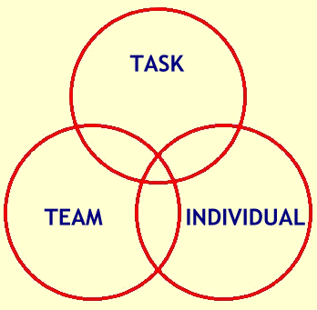John Adair's Action Centred Leadership (exercise)

As a Leader of a team how do you motivate them within the workplace?

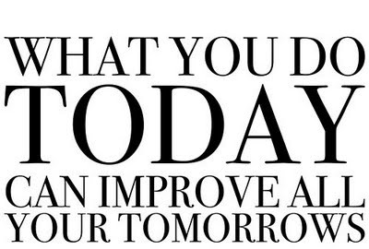

Emotional Intelligence

When you think of a "perfect leader," what comes to mind?

You might picture someone who never lets their temper get out of control, no matter what problems they are facing. You might think of someone who has the complete trust of their staff, always speaks kindly, listens to their team, is easy to talk to and always makes careful, informed decisions.

These are qualities of someone with a high degree of emotional intelligence. We'll look at why emotional intelligence is so important for leaders – and how you, as a leader, can improve yours.

What Is Emotional Intelligence?

Emotional intelligence (EI) is the ability to understand and manage both your own emotions, and those of the people around you. People with a high degree of emotional intelligence usually know what they're feeling, what this means, and how their emotions can affect other people.

For leaders, having emotional intelligence is essential for success. After all, who is more likely to succeed – a leader who shouts at their team when they are under stress, or a leader who stay in control, and calmly assesses the situation?

According to Daniel Goleman, an American psychologist who helped make the idea of EI popular, there are five main elements of emotional intelligence:

- Self-awareness

- Self-regulation

- Motivation

- Empathy

- Social skills

The more that a leader manages each of these areas, the higher the emotional intelligence.So, let's look at each element in more detail and examine how you can grow as a leader.

Emotional Intelligence in Leadership

1. Self-awareness

If you're self-aware, you always know how you feel, and you know how your emotions, and your actions, can affect the people around you. Being self-aware when you're in a leadership position also means having a clear picture of your strengths and weaknesses. And it means having humility.

So, what can you do to improve your self-awareness?

Keep a journal – Journals help improve your self-awareness. If you spend just a few minutes each day writing down your thoughts, this can move you to a higher degree of self-awareness.

Slow down – When you experience anger or other strong emotions, slow down to examine why. Remember, no matter what the situation, you can always choose how you react to it.
2. Self-regulation

Leaders who regulate themselves effectively rarely verbally attack others, make rushed or emotional decisions, stereotype people, or compromise their values. Self-regulation is all about staying in control.

This element of emotional intelligence, according to Goleman, also covers a leader's flexibility and commitment to personal accountability.

So, how can you improve your ability to self-regulate?

Know your values – Do you have a clear idea of where you absolutely will not compromise? Do you know what values are most important to you? Spend some time examining your "code of ethics." If you know what's most important to you, then you probably won't have to think twice when you face a moral or ethical decision – you'll make the right choice.

Hold yourself accountable – If you tend to blame others when something goes wrong, stop. Make a commitment to admit to your mistakes and face the consequences, whatever they are. You'll probably sleep better at night, and you'll quickly earn the respect of those around you.

Practice being calm – The next time you're in a challenging situation, be very aware of how you act. Do you relieve your stress by shouting at someone else? Practice deep-breathing exercises to calm yourself. Also, try to write down all of the negative things you want to say, and then rip it up and throw it away. Expressing these emotions on paper (and not showing them to anyone!) is better than speaking them aloud to your team. What's more, this helps you challenge your reactions to make sure that they're fair!

3. Motivation

Self-motivated leaders consistently work toward their goals, and they have extremely high standards for the quality of their work.

How can you improve your motivation?

Re-examine why you're doing this – It's easy to forget what you really love about your career. So, take some time to remember why you wanted this job. If you're unhappy in your role and you're struggling to remember why you wanted it, try the ‘Five Whys’ technique to find the root of the problem. Starting at the root often helps you look at your situation in a new way, and make sure that your goal statements are fresh and energising.

Know where you stand – Determine how motivated you are to lead. If you need to increase your motivation to lead, look at how you can change this.

Be hopeful and find something good – Motivated leaders are usually optimistic, no matter what they face. Adopting this mindset might take practice, but its well worth the effort. Every time you face a challenge, or even a failure, try to find at least one good thing about the situation. It might be something small, like a new contact, or something with long-term effects, like an important lesson learned, but there's almost always something positive – you just have to look for it.

4. Empathy

For leaders, having empathy is critical to managing a successful team or organisation. Leaders with empathy have the ability to put themselves in someone else's situation. They help develop the people on their team, challenge others who are acting unfairly, give constructive feedback, and listen to those who need it.
If you want to earn the respect and loyalty of your team, then show them you care by being empathic.

How can you improve your empathy?

Put yourself in someone else's position – It's easy to support your own point of view. After all, it's yours! But take the time to look at situations from other people's perspectives!

Pay attention to body language – Perhaps when you listen to someone, you cross your arms, move your feet back and forth, or bite your lip. This body language tells others how you really feel about a situation, and the message you're giving isn't positive! Learning to read body language can be a real asset when you're in a leadership role because you'll be better able to determine how someone truly feels. This gives you the opportunity to respond appropriately.

Respond to feelings – You ask your assistant to work late – again, and although they agree, you can hear the disappointment in their voice. So, respond by addressing their feelings. Tell them you appreciate how willing they are to work extra hours, and that you're just as frustrated about working late. If possible, figure out a way for future late nights to be less of an issue (for example, give them Monday mornings off).

5. Social skills

Leaders who do well in this element of emotional intelligence are great communicators. They're just as open to hearing bad news as good news, and they're experts at getting their team to support them and be excited about a new mission or project.

Leaders who have good social skills are also good at managing change and resolving conflicts diplomatically. They're rarely satisfied with leaving things as they are, but they're also not willing to make everyone else do the work. They set the example with their own behaviour.

So, how can you improve your leadership by building social skills?

Learn conflict resolution – Leaders must know how to resolve conflicts between their team members, customers, or vendors. Learning conflict resolution skills is vital if you want to succeed.

Improve your communication skills – How well do you communicate?

Learn how to praise others – As a leader; you can inspire the loyalty of your team simply by giving praise when it's earned. Learning how to effectively praise others is a fine art, but well worth the effort.

Key Points

Thanks to the many challenges and opportunities that arise when working with others, leaders must have a solid understanding of how their emotions and actions affect the people around them. The better a leader relates to and works with others, the more successful they will be.


