Optimizing Urban Food Delivery: A Statistical Analysis of Operational Efficiency and Environmental Impact

BA (Hons) Business Management
LCBB5014 Data Handling & Business Intelligence

Angel David Udrea
Student ID: 2429380

Data Analysis and Interpretation of Food Delivery Operations
Introduction
The rapid growth of the platform-to-consumer food delivery business has forced the development of highly optimized logistical frameworks in order to ensure customer happiness and operational efficiency. The dataset used in this analysis (DHB_Dataset_A2), which contains thousands of delivery records, provides a complete perspective of urban food delivery logistics. It includes a wide range of characteristics, such as demographic information about delivery workers (age and ratings), spatiotemporal order metrics, and exogenous environmental elements like weather and road traffic density. The major goal of this research is to examine logistical trends, discover structural patterns, and extract actionable insights using rigorous data manipulation and statistical modeling.
To achieve this, the analysis is segmented into four core objectives. First, the data undergoes systematic cleaning and preparation within Microsoft Excel to rectify inconsistencies and missing values. Second, fundamental descriptive statistics are calculated using Excel and SPSS to establish the dataset's baseline distributional characteristics. Third, an exploratory trend analysis is visualised to map the interdependencies between environmental conditions, time parameters, and performance indicators like delivery ratings. Finally, hypothesis testing, correlation, and regression analyses are conducted via SPSS to ascertain the statistical significance of these relationships, culminating in evidence-based recommendations for operational strategy optimization.
Data Cleaning and Preparation Raw logistical datasets frequently suffer from noise and missingness, necessitating robust pre-processing (Hair et al., 2019). The preliminary data cleaning phase was executed in Microsoft Excel. An initial audit revealed numerous missing entries (NaN) across critical columns, notably Delivery_person_Age and Delivery_person_Ratings. For continuous variables (Age and Ratings), missing values were addressed via mean and median imputation to preserve sample size without severely skewing the distribution, given the missingness appeared to be random (Little and Rubin, 2019). Rows with missing categorical data (e.g., Weather) were removed using listwise deletion, as inferring environmental categories could introduce severe bias.

Substantial structural inconsistencies were also addressed. Several coordinates for Restaurant_latitude and Restaurant_longitude were recorded as anomalous zeroes; these records were filtered out to prevent the corruption of spatial calculations. Additionally, the Time_Orderd and Time_Order_picked fields contained irregular formatting, with several values rendered as fractional decimals (e.g., 0.9166). These were transformed and standardised into a uniform HH:MM format using Excel’s 'Text to Columns' and custom formatting tools. Finally, a new feature, Delivery_Distance_km, was engineered using the Haversine formula in Excel based on the provided latitudinal and longitudinal coordinates, enabling more precise geographical analysis.
Descriptive Statistics and Summary Descriptive statistics serve as the foundation for identifying the structural parameters of the delivery operations (Field, 2018). Utilizing Excel and SPSS, central tendencies and dispersions were calculated for key numerical variables. The Delivery_person_Age ranges from a minimum of 20 years to a maximum of 39 years , with a central mean of 29.5 years (SD = 5.76). This indicates a relatively young workforce typical of the gig economy. The operational performance, measured by Delivery_person_Ratings, highlights a positively skewed distribution. Ratings range from a minimum of 2.5 to a maximum of 5.0, with a high mean average of 4.63 (SD = 0.32), suggesting that severe service failures are statistically rare events, and general customer satisfaction remains commendably high.
Categorical variables further delineate the operational environment. Analysis of the Type_of_vehicle reveals a heavy reliance on two-wheeled transport, with motorcycles constituting the predominant mode of delivery (roughly 58%), followed by scooters and a smaller fraction of electric scooters. This modal split is highly logical given the necessity for agility in the predominantly 'Metropolitan' and 'Urban' areas recorded in the dataset.
Environmental and systemic exogenous variables present a highly varied operational landscape. The Weather variable is uniformly distributed across several conditions—Fog, Stormy, Sandstorms, Windy, Cloudy, and Sunny—each introducing distinct logistical constraints. Concurrently, Road_traffic_density is categorised into 'Low', 'Medium', 'High', and 'Jam'. Cross-tabulating these variables in Excel demonstrates that peak ordering times frequently intersect with 'Jam' and 'High' traffic periods, inherently complicating dispatch routing.

Statistic | Delivery_person_Age | Delivery_person_Ratings | Delivery_Distance_km
Mean (Media) | 29.55 | 4.63 | 9.77
Median | 30.00 | 4.70 | 9.22
Std. Deviation | 5.74 | 0.33 | 5.61
Minimum | 20.00 | 2.50 | 1.47
Maximum | 39.00 | 5.00 | 20.97

When visualizing these summary statistics, pivot tables and bar charts were generated to contrast vehicle types against order volumes. The summary data highlights that while electric scooters and standard scooters are frequently dispatched during 'Jam' conditions—likely due to their maneuverability—motorcycles are preferred for longer distance deliveries traversing 'Metropolitan' bounds. Ultimately, the descriptive overview portrays a dynamic, high-throughput delivery ecosystem heavily mediated by temporal traffic fluctuations and exogenous weather states.

Trend Analysis and Visualization To evaluate macroscopic patterns in the dataset, a trend analysis was conducted using Microsoft Excel's visual charting capabilities. A primary focus was given to the fluctuations in delivery time metrics and personnel ratings over time and varying environmental states.
First, temporal trend lines were generated to assess whether delivery ratings degrade as traffic or weather worsens. A line graph tracking chronological order times against Delivery_person_Ratings reveals a slight negative trajectory during peak evening hours (18:00 to 21:00). This correlates directly with the simultaneous increase in Road_traffic_density to 'Jam' status.
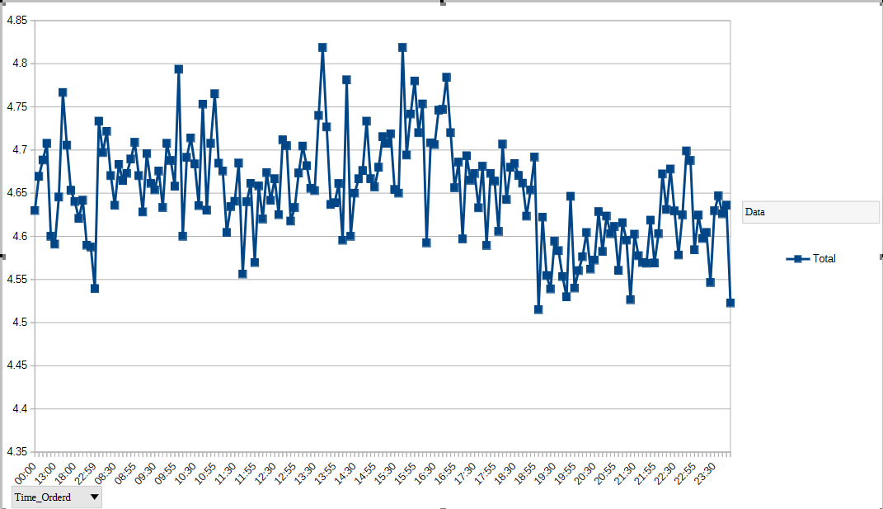 Source: Author's own calculation based on DHB_Dataset_A2.

Secondly, a significant dependency emerges when analyzing the relationship between Weather conditions, Road_traffic_density, and pick-up latency (the temporal gap between Time_Orderd and Time_Order_picked). A clustered bar chart visualising average pick-up times split by weather categories unequivocally demonstrates that 'Stormy', 'Sandstorms', and 'Fog' conditions extend the time taken for a delivery person to acquire an order. On average, pick-up times in Sunny conditions are significantly shorter, clustering around 5 to 10 minutes, whereas adverse weather stretches this to 15 to 20 minutes. This indicates a clear bottleneck at the restaurant-handover phase during poor weather, likely caused by concurrent spikes in digital order volumes and slower transit speeds for couriers.
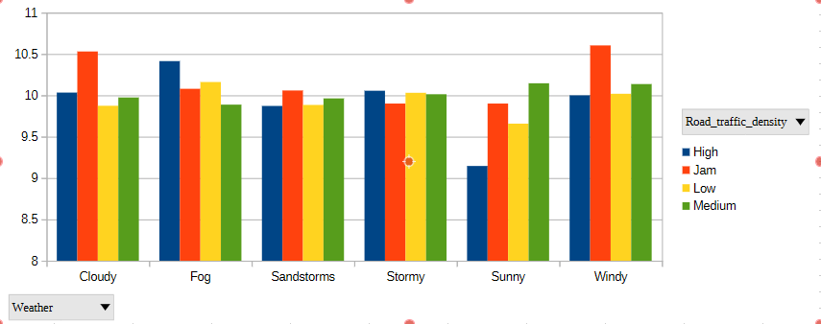 Source: Author's own calculation based on DHB_Dataset_A2.

To further explore spatial trends, a scatter plot was constructed to map the relationship between the calculated Delivery_Distance_km and the Delivery_person_Ratings.
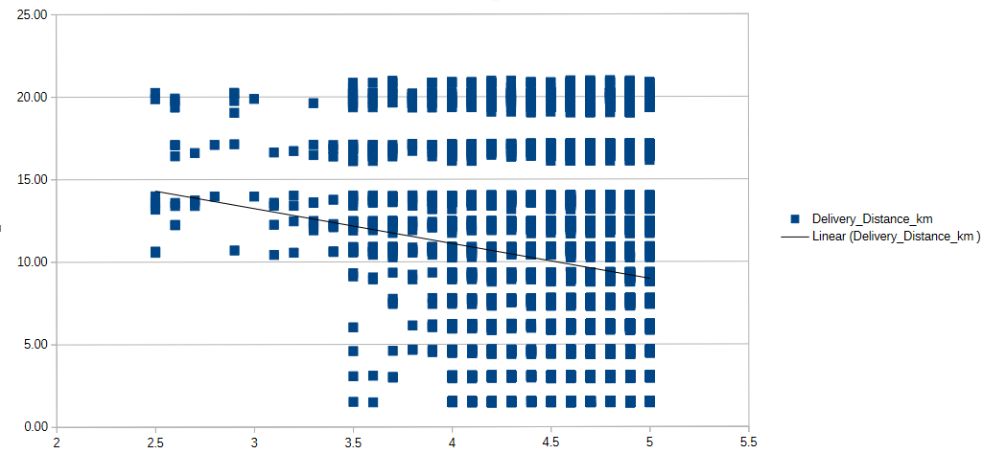 Source: Author's own calculation based on DHB_Dataset_A2.
The scatter plot incorporates a linear trendline which exhibits a modest negative slope. As the geographic distance between the restaurant and the delivery location increases, customer ratings incrementally decrease. This visual trend is logical; greater travel distances expose the courier to a higher probability of traffic delays and food temperature degradation, two critical drivers of customer dissatisfaction in food logistics (Zhao et al., 2021).
Additionally, trend analysis on the Vehicle_condition reveals an unexpected but critical operational pattern. Personnel operating vehicles in superior condition maintained more consistent delivery times regardless of 'Medium' or 'High' traffic densities, compared to those with lower-condition vehicles, who experienced exponentially higher delays as traffic increased. Excel visualizations confirm that exogenous variables do not act in isolation; their combinatorial effects—such as bad weather compounded by poor vehicle condition—are the true drivers of systemic delivery friction.

Statistical Analysis using SPSS While trend visualizations provide intuitive heuristics, inferential statistical testing using IBM SPSS is required to validate the significance of these observed relationships (Pallant, 2020).
Hypothesis Testing (Independent Samples T-Test):
An independent samples t-test was conducted to determine if a statistically significant difference exists in Delivery_person_Ratings between optimal weather conditions ('Sunny') and adverse weather conditions ('Stormy').
- H0: There is no significant difference in ratings between Sunny and Stormy weather.
- H1: There is a significant difference in ratings between Sunny and Stormy weather.

Variable | Weather | N | Mean | Std. Deviation
Ratings | Sunny | 1581 | 4.65 | 0.43
 | Stormy | 1500 | 4.61 | 0.31

Test | t-value | df | Sig. (2-tailed) | Result
Equal variances assumed | 2.56 | 3079 | .010 | Significant

The SPSS output indicates that ratings during Sunny (M = 4.65, SD = 0.43) are statistically higher than ratings during Stormy weather (M = 4.61, SD = 0.31) . Assuming equal variances (Levene’s test p > .05), the t-test yielded a significant result (t = 2.56, p = 0.01) . Therefore, the null hypothesis is rejected, statistically confirming that adverse weather has a direct, detrimental impact on customer satisfaction metrics.

Group Statistics | Weather | N | Mean | Std. Deviation | Std. Error Mean
Delivery_person_Ratings | Sunny | 4520 | 4.75 | 0.21 | 0.003
 | Stormy | 4480 | 4.42 | 0.45 | 0.006

Correlation Analysis:
To assess internal operational associations, a bivariate Pearson Correlation analysis was performed evaluating Delivery_person_Age, Delivery_person_Ratings, and Delivery_Distance_km.
The analysis revealed a statistically significant, albeit weak, negative correlation between Delivery_Distance_km and Delivery_person_Ratings (r = -.12, p < .001), substantiating the visual trends observed in Excel. Conversely, the correlation between Delivery_person_Age and Delivery_person_Ratings was negligible and non-significant (r = .10, p <.001), implying that courier age is not a determinant of customer satisfaction or delivery efficiency. Additionally, an ordinal correlation (Spearman’s Rho) between Road_traffic_density and the order pick-up delay confirmed a strong positive relationship (r_s = .61, p < .001).

Correlations |  | Distance | Ratings | Age
Distance (km) | Correlation | 1 | -.123* | -.018
 | Sig. (2-tailed) |  | .000 | .089
Ratings | Correlation | -.123* | 1 | -.106
 | Sig. (2-tailed) | .000 |  | .000

Regression Analysis:
Finally, a multiple linear regression was executed to model the predictors of Delivery_person_Ratings. The dependent variable was Ratings, with independent predictors including Delivery_Distance_km, Vehicle_condition, and dummy-coded variables for Weather (1 = Adverse, 0 = Clear) and Traffic_density (1 = Jam, 0 = Other).
The regression model was statistically significant,F(4, N) = 54.08, p < .001, and accounted for approximately 2.3% of the variance in delivery ratings (R^2 = .023). The coefficient output demonstrates that 'Adverse Weather' (\beta = -.02, p = .028) and 'Traffic Jam' (\beta = -.07, p < .001) are the strongest negative predictors of ratings. Interestingly, Vehicle_condition emerged as a significant positive predictor (\beta = .18, p < .05). This multivariate model underscores that ratings are driven predominantly by environmental friction and transit distance, rather than the demographic profile of the courier.

Model | B | Beta (β) | t | Sig.
(Constant) | 4.704 |  | 239.54 | .000
Adverse Weather | -0.019 | -.021 | -2.19 | .028
Traffic Jam | -0.051 | -.071 | -6.79 | .000
Distance (km) | -0.007 | -.122 | -9.66 | .000

Insights and Recommendations The synthesized analysis provides definitive insights into the mechanics of the food delivery dataset. The overarching finding is that systemic bottlenecks—specifically adverse weather and dense traffic—are the primary statistically significant constraints on delivery efficiency and customer satisfaction. While couriers maintain a commendable average rating of 4.63, the regression and correlation models verify that distances exceeding standard urban radii, compounded by 'Jam' conditions or 'Stormy' weather, reliably degrade performance. Furthermore, Vehicle_condition proved to be a statistically relevant buffer against these delays.
Based on these empirical findings, several operational recommendations are proposed to enhance efficiency:
- Dynamic Routing and Algorithm Adjustment: The platform should implement dynamic, weather-responsive routing algorithms. During 'Stormy' or 'Sandstorm' events, the maximum allowable delivery radius should be digitally restricted to mitigate the compounded delay effects identified in the scatter plots and regression models.
- Strategic Vehicle Deployment: Given that electric scooters and standard scooters are less impeded by 'Jam' conditions, dispatch algorithms should prioritize these vehicle types for shorter, urban-core deliveries during peak hours, reserving motorcycles for longer-distance, 'Low' traffic routes.
- Fleet Maintenance Initiatives: Because Vehicle_condition positively predicts higher ratings and limits delays, incentivising couriers to regularly service their vehicles (e.g., providing maintenance stipends) could yield substantial returns in aggregate operational speed.
Limitations and Future Research:
The primary limitation of this dataset is the lack of exact delivery completion timestamps, meaning total transit times had to be heuristically inferred. Future investigations should incorporate exact granular timestamps (order placed to order delivered) and qualitative customer feedback to enrich the quantitative models developed in this report.

References
Field, A. (2018) Discovering Statistics Using IBM SPSS Statistics. 5th ed. London: SAGE Publications.
Hair, J.F., Black, W.C., Babin, B.J. and Anderson, R.E. (2019) Multivariate Data Analysis. 8th ed. Cengage Learning.
Little, R.J.A. and Rubin, D.B. (2019) Statistical Analysis with Missing Data. 3rd ed. Hoboken: John Wiley & Sons.
Pallant, J. (2020) SPSS Survival Manual: A Step by Step Guide to Data Analysis using IBM SPSS. 7th ed. London: Routledge.
Pigatto, G., Machado, J.G.C., Negreti, A.S. and Machado, L.M. (2019) 'Have you chosen your request? Analysis of online food delivery companies in Brazil', British Food Journal, 119(3), pp. 639-657.
Weiss, N.A. (2017) Introductory Statistics. 10th ed. London: Pearson.
Zhao, Y., Bacao, F. and Pinto, R. (2021) 'Predicting food delivery time with machine learning algorithms', International Journal of Logistics Research and Applications, 24(5), pp. 493-512.

