University of Wales Trinity Saint David
Wales institute of science and art


How geometry affects the handling of a motorbike
Academic and laboratory skills

Ethan Thomas
2511104
October 2025
Table of Contents
1 Introduction 2
1.1 Brief definitions and effects on handling 2
2 Trail 3
2.1 Types of trail 3
2.1.1 Mechanical trail 3
2.1.2 The castor effect 3
2.2 Summary of trails effects 4
3 Rake 4
3.1 A short history 4
3.1.1 The effect of rake on the castor effect 4
3.1.2 Steering head drop 4
3.2 Summary of rakes effects 5
4 Wheelbase 5
4.1 The effects of wheelbase 5
4.1.1 Deflection 5
4.1.2 Load transfer 5
4.2 Wheelbase decisions 5
5 List of figures 6
6 List of tables 7
7 Reference List 8

Introduction
This technical report will explain and analyse some of the elements used for a motorcycle’s geometry and their effects on the ride and handling.
These elements will be:
(2-2.2) Trail
(3) Rake
(4) Wheelbase

Brief definitions and effects on handling
Trail is the distance between the extrapolated line of the steering axis and the front wheel center line (see figure 1) usually measured in mm however can be measured in inches as in figure one. This is the main factor in steering and stability as an increased Trail makes the bike more stable however make it more difficult to change direction and obviously inverse affects with a shortened Trail. (Suspension Secrets, 2019)
Rake or caster is the angle of the steering axis from the front wheel center line. It is one of the areas used to set trail and is usually governed by the frame steering axis mount and ride heights (see figure 1). A larger angle means more stability and a smaller angle means faster steering. (Suspension Secrets, 2019)
Wheelbase is the length from the front axle bolt to the rear axle bolt (see figure 3). A longer wheelbase means more stability at high speeds but slower to flick about.
One final thing to note is that throughout this technical report I will be focusing on motorbikes as whole, if you would like to see how things differ from different types of motorbikes e.g. SuperSport, street, cruiser, a tricker is mentioned and although it is listed as a street bike in the tables it is trials and stunt orientated and such is smaller and has a lower rake see figure 3 for a photo of this bike

Trail
The primary function of Trail is the build in a certain amount of steering stability into a motorbike, as well as contributing hugely to the lean- in phase when cornering.

Types of trail
Let’s start on the ground trail, this is where the contact patch of the tyre trails behind the steering axis. Steering axis being the point of which the handlebars turn from the head stem

Mechanical trail
Let’s focus on real or mechanical trail which is approximately 90% of the ground trail for bikes with a typical rake angle and is equal to the ground trail for a zero-rake angle. Mechanical trail Is measured in right angles to the steering axis and is also calculated by the reducing the cosine of the rake angle from the ground trail.

The castor effect
Positive trail and the side force from slip angle combine to produce a force that tends to restore deflected steering back to the straight position. This gives that degree of straight-line stability. Look at the figure 5 below to understand more clearly 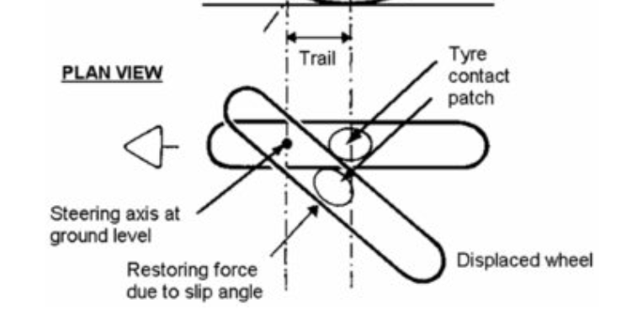
Figure 4- plan view of how trail causes a self-centering effect- (foale, 2002)
Because the wheel is at an angle to the direction of travel a force at right-angles to the tyre is generated and since the contact patch is behind the steering axis (positive trail) a correcting force is applied to the wheel
This is the same for the rear wheel as although the positive trail of the rear wheel is greater, the rear would be affected more but because the rear is on a fixed point and such the slip angle is much smaller and such the restoring effect

Summary of trails effects
From all this we can see that the increasing the trail can be a means of increasing stability of a motorbike.
It is important to note that trail is not a fixed value as there are several factors that can cause the trail to vary. These include lean angle, steering angle and the profile of the tyre but we will not be explaining these today. information from. (foale, 2002)

Rake
What is rake? Rake or castor is the angle that the steering axis is moved from the center of the wheel.

A short history
Over the past couple of decades however there has been a trend towards more forward weight distributions with the rider being moved forward. These changs have been made easier by moving the headstock forward thereby reducing the rake and this reduced rake helps compensate for the increased load on the front wheel.

The effect of rake on the castor effect
we will be talking about the reduction of the previously mentioned self-aligning torque on the front wheel; this is because when the rake is increased the given ground trail and subsequently the real trail is reduced and as we know the higher the trail the more self centering torque is increased, reducing stability of the motorbike.

Steering head drop
Steering head drop is as it sounds, the steering head will drop when the handlebars are turned it is important to note that the steering head is not the same as the handlebars it the connecting part of the handlebars and the frame. On a normal motorcycle (those with positive rake and trail) the steering head will drop, and the inverse goes if the rake and trail are also inverse which is not normal. The greater the rake angle, the greater the drop. This drop however works against the self-centering effect as to return the steering straight we must lift the extra weight that is on the front wheel. While this does not work in the favour of stability, it does help to steer the wheel into a corner when leaning. It is important not to dramatise these effects as the bike will be difficult to handle when at lean which is the most dangerous position to be in on a bike. More lean is equal to more risk simply because less of the contact patch is used. More steering torque is needed to pick the bike back up at larger handlebar angle and the inverse is true. “At 27 degrees rake and 45 degrees of steer the front-end drop is only about 8.2mm. and the restoring torque needed is below 6nm for each 50gkf of front-end weight. At less extreme handlebar angles the effect is much less, up to 10 degrees of steer the drop is no more 0.5mm” - chapter 3, subsection 10 (foale, 2002)
All information gathered from (foale, 2002)

Summary of rakes effects
To summarise Rake’s effect is arguably slim to none and is just possible that we don't need it. However, in a few cases, there are benefits from small rake angles, which were not offset by compensating disadvantages. The common rake angles for bikes these days are around 20-30 degrees

Wheelbase
Let’s talk about wheelbase then, wheelbase is the length from one axle to the other. And a rule of thumb is that a shorter wheelbase means a quicker turn in, and less steering input is needed for a corner.

The effects of wheelbase

Deflection
A longer wheelbase means that any deflection in the front wheel say from bumps will have less effect on its stability when cornering as well as the angle of the rear wheel to the direction of travel is smaller further improving directional stability.

Load transfer
the wheelbase has an effect on the load transfer as well under braking and acceleration a shorter wheelbase will have a higher load transfer as there is for lack of a better term less machine for that force to transfer through meaning a shorter wheelbase is more agile and flickable whereas a longer wheelbase will feel more sluggish and stable, imagine a cruiser compared to a SuperSport. reference table 3 for actual data.

Wheelbase decisions
The wheelbase is decided with the main intention of the machine. A cruiser and tourer require relaxed riding and good directional stability; a racing bike needs to be stable at high speeds but also require quick handling and so needs to compromise between the 2.

List of figures
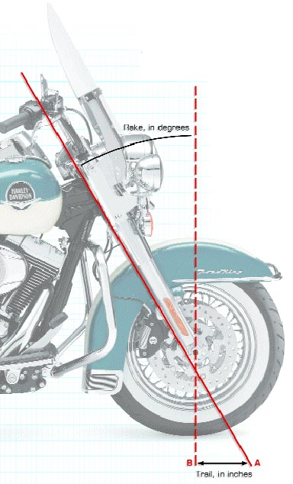
Figure 1 - Rake and Trail (rider magazine, 2009)
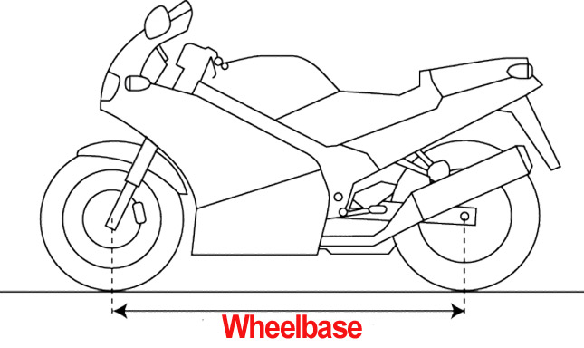
Figure 2 - Wheelbase (lemmy, 2019)
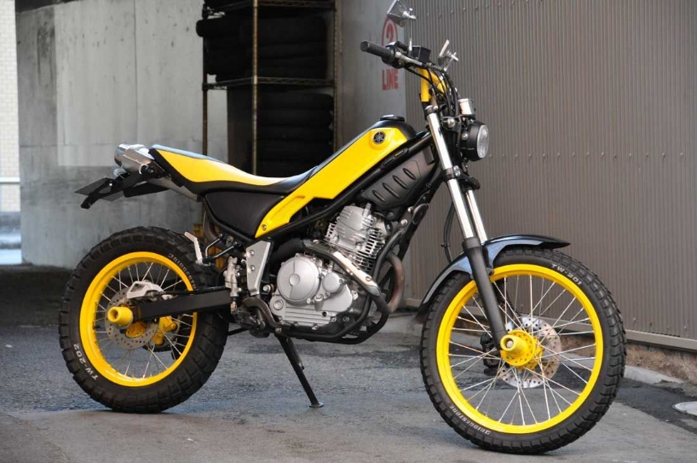
Figure 3 - Yamaha tricker (recta, 2018)

List of tables
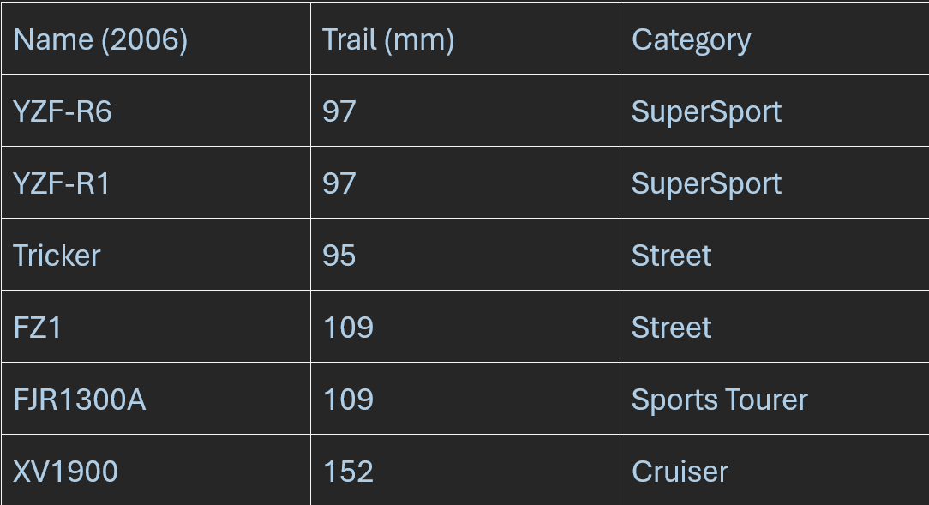
Table 1 – Trail (part, n.d.)
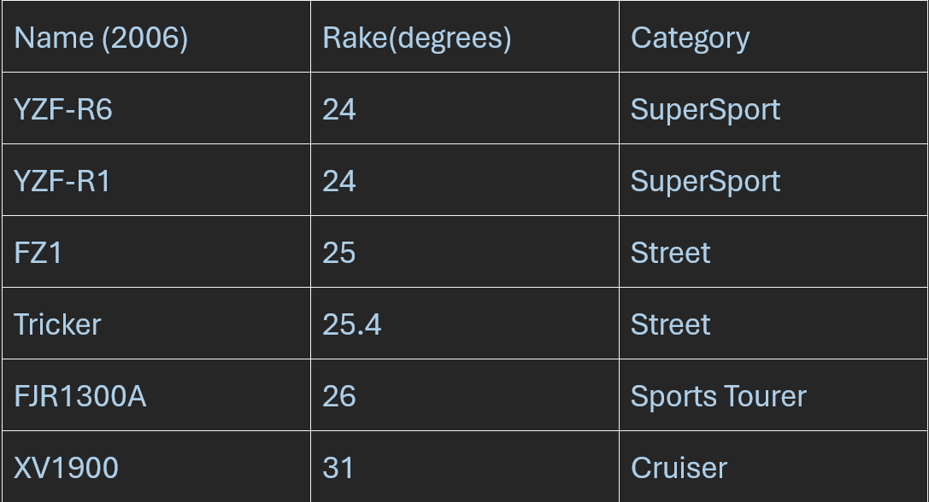
Table 2 – Rake (part, n.d.)
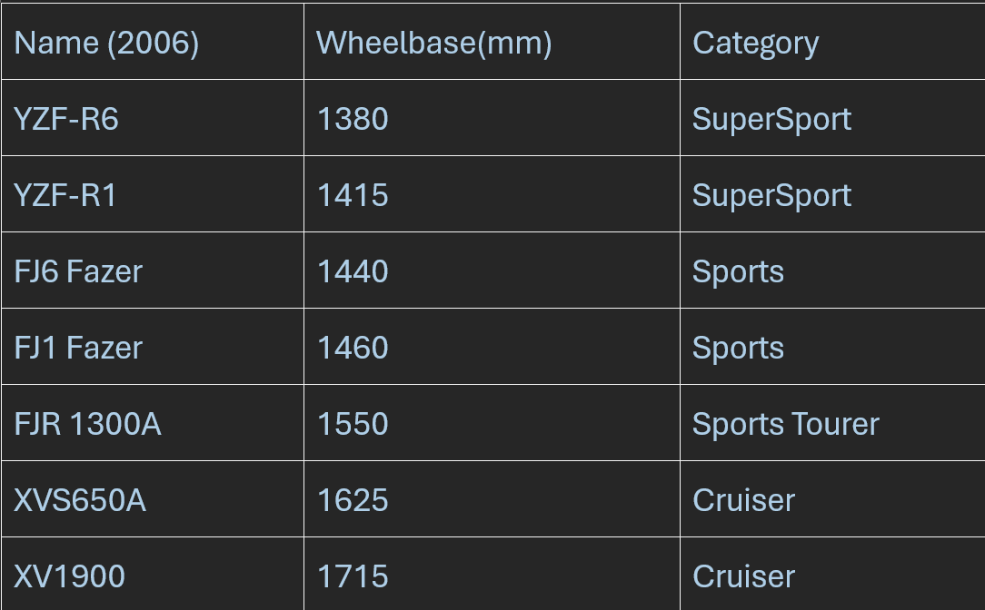
Table 3 - Wheelbase (part, n.d.)

Reference List
foale, T., 2002. motorcycle handling and chassis design, the art and science. 3rd ed. s.l.:s.n.
lemmy, 2019. revzilla. [Online]
Available at: https://www.revzilla.com/common-tread/how-to-read-a-motorcycle-spec-sheet?srsltid=AfmBOopmgjroKQV6vLMUDvbRRyLiFLOTIh2rltlreKdc59yWMD8odcgY
[Accessed October 2025].
part, y., n.d. motorcycle workshop. part 1: chassis geometery. [Online]
Available at: https://www.yamahapart.com/part1chassisgeometry
[Accessed October 2025].
recta, r., 2018. pinterest. [Online]
Available at: https://au.pinterest.com/rizarecta1414/tricker-yamaha-stunt-bike
[Accessed October 2025].
rider magazine, r. k., 2009. understanding motorcycle rake and trail. [Online]
Available at: https://ridermagazine.com/2009/06/30/understanding-motorcycle-rake-and-trail
[Accessed October 2025].
Suspension Secrets, 2019. Suspension Secrets. [Online]
Available at: https://suspensionsecrets.co.uk/motorcycle-front-geometry
[Accessed October 2025].

