  Component One:  Contribution to Overall Module Assessment: 25% | Student No: | 2211724
 | Module Title: | Operating Hotel Facilities
 | Module Code: | BMIH4006
 | Lecturer: | Muhammad Cassamo
Key Skills to Work with the Housekeeping Team
To work with the housekeeping team, the employees must have some key skills to accomplish the assigned tasks. The important skills for the housekeeping team are identified and they are explained below:
- Time Management Skill: It is one of the most critical skills for the housekeeper. To accomplish the assigned task within a given timeframe is very difficult. Time management skills enable the team members to identify the important tasks and complete them within the due time (Espellita and Maravilla Jr, 2019). This skill is essential for bringing efficiency and productivity to the team.
- Attention to Details: The team members in the housekeeping team get the responsibility to look after every need and instruction of the clients to make them satisfied with the service. They must be able to notice every single aspect of the cleaning, and instructions to ensure high-quality standards of the hotel brand.
- Communication Skills: Companies in the hospitality and tourism industry seek strong communication skills as it is necessary for rapport building in the team, and providing better service to the customers (Nimri et al., 2020). Strong communication skills help to understand what the clients are expecting from the service and the housekeeping team can perform accordingly.
- Management Skills: The work related to housekeeping needs careful planning and management. The members of the housekeeping team should have management skills so that they can do the right task at the right moment efficiently (Espellita and Maravilla Jr, 2019).
- Problem-solving Skills: Housekeepers are exposed to various challenges regarding cleaning, staffing, and complaints management (Raghubalan and Raghubalan, 2016). The team members must be able to solve all these problems in the most innovative ways.
- Interpersonal Skills: These skills enable the housekeeping team to be courteous, friendly, and polite with the guests (Singh and Jaykumar, 2019). The team members can professionally deal with everyone they face in the workplace.

Reflection on the Key Skills Development
I will use Gibbs's reflective model for the experience that I have gained from working at Hotel Inn in Sunderland. The model has 6 stages of learning (Williams, Woolliams and Spiro, 2020). These stages are explained below:
Description: I got my placement at the Holiday Inn in Sunderland to work with the housekeeping team. The housekeeping team is responsible to manage and ensure hygiene and cleanliness in the hotel. My team has to manage and prepare 20 rooms within 30 minutes every day. My responsibility was for four rooms. The work feedback that we provide at the front desk is communicated with the supervisor and management.
Feelings: As I started my journey to work with the housekeeping team, I had a mix of feelings. I was both excited and nervous. I was very excited and eager to work in a team so that I could demonstrate my housekeeping skills and learning. My teammates contributed great experience by providing their support to make me understand the use of different equipment. However, I faced challenges when I faced some customers who were behaving aggressively and when there was a rush due to the high number of guests visiting.
Evaluation: I have demonstrated my working capabilities as a housekeeper successfully by demonstrating the key skills. My colleagues and supervisor have provided positive feedback on my work. However, I had a bad experience in a couple of incidents. Once I forgot to check the mini bar in one of the rooms. Then I also missed a spot on the mirror in another room. These incidents have questioned my working capability within the team.
Analysis: The identified above key skills are very crucial to achieving success as a housekeeper. I have demonstrated all these skills in my placement hotel brand. I could show time management skills as I was given the checklist to accomplish my job. I set goals and started my work. It helps me perform better. Marriott Hotel is a renowned hotel brand which tracks and monitors all of the employee's performance using technologies (Marriott, 2023). I applied my attention to detail skills to make sure that I fulfilled the Hotel Inn's safety and hygiene guidelines and standards. I have created a strong understanding with my team members, supervisor, and other people by interacting with them effectively. These skills are vital to success in the organisation. Moreover, management skills, interpersonal skills, and problem-solving skills received the attention of the supervisor and my team members as I was doing my job very well.
Conclusion: I have learnt a lot of things and gained vital experience from the placement. I can use this learning in my future career. However, I should focus on my development activities to overcome the issues I have faced.
Action Plan: I will read more books, take online courses, and participate in the training program for getting more experience and develop the required skills.

Word Count | 811

Component Two:
Essay: "Effectiveness of the Checklists for the Housekeeping Team”
The housekeeping department is one of the most crucial areas of the hotel brand because this department is concerned with the cleanliness, hygiene, and comfort of the guests (Sampson, 2018). Holiday Inn, Sunderland has been facing guest complaints because of the consistent lack in the housekeeping department. The author has prepared some checklists for the housekeeping. This essay will explain how the checklists will ensure the brand's standards, the effective ways to improve the team performance, and the effectiveness of the checklist.
Since the guests are complaining about the cleanliness and hygiene of the hotel, the checklist addresses all the cleaning and hygiene aspects of the room and other living areas. The bedroom, outdoor, living area, bathroom, and other areas of the hotel are included in the checklist for cleaning properly (Safety Culture, 2023). The checklist covers activities such as dusting the amenities, vacuuming the floor on flat surfaces, and replenishing the essentials. The checklist also includes the maintenance issues which the housekeeper must make a note of and inform the respected authorities. It ensures that all cleanliness and hygiene aspects are covered, and nothing is missed or overlooked (Casado, 2012). Hence, the checklist will be able to maintain the brand standards.
To provide superior housekeeping service to the guests, it is important that the housekeeping department has a functioning team. The effectiveness of the team can be increased by establishing clear communication, collaboration, understanding, and a supportive environment (Tavitiyaman et al., 2021). The housekeeping department has to hold meetings and briefings with the team members regularly. In meetings, they should discuss the process and standards of the hotel for cleanliness, hygiene, and other services. The company can invest in technology for introducing a mobile app in which the employees of the company can update their progress in their job responsibilities. Most importantly, the management needs to work and take the initiative to motivate the employees within the team. They should be appraised based on their performance and be given rewards for better performance demonstration (Mangco and Andales, 2023). These actions can be taken to improve the overall team performance.
The prepared checklist is effective, and it will be able to address the current issues that Holiday Inn in Sunderland is facing. The effectiveness of the checklist lies in the understanding of all points by the housekeeper. The author has constructed the sentences of the checklist clear, simple and comprehensive way so that each of the lists can be easily understood. Unnecessary and redundant information has been avoided and the specific procedures and instructions are given in a systematic way. The checklist covers almost all aspects of housekeeping which increases its effectiveness (Safety Culture, 2023). Hence, the guests' issues will be addressed. If the team members of the housekeeping uses this checklist, they will be able to ensure high-quality guest services.
The room cleaning checklist created by the author is effective in ensuring the guest's comfort and satisfaction. It can address the issues identified by the management. Moreover, using the checklist, the author will be able to work professionally as a housekeeper and gain more experience in the industry.

Component Three:
Presentation
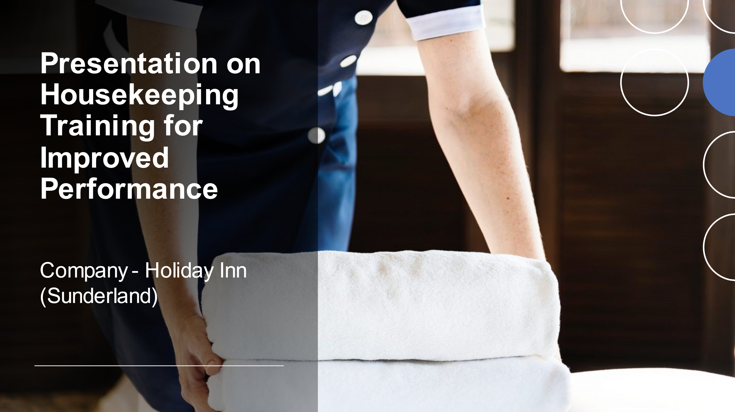

Training Notes:
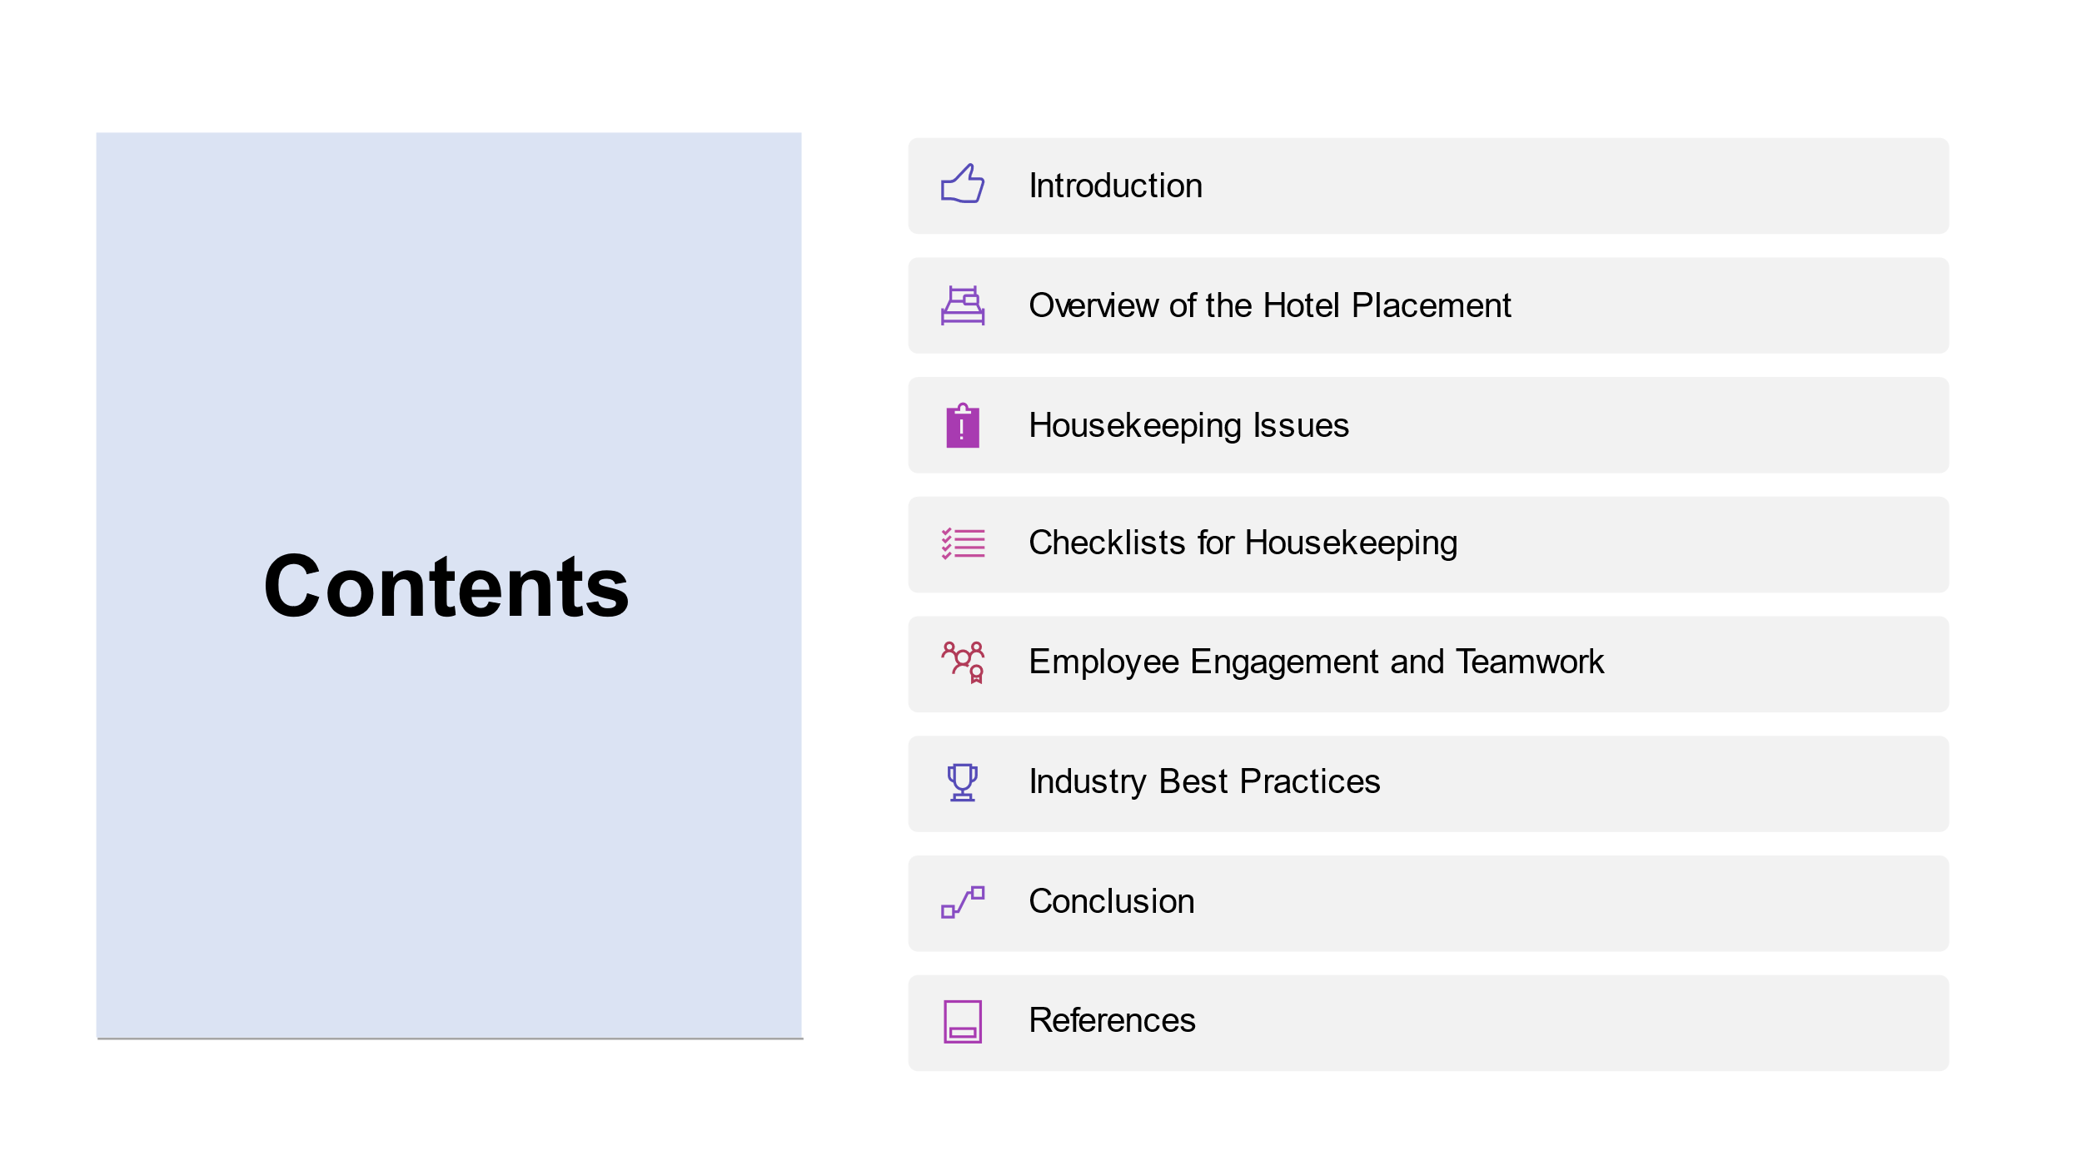
Training Notes:

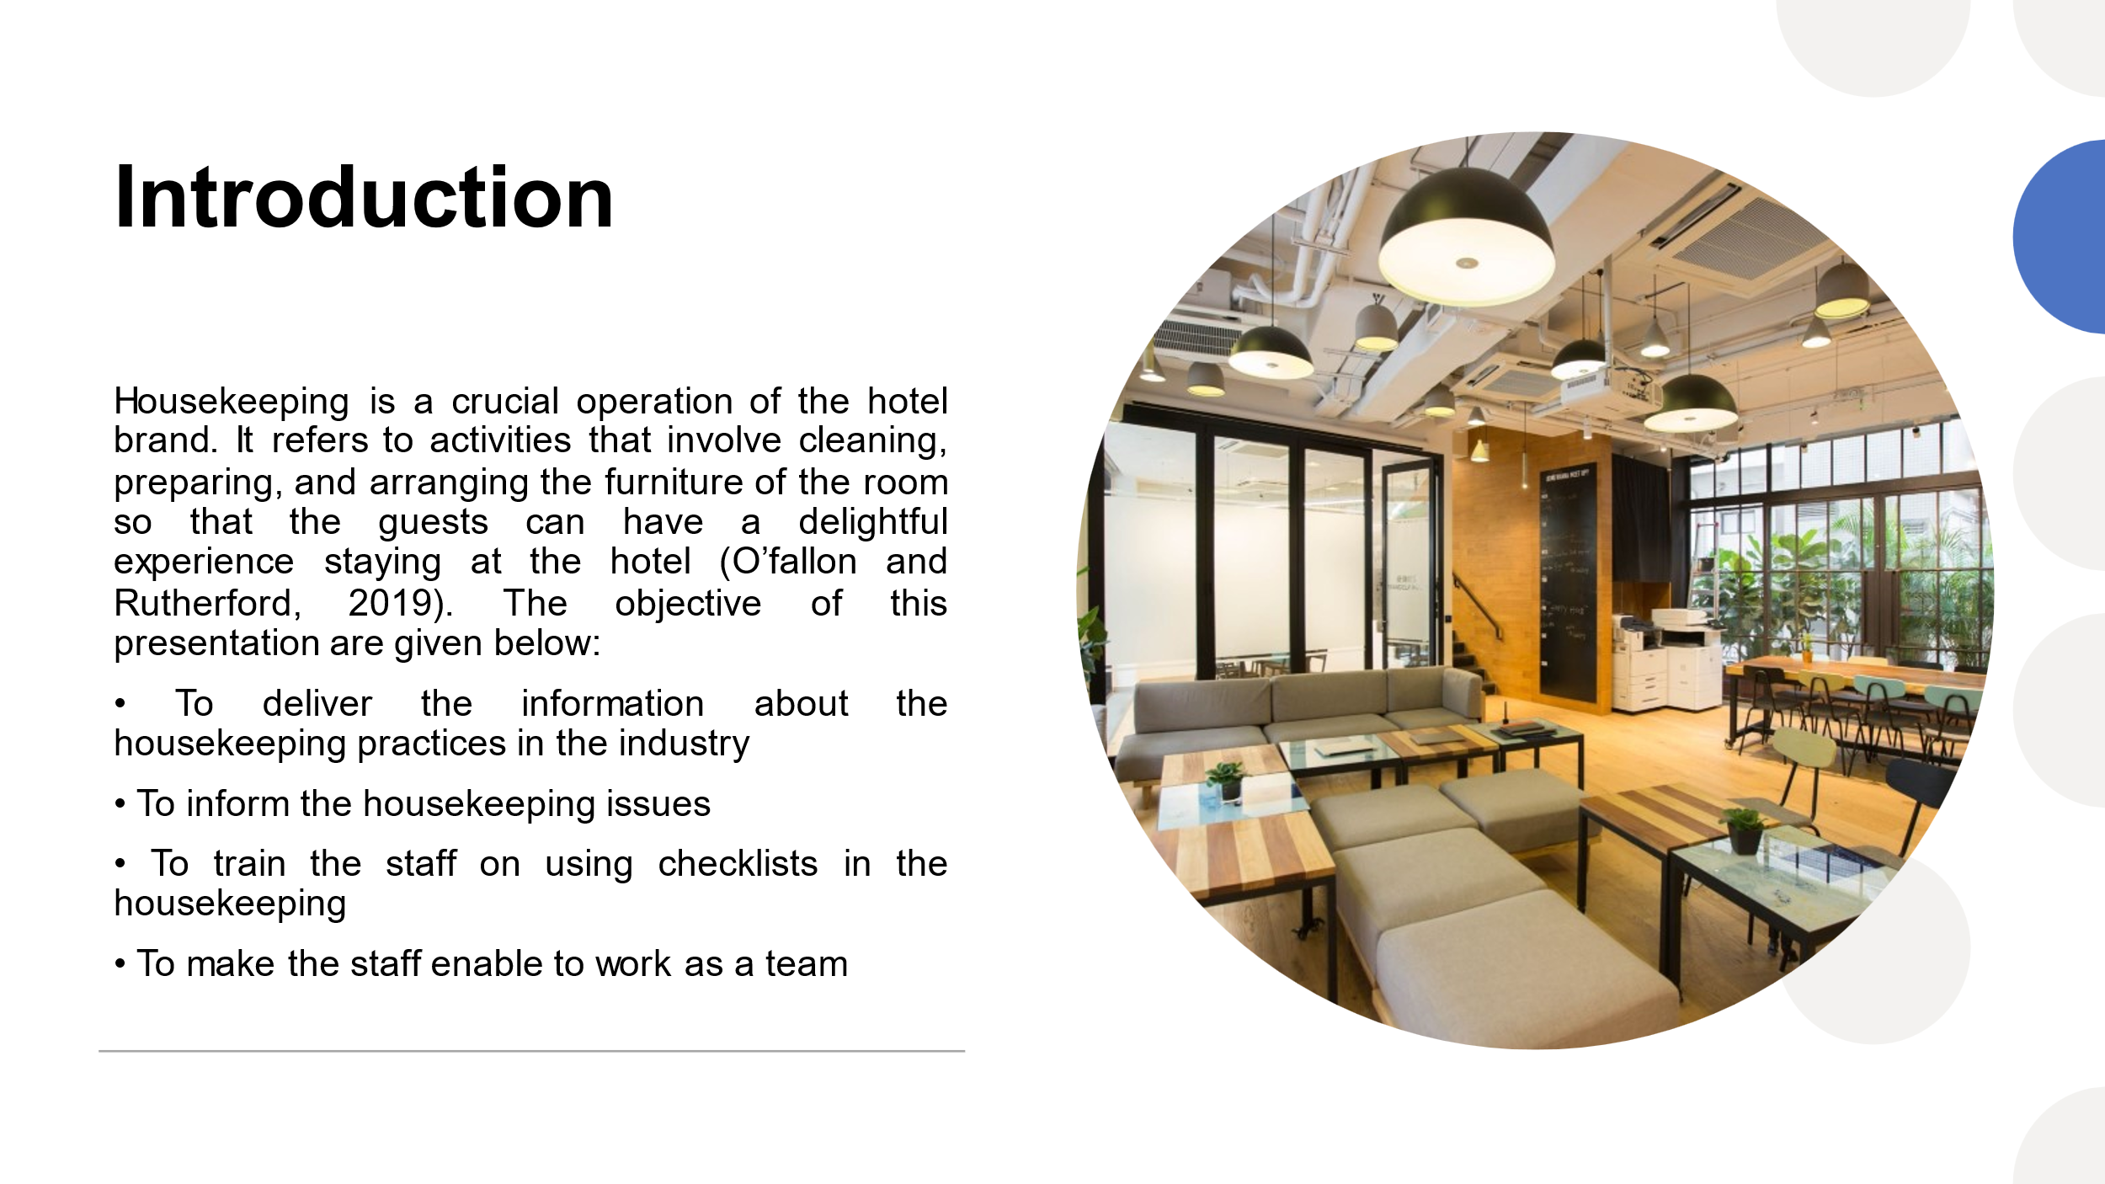
Training Notes: Housekeeping is an important area of the hospitality industry. Hotel businesses have to rely on this department for cleaning, arranging, managing household chores, bed preparation, and other activities that are much needed for providing a better customer experience. Only luxury facilities do not suffice for a great experience. It is the housekeeping team that makes everything right, keeps the amenities and furniture in place and does the cleaning. The objectives of my training presentation are to inform you of the best housekeeping practices in the hospitality industry, to let you know the emerging issues in this area, to teach you how to use checklists for housekeeping activities, and to train you to be effective in team performance.

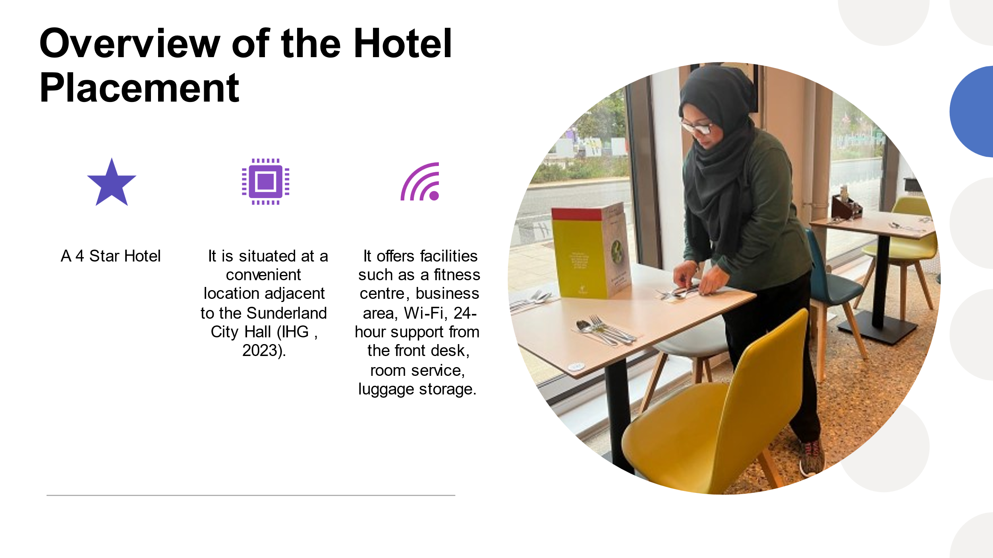

Training Notes: Before performing our job in a workplace setting, we should keep a complete understanding of the place. It enables us to be well-equipped with the required skills and tactics. My placement was at the Holiday Inn, Sunderland. It is a 4-star rated hotel that is well-known in the city. The hotel has a stunning establishment, and its location is made in the most convenient place so that tourists or visitors can easily reach the hotel. Sunderland City Hall is adjacent to this hotel. Hotel Inn has so many options for the guests including customer service, room service, fitness centre, WiFi, luggage storage facilities, and so on.
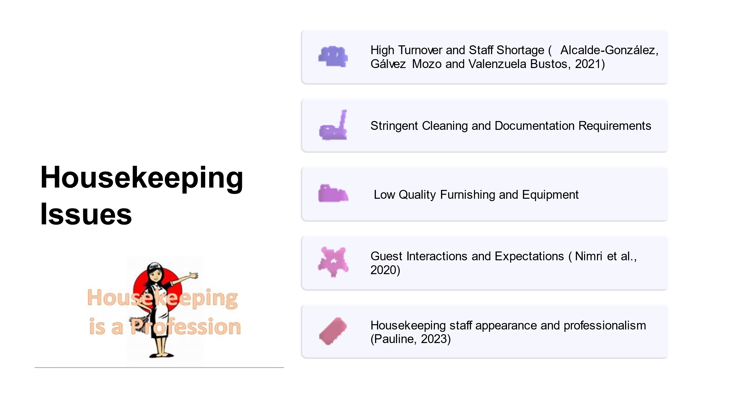

Training Notes: The housekeeping job is somewhat challenging in the UK hospitality industry. There are so many issues that make the job difficult.
There exists high turnover and staff shortage in the hospitality industry. As a result, the employees working in the housekeeping team do not have the right skills or experience. In addition, the shortage of employees makes the job difficult for the existing employees because they have to perform more tasks within the same timeframe. The COVID-19 pandemic has changed the housekeeping practices. The staff needs to maintain stringent cleaning and documentation requirements. Many hotel brands use low-quality furniture and amenities which can create great threats to the brand value of the hotel. Because customers will judge this and leave negative reviews. Guest interaction and expectations are two different aspects. When housekeeping staff interact with the guests but fail to understand their expectations, the experience of the guests gets poor. The housekeeping staff's appearance can also create problems if he/she cannot demonstrate professionalism through their behaviour and appearance.

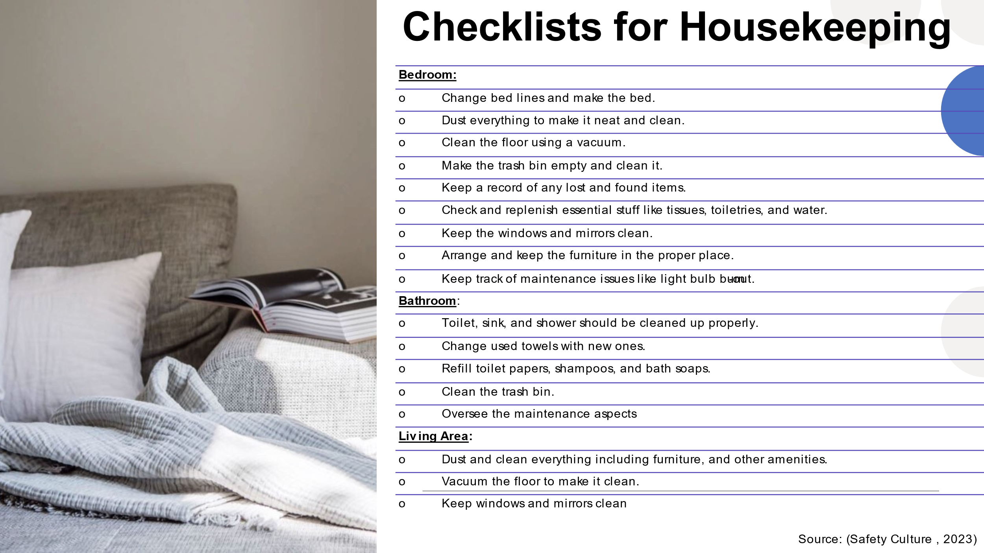

Training Notes: Housekeeping jobs become very stressful sometimes and the staff forgets their tasks because so many tasks completed by them overwhelm them. I have prepared checklists that the housekeeping team can use for upholding the brand standard. The checklist covers three aspects. At first, the housekeeper should prepare the bedroom by ensuring that all these checklists are completed. Then, she will clean the bathroom and replenish the necessary items. Finally, tasks in living areas should be completed. By accomplishing all these checklists, the housekeeper will be able to achieve guest satisfaction and comfort.
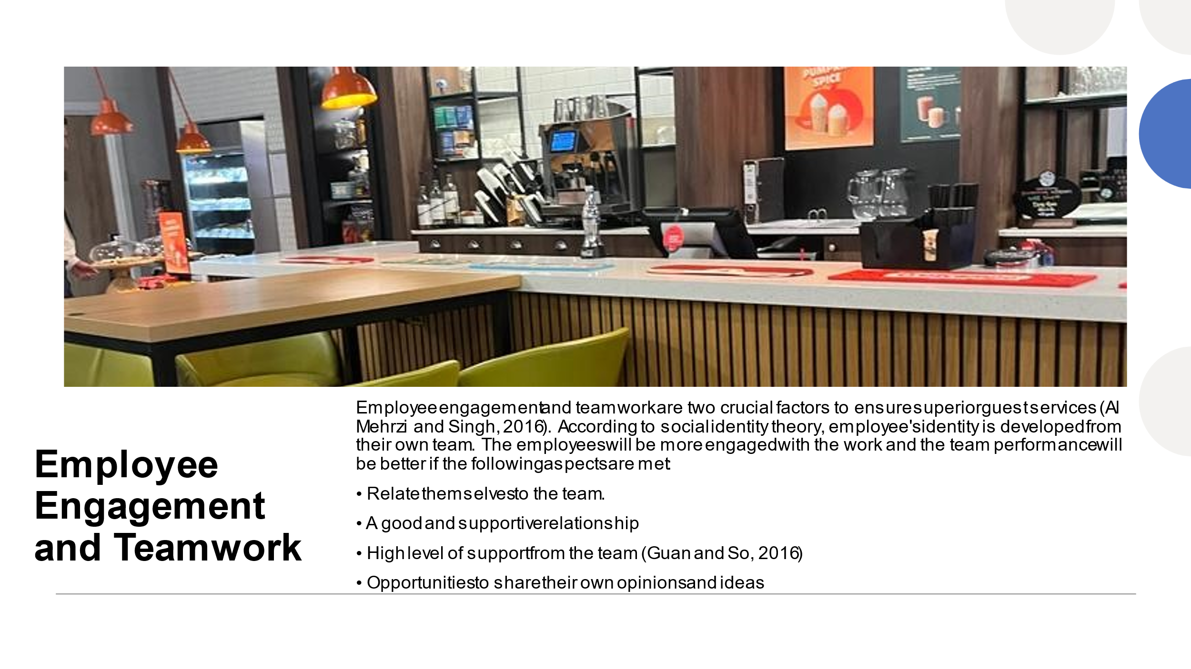
Training Notes: If we want to perform better and address all the feedback and negative reviews, we have to perform as a team. Individual performance is important, but it is more important that we should work as a team. The social identity theory suggests that employees try to find their identity in their team which means the team has to engage all the employees in the decision-making so that they can have a sense of ownership toward the team. I want to engage everyone while making any crucial decisions for our housekeeping departments. There should be good and supportive relationships among everyone. If anyone gets overwhelmed because of the workload, he/she will get the support of the team. Anyone with a better idea or thoughts can come forward as ideas and suggestions are appreciated. We can make sure that we have achieved superior customer satisfaction only when our team is functioning well as expected.
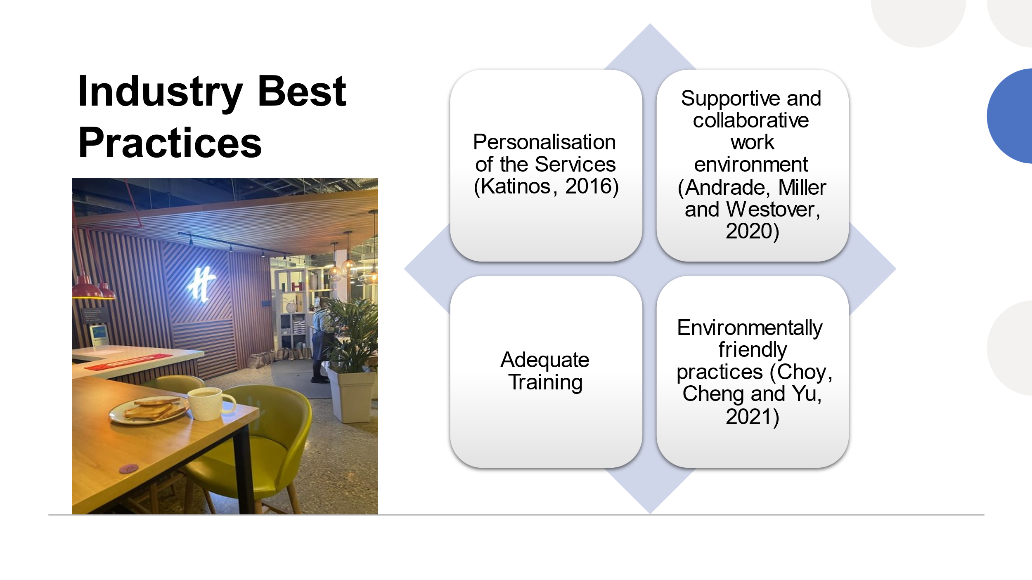
Training Notes: If we look at other hotel companies in the hospitality industry, we can see that they have certain established workplace practices that lead them to success. The first practice that I have identified is personalised services. They offer customers personalised services which means customers can structure and choose their desired level of services. It gives them the scope to get the expected services. We can also offer our guests personalised housekeeping services. The Workplace of the renowned hotels have a positive work environment where everyone feels empowered and supported. We can also provide support and collaborate with other staff regarding the room cleaning and housekeeping activities. The staff are given adequate training such as how to use equipment, follow the procedures, and so on. It improves performance. Finally, the use of cleaning materials needs to be environmentally friendly. We should not do any task which can harm the environment.
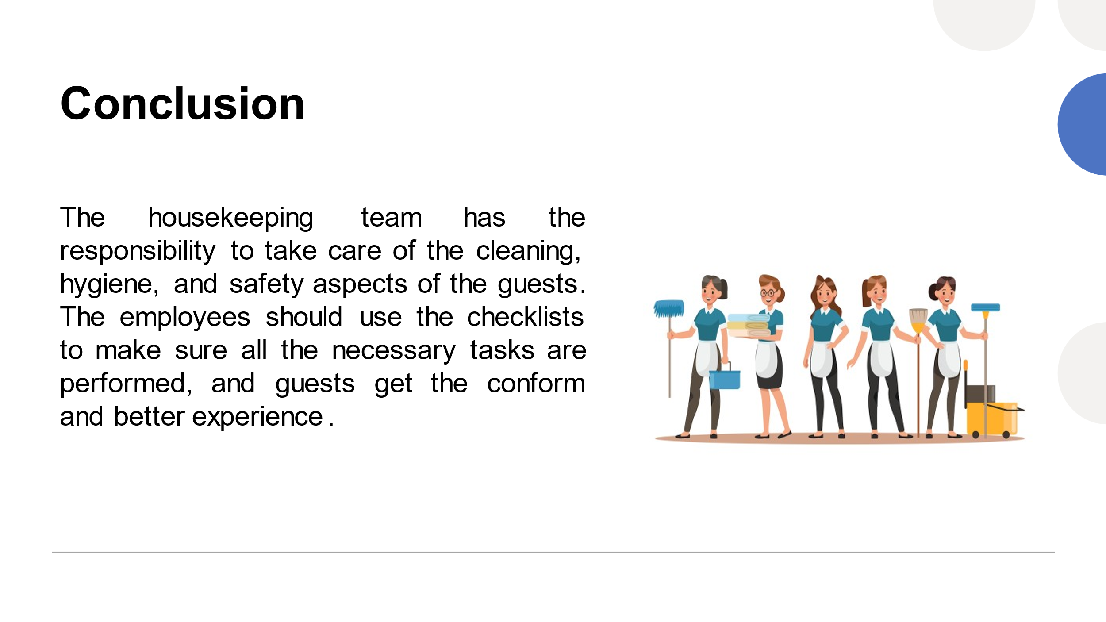

Training Notes: The housekeeping staff can improve the service quality of this hotel brand. For that, everyone needs to work as a team and ensure a supportive environment.
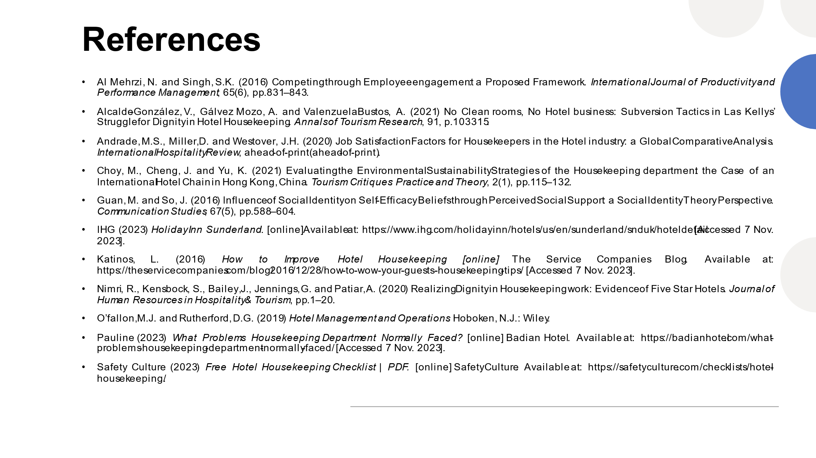

Training Notes:

References
Component 1-
Espellita, S. and Maravilla Jr, V.S. (2019) Employable Skills for Hospitality Graduates as Perceived among Hotel Supervisors in Cebu City. SSRN Electronic Journal.
Marriott (2023) The Marriott Voyage Program Overview: Salary, Details & More. [online] Marriott Careers. Available at: https://careers.marriott.com/blog/voyage/.
Nimri, R., Kensbock, S., Bailey, J., Jennings, G. and Patiar, A. (2020) Realizing Dignity in Housekeeping work: Evidence of Five Star Hotels. Journal of Human Resources in Hospitality & Tourism, pp.1–20.
Raghubalan, G. and Raghubalan, S. (2016) Hotel Housekeeping - Operations and Management. 3rd ed. Oxford University Press.
Singh, A. and Jaykumar, P. (2019) On the Road to consensus: Key Soft Skills Required for Youth Employment in the Service Sector. Worldwide Hospitality and Tourism Themes, 11(1), pp.10–24.
Williams, K., Woolliams, M. and Spiro, J. (2020) Reflective writing. Bloomsbury Publishing.
Component 2-
Casado, M. (2012) Housekeeping Management. London: Wiley.
Mangco, C.A. and Andales, N. (2023) Assessing Hygenic Practices, Sanitation Procedures of Housekeeping Department Perceived by Hotels-Motels Housekeeping Heads. Interdisciplinary Social Studies, 2(8), pp.2186-2193.
Safety Culture (2023) Free Hotel Housekeeping Checklist | PDF. [online] SafetyCulture. Available at: https://safetyculture.com/checklists/hotel-housekeeping/.
Sampson, E. (2018) Hospitality Management. Scientific e-Resources.
Tavitiyaman, P., Tsui, B., Chan, C.L.F. and Miu, H.W. (2021) Employee Productivity of Hotel Room Attendants: an Input–Output Perspective. International Journal of Hospitality & Tourism Administration, pp.1–28.

Component 3-
Al Mehrzi, N. and Singh, S.K. (2016) Competing through Employee engagement: a Proposed Framework. International Journal of Productivity and Performance Management, 65(6), pp.831–843.
Alcalde-González, V., Gálvez Mozo, A. and Valenzuela Bustos, A. (2021) No Clean rooms, No Hotel business: Subversion Tactics in Las Kellys’ Struggle for Dignity in Hotel Housekeeping. Annals of Tourism Research, 91, p.103315.
Andrade, M.S., Miller, D. and Westover, J.H. (2020) Job Satisfaction Factors for Housekeepers in the Hotel industry: a Global Comparative Analysis. International Hospitality Review, ahead-of-print(ahead-of-print).
Choy, M., Cheng, J. and Yu, K. (2021) Evaluating the Environmental Sustainability Strategies of the Housekeeping department: the Case of an International Hotel Chain in Hong Kong, China. Tourism Critiques: Practice and Theory, 2(1), pp.115–132.
Guan, M. and So, J. (2016) Influence of Social Identity on Self-Efficacy Beliefs through Perceived Social Support: a Social Identity Theory Perspective. Communication Studies, 67(5), pp.588–604.
IHG (2023) Holiday Inn Sunderland. [online] Available at: https://www.ihg.com/holidayinn/hotels/us/en/sunderland/snduk/hoteldetail [Accessed 7 Nov. 2023].
Katinos, L. (2016) How to Improve Hotel Housekeeping. [online] The Service Companies Blog. Available at: https://theservicecompanies.com/blog/2016/12/28/how-to-wow-your-guests-housekeeping-tips/ [Accessed 7 Nov. 2023].
Nimri, R., Kensbock, S., Bailey, J., Jennings, G. and Patiar, A. (2020) Realizing Dignity in Housekeeping work: Evidence of Five Star Hotels. Journal of Human Resources in Hospitality & Tourism, pp.1–20.
O’fallon, M.J. and Rutherford, D.G. (2019) Hotel Management and Operations. Hoboken, N.J.: Wiley.
Pauline (2023) What Problems Housekeeping Department Normally Faced? [online] Badian Hotel. Available at: https://badianhotel.com/what-problems-housekeeping-department-normally-faced/ [Accessed 7 Nov. 2023].
Safety Culture (2023) Free Hotel Housekeeping Checklist | PDF. [online] SafetyCulture. Available at: https://safetyculture.com/checklists/hotel-housekeeping/.

