

Module Code: LCBB4003
Module Title: Introducing the Modern Workplace
Assesstment 1

Student Name: Florentin Cocea
Student ID: 2134124
Lecturer: Sadeque Shaikh
Submission Date:30.04.2023

Table of Contents
Introduction 3
Organisational Structure and Culture 3
Organisational Structure of Tesco 4
Tesco's organisational culture 4
The Impacts of Tesco's Corporate Culture and Organisational Structure 5
The Role of Management and Leadership in Tesco 5
Employee Motivation in Tesco 5
Evaluation of the Behavioural Approach to Management in Tesco 8
Conclusion 9
References 10

Introduction
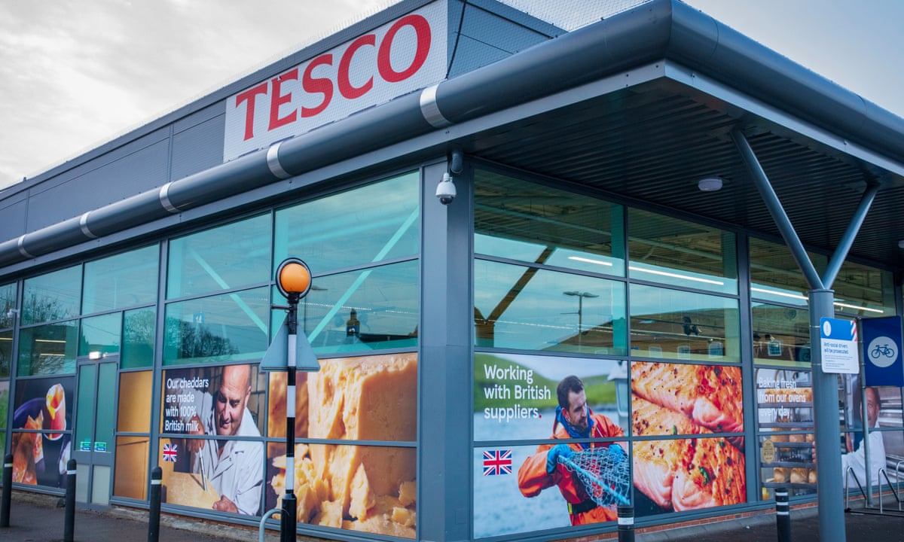
Image: Tesco PLC (Kollewe and Partridge, 2023)
Tesco PLC is one of the UK's largest and most profitable retail companies (Statista, 2021). Tesco has grown from a single grocery store founded by Jack Cohen in 1919 to a multinational organisation with operations in several nations (Tescoplc, 2021). Tesco's organisational structure, culture, and people management methods have proven to be effective and successful.
The goal of this study is to look into the interactions between Tesco's organisational structure, corporate culture, employee performance, and workforce, with a focus on the elements that contribute to the company's overall success. This introduction is one of six sections that comprise the report. Sections 2 and 3 will go through Tesco's organisational structure, culture, management function, and leadership, as well as how these aspects affect performance. Section 4 investigates employee motivation tactics and their effects on organisational performance. Section 5 will look at Tesco's management style and its importance to the organisation. Section 6 will conclude with a summary of the main findings and recommendations for improvement.
By evaluating Tesco's organisational practises, this study aims to shed light on the variables that contribute to the company's success and make suggestions for how the company could operate more efficiently.

Organisational Structure and Culture

The Organisational Structure of Tesco
Seth and Randall (2011) assert that Tesco adheres to a hierarchical organisational framework that encompasses functional divisions and decentralisation. The aforementioned structure was expounded upon with more comprehensive information in the preceding sentence. Palmer (2014) asserts that the corporate divisional structure is designed based on geographical regions, such as the United Kingdom (UK), Asia, and Europe, to effectively cater to the distinct demands of each market. Table 1 showcases the application of Mintzberg's (1980) typology of organisational structures to Tesco.
Table 1: Mintzberg's Organisational Structure Applied to Tesco
Organisational Part | Description
Strategic Apex | Top management, including the CEO and the board of directors
Middle Line | Regional and divisional managers, who implement strategies and oversee operations
Operating Core | Employees responsible for carrying out day-to-day tasks, such as store workers and customer service representatives
Technostructure | Specialists who design, plan, and control the organisation's processes, such as IT professionals and analysts
Support Staff | Employees who provide indirect support to the organisation, such as human resources and finance professionals

Tesco's organisational culture
Hassan and Qureshi (2013) suggest that an organization's culture comprises of traits that are focused on both the success of the organisation and the satisfaction of the consumer. Tesco plc (2021) asserts that the cultural features are reflected in the fundamental beliefs of Tesco, which are encapsulated in the company's mission statement. For instance, the company's mission statement includes the principles of "no one tries harder for customers" and "we treat people how we like to be treated."
Relationship between Tesco's Structure and Culture
To understand Tesco's organisational structure and culture, one might use Schein's (2010) three-level model of organisational culture. The current model can be used in the Tesco setting because it has separate parts, clearly stated goals, and strong beliefs at its core. There are several artefacts in Tesco's organisational structure, such as its hierarchical structure, functional divisions, and regional divisions. The stated goals and guiding principles of a company, which are often expressed in mission statements and catchphrases, are a reflection of the values that the organisation says it wants to uphold. The main tenets of Tesco's organisational approach are in line with the company's core values because they focus on doing a good job and making customers happy. Fundamental presumptions are the underlying assumptions and presumptions that affect how people behave in a company. Everyone knows that these thoughts and beliefs have an effect. The structure and mindset of Tesco, which support efficiency, competition, and putting the customer first, have an effect on the hypotheses being looked at.

The Impacts of Tesco's Corporate Culture and Organisational Structure
Tesco's organisational structure and culture both have a significant impact on how well the business performs overall. The way the group is organised facilitates communication and decision-making (Seth & Randall, 2011). This is due to the company's geographic and functional division, which enables it to adequately serve the demands of each market and department. According to Hassan and Qureshi (2013), performance-focused cultures promote efficiency and competition while customer-focused cultures foster strong customer relationships and loyalty. Tesco's ability to maintain its growth and success in the retail sector can be attributed to the alignment of the organization's corporate culture and overall strategic goals.

The Role of Management and Leadership in Tesco
Tesco's Managerial Work Environment
Using Mintzberg's (1973) framework of managing responsibility, which consists of three distinct components, namely interpersonal, informational, and decisional, would make it easier to analyse the managerial activity at Tesco. This is one illustration of how an academic rewrite of the user's text might look. Palmer (2014) asserts that the managerial team at Tesco is in charge of overseeing a number of departments, including operations, marketing, and finance, and that they are essential in achieving a balance between the organization's long-term strategic objectives and ongoing business operations.
Leadership Styles at Tesco
Tesco employs both transactional and revolutionary leadership concepts. Tesco's dedication to creating a climate that is open to innovation and teamwork is an illustration of transformational leadership. According to Bass (1985), this particular leadership approach is unique in its capacity to inspire employees, help them go above and beyond expectations, and promote higher levels of output. Tesco employs transactional leadership to boost productivity throughout its business. The procedure, according to Burns (1978), entails the collection of customs duties, defining goals, and gauging success.
Leadership's Effect on Organisational Performance
Effective leadership has a positive effect on organisational performance because it increases employee engagement, motivation, and satisfaction (Zhu et al., 2013). The leadership team is crucial in developing Tesco's values and culture, which has a big impact on the organization's overall success and operational results, according to Tescoplc's findings from 2021.
Factors That Determine Effective Leadership and Management
According to Yukl (2010), communication, adaptability, abilities, and experience are only a few of the factors that contribute to Tesco's good management and leadership. good Tesco executives have good communication skills, which are crucial for outlining the company's vision and goals and inspiring and directing employees to achieve them. Tesco's managers and executives must have essential traits including adaptability and receptivity to change due to the constantly evolving nature of the business and the advent of new challenges (Seth & Randall, 2011).

Employee Motivation in Tesco
Performance-Based Rewards
Armstrong and Taylor (2014) assert that Tesco employs a performance-based reward system to incentivize and stimulate its workforce. The aforementioned approach enables the workforce to obtain remuneration and additional monetary rewards contingent on their joint and personal accomplishments. Furthermore, employees have access to various financial benefits and incentives. The aforementioned approach aims to synchronise the goals of an organisation with the drive of its workforce, thereby stimulating personnel to surpass anticipated outcomes and enhance efficiency. Tesco aims to establish a workplace atmosphere that is favourable to the contentment, involvement, and retention of its employees. This outcome is attained through the act of commending employees for their unwavering commitment and persistence. The principal objective of this practice is to maintain the workforce.
Recognition and a number of additional non-monetary advantages
Tesco, according to Mullins (2010), places a lot of focus on non-cash rewards including recognising and appreciating employees' accomplishments. This is but one example of the value Tesco placed on it. Tesco's employees are honoured for their persistent efforts and everlasting commitment to the business through initiatives like the "Tesco Values Awards," which are meant to show staff how much they are appreciated. As a result of this factor's contribution to the creation of a more favourable work environment, employees will experience an uptick in job satisfaction. These non-financial perks promote a sense of community and pride among employees, which raises their motivation and commitment to the company. These non-cash advantages help employees feel proud of their work and a part of the community.
Opportunities for Training and Professional Development
Tesco, according to Stredwick (2013), makes investments in its employees' professional growth by providing a range of training and development options. Classroom teaching and on-the-job training are two of these substitutes. Apprenticeships, internal training programmes, and other programmes promoting leadership development are included in this category of courses. Tesco's main goal is to support staff professional growth so that it can build a better qualified and experienced workforce. Tesco's main goal is to develop a workforce that is more qualified and competent. Performance will consequently improve, and the business's success will be maintained. Due to the fact that employees are more likely to stick with organisations that provide opportunities for growth and progress, investing in staff development helps recruit and keep top talent. Companies that provide opportunities to find and keep excellent people are more likely to retain their customers' loyalty. People are more inclined to stay committed to organisations that provide prospects for progress. Employee loyalty is higher when a firm provides opportunities for both professional and personal growth.
Table 1: Summary of Employee Motivation Strategies in Tesco
Motivation Strategy | Description
Performance-Based Rewards | Financial incentives tied to individual and team performance
Recognition and Non-Financial Incentives | Celebrating employee achievements through awards and other recognition programs
Training and Development Opportunities | In-house training, apprenticeships, and leadership development programs

Theoretical Frameworks
Tesco's employee motivation strategies can be compared to Herzberg's two-factor theory, developed in 1959, and Maslow's hierarchy of needs, developed in 1943. These two theories were developed in the 1940s and 1950s, respectively. This is evident in the method Tesco uses to motivate its employees. Maslow's hierarchy emphasizes the need to meet lower-order needs before addressing higher-order ones. However, Herzberg's theory asserts that performance and recognition have a significant impact on job happiness. Tesco can successfully meet the various motivational needs of its employees by offering both monetary and non-monetary rewards and by supporting staff development. This ultimately determines the firm's performance and success.

Evaluation of the Behavioural Approach to Management in Tesco
Overview of the Behavioural Management Approach
The behavioural approach to management emphasises understanding individual and group behaviour within organisations toto enhance their efficiency and effectiveness (Robbins & Judge, 2013). This strategy emphasises the significance of communication, leadership, motivation, and interpersonal relationships to the success of an organisation.
Elements Influencing Individual Behaviour at Tesco
Individual discrepancies in behaviour at Tesco are caused by several factors, such as:
- Personality Traits: The Big Five personality traits—extraversion, agreeableness, conscientiousness, emotional stability, and openness to experience—are often used to explain why people behave differently from one another (Mullins, 2010).
- Values and attitudes: Employees with diverse values and attitudes contribute unique strengths and weaknesses, which can affect Tesco's performance as a whole.
Implications for Tesco's Management and Leadership
Tesco's management can successfully engage and motivate employees by changing their approach thanks to their understanding of the factors that affect individual behaviour. Employing a behaviour-based approach allows managers to focus on:
- Improving communication
- Establishing positive organisational values
Application of Appropriate Theories and Frameworks
Tesco's behavioural management strategy may be impacted by the first two main theories outlined below:
Theory X maintains that people are naturally unmotivated and need strict supervision, in contrast to Theory Y, which holds that workers are self-motivated and hunger for responsibility. Tesco's management should try to implement Theory Y strategies that support a dependable, liberated, and employee-empowering culture.
Tesco gains a lot from the behavioural approach to management since it enables the identification and control of variances in individual behaviour. Tesco can encourage a positive corporate culture, motivate staff members, and ultimately improve organisational performance by applying the right concepts and frameworks.

Conclusion
In a nutshell, Tesco's organisational structure and culture have a big influence on how well the company does. By understanding the connections between structure, culture, people, and performance, Tesco may become more efficient and flexible in the competitive retail sector. Strong management and leadership are essential for Tesco's success since they boost employee morale and improve productivity. Tesco may manage individual behavioural differences and promote a positive company culture by utilising current theories and frameworks like transformational leadership, Maslow's hierarchy of needs, and Theory Y. Tesco must continuously review and adjust its management techniques in order to maximise organisational performance if it hopes to keep its competitive advantage.

References
Armstrong, M. & Taylor, S., (2014). Armstrong's Handbook of human resource management practice. 13th ed. London: Kogan Page.
Bass, B. M. (1985). Leadership and performance beyond expectations. New York: Free Press.
Burns, J. M. (1978). Leadership. New York: Harper & Row.
Hassan, S. & Qureshi, T. (2013) 'Relationship between Organizational Culture and Performance Management Practices: A Case of University in Pakistan', Journal of Competitiveness, 5(2), pp. 78-86.
Herzberg, F., (1959). The motivation to work. New York: John Wiley & Sons.
Kollewe, J. and Partridge, J. (2023) Tesco to make big changes to stores, affecting 2,100 jobs, the Guardian. Available at: https://www.theguardian.com/business/2023/jan/31/tesco-stores-jobs-supermarket-chain-managers.
Maslow, A.H., (1943). A theory of human motivation. Psychological Review, 50(4), pp.370-396.
McGregor, D., (1960). The Human Side of Enterprise. New York: McGraw-Hill.
Mintzberg, H. (1973). The nature of managerial work. New York: Harper & Row.
Mintzberg, H. (1980) Structure in Fives: Designing Effective Organizations, Englewood Cliffs, NJ: Prentice-Hall.
Mullins, L.J., (2010). Management and organisational behaviour. 9th ed. Harlow: Pearson Education.
Palmer, A. (2014). Introduction to marketing: Theory and practice. Oxford: Oxford University Press.
Robbins, S.P. & Judge, T.A., (2013). Organizational Behaviour. 15th ed. Harlow: Pearson Education.
Schein, E.H. (2010) Organizational Culture and Leadership, San Francisco: Jossey-Bass.
Seth, A. & Randall, G. (2011) The Grocers: The Rise and Rise of Supermarket Chains, London: Kogan Page.
Statista (2021) Market share of grocery stores in Great Britain from 2010 to 2021. Available at: https://www.statista.com/statistics/280208/grocery-market-share-in-the-united-kingdom-uk/ (Accessed: 28 April 2023).
Stredwick, J., (2013). An introduction to human resource management. 3rd ed. London: Routledge.
Tesco plc. (2021). Our values. Available at: https://www.tescoplc.com/about-us/our-values/ (Accessed: 28 April 2023).
Yukl, G. (2010). Leadership in organizations. Upper Saddle River, NJ: Pearson.
Zhu, W., Newman, A., Miao, Q., & Hooke, A. (2013). Revisiting the mediating role of trust in transformational leadership effects: Do different types of trust make a difference? The Leadership Quarterly, 24(1), 94-105.

