
University of Wales Trinity Saint David
School of Engineering

Extraction of Heavy Metal from Waste Mining Sludge
Group Project M5X00400

Envirochanical
01/04/2019
Andrew Thorn, Rachel Alexander

Abstract
The aim of this report is to set out relevant background information, research, analyses and conclusions pertaining to the problem of ‘Extraction of Heavy Metal from Waste Mining Sludge’. As this was a group project, roles within the team were assigned due to the academic backgrounds of each member. Each member then carried out their respective research tasks and then analysed their data. The team then met to collate their findings and to come up with a final solution. The team concluded that a hybrid method of chemical leaching and flotation would best solve the problem and its very specific localised issues.

Table of Contents
Abstract ii
1 Introduction 1
1.1 Project Selection 1
1.2 Project Brief 1
2 Project Organisation 2
3 Individual Contributions to the Project 3
3.1 Paul Michael Williams 3
3.1.1 Background Research of Mining in the Arctic Circle 3
3.2 Iwan Dyer 4
3.2.1 Laws and Regulations relating to the Environment 4
3.2.2 Valuation of Cobalt 4
3.3 Yalan Mo 6
3.3.1 Introduction of Cobalt 6
3.4 Xiaona Lin 8
3.4.1 Testing for Cobalt 8
3.4.2 Test of quantity 12
3.5 Yalan Mo 16
3.5.1 Overview of the experiment 16
3.5.2 Theory 16
3.5.3 Experimental materials 17
3.5.4 Procedure 18
3.5.5 Experimental data and calculations 20
3.5.6 Discussion 25
3.5.7 Conclusion 26
3.6 Mengjie Yuan 27
3.6.1 Basic statements of Cobalt 27
3.6.2 Selection of extraction chemical methods 30
3.6.3 Comparison of three precipitating materials 31
3.6.4 Discussion 33
3.6.5 Conclusion 34
3.7 Iwan Dyer 36
3.7.1 Safety Brief for Ammonium Sulphate 36
3.7.2 Electrolysis 36
3.7.3 Ultrafiltration 39
3.8 Xiaona Lin 41
3.8.1 Bioleaching 41
3.8.2 Mechanism 41
3.8.3 Advantages and disadvantages 42
3.9 Paul Michael Williams 43
3.9.1 Flotation Method 43
3.9.2 Conclusion 47
3.9.3 Cost Analysis 47
4 Conclusion 50
5 Achievements and Progress 52
6 Review of Successes and Failures 54
6.1 Group work 54
6.2 The project 54
6.3 Recommendations 54
7 References 56

Table of Figures
Figure 2-1 Group members 2
Figure 3-1 The price of cobalt 5
Figure 3-2 Physical properties of Cobalt 6
Figure 3-3 Spectrophotometer 12
Figure 3-4 The basic structure of spectrophotometer 12
Figure 3-5 Light absorbed by sample in a cuvette (Clark, 2017) 13
Figure 3-6 Cobalt absorption spectra (Jiang Yuexi, 1973) 14
Figure 3-7 The elements that can be detected by ICP-MS 14
Figure 3-8 The components of ICP-MS (M.Aceto, 2016) 15
Figure 3-9 The calibration curve of cobalt 15
Figure 3-10 Jenway 6700 Visible Scanning Spectrophotometer 17
Figure 3-11 SBS-LW Balance Scale 18
Figure 3-12 Stockli Dehydrator with Stainless Steel Trays 18
Figure 3-13 Calibration Curve for cobalt analysis (first time) 21
Figure 3-14 Calibration Curve for cobalt analysis (second time) 22
Figure 3-15 Calibration Curve for cobalt analysis (third time) 23
Figure 3-16 Electrolysis 37
Figure 3-17 (scialert) 38
Figure 3-18 (scialert) 38
Figure 3-19 The relationship between metal rejection and pH (Braakat, 2010) 39
Figure 3-20 Synthesis of ATP by oxidation of Fe (II) by Thiobacillus ferrooxidans (Yang Xianwan, 2003) 41
Figure 3-21 Broken Hill Mine 1907 (State Library of Australia, 2004) 43
Figure 3-22 Single flotation cell (Michaud, 2016) 44
Figure 3-23 A modern flotation cell (Valenzuela, 2015) 45
Figure 3-24 (Alibaba, 2019) 48
Figure 4-1 (Luszczkiewicz, et al., 2012) 50
Figure 5-1 Gantt Chart 52

Table of Tables
Table 3-a Absorbance under the condition of different quantity of NH₄SCN and different time for "colour developing" 20
Table 3-b Measured Absorbance by Spectrophotometric Analysis (first time) 20
Table 3-c Measured Absorbance by Spectrophotometric analysis (second time) 22
Table 3-d Measured Absorbance by Spectrophotometric analysis (third time) 23
Table 3-e The moisture content of the sludge 24
Table 3-f The calculation of cobalt content in the sludge 24

Introduction

Project Selection
There were various project opportunities available, encompassing all aspects of engineering. The group contains engineering students from various backgrounds and nationalities, due to the diverse nature of the group, it was felt that “Extraction of Heavy Metal from Waste Mining Sludge” was the best prospect for a project. This project contained enough elements to represent the group as a whole and also engage the team with relevance to their backgrounds.

Project Brief
There is a large mine, operating in the arctic circle that has come up against some difficulties within their operation. The mining sludge or waste has been analysed and been found to contain high concentrations of Cobalt, due to the strict environmental controls in place, the Cobalt would need to be extracted. Cobalt is also very valuable and hence adds another aspect to the project. The brief states that the Cobalt should be extracted on site and all aspects of the process reported upon where relevant.

Project Organisation

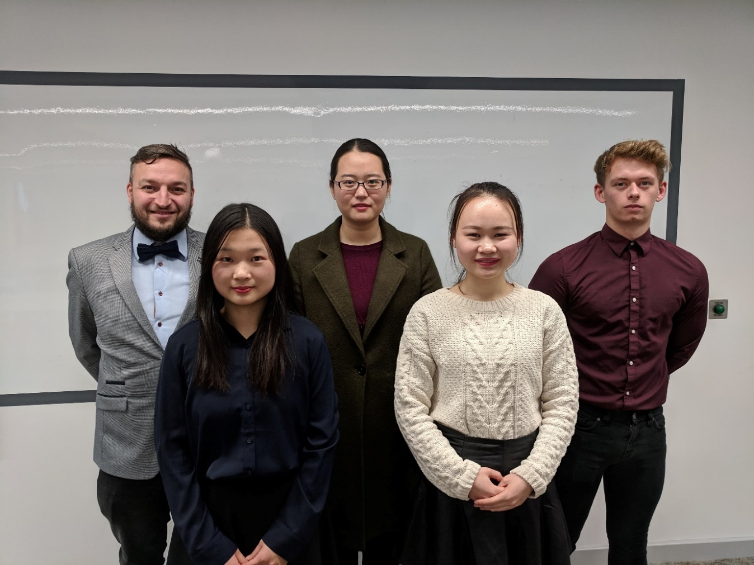
Figure 2-1 Group members
Team Leader: Yalan Mo (Second from the right)
Responsibilities: Team supervision, research of biological methods and analysis of experiment results.
Team Member: Iwan Dyer (Far right)
Responsibilities: Research and analysis of mechanical methods.
Team Member: Mengjie Yuan (Centre)
Responsibilities: Research and analysis of chemical methods.
Team Member: Xiaona Lin (Second from the left)
Responsibilities: Research and analysis of testing methods
Team Member: Paul Williams (Michael) (Far left)
Responsibilities: Research and analysis of mechanical methods and cost analysis.

Individual Contributions to the Project
The following sub headings will be named after the persons responsible for their composition, the order of works are in no way representative of importance to the project but more a comment towards cohesion of the timeline and work completed. Due to continuity to the timeline, some sections have been split into two parts, again this doesn’t represent extra work completed but makes the flow of the report more palatable.

Paul Michael Williams

Background Research of Mining in the Arctic Circle
As the project brief did not mention a specific mine or company in conjunction with the project, it was decided that a case study would be selected that could be comparable to the brief and also in that the group’s selected methodologies could be analysed with some real-world context. After some research, there was a mining area containing similar aspects to the brief, the mining area is called Bornite within the Ambler mining district, North West Arctic borough of Alaska. The area was also selected as it was located within the Arctic Circle and would yield similar results for the context of this report. The main point of reference taken from the Bornite mining area is the amount and concentration of Cobalt in the ground and the climate and remoteness of the environment as variables to the findings of this report.
The location of the mine is near the arctic circle, within the borders of Alaska, thus this location in incredibly remote. The location has four well maintained airstrips between 40Km and 15Km, each being approximately 1.5Km long. During the summer, the Dahl creek air strip can accommodate large aircraft up to and including a C-130. The mine, Bornite, has its own independent airstrip 700m long that can be used for small aircraft and helicopters. The site itself does not have any direct water access but Kobuk river runs between several of the settlements that are nearby. There is no highway access that is commutable, the closest one is about 285Km to the east of the site. This makes it incredibly hard for any equipment to be brought in via truck. The area in general has a sub-arctic climate, so the winter months can drop as low as -25c and the summer months, 20c at the hottest. The temperature makes it near impossible to work through the winter months, as everything would freeze. Another problem during summer months would be permafrost, frost that has been in the ground for many years, sometimes many thousands of years. When permafrost is found, then it can be dealt with by shooting high pressure water into the ground. Permafrost adds time and cost to whenever it is present. Hence most work is done throughout the summer months, it also doesn’t help that the snow fall is very unpredictable and could fall at any time throughout the year.

Iwan Dyer

Laws and Regulations relating to the Environment
Alaska has very strict laws when it comes to environmental protection as most of Alaska’s wildlife and environment is fragile and any change in the surroundings could lead to a mass loss in a rare plant or animal life, therefore the federal fisheries act was created. This act is in place to stop companies from dumping chemicals in any water sources, it holds a $1 million fine and up to 3 years imprisonment. Every day in violation is considered its own offence, which means that the fines and time can be stacked. (franson, 2012)
There is a different act that affect most industries including mining, which is the Canadian environmental act 1999 this outlines more of what can and can’t be done within Canada by industry, this include allowing harmful gas into the environment dumping of mining waste and large-scale destruction of the environment or aa area. Being a mine means that most of these laws would restrict what could be done day to day at the plant.
Under section 402/section 404 the mine would need a permit. If a 402 permit was needed, then the Alaska department of environmental conservation would have to issue the permit, which is for mining operations that don’t qualify for a general permit. Section 404 is given by the army engineering branch, this is a permit that allows disruption of the ground because of mining or urban development.

Valuation of Cobalt
Cobalt is a fairly expensive metal at the moment, as it is a key component in some batteries and batteries are becoming increasingly important since electric cars have started to become more popular. Most use a lithium cobalt ion as the main component of the battery. For an idea about the price of cobalt. See Figure 3-1 for the highs and lows and average price of Cobalt.
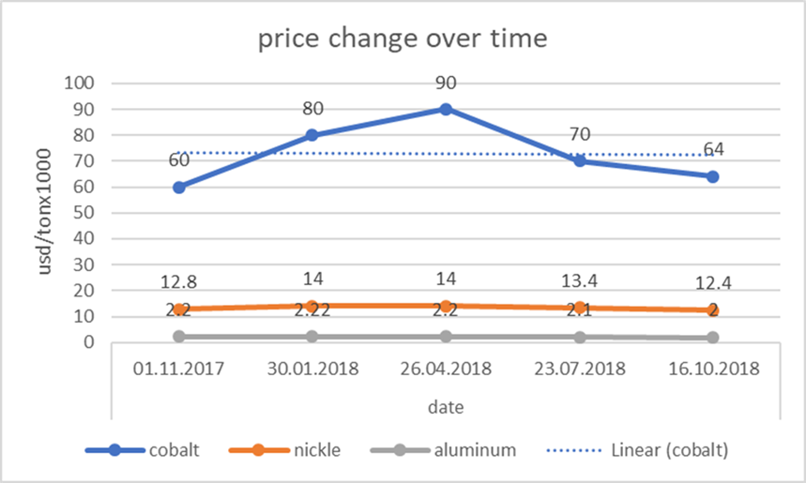
Figure 3-1 The price of cobalt
This graph is the price of metals prices on the stock market from the 1st of November 2017 to the 16th of October 2018 it shows cobalt (blue), nickel(orange) and aluminium (grey) and their respective prices over this time. Cobalt at its highest is six time more expensive than nickel is at the same time which makes it 40 times more expensive than aluminium. Over this period cobalt’s average price was $72,000 per ton which for a none precious metal is incredibly expensive as the graph shows. Admittedly, there is a rather large flux in the price, being a 50% overall change from the highest to the lowest value depending on the of the year.
The global demand for cobalt is increasing exponentially every year as in 2010 the world wide usage of cobalt was 88,000 tons (cite dater1) and in 2017 this world used 111,000 in 2017 (cite dater1) just to give an idea of the amount of cobalt that the mine has there is approximately 35 tons of pure cobalt present in the mining waste, the ground has an average consideration of 0.019% cobalt, when taking in to account the price of cobalt currently, the mine is losing 2.5 million dollars in cobalt (at an average stock price of 72000x35) which is a big loss for a mine to be having.

Yalan Mo

Introduction of Cobalt
The chemical element Cobalt, symbolised Co, has an atomic number of 27. In the Earth's crust, cobalt only exists in form of compound just like nickel, found in small deposits of natural meteoric iron alloys. Nowadays, many cobalt products come from one of numerous metallic-lustered ores such as cobaltite (CoAsS). However, most of cobalt is produced as a by-product in the nickel and copper mining process. The pure metal cobalt is hard, lustrous and silver-grey. It is also a ferromagnetic metal like iron. The physical properties of Cobalt are similar to nickel and iron, some of which has shown in Figure 3-2 (Greenwood & Earnshaw, 1997) .
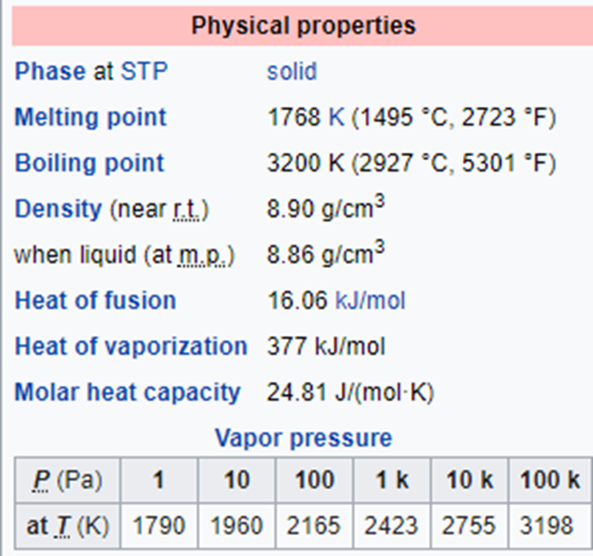
Figure 3-2 Physical properties of Cobalt
In terms of the chemical properties of Cobalt, it is stable in air and unaffected by water, but reacts slowly with dilute acids. Cobalt is a weakly reducing metal which typical forms a passivating oxide film to protect itself from oxidation. Although oxidation states of cobalt compounds range from −3 to +5, the most common ones are +2 and +3. Cobalt can form many compounds, including oxides, sulphides, halides, organometallic compounds, coordination compounds, etc. Some typical cobalt compounds include CoO, Co2O3, Co3O4, CoS, etc (Petitto, et al., 2008).
Last but not least, cobalt is essential to the life. It is the active centre of a group of coenzymes called cobalamins, of which the typical example is Vitamin B12, an essential vitamin for all animals. Inorganic cobalt is a micronutrient for bacteria, algae, and fungi as well. However, if the concentration of cobalt is too high, it may cause damage to human health. In some cases, those who work with cobalt suffer from lung illness such as asthma and pneumonia because of breathing in too high concentrations of cobalt through air (Lenntech , 2019) .

Xiaona Lin

Testing for Cobalt

Analytical chemistry
Analytical chemistry is aimed at separating, identifying, and quantifying matter by using instruments and methods (Skoog, et al., 2014). As a matter of fact, separation, identification or quantification is likely to constitute the whole analysis, however they may need to be combined with another method in some cases. The function of separation is to isolate analytes. The function of qualitative analysis is to identify analytes, and the function of quantitative analysis is to determine the numerical amount or concentration of analytes (Skoog, et al., 1988).
There are two branches of analytical chemistry, one is classical, wet chemical methods and the other one is modern, instrumental methods (Skoog, et al., 2007). The analytical chemistry can be divided into two classic parts, one is the qualitative analysis and the other is quantitative analysis (Yuqing, 2011). Separations such as precipitation, extraction, and distillation are applied in qualitative analysis, which are called classical methods of qualitative analysis (Skoog, et al., 1988). Differences in colour, odour, melting point, boiling point, radioactivity or reactivity are the bases of identification. Mass or volume changes are two important aspects which are used in classical quantitative analysis to quantify the numerical value of analytes. Chromatography, electrophoresis, field flow fractionation and etc. are instrumental methods, which is designed to separate samples (Skoog, et al., 1988). The same instrument can then be used for qualitative and quantitative analysis, and light interactions, thermal interactions, electric fields or magnetic fields may be used. Typically, separation, identification, quantification of analytes can be performed in the same instrument. Analytical chemistry is widely used in, medicine, science, engineering and other fields (Skoog, et al., 1988)

Qualitative Analysis
In chemistry, qualitative analysis, a branch of chemistry, is the determination of the chemical composition that presents in a sample (Helmenstine, 2019; Encyclopaedia Britannica, 2012). Qualitative analysis includes many analytical chemistry techniques, which vary depending on the nature of the specimen, that can supply numerical information about the sample (Helmenstine, 2019; Encyclopaedia Britannica, 2012). In some cases, it is only inevitable to verify the presence of certain elements or groups for which specific tests (e.g., flame tests, point tests) that are directly applicable to the sample can be used. More often, samples are complex mixtures that must be systematically analysed to identify all components (Encyclopaedia Britannica, 2012). Qualitative analysis can tell whether an atom, ion, functional group, or compound is present or absent in a sample, but it doesn't provide information about its quantity. Quantification of a sample, in contrast, is called quantitative analysis. (Helmenstine, 2019)
The classical procedure for the complete systematic analysis of an inorganic sample consists of several parts. First, a preliminary dry test may be performed, which may consist of heating the sample to detect the presence of such constituents as carbon (marked by the appearance of smoke or char) or water (marked by the appearance of moisture) or introducing the sample into a flame and noting the colour produced. Certain elements may be identified by means of their characteristic flame colours (Encyclopaedia Britannica, 2012).
Some preliminary tests need to be performed before doing the analysis of cations (amrita.olabs, 2013), which may consist of physical appearance, flame test, borax bead test etc.
(a) Physical Appearance
The physical examination of the unknown sample includes the study of colour, odour and density, which may be less reliable, but to some extend helps identify some coloured cations. Some ions have characteristic odour which can be easily identified, such as ammonium ion (amrita.olabs, 2013).
(b) Flame Test
Certain metals or their volatile compounds give the flame a characteristic colour when burned in a colourless flame (Suyun, 2011). Commonly, concentrated HCl is used to react with salt to form their chloride that is volatile in non-luminous flame (Suyun, 2011). Each element has its own spectrum so that their vapours can impart characteristic colour to the flame (Suyun, 2011). This colour can give reliable information of the presence of certain cations. For proceeding to this test, the sample is usually in the form of a powder or a small piece and the paste of the mixture with concentrated HCl is placed in a flame (usually blue flame) using a clean and less reactive wire (such as platinum or nichrome) (amrita.olabs, 2013; Suyun, 2011).
(e) Borax Bead Test
Borax (Na2B4O7.10H2O) melts and loses water of crystallization upon heating that make it swells into a fluffy white porous mass which then melts into a colourless liquid, which then forms a clear glassy bead consisting of boric anhydride and sodium metaborate (amrita.olabs, 2013).Boric anhydride is non-volatile. When reacted with a non-ferrous metal salt, characteristic non-ferrous metal metaborate beads are formed. In those cases, where different colour beads are obtained in the oxidizing and reducing flames, the metaborate salts of the various oxidation states of the metal are formed (amrita.olabs, 2013).
After the preliminary tests, typically the sample is dissolved into solution for subsequent determination of anionic components and cationic components (Encyclopaedia Britannica, 2012). The subsequent procedures use a series of reagents to treat the solution so that components can be separated by different reagent (Encyclopaedia Britannica, 2012). When components are separated, further examination is performed to confirm their presence and to determine the numerical amount (quantitative analysis). (Encyclopaedia Britannica, 2012).

Quantitative analysis
Quantitative analysis is to determine quantity of certain components in a sample. Concentration, mass, and relative abundance can be used to express the quantity of certain components of a sample (Helmenstine, 2018). The methods used to quantify components vary and may be broadly classified into two parts, chemical and physical methods (Helmenstine, 2018).
Chemical methods use chemical reactions, like precipitation, oxidation, or neutralization, to form a new chemical compound. Titration, wet chemistry tests, gravimetric analysis, combustion analysis, and inert gas fusion are chemical methods of quantitative analysis.
Physical methods measure the physical property, such as adsorption of light, density, and magnetic susceptibility (Helmenstine, 2018). Atomic Emission Spectroscopy (AES), Fourier Transform Infrared Spectroscopy (FTIR), trace element analysis, Energy Dispersive X-ray Spectroscopy (EDS), x-ray fluorescence spectroscopy, ICP-AES, and ICP-MS are physical methods of quantitative analysis (Helmenstine, 2018; Mao Yunzhong. Ling Xia, 2006).

Test of cobalt
A common oxidation state of cobalt for simple compounds is +2 (cobalt (II)) (Greenwood & Earnshaw, 1997). Analytical chemistry includes several methods that can test the existence and concentration of cobalt (II) ions.

Test of existence
The test of existence of cobalt is based on qualitative analysis, which includes the preliminary test and confirmatory test. The preliminary test is dry heating test which heat the sample solution making it lose water and become solid to get the colour of the salt, which can indicate whether cobalt iron exist or not. In fact, when during the heating, the cobalt ions may react with oxygen and water, which will form different substances (amrita.olabs, 2013). The chemical equation of cobalt ions react with oxygen under high temperature is shown in equation (1), which forms the black solid-. The chemical equation of cobalt ions react with oxygen and water under high temperature is shown in equation (2), which forms the brown solid- (Greenwood & Earnshaw, 1997).
(1)
(2)
The procedure is to heat the unknown solution until it loses the water and become solid, then use the colour of the solid compound to determine whether there exists cobalt ion or not. If the colour of the solid compound is brown or black that indicate there may be cobalt ion.
After the preliminary test of cobalt ion, then the confirmatory tests of Cobalt (II) ion (Co²⁺) (amrita.olabs, 2013) is performed.

(a) Borax bead test
Borax bead test is a confirmatory test of many metal ions. It uses a platinum wire ring to draw a little borax, burn and melt, to produce a colourless glassy bead, then take a small amount of the powder or solution of the test sample, continue to burn, the beads will show different colours, which can be tested the presence of certain metallic elements. This method utilizes molten borax to form characteristics of various colour compounds with oxides and salts of most metal elements. In this test Co²⁺ ion produces blue beads in both oxidising and reducing flames (Lange N A, 1979).

(b) Potassium nitrite test
Cobalt ion reacts with potassium nitrite in presence of acetic acid to form yellow precipitate of Potassium cobalt nitrite (amrita.olabs, 2013; amritacreate, 2016). In potassium nitrite test, cobalt ion reacts with potassium nitrite which forms cobaltous nitrite, as the equation (3) shows. And potassium nitrite reacts with acetic acid forms nitrous acid, as the equation (4) shows. Later, cobaltous nitrite reacts with nitrous acid that oxidizes cobalt (II) to cobalt (III), as the equation (5) shows. Finally, cobalt (III) reacts with potassium nitrite that forms potassium cobalt nitrite, which is yellow precipitate, as the equation (6) shows.
(3)
(4)
(5)
(6)

(c) Ammonium thiocyanate - ether test
Ether can form a separated layer above the unknown salt solution. On addition of ammonium thiocyanate, cobalt ion reacts with thiocyanate ion that forms ammonium cobalt thiocyanate which is blue and can dissolve in the ethereal layer making it turn blue (amrita.olabs, 2013; amritacreate, 2016).
(7)

Test of quantity

Spectrophotometric method
Spectrophotometry is to measure how much light is absorbed by a chemical substance bases on Beer-Lambert law. The basic principle is that each compound absorbs or transmits light over a certain range of wavelength. This measurement can be used to measure the amount of a known chemical substance. Spectrophotometry can also be used to detect the unknown substance base on the characteristic absorption of different ions (chem.libretexts, 2018).
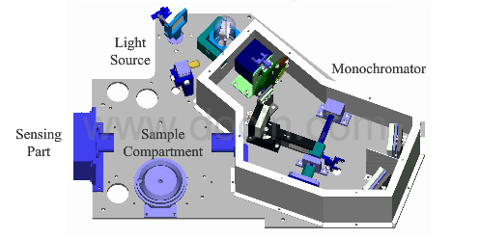
Figure 3-3 Spectrophotometer
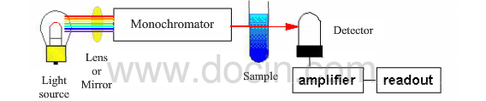
Figure 3-4 The basic structure of spectrophotometer

Beer-Lambert law
Bill-Lambert's Law relates the attenuation of light to the properties of light-propagating materials (Clark, 2017). When a bundle of parallel monochromatic light passes vertically through a uniform non-scattering light absorbing material, its absorbance A is proportional to the concentration of the light absorbing material and the thickness of the absorbing layer (Yuguang, 2016).
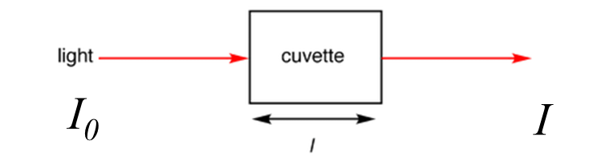
Figure 3-5 Light absorbed by sample in a cuvette (Clark, 2017)
The absorbance (A) (Clark, 2017) is defined via the incident intensity and transmitted intensity by equation (8).
. (8)
The absorbance can also be written as equation (9).
(9)
is the absorbance coefficient.
The concentration of the substance can be calculated with these two equations.

Procedure of spectrophotometry
Spectrophotometry can be divided into 3 main steps. First, the characteristic spectrum of cobalt ion should be detected by the spectrophotometer which is going to be used. The characteristic spectrum of cobalt is around 510nm (Fig.4) (Jiang Yuexi, 1973), which may be little fluctuation due to different equipment. And the spectrophotometer should not change throughout the whole test, because change of equipment may cause errors. Then the calibration is performed using the characteristic spectrum as the wavelength of the incident light, which is to tests the absorbance of a set of standard solutions of cobalt that the concentration is known, to obtain the concentration-absorbance curve that should be linear. Each absorbance can find the corresponding concentration in the concentration-absorbance curve. Later, the sample solution is tested using the same light to obtain the absorbance. Then the tested absorbance can find the concentration of the sample solution in the concentration-absorbance curve.
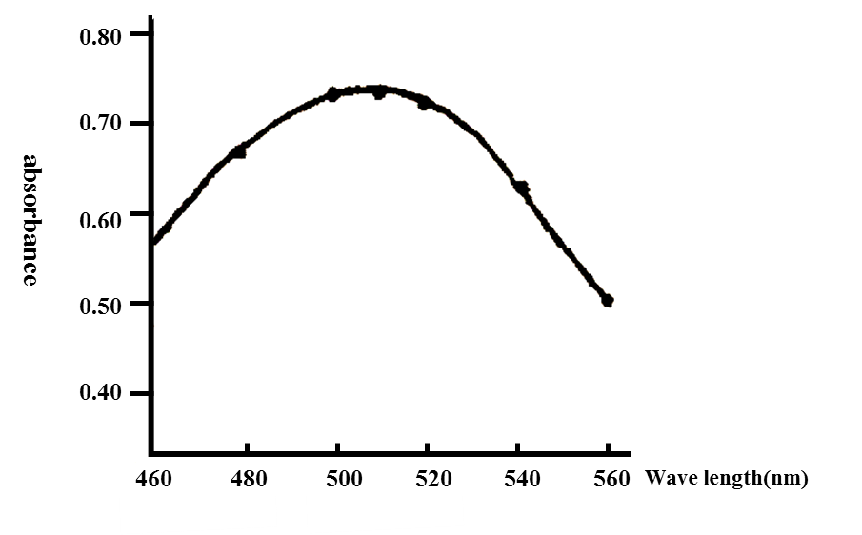
Figure 3-6 Cobalt absorption spectra (Jiang Yuexi, 1973)

ICP-MS
Inductively coupled plasma-mass spectrometry (ICP-MS) is a powerful instrument to analyse trace metals which concentration is very low in samples. The ICP-MS system can detect and quantify more than 70 elements, that is shown in Figure 1 (Arianne & Jacob, 2012).
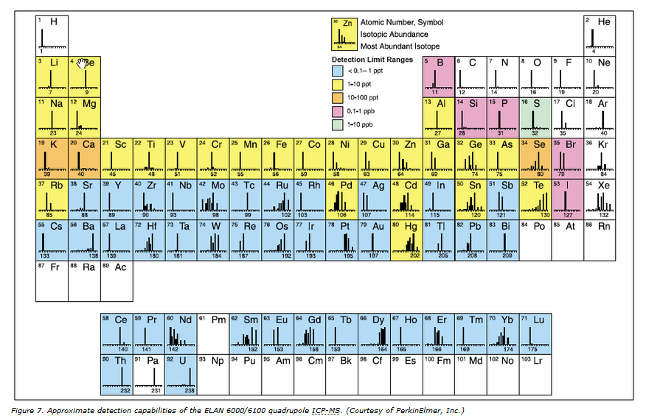
Figure 3-7 The elements that can be detected by ICP-MS
The process of ICP-MS can be divided into four steps: sample introduction, ICP torch, interface, and MS (Figure 2). Sample introduction is to make sample in a gaseous or aerosol form for analysis. In the ICP torch, the gaseous or aerosol sample is ionized due to the high temperature plasma. MS includes quadrupole and detection. Focalisation is to make the ion current focused into the quadrupole region through a single ion lens. Then the quadrupole separates the interest ion and others as the quadrupole is a mass filter that only allows ions with a specific range of m/z values to pass (Arianne & Jacob, 2012). The specific ions pass the quadrupole and reach the detector, then the detection can detect its count per second(cps), that is the number of ions that hit the detector per unit of time.
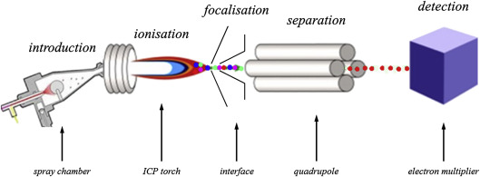
Figure 3-8 The components of ICP-MS (M.Aceto, 2016)

The process of ICP-MS
When using ICP-MS, you need to calibrate the interest element-cobalt to obtain the calibration curve of cobalt (Figure 3). Then the intensity of the sample is detected with which the concentration of cobalt is obtain in the calibration curve.
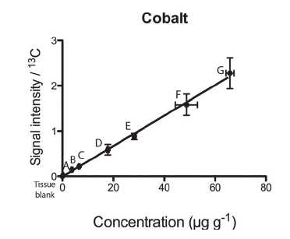
Figure 3-9 The calibration curve of cobalt

Yalan Mo

Overview of the experiment
With the rapid expansion of analytical fields such as material, biological and environmental monitoring of trace metals, many sensitive and selective analytical techniques have been widely applied to the determination of cobalt, such as X-ray fluorescence, spectrofluorimetry, atomic absorption, spectrometry, neutron activation analysis, chemiluminescence and so on. Be that as it may, the spectrophotometric method is still commonly used in the lab as a result of its advantages of being simple and not needing complex or expensive or test apparatus (Nassir, 2007). For this reason and the equipment existed in the lab, the spectrophotometric method has been selected to test cobalt and determine the cobalt content of the unknown sludge sample. But please note, this method is only a trial because the equipment is not as precise as Atomic Absorption Spectrometry (AAS) (SHAMADZU CORPORATION, 2012) and the cobalt content in the waste mining sludge is too low, it is likely that the result has a big error or even the cobalt cannot be detected.

Theory
Spectrophotometry is a detection method which measures the amount of light absorbed by a chemical substance by means of measuring the intensity of light after it passes through sample solution. The primary principle is that each compound absorbs or transmits light over a certain range of wavelength (The LibreTexts libraries, 2018). The absorbance of light that is allowed to be transmitted is directly proportional to the concentration thickness evaluated. Typically, the thicker the concentration of the substance is, the less light will be available to be transmitted to the cuvette (Benavidez, 2016). This theory is known as the Beer-Lambert Law, which can be expressed by the equation:
A= εbc
Where A is absorbance, ε is the extinction coefficient (M⁻¹cm⁻¹), b is the solution path length (cm) and c is the concentration (moles litre⁻¹) (IUPAC, 2014).
Not all substances obey the linear Beer-Lambert law over all concentration ranges. Therefore, it is essential to construct a calibration curve to provide the relationship between concentration and absorbance under the conditions used for the analysis.
Another important principle is the reaction that when Cobalt (II) is combined with Ammonium thiocyanate (NH₄SCN) to form an intense coloured complex ((NH₄)₂[Co (SCN)₄]). The intensity of the coloured species is measured using a spectrophotometer. A calibration curve (absorbance versus concentration) is constructed for Cobalt (II) and the concentration of the unknown Cobalt sample is determined.
Last but not least, extra cobalt needs to be added to the sludge in order to simulate the cobalt content in the real waste mining sludge sample so that it is necessary to calculate how much cobalt should be added in this experiment. The calculation is as follows.
According to the research, the cobalt content in soils around Bornite mine sites has been reported as high as 6,450 ppm, that is 6.45 g/kg (Frank, et al., 1976).
The cobalt content in 98% Cobalt(Ⅱ) sulphate heptahydrate (CoSO4·7H2O) is:
98%×58.93÷281.1=20.54%
Assume 5g final dehydrated sludge sample (including the added cobalt) is used to test, the mass of 98% Cobalt(Ⅱ) sulphate heptahydrate (CoSO4·7H2O) added to the sludge sample is: 6.45×0.005÷20.54%=0.157g.
Then, the mass of dehydrated sludge needed to make is: 5-0.157=4.843g

Experimental materials

Apparatus
Jenway 6700 Visible Scanning Spectrophotometer (Figure 3-1), SBS-LW Balance Scale (Figure 3-2), a Stockli Dehydrator with Stainless Steel Trays (Figure 3-3), one 200mL volumetric flask, five 100mL volumetric flasks, durable polypropylene funnels, test tubes, a 10.00mL pipet, three 50mL centrifuge tubes, cuvettes, spatulas, a 140mL flat bottom evaporating dish, a 500mL round media storage bottle, four 100 mL round media storage bottle, a mortar and pestle, beakers, etc.
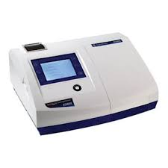
Figure 3-10 Jenway 6700 Visible Scanning Spectrophotometer
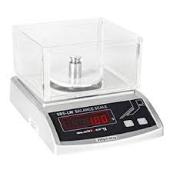
Figure 3-11 SBS-LW Balance Scale
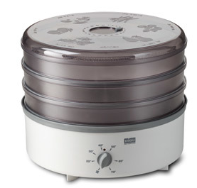
Figure 3-12 Stockli Dehydrator with Stainless Steel Trays

Reagents
98% Cobalt(Ⅱ) sulphate heptahydrate (CoSO₄·7H₂O), 99+% Ammonium thiocyanate (NH₄SCN), Deionized water.

Procedure
- A stock solution of cobalt (II) (1000 mg/L) was prepared by dissolving 0.9732g of 98% Cobalt(Ⅱ) sulphate heptahydrate (CoSO₄·7H₂O) in 200 ml of the water. Use the balance scale to weigh 0.9732g of 98% Cobalt(Ⅱ) sulphate heptahydrate (CoSO₄·7H₂O) with a 140mL flat bottom evaporating dish; pour it into a labelled 200 mL volumetric flask via a durable polypropylene funnel; add the moderate amount of deionized water, invert and shake the flask to dissolve the solid; then add more deionized water to the mark and invert and shake the flask to mix the solution. Use a 500mL round media storage bottle to store the 1000mg/L stock cobalt (II) solution.
- Prepare the following cobalt calibration solutions by pipetting 10mL of the cobalt solution from the last step into labelled 100mL volumetric flasks. For example, to make the 100mg/L cobalt calibration solution, pipet 10mL of the 1000mg/L cobalt stock solution into a labelled 100mL volumetric flask, dilute to the mark with deionized water and then invert and shake the flask several times to mix the solution. To make the 10 mg/L cobalt calibration solution, pipet 10mL of the 100mg/L cobalt calibration solution into a labelled 100mL volumetric flask, dilute to the mark with deionized water and then invert and shake the flask several times to mix the solution. The same method was utilised to make the 1mg/L and 0.1mg/L cobalt calibration solutions.
- While the solutions are sitting, calibrate the spectrophotometer so the wavelength is 514 nanometres and the transmittance is zero.
- Pour the 1000mg/L stock cobalt solution into a cuvette; place the cuvette into the spectrophotometer, recording the absorbance it reads.
- Pour the 1000mg/L stock cobalt solution into a test tube reaching its mark; weigh 99+% Ammonium thiocyanate (NH₄SCN), pour it into the same test tube, put the lid on it and then shake the test tube to mix the solution. Then pour the solution into a cuvette and record the absorbance it reads.
- Find the appropriate quantity of Ammonium thiocyanate (NH₄SCN) as the colour developer and the appropriate time for “colour developing” period. Pour the 100mg/L cobalt calibration solution into three test tubes respectively; then weigh 0.100g, 0.200g and 0.300g of 99+% Ammonium thiocyanate (NH₄SCN) and pour them into the three test tubes; put the lids on them and shake them to mix the solutions. Set different time for “colour developing” period: in 10 mins, 20 mins, 30 mins and 40 mins, pour the solutions from the test tubes into three cuvettes and place the cuvettes one by one into the spectrophotometer, recording the absorbance it reads.
- Test the absorbances of all the cobalt calibration solutions with the appropriate quantity of Ammonium thiocyanate (NH₄SCN) and the appropriate time for “colour developing” period according to the results from the last step. As a result, the calibration curve can be constructed for cobalt (II).
- According to the data obtained from the last step, plot a graph of concentration (mg/L) vs. absorbance and draw the best straight fitting line through the points, namely the Beer-Lambert Law plot.
- Repeat step 7 and step 8 twice to avoid potential anomalies and get the calibration curve of cobalt (II) with as small deviation as possible.
- Prepare the sludge sample and test its moisture content. Weigh the sludge and subsequently put the sludge sample into the Stockli Dehydrator with Stainless Steel Trays to dry the sample for 12 hours. After 12 hours, weigh the sludge again. Then calculate the moisture content of the sludge.
- Take enough dehydrated sludge and grind it into powder.
- According to the calculation, weigh 4.843g sludge powder and add the 98% Cobalt(Ⅱ) sulphate heptahydrate (CoSO4·7H2O) into the sludge sample to the weight of 5.000g. Mix the cobalt(Ⅱ) powder and the dry sludge completely.
- Wash out the cobalt from the sludge and form a solution containing cobalt. Pour deionized water to the mark of the 50mL centrifuge tube; then, add the 5.000g mixture of cobalt powder and dry sludge into the tube and invert and shake it fiercely to mix the solution completely. Let the solution stand for about 5 minutes and the filter it through the durable polypropylene funnels.
- Repeat step 12 through 13 to make another two solutions as comparisons.
- The same method in the step 7 was utilised to test the absorbance of the three sample solutions.
- Place the absorbance value from the last step onto this plot and determine the concentration of the three sample solutions.
- After finishing the experiment, remember to clean and put away the materials appropriately.

Experimental data and calculations
The result obtained from step 6 is shown in Table 5-1.
Table 3-a Absorbance under the condition of different quantity of NH₄SCN and different time for "colour developing"
Mass of NH₄SCN(g)/Absorbance (AU)/Time(min) | 10 | 20 | 30 | 40
0.100 | 0.048 | 0.206 | 0.206 | 0.206
0.200 | 0.046 | 0.217 | 0.217 | 0.217
0.300 | 0.071 | 0.251 | 0.251 | 0.251
According to the results above, it can be concluded that the appropriate quantity of NH₄SCN as the colour developer is 0.100g (0.100g has been enough for the solution to be detected sensitively) and the appropriate time for “colour developing” is 20 mins (since 20 minutes, the absorbances of different mass of NH₄SCN have been stable).
In step 7, a record of measured absorbance for the two blank solutions and the five standard solutions is shown in Table 5-2.

Table 3-b Measured Absorbance by Spectrophotometric Analysis (first time)
Number | Identification | Mass of NH₄SCN (g) | Measured Absorbance
1 | Deionized water blank | 0 | 0.000
2 | Colour developer blank | 0.101 | 0.001
3 | 0.1 mg/L Standard | 0.102 | 0.001
4 | 1 mg/L Standard | 0.101 | 0.005
5 | 10 mg/L Standard | 0.101 | 0.025
6 | 100 mg/L Standard | 0.108 | 0.136
7 | 1000 mg/L Standard | 0.100 | 0.243
Using the measured absorbance values for the working standards, listed as samples no. 3 through 7 in Table 5-2, the calibration curve shown in Figure 2 was constructed. Note that the absorbance for sample no.3 was too low for the spectrophotometer to recognize at the specified settings so it was removed from the calibration curve to minimize the error. This curve simply plots the measured absorption of a monochromatic light in the spectrophotometer relative to the known cobalt concentration. In general, linear regression is used to get a straight line approximated through the data points (Laminar, 1998). But as a result of the large concentration range in this experiment, the logarithmic fit was utilized in this experiment. As shown in the Figure 5-1, the equation of the approximated line is best described as:
[Absorbance] = 0.0358ln [Concentration]-0.0215
The line has a slope of 0.0358 and an R² value of 0.9356 from a logarithmic fit.
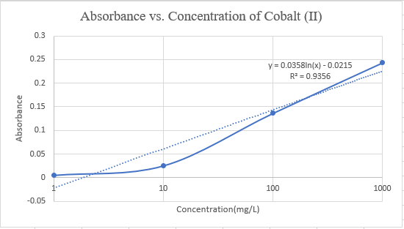
Figure 3-13 Calibration Curve for cobalt analysis (first time)
The result of the second time is shown in Table 5-3.
Table 3-c Measured Absorbance by Spectrophotometric analysis (second time)
Number | Identification | Mass of NH₄SCN (g) | Measured Absorbance
1 | Deionized water blank | 0 | 0.000
2 | Colour developer blank | 0.101 | 0.001
3 | 0.1 mg/L Standard | 0.102 | 0.001
4 | 1 mg/L Standard | 0.101 | 0.008
5 | 10 mg/L Standard | 0.101 | 0.028
6 | 100 mg/L Standard | 0.108 | 0.145
7 | 1000 mg/L Standard | 0.100 | 0.254
The same method was utilized to get the calibration curve of the second time which is shown in Figure 5-2. The equation and the R² value are also shown below.

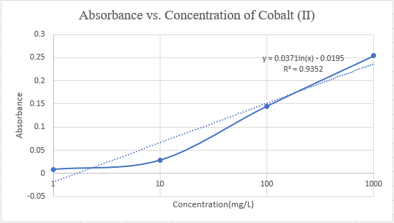
Figure 3-14 Calibration Curve for cobalt analysis (second time)

The result of the third time is shown in Table 5-4.
Table 3-d Measured Absorbance by Spectrophotometric analysis (third time)
Number | Identification | Mass of NH₄SCN (g) | Measured Absorbance
1 | Deionized water blank | 0 | 0.000
2 | Colour developer blank | 0.103 | 0.001
3 | 0.1 mg/L Standard | 0.104 | 0.001
4 | 1 mg/L Standard | 0.108 | 0.005
5 | 10 mg/L Standard | 0.102 | 0.028
6 | 100 mg/L Standard | 0.100 | 0.146
7 | 1000 mg/L Standard | 0.101 | 0.264

The result of the third time is shown in Figure with its equation and R² value.
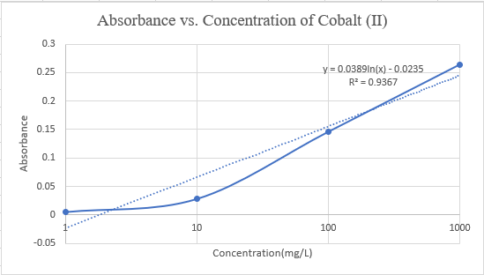
Figure 3-15 Calibration Curve for cobalt analysis (third time)

The results obtained from step 10 is shown in Table 5-5.
Table 3-e The moisture content of the sludge
Number | Mass of raw sludge(g) | Mass of dehydrated sludge(g) | Moisture content
1 | 172.859 | 120.288 | 30.413%
2 | 118.221 | 82.050 | 30.596%
Take No.1 for example to show the calculation of the moisture content of the raw sludge:
No.1 moisture content= (172.859-120.288)/172.859×100%=30.413%
Therefore, it can be calculated that the moisture content of the sludge is: (30.413%+30.596%)/2=30.505%
The results obtained from step 12 through 16 is shown in Table 5-6. The absorbance values of the three samples were placed onto this plot of the third time to determine their concentrations because the calibration curve of the third time has higher R² which means higher precision.

Table 3-f The calculation of cobalt content in the sludge
Sample | Mass of dry sludge(g) | Mass of dehydrated sludge and Co(Ⅱ)(g) | Absorbance | Concentration of Co(Ⅱ)(mg/L) | The content of Co(Ⅱ) in the raw sludge
1 | 4.843 | 5.006 | 0.168 | 137 | 0.0952%
2 | 4.843 | 5.000 | 0.164 | 124 | 0.0863%
3 | 4.843 | 5.000 | 0.199 | 305 | 0.212%

Take sample 1 as example to show the calculation of the concentration of cobalt and its content in the raw sludge:
Concentration of Co(Ⅱ)=exp [(0.168+0.0235)/0.0389] =137mg/L
Content of Co(Ⅱ) in the raw sludge=(0.137g/L) × (0.05L) ÷ (5.006g) × (1-30.413%) = 0.0952%
Obviously, the result of sample 3 had a big error so it was removed when calculating the average content of cobalt in the sludge. The cobalt content in the sludge is: (0.0952%+0.0863%)/2=0.0908% that is 908ppm.

Discussion
This exercise was useful in determining concentration of a trace metal and helpful for understanding the spectrophotometric technique. In this section, the data obtained will be briefly discussed, some errors appearing in this experiment and their potential causes are addressed, and general trends and relationships are presented (Laminar, 1998).
As anticipated, a more intensely coloured solution of sample and the colour developer yielded a higher absorbance and, in turn, a higher apparent cobalt concentration. For this experimental analysis, the calibration curve developed from the working cobalt(Ⅱ) standards basically fitted the Beer-Lambert law and was approximated by a logarithmic fit. But the calibration curve was not ideal because of many errors in this experiment with the R² value of some 0.93 (Ideally, this value should be over 0.95 to make results as sensitive and accurate as possible (JoVE, 2019)). The errors mainly result from the apparatuses including the Spectrophotometer, Balance Scale and other quantitative instruments used in this experiment whose precisions are not very high. Also, a potential error may arise from the fact that there would be a loss of the cobalt when many volumetric transfers of solution from one container to another. Besides, the measured absorbance values may vary slightly among different laboratory operators because reading the spectrophotometer is affected by a certain level of personal judgment and experience, which also leads to a potential error.
The content of cobalt in the raw sludge sample which was figured out according to the experimental data significantly deviated from the theoretical value (908ppm vs. 6,450ppm). The main potential causes are given as follows.
- The calibration curve was not ideal enough so that the concentration of cobalt(Ⅱ) deduced from this plot was not accurate;
- The cobalt in the dehydrated sludge sample was not washed out completely by deionized water (Typically, the acid is used to wash out the cobalt which can get higher effectiveness) and there were a lot of losses during the process of filtering (some cobalt was left on the filters and the residual sludge);
- Some losses of cobalt were also likely to result from many transfers of the sludge sample from one container to another.
As a result of the limited conditions of this experiment such as a lack of appropriate experimental materials and apparatuses, the results obtained from this experiment are not conclusive enough to be considered.

Conclusion
Overall, although the experimental results are not ideal and cannot be actually applied in this whole project, the experiment has successfully served its purpose of helping the group members have a good understanding of spectrophotometric analysis techniques and its application in the determination of cobalt. The group members also have learned how to design an experiment to resolve the actual problems in the project including preparing standard solutions, making experimental samples, applying the Beer-Lambert Law and so on. What is more, it can be concluded that the spectrophotometric method is not suitable for the determination of cobalt especially the cobalt in the waste mining sludge because the content is too low for the spectrophotometer to detect precisely and sensitively. Therefore, a higher-precision method should be applied to test the content of cobalt in this project so that the performance of the methods to extract the cobalt from waste mining sludge can evaluated.

Mengjie Yuan
The main requirement of the task is to extract Cobalt from sludge, it is feasible to extract Cobalt by using chemical methods. There are two types of chemical methods that can be utilized to extract Cobalt, pyrogenic process and wet process. By analysing the characteristics of them, wet process is chosen to extract Cobalt. Then each step, in wet process, is analysed and selected. Finally, the costs of chemical methods can be calculated.

Basic statements of Cobalt

Natural Cobalt
Cobalt minerals are rarely found alone in nature, it is mostly associated with copper Cobalt ore deposits, nickel Cobalt ore deposits, arsenic Cobalt ore deposits and pyrite deposits. There are few independent Cobalt minerals and the reserves of terrestrial resources are small. Submarine manganese nodule is an important prospective resource of Cobalt. Cobalt smelting is characterized by low grade of raw materials, long extraction process and various extraction methods (Encyclopaedia Metalium, 2010).

Extraction of Cobalt
There are many kinds of Cobalt wastes, such as waste high-temperature alloy, waste hard alloy, waste magnetic alloy, waste catalyst and waste secondary battery materials. The composition of Cobalt scrap is complex, generally containing copper, zinc, manganese, nickel, cadmium and other valuable metals.
The smelting of Cobalt is generally divided into three steps: first, Cobalt is transferred from ores into solutions, or into coarse Cobalt alloys or Cobalt mattes, and then into solutions; two is to remove impurity purification; three is to extract Cobalt (Encyclopaedia Metalium, 2010).
Although there are many ways to extract Cobalt, two are the most common methods to use. One is called pyrogenic process; another is the wet process.
The principles of Pyrogenic process are using oxygen to unite with metal elements in sludge based on the function of affinity. Metallurgical method which is frequently used to separate metal elements is based on the order of affinity between the metal element and oxygen: Al> Si> V> Mo> Cr> C > P> Fe> Ni> Co> Cu. When using pyrogenic process to extract cobalt from sludge, the sludge which contain Cobalt is put into the electric arc furnace with high temperature melting, and then the slag can be obtained by the role of air blast. Under the action of affinity between metal and oxygen, when the metal elements have a higher affinity with oxygen than Ni, it would enter the slag to varying degrees. At the same time, the Nickel anode which contains Co and Ni can be got. The membrane is used to electrolyze Nickel anode to produce Cobalt and Nickel which are involved in the anode solution. The alloy materials which contain Nickel and Cobalt can be treated well by this method to extract Cobalt (Zhongwei Zhao, 2008).
Wet process mainly has the following steps: Leaching, Removing the interfering metal from the solution containing Cobalt, Purification of solution and separation of Cobalt.
1, Leaching. Leaching can be classified into four types: chlorine oxidation leaching, acid leaching, microbial leaching and electrochemical leaching.
(1) Acid leaching uses sulphuric acid, hydrochloric acid and nitric acid to transfer the metal in the sludge into the solution, the general chemical formula is:
If the oxygen is added into the reaction, more metals like copper would be leached out as ions to ether the solution, the equation is as follows:
(2) Chlorine oxidation leaching: This leaching method is based on sulphuric acid leaching method by adding chlorine gas to intensify the strength of the leaching process and increase the rate of metal leaching. However, chlorine gas is not common to use due to it is easy to spill which would cause environmental pollution.
(3) Electrochemical leaching: When an electrolytic reaction is performed, there are three indispensable components to form the electrolytic cell: anode, cathode and electrolyte. In the process of electrochemical leaching, the anode is sludge and the cathode is copper plate, which is inactive. The electrolyte designates sulphuric acid medium. When the electrolytic cell starts to work, the metal in anode would be transferred into solution with the help of current passed through. The formula is as follows:
(4) Microbial leaching: This leaching method belongs to the biological leaching method which uses microorganisms or their metabolites to achieve the oxidization, reduction, dissolve and absorption effects on minerals to leach Cobalt into solution. Microbial leaching has the advantages of low-cost investment, high extraction rate and less environment pollution which is appropriate for tailings, treating lean ore and so on (Songrong Yang, 2001).

2, Removing the interfering metal from the solution containing Cobalt. After leaching process, the solution has not only Cobalt ion but also other ions of interfering metals. To remove them, two methods are commonly used: sodium pyrite method and oxidation- neutralization method. Each method has the specificity to remove certain metal.
(1) Sodium pyrite method: This method is appropriate to remove iron ion from sulphate solution. After the leaching solution is obtained, the ferric iron can be precipitated as a pale-yellow precipitate crystalline compound from sulphate solution which also contains sodium ion, potassium ion and others.
(2) Oxidation-neutralization method: This method is appropriate for removing low - valent metal ions that are reducible. The principle of this method is based on oxidation. By using strong oxidizer such as HNO₃, Cl₂ and adjusting the pH of solution, the reducing metal ions in the solution will be oxidized to high value ions and then precipitated with hydroxide to be removed. Examples are shown below (Zhongwei Zhao, 2008).
3, Purification of solution and separation of Cobalt. It has two types: extraction and liquid film method.
(1) Extraction. Based on the benefits of simple operation, high sensitivity, high degree of automation, it becomes more common to use extraction method to get Cobalt. There are two mature extraction methods: one is using chemical materials to form precipitates with Cobalt and collect the Cobaltous compound; another is using extractants. Two common extractants in China are used. P204 is the early extractant to separate interfering metal. Through development, P507 was invented with the aim of improving certain properties of the extractant. The metal impurities such as iron, copper and calcium can be effectively removed by P204; P507 can separate Nickel and Cobalt effectively. If blending the two extractants, it will have a better effect on removing impurities.
(2) Liquid film method: This method is to use specific membranes to separate impurities from Cobalt. For example, at the pH range of 4.2~5.3, surfactant membrane which is combined with P507 can be used as a flow carrier to separate Nickel and Cobalt from other impurities in industrial wastewater. Then Cobalt can be obtained by using electrolytic method. The separation effect of whole process is good (Baiduwenku, 2018).

Selection of extraction chemical methods

The methods selected for the extraction process
Based on the discussion above, compared to wet process, pyrogenic process is complicated and hard to operate. It is sensible to choose wet process as the extraction methods of Cobalt. According to the three steps of wet process, the first step of leaching is suitable to choose acid leaching on account of its wide application range, easy operation and low cost; the second step of removing other metals from solution is a specific removal process. It depends on the composition of sludge. Since most of the impurity metals in the sludge are reducing metals, oxidation-neutralization method is widely used in most cases. The first two steps can be basically determined. Last step is to purify of solution and separation of Cobalt which is an important procedure and needs more comparison and discussion. Due to the method of extraction has a large application, it is convenient to add chemical materials to form precipitates with Cobalt. After searching articles, some real cases show the most commonly used materials to react with Cobalt to form precipitates.
1, In the case of extracting Cobalt from Cobalt waste, the waste was dissolved with a strong base firstly, and then Co (OH)₂ solution was obtained. Na₂S was used to react with Cobalt and get a black precipitate. The equation is (Yongli Wang, 2005):
2, When extracting Cobalt from residue of industrial waste, the residue can be first treated with a mixture of acid solutions of hydrochloric acid, nitric acid and sulphuric acid. After this leaching treatment, Cobalt solution can be obtained. By adding sodium carbonate to the cobalt containing filtrate, Cobalt carbonate can be obtained. The remaining residue can be used to make building bricks or cement, so that the entire process not only extracts cobalt, but also makes use of waste which bring higher economic benefits. The equation is (university, 2011)
3, In the case of extracting Cobalt from Cobalt oxide ore, Cobalt oxide is first leached with sulphuric or hydrochloric acid, and then the interference of other metallic elements is removed. The ammonium oxalate was added to obtain cobalt oxalate precipitation. The oxalate of cobalt divalent is usually pink, insoluble in water, slightly soluble in acid, and becomes anhydrous when heated in air. The equation is shown below (Weifeng Lan, 2008).

Comparison of three precipitating materials

Sodium sulphide
Advantages: (1) It is suitable for ferromanganese ore. Due to the differences of ksp, impurities such as iron and manganese can be effectively removed by adjusting pH. Cobalt sulphide is precipitated in the buffer system with pH =3, while manganese sulphide hardly precipitates under this condition, so the purification of Cobalt can achieve high efficiency (Ji, 1997).
(2) Cobalt sulphide has a stable property which is beneficial to the extraction process.
(3) Sodium sulphide can be used as a detoxification agent and ore flotation agent before separation of mixed concentrate.
(4) This method has strong operability.
Disadvantages: (1) The condition of the whole reaction process is harsh; pH must be strictly controlled to remove impurities.
(2) Cobalt sulphide has acute toxicity: oral LD50: >5mg/kg in mice. It means that the lethal dose of the experimental mice was 5mg of cobalt sulphide per kg of mice by oral administration ( Chinese chemical manufacturing network, 2009).
(3) Water hazard level 3: extremely hazardous to water, even a small amount of waste infiltrated into the ground will cause harm to drinking water. If no permission, it cannot be discharged into the surrounding environment.
(4) Sodium sulphide chemical properties are unstable, easy to react with water. skin and hair will cause burns; In case of acid decomposition, release highly toxic flammable gas; Explosion may occur by impact or rapid heating; Acute toxicity: LD50:820mg/kg (Chemical book, 2013).
(5) After the extraction of cobalt, waste liquid is mainly alkaline wastewater which is black with an irritating smell. It is not conducive to large-scale treatment. pH will reduce part of hydrogen sulphide escaping in the atmosphere. It will pollute the air and disturb the life of people.
The price of sodium sulphide is expensive: RMB195/kg=pound22/kg.

Sodium carbonate
Advantages:
(1) Cobalt carbonate is stable in nature, almost insoluble in water, alcohol etc, soluble in acid, which is conducive to the storage of the extraction process.
(2) Sodium carbonate has good thermal stability. When heating, it is not easy to decompose which is conducive to the storage of the extraction process.
(3) Sodium carbonate has low price, low cost and high economic benefits.
Disadvantages:
(1) The cobalt carbonate produced is toxic and will irritates the eyes, skin and respiratory system, which is difficult to handle after extracting the cobalt. Sodium carbonate also irritates eyes and is not suitable for the extraction.
(2) Attention should be paid to dust and dust removal at work. Workers should wear a respirator to reduce the damage to respiratory organs. Workers should also wear dust work clothes, protective gloves, in order to protect the skin. All of these will increase the cost.
(3) Cobalt carbonate is also harmful to water bodies.
The price of sodium carbonate is cheap: RMB 9.4/kg=pound 1/kg (Chemical book, 2013).

Ammonium oxalate
Advantages:
(1) Cobalt oxalate has good physical properties and stable chemical properties (avoid oxide moisture contact).
(2) High precipitation rate, high selectivity and good extraction effect.
(3) Ammonium oxalate is colourless 、tasteless and environmentally. When it is applied to large-scale sludge treatment, it won't produce waste gas.
(4) Suitable for copper, zinc, manganese, nickel, cadmium mine and can recover valuable metals.
(5) The price is competitive and has a good economic benefit.
Disadvantages:
(1) Ammonium ions is contained in the remaining liquid, which should be strictly controlled. The concentration of ammonium ions is required in the comprehensive sewage discharge standard. If discharged directly, it may cause eutrophication of water, which is bound to pollute the environment.
(2) Cobalt oxalate is slightly harmful to water.
(3) Slight toxicity and irritation.
The price of ammonium oxalate is RMB 30/kg=pound 3.5/kg, purity > =99.5% ( Chemical book, 2013).

Discussion
1. Based on the comparisons above, when choosing wet process, the first step and the second step has been determined, and the final step can be determined by the summary table below:
methods  aspects | Sodium sulphide | Sodium carbonate | Ammonium oxalate
Economic benefits | good | best | better
Environment impacts | worst | worse | bad
Operational convenience | worst | worse | good
Extraction efficiency | good | good | better

Table 1 summary of three precipitants with Cobalt.
As analysed above, three materials have their own benefits and limitations. To consider more thoughtful for the project, it is sensible to select ammonium oxalate as the reactant to form precipitate due to its better economic benefits, better extraction efficiency and good operational convenience.
2. Costs:
(1) The cost of sulphuric acid used to leach: Due to the article (Zhongwei Zhao, 2008), the general leaching rates of cobalt reached 95.37% （for the quality of cobalt). So, if the amount of Cobalt in sludge is 1 gram, only 0.9537gram of Cobalt can be leached, by sulphuric acid. According to the components of Cobalt sulphate, 1 mole Cobalt ion would react with 1 mole sulphuric acid. The relative atomic mass of cobalt is 58.93g/mole molar mass of sulphuric acid is 98 g/mole. Assuming the cobalt mass in sludge to be treated is 1 gram, 0.9537 g can react with sulphuric acid, the amount of sulphuric acid that is needed:
The price of sulphuric acid which has a mass fraction of 98% is 50 pounds/ton (Business club, 2019).
(2) The cost of ammonium oxalate: The price of ammonium oxalate is 3.5 pounds/kg. According to the equation below:
Molar mass of Cobalt sulphate is 281.15 g/mole and molar mass of ammonium oxalate is 124.10 g/mol. It indicates the quantitative relationship between ammonium oxalate and cobalt sulphate. The relative atomic mass of cobalt is 58.93g/mole. 1 mole of Cobalt sulphate would consume 1 mole of ammonium oxalate to form precipitate. Assuming the cobalt mass is 1 gram, the amount of ammonium oxalate can be calculated as follows:
3. Discussion on chemical wastewater after cobalt extraction:
According to the secondary standard of sewage discharge, the maximum permissible limit of ammonia nitrogen is 50 mg/L. As calculated before, if the amount of Cobalt is 1g, the mole of Cobalt is 0.017 which is also the mole of ammonium sulphate. When the amount of Cobalt is 35 tons, the mole of ammonium sulphate is 0.017x35000000=595000mole. The molar mass of ammonium sulphate is 132 g/mole. So, in the whole process capacity, the mass of ammonium sulphate is 595000x132= 78540000 g = 78540000000mg. After forming a precipitate with 35 tons of Cobalt (Anon., 2018), the concentration of ammonium sulphate would depend on the amount of water. To reach 50 mg/L, the amount of water is 78540000000/50=1570800000L.

Conclusion
In the part of chemical extraction methods,
1. To sum up, by comparing the advantages and disadvantages of various methods, a more reasonable theory is obtained: cobalt in sludge can be purified by wet process with sulphuric acid leaching, oxidation-neutralization method to remove metal impurities and ammonium oxalate process to extract Cobalt.
2. In this project, based on articles (Anon., 2018) (Anon., 2001), the estimated reserves of Cobalt in the mine is 35 tonnes. So, the calculation costs of chemical materials which are sulphuric acid and ammonium oxalate are:

Iwan Dyer

Safety Brief for Ammonium Sulphate
When handling and removing ammonium sulphate care must be taken as it is an irritant if ingested or breathed in and can become a strong irritant if it come in contact with the eyes. Simple actions can be taken when handling ammonium sulphate to minimums the risk to an employee as protective glasses should be part of standard uniform anyway and making sure one wears gloves when working with ammonium sulphate what help reduce the chance of skin irritation. However unlikely if someone was to eat the sulphate and then proceeds to feel unwell then a doctor should be contacted first aid so that the employ can be monitored, and the correct treatment could be applied. (https://beta-static.fishersci.com/content/dam/fishersci/en_US/documents/programs/education/regulatory-documents/sds/chemicals/chemicals-a/S25176A.pdf ). The dumping of ammonium sulphate straight So, this would not be feasible to do as a disposable method so it would be the suggestion of this report that using ultra filtration to get the ammonium sulphate out of solution then when it is removed from the filters the solid ionic compound. This then can be dried and removed from the site via a vehicle and either disposed of properly or solid as amomum sulphate itself is worth about £3kg and with the vast quantities that will be produced from this method the mine could make some of its overheads back by selling this compound after it has been produced.

Electrolysis
Electrolysis is an electrochemical reaction that is typically used to reduce a metal to its pure state, a good working example would be lithium. Lithium oxides form very quickly in air, so the only way to remove the oxygen from the lithium’s surface, is by reducing it to its base state. All chemicals have a different capacity for electrolysis depending on their ionic charge, for example some may be highly positive, and some may be negative such as the OH-1 ion, which can even be formed in water without passing a current through it.
The method for electrolysis is shown below (energy, 2016).
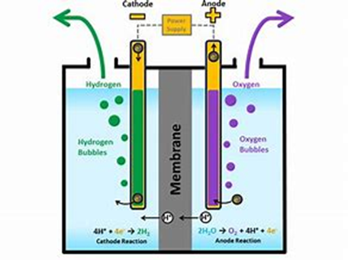
Figure 3-16 Electrolysis
The image above shows the electrolysis of water in to oxygen and hydrogen, this happens on a couple of stages. Firstly, this report will break down the equipment need. Firstly, you need a water proffer container such as an H cylinder which is typically what electrises of water is done in there need to be a liquid (typically water) that is needed to pass a current though. There must be an anode and a cathode suspended in the liquid, to make a circuit. The negative charged ions in the water will be drawn to the anode and the positively charged ions will be pulled to the cathode. the process of electrolysis can work on most compounds as long as there is an ionic charge difference between the elements making up the communed in the water or the water its self. When a negatively charged element come in to contract with the anode it will take the electron that’s making it negatively charged in to itself and the make the element stable or make it form a pair of elements and they will ether become suspended in the solution or if in there stable state they will become gas and rise to the top of the H cylinder. The same thing will happen on the cathode, but the cathode gives electrons to make the chemical stable which will bring it out of solution.
There are 2 every effective ways of removing cobalt from a solution via electrolysis one is by using a diaphragm cell this cell give a 99% purity yield though some of the cobalt will be left in solution no matter whether or not the cell is left running indefinitely (though most if not all methods of extraction will leave some of the product left in solution) . though this method itself will only work with cobalt oxide and any other impurity’s drastically effect the efficiency of the reaction. (N.Fedotov, 1944)

The other method is normally used for getting cobalt out of drinking water (as cobalt is linked to cancer) in lab condition it normally preformed in a 2 litter tank but can and has been scaled up in the past (scialert) is uses aluminium anodes and cathodes with a metal bas spinning in the tank acting as a stirrer to mix the acquis solution about. Once the reaction is believed to be at equilibrium the solution is then passed though filter paper (grade 40) this can either be gravity assessed are vacuumed filtered to in cress its effectiveness. The cobalt should be deposited in the filter paper along with any other impurity’s and the water should not have any heavy metals in it. The current doesn’t even need to be that high for this method ranging from 0.01Am-2 to 0.04Am-2. The draw back with this method is time as the reaction become exponential slower the larger the tank is compared to the amount of cobalt in solution. Even though the mine that this report is discussing has the highest recorded parts per million in a mine there still would be a significant amount of impurity’s meaning that the tank would have to be massive.
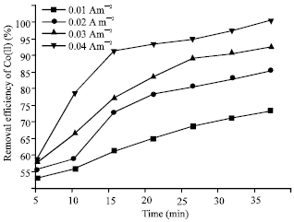
Figure 3-17 (scialert)
This graph shows the efficacy of the extraction over time deepening on the current supplied to the cell. It shows that at 0,04Am-2 is where it is the most effective and seems to get most cobalt out of the solution, the only problem with this is, that the increases the voltage needed. Is that the pH increases to the protons in the water.
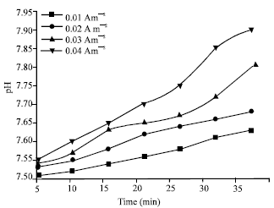
Figure 3-18 (scialert)
The increases in pH is shown by this graph in most drastic impact this change in the pH of the water would not even matter but because of where the mine is this could be seen as a later problem as the mine is located in a fragile ecosystem so if this waste water is not deal with after uses if could has some damaging effect to both the environment and to the system dew to fines from the government. An easy way around this would be to remove the water from the site and have it treated but because of how isolated the mine is there would be hard and incredibly expensive.

Ultrafiltration
Ultra-filtration is a method that used typically used for the extraction of heavy metals from drinking water. The most common metals that are extracted are iron copper and chromium, though cobalt is also known to be extracted from the water along with these metals, as they share many common properties such as atomic mass and atomic density. These factors allow the fine mesh to extract the metal and anything of greater atomic mass to be extracted from the water while allowing the water itself though the mesh. The filter type has a massive effect on the extraction efficacy of this filtration for example if a fillet is very porous allowing most stuff will pass though it with easy and something with incredibly small pours would not allow a lot though (so possibly just water). Also, in some cases with some filtered the pH has a larger effect extraction efficiency. For example ( (Braakat, 2010) ) show just how much the pH can affect the extraction of aqua heavy metals.
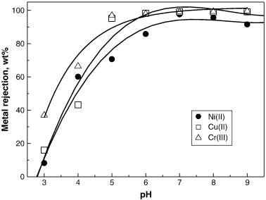
Figure 3-19 The relationship between metal rejection and pH (Braakat, 2010)
This graph shows nickel, chromium and copper being extracted from water. The y axes is the waters rejection of the metals agents the pH of the solution. As is clearly visible from the graph and its trended lines the more acidic the solution the less likely the metals are to be regarded from the solution. And the closer the pH get to 7 (which is approximately neutral) the more of the metal is rejected when going through the filter. “The metal rejection efficiency values, with initial metal ion concentration of 10 mg/L, were 97.6, 99.5 and 99.1% for Cu (II), Cr (III), and Ni (II), ions, respectively at pH 7.” (Braakat, 2010)this shows just how effect ultra-filtration is when in the correct pH though there is one large problem, this experiment was run at 7.5 letter/hour which is incredibly slow for a extraction prosses, this becomes even worse when even in its highest constrain of waste in the water is 100mg/litter so at best this prosses at this size would only be able to extract 750mg/hour. This however could be scale up as it would be used in industry but any pumps or other stuff such as the filters become increasingly more expensive as you scale up and replacing parts also becomes very expensive.
Ultra-filtration itself could not be used viably for a primary method but with most methods there will such as electrolysis. The biproducts such as any salts that are formed could be easily extracted using filtration. Obviously if the chemical is too small for the filter it will pass through with or if all the chemicals in the water are about the same size, they all will get trapped in the filter. This though could be used to either catch the chemicals that are wanted or any waste in the water after a process is completed. For example, as stated above there is a by-product of the chemical method which is ammonium-sulphate, this is a salt, it is harmful to the environment in large quantities and to people it is an irritant if digested. In Alaska there are very heavily enforced environmental laws that effect mining and what can and cannot be put in to water or the ground and ammonium-sulphate cannot be water in anything but as trace elements. This would make filtration a very good way to removing any other chemicals that are formed dew to the reaction between the acid and the metals are the solution as there would still be trace amounts of other metals in the flotation tank.

Xiaona Lin

Bioleaching
Bioleaching, also known as bio metallurgy, in layman's terms, is the process of using a microbial-containing leachate to interact with ore to obtain valuable metals. These microorganisms feed on ore and obtain energy by oxidation; these ores are capable of extracting minerals from solution by being oxidized and becoming insoluble in water (Ashish Pathak, 2009). Bio metallurgy is mainly used to dissolve lean ore, waste ore, tailings and Daye furnace slag to recover certain precious metals and rare metals (Chang-song, 2014).
There are several bacteria can be used to leach metal. According to the different optimal temperature of growth, they can be divided into 3 parts, mesophile, moderate thermophile, thermophile (Yang Xianwan, 2003). Thiobacillus ferrooxidans (T.f) is one of mesophile, that is used widely, and cobalt is not the exception (Natarajan, 2018).

Mechanism
Bacteria can dissolve metals from ore by the metabolism (Yang Xianwan, 2003; Ashish Pathak, 2009). Taking thiobacillus ferrooxidans as the leaching bacteria to deal with Sulphide ore as example, in this reaction, sulphuric acid and ferric sulphate are produced by the action of bacteria, and then the useful metal in the ore is extracted by using sulphuric acid or ferric sulphate as a solvent. In this process, the bacteria obtain the required energy, and the ferric sulphate can oxidize the ore to convert copper, nickel or cobalt therein into soluble compounds and dissolve them from the ore (Torma, 1983).
The effect of bacteria is that metal sulphides are oxidized by Fe (III) in solution and Fe (III) gaining an electronic is reduced to Fe (II):
Fe (II) ions are oxidized by the participation of bacteria, and bacteria gain energy from it:
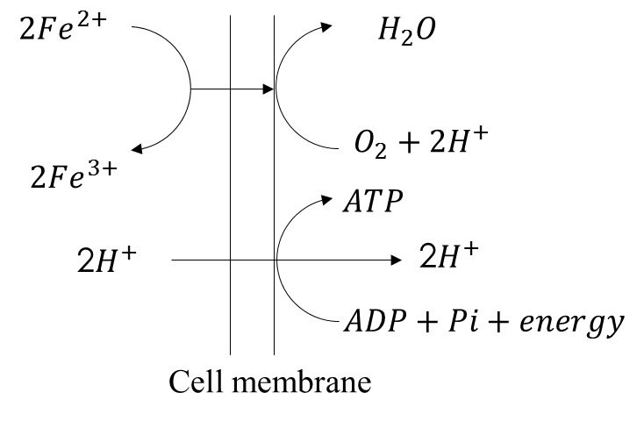
Figure 3-20 Synthesis of ATP by oxidation of Fe (II) by Thiobacillus ferrooxidans (Yang Xianwan, 2003)
Fe (III) is regenerated and then can oxidize metal sulphides again, so that they are cycled back and forth.

Advantages and disadvantages
There are several advantages of bioleaching. First, the investment and operating costs of bioleaching are much lower than for conventional pyrometallurgical and hydrometallurgical processes as microorganisms is cheap and can be recycled during the process (Power I M, 2010). Second, it does not have complex machinery and the procedures are not complicated and are easy to control. What is more, the waste product is less hazardous because it does not introduce toxic material. Last but not least, metal can be extracted from low grade ores using bioleaching (Yang Xianwan, 2003).
However, as a new method, it has some advantages. The leaching effectiveness depends largely on the efficiency of the microorganisms and on the chemical and mineralogical composition of the ore to be leached. The maximum yields of metal extraction can be achieved only when the leaching conditions correspond to the optimum growth conditions of the bacteria (Yang Xianwan, 2003).The processes tested on individual types of ores cannot be transferred to other ones. Before a technical application is possible the optimum leaching conditions must be elaborated for each type of ore (Yang Xianwan, 2003). Bioleaching is very slow and needs a long period and the efficiency is low (youtube, 2014).
So, the bioleaching method is not suitable for extraction of cobalt.

Paul Michael Williams

Flotation Method

A Brief History of Flotation
The history of flotation began in the nineteenth century, it is considered to be the most important development of the twentieth century mining and milling industry. It replaces the earlier and cruder gravity methods developed by early metallurgists. Gravity separation is one of the oldest mineral processing techniques, used as early as 3000 BC by the Egyptians to separate gold. At the end of the nineteenth century, the world had almost depleted its supply of high-grade ore. Engineers and inventors worked to create a method to treat and concentrate the world’s abundant supply of low-grade and complex ores, which always yielded low profitability. In 1905, the world’s first commercially viable flotation mill was established in Broken Hill Australia.
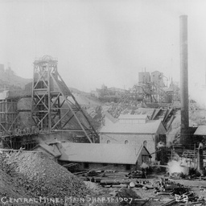
Figure 3-21 Broken Hill Mine 1907 (State Library of Australia, 2004)
Soon after experimental plants sprung up in Australia, Great Britain and the United States and also spread news of their successes. Almost overnight the mining industry was transformed, shifting from a diminishing supply of high-grade ore to an abundant supply of low-grade ore. Without the introduction of flotation, metals would have become increasingly difficult and costly to produce, flotation directly impacted the world’s economy in a positive manner. Industrialisation combined with the introduction of flotation propelled the mining industry into a new age. With the improvements to older separation techniques came advancements in the ability to mine different types of minerals previously locked in sediment or mining waste. Flotation opened the market to new minerals, rising to twenty-four metallic minerals and nineteen non-metallic minerals by the mid twentieth century. Flotation is the most widely used mineral extraction method in the world. It solved an industry dilemma but also increased mineral separation to meet modern industrial and manufacturing demands. Modern engineers assert that the development of the flotation process was the most important technological advancement of the century. (Bunyak, 2000)

The Flotation Process
Flotation is a method of concentrating valuable metals from finely ground ores in a water bath, with either the ore pulp or water treated with reagents or frothers to encourage separation. Today the process is more commonly referred to as froth flotation. The process includes the following processes;
- Reduction or crushing of ore to release the targeted mineral
- Addition of water, frothers and reagents which encourage the minerals to adhere to the air bubbles
- Creation of a rising current of air bubbles to the surface
- Formation of the ore laden froth on the surface
- Skimming of the froth from the surface
- Drying of the resultant minerals for smelting
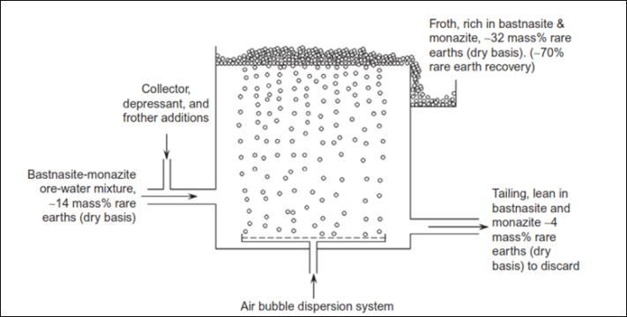
Figure 3-22 Single flotation cell (Michaud, 2016)
This process can be repeated as many times needed to gain the results desired. This led to a later development where numerous flotation cells were place in series so that the process aforementioned, could be run in sequence to achieve greater end results. In Figure 10 you see a simple flotation cell, for a series and ultimately completing the recovery of necessary minerals in one run you would have a series of the above flotation cells. This type of method can be used to recover more than one mineral, with different chemicals or reagents in each cell targeting different minerals. (Bunyak, 2000)
Modern flotation cells are slightly more sophisticated than the above example. They contain impellers to stir as well as pneumatic air input for double agitation of the fluids. See Figure below for a detailed view of a modern flotation cell.
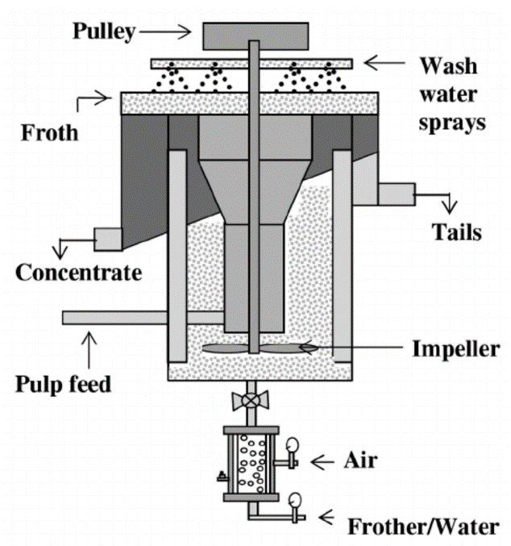
Figure 3-23 A modern flotation cell (Valenzuela, 2015)

How does Flotation Work?
Froth flotation uses the hydrophobicity of particles to its advantage and uses this to collect the targeted mineral at the surface. When a particle is hydrophobic, it neither wants to closely associate with water nor form hydrates of water on its surface. Particles that repel water from their surfaces have a tendency to prefer to associate with oily or hydrocarbon-based materials. It’s common knowledge that oil and water do not mix well and will separate into layers unless agitated. In a somewhat kindred manner, fine particles that are naturally hydrophobic or more importantly, are made to be hydrophobic with the use of chemicals adsorbed on to their surfaces are very unstable in water. On the other hand, hydrophilic surfaces are compatible with water as evidenced by the difficulty of removing water even by drying. The process of froth flotation is based on the simple notion of using air bubbles as an escape mechanism for hydrophobic particles. This is where the frothing agent comes into play, the bubbles formed are inherently comprised of oil and so the hydrophobic particles will adsorb to the bubbles and escape the water environment. Once attached the hydrophobic particles are carried to the surface, where a stabilised froth is formed and can be collected or skimmed to be further treated later. The unattached hydrophilic material, otherwise known as gangue, remains submerged in the tank and can either be retreated or collected. This process can be used in two ways, either the valuable material is collected by the froth or the valuable material is in the gangue and can also be easily collected. (Michaud, 2016)

Variables used to Manipulate Froth Flotation
There are several ways to manipulate the flotation process to either gain better results or to also be selective with which materials you are trying to collect. There are two groups of factors that can be manipulated within the flotation process, operating factors i.e. Physical and mineral i.e. chemical factors. On the physical end, you have air flow rate, impeller speed, froth stability and pulp density. On the other hand, you have particle size or chemical, when you use chemicals that have certain affinities with your target material.

Air Flow Rate
The air flow rates directly impact recovery rates and recovery grades within the flotation process. The air flow rate has two effects on the process, firstly in cases of low air flow rate then an increase can speed up flotation. Alternatively, if the air flow rate is too high it will cause a reduction in the density of the slurry and reduces attachment, therefore having a negative effect. The air flow rate can be raised to slightly increase recovery rates, but that increase is seen to be marginal. Also, this reduces the grade of the concentration that is collected, so experimentation should be carried out to find the ideal air flow rate per each type of material to be recovered. (Zhang, 1989)

Impeller Speed
Impeller speed has several impacts on the process, it changes the turbulence of the pulp, increasing the collision between particles and bubbles. Also, it changes the approach speed of particles resulting in greater impact between particles and bubbles, therefore changing the probability of attachment. Impeller speed will affect the projection of unattached particles into the froth where they might be retained. Impeller speed will affect the stability of the froth. And lastly impeller speed will affect the particles suspension in the flotation cell. Impeller speed will increase flotation when increasing from a low starting impeller speed but after a certain point (around 1300rpm) then impeller speed will reduce flotation due to excessive turbulence. (Zhang, 1989)

Particle Size
The particle size affects the flotation process, the greatest recovery rates are achieved between 10 and 50 microns with a sharp decrease in recovery when particle size was over this limit and a gradual decline in recovery with particle size below this limit. (Zhang, 1989)

Other Factors
Other factors that will influence the flotation process include, pulp density, reagent dosage, flotation temperature and pH. The effects of the reagent dosage, flotation temperature and pH are closely linked to the targeted mineral properties and should be adjusted as to match the flotation required. Pulp density in particular can be troublesome, high density will cause bubble overloading and make flotation impossible. High pulp density might also cause very fine bubbles which are too heavy to float when mineralised. (Zhang, 1989) Reagents are split into two main groups, collectors and depressants. Collectors are chemicals that make the surface of a particle hydrophobic. Depressants are chemicals that prevent the adsorption of unwanted minerals to the bubbles, essentially rendering unwanted minerals hydrophilic. These reagents used in conjunction make the flotation process extremely selective.

Variables of Froth Flotation Specific to the Recovery of Cobalt
As previously discussed, there are certain conditions within the flotation process that will affect the recovery rates of minerals. When it comes to the recovery of cobalt there are specific conditions needed. There are four main variables specific to cobalt, they are pH level, depressant dosage, collector dosage and percentage of solids in the feed. These are ranked in order of importance with pH level having the biggest effect on the recovery rate of cobalt. The optimum conditions for the recovery of cobalt are, a pH level of 10.15, depressant dosage of 100g/tonne, collector dosage of 80g/tonne and a solid percentage of 20%. (Masiya & Nheta, 2014)

Conclusion
From the standpoint of mechanical engineering, Froth Flotation would seem to the best solution to the problem stated in the brief. The volumetric flow rate potential is theoretically unlimited with froth flotation cells run in series. The only limiting factors would be profitability and the output capacity of the mine feeding the froth flotation cells. A single froth flotation cell can range from 1m³ up to 60m³ and in general consensus, the flow rate through the cells seem to be around 300m³/hour per 1m³ of actual volume. Hence a single 60m³ cell can process 2400m³/hour of pulp or 57600m³ per day. All the while, producing recovery rates of around 90%. (Institute of Non Ferrous Metals, n.d.)

Cost Analysis

Capital Cost
When considering the cost analysis of this report, several factors need to be accounted for. There isn’t a working example of the problem stated so the costs stated where possible are very crude and further analysis would be warranted. The area chosen as a case study for this report is highly rich in copper with a significant deposit of cobalt also. The brief questioned the viability and method of extracting the cobalt from mining waste, as the case study is hugely copper rich (possibly the biggest known copper deposit to date), then for the purposes of this costing, it is assumed that a large copper mining operation would be processing the site. As such they would be dealing with the cobalt as an afterthought. In the following Figure 3-24, find a typical simple copper mining flow chart. This a crude example and it is assumed that there is a filtration process at the end of the line, as is widely expected in the industry.
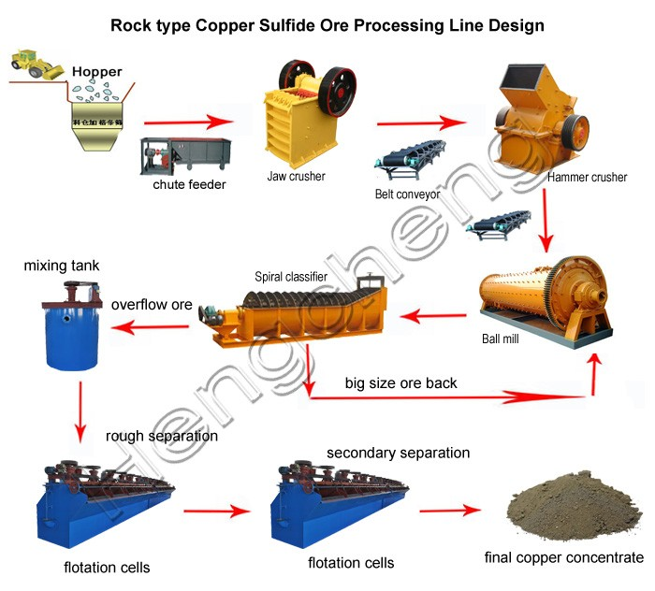
Figure 3-24 (Alibaba, 2019)
The selected solution to the problem is a hybrid flotation/leaching method as seen in the conclusion. For the purposes of costing, the capital costs to a copper mine would be relatively low or zero. The only extra equipment needed would be a leaching pool between the flotation cells. This statement was made with the assumption that several of the flotation cells could be commandeered and setup specifically for cobalt. If this is not the case, then extra floatation cells would be needed to be purchased and would decrease the nett profit. As stated above this is an entirely theoretical and crude costing exercise and will not show any accurate results.

Operating Costs
If the solution stated above was to be implemented, the only real additional operating costs would be the cost of the sulphuric acid that would come with the addition of the leaching tank into the process. In section 3.6.5, the cost of sulphuric acid was calculated to process one tonne of pure cobalt as £2831.50 per tonne. Using this figure, we can calculate the cost of sulphuric acid per tonne of unrefined ore. 2831.50 x 0.019 = £53.80/tonne. Another consideration would be labour, as it would be an unmanned process then labour costs can be discredited.

Conclusion
The final solution found by this report is that a hybrid method containing elements from the mechanical side and the chemical side could theoretically be used. The leaching element from the chemical method could easily be incorporated into a flotation cycle, both these methods would yield very good results individually. They have been selected to go together because of the remoteness and environmental issues within the arctic circle. If a pure chemical method was to be deployed, then there would probably be leaching ponds needed. Due to the environmental issues plus water access then this wouldn’t be desirable. When incorporating leaching into flotation then the need to process the waste water (for sulphuric acid) is negated as most copper mining companies would use some sort of filtration at the end of line, to deal with the reagents within the process anyway. After coming to this conclusion, some research was put into the possibility of this type of solution and there have been several proposals made and implemented with this type of hybrid system. (Luszczkiewicz, et al., 2012) See the figure below that shows a similar system as has been proposed in this report.
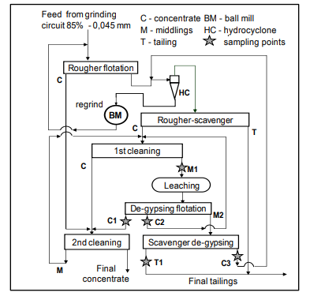
Figure 4-11 (Luszczkiewicz, et al., 2012)
This type of hybrid system increases the recovery rates between 3.5% up to 20% in cases of poorly performing flotation setups.
From an economic point of view, it would be very easy for a large copper mining outfit to absorb any capital cost involved, even though it is assumed capital outlay would be minimal, due to most machinery already on site. The only significant operating cost would be the cost of the sulphuric acid at £53.80 per tonne but with potential value of $2.5 million, this operating cost would easily be incorporated. Also, with the bulk buying of sulphuric acid then this cost could very well be significantly reduced.

Achievements and Progress
Figure 5-1 Gantt Chart
As you can see in the Gantt chart above, the team’s initial timing plans were very optimistic to the point of naiveté. Almost every aspect of the Gantt chart was either started later than planned or took longer than expected. As with any real-world project there will be unforeseen road bumps or hiccups that will compromise the smooth timing of the project. A good team will overcome these little problems and endeavour to complete the project to the ultimate deadline. Some such problems that this particular team has faced have been, to obtain use of the laboratory for the conduction of the experiment, supervision was required and the purchasing of materials. The supervision came in the form of a PHD candidate who was extremely helpful but due to timetabling issues could not supervise the team until much later than the team had originally anticipated. Another problem arose in the form of one team member’s wife giving birth mid project, this led that team member to struggle to keep to the planned timing within the Gantt chart. These such problems occur in all types of businesses and projects. The team coped well with these problems and as the Gantt timing became more fluid, the team ultimately met all deadlines of importance.

Review of Successes and Failures

Group work
Despite the language barrier between the team members because of our various nationalities, all the group work was completed smoothly, and we have tried our best to design a feasible and cost-efficient project, regarding the subject we selected. Every member is very helpful and works as not only an individual but also a part of the team, contributing their knowledge to the project as much as possible. The biggest failure among the whole group work may be the experiment, the initial purpose and anticipated experimental results were not achieved as a result of inadequate experimental conditions, limited time, some unstandardized operations performed by the non-professional team members, etc. But we still gained a lot of experience from the experiment. Besides, we have not completely understood the working part of each member until the whole group work is almost done because of the communication barrier and different academic backgrounds. But all in all, we have good teamwork and finished the group project as best as we can.

The project
In this project, in order to combine the knowledges of each team member, the method used to extract and recover cobalt from waste mining sludge is the physical method supported by the chemical method. It is a quite new method because nowadays the conventional methods are mainly chemical methods. An insight of the extraction efficiency and cost benefits of this method we design can be obtained and compare with the conventional methods. But because of the immaturity of this method, our design is just a theoretical proposal and needs further evaluation and verification. Moreover, even though the experiment failed, it was still known that the method of spectrophotometry was not suitable for testing cobalt and a more precise method was required. If possible, a better and comprehensive experiment scheme needs to be performed in order to evaluate the method we designed.

Recommendations
On a basis of the results of the group work and the project analysis, some recommendations are put forward below to optimize the project and make it more practical to perform in the real world.
- Establish a complete assessment system. Because of many limited factors, we have no chance to assess the methods we designed, including their efficiency to extract the cobalt form waste mining sludge, their feasibility, specific process requirements and so on, most of which are based on theoretical analysis in this project. But in fact, a complete and strategic assessment system is essential to evaluate our design, which can make it more credible to the company we serve.
- Besides the cost estimation, cost benefits can be also taken into consideration. In this project, we only need to analyse the costs of the whole project. However, in order to make the project more realistic, the cost benefits should be also included in this project such as calculating the cost savings and the payback period of this project.
- More details of our design combined the physical methods and chemical methods need to be considered carefully if the company wants to carry out it in the real world. These details can include the selection of chemicals and equipment, the specific layout of the entire process, the size design of each tank, etc. Those all will have a significant influence on the project’s efficiency, cost, environmental implications and so on.

References
Chemical book, 2013. https://www.chemicalbook.com/Search.aspx?keyword=草酸铵. [Online].
Chinese chemical manufacturing network, 2009. http://product.chemmade.com/detail-硫化钴.html. [Online].
Alibaba, 2019. High recovery sulfide copper processing plant with full engineer service. [Online]
Available at: https://www.alibaba.com/product-detail/high-recovery-sulfide-copper-processing-plant_60440570830.html
[Accessed 27 March 2019].
amrita.olabs, 2013. Qualitative Analysis of Cations. [Online]
Available at: http://amrita.olabs.edu.in/?sub=73&brch=7&sim=180&cnt=1
[Accessed 3 3 2019].
amritacreate, 2016. Tests for Cobalt Ion - MeitY OLabs. [Online]
Available at: https://www.youtube.com/watch?v=MRELKbMFF_E
[Accessed 2 3 2019].
Anon., 2001. Cobalt in the environment. s.l.:s.n.
Anon., 2018. Trilogy Metals Inc NI 43-101 Technical Report , s.l.: BD Resource Consulting, Inc.
Arianne, B. & Jacob, W., 2012. Inductively Coupled Plasma-, s.l.: s.n.
Ashish Pathak, M. D. T. S., 2009. Bioleaching of heavy metals from sewage sludge: A review. Journal of Environmental Management, 19 3, p. 2343–2353.
Baiduwenku, 2018. https://wenku.baidu.com/view/c5882fa39a89680203d8ce2f0066f5335a816704.html. [Online].
baike.baidu, n.d. Analytical chemistry. [Online]
Available at: https://baike.baidu.com/item/%E5%8C%96%E5%AD%A6%E5%88%86%E6%9E%90/10949130
[Accessed 2 3 2019].
baike.baidu, n.d. The Beer-Lambert Law. [Online]
Available at: https://baike.baidu.com/item/%E6%9C%97%E4%BC%AF%E6%AF%94%E5%B0%94%E5%AE%9A%E5%BE%8B/11056709?fr=aladdin
[Accessed 3 3 2019].
Benavidez, N., 2016. Lab Report-1-Spectrophotometric Analysis of a Cobalt (II) Chloride Solution. [Online]
Available at: https://www.coursehero.com/file/22499723/Lab-Report-1/
Braakat, M., 2010. sicencedirect. [Online]
Available at: https://www.sciencedirect.com/science/article/pii/S0011916410000706
[Accessed 12 match 2019].
Bunyak, D., 2000. To Float or Sink A Brief History of Flotation Milling. The Mining History Journal, pp. 35-44.
Business club, 2019. http://liusuan.100ppi.com/. [Online].
Chang-song, H., 2014. Introduction to Biometallurgy. China Nonferrous Metallurgy, p. 78.
chem.libretexts, 2018. Spectrophotometry. [Online]
Available at: https://chem.libretexts.org/Bookshelves/Physical_and_Theoretical_Chemistry_Textbook_Maps/Supplemental_Modules_(Physical_and_Theoretical_Chemistry)/Kinetics/Reaction_Rates/Experimental_Determination_of_Kinetcs/Spectrophotometry
[Accessed 4 3 2019].
Chemical book, 2013. https://www.chemicalbook.com/ProductChemicalPropertiesCB3429046.htm. [Online].
Chemical book, 2013. https://www.chemicalbook.com/Search.aspx?keyword=碳酸钠. [Online].
Clark, J., 2017. The Beer-Lambert Law. [Online]
Available at: https://chem.libretexts.org/Bookshelves/Physical_and_Theoretical_Chemistry_Textbook_Maps/Supplemental_Modules_(Physical_and_Theoretical_Chemistry)/Spectroscopy/Electronic_Spectroscopy/Electronic_Spectroscopy_Basics/The_Beer-Lambert_Law
[Accessed 4 3 2019].
Encyclopaedia Britannica, 2012. Qualitative chemical analysis. [Online]
Available at: https://www.britannica.com/science/qualitative-chemical-analysis
[Accessed 3 3 2019].
Encyclopaedia Britannica, n.d. Qualitative chemical analysis. [Online]
Available at: https://www.britannica.com/science/qualitative-chemical-analysis
[Accessed 3 3 2019].
Encyclopaedia Metalium, 2010. http://baike.asianmetal.cn/metal/co/extraction.shtml. [Online].
energy, 2016. electrolysis. [Art] (energy.gov).
Frank, R., Ishida, K. & Suda, P., 1976. Metals in agricultural soils of Ontario. Canadian Journal of Soil Science, 56(3), pp. 181-196.
franson, R. t., 2012. the canadian encyclopedia. [Online]
Available at: https://www.thecanadianencyclopedia.ca/en/article/environmental-law
[Accessed 10 march 2019].
Greenwood, N. N. & Earnshaw, A., 1997. Chemistry of the Elements. 2 ed. s.l.:Butterworth-Heinemann.
Greenwood, N. N. & Earnshaw, A., 1997. Chemistry of the Elements. 2nd ed. s.l.:Butterworth-Heinemann.
Helmenstine, A. M., 2018. Understanding Quantitative Analysis in Chemistry. [Online]
Available at: https://www.thoughtco.com/definition-of-quantitative-analysis-604627
[Accessed 3 3 2019].
Helmenstine, A. M., 2019. Definition of Qualitative Analysis in Chemistry. [Online]
Available at: https://www.thoughtco.com/definition-of-qualitative-analysis-604626
[Accessed 2 3 2019].
Institute of Non Ferrous Metals, n.d. Flotation Machines for the Mining Industry. Poland: Institute of Non Ferrous Metals.
IUPAC, 2014. Beer–Lambert law (or Beer–Lambert–Bouguer law). [Online]
Available at: http://goldbook.iupac.org/html/B/B00626.html
Jiang Yuexi, Z. Y., 1973. Determination of trace cobalt in ore by PAR colorimetry. Geology and Prospecting, pp. 34-36.
Ji, J., 1997. Recovery of cobalt from the spent catalyst. Chinese material regeneration, pp. 3-4.
JoVE, 2019. Calibration Curves. [Online]
Available at: https://www.jove.com/science-education/10188/calibration-curves
Laminar, D., 1998. Example Lab Report-Spectrophotometric Analysis, s.l.: s.n.
Lange N A, D. J. A., 1979. Lange's Handbook of chemistry. s.l.:s.n.
Lenntech , 2019. Lenntech B.V.. [Online]
Available at: https://www.lenntech.com/periodic/elements/co.htm
Luszczkiewicz, A., Chmielewski, T. & Konieczny, A., 2012. LEACHING AND FLOTATION OF CONCENTRATE AND MIDDLIGS IN FLOTATION CIRCUITS OF CARBONATE -SHALE COPPER ORES. New Dehli, IMPC.
M.Aceto, 2016. The Use of ICP-MS in Food Traceability. Advances in Food Traceability Techniques and Technologies, pp. 137-164.
Mao Yunzhong. Ling Xia, C. Y., 2006. Mao, Lin, Chen. Review of cobalt detection methods.PTCA.2006. PTCA, pp. 861-864.
Masiya, T. T. & Nheta, W., 2014. Flotation of Nickel-Copper Sulphide Ore: Optimisation of. Prague, s.n.
Michaud, D., 2016. 911 Metallurgist. [Online]
Available at: https://www.911metallurgist.com/blog/flotation
[Accessed 7 November 2018].
N.Fedotov, 1944. http://jes.ecsdl.org/content/87/1/547.short. [Online]
Available at: http://jes.ecsdl.org/content/87/1/547.short
[Accessed 28 feb 2019].
Nassir, N. A., 2007. Spectrophotometric Determination of Cobalt (II) Using. National Journal of Chemistry, Volume 26, pp. 263-269.
Natarajan, K., 2018. Biotechnology of Metals. s.l.:s.n.
Petitto, S. C., Marsh, E. M., Carson, G. A. & Langell, M. A., 2008. Cobalt oxide surface chemistry: The interaction of CoO(100), Co3O4(110) and Co3O4(111) with oxygen and water".. Journal of Molecular Catalysis A: Chemical, pp. 49-58.
Power I M, D. G. M. ,. S. G., 2010. Bioleaching of Ultramafic Tailings by Acidithiobacillus spp. for CO2 Sequestration. Environmental Science & Technology.
SHAMADZU CORPORATION, 2012. ATOMIC ABSORPTION SPECTROPHOTOMETRY COOKBOOK. s.l.:s.n.
Skoog, D. A., Holler, F. J. & Crouch, S. R., 2007. Principles of Instrumental Analysis.. Belmont: Thomson.
Skoog, D. A., West, D. M., Holler, F. J. & Crouch, S. R., 2014. Fundamentals of Analytical Chemistry. Belmont: Cenage Learning.
Skoog, D., West, D. & Holler, F., 1988. Fundamentals of Analytical Chemistry. 5th ed. New York: Saunders College .
Songrong Yang, G. Q. J. X., 2001. Advances in biooxidation extraction technology abroad. Non-ferrous metal, pp. 53-53.
State Library of Australia, 2004. Forty eight views of Broken Hill. [Online]
Available at: https://collections.slsa.sa.gov.au/resource/B+54756/32
[Accessed 26 March 2019].
Suyun, N., 2011. Simple Flame Reaction Experiment. Chemistry Teaching, p. 46.
The LibreTexts libraries, 2018. Spectrophotometry. [Online]
Available at: https://chem.libretexts.org/Bookshelves/Physical_and_Theoretical_Chemistry_Textbook_Maps/Supplemental_Modules_(Physical_and_Theoretical_Chemistry)/Kinetics/Reaction_Rates/Experimental_Determination_of_Kinetcs/Spectrophotometry
Torma, A. E., 1983. Biotechnology applied to mining of metals. Biotechnology Advances, pp. 73-80.
university, F., 2011. Cobalt is extracted from industrial waste residue. s.l. Patent No. CN1480541.
university, F., n.d. s.l. Patent No. CN1480541.
Valenzuela, J. L., 2015. Research Gate. [Online]
Available at: https://www.researchgate.net/figure/Schematic-of-Bacis-flotation-cell_fig1_286806106
[Accessed 28 March 2019].
Weifeng Lan, X. M., 2008. Experimental study on extracting cobalt from cobalt oxide ore. hydrometallurgy of China.
wikipedia, n.d. Cobalt. [Online]
Available at: https://en.wikipedia.org/wiki/Cobalt#Oxygen_and_chalcogen_compounds
[Accessed 1 3 2019].
wikipedia, n.d. Cobalt. [Online]
Available at: https://en.wikipedia.org/wiki/Cobalt#Oxygen_and_chalcogen_compounds
[Accessed 2 3 2019].
Yang Xianwan, S. Q. G. Y., 2003. Microbial hydrometallurgy. s.l.:Metallurgical Industry Press.
Yongli Wang, L. Z., 2005. Advances in the extraction of cobalt from cobalt - containing wastes. Research on renewable resources.
youtube, 2014. A level. S.1 Intro to Biotech and Bioleaching (Ms Cooper). [Online]
Available at: https://www.youtube.com/watch?v=vn6S6hdIqCg
[Accessed 5 3 2019].
Yuguang, L., 2016. Instrumental Analysis. s.l.:China Medical Science and Technology Press.
Yuqing, S., 2011. Analytical Chemistry Experiment. s.l.:Science Press.
Zhang, J.-G., 1989. Factors affecting the kinetics of froth flotation, Leeds: Leeds University.
Zhongwei Zhao, D. W. ,. A. C., 2008. Research status and prospect of extracting cobalt from copper - cobalt alloys and cobalt - containing wastes. hydrometallurgy, 12.

