
Tommy Came
Continental teves
reflective project report 2021/22
Contents
Introduction 3
Section 1 – Design / Planning 4
Project idea – MCH 500 Table Damage 4
Problem Description 4
Root Cause Analysis 4
Possible Solutions 4
Ultimate Goals 4
Research 0
Gantt Chart – Purpose & Explanation 0
Critical Path Analysis 0
Other Methods of Project Management 1
Scrum Board 1
Project Management Timeline 2
Kanban Board 2
Evaluation of Potential Planning Techniques 3
Critical Evaluation of Project Plan 3
Evaluation of Project Solutions 4
Other Evaluation Methods 4
Product / Component Ideas – 1,2 and 3 with Evaluations 6
Lifting Rig 6
Re-design of Machine – Evaluation 6
Guides for Location – Evaluation 6
Evaluation of Final Design – Lifting Rig 7
Improved Designs – 3D Drawings / Prototypes 8
Final Gantt Chart 14
Section 3 – Analysis 15
Assessment of Design Solution for Safety & Risk Management Issues – Potential Limitations 15
Evaluation of the Effectiveness of Industry Standard Technical Design Report 15
Analysis 16
Section 4- Communication/Evaluation 17
Communication Methods to Present Project findings 17
Reflect on effectiveness of the Communication Strategy When Presenting Findings 17
Presentation Feedback 17
Critical Evaluations of Project Outcomes & Planning 18
Recommended Improvements 18
Justification of Improvements based on Feedback 18
Self-Evaluation of Performance Throughout Project – Possible Improvements 19
List of Figures 20

Introduction

In this report I will analyse a project previously carried out within my workplace. During the time I undertook this project, my overall goal wass to improve a current process by implementing an improvement to the maintainability and productivity of a specific piece of equipment whilst also reducing cost to the company over a period of time or straight away. This improvement could be a reduction in cost for the highlighted issue, a general reduction in downtime by improving a process or a general increase in component production. I assessed the information that was already available to me about maintenance processes that could be improved; this included: SAP reports, downtime data, SOP reviews, cost reviews for specific machinery and equipment etc. The problems that I analysed are mostly due lack of current procedure or lack of ownership; a secondary goal of this project was to not only implement a solution but maintain the ongoing improvement and make sure the procedure is followed in the future.
I analysed 3 potential project solutions, collecting relevant data so that I had enough information to back up my chosen project idea. I looked at specific design specifications for my chosen project within my work. The relevant principles were applied, technical solutions and the appropriate software to do so.

Section 1 – Design / Planning

Project idea – MCH 500 Table Damage

Problem Description
The MCH 500 is a 4-Axis CNC Milling Machine, it is used for the manufacture of automotive components, specifically brake callipers. The problem that is occurring is that when a fixture is being removed and replaced onto the machine it is damaging the hydraulic clamping elements and the seating faces on the machine bed. Quite often two setters are required to carry out this procedure costing the company money.

Root Cause Analysis
The reason that this problem is occurring is due to a lack of proper lifting equipment which means the setter is unable to keep to fixture flat when installing or removing from the machine. The fixture is currently only being held on two eye bolts in the centre which allows it to swing freely. An additional setter is required to leave their current job to assist keeping the fixture square, which is unnecessary.

Possible Solutions
- Design a lifting rig that allows the fixture to be evenly lifted at four corner points
- Use a different kind of table, that doesn’t include hydraulic clamping
- Design guides for the fixture so it can only be lifted/lowered square
- Redesign the machine clamping elements, involving the AMS Engineers.

Ultimate Goals
The ultimate goal of this project is to eliminate the damage to the machine when removing and replacing fixtures during a changeover by finding a way to effectively remove/replace fixtures square to the machine bed.
Secondary Goals:
- Improve changeover times to increase productivity

Pros | Cons
Reduced maintenance cost on machine | Cost to manufacture compliant lifting rig
Reduced time spent on machine replacing parts | Testing required to ensure safety of equipment
Increased machine productivity
Could possibly be used on other machines – multipurpose

Research
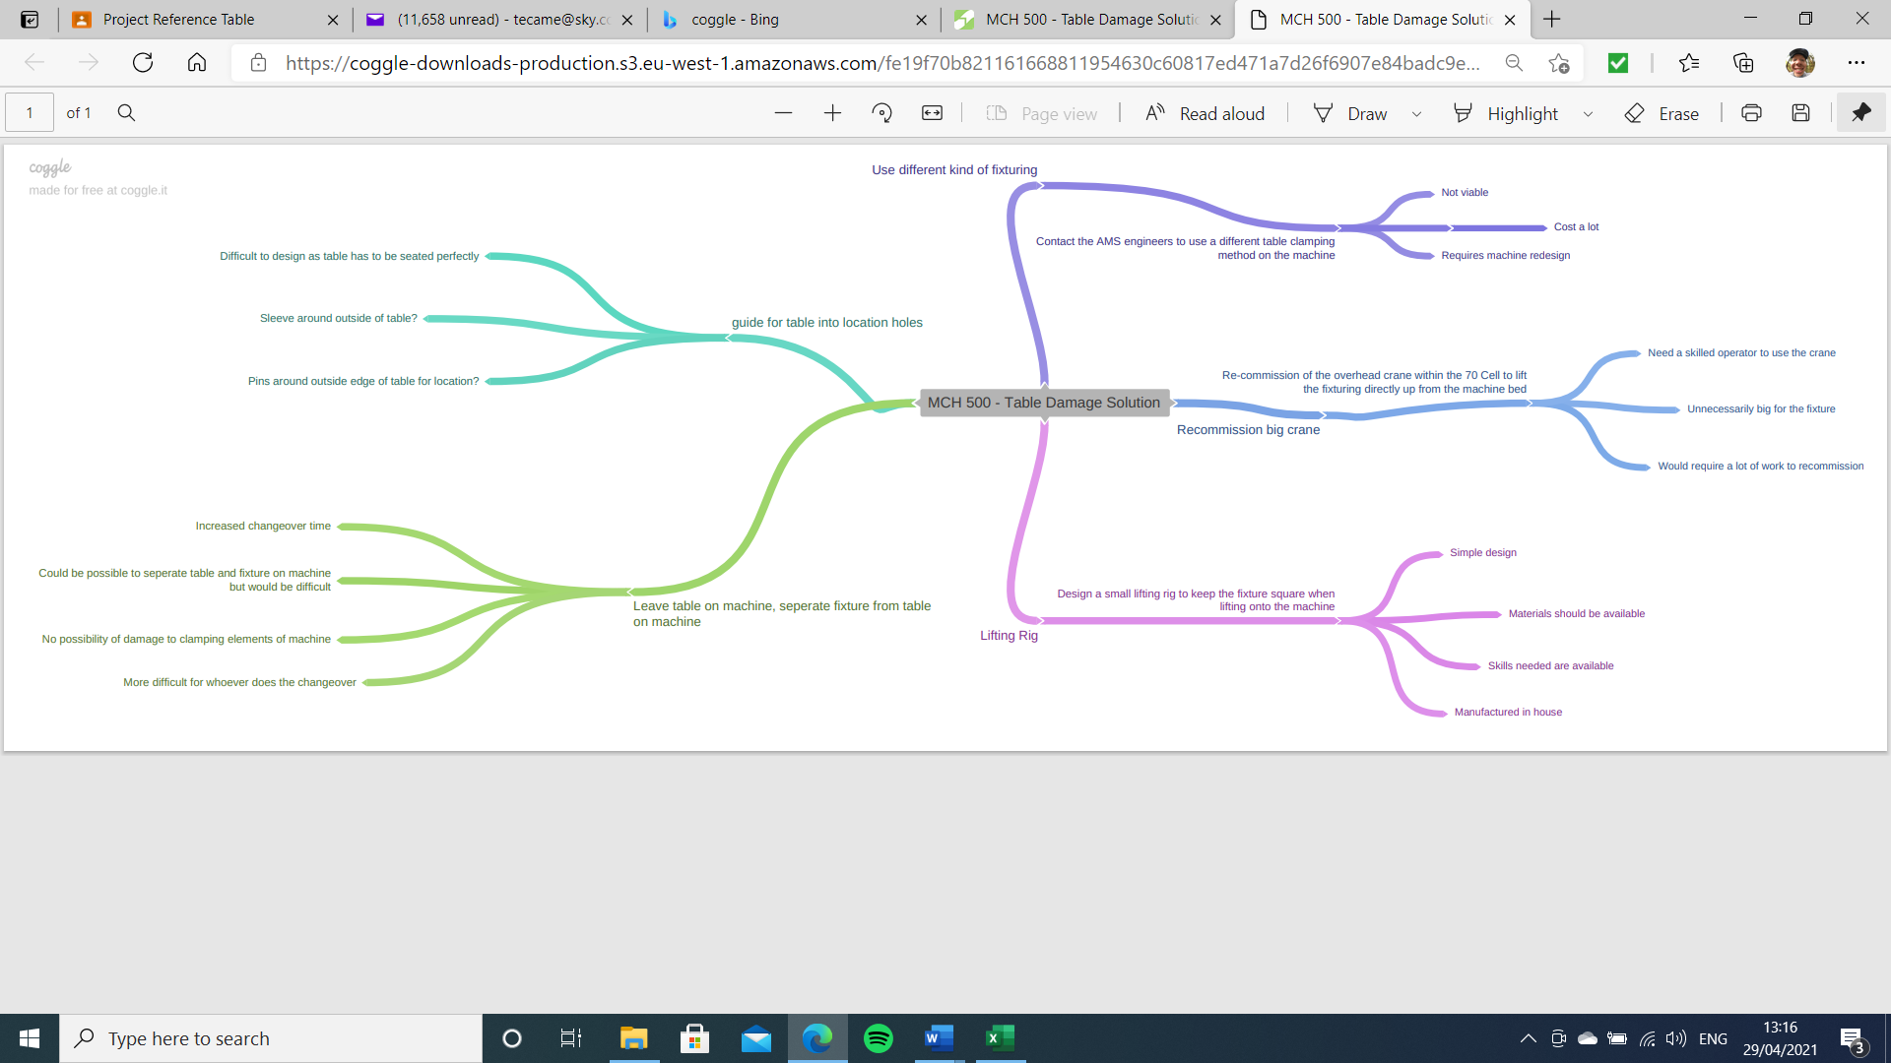
Figure 3 - MCH500 - Table Damage Solution Brainstorm

Gantt Chart – Purpose & Explanation
A gantt chart is an important tool for project management, where the main events in the project are shown in a graphical way. The tasks are also shown in a table along side the graphical illustrations where they are formed into categories such as:
- Task Title
- Task Owner
- Start Date
- Due Date
- Duration of Task
- % of Completion
As the project goes on it is important to reference the gantt chart to check whether the project is on track or whether it is falling behind the plan, if so then dates can be amended to suit.
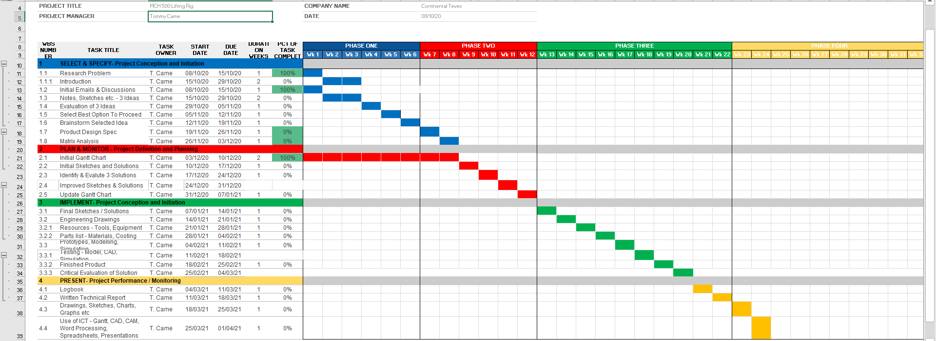
Figure 4 - Initial Gantt

Critical Path Analysis
Within project management, a critical path refers to longest possible route through a project, for example, these are the tasks that are longest and don’t have any ‘float’ meaning they must be completed on time or the completion of the project will be delayed. It is more important to consider the critical path tasks as opposed to the tasks with more float, to ensure the project deadline is met. Critical path analysis is the analysis of how much float there is within the tasks in your project before it becomes late and off schedule.
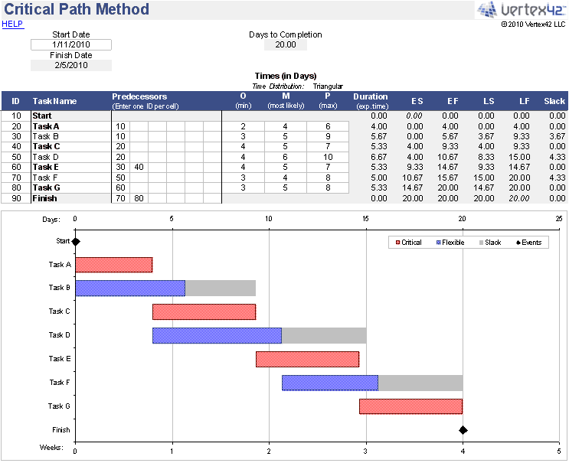

Figure 5 - Critical Path Analysis
The above Critical Path table is a good example of illustrating which tasks have float and which are critical, the tasks in blue have the float shown by the grey extended boxes whereas the tasks in red mare critical and must be completed on time.

Other Methods of Project Management

Scrum Board
A scrum board is a visual chart featuring different columns helping to show progress in the project, it also helps divide and allocate tasks to different team members. An example of a scrum board is as follows:
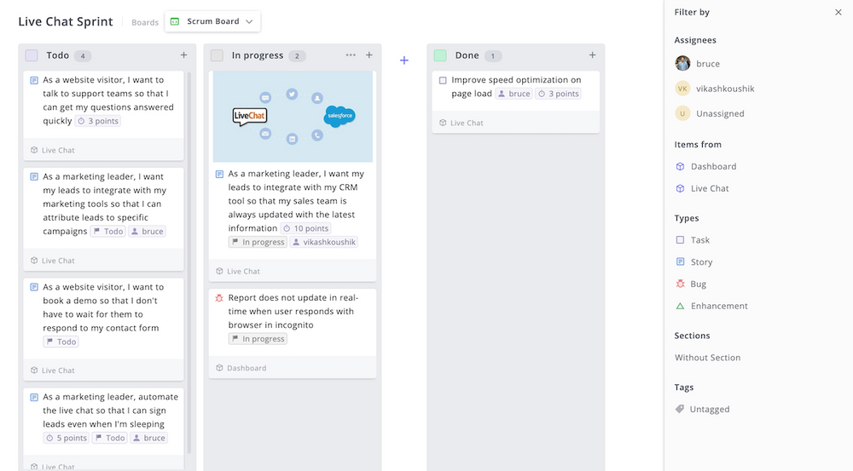
Figure 6 - Scrum Board
The above picture shows a scrum board with the respective columns: To do, In Progress and Done; although simple, this is a clear method of showing which tasks have been completed and which are still outstanding.

Project Management Timeline
A project management timeline is basically a simpler form of a Gantt Chart, which means it can be more easily presented to someone such as a stakeholder who doesn’t particularly need to know the intricate details of the project timeframe, just the key milestones; and this timeline makes it a lot easier to just present this information.
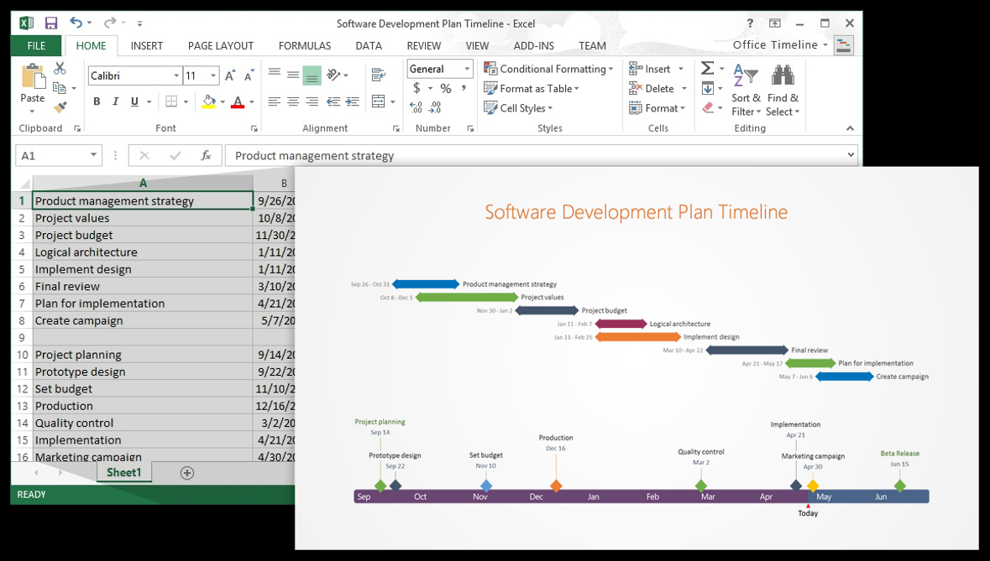
Figure 7 - Project Management Timeline
Above is an example of a project management timeline, showing a clear and concise layout of key events within the project timeline extracted from the main gantt chart for illustrative purposes.

Kanban Board
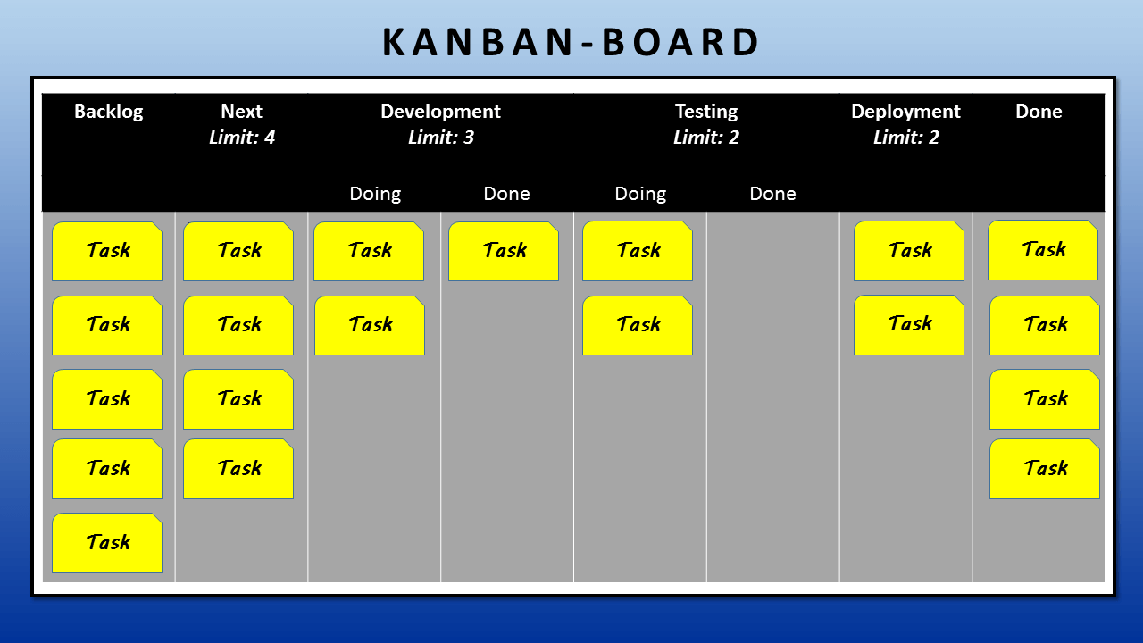
A Kanban Board tends to be more suited to a project with a lot of flexibility, similar to a Scrum board the Kanban has different columns to illustrate the tasks and the progress on them, but dissimilarly the Kanban is more for a longer timeframe whereas the Scrum is for around two weeks so must be constantly updated.
Figure 8 - Kanban Board

Evaluation of Potential Planning Techniques
After researching the different planning techniques that could possibly be used within a project and the various methods these planning techniques can be used, I believe that the use of the Gantt chart planning technique is most beneficial to an engineering project, if being used by the project manager; the project timeline is also a useful presentation aid for the project manager stemmed from the Gantt chart.
Using a Gantt chart as a planning technique is beneficial as it is extremely detailed with the project scope and deadlines to be met. In comparison with another technique such as a scrum board where there are just columns with task progress markers rather than an actual deadline set. Being so detailed is also imperative to ensuring that forms of data aren’t missed and everything that needs to be completed is completed fully as a task is easily broken down in to sub sections and delegated to specific team members.
A Gantt chart also has the function to create a critical path analysis, as mentioned earlier this is a major contributing factor to the success of a project and a very useful aid within project management as a whole but specifically within engineering as some things are time critical for example, machine downtime when needed for carrying out an improvement. On the other hand, a Kanban board does not possess this quality as it is a lot more simplistic

Critical Evaluation of Project Plan
To evaluate the project plan that was implemented during the beginning of the project, specific reference points must be in place to refer to. These points will generally come from the Gantt chart created at the beginning. In order to gauge the success of the project plan the points on the Gantt chart must be on task to be completed or been completed by the dates set.
So, in evaluation of my own set project plan I aimed to mainly complete a task on the Gantt xhart each week that the project was running, as I could not see a reason as to why this would not be possible, however, as with every project there were some draw backs which impacted the initial plan on the completion of some of the tasks within the project plan. These setbacks were the fault of the project manager, being myself, as opposed to the system being used to plan the project.
Although, as the project progressed, I was able to amend some of the tasks without affecting the critical path which is of course the most important part of the project plan and completing the project on time.
To improve going forward I would ensure that the planning method used ie the Gantt, is followed religiously and viewed daily if possible to ensure that tasks that need amending are amended before the project is drawing ever closer towards its completion date. Also, having another team member check the schedule to ensure that they agree it is possible if very important, if not the whole team.

Matrix Analysis - Solutions
Product Design Specification Criteria | Project Solution 1 – Lifting Rig | Project Solution 2 –  Machine Re-design | Project Solution 3 – Guides for Location
Ease of Manufacture | 3 | 1 | 1
Materials | 5 | 1 | 4
Cost | 4 | 1 | 3
Simplicity | 3 | 1 | 1
Maintenance | 5 | 3 | 3
Environmental Impact | 3 | 2 | 5
Sustainability | 5 | 4 | 4
Safety Issues | 4 | 2 | 3
Ergonomics | 4 | 2 | 3
Size | 3 | 2 | 5
Total | 39 | 19 | 34
Rank | 1st | 3rd | 2nd

Evaluation of Project Solutions
The matrix analysis for the solution best suited to the project shows that project solution 1 is the best solution to carry forward within the next few months, however some aspects of the analysis may be deemed more important than other, as explained previously. In this matrix analysis table we see that the first element which is ‘ease of manufacture’ is relatively low scoring across the board, so even though solution 1 is the leading solution, it is still not ideal to manufacture and will take some doing; however the next element which is ‘materials’ is significantly higher scoring for solution 1 as the materials should be readily available within the plant meaning the material cost and sourcing is a lot easier in comparison to solution 2 for example, the materials would firstly have to be decided upon after the engineers consultation and then precision machined, imported etc etc. meaning this is not a good score.

Other Evaluation Methods
As well as the matrix analysis table used within the project, there are other methods of coming to the same conclusion, however it is based upon the preference of the project manager which method is used for the application.
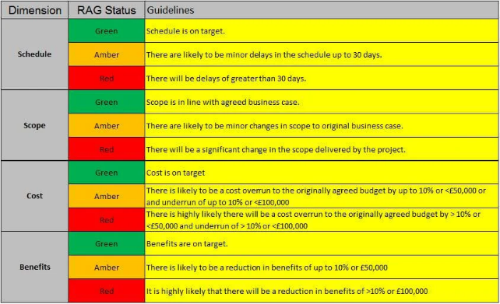
RAG Analysis can be used in a similar way to the matrix analysis table shown in the project which has the Red, Amber and Green colours already incorporated for illustrative purposes, however RAG relies solely on the colour scheme to indicate the best scores, this is more simplistic than the other methods and only leaves room for 3 score ratings, whereas other methods can have as many as required.

Figure 9 - RAG Analysis

https://www.pmmajik.com/wp-content/uploads/2015/02/pmo_rag_reporting_level_guide.jpg
A Pugh Matrix can also be used to come to a decision based upon a scoring system, however the scoring system of a Pugh Matrix is different to that of a Matrix Analysis table; the Pugh Matrix will have a scoring system for each category of -1, 0, +1 and then after each category has been filled in the highest total will be the best solution; once again however, the decisions within the scoring of the Pugh Matrix will be based entirely on what the project manager or teams experience tells them the score should be, there is no hard, defining way of choosing a score.
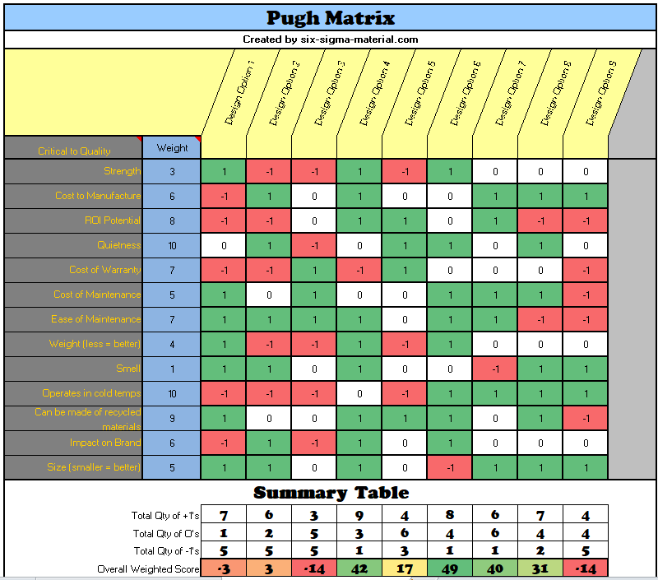
Figure 10 - Pugh Matrix

https://www.six-sigma-material.com/images/Pugh_Matrix_Example.png.pagespeed.ce.7pRjOCf0W9.png

Product / Component Ideas – 1,2 and 3 with Evaluations

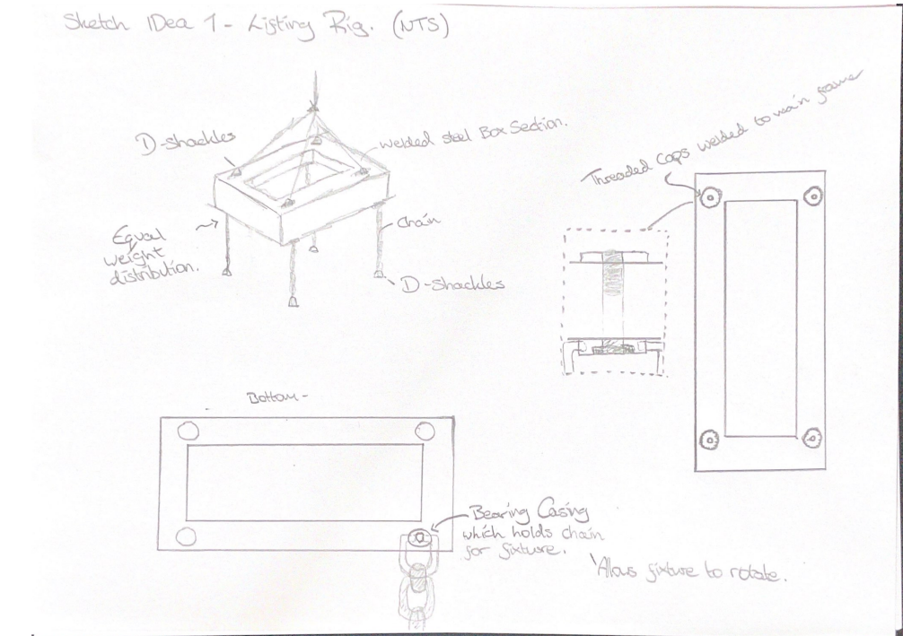
Lifting Rig
Figure 11 - Lifting Rig Sketch

Re-design of Machine – Evaluation
This idea stemmed from the use of other machinery around the plant and how certain machines have been adapted over time to suit the operations required of them. The hydraulic table clamping element of this particular machine is not only for the table clamping but also for fixture clamping, which in fact isn’t used at all, as the components are clamped manually in the fixture. So if there were to be an alternate way of clamping the table to the machine without the possibility of damaging elements of the machine (as we have got with a lot of other machines) then it would be beneficial to look in to; however, with an ever changing and improving industry such as the automotive industry, it would be incredibly poorly thought out to essentially downgrade a machine capable of move than is CURRENTLY required of it. Another point to consider is the cost associated with this solution as we are not able to alter the machine on site, it would need specialist engineering involvement from the manufacturers.

Guides for Location – Evaluation
The idea of guides for the fixture to locate to the table is a good idea as it would mean the holes would be located correctly every time to the machine bed hydraulic clamping elements. The machine bed would have to be drilled & tapped in exact positions and every fixture would have to be drilled to a suitable size which would be a diameter slightly larger than the proposed guide diameter. Although it would be a good idea to do it, it would also mean any future fixtures would need to be modified in this way, which is not suitable to do.

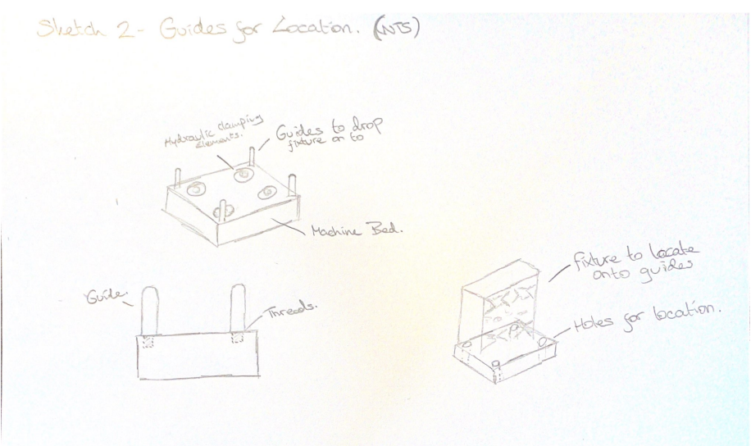
Figure 12 - Guide Pin Sketch

Evaluation of Final Design – Lifting Rig
With the help of the matrix analysis tables previously used, it was possible to come to a conclusion which project solution would be most viable to continue with; this was the lifting rig design solution for the damage to the hydraulic clamping elements of the MCH500 fixture table. Although there were two other solutions it was decided based upon different factors that the lifting rig would be most beneficial to the factory.
As every fixture is split from the base plate off the machine the easiest solution to allow the lifting rig to be usable on all fixtures is the modify the base plate by drilling and tapping holes for four brackets which the lifting rig can be attached to, this will be carried out however it is not incorporated into my final design.
The final product produced from the design spec should be sustainable, so it must be able to cope with the stresses and strains that will be put upon it on a regular basis and also it must be simple to repair if a smaller component were to fail, which I believe is the case with this particular design solution.
Environmental impact is good as all materials can be recycled after the products working life which is a positive for everyone involved.
Conformity with the correct regulations within this project design is vital to the success of the project and whether it would be able to be used within the workplace safely. The design will comply with LOLER regulations to adhere to all lifting standards. Further components will be designed to ISO 53.020.30 which includes the accessories for the rig such are the shackles, chains and eye bolts.

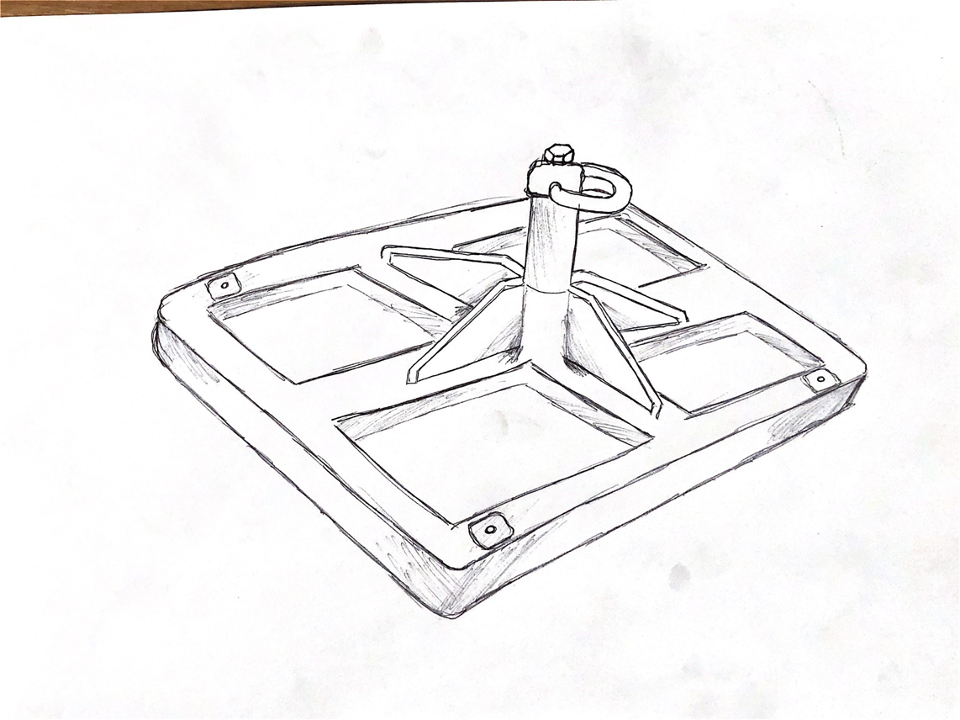
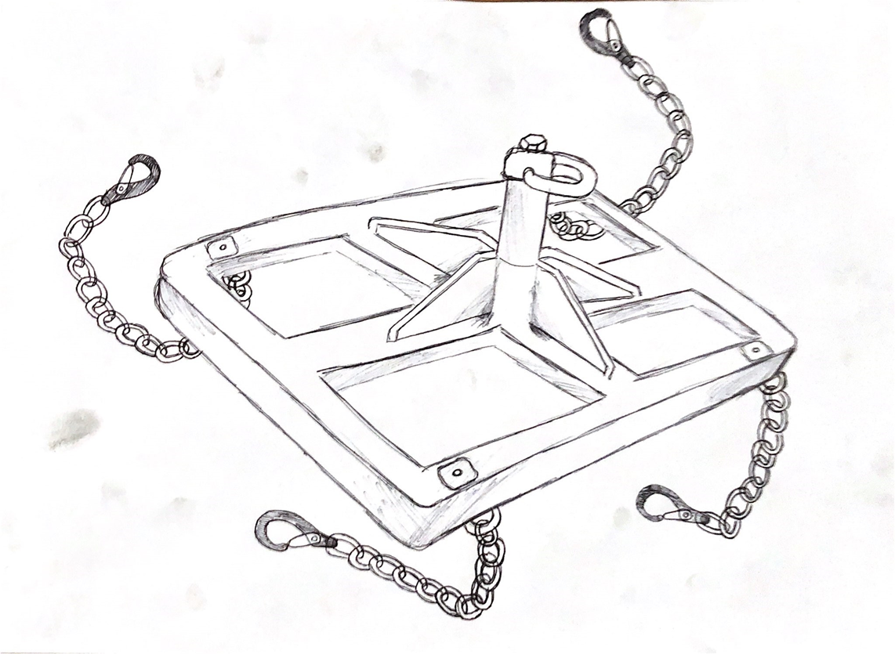
Improved Designs – 3D Drawings / Prototypes
Figure 13 - Improved Lifting Rig Sketch

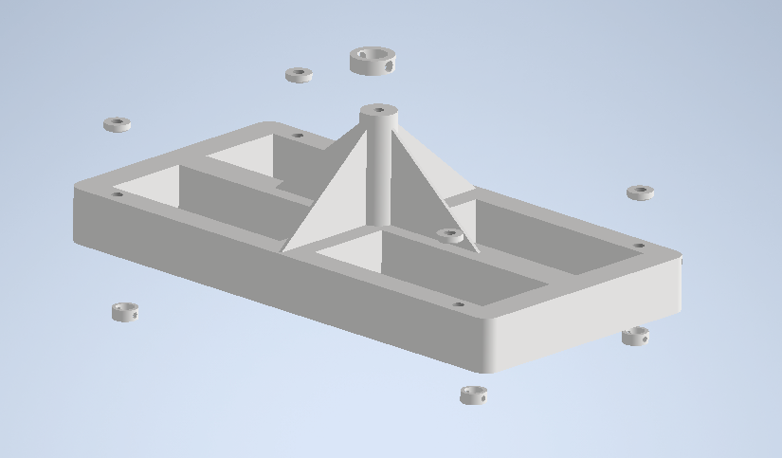
Above are improved 3D sketches of the final design which is to be taken forward during the duration of the project scope, also included are computer modelled designs of the product which have been produced on AutoDesk Inventor. The designs above are just improved sketches and are therefore not dimensioned, this will be done on the CAD software as the design progresses.
Figure 14 - Assembly Exploded
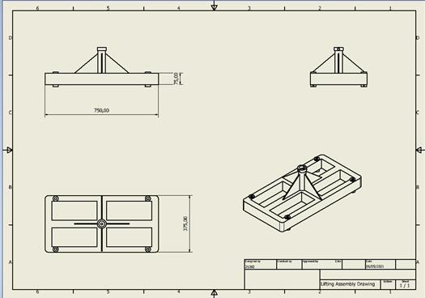

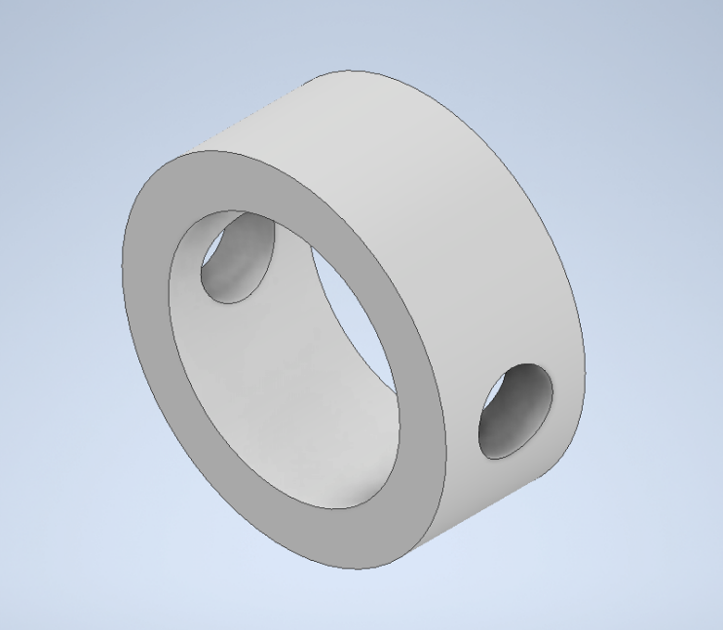

Figure 15 - Small Casing

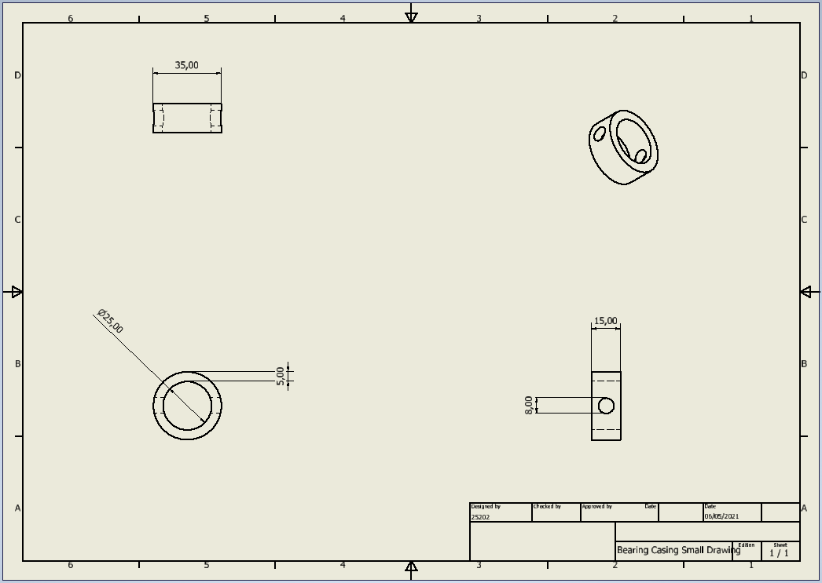
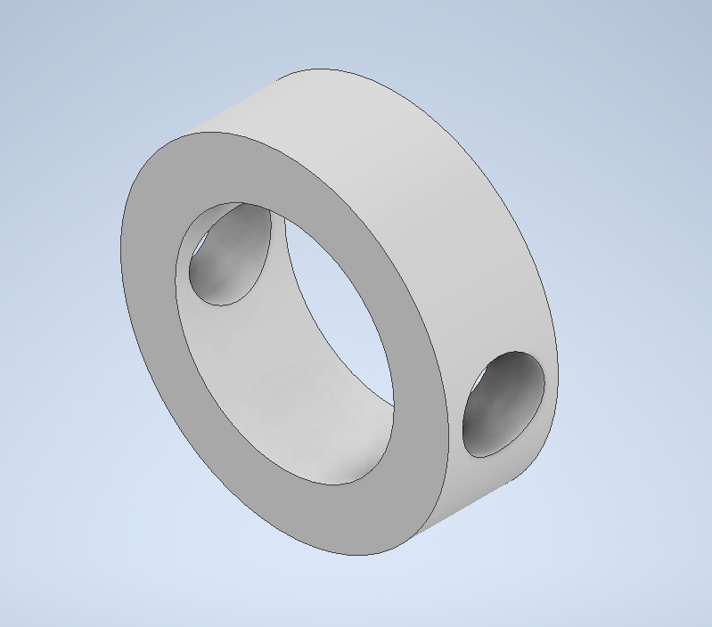
Figure 16 - Large Casing

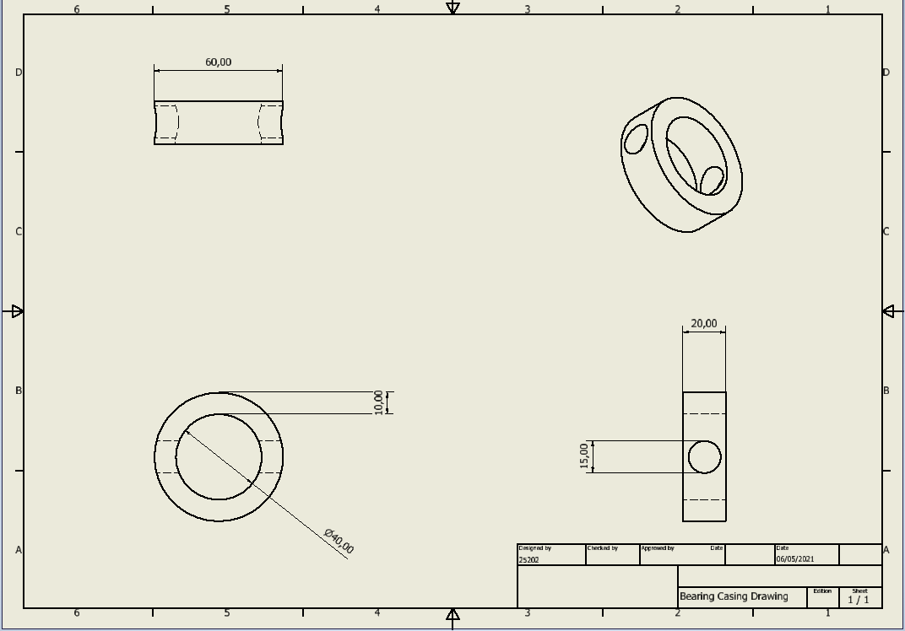

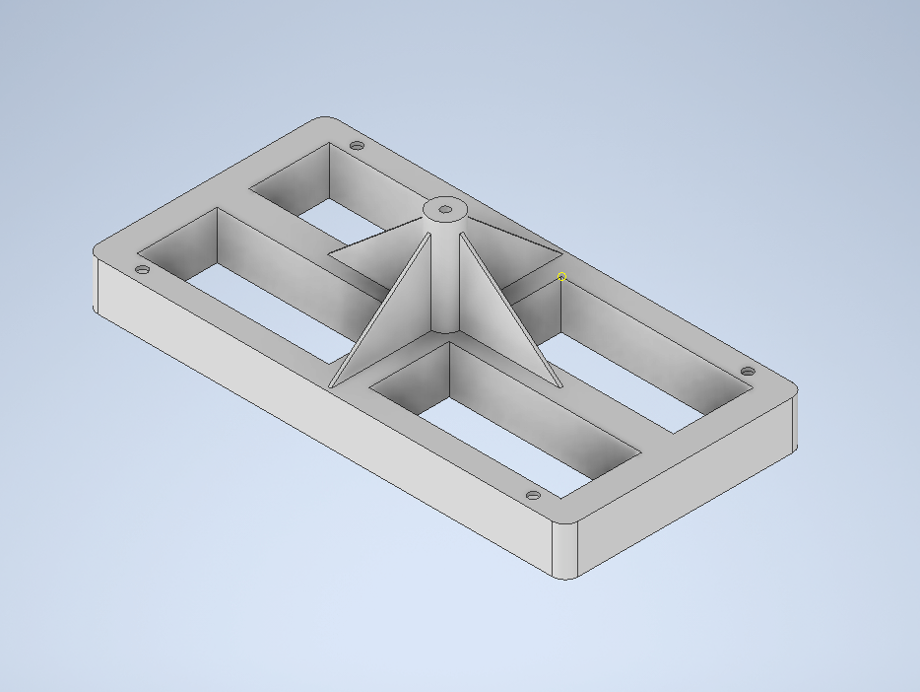
Figure 17 - Main Body

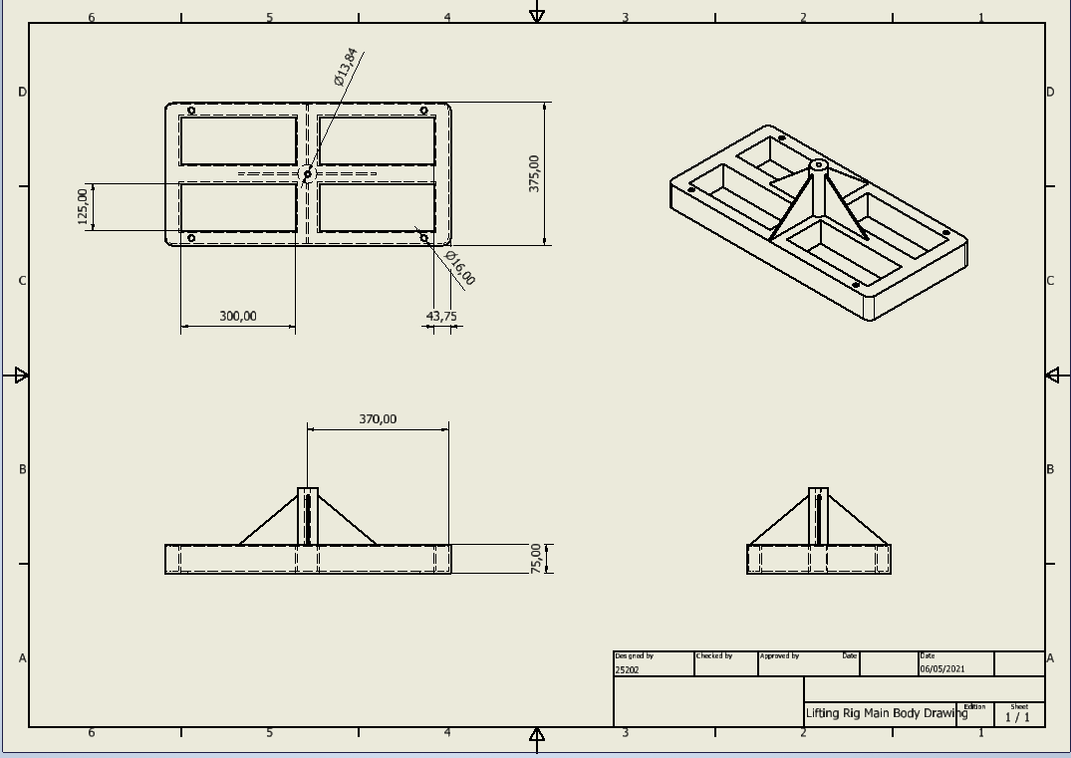

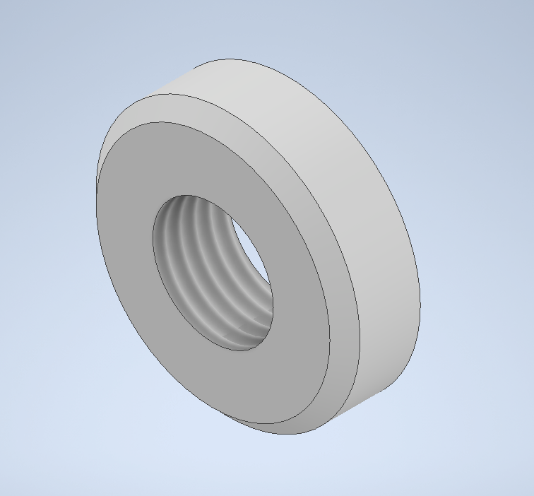
Figure 18 - Threaded Cap

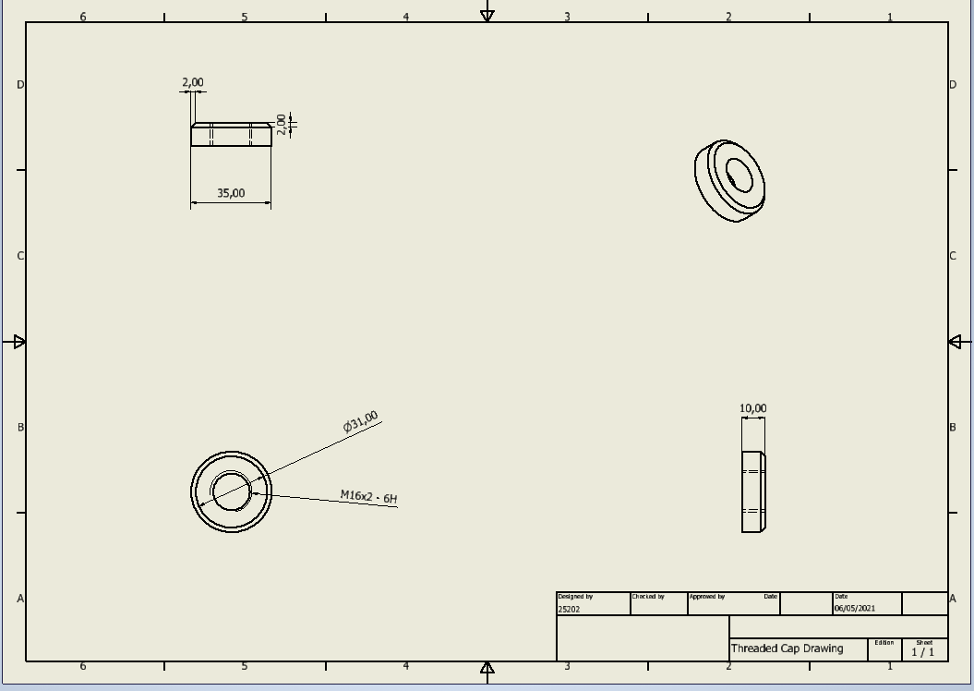

Final Gantt Chart
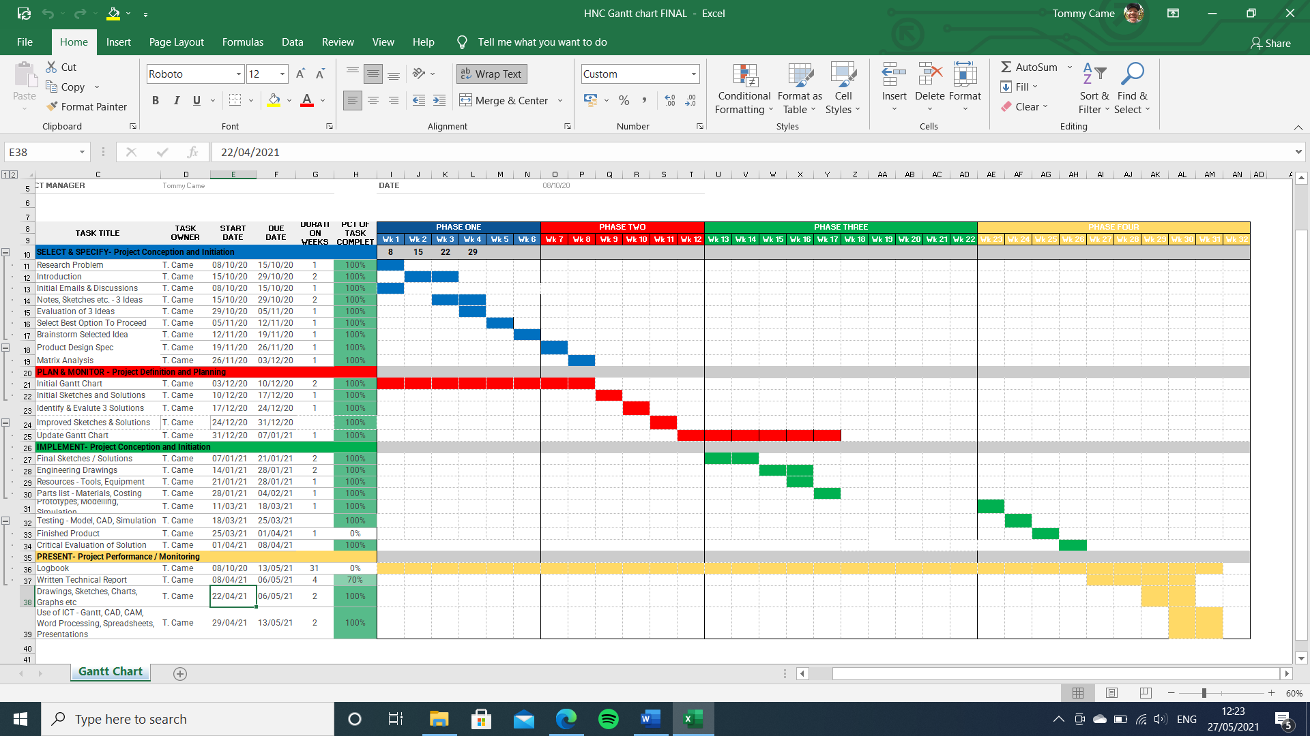
Figure 19 - Final Gantt Chart

Section 3 – Analysis

Assessment of Design Solution for Safety & Risk Management Issues – Potential Limitations
As mentioned earlier in the technical report conformity with the correct regulations within this project design is vital to the success of the project and whether it would be able to be used within the workplace safely. The design will comply with LOLER regulations to adhere to all lifting standards. Further components will be designed to ISO 53.020.30 which includes the accessories for the rig such are the shackles, chains and eye bolts. Fundamentally, the designer has prioritised the regulations and requirements for producing such a component and as forementioned in the PDS, the correct regulations have been considered.

Evaluation of the Effectiveness of Industry Standard Technical Design Report
Technical design reports are effective methods of showing how engineers carry out the design process and come to a final constructed design. The design methodology usually stems from a problem that is faced within industry which is a hinderance to the way in which the plant is run, impacting maintenance, production times or capability. When the problem is established, it is researched further into causes and possible solutions, analysing methods of solving the problem. The next step usually comes with generating 3D models, drawings and finalising the testing processes involved with the design and manufacture of the improvement, (if the project scope is a physical improvement.) The established effectiveness of the technical design report is entirely based on whether the project scope has been achieved to the standard that is required and whether the report explains everything clearly and concisely to the relevant people, such as stakeholders and supervisors.
I believe that the project did follow the template for a good technical report to be produced at the end, and could be presented to engineers in a professional manner. The targets that were set were accurately met through the duration of the project and I believe the project plan and outcomes were clearly illustrated throughout the report. Another key factor of the technical report is the feasibility study, this explains exactly why the project should go ahead, highlighting key advantages and disadvantages.
The initial sketches pose as a great tool to show exactly what is required and what can be designed to improve the current process that the project is based upon. These sketches are then improved by the addition of CAD software to create 3D models and accurate engineering drawings for the engineers to be presented with, showing clearly and accurately what is being proposed and whether it is possible to do. The 3D CAD models and digital engineering drawings also allow ease of data transfer between departments so that everybody involved with the project can easily access this data.
Finally, the assessment and analysis of all the data that has been collected and provided within the project report, the analysis shows the critical safety features, time of implementation, regulations to be followed and the maintainability of the project.
As a conclusion I am confident that the technical design report for this project contains the relevant information to design and manufacture the product required for the issue faced within the plant. The information supports the decisions made within the project which is a benefit when presenting the findings.

Analysis
During the course of the project, I found initially that there was a problem with a specific machine being damaged when the hydraulic fixture was being lifted onto the table, which was causing unnecessary maintenance costs.
Firstly, Section 1 was a big section of the technical project report, the section highlighted the potential ideas for improvement around the plant which were identified by communicating with various staff. Each potential idea was laden with detailed descriptions of the problems, root cause analysis, solution ideas and an idea of the goals to stem from the project if taken forward. I believe this part of the project was undertaken well, clearly showing the problems that were present and gave also a good insight into the brainstorming process for potential solutions. The feasibility study is extremely important in this section as it highlights why the project should be taken ahead and can be easily presented to the stakeholders before the project is developed any further; if there were to be any disagreements from the engineering or management teams, it would be brought up now. The feasibility study proved effective as it was detailed enough to fulfil the questions of the potential stakeholders within the project who were happy for the continuation. I then moved onto the design brief and PDS, these sections are very important as they are what needs to be referred to throughout the whole design and manufacture process, which I believe I successfully did. The Gantt chart played a significant role in making sure the project stayed on track but also accounting for anything that did fall slightly behind, making it possible to visually see where the project timescale was heading.
The second section of the project was the development stage of the project which firstly consisted of matrix analysis tables and the discussion of other evaluation methods and techniques. The matrix analysis proved useful in the decision making regarding the potential solutions for the final decided problem to tackle; which then meant it was easier to continue onto the design and improvement stages in the section which consisted of actually designing the components for the finished article.
Section 3 highlighted the importance of different aspects of the project process, including the PDS, designing for safety and the whole technical report; the section was successful as I believe I provided a good outlook as to the importance of understanding why these requirements are in place when designing and manufacturing a component or product.
Section 4 focuses on the communication techniques employed during the presentation of the project findings with reference to the initial PDS. It also reflects on whether the these communication techniques were effective when presenting, along with critically evaluating the project findings.

Section 4- Communication/Evaluation

Communication Methods to Present Project findings
During the project duration it was important to demonstrate different types of communication methods and that I was able to use these methods effectively. The demonstration of different formats and methods suitable for different levels of understanding was important to understand when developing the project further. Primarily the communication when presenting my project findings were PowerPoint and written explanations, however, other forms of communication methods include:
- Gantt Charts
- Engineering Drawings
- Sketches
- 3D Models
- Matrix Analysis Tables

Reflect on effectiveness of the Communication Strategy When Presenting Findings
I believe that using PowerPoint to communicate my project findings proved successful because I was able to portray the information that I believed was suitable for the audience. The presentation itself I aimed to keep minimal, with little writing, summing up the different aspects of the project quickly and understandably. One of the main benefits of using this communication method is the adaptability when using the software, allowing images and designs to be added easily, making for a more effective presentation when aiming to engage the listener.

Presentation Feedback
Based upon the feedback I received from my presentation I believe I was effective at presenting the information clearly and concisely, however, there were definitely improvements that could be made. I feel that when presenting the PowerPoint that I had previously prepared I was lacking in confidence when delivering the presentation when it always portrayed to the audience and will not sell a potential project idea or give the stakeholder a confidence in the project findings. I also failed to introduce myself and my company properly which is a vital part of engaging the listener from the very start. Another point I could have improved on is the use of media within the presentation itself; although I used static images and designs, I did not include any presentation aids which were readily available to me if I were to be more capable on the 3D modelling software. I could have also maybe included some videos in the presentation and more data to back up my findings. Positively though, I feel as though the methods I did use illustrated well what the project was about and I will definitely work with the criticisms going forward.

Critical Evaluations of Project Outcomes & Planning
The goal of this project was to not only to plan and design a process improvement for the plant and the company, it was to improve my own project management skills. The initial problem which was brought to my attention a few years ago when I was carrying out the job myself, was waiting for the opportunity to come into a project such as this one.
Now at this closing stage of the project report it is possible to analyse and reflect on whether the problem has been improved to increase plant maintainability by reducing costs to the maintenance department as a whole. In terms of the design idea, I strongly believe that this has a good potential to dramatically decrease the maintenance downtime due to damaged hydraulic clamping elements, time will only tell as we analyse the downtime for the machine in future weeks and months and continue to collect the data relating to this problem; only then will we see if there has been an improvement.
As for the maintainability part of the project, I believe the idea to try to reduce the maintenance costs also covers the maintainability of the plant, as without these kinds of ideas it would not be possible to run a maintainable business.
As mentioned earlier, another key project outcome was to improve my own project management skills, I think this has definitely been achieved as this is the first, proper project I have ever had to do. My time managements skills, although still maybe slightly underdeveloped, have definitely improved, with the use of Gantt charts and other planning and time management methods helping to stick to project milestones.

Recommended Improvements
- More data collection methods
- Improved CAD drawings
- Manage time more professionally
- Presentation of findings could be improved
- Make sure to be allocated more time to focus on project

Justification of Improvements based on Feedback
The feedback I received on my project based on my presentation methods was that I need to make sure everything used as an accessory to my finished product is industry standard, so tools, eyebolts etc.
Everything used in conjunction with the product will be to the industry standard and will not specialist tooling, the product itself is a specialist design for the machine but could actually be used on similar machines although not specifically designed to, this is definitely something else that can b looked into in the future after the original designed use is tried and tested.

Self-Evaluation of Performance Throughout Project – Possible Improvements
In order to improve in the next project that I undertake it is imperative that I critically evaluate my performance throughout the duration of the project, good and bad points.
My time management on the whole was good, I think that I stuck mainly to the Gantt chart that I wanted to at the beginning of the project, however there were unexpected problems with this, such as being taken off the project to work on a more important job within the plant, this was not ideal but with an altered Gantt chart which accounted for this time off I feel that the project was able to stay on track. Other tasks sometimes ran a week or two over the due date but mainly these tasks were not on the critical path so the project could continue.
My CAD skills were definitely developed within the project, having started with little to no CAD experience, it was not only enjoyable to learn a new skill but was greatly beneficial when portraying the product that I had spent the time designing. There is still definitely a lot to be improved but I feel as though I now have a good knowledge of how to use basic CAD software.
My report writing and project management skills in general have definitely drastically improved as I have only ever done one previous project but it was awful so I struggle to even class it as a project. I feel as though I have greatly benefitted from carrying out this project and that I would be confident working alongside an engineer to develop my project management skills further and have a basic understanding of the methods and tools used.
My decision-making skills have developed through the use of tools such as matrix analysis and RAG analysis, these tools will definitely be useful in future projects to come and have expanded my mind to researching other kinds of tools that could be beneficial to future projects.

List of Figures

Figure 3 - MCH500 - Table Damage Solution Brainstorm
Figure 4 – Initial Gantt
Figure 5 – Critical Path Analysis
Figure 6 – Scrum Board
Figure 7 – Project Management Timeline
Figure 8 – Kanban Board
Figure 9 – RAG Analysis
Figure 10 – Pugh Matrix
Figure 11 – Lifting Rig Sketch
Figure 12 – Guide Pin Sketch
Figure 13 – Improved Lifting Rig Sketches
Figure 14 – Assembly Exploded
Figure 15 – Small Casing
Figure 16 – Large Casing
Figure 17 – Main Body
Figure 18 – Threaded Cap
Figure 19 – Final Gantt Chart

