UNIVERSITY OF WALES TRINITY SAINT DAVID
LONDON

BA BUSINESS MANAGEMENT

MODULE : PROJECT MANAGEMENT

TUTOR NAME: KENNY TANG

ASSINGMENT (1):PROJECT MANAGEMENT (BANK MANAGEMENT SYSTEM)

STUDENT ID: 1704795

STUDENT NAME: BRIJESHKUMAR PATEL

DATE OF SUBMISSION: 16 January 2019

WORD COUNT: 2220

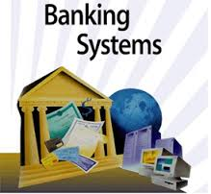

INDEX
SR NO | CONTENT | PAGE NO
1 | ABSTRACT | 4
2 | INTRODUCTION OF PROJECT | 5
3 | PROJECT PLANNING(PMP) | 6
4 | GANTT CHART | 19
5 | SNAPSORT | 20
6 | CONCLUSION | 25
7 | REFERENCES | 26

ABSTRACT
The bank management system is an application which manages people’s account in bank. In this project I tried to cover basic functionality of bank. The project provides flexibility so the customers can processes easily and quickly. Main thing cover in this project is, it overcomes the manual system so the people don’t need to go bank and perform transaction. He or she can perform all the transaction at home.
The system designed by MYSQL, PHP and HTML. The system is very user-friendly and attractive. It divided in to two systems, first is interactive system: it deals with system interaction with the admin and users. Second is content management system: it deals with data entry, validation confirm and updating.
Thus, the features of system will save transaction time and increase the efficiency of system.

INTRODUCTION OF PROJECT
(BANK ACCOUNT MANAGEMENT SYSTEM)
Today’s world is a genius computer world and is growing day-by-day. All most people performing activities online through computer.
Bank is the place where customers feel the sense of safety for their priority. The main activities perform by customer are deposit and withdraw money. Now a day’s managing the activities related to bank is very difficult. So the software can reduce the work (Archibald, 1967).
This project provides some facility for customer. So, the customers don’t need to going to bank and perform transaction. He or she can perform all the transaction online at home through their computer.
Bank account management system is a one type of application for maintains a person’s account in a bank. This site enable the customer’s to perform some of basic functionality related to bank at home or office through PC or laptop.
So basically, the customer can create an account and also deposit/withdraw cash from his account. And also gather the detail of all present account. All truncations are carried out online by transferring from accounts in the same bank or international bank (Crawford, 2014).
We can say that the software can reduce the drawback of manual system.

PROJECT PLANNING (Main concepts of PMP)

- Schedule:

This phase contain basic activities perform by project and also the resources need for performing the task. And create a critical path for between the task and the other task which depend on it.

Activities perform by project (application):

- Create account: Customers can create an account in bank through internet at home.

- Perform transactions: People can deposit money in account as well as withdraw money from account through this site.

- View detail: If customer wants to check the balance of his account then, the site provides all the details of their account.

- Display: it shows transaction report, statistical summary of account type and interest information.

- Bill payment: you can pay a bill from this site and also if you make a regular payment every month, then you can set up an automatic withdraw from your account.

- Order cheques: customer can order the cheques from BAMS website.

- View your visa* account: you can do your credit card payments online.

- Scope:
This step set the boundaries of projects and also the objectives, goals, and purpose are mention here.

- Goal: This project is to maintaining the whole banking process related to administration accounts, customer’s accounts.

- Customer satisfaction: The main motive is privacy. Client performs all operations without loosing of his privacy.

- Saving time: Clients doesn’t need to go to the bank for banking activities.

- Protecting customer: It provides comfort and safety to client’s account, money.

- Requirements:

This phase describe all the requirements of project.

Hardware requirement:

- Processor
- Main memory(RAM)
- Cache memory
- Monitor
- Keyboard
- Mouse
- Hard disk
Software requirement:
- Front End language: PHP
- Back End language: MYSQL
- Additional tools
- Operating system: windows 7,8,9,10

- Deliverables:

This section contains a report, a document, a software product, a server upgrade or any other building block of an overall project that is intended to deliver to the customer.

Design:

- Data flow diagram:

- Creating account

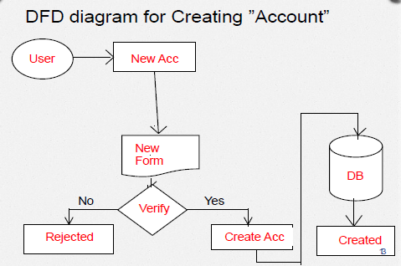

- Deposit/withdraw account

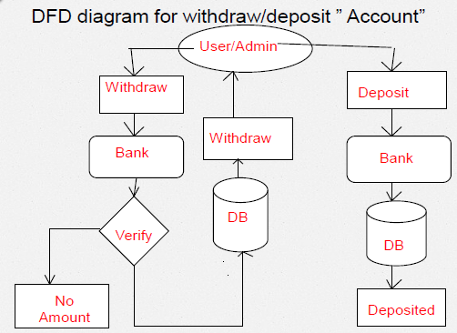

- Deleting account

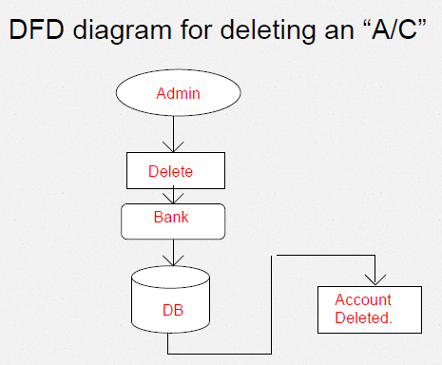

- Use case diagram:

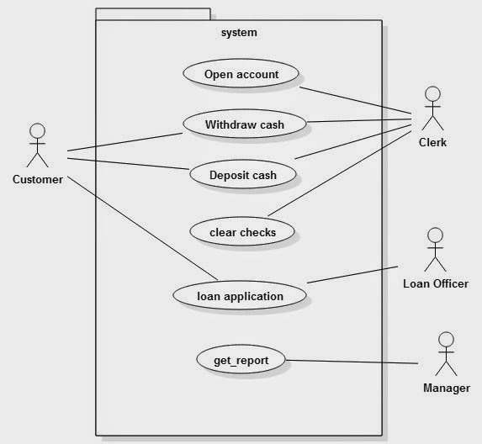

- Cost:

The project cost or budget is most important part of project which is divided in to tree types: capital item, expense item, labor.

Factor | Cost
Set up | £ 0
Design & building | £ 1(template)
Content creation | £ 0
Maintenance | £ 50
Internet usage | £ 30
Documentation | £5
Total | £ 86

Capital items: capital items are man-made goods use to produce services which is include resources, tools, machinery.

Expense items: Expense goods are a purchased service.

Labor: All the employees, project staffs are consider as a labor of project.

In this phase, project cost is estimated by calculating the costs which allocated to each resource.

- Time

This phase describe how much time project was going to take.

The basic steps for estimate project time:
- The first step is to identified the deliverables associated with the project
- In the second step break down main project in to simple tasks such as project planning, design, testing.
- In next step estimate the time for completing each task.
- Now, add all the time together for calculating the time of main project.
For estimating project time some factors are consider:
- Project management time
- Customer turnaround time
- Debugging
- Holiday or day off that occur during the project
- Time to review work of subcontractor

- Human resources:

This step defines the project team organization, roles and responsibility requirement. This phase also develop a project training plan.

The main group include in project human resources:

- The project sponsor:
- Identifies the project manager
- Formally Accept the deliverable and product
- Approves the project management plan
- Approves or rejects changes
- Provide funding

- The function manager
- Monitor the activity of project team
- Participates in starting planning of project
- Manage project tasks

- The stakeholders
- Provide requirements
- Basically stakeholder is an individual, group or organization who are affected by activity or outcome of project

- Project manager
- It responsible for all the aspects of project
- Ultimately responsible for success or failure of project
- Monitor all the project team staffs
- Responsible for the time, cost, planning, requirement, etc.
- Ensuring the customer satisfaction
- Managing project risk
- Monitoring progress

- Risk:

This section contains all the process which related to manage risk.

No project is risk free. But the responsibility of project manager to make a project that prevents the risks. And prepare for the unknown and keep your project on track if problem is occurring (Fleming, 2016).

Risks associated with online banking:

- Security risk:
Online banking choose internet for the medium of transaction. Security risk arises on unauthorized access of account.
A breach of security will outcome in direct financial loss to the bank.

For example: Hackers could access all the customer information which is very confidential and also can spread virus.
This may result in loss of data, theft of customer information as well as cost of repairing this etc.

- Legal risk:
Legal risk comes from violation, rules, regulations, or when the obligations of parties to a transaction are not well established.
For enhancing the client’s service bank link their internet site with other sites. This may cause legal risk. Hacker may use the linked site to defraud a bank client (Harrison, 2017).

- Reputational risk:
Reputational risk is a risk come from customer’s negative opinion which may cause in funding and other customers.

The main reason behind that is project not working as per the expectations of customer.

- Operational risk:
Operational risk is a most common risk associated with the internet banking.

It contains inaccurate process of transaction, compromise in data integrity, data privacy, confidentiality and unauthorized access etc.

- Money laundering risk:
For internet banking, the method of payment will be performing online. So it may possible that the bank cause by risk.

To avoid this, banks need to design proper customer verification, screening technique, conduct periodic compliance review, etc.

- Traditional risk:
Traditional risks such as market risks, credit risks, and interest rate risks are also present in online banking system.

- Strategic risk:
This risk is associated with the new product or service.

It includes various issues related to the business plan, sufficient resources for plan and technologies.

For avoid this situation, the bank need to take a proper survey, consults expert, establish goal and monitor performance.

- Quality control:

In the project, every employees make not a simple product, actually they make “Quality product”.

Quality department, such as quality control and quality assurance are responsible for testing the sample outcome of project against specification.

Quality management insures that:
- Check the final product is as per the requirements.
- Work processes are performing efficiently and well documented.
- Monitor and verify that project deliverable meet with quality standards.
Quality control phase contain different types of testing:
- Unit testing:
In this testing the project are divided into small units such as functions, methods, individual program, procedure, etc.

Then, individual units are tested to check that each unit of performance as designed.

- Integration testing:
In this testing the individual units are combined as a group and test their performance to determine the faults in the interaction between integrated units.

- System testing:
In this testing the complete and integrated software is tested to validate the performance of software is as per the specification or not.

- Acceptance testing:
This testing is carried out for check the acceptability of system to determine whether it is acceptable for delivery.

Basically it is a formal testing with respect to user needs, requirements and business processes conducted to check whether or not the software satisfies the acceptance criteria.

10. Communication
This section describes the system of communication and project performance documentation that will be provided to the various stakeholders.

Communication plan enables you to communicate effectively on a project with your client, team, and other stakeholders.

It sets the clear view for how the information will be shared and who is responsible for the communication loop in project (Kerzner, 2013).

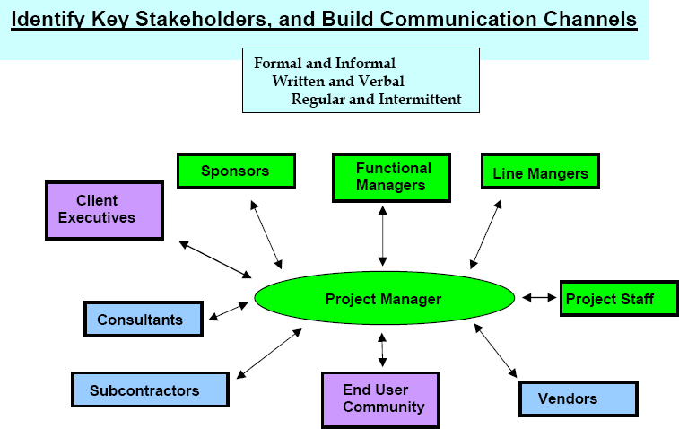

There are many method used for communication in project:

- Email:
In this method all the project staffs send or receive email related to project.

- Meetings:
In this method project team arrange a meeting for discussing the process of project.

- To-do lists:
In this method the list is prepared which is contains all the activities perform during project development.

- Surveys:
The regular surveys will be taken by project manager for checks the performance of other stakeholders.

- Discussion board:
In this method a board is use for discuss regular small task.

- Newsletters:
Newsletters are one type of document or report that contains all the activities in form of mail and send to all project members.

- Internet/intranet webpage:
Intranet webpage is project own website use by all project team.

GANTT CHART OF PROJECT

NO | TASK | DUR. | 2018-2019
 |  |  | NOV | DEC | JAN | FEB | MAR | APR
1 | Requirement  analysis | 2 Months
2 | Database  design | 3 Months
3 | Programming | 4 Months
4 | Testing/  presentation | 3 & half Months
5 | Documentation | 1 Months
6 | Handover/  Project closure | 3 Days

SNAPSHOTS

- Home page:

- Admin login page:

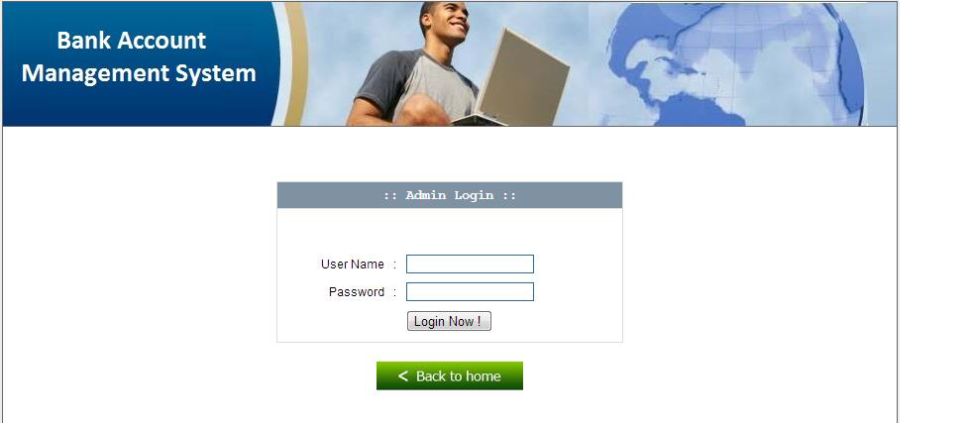
- Admin main page:

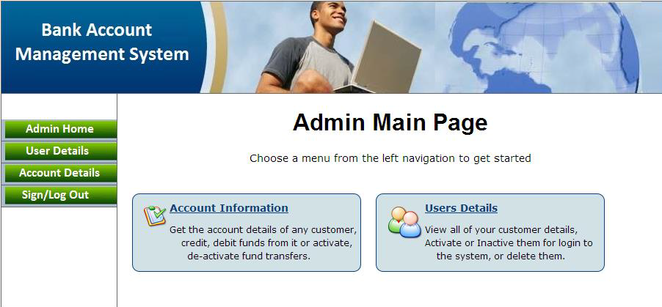

- User login page:

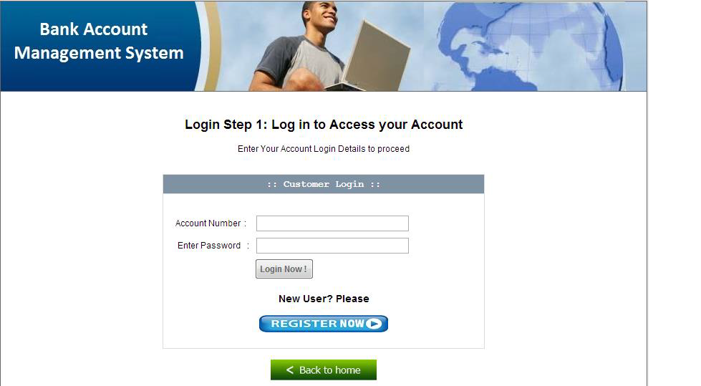

- Enter pin:

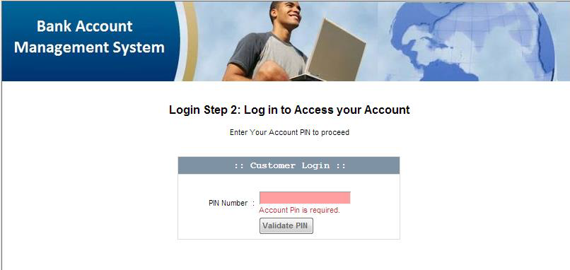

- Registration form:

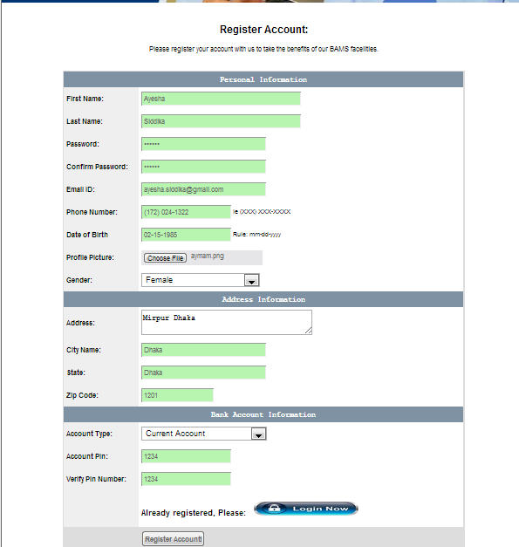
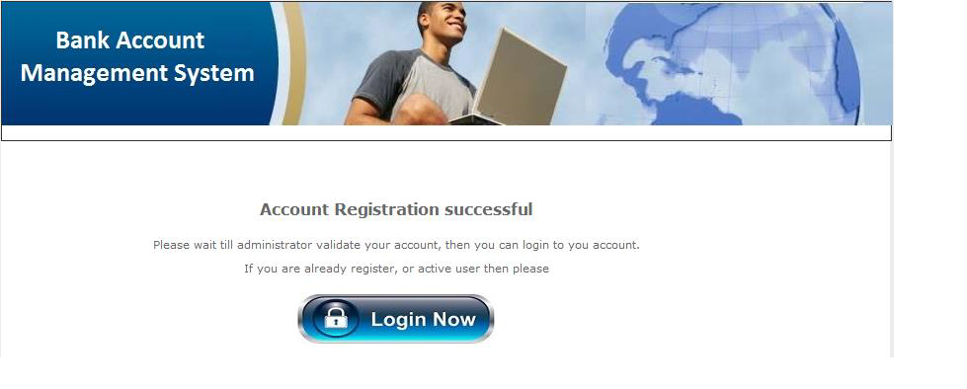

- Modified user’s email_id:

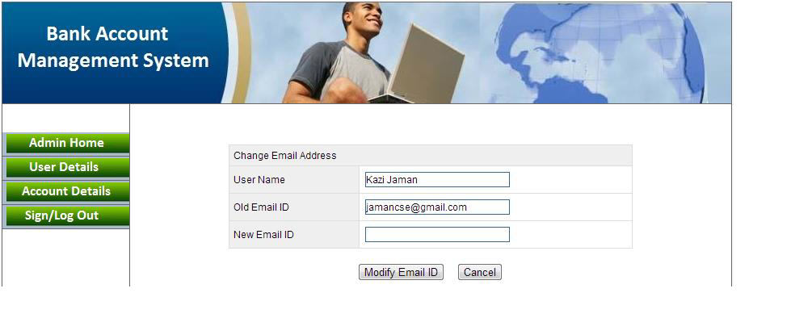

- Change account pin and password:

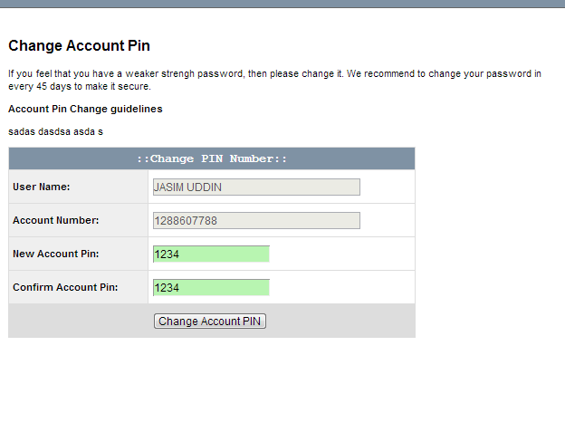

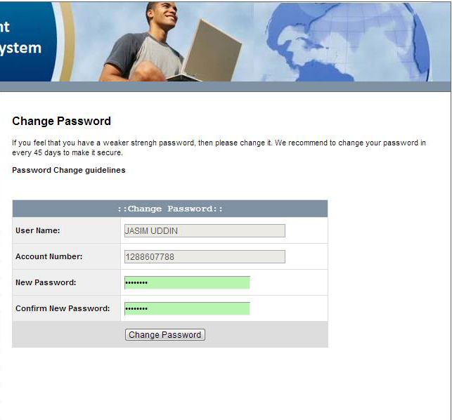

CONCLUSION

Banking has been with us for as long as people have been using money. Internet banking saves time of bank as well as those of customers.
This project is developed to fulfill the needs of a customer in a banking sector by embedding all the activities of transactions taking place in bank.
It is estimated that maximum numbers of internet bank account holders are youth and business man.
Online banking is innovative software that is grow fast become a necessity. It is a user friendly website so the clients are easily uses the site.
It can be concluded that, using this system the user can easily perform all the activities related to banking such as deposit, withdraw, payment, funds, view balance, etc. without going to bank or we can say that without wasting the time.

References
Archibald, R. D. L. V., 1967. Network based management systems. New York: Wiley.
Crawford, J., 2014. Project management maturity model. s.l.:Auerbach Publications.
Fleming, Q. a. K. J., 2016. Earned value project management. : Project management institute.
Harrison, f. a. L., 2017. Advanced project management:a structured approach. s.l.:Routledge.
institute, P. M., 2017. Project Management Body of Knowledge. six ed. s.l.:Project Management institute.
Kerzner, H., 2013. Project Management. 11 ed. s.l.:Wiley.
Marchewka, J., 2014. Information technology projrct management. s.l.:wiley.
Moder, J. J. C. R. P., 1970. Project management with CPM and PERT. 2nd ed. New york: Van Nonstand-Reindhold Company.
Walker, A., 2015. Project Management in Construction. s.l.:John Wiley & sons.

