University Land Holdings
This essay will research into the topic of the land given to the then, St. Davids College, Lampeter. Today it has merged with establishments in Carmarthen, Cardiff, Swansea and London to create The University of Wales Trinity Saint David.
With the use of the Roderic Bowen archive office on Lampeter campus, this essay aims to find out how the land was acquired and how the university was founded. Not only this, but why was Lampeter chosen as the location for St David’s College?
To complete my research, I had access to the Roderic Bowen Archives. This archive office holds all documents in regards to the ST David’s College, now UWTSD Lampeter. I requested all documents which have information about the land of the university. After looking through all documents, it was apparent that there was a mixture of documents which give basic information in reg to the university’s foundation. Furthermore, I researched books on the history of Lampeter, some of which were kept at the university library and other I found online using google books to search for key words relating to the university’s land holdings. Websites such as google maps and the National Library of Scotland proved useful when looking at the university’s land
This section will focus and explain what interesting discoveries were made whilst looking through archive documents and online methods.
The first source I found was copied from the report of the proceedings of the society for promoting Christian knowledge and church union in the diocese in the box D/1/1. This was a report of the committee proposed establishment for the education of young men intended for holy orders. The report included information about the location of the university. It provided interesting as I discovered that the university was originally planned to be established in a village north of Lampeter, called Llandewi Brefi. The land in this village was owned by the Bishop of St David, Thomas Burgess, the founder of the university. This was chosen as the initial site of the university as the village is rural, secluded and far away enough from populous society. These were positive factors for men as it meant that they wouldn’t be influenced. Furthermore, the site had a spacious church and was convenient for stone, water, fuel and “healthy stimulation”. These plans were prominent from the time Thomas Burgess was first a bishop in Wales up until he met John Harford in 1820.
The next document I came across was a copy of the Royal Charter for the university. The copy was a printed copy of the original charter, in an A4 booklet. The charter begins by stressing the need for a university in South Wales. King George the 4th gave land and freehold to the university, grants the university rectories and vicarages in the three surrounding counties, Carmarthenshire, Ceredigion and Pembrokeshire. The sale was dated August 1822. This sale was made between John Hardford, Abraham Grey Hardford Battersley and Alfred Harford, Lord Bishop Burgess, Herbert Evans and John Jones. The Harford family, who let the land, received £100.
Whilst looking through the library at Lampeter I came across a book by W.J. Lewis, called “A History of Lampeter”. This book provides information regarding Harford family, who sold land to establish the university. The book also shared reasons that the Harfords supported the university, including reasons such as it would improve the town, help the town grow and also civilise the vicinity. The land donated was a field where a medieval castle, locally known as Stephen’s Castle, sat.
These three sources form the Roderic Bowen library and archives give a basic understanding of how the land for the university, after much consideration, was chosen. It also states who gave the land, what was intended for the university. The next source demonstrates the need for the university to expand to meet its growing number of students in the late 20th century. A report from the working party on university expansion in box D/172 in the archives is a document which lists 15 reasons the university should expand and issues regarding the expansion of the university. Some of the reasons/issues surrounding expansion include:
- The need to expansion needs to be recognised
- To keep up with other rapidly expanding universities across the UK
- Students from England must want to attend Lampeter
- Academic standards must be preserved
- Wider subject choice must be available
- To have a campus that isn’t split over different locations
- Want to expand but do not want to build more accommodation
- Do not want to have accommodation = high prices – want private rent in town
- Want to be able to hold around 6,000 students

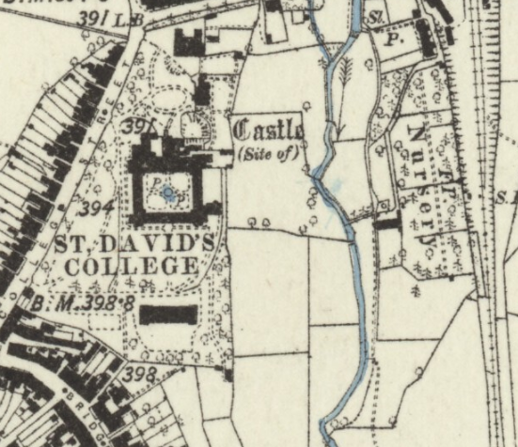
Cardiganshire XXXIV.SW (includes: Cellan; Lampeter; Lampeter Rural; Llanfair Clydogau; Pencarreg; Silian.)
Surveyed: 1887
Published: 1888

This map, taken from the National Library of Scotland, demonstrates the land owned by St David’s College, published in 1889. This demonstrates that it only owns the field between college street on the left and Stephen’s Castle on the right. The land has grown significantly until present day.
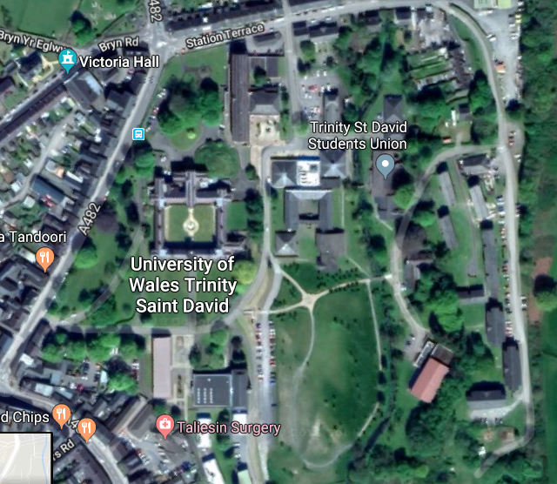
This map was taken from Google Maps. In comparison to the earliest map available, it is obvious to see that the university’s land has almost tripled in size. On the right, where Stephen’s Castle was labelled in the earlier map, now belongs to the university. The expansion has infact created a new lecture building, housing offices and lecture halls, a canteen and a block of accommodation. Further left, after the stream, has also been developed as part of the university’s land.
Overall, there wasn’t much to be found in the archives that related specifically to the land holdings. There did not seem to be any document explaining if the university owned any other land than the field donated in 1822. This was disappointing as it would have been interesting to find out if the university had land nearby, or to what extend they owned. There also wasn’t much detail about the expansion and how the university ended up growing eastwards.
To conclude, the archives provided a basic knowledge on how the university ended up being established in Lampeter. If it wasn’t for the donated land by the Harford family, then the university would have been built in Llandewi-Brefi. Furthermore, it provides a decent amount of detail in the Royal Charter which provided useful when reading the small print.
If I was to do this assignment again I would perhaps focus on Thomas Burgess, the man who founded the university and the family that donated the land. I’m interested in why they wanted to help establish a religious university and how the family acquired the land in the first place.
Bibliography
Lewis, W.J, A History Of Lampeter (Ceredigion: Ceredigion County Council, 1997)
"View: Cardiganshire XXXIV.SW (Includes: Cellan; Lampeter; Lampeter Rural; Llanfair Cly... - Ordnance Survey Six-Inch England And Wales, 1842-1952", Maps.Nls.Uk, 2018 <https://maps.nls.uk/view/101608564> [Accessed 8 March 2018]
"University Of Wales Trinity Saint David", University Of Wales Trinity Saint David, 2018 <https://www.google.co.uk/maps/place/University+of+Wales+Trinity+Saint+David/@52.0252549,-13.109925,1806683m/data=!3m1!1e3!4m7!3m6!1s0x486f061b3f8e9565:0x673ad7fa4b675f2e!5m1!1s2018-06-24!8m2!3d52.113607!4d-4.07654> [Accessed 18 June 2018]

Lewis, W.J, A History Of Lampeter (Ceredigion: Ceredigion County Council, 1997)

