
DIGITAL FORENSICS RESEARCH AND INVESTIGATION REPORT
Task 1— Task 2: Digital Forensic Investigation Report
Digital Forensics Analysis
ACCA7031
Student name: Hiral Jitubhai Jasoliya
Student ID number: 2507162
Programme: MSc Cybersecurity and Digital Forensics
Lecturer: Dr. Mohamed Ghanem
Internal Verifier: Mr. Munyaradzi Murira
TABLE OF CONTENTS
PART A — TASK 1: RESEARCH REPORT
1. Introduction 3
2. Current State of Digital Forensics 3
3. Digital Forensic Tools: Features and Capabilities 3
4. Intersection of Digital Forensics and Cybersecurity 3
5. Emerging Trends in Digital Forensics 4
6. Key Challenges 4
7. National Job Market 5
8. International Job Market 5
9. Task 1 Conclusion 5
Task 1 References 6
PART B — TASK 2: DIGITAL FORENSIC INVESTIGATION REPORT
1. Broad Summary 7
2. Investigation Scope and Objectives 7
3. Evidence Inventory 7
4. Evidence Integrity and Chain of Custody 7
5. Evidence Acquisition and Hash Verification 8
6. Communication Analysis 9
7. Chronological Timeline 10
8. Call Log and Email Correlation 10
9. File and Metadata Analysis 13
10. Suspect Analysis 14
11. Critical Evaluation of Findings 15
12. Evidence Limitations 15
13. Conclusion 15
14. Recommendations 15
15. Reflection 15
Task 2 References 16

PART A — TASK 1: RESEARCH REPORT

1. INTRODUCTION
Digital forensics is the scientific process of identifying, preserving, analysing and reporting digital evidence to support legal and organisational outcomes [1]. As cybercrime grows in scale, forensics has moved from a niche specialism to a core cybersecurity capability. This report evaluates the current state of digital forensics, key tools, its relationship with cybersecurity, emerging trends, principal challenges, and the national and international job markets, before concluding on the field's direction.

2. CURRENT STATE OF DIGITAL FORENSICS
Evidence now spans mobile devices, cloud platforms and endpoints at once, rather than sitting on one disk image. A 2024 survey found 66% of DFIR practitioners saw a rise in mobile and cloud reliance, and 57% said keeping the chain of custody intact had become harder [2]. Acquisition can no longer be treated as a single-device task; investigators need to pull evidence together from scattered sources instead. Teams have responded by automating more of the process, with 43% now using automated evidence handling and 19% using AI-assisted triage [2]. That helps with throughput but does not solve the harder problem: who owns cloud data, which jurisdiction it sits in, and how it is encrypted all remain unresolved [3]. The discipline is getting faster to work with, without getting any easier to work through legally.

3. DIGITAL FORENSIC TOOLS: FEATURES AND CAPABILITIES
Forensic tools differ sharply in purpose and cost. Autopsy is an open-source platform for disk and file-system analysis, popular in academic settings [4]. FTK handles high-volume enterprise work. Cellebrite UFED is the mobile forensics standard for locked Android phones, backed by ongoing exploit research and a high licence cost [4]. A peer-reviewed study compared Cellebrite UFED, MSAB XRY and Magnet AXIOM on four phones. Artefact counts varied a lot by device. AXIOM recovered more artefacts on some devices (mostly cache and web-history data) and scored highest for usability: 71.0, against 69.2 for UFED and 59.7 for XRY. Artefact volume alone, then, does not show evidential value; usability matters too [5]. No single tool does everything, so labs typically combine an open-source tool with commercial mobile and multi-source tools [4].
Tool | Main Use | Key Capability | Strength | Limitation
Autopsy | Disk/file-system analysis | Open-source, Sleuth Kit-based examination | Free; widely used academically | Slower on very large, complex cases
FTK | Enterprise/e-discovery | Indexed high-volume processing | Handles large datasets efficiently | Limited imaging customisation
Cellebrite UFED | Mobile extraction | Physical extraction from locked devices | Industry standard for locked Android/iOS | High annual licence cost
Magnet AXIOM | Multi-source correlation | Unified mobile/cloud/computer timeline | Fast, accessible case correlation | Less deep than Cellebrite for locked devices
Table 1: Comparison of digital forensic tools [4], [5].

4. INTERSECTION OF DIGITAL FORENSICS AND CYBERSECURITY
Cybersecurity and digital forensics are related but different. Cybersecurity focuses on prevention, detection and real-time response. Digital forensics deals with evidence preservation, examination and reconstruction after an event [6]. Together, under the label DFIR, they let organisations contain an incident and still work out how it happened [1]. NIST SP 800-86 builds forensic technique into the incident-response lifecycle, so evidence must be preserved even during containment [6]. This creates a real tension: responders want speed, examiners want an unbroken chain of custody, and rushed containment can destroy evidence needed later for prosecution [1]. DFIR works best as a sequenced process, where lessons from the forensic phase feed back into prevention.
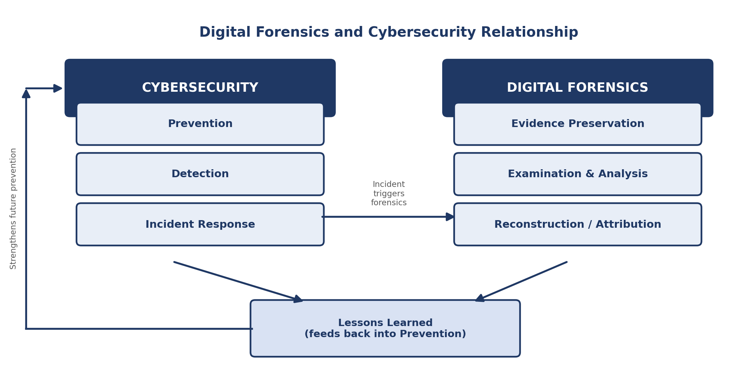
Figure 1. How cybersecurity and digital forensics work together, linked by a lessons-learned feedback loop [6], [1].

5. EMERGING TRENDS IN DIGITAL FORENSICS
Several trends are reshaping practice. Cloud forensics has grown fastest, since data ownership and evidence extraction increasingly depend on third-party providers rather than the device itself [3]. Mobile forensics still needs device- and OS-specific extraction techniques as encryption gets stronger [4]. AI-assisted analysis is speeding up log filtering and anomaly detection: NIST-benchmarked deepfake-audio detection has reached 92% accuracy, though model transparency is limited, and training bias can work its way into forensic error [7]. Automation is cutting manual triage time industry wide [2]. IoT forensics, by contrast, remains fairly immature, held back by fragmented, proprietary data formats. These tools are making investigations faster and larger in scale, but they raise reliability questions older forensic standards were never built to answer.
Trend | Practical Effect on Investigation
Cloud forensics | Evidence acquisition depends on third-party provider cooperation and jurisdiction.
Mobile forensics | Device- and OS-specific extraction techniques required as encryption strengthens.
AI-assisted analysis | Faster log filtering and anomaly detection; raises transparency and bias concerns.
Automation | Reduces manual triage time but does not resolve legal/jurisdictional barriers.
IoT forensics | Remains immature due to fragmented, proprietary data formats.
Table 2: Emerging trends and their effect on investigation [2], [7], [4], [3].

6. KEY CHALLENGES
Encryption is the most persistent barrier. Strong encryption can block extraction outright, so modern mobile forensics often relies on bypassing security features rather than straightforward acquisition [12]. Cloud data adds jurisdictional uncertainty, since it may be legally out of reach depending on where a provider hosts it [7]. Data volume is a separate problem: larger extractions take longer and add to case backlogs [2]. Anti-forensic techniques, such as data hiding and secure deletion, work directly against reconstruction. There is also a shortage of qualified investigators, which the ISC² workforce study [8] links to declining confidence in these skills. None of this can be solved by technical capability alone; it needs legal and workforce investment too.
Challenge | Effect | Forensic Implication
Encryption | Blocks direct data access | Forces reliance on costly exploit-based extraction tools
Cloud jurisdiction | Data legally inaccessible in some regions | Requires case-by-case cross-border negotiation
Data volume | Slows processing | Expands case backlogs
Anti-forensics | Hides or destroys evidence | Undermines reconstruction and attribution
Workforce shortage | Fewer qualified investigators | Limits case throughput and specialist coverage
Table 3: Key challenges and their forensic implication [12], [7], [2], [8].

7. NATIONAL JOB MARKET
UK demand centres on financial services, incident-response consultancies, technology firms, law enforcement and government, with London, the Manchester/Leeds corridor and Cheltenham/Bristol the key hubs [9]. Entry-level hiring has tightened: demand for candidates with under a year's experience fell from 25% in 2022 to 17% in 2024, while 63% of core postings asked for two to six years' experience [10]. This points to a UK market that is maturing and rewarding demonstrable forensic and reporting skill more than entry-level credentials alone.

8. INTERNATIONAL JOB MARKET
The global digital forensics market is projected to grow from $10.12 billion in 2023 to $26.15 billion by 2030, a 15.1% CAGR [11], which points to sustained demand across borders. Yet the ISC² workforce study [8] records digital forensics and incident response as a declining specific skill priority, down three percentage points year-on-year to 22% relative to broader cybersecurity roles. So, while the market is growing financially, forensic specialists increasingly compete within a wider, generalist cybersecurity talent pool.

 | Aspect |  | UK (National) |  | International
Market driver |  | Regulatory compliance, financial services, government |  | Overall cybersecurity market growth (15.1% CAGR)
Experience demand |  | Entry-level share falling; 63% mid-level (2-6 yrs) |  | Digital forensics/IR share of skill demand declining vs. broader cyber
Key hubs/regions |  | London, Manchester/Leeds, Cheltenham/Bristol |  | North America leads regional market share
Competitive position |  | Specialist niche within cyber security sector |  | Increasingly absorbed into generalist cybersecurity roles
Table 4: UK vs international job market comparison [10], [9], [11], [8].

9. TASK 1 CONCLUSION
Digital forensics has matured into a sophisticated, increasingly automated discipline now inseparable from cybersecurity practice, though encryption, jurisdictional complexity and workforce shortages still hold it back. Tool choice needs to match the evidence type rather than default to one platform. Employability remains strong nationally and internationally but increasingly favours people who combine specialist forensic skill with broader cybersecurity competence.

TASK 1 REFERENCES
[1] IBM, "What is Digital Forensics and Incident Response (DFIR)?" 2025. [Online]. Available: https://www.ibm.com/think/topics/dfir. [Accessed: 15-Aug-2026].
[2] SANS Institute, "Advanced Evidence Collection: DFIR's 2024 Mobile and Cloud Shift," 2025. [Online]. Available: https://www.sans.org/blog/advanced-evidence-collection-dfir-s-2024-mobile-and-cloud-shift. [Accessed: 15-Aug-2026].
[3] M. M. Alshabibi, A. K. Bu Dookhi, and M. M. Hafizur Rahman, "Forensic Investigation, Challenges, and Issues of Cloud Data: A Systematic Literature Review," Computers, vol. 13, no. 8, p. 213, 2024. doi: 10.3390/computers13080213.
[4] scmGalaxy, "Top 10 Digital Forensics Tools: Features, Pros, Cons & Comparison," 2026. [Online]. Available: https://www.scmgalaxy.com/tutorials/top-10-digital-forensics-tools-features-pros-cons-comparison/. [Accessed: 15-Aug-2026].
[5] S. J. Sinaga, M. A. Asykar, H. Manurung, W. C. Wibowo, et al., "Comparative evaluation of artifact extraction performance and usability in digital forensic tools: A study of Cellebrite UFED, MSAB XRY, and Magnet AXIOM," Journal of Forensic Sciences, 2026. doi: 10.1111/1556-4029.70320.
[6] Palo Alto Networks, "What is Digital Forensics and Incident Response (DFIR)?" n.d. [Online]. Available: https://www.paloaltonetworks.com/cyberpedia/digital-forensics-and-incident-response. [Accessed: 15-Aug-2026].
[7] SalvationData, "Key Trends in Digital Forensics for 2025: Challenges and Innovations," 2025. [Online]. Available: https://www.salvationdata.com/knowledge/key-trends-in-digital-forensics-for-2025/. [Accessed: 15-Aug-2026].
[8] (ISC)², "2025 ISC2 Cybersecurity Workforce Study," 2025. [Online]. Available: https://www.isc2.org/Insights/2025/12/2025-ISC2-Cybersecurity-Workforce-Study. [Accessed: 15-Aug-2026].
[9] Security Cleared Jobs Community, "Digital Forensic Investigator Roles in the UK: Skills, Salaries and Career Paths," 2026. [Online]. Available: https://community.securityclearedjobs.com/article/digital-forensic-investigator-roles-in-the-uk-skills-salaries-and-career-paths/. [Accessed: 15-Aug-2026].
[10] GOV.UK, Department for Science, Innovation and Technology, "Cyber Security Skills in the UK Labour Market 2025," 2025. [Online]. Available: https://www.gov.uk/government/publications/cyber-security-skills-in-the-uk-labour-market-2025/cyber-security-skills-in-the-uk-labour-market-2025. [Accessed: 15-Aug-2026].
[11] Grand View Research, "Digital Forensics Market Size, Share & Growth Report, 2030," n.d. [Online]. Available: https://www.grandviewresearch.com/industry-analysis/digital-forensics-market. [Accessed: 15-Aug-2026].
[12] A. Fukami, R. Stoykova, and Z. Geradts, "A new model for forensic data extraction from encrypted mobile devices," Forensic Science International: Digital Investigation, vol. 38, 2021. doi: 10.1016/j.fsidi.2021.301169.

PART B — TASK 2: DIGITAL FORENSIC INVESTIGATION REPORT

1. BROAD SUMMARY
Quantum Tech's IT security team detected unauthorised access to its proprietary patent database, specifically the AI chip design patent QT-AI-2025. The primary suspect, referred to as “Emma,” allegedly tried to sell the design to NexGen Circuits through an intermediary, “Joe.” “Norman” and NexGen's R&D Director “Vanessa” are suspected buyers. The matter was reported to law enforcement, and four Android devices were seized under continuity-of-evidence protocols for forensic examination.
The assigned examiner: Hiral Jitubhai Jasoliya, Location: UWTSD-London, Date: August 2026 examined all four exhibits using Cellebrite Physical Analyzer v7.73.0.11 and Cellebrite UFED 7.76.0.24. This report sets out the evidence recovered from those examinations, keeps directly observed evidence separate from interpretation, and reaches a defensible, evidence-led conclusion in line with established digital forensic practice [1].

2. INVESTIGATION SCOPE AND OBJECTIVES
The objectives of this examination were to:
- Identify relevant digital artefacts across the four seized devices.
- Preserve evidential integrity throughout acquisition and examination.
- Examine communications for evidence of data exfiltration and negotiation.
- Reconstruct relevant activity through a cross-device timeline.
- Correlate independent artefacts to test device-to-person attribution.
- Produce an evidence-based, defensible forensic conclusion.

3. EVIDENCE INVENTORY
Four Android exhibits were seized and examined. Attribution evidence and suspected roles are summarised below. Roles remain suspected pending corroboration and are examined critically in Sections 10 and 11.
Exhibit | Device | OS | Attribution Evidence | Suspected Role
EX-01 | Huawei POT-LX1 P Smart | Android 10 | Google account: peter_dover / dovp59@gmail.com | Perpetrator
EX-02 | Nokia C2 2nd Edition | Android 11 (HMD Global) | Google account “Norman” | Buyer
EX-03 | Samsung SM-A137F Galaxy A13 | Android 14 | SIM registration 07476538686 | Intermediary
EX-04 | Ulefone Note 14 | Android 12 | No attributing account recovered | Peripheral
Table 5: Evidence inventory for the four seized exhibits.

4. EVIDENCE INTEGRITY AND CHAIN OF CUSTODY
Original evidence was never examined directly. A forensic image is a bit-for-bit copy of a device's storage, captured so the source data cannot be altered by the examination process itself, in line with recognised good-practice principles for digital evidence [2], [3]. Once acquired, each image was hashed using SHA-256 and checked against its extraction record: a matching hash value confirms the image is an exact, unaltered copy of the data taken from the device. SHA-256 was used rather than older algorithms such as MD5 or SHA-1, both of which have known collision weaknesses and are no longer considered adequate for verifying evidential integrity [6].
The acquisition workflow followed the same steps for each exhibit: device identification → evidence preservation → forensic acquisition → forensic image → integrity verification (SHA-256) → examination [4]. Each extraction was confirmed as “verified” at acquisition, with no sign of alteration. The examiner named in Section 1 conducted this examination. Precise acquisition date, time and evidence-ID fields beyond the tool-level timestamps were not in the supplied material.

5. EVIDENCE ACQUISITION AND HASH VERIFICATION
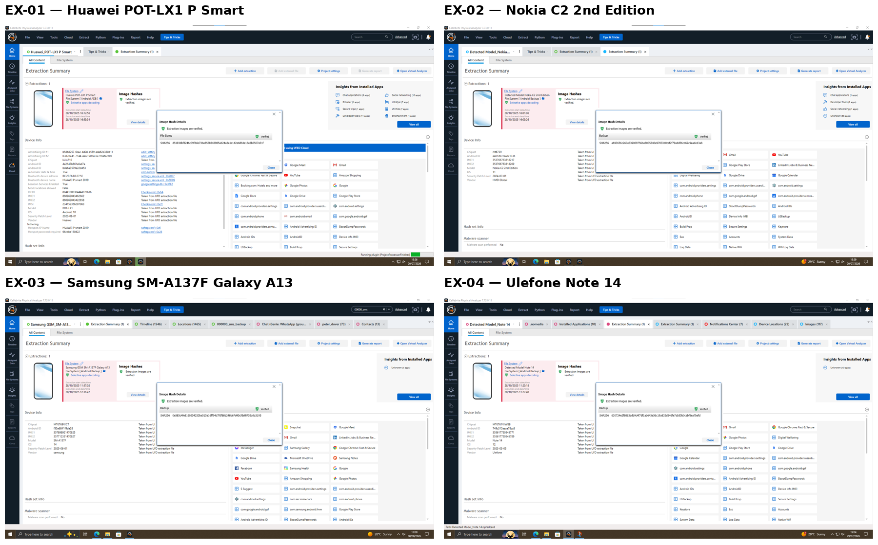
Figure 2. EXHIBIT T2-01–04: extraction summaries for all four exhibits, EX-01 to EX-04, showing verified status and hash values.
OBSERVED EVIDENCE: Each summary shows a verified status, SHA-256 hash value, and source-tool timestamp.
INTERPRETATION: A verified hash confirms the image matches the device data at acquisition. It does not prove custody afterwards.
CONCLUSION: No alteration was found in any of the four device images. This supports the reliability of the evidence in Sections 6 to 9.

Acquisition Workflow Demonstration
Figure 3 shows the acquisition workflow demonstrated on the examiner's own device (Detected Model CPH2213, Android 13) using Cellebrite UFED 7.76.0.24, from device detection through to a completed, itemised extraction, following recognised mobile device forensics guidance [6]. This demonstration is procedural; it does not form part of the case evidence against EX-01 to EX-04.
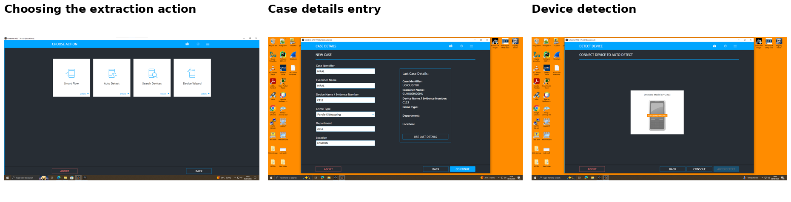
Figure 3. Acquisition workflow demonstrated on the examiner's own device.

6. COMMUNICATION ANALYSIS
Two communication threads recovered from EX-01 (Huawei) form the core of the negotiation evidence: a WhatsApp exchange on 21 August 2024 and a Facebook Messenger exchange on 31 January 2025. Both are unedited tool exports, retaining the Cellebrite window, source tabs and the Windows system clock as a timestamp reference.
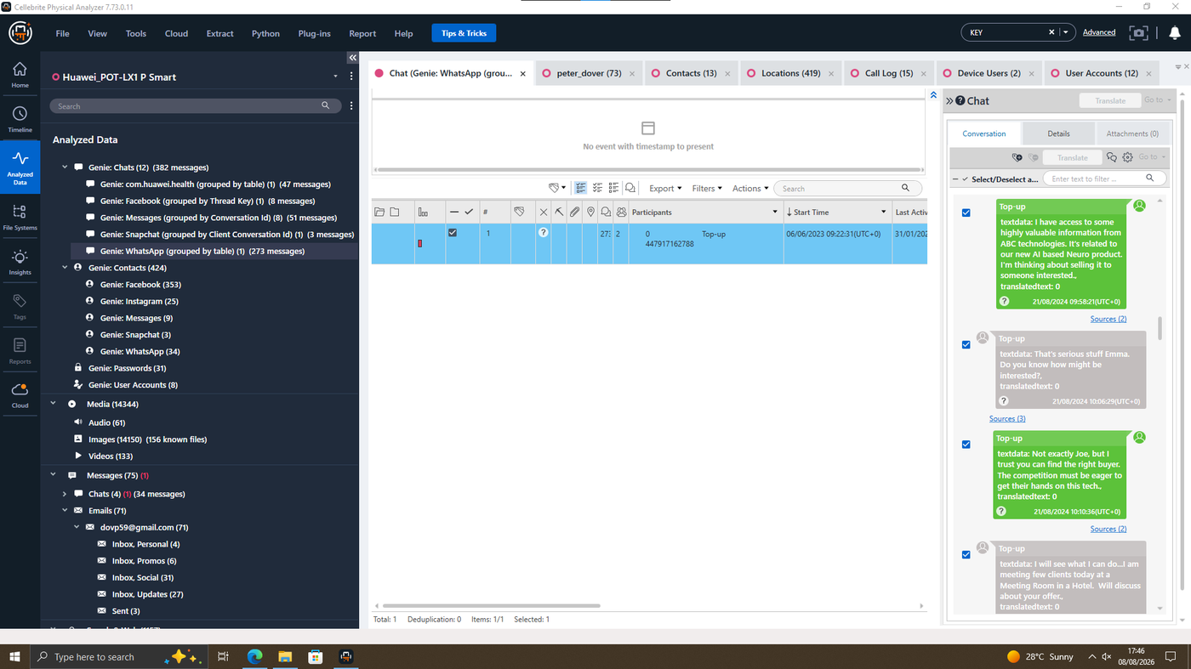
Figure 4. EXHIBIT T2-05: EX-01, WhatsApp messages, 21 Aug 2024, showing the initial offer.
OBSERVED EVIDENCE: The device owner offers to sell “AI based Neuro product” information. The counterpart (saved contact “Top-up”) addresses the sender as “Emma” and proposes a hotel meeting.
INTERPRETATION: The counterpart's direct use of “Emma” carries more weight than other names in the thread, since it is the counterpart, not the device owner, applying it.
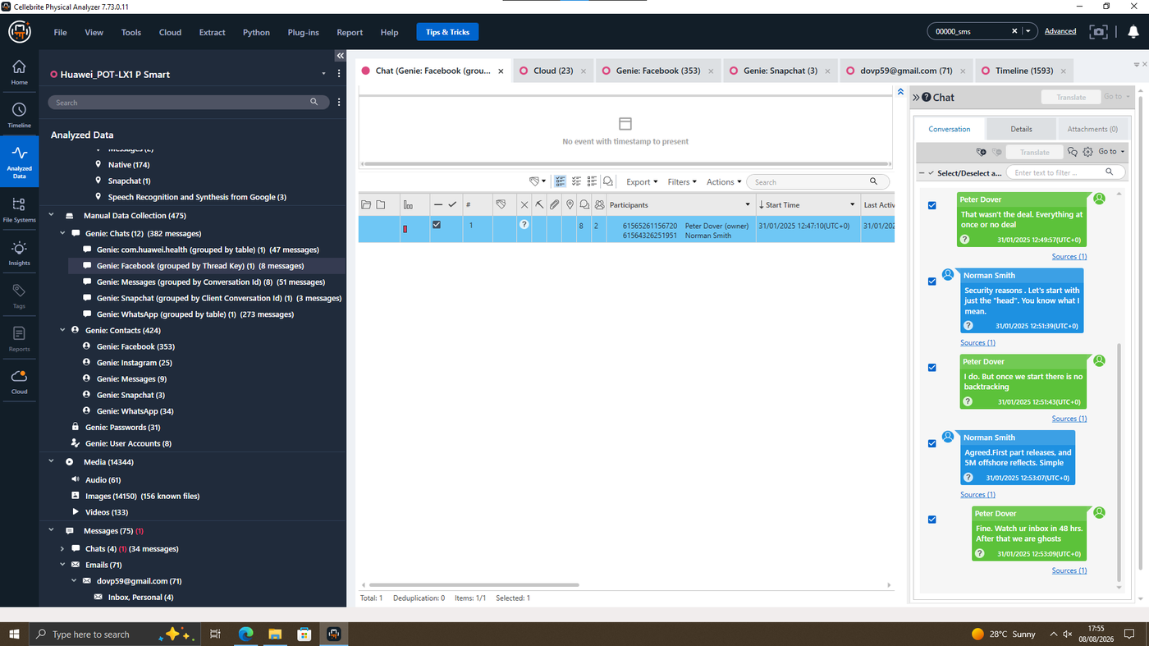
Figure 5. EXHIBIT T2-06: EX-01, Facebook Messenger messages, 31 Jan 2025, showing the payment terms.
OBSERVED EVIDENCE: The thread contains confirmed payment terms (“5M offshore”) and a 48-hour deadline.
CONCLUSION: Content moves from an initial offer in August 2024 to confirmed payment terms in January 2025, consistent with a completed negotiation. Names in the message text (“Emma,” “Joe”) are conversational, not device-assigned labels, and are treated with caution.
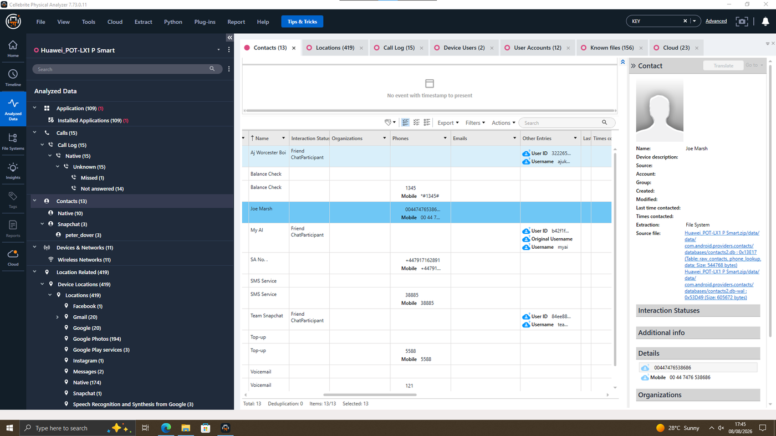
Figure 6. EXHIBIT T2-07: EX-01, contacts list showing the saved contact “Joe Marsh.”
This contact entry underpins the device-to-device correlation in Section 8, where the same number is found registered to EX-03 (Samsung).

7. CHRONOLOGICAL TIMELINE
The table below sets out the chronological reconstruction of relevant activity across the exhibits. Only dates and times directly shown in the evidence are used; gaps are not filled with assumptions.
Date / Time | Source | Event | Evidential Status
2–19 Aug 2024 | EX-01 · Call Log | Repeated unanswered call attempts to “SA No.” before the WhatsApp approach (Table 7, C-3). | Directly Observed
21 Aug 2024, 09:58–10:36 | EX-01 · WhatsApp | Initial approach and offer to sell “Neuro product” information; hotel meeting proposed. | Directly Observed
Aug–Nov 2024 | Case record | Reported period of ongoing buyer-side coordination (per investigative brief). | Inferred
31 Jan 2025, 12:47–12:53 | EX-01 · Facebook Messenger | Peter Dover / Norman Smith confirm deal terms (“5M offshore”) and a 48-hour deadline. | Directly Observed
Table 6: Chronological timeline of relevant activity.
EX-02 records an image capture on 17 August 2024 at 15:35, with coordinates -21.207139 / 27.548097. EX-03 carries a lower-confidence location entry from 1 February 2024, discussed further in Section 9.

8. CALL LOG AND EMAIL CORRELATION
EX-01's contacts list provides the number match at C-1, and its call log provides the timing correlation at C-3 (Table 7 below).
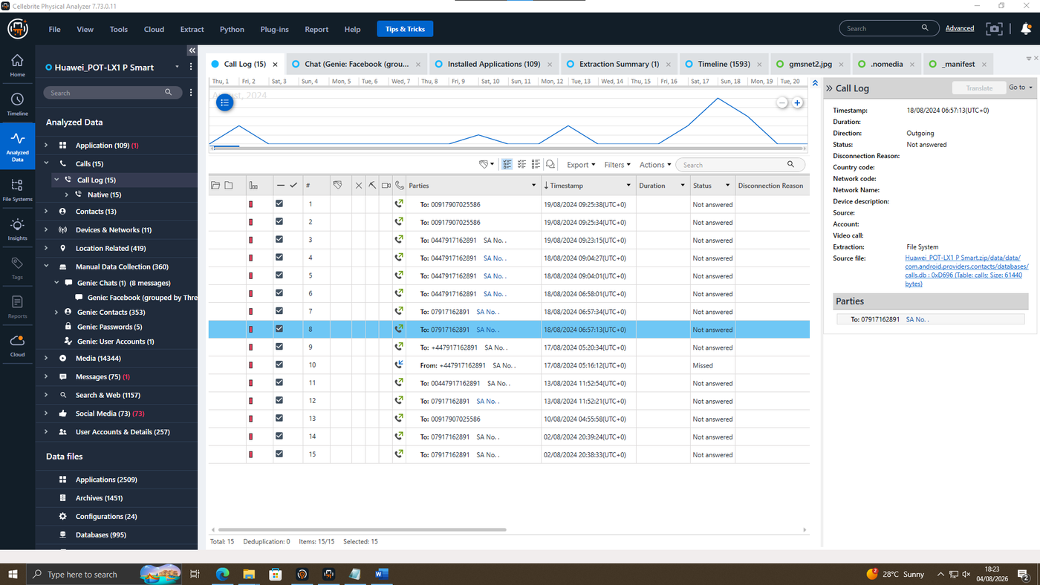
Figure 7. EXHIBIT T2-15: EX-01, call log, 15 entries between 2 and 19 August 2024.
OBSERVED EVIDENCE: 12 of 15 calls are to “SA No.” (07917162891), all unanswered except one missed call. The other 3 calls, on 10 and 19 August, go to an unnamed number, also unanswered.
INTERPRETATION: No call to “SA No.” shows a connected duration, so the log evidence repeated attempts to make contact rather than a completed conversation. The unnamed number's relevance is not established in the supplied material.
An email artefact from EX-01, referencing SIM account details, is shown below (EXHIBIT T2-11). It provides supplementary context but does not alter the findings of Sections 6 and 11.
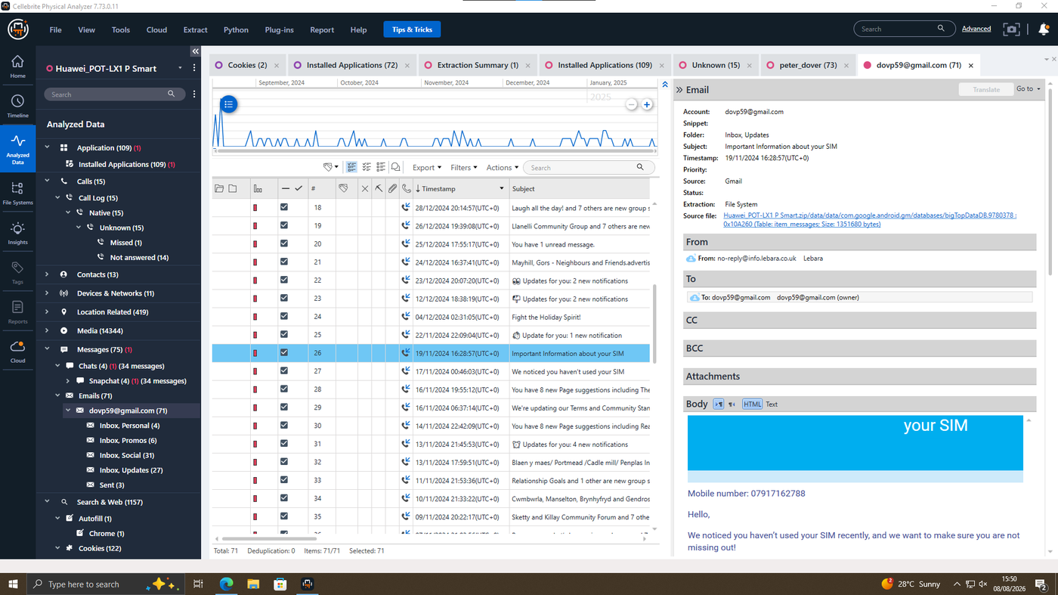
Figure 8. EXHIBIT T2-11: EX-01, email referencing SIM account details.

Correlation Summary (C-1 to C-3)
Ref | Evidence A | Evidence B | Significance | Weight | Limitation
C-1 | EX-01 contacts: “Joe Marsh,” 00447476538686 | EX-03 SIM registration: 07476538686 | Indicates EX-03 is linked to the “Joe” persona in the WhatsApp negotiation. | Corroborating | Confirms a device/number association only; does not establish who held the handset.
C-2 | EX-01 WhatsApp: counterpart replies, “That's serious stuff Emma…” (21 Aug 2024) | EX-01 registration: account holder Peter Dover, dovp59@gmail.com | Supports an identity link between the registered Huawei account and the “Emma” persona referenced in the case brief. | Corroborating | Conversational third-party use of a name is corroborating, not conclusive.
C-3 | EX-01 contacts: saved contact “SA No.” | EX-01 call log: 12 call attempts to “SA No.” between 2–19 Aug 2024, all unanswered or missed (EXHIBIT T2-15) | Shows repeated attempts to reach “SA No.” before the written offer. | Circumstantial | No call shows a connected duration; evidence of attempted contact only.
Table 7: Correlation of independent artefacts (C-1 to C-3). C-1 and C-2 are corroborating; C-3 is circumstantial.

9. FILE AND METADATA ANALYSIS
Location and media artefacts were examined across all four exhibits. The most evidentially significant is a Gmail-sourced location on EX-01, which ties the account dovp59@gmail.com to a physical address.
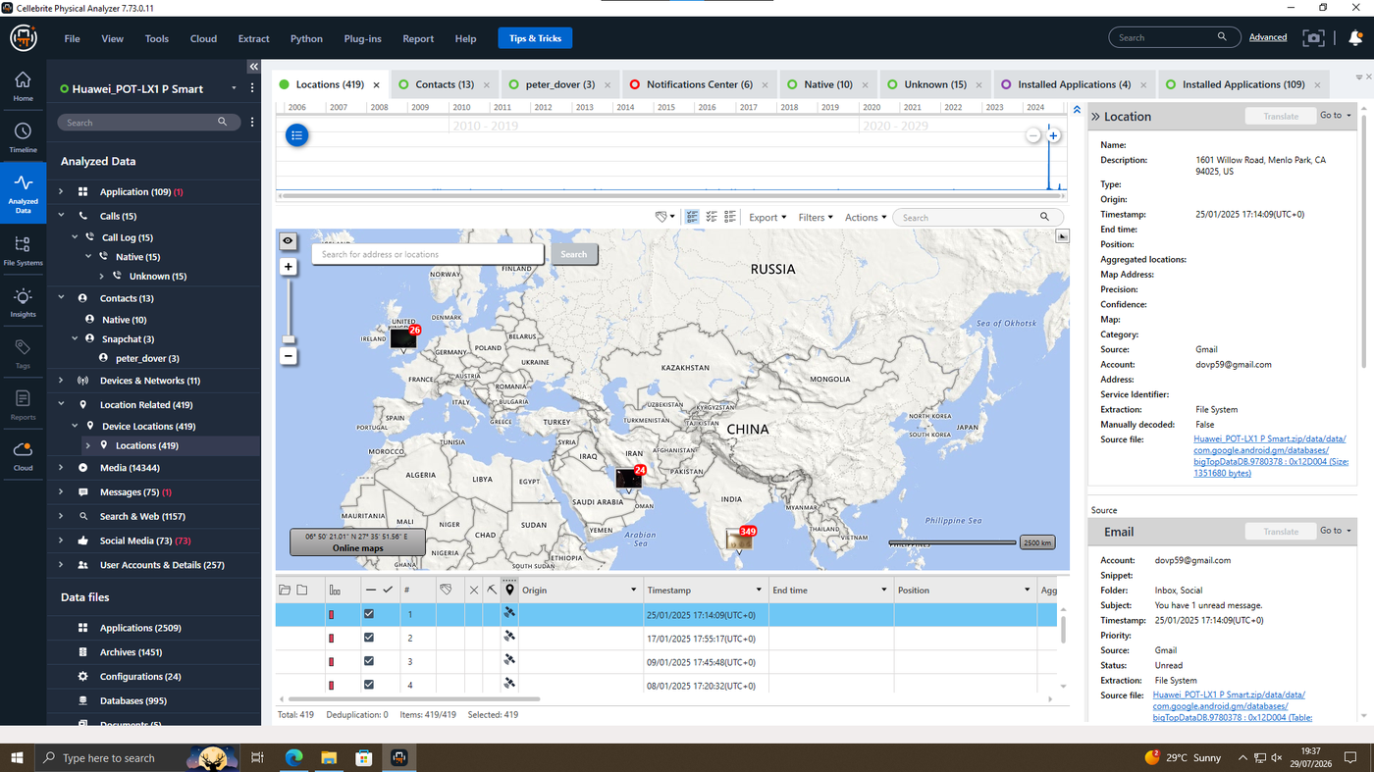
Figure 9. EXHIBIT T2-08: EX-01, location data, Menlo Park CA, sourced from Gmail.
OBSERVED EVIDENCE: A Gmail-sourced location record for account dovp59@gmail.com resolves to 1601 Willow Road, Menlo Park, CA.
INTERPRETATION: This supports the account-holder identity (Peter Dover) already shown by device registration, though it does not prove physical possession at the time.
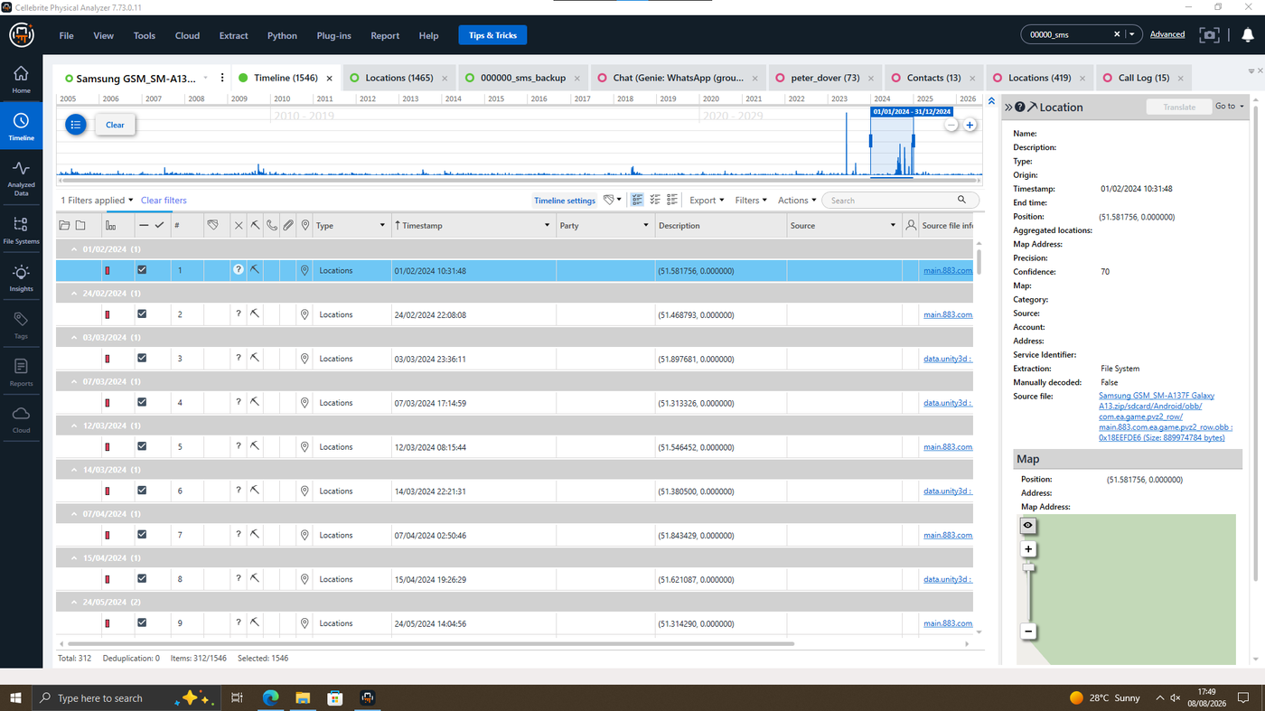
Figure 10. EXHIBIT T2-09: EX-03, location entry, 1 February 2024, confidence score 70.
OBSERVED EVIDENCE: The location entry has a confidence score of only 70, from a third-party app file rather than a native OS log; the exact basis is not detailed in the material.
INTERPRETATION: This is treated as lower-reliability corroboration and is not relied upon as primary evidence of location or possession.
Location and media artefacts recovered from EX-02 and EX-04 provide additional, lower-weight corroboration (EXHIBITS T2-10, T2-12, T2-13, T2-14). No further metadata beyond what is visible in these captures was present in the supplied material.
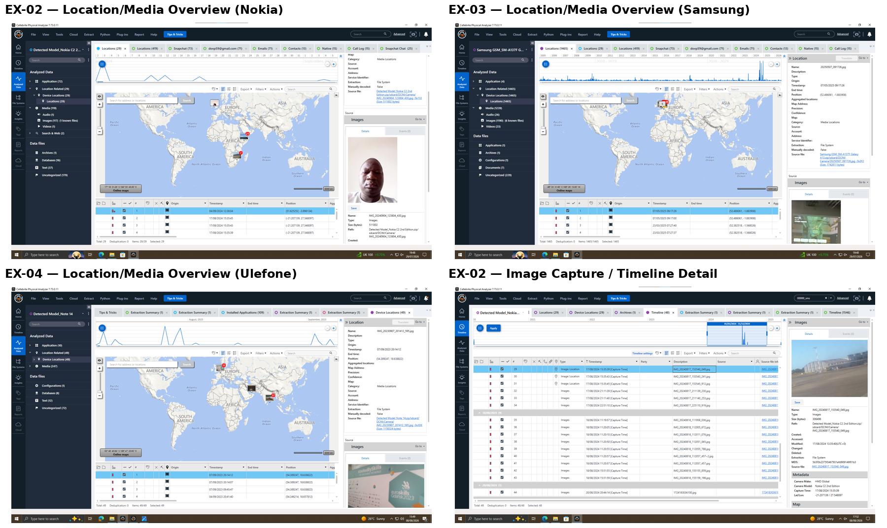
Figure 11. EXHIBIT T2-10, T2-12–14: supplementary location/media artefacts, EX-02–EX-04.
None of this supplementary location and media material independently changes the attribution findings in Section 10.

10. SUSPECT ANALYSIS
The table below summarises device attribution and suspected role for each exhibit. The subsections that follow analyse each named individual separately, weighing up the supporting evidence against its limitations.
Exhibit | Evidence Indicates | Supporting Evidence | Limitation
EX-01 Huawei POT-LX1 (Perpetrator – suspected) | Peter Dover | WhatsApp offer; Facebook Messenger deal confirmation; addressed as “Emma” by counterpart. | Relies on conversational address plus device registration, not a device-side profile name.
EX-03 Samsung SM-A137F (Intermediary – suspected) | Unidentified — number consistent with “Joe” | SIM registration number matches the “Joe Marsh” contact saved on EX-01. | Matching number does not independently confirm who held the device.
EX-02 Nokia C2 2nd Edition (Buyer – suspected) | Google account “Norman” | Device-registered account name consistent with the “Norman” role in the case brief. | No direct communication confirms this account holder as an active participant.
EX-04 Ulefone Note 14 (Peripheral device) | Not established | Location and media artefacts only; no attributing account recovered. | Evidential contribution to the negotiation itself is not established.
Table 8: Device attribution and suspected role for each exhibit.

Emma (device owner, EX-01 — suspected Perpetrator)
The WhatsApp, Facebook Messenger and Gmail-location artefacts in Table 8 all trace to the same account, strengthening the identity link, but none independently place Peter Dover in physical possession of the handset. The finding rests on account registration and a third party's conversational use of “Emma,” which is corroborating rather than conclusive.

Joe (suspected Intermediary, linked to EX-03)
Joe is linked to EX-03 via the number match at C-1 (Table 7) alone; no communications, calls or emails naming “Joe” were recovered from EX-03 itself, so who held the device cannot be reliably established.

Norman (suspected Buyer, linked to EX-02)
Norman's link to EX-02 rests on the device-registered account name alone (Table 8); no communication content from EX-02 confirms active participation, so his active role cannot be reliably established.

EX-04 (Ulefone Note 14 — peripheral device)
EX-04 was seized in the same sweep as EX-01 to EX-03, but no attributing account or communication was recovered; its contribution is limited to the artefacts in Section 9. Its inclusion reflects the scope of the seizure rather than a demonstrated role: an unexamined device cannot be ruled out as readily as an examined one.
NexGen Circuits' R&D Director “Vanessa” is referenced in the case brief but is not evidenced within the four exhibits, so is not analysed separately above. This absence of evidence is not evidence of absence: no device attributable to Vanessa was seized, so the material offers no basis to assess her involvement either way.

11. CRITICAL EVALUATION OF FINDINGS
Table 7 sets out the three correlations underlying this attribution; none is individually conclusive, and the strongest — the cross-device number match at C-1 — still does not confirm possession of the handset.
Together, these three weak indicators reinforce each other because they all point the same way: EX-01 and EX-03 are linked through the same negotiation. This convergence is the strongest basis for Section 13’s findings.

12. EVIDENCE LIMITATIONS
- Content of voice calls is not recoverable — the correlation to “SA No.” is timing-based only.
- Location confidence on EX-03 is comparatively low (70); no attributing account was recovered for EX-04.
- Physical possession or custody of each device at the time of use is not established by digital artefacts alone.

13. CONCLUSION
The examined artefacts establish that exhibit EX-01 (Huawei) was used to negotiate the sale of proprietary AI product information, with the account holder addressed directly as “Emma” by the counterpart. A recovered contact number of links EX-01 to EX-03, consistent with Joe’s intermediary role. EX-02, EX-04, Norman and Vanessa are named in the case record but not confirmed by the digital evidence here.
Overall confidence in the EX-01/EX-03 link is moderate-to-high: it rests on three independent lines of evidence (Section 11) that all point the same way, even though each one is contestable alone. Confidence in EX-02's active role and in Vanessa's involvement is low, since both rest on account-naming or the case brief alone, with no supporting communication content in the digital artefacts.

14. RECOMMENDATIONS
- Preserve full chain-of-custody documentation for all four exhibits pending any evidentiary hearing.
- Extend examination to email and cloud-linked accounts associated with dovp59@gmail.com and df2025class@gmail.com.
- Apply access controls and data-loss-prevention monitoring to Quantum Tech's patent database (QT-AI-2025).
- Refer the EX-01/EX-03 findings to the investigating law enforcement unit for consideration of offences under the Computer Misuse Act 1990, sections 1 and 3 (unauthorised access and unauthorised acts impairing operation), the Fraud Act 2006, section 4 (fraud by abuse of position), and the Trade Secrets (Enforcement, etc.) Regulations 2018, alongside further identity verification of “Joe,” “Norman” and “Vanessa.”

15. REFLECTION
This examination mixed routine tasks, like verifying hashes, with judgement calls about how much weight each artefact could carry. The clearest skill developed was ranking evidence by strength: a number match across two devices (EXHIBIT T2-07) is stronger than a call-log timing pattern. The report works best where that’s stated plainly.
The main difficulty was resisting over-interpretation. It was tempting to treat the WhatsApp counterpart's use of “Emma” as settling the identity question. Separating that from the account-registration evidence, and calling it corroborating rather than conclusive, took a deliberate second look.
Doing this again, more time would go into what the material did not show, such as the basis for Cellebrite's confidence scores. That is the core of DFIR practice: acquisition is mostly mechanical, but evidential value depends on correlating sources and being honest about what remains unresolved.
TASK 2 REFERENCES
[1] E. Casey, Digital Evidence and Computer Crime: Forensic Science, Computers and the Internet, 3rd ed. Waltham, MA: Academic Press, 2011.
[2] Association of Chief Police Officers (ACPO), Good Practice Guide for Digital Evidence, 2012.
[3] International Organization for Standardization, ISO/IEC 27037:2012 — Information technology — Security techniques — Guidelines for identification, collection, acquisition and preservation of digital evidence. Geneva: ISO, 2012.
[4] M. Reith, C. Carr, and G. Gunsch, "An examination of digital forensic models," International Journal of Digital Evidence, vol. 1, no. 3, pp. 1–12, 2002.
[5] Cellebrite DI Ltd, Physical Analyzer User Guide. Petah Tikva: Cellebrite DI Ltd, 2024.
[6] National Institute of Standards and Technology, Guidelines on Mobile Device Forensics, NIST Special Publication 800-101, Rev. 1. Gaithersburg, MD: NIST, 2014.

