ASSIGNMENT TITLE: Synthesize a solution to a potential real-lifE scenario
MODULE: ACCA4024 Networks and Cyber Security Essentials

Student name: Andrew Ross Pullin
Student ID: 0851963
Course Title: Computing (Data and Information Systems)

Table of Contents
Introduction 2
Identification of Modern Threats 3
Modern Security Policies (Zero Trust Approach) 5
Technical Mitigation Measures 6
Zero Trust Architecture Diagram 7
Proactive Monitoring and Incident Response 8
Continuous Training and Awareness Program 9
Business Impact and Strategic Justification 10
Conclusion 10
References 11

Introduction

Cyber security has evolved into a critical concern for organisations operating in the financial services sector. Institutions such as Vigilant Trust & Asset Management (VTAM) could be particularly attractive targets for cybercriminals due to the high value of financial data, customer information, and systems they maintain. The rapid adoption of cloud computing, mobile devices, and hybrid working environments has significantly increased the attack surface, making traditional perimeter-based security models inadequate. [1]
Recent incidents within VTAM, including an advanced phishing campaign that bypassed email filters and an attempted ransomware attack, highlight weaknesses in existing security controls. These events are consistent with global trends where attackers increasingly leverage advanced technologies such as artificial intelligence (AI), automation, and service-based cybercrime models. [2]
This report proposes a comprehensive cyber security framework based on the Zero Trust architecture, supported by internationally recognised standards including the NIST Cybersecurity Framework (CSF) and ISO/IEC 27001 [3]. The objective is to enhance VTAM’s ability to prevent, detect, respond to, and recover from modern cyber threats while promoting a culture of continuous security awareness.

Identification of Modern Threats

External Threats
One of the most significant emerging threats is Ransomware-as-a-Service (RaaS). This model enables cybercriminals to purchase or subscribe to ransomware tools, significantly lowering the technical barrier required to launch attacks. According to the Cybersecurity and Infrastructure Security Agency (CISA), ransomware attacks have increased dramatically, with financial institutions frequently targeted due to their ability to pay large ransoms [4]. RaaS campaigns often include double extortion tactics, where attackers both encrypt and threaten to leak sensitive data.
Another growing concern is AI-powered social engineering, particularly phishing and vishing (voice phishing). Attackers now use machine learning algorithms to craft highly personalised and convincing messages. Fake voice technology can impersonate executives, making vishing attacks especially dangerous. These techniques significantly increase the likelihood of bypassing traditional security filters and exploiting human vulnerabilities.
Cloud-related threats are equally significant. Misconfigured cloud storage, weak identity and access management (IAM), and insecure APIs can expose sensitive financial data. As VTAM increasingly relies on cloud services, these vulnerabilities must be addressed proactively.

Internal Threats
Internal threats remain a persistent issue. Employees may unintentionally expose data through phishing attacks or misconfigurations. In some cases, malicious insiders may deliberately exploit their access privileges for financial gain.
The use of shadow IT, where employees adopt unauthorised applications, further increases risk by bypassing security controls [5]. Additionally, weak authentication practices, such as password reuse, contribute to credential compromise and unauthorised access.

Mapping Threats to NIST CSF
The NIST CSF provides [6] a structured approach to understanding cyber risks through five core functions:
- Identify: Lack of asset visibility and third-party risk management.
- Protect: Weak authentication and insufficient access controls.
- Detect: Limited monitoring and lack of real-time analytics.
- Respond: Inefficient incident response processes.
- Recover: Inadequate backup and recovery strategies.
This framework ensures that VTAM adopts a holistic and structured approach to cyber security.

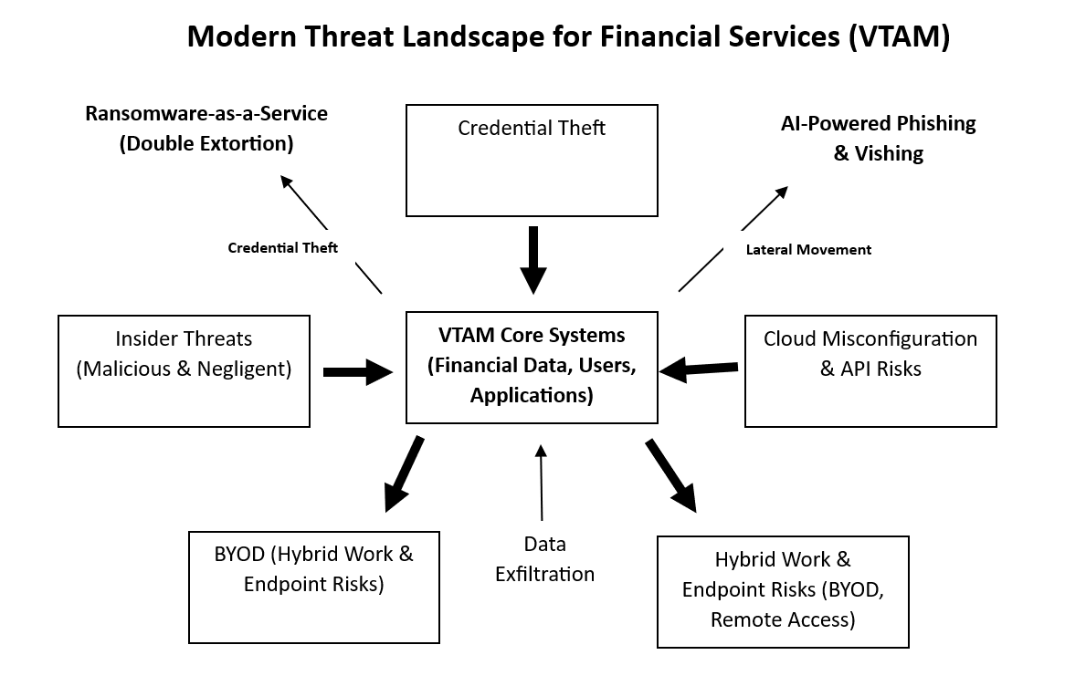Fig 1 - Modern Threat Landscape diagram

Modern Security Policies (Zero Trust Approach)

The Zero Trust model is based on the principle of “never trust, always verify.” Unlike traditional models that assume internal networks are secure, Zero Trust requires continuous verification of all users, devices, and applications. [7]

Core Policies
Identity and Access Management Policy
VTAM must enforce least privilege access, ensuring users only have access to resources necessary for their roles. Multi-Factor Authentication (MFA) should be mandatory across all systems, particularly for remote access and cloud platforms. Regular access reviews must be conducted to remove unnecessary privileges.
Data Protection Policy
Sensitive data must be classified and protected using encryption both at rest and in transit. Data loss prevention (DLP) tools should be deployed to monitor and control data movement.
Device Security Policy
All devices accessing corporate systems must comply with security standards, including up-to-date antivirus software and patch levels. Endpoint Detection and Response (EDR) solutions should be mandatory.
Network Security Policy
Network segmentation should be implemented to limit lateral movement within the network. Micro-segmentation ensures that even if one system is compromised, attackers cannot easily access others.
Incident Response Policy
A formal incident response plan must define procedures for detecting, reporting, and responding to incidents. Regular testing through simulations is essential to ensure effectiveness.

Alignment with ISO/IEC 27001
The proposed policies align with key ISO 27001 control areas, including:
- Access control through MFA and role-based access.
- Cryptography via encryption.
- Operations security through monitoring systems.
- Supplier relationships addressing supply chain risks.
- Incident management through structured response plans.
This alignment ensures compliance with internationally recognised security standards.

Technical Mitigation Measures

Multi-Factor Authentication (MFA)
MFA significantly reduces the risk of unauthorised access by requiring multiple verification factors. VTAM should implement app-based authentication methods, as SMS-based MFA could be vulnerable to SIM-swapping attacks.
Security Information and Event Management (SIEM)
SIEM systems collect and analyse logs from across the organisation, enabling real-time detection of suspicious activities. Integration with threat intelligence enhances detection capabilities.
Security Orchestration, Automation, and Response (SOAR)
SOAR platforms automate repetitive security tasks, reducing response time and human error. For example, compromised accounts can be automatically disabled upon detection.
Endpoint Detection and Response (EDR)
EDR tools monitor endpoint activity and detect malicious behaviour. They can isolate infected devices to prevent the spread of malware.
Cloud Security Posture Management (CSPM)
CSPM solutions continuously monitor cloud environments for misconfigurations and compliance violations, reducing the risk of data exposure.
Patch Management (CISA KEV)
VTAM should prioritise vulnerabilities listed in the CISA Known Exploited Vulnerabilities catalogue. Automated patch management systems ensure timely updates.
Immutable Backups
Backups must be protected against modification or deletion by ransomware. Immutable storage ensures that data can be recovered even after an attack.

Zero Trust Architecture Diagram

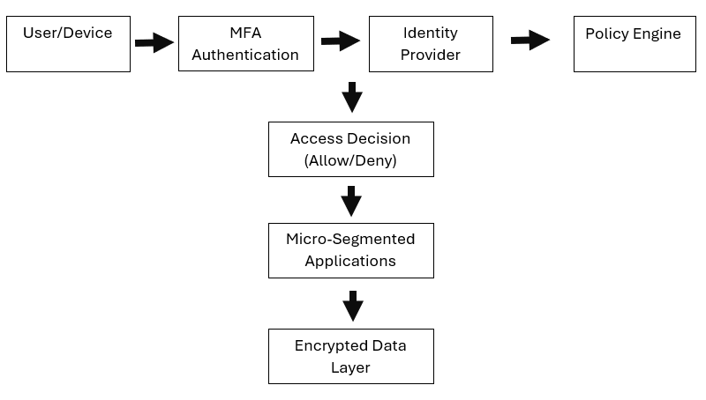
Fig 2 - Zero Trust Architecture Diagram
This architecture ensures that every access request is verified and continuously monitored, reducing the risk of unauthorised access.

Proactive Monitoring and Incident Response

24/7 Monitoring Strategy
Continuous monitoring is essential for early threat detection. SIEM systems should be configured to collect logs from endpoints, servers, and cloud services. Integration with threat intelligence sources enables identification of known attack patterns.
Incident Response Framework
The incident response process should follow a structured lifecycle:
- Preparation: Establish policies and tools.
- Detection and Analysis: Identify and validate threats.
- Containment: Limit the spread of the attack.
- Eradication: Remove the threat.
- Recovery: Restore systems.
- Lessons Learned: Improve future responses.

Incident Response Flow Diagram
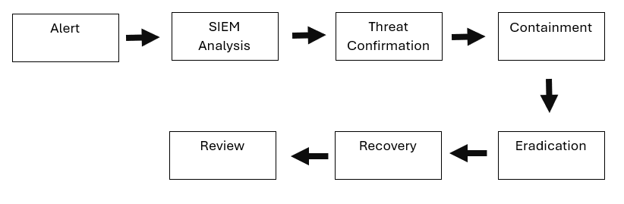
Fig 3 - Incident Response Flow Diagram
Ransomware Response Plan
In the event of a ransomware attack, VTAM should:
- Immediately isolate affected systems.
- Disable network access.
- Restore systems from secure backups.
- Notify regulators and stakeholders.
- Conduct forensic analysis.

Continuous Training and Awareness Program

Human error remains one of the leading causes of security breaches [8]. Therefore, VTAM must implement a continuous and engaging training program.
Training Strategies
Phishing Simulations
Regular simulated phishing campaigns help employees recognise and report suspicious emails.
Vishing Simulations
Simulated voice attacks train staff to verify identities and avoid social engineering traps.
Role-Based Training
Different roles require tailored training. For example, IT staff need advanced technical training, while finance staff should focus on fraud detection.
Gamification
Incorporating rewards and leaderboards increases engagement and encourages participation.
Building a Security Culture
A strong security culture encourages employees to report incidents without fear of punishment. Continuous communication, leadership support, and regular updates reinforce the importance of cyber security.

Business Impact and Strategic Justification

Cyber security incidents can have severe consequences [9]:
Financial Impact
Costs include ransom payments, legal penalties, and recovery expenses.
Operational Impact
System downtime disrupts business operations and reduces productivity.
Reputational Impact
Loss of customer trust can have long-term effects on revenue and brand image.
Investing in cyber security is therefore not optional but essential. A proactive approach reduces risk, ensures regulatory compliance, and enhances organisational resilience.

Conclusion

VTAM operates in a high-risk environment where cyber threats are increasing and persistent. The adoption of a Zero Trust framework, supported by NIST CSF and ISO 27001, provides a robust and scalable approach to managing these risks.
By implementing strong security policies, advanced technical controls, proactive monitoring, and continuous training, VTAM can significantly enhance its cyber resilience. Ultimately, cyber security should be viewed as a strategic investment that protects both the organisation and its stakeholders.

References

[1] | A. Jonker, “IBM,” [Online]. Available: https://www.ibm.com/think/topics/cybersecurity. [Accessed 14 04 2026].
[2] | “Gov.uk,” [Online]. Available: https://www.gov.uk/government/publications/emerging-technology-pairings-and-their-effects-on-cyber-security/emerging-technologies-and-their-effect-on-cyber-security. [Accessed 14 04 2026].
[3] | IBM, “IBM,” [Online]. Available: https://www.ibm.com/products/cloud/compliance/iso-27001. [Accessed 14 04 2026].
[4] | “CISA,” [Online]. Available: https://www.cisa.gov/stopransomware/resources. [Accessed 14 04 2026].
[5] | “NCSC,” 27 07 2023. [Online]. Available: https://www.ncsc.gov.uk/guidance/shadow-it. [Accessed 14 04 2026].
[6] | “Industrial Defender,” 2021. [Online]. Available: https://www.industrialdefender.com/resources/nist-cybersecurity-framework-mapping-guide-industrial-defender. [Accessed 14 04 2026].
[7] | Microsoft, “Microsoft,” 27 02 2025. [Online]. Available: https://learn.microsoft.com/en-us/security/zero-trust/zero-trust-overview. [Accessed 14 04 2026].
[8] | K. Babcock, “bitwarden,” 18 02 2026. [Online]. Available: https://bitwarden.com/blog/how-to-protect-your-organization-from-human-error-and-data-breaches/. [Accessed 05 05 2026].
[9] | “Department for Science, Innovation and Technology,” [Online]. Available: https://www.gov.uk/government/publications/independent-research-on-the-economic-impact-of-cyber-attacks-on-the-uk/summary-of-research-on-the-economic-impact-of-cyber-attacks. [Accessed 05 05 2026].

