

STUDENT NAME: SABIN GHEORGHE
STUDENT ID: 2213752
MODULE CODE: LCBB6023
LECTURES NAME: LIYANAGE RODRIGO
WORDS: 2500

Managing Cultural Differences Between the UK and Japan: A Study of Rolls-Royce Holdings plc

In the age connected world economy of today, globalization requires multinational corporations to be global enterprises as multinational enterprises operate across several national borders where there exist important cultural differences that heavily impact how managers behave and how they communicate in the workplace. While the era of globalization had facilitated the lowering of costs of goods and services, the cultural differences between nations still determined the way the workers interact, act, and make sense of meaning in the workplace. For British multinationals looking for strategies to expand in Asian countries such as Japan, Japan has great strategic potential, but some of these are well-documented as well with respect to cultural competence and intercultural communication. In this essay will discuss communication differences as Rolls-Royce Holdings plc, the UK multinational company involved in engineering, moves into a Japanese sector. One way in which Rolls-Royce's corporate culture exhibits tendencies is with flat structures, focus on the individual’s performance (understanding, and management), and direct, explicit communication styles. By contrast, Japanese culture prioritizes collective responsibility, respect for hierarchy, long-term relationship-making, and indirect communication as a way of preserving social harmony. This essay seeks to critically examine how such cultural differences can contribute to communication misunderstandings and miscommunication between the UK and Japanese teams, specifically the aim is to review how this intercultural bias plays a role and its implications in making the differences and misunderstandings between UK and Japanese team performance. To inform this analysis, grounded theories around the global communication, such as Hofstede’s (1980; 2001) Cultural Dimensions model, Hall’s (1976) High-Context and Low-Context communication theory, and the GLOBE model on leadership and cultural practices (House et al., 2004) are used as tools to support this analysis. These are conceptual frameworks which offer a framework to analyse how dissimilar communication style, leadership expectations and decision-making behaviour are discussed and analysed through a structured approach. The crux of this essay is that there will no ‘failure culture’ between the United Kingdom and Japan; rather, cultural differences create complexity that must be managed strategically. With the help of culturally sensitive leadership, leaders willing to adapt themselves, and communication systems with sufficient efficiency, multinational enterprises like Rolls-Royce can use cultural diversity as an enabler of organisation and sustainable competitive edge.

Overview of Rolls-Royce Holdings plc
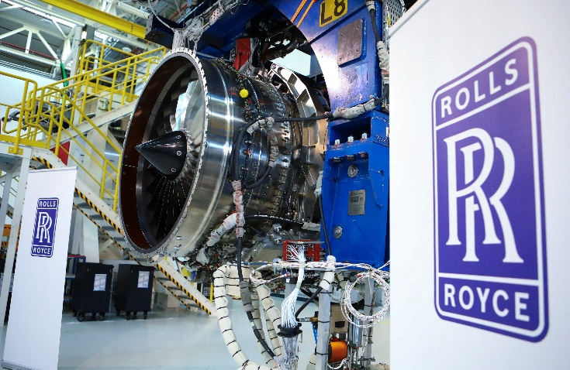


Rolls-Royce Holdings plc is a British multinational company, based in London that focuses on aerospace, defence, and power systems engineering. Rolls-Royce corporate environment in UK can be described as:
• Relatively low hierarchical distance
• Emphasis on technical expertise
• Direct and structured communication
• Performance-based evaluation
• Innovation-driven culture Problem-solving, analytical thinking and open discussion are valued aspects of British engineering culture during project development.


Japanese Business Environment

Japan’s industrial sector is highly advanced and globally respected. Japanese business culture emphasises:
- Group harmony (wa)
- Hierarchical respect
- Long-term strategic planning
- Detailed risk management
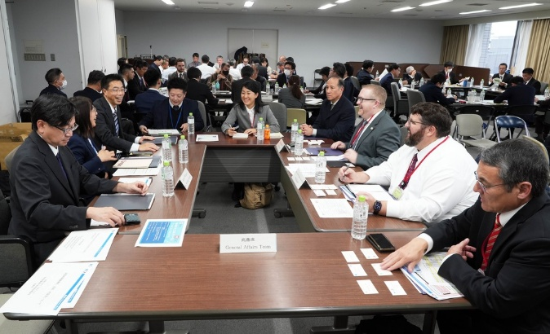
- Consensus-based decision-making
Japanese corporations often value long-term partnerships over short-term profitability. In high-precision industries such as aerospace and engineering, attention to detail and structured procedures are fundamental.
Understanding these contextual foundations is essential for evaluating communication differences.

Theoretical Framework
Hofstede (1980; 2001) outlined six dimensions to account for national differences in culture. Some are especially pertinent to the UK–Japan collaboration:
Individualism vs Collectivism. The UK is very much an individualist society. Employees are enabled to share opinion, to show their personal opinion and take individual ownership. Organisational collectivism is a stronger feature in Japan. Workers value team harmony and group results above all.
Power Distance. The UK has relatively low power distance, though. Employees are willing to challenge ideas openly; managers are approachable. Japan shows moderate to higher power distance. Communication flow is influenced by hierarchical respect.
Uncertainty Avoidance. Japan scores very high in uncertainty avoidance. Detailed planning and avoiding risk are highly cherished. The UK scores lower (again a measure of an appetite for ambiguity and flexible planning).
Long-Term Orientation. Japan comes in very high, favouring long-term strategic stability and sustainability. The UK has one where performance is shorter term. Hence, the communication patterns along with the operational approaches develop in these differences.

3.2 Hall’s High-Context and Low-Context Theory
As per Hall (1976), cultures vary in how meaning is expressed. The UK places a premium on being low context. Communication should be clear, explicit, and direct. Meaning is expressed most through words. Japan has a high-context culture. Communication is indirect, implicit, and based on common knowledge. A British manager might, for example:
“This design doesn’t adhere to the standard required.”
A Japanese engineer might reply:
“We may need to reconsider certain aspects.” Japanese reply also may reflect grave concern but expresses it indirectly to save the peace. Not paying attention would lead to interpretation errors.

The GLOBE Model
Global comparison of values to predict outcomes indicates that cultural values shape expectations, success, and the effectiveness of leaders across nations. While Hofstede’s model focuses mainly on national value dimensions, the GLOBE project highlights both cultural practices (that is “as is”) versus cultural values (that “should be”), adding depth of understanding leadership preferences. The GLOBE results indicate Japan as characterized by high performance orientation, high institutional collectivism, high uncertainty avoidance and moderate assertiveness (House et al., 2004). High performance orientation implies a strong emphasis on quality, excellence, accuracy, and ongoing improvement in Japanese organisations. Yet, this focus on performance exists in a collectivist perspective, and is rooted in an organizational loyalty to the group and harmony in the collective and group respect is given more importance than the success of individuals. Under the umbrella of institutional collectivism, practices are believed to favour shared responsibility and resource-sharing. As a result, leadership in Japan is presumed to encourage group consensus, stability and long-range alignment rather than lone person action. Similarly, Japan’s high uncertainty avoidance suggests a high preference for structured protocols, a formal code of conduct, and minimisation of risk. Accordingly, the leaders are expected to express clarity, detailed planning, and procedural instructions (House et al., 2004). This sense of assertiveness is there but tempered by an emphasis on harmony: a conflict-seeking culture is not valued through open confrontation. Consequently, the United Kingdom displays higher performance orientation, weaker institutional collectivism and lower uncertainty avoidance. British organisational culture is more inclined to value individual agency and is more prone to uncertainty and strategic risk (House et al., 2004). Moreover, in many ways, high assertiveness in the UK has been linked to effective leading where there is high debate, direct feedback, challenge-oriented communication, and both all elements need to play a role. Thus, leadership behaviours being seen to be effective in the UK: direct criticism, strong verbal persuasion, fast decision-making, etc., may be perceived in Japan as overly confrontational or insufficiently consultative. This difference shows that in a global context it is much better to have culturally adaptive leadership in place.

Comparative Analysis of Communication Styles & Direct vs Indirect
At Rolls-Royce Holdings plc in the UK, meetings are conducted in a straightforward manner where open conversation is encouraged. Engineers and managers discuss and emphasize technical weaknesses, operational risks, and areas for potential design improvements, all as part of a team-oriented approach to problem-solving. Direct feedback is generally viewed as constructive and professionally necessary to elevate the level of engineering. Hall’s (1976) low-context communication model suggests that meaning is conveyed explicitly through clear verbal expression, and disagreement is a normal aspect of organizational dialogue. In contrast, Japanese business communication operates within a high-context framework where meaning is inferred rather than explicitly stated (Hall, 1976). Criticism may be delivered subtly to maintain interpersonal harmony and avoid public embarrassment. Silence can indicate contemplation or disagreement, rather than agreement. UK managers might interpret silence as approval because it is seen as equivalent to acceptance, whereas Japanese employees may view direct criticism as confrontational or disrespectful, potentially leading to relational tension and diminished trust.

Power Distance and Hierarchy
Power distance greatly impacts the communication style between teams in the UK and Japan. Power distance, according to Hofstede (2001), is defined as the extent to which less powerful members of organisations accept unequal distribution of power. In the United Kingdom power distance is low, meaning hierarchical boundaries are less rigid and managers are generally accessible. In UK teams, junior engineers will challenge senior managers even when technical concerns emerge, as expertise is more powerful than rank. Constructive disagreement has significance as professional engagement, not insubordination. Japan, on the other hand, shows a moderately high-power distance, where hierarchy and seniority have significant social consequences (Hofstede, 2001). Workplace communication is influenced by social respect for authority and age, and junior employees are less likely to publicly contradict superiors. This helps maintain organisational order and respect, but it can limit upward feedback. If they do share any concerns, the issue is unlikely to surface straight away, resulting in problems being identified in a slower time frame, or UK managers concluding that Japanese people aren’t taking the initiative to fix the problem. Indeed, this behaviour is a product of, rather than disinterest from, culturally constructed respect norms.
Individualism vs Collectivism
Hofstede (1980, 2001) also classifies cultures in the dimension individualism versus collectivism. The UK is a highly individualistic culture where personal responsibility and freedom, and original and innovative thinking are encouraged. Employees are rewarded for reaching an individual goal. On the other hand, Japan has a much more collectivist culture, which prioritizes group harmony, collective responsibility and consensus-building. Decision-making often begins with input on all levels, to ensure buy-in before the conclusion. And these divergent perspectives influence project timelines and communication flow. This might work differently, where UK teams might focus on rapid, leader-driven decision making, but in Japan, on the other hand group decision making and other leadership-related decision-making processes may take additional time. While it could slow things early on, it generally gets you more collective buy-in and a smoother roll-out (Hofstede 2001).
Fear of Uncertainty/ Risk and Risk Management. So, in aerospace engineering, due to the extreme safety standards, regulatory pressures, and high degree of difficulty involved, it is imperative to manage risk appropriately. However, risk perception and management within multinational teams is highly influenced by national cultural differences. Japan ranks high on the Hofstede scale for uncertainty avoidance (Hofstede, 2001), suggesting that Japanese institutions value predictability, formal procedures and risk minimisation. Given this cultural context, Japanese engineering teams will tend to demand careful analysis, thorough documentation, and a long period of testing before progressing to next phases. Preparation reduces ambiguity and increases long-term reliability on which Japanese companies base their policies which is highly appreciated in Japanese corporate sector. Conversely, the United Kingdom has lower uncertainty avoidance (Hofstede, 2001). UK-based teams may thus be quite adept at tolerance of ambiguity and are also more accepting of iterative processes like rapid prototyping and continuous testing. This may speed up the pace of innovation and decrease the time it needs to develop, but at the same time it can lead to tension with Japanese teams that are used to less gradual development methods. As a result of such differences in risk tolerance, misunderstandings about schedule and quality are potentially present. Decision-making and time orientation are closely related to uncertainty avoidance. A common procedure for Japanese companies is to build consensus before being officially ratified. Though it cannot always be seen by external observers, this is done internally with consultation from the entire organization to get consensus and to avoid future opposition. The GLOBE study highlights Japan’s strong institutional collectivism and long-term orientations (which emphasise responsibility shared and implementation done collaboratively) (House et al., 2004). In the UK, this might look slow and bureaucratic from a managerial view: executive-driven decision models that are focused on efficiency and management are more effective and authoritative on a managerial level. But once agreement has been struck, Japanese teams tend to execute decisions with great cohesion and discipline, so there is also less chance of internal friction. On the other hand, more rapid UK decision-making speed may mean later adjustments need to be made in the UK if not initially all the elements were aligned and all stakeholders had the same decision makers. These structural differences are the foundation of a number of common challenges in navigating cross cultural operations. Misconception of indirect communication may hinder transparency and trust. Perceived delays in consensus processes could lead to frustration. Discrepancies in hierarchy may change feedback mechanisms, whereas varying risk tolerance levels may lead to disagreements over technical procedures. In addition, when cultural differences in leadership style and misunderstandings in written communication—such as email tone—can be exacerbated, tension increases. And without good cross-cultural management, these may lead to less organizational cohesion, long project milestones and cross-border conflict in multinational business.
Strategies to Mitigate Cultural Barriers
To ensure cross-cultural collaborations between UK and Japanese teams, strategic interventions must be undertaken as Country Director. One of the key steps is the introduction of well-organised cross-cultural training programmes. Based on Hofstede’s cultural dimensions and Hall’s high- and low-context communication theories, this type of training can improve employees’ cultural awareness and build cultural intelligence (Earley & Ang, 2003). Managers and engineers who recognise differences in hierarchy, mode of communication, and perceived risk are better able to comprehend these and thus, to interpret behaviour more closely and prevent misunderstanding. Also, structured communication protocols are important for ambiguity reduction. Making written documents in detail prior to a meeting, writing commitments down, as well as giving a written confirmation of the agreement and sharing clear summaries of meetings will provide a solution to this conflict between low-context and high-context communication styles. These mechanisms add transparency and reduce confusion. Adaptive leadership is also a fact of life. Cross-cultural leadership research suggests that global leaders who are effective will adapt their behaviour according to local cultural norms to fit these specific styles (House et al., 2004). If leaders are not confrontational but consultative in Japan, so-called passive leadership will be more acceptable, more likely to collaborate. Also, creating space for them to share private and safe information promotes open communication without hindering group harmony. Finally, long-term relationship-building can drive a strong sense of trust which is still very much entrenched within Japan’s culture and is necessary for collaboration success.
Conclusion
Rolls-Royce Holdings plc has a strategic opportunity to enter Japan as it will gain access to advanced technological expertise and a highly skilled workforce along with a stable industrial market. Yet there are also serious cross-cultural communication problems that are bound to happen with all these opportunities. Cross-country operations and solutions are not merely technical but can be approached through cultural sensitivities or strategic adjustments. The application of Hofstede’s Cultural Dimensions (1980; 2001), Hall’s High-Context and Low-Context communication framework (1976), and the GLOBE model (House et al., 2004) clearly demonstrates that the United Kingdom and Japan are two totally different cultural regions in terms of orientation. The UK’s relatively low power distance, strong individualism, direct communication style, and lower uncertainty avoidance all contrast sharply with Japan’s higher collectivism, structured hierarchy, indirect communication patterns, and strong preference for risk reduction. These differences shape managerial expectations, feedback mechanisms, how organizations approach technological innovations, and when decisions are taken, especially from a business perspective. These cultural differences play a role in the dynamics of the organisation with regard to communication clarity, who has the authority, risk management process, and consensus-building. Underscoring this risk however, will also serve to create misconstrued messages that can in turn delay a project or erode trust, even creating friction internally. Yet cultural differences must not be seen as strictly barriers. But when managed successfully via adaptive leadership, cross-cultural training, structured communication systems, and continued, strong relationship-building, such differences can be turned into complementary strengths. This does not require the elimination of national divisions, and it’s about bridging cultures when needed. On the contrary, it is understanding and managing the diversity of cultures with due planning that will foster collaboration, develop innovative responses, and enhance long-term international competitiveness. Here intercultural competence makes sense, and multinational success is one of leadership capability at their heart.

References (Harvard Style)
Earley, P.C. and Ang, S. (2003) Cultural intelligence: Individual interactions across cultures. Stanford, CA: Stanford University Press.
Hall, E.T. (1976) Beyond culture. New York: Anchor Books.
Hofstede, G. (1980) Culture’s consequences: International differences in work-related values. Beverly Hills, CA: Sage Publications.
Hofstede, G. (2001) Culture’s consequences: Comparing values, behaviours, institutions and organizations across nations. 2nd edn. Thousand Oaks, CA: Sage Publications.
Hofstede, G., Hofstede, G.J. and Minkov, M. (2010) Cultures and organizations: Software of the mind. 3rd edn. New York: McGraw-Hill.
House, R.J., Hanges, P.J., Javidan, M., Dorfman, P.W. and Gupta, V. (eds.) (2004) Culture, leadership, and organizations: The GLOBE study of 62 societies. Thousand Oaks, CA: Sage Publications.
Jackson, T. (2020) International HRM: A cross-cultural approach. 2nd edn. London: Sage Publications.
Minkov, M. and Hofstede, G. (2011) ‘The evolution of Hofstede’s doctrine’, Cross Cultural Management: An International Journal, 18(1), pp. 10–20.
Schneider, S.C., Barsoux, J.-L. and Stahl, G.K. (2014) Managing across cultures. 3rd edn. Harlow: Pearson.
Trompenaars, F. and Hampden-Turner, C. (2012) Riding the waves of culture: Understanding diversity in global business. 3rd edn. London: Nicholas Brealey Publishing.
Tung, R.L. (2016) ‘New perspectives on human resource management in a global context’, Journal of World Business, 51(1), pp. 142–152.
Adler, N.J. (2008) International dimensions of organizational behavior. 5th edn. Mason, OH: South-Western Cengage Learning.
Thomas, D.C. and Peterson, M.F. (2018) Cross-cultural management: Essential concepts. 4th edn. Thousand Oaks, CA: Sage Publications.
Meyer, E. (2014) The culture map: Breaking through the invisible boundaries of global business. New York: PublicAffairs.
Beugelsdijk, S. and Welzel, C. (2018) ‘Dimensions and dynamics of national culture: Synthesizing Hofstede with Inglehart’, Journal of Cross-Cultural Psychology, 49(10), pp. 1469–1505.

