Today Merlin will be the artefact that will link the sessions together.

Brief History of Merlin – the mythological Magician.

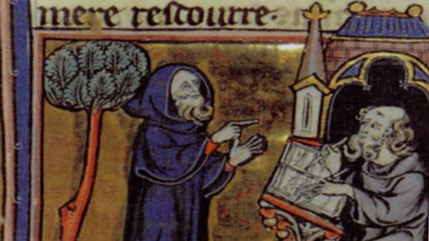

The tradition of Merlin has deep roots in Carmarthen. According to tradition he was born here the end of the 5th century. He first appears in the 6th century as an eccentric poet and he is referred to as the ‘Wild Poet’ who, today, is world famous. He had a gift of being able to predict the future. Be became famous for his ability to be able to prophesise the future.
During this early time he was a poet to King Gwenddoleu, who was the King of Welsh land South of Scotland and Northern Ireland.

Merlin, as we know him today, appears in writing for the first time in 1138 in the 'Historia Regum Britanniae’ by Geoffery of Monmouth. The author was of Welsh -Norman background and he changed the name from ‘Myrddin’ to ‘Merlin’ because Myrddin sounded too similar to the French word for manure!

It is thanks to Geoffery of Monmouth that Merlin has been associated to the folk tales of King Arthur. In doing so, today, Merlin is now a key character in the mythology of King Arthur and his tales. Merlin, over the years has grown to be a character of magical powers and talent and the mythology was that he and King Arthur had lived in North East Wales and Carmarthen also!

Until fairly recently, there stood a tree called ‘Merlin Oak Tree’ in Priory Street on the side of the main road that leads through town. It is believed that the tree had been there since 1659. According to the prophesy - Carmarthen town would flood if the this tree were to fall : "When Merlin's Oak comes tumbling down, down shall fall Carmarthen Town".

This is why the tree was reinforced with concrete and pieces of metal after it died in the 19th century. In the 1970’s the tree was moved in order to make improvements to the road as we now know today. A piece of the tree can be seen in St Peters Hall. Then, a couple of years after it’s removal, in 1987, Carmarthen suffered the worst floods since records began.

In the 19th century interest in the folk tales about King Arthur were revived with poets such as Tennyson creating work based on the tales. Also, famous artists such as Rossetti and William Waterhouse contributed towards the imagery of Camelot.

Therefore, from this time until today, Merlin has had an important part to play with regards to powerful Celtic folk tales from Wales.

Cafwyd y wybodaeth uchodd oddi wrth :-
www.bbc.co.uk/cymru/cymorth/safle/archif

