May, 2020

NAME: Consuela Simina Moise
STUDENT NUMBER: 1913406
LECTURER NAME: TANJA NATHAN

Philip Morris International

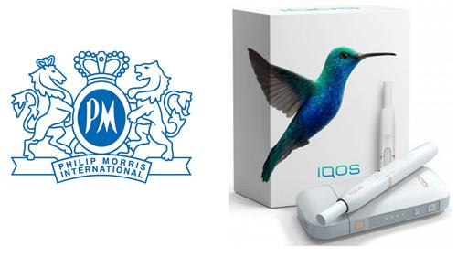

INTRODUCTION

Philip Morris International Inc. (PMI) is a Swiss-domiciled global cigarette and tobacco fabricating organization, with items sold in more than 180 nations. It is headquartered in New York, United States. The most perceived and top of the line result of the organization is Marlboro.
With the overall reduction in smoking in the 21st century, portions of Philip Morris were not, considered the "place of refuge" they once were. The organization positioned No. 108 in the 2018 Fortune 500 rundown of the biggest companies by absolute revenue.
PMI has pronounced on its landing page the aim to supplant cigarettes with sans smoke items and to "switch ... grown-up smokers" to these items as the main period of a business methodology, as a dependable choice to help "grown-up smokers" and the organizations investors and employees.
The fundamental qualities of the organization are that they have a solid condition in relation to money, established and known brand names, are endowed around prepared and different workforce, have a solid leading supervisory crew and many offers in the world's top markets.

HISTORY
Key milestones
The organization tells its story with the beginning of a London tobacconist, Philip Morris, who in 1847 opened a single store on London Bond Street, which sold tobacco and cigarettes. In 1881, Leopold Morris, Philip's son, took the lead and began to grow the business, bringing in new collaborators and investors. By 1908, Philip Morris was able to develop a well-known product called MARLBORO, which is conventional and was registered as a trademark. By 1972, Marlboro had become the company's best-known product and had the greatest success in cigarette sales worldwide. For a considerable length of time, Marlboro cigarettes were all but the equivalent of their notorious mascot, the Marlboro Man, the tough rider in the fields he rode a horse in the organization's notorious 20th-century commercials and TV commercials.
As a brand, Marlboro has positioned itself to represent a way of life of autonomy and trust. In any case, its history is unmistakably progressively tangled. The brand previously ventured into a women's cigarette in 1924. At the time, smoking was seen as a violation of social rights mores among decent ladies. In any case, numerous tobacco organizations, including Marlboro, considered female to be as an undiscovered market. In any case, Marlboro's ads were still saturated with sex generalizations. They included debutantes worried about keeping their lipstick flawless or hovering housewives who ached for indistinguishable cigarettes from their spouses.
Marlboro man
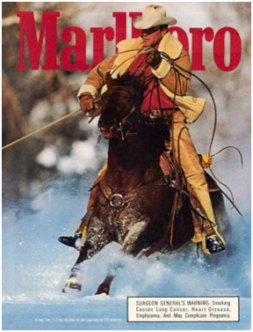

Deborah Arnott, CEO of Action on Smoking and Health, said smoking will kill one billion people in the 21st century, mostly in poor countries, and Philip Morris is a tobacco organization and benefits from the sale of cigarettes but Andre Calantzopoulos, CEO the PMI said that it may want to work with governments to "eliminate" regular cigarettes.
The government's strategy for the advancement and supply of tobacco-related items prevents the organization from forcibly presenting and advancing its articles, and this is the organisation's shortcoming.

NEW ERA OF A SMOKING-FREE FUTURE

In 2013, Philip Morris International begins to develop the IQOS project, and by 2014 P.M.I is financing the first low-risk creation, 500 million are invested to create it. IQOS is an abbreviation which means I QUIT ORIGINAL SMOKING.
PMI is piloting IQOS, its first product, in Italy and Japan, therefore a device that heats and does not burn tobacco, a low-risk and short-term product in strategic cities such as Romania, Russia and Switzerland where this new product succeeds in a few years to be successful.
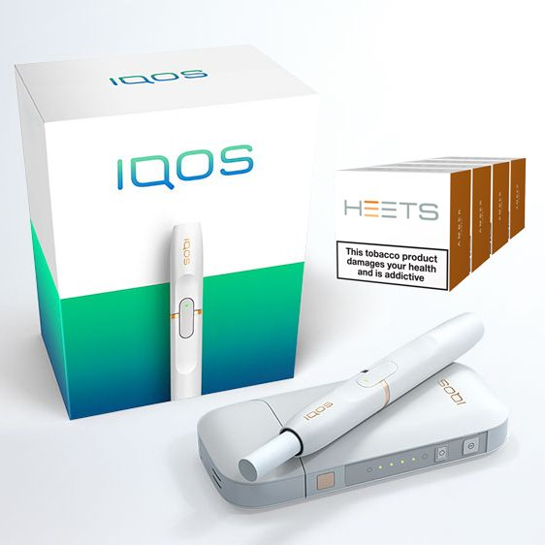
TRANSFORMATION
Delivering a smoke-free future
The name "Philip Morris International" or "PMI" most likely refers to the "tobacco organization" and "cigarette manufacturer". However, today, they are significantly more than that. The truth is that they wanted to change their organization and mark the future of replacing cigarettes with smoke-free options. A total of more than 1 billion cigarettes will be smoked and, according to the World Health Organization, there will be, in any case, more than 1 billion smokers by 2025. Philip Morris International must offer those of these billions or more smokers who do not stop, preferred alternatives to continue smoking.
IQOS is definitely a bonus of this cigarette organization as they increase the tobacco arcade and were also an opportunity to be the first tobacco company to come up with such an innovative product on the market. They are willing to change society and convey a superior, sans smoke future. To make their vision a reality they were changing and marking the whole future on a line of sans smoke items. This is the greatest move throughout the entire existence of Philip Morris International. Providing a smoke-free option has been taking numerous years really taking shape, and thanks to the creative mind and persistence of thousands of individuals at PMI, it is been created sans smoke items that are better options in contrast to cigarettes.

SCIENCE
Since 2008, Philip Morris International, put more than USD 7.2 billion into the science and research of creating sans smoke items, and they utilized in excess of 400 world-class researchers, architects and professionals to support them. So as to show that changing to risk reduced products brings about a noteworthy decrease in the danger of malady contrasted and kept smoking, they are following a thorough logical appraisal program. The program applies very much perceived practices in toxicology, just as an inventive Systems Toxicology-based way to deal with hazard appraisal. Evaluation program covers the full range of exercises from starting item improvement to the checking of these items once they are available.
-mounting product
-research laboratory revisions
-experimental studies
-purchaser procedure investigation
-long-term valuation

ENTERPRISES
The maintainability of a tobacco organization begins with tending to the negative wellbeing effects of its items this implies, above all else, creating and commercializing less unsafe options in contrast to cigarettes while dealing with our social and natural effects over our activities and worth chain. In 2016, PMI promised to make the world sans smoke and they went to Cannes to help conversion the lives of one billion individuals who smoke. They needed to motivate the best innovative minds on the most powerful stages to go along with us on this strategic they felt that smokers merit precise data pretty much the entirety of the choices accessible to them, which incorporate choices that present less danger of mischief. PMI needed to change the organization from the back to front to accomplish a vision of a without smoke future, so they chose to open the inventiveness and development inside their workforce, utilizing incorporation and assorted variety to achieve their central goal.
PMI was the main worldwide organization to acquire the EQUAL-SALARY name in Switzerland in 2015. (The EQUAL-SALARY Foundation is a free, non-benefit situated in Switzerland. The EQUAL-SALARY Certification confirms that associations have supportable approaches and practices to guarantee that they pay their male and female representatives similarly for equivalent work.)
According to Melissa Whiting they needed to encourage trust among their representatives and future ability by making a working environment established on reasonableness, incorporation and assorted variety which are fundamental elements for their business change.

CAREERS
Philip Morris International is a top universal tobacco organization with a workforce of approximately 73,500 people from all over the globe.
PMI items are sold in more than 180 markets. Philip Morris International is a major universal tobacco organization with a diverse workforce of approximately 80,000 people from all over the globe.
They are focused on being an incredible business and a decent corporate resident and try to be able naturally and socially, in addition, they are dedicated to fighting against the illegal exchange of cigarettes. Moreover, they support the networks in which the source of tobacco is located where the representatives live and work.
They are committed to achieving something sensational - replacing cigarettes with them without smoke objects that are being created and sold now. That is why they have more than 400 dedicated researchers, specialists and experts who grow less safe options, in contrast to cigarettes from two research and development destinations in Switzerland and Singapore.
PMI has been asserted as a "top employer in Europe" for four years and unprecedented for the Middle East and Africa, in recognition of the exclusive demands of greatness in the workplace and the extraordinary openings it offers. At PMI, everyone has the chance to have any kind of effect and create outstanding professions. Within excess of 1000 cross-practical moves a year, the open doors for experience are unending. To help workers' self-awareness and to expand the business and practical information, they give a wide scope of advancement exercises and apparatuses.
• On-the-work improvement exercises are the best learning techniques. Give a rich domain to an assortment of encounters.
• Off-the-Job improvement exercises go from instructional classes to proceed with training.
• Internal Training Programs, for example, study hall preparing, e-learning and inside accreditations, are given to workers.
• Internal Development Initiatives bolstered by supervisors and associates support advancement through exercises, for example, instructing, tutoring, and 360-degree input.
• External Development Activities, for example, study hall preparing, e-learning, and outer accreditations are conveyed by outside suppliers.
Philip Morris is known as extraordinary mentor. Representatives have 3x3 instructing meetings, protective drive courses, deals, arrangement, item preparing and extends in which they effectively partake with new thoughts.
This is an IQOS store
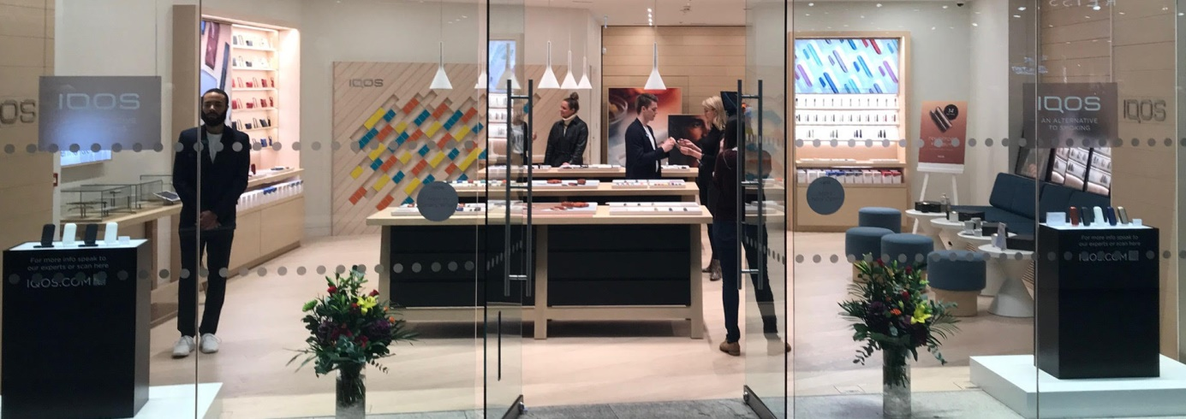
The IQOS store is characterized by the action of sales specialists in this store, which includes the introduction and advancement of the item and accessories identified with the brand, and their main purpose is to convert conventional smokers to the new less harmful smoking mode.
PMI connects just in dependable deals and showcasing and advancement exercises and sells capably and just too grown-up smokers and it connects just in dependable deals and advertising and advancement exercises and sells mindfully and just items and special exercises and offers are planned for adults who smoke or have changed into non-smoking items. This is complemented by in-store sales experts who have been trained and consider the required regulations, as well as the methods established by those responsible for sales practices. The appearance, attitude and communication of the experts are also important, as they represent the brand image. At the same time, it is imperative that the correct information is shared, for this they have frequent training with their superiors. Open trust in PMI is significant for long-term business advancement. So, in order to maintain this trust, every external correspondence, formal or casual, must be true, appropriate and not misleading.
The biggest danger is that the government's standard of banning transactions in tobacco-related products to people below specific age limits and the various principles identified with an open-air smoking ban may reduce tobacco offers. As an innovator in the tobacco business, PMI adds to forestalling the utilization of our items by minors. All showcasing exercises must experience procedure counselling. Since an exclusive expectation is met, this procedure consolidates trust and regard for one's judgment and imagination with a legitimate confirmation. When PMI checks the proposed advertising exercises, it includes individuals with various capacities and with various encounters.
The activity must proceed according to the management plan; therefore, they have a team leader.
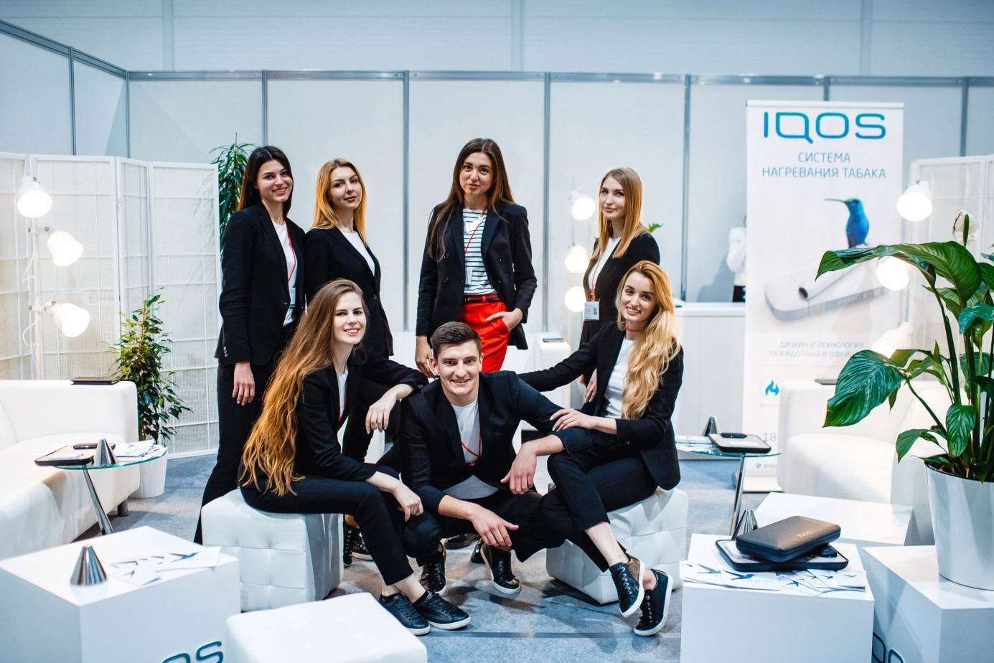

TEAM LEADERS OR SUPERIORS
All leaders need to ensure that their groups know and understand the PMI guidance, principles and practices that apply to their position, as it is reasonable and predictable. Also, these individuals do not hesitate to make a move on issues of consistency and morality and anticipate that their interests must be listened to by the organization.
Representatives show respectability in their work if they act with confidence, reasonableness and respect.
A good leader should maintain a proper culture, which is a significantly more difficult task than passing on to workers on a regular basis but most importantly he must have a certified soul of the initiative. It has to show what respectability means in real life. The trust of the group can be ensured by talking about important topics for the organization and people, asking questions, adapting what they have to say and acting similarly.
Being a pioneer must help motivate their roofs to adapt, creating a network soul and propelling productive difficulties. The way they complement each other as a group, the notoriety for authenticity, the reasonableness of the association, in terms of partners and buyers, the visualization of corporate strategies, the pressure of rivalry and even gossip, all contribute to a positive or negative approach to a corporate culture which depends on the management of others. Leaders have a unique obligation in terms of shaping the corporate culture and workplace of the groups they lead.

REFERENCES
- https://www.pmi.com/who-we-are/designing-a-smoke-free-future, https://www.pmi.com/who-we-are/our-goal-and-strategies

- Tiffany Kary (April 17, 2019). "Philip Morris Says It Doesn't Want You to Buy Its Cigarettes", Bloomberg accessed may 17, 2020

- Zlata Rodionova (30 November 2016). "André Calantzopoulos said he would like to work with governments towards the 'phase-out' of cigarettes", The Independent, accessed may 17, 2020
- Felsted, Andrea (27 September 2018). "Has the Marlboro Man Gasped His Last?". Opinion. Bloomberg.

- "Fortune 500 Companies 2018: Who Made the List". Fortune. Retrieved 10 November 2018.

- https://www.businessinsider.com/marlboro-man-cigarette-brand-history-vintage-ads-2020-2?r=US&IR=T accessed MAY 16, 2020

- https://www.pmi.com/our-transformation

- https://www.pmi.com/our-science

- https://www.pmi.com/our-initiatives

