Learning in the digital era

Theo Tiencken
2534156
E-portfolio creation
Computer networking and cyber Security
Table of Contents
E portfolio 2
Task 1 3
Task 1a 3
Task 1b 4
Task 1c 5
Task 2 Mind-Map and Academic poster 6
Mind-Map 6
Academic Poster 7
Refworks Automatic referencing tool 8
E-portfolio review 9
Page 1 E-Portfolio 10
Page 2 E-portfolio 11
Page 3 12
Page 3 13
Page 4 14

E portfolio
Here is a link to the Eportfolio = https://theotees.co.uk/#
Here is a Photo of the Home page of the E-portfolio - 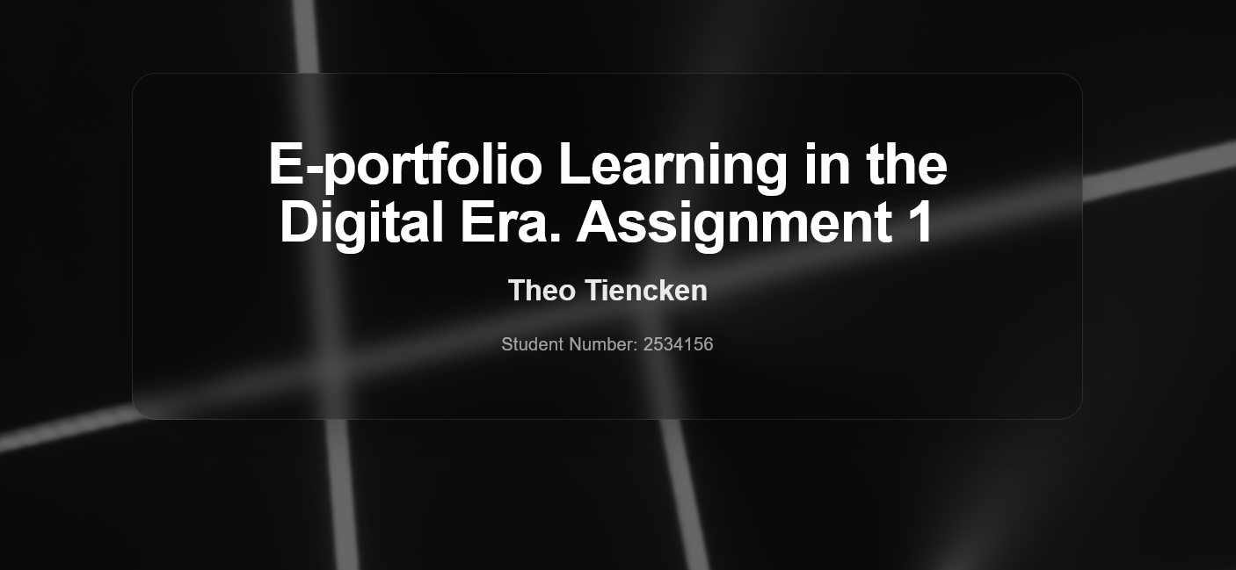

Task 1

Task 1a
Here is a photo of task 1a 1b and 1c in my web page. Detailing key employability skills which are important for the workplace as well as showing my ability to reference sources.
Below is a photo of task 1a on my webpage

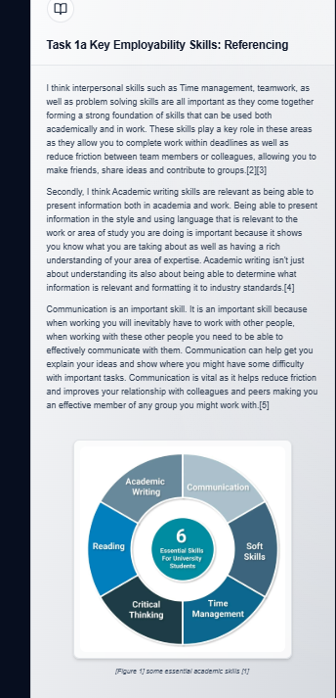

Task 1b
Below is a photo of task 1b in my E-Portfolio
This task went into how A.I tools can help me in my career as a Social Media Manager for my company. This shows a written account of how I believe it could help along with two generated images showing how.
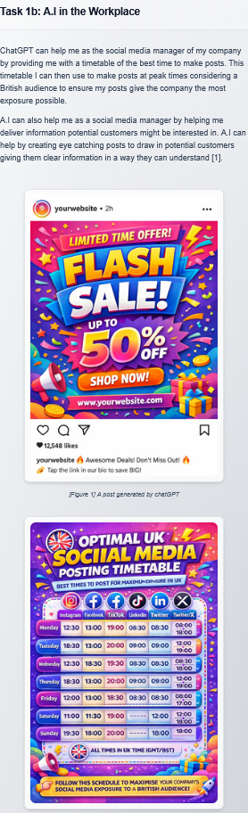

Task 1c
This task was a self-reflection on the previous two tasks. I had to assess my work after submitting it into a TURNATIN submission link in which it gave me similarity score.
Photo of task 1c in my E- Portfolio-
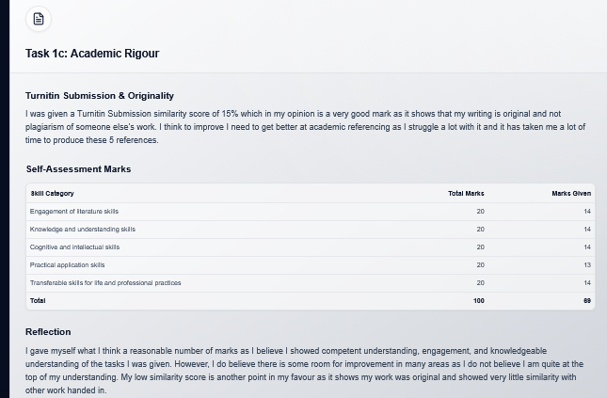

Task 2 Mind-Map and Academic poster

Mind-Map

Below is a photo of the collaborative Mind-Map which Myself, Collete Owens, Kyle Hall and Morgan Jenkins worked together to make.
Here is a link to view the mind map online www.mindmeister.com/app/map/3930377728
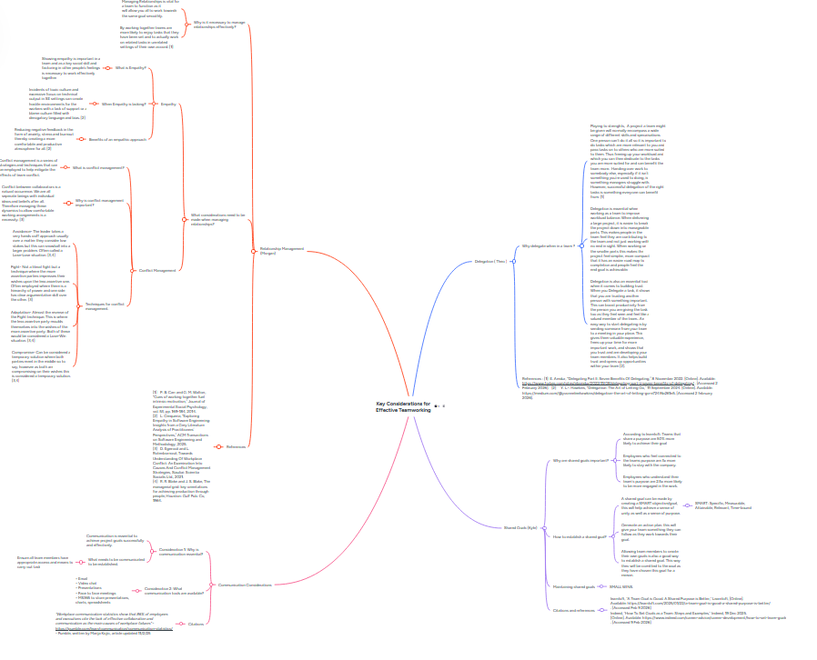

Academic Poster

Here is a link to my Academic Poster LDE poster completely finished final .pptx

Below is a photo of my Academic poster. 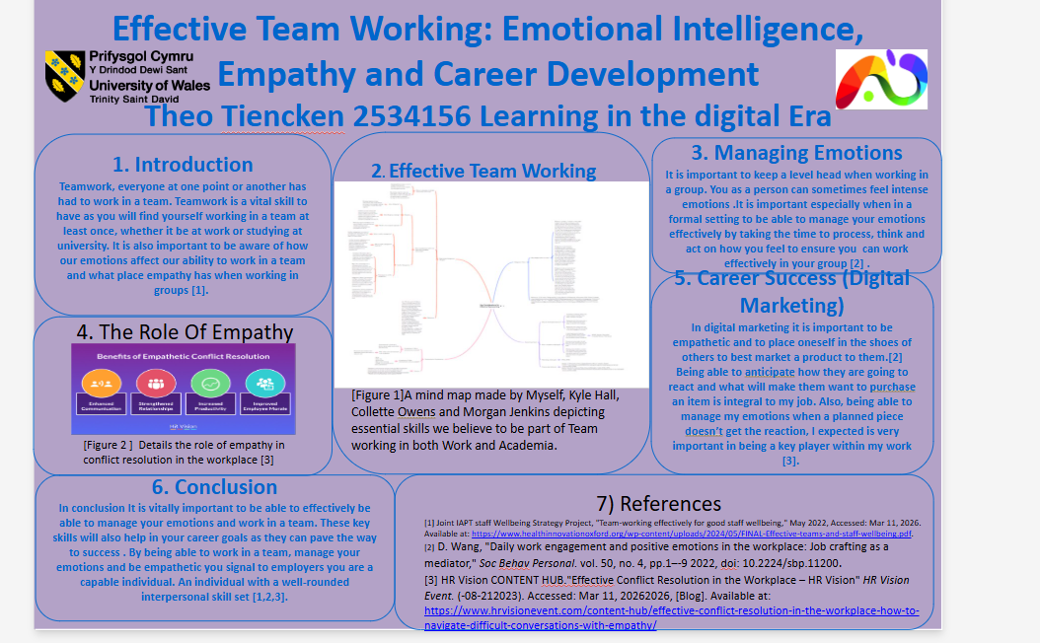

Refworks Automatic referencing tool

Below is a screenshot which documents my use of the reworks referencing tool to compile references and add sources.

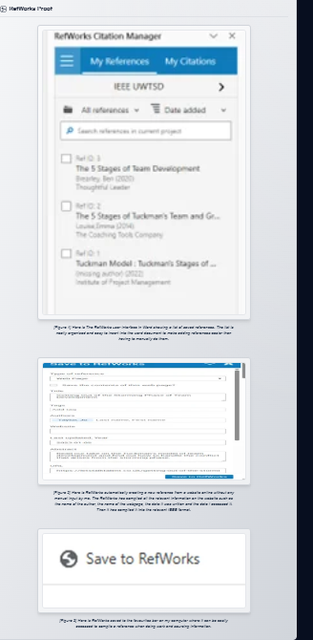

E-portfolio review

Below are photos of the different pages of my E-Portfolio. These include the landing page, Task 1, Task 2, Task3 and 4.
Below is the photo for the landing page of the E-Portfolio


Page 1 E-Portfolio

Below is a photo for the first Tab of the E.portfolio

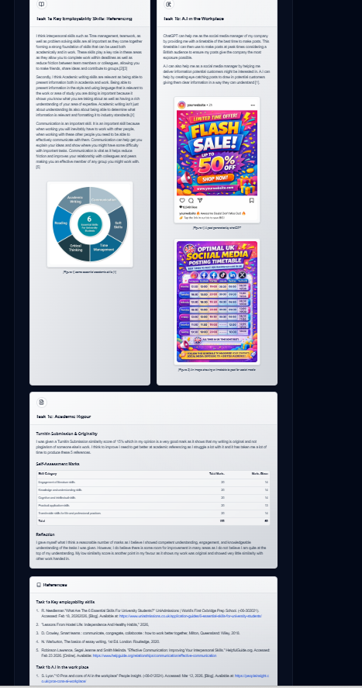

Page 2 E-portfolio

Below is a photo for the second page of the E-portfolio.

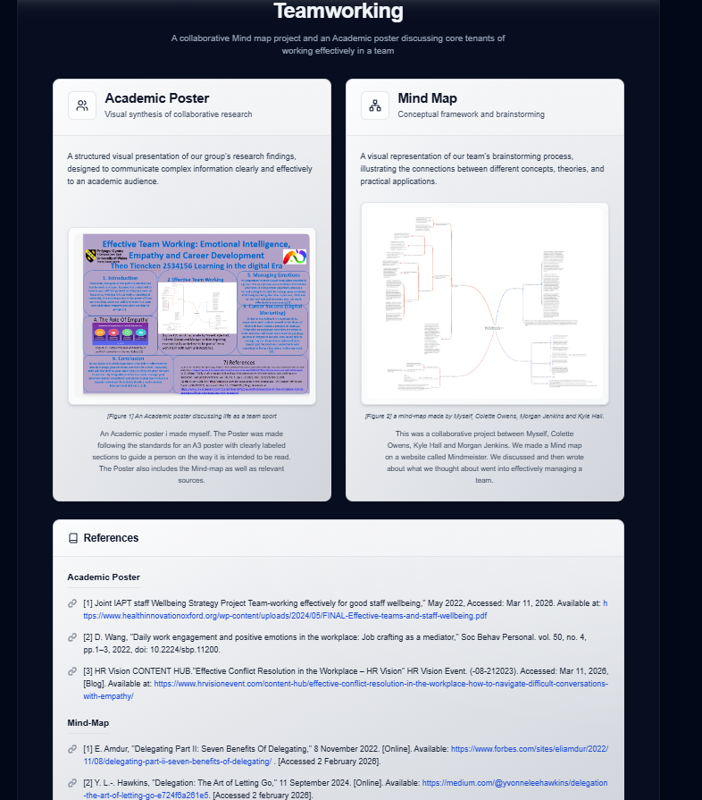

Page 3
Below is a photo for the 3rd page of the E-portfolio. This photo shows proof of the Refworks referencing tool.

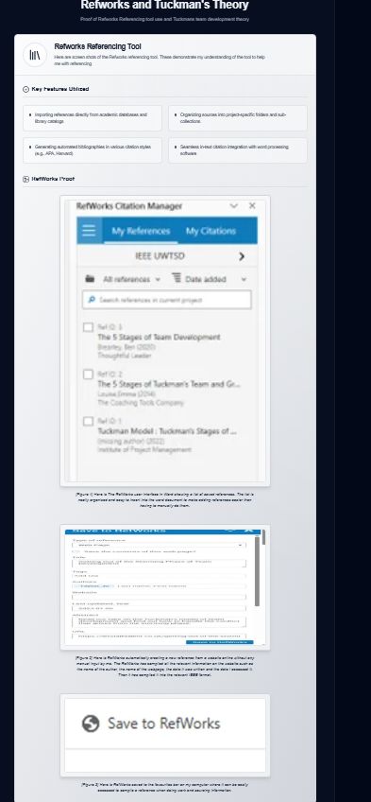

Page 3
This photo also shows the 3rd page of the E-portfolio but shows the Tuckman’s Theory of team formation.
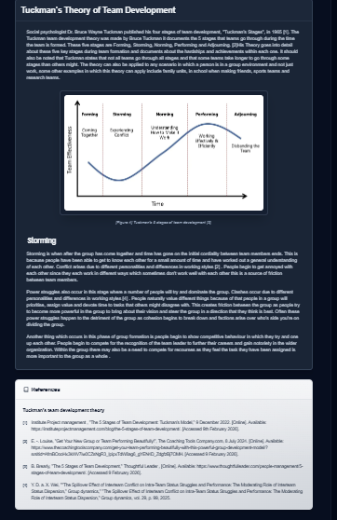

Page 4
This last photo shows the 4th and final page of my E-Portfolio. Detailing why I chose Hostinger.com to make my website


