Strategic Management for SMES
BMSW6104
Lecturer – Paul Bocij
Student – Rume Meah
Student ID – 1813924



Table of Contents

- Introduction 4
- Current Strategic Direction 5
2.1 Current strategy 7
3. Porters Five Forces 8
3.1 Threat of new entrants 8
3.2 Buyer bargaining power…………………………………………………………………………. 9
3.3 Threat of Substitutes………………………………………………………………………...…..10
3.4 Bargaining power of suppliers…………………………………………………………….……10
3.5 Rivalry between competitors………………………………………………………….………10 4. Value Chain……………………………………………………………………...……………………11
4.1 Primary Activities………………………………………………….…………………………….11
Customer Operations……………………………………………………………..……………11
Inbound Logistics………………………………………………………………………..…..…12
Outbound Logistics…………………………………………………………...…………..……12
Marketing & Sales…………………………………………………………….………..………13
4.2 Secondary Activities……………………………………………………………….…..………13
Infrastructure…………………………………………………………………….….……..……13
Human Resources…………………………………………………………………..…………13
Technology Development………………………………………………………...……..……14
5. Balance Score card………………………………………………………………….…..……..……14
5.1 Analysis – Key Findings………………………………………………………….……………15
6. Environmental Analysis……………………………………………………………………..………16
6.1 PESTLE Analysis….…………………………………………………...………………..……16
Primary Factors……………………………………………………………..………………..…17
6.2 SWOT Analysis …………………………………………………………..……………..……18
Advanced SWOT…………………………………………………………………………..……19
6.3 VRIO Analysis ……………………………………………………………….…………..……20
VRIO……………………………………………………………………………….…..…………21
6.4 Ansoff Matrix ……………………………………………………………………..……………22
7. Stake holder Mapping………………………………………………………………..………………23
7.1 Gram Bangla - Stakeholder power/ interest……………………………………….…………24
8. Strategic Growth Options……………………………………………………………………………26
8.1 Option 1: HR and Logistics expansion ……………………………….………………………26
8.2 Option 2: Cool room investment ……………………………………………………………26
8.3 Option 3: Change customer direction …………………………………………………..…27
SAF Matrix……………………………………………………………………………………27
9. Developing Business Level Strategies…………………………………………………….……28
9.1 Resistance to change…………………………………………………………..……………28
9.2 Human Resource Expansion…………………………………………………………….…30
10. Competitor’s reaction to Strategic change………………………………….…………………31
11. Conclusion………………………………………………………………………………….…….32
Increasing workforce…………………………………………………………….………………32
Sustainability of Produce…………………………………………………………….…….……32
12. References…………………………………………………………………………..…….……..33

- Introduction

This report will critically appraise the current situation of Gram Bangla Wholesale. Once this is determined, a strategic plan will be devised, to enhance the position both in value and longevity of this business.

Gram Bangla Wholesale Ltd, is based in the outskirts of Birmingham City centre, this company sells fresh produce sourced from overseas, primarily Bangladesh, India, Thailand, and Malaysia to local retailers. It is relatively a new company in comparison to the competitors based in Birmingham, who have been in business 15+ years. Gram Bangla commenced in October 2018 (pre covid) with 2 employees and has steadily been making a mark on the local cliental, this is primarily due to the fact the Director has been in the business for over 10 years, as an ex-employee for some of the current competitors, so he is already a very well-known established salesperson within the business.

Making a profit as a Fruit and Vegetable wholesaler is very hard due to various reasons one being that larger competitors can “undercut prices” to strategically “squeeze” the smaller competitors out of the business, especially in the peak of the Covid pandemic however, Gram Bangla has been fortunate enough to keep afloat due to minimal costs and help provided from the Government. Due to the size of Gram Bangla, increasing employees will be beneficial to sustainability of the business, ways to recruit staff and maintain staff will be explored.

- Current Strategic Direction

Strategic planning is a management tool which establishes a direction for businesses to take. It pushes businesses to clarify objectives, providing a framework in allocation resources in line with the company’s mission and vision (Boyne, 2010). Studies suggest that Strategic management positively correlated with financial performance, however it may impact innovation within the business. Structural choices, limit the empowerment and incentives in employees, impacting outcome (Arend et al, 2017).

This report will use primary/ secondary data to ascertain where Gram Bangla is now. Implementation of the Strategic management process (fig 1) analysis will identify key areas required to generate an advantageous level of competitiveness for Gram Bangla (Voloshina, 2014)

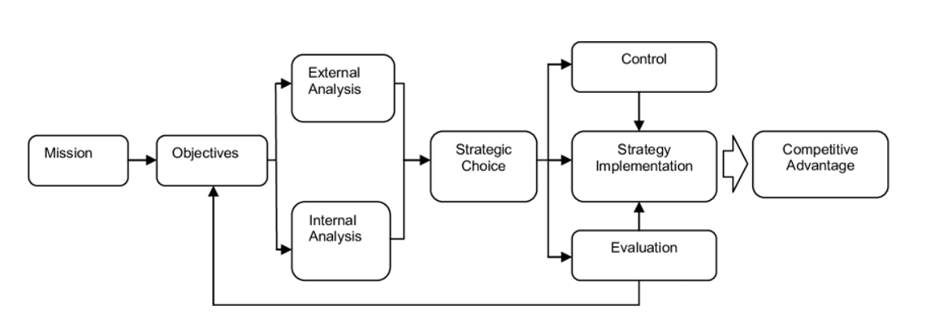
Figure 1: “The strategic Management Process”

Gram Bangla is a small company with 2 employees, their cliental focus is central Birmingham and its surrounding areas. (Fig 2).



Figure 2: Geographical Reach (Source - Google Maps, 2022)

Gram Bangla does not at present have a specific mission or vision in place, this has not been a factor due to being a small business with two employees, however this will be advised once we recognise the functionality of the business. The primary reason for starting in business was to have a guaranteed basic monthly income and covering overhead costs, by staying afloat with minimal income. During Covid this approach has been positive, however if there was no Government handout, then this method would have been detrimental to surviving in the long term.

  - Current strategy

Gram Bangla have acquired customer within their geographical reach, high street shops in Asian areas are targeted. Customer requirements differ to the size of a business, at present Gram Bangla adapt their customer services to incorporate their customers business demands. (fig 3),

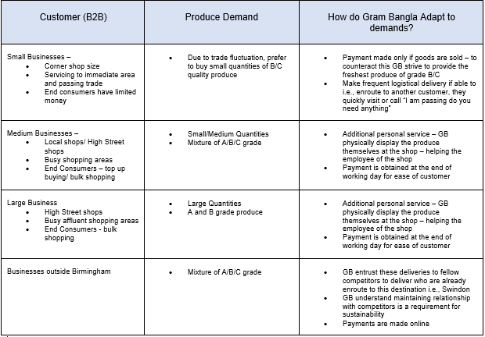
Figure 3: Structure of How demands met

This approach been successful, however for the longevity of the business it cannot be sustainable with minimal employees. Should employees become unwell, it will impact the business. One employee can only manage so many customers and will lead to loss to customers. At present when an employee of unwell, they make alternative arrangements to deliver produce into the market through communication with customers, who will pick up produce direct from the warehouse, however if this does not happen then the business will be in standstill, effectively losing out in sales and detrimental to the quality of produce and cost. When this occurs, the company sells to other wholesalers at either cost price or at a loss.

- Porters Five Forces
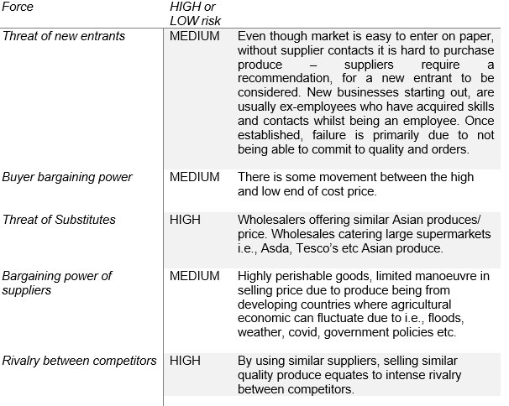

  - Threat of new entrants
New entrants can easily start a new business, which requires registering with a bank, government bodies – DEFRA, Cargo agent, there are no additional requirements. The main barriers are acquiring suppliers, who require recommendations from affluent people (usually competitors) already in the industry to vouch for the new entrants. This is a barrier as businesses are less likely to endorse new competition. Acquiring customers that already have a supplier in place, is another barrier unless you can provide a better product/ price, getting your foot in the door will be hard. New entrants tend to find a supplier who is also new to the business (usually an ex-employee of the supplier who has branched out on their own), this is hard to sustain as both parties are new to running a business and financial constraints provided added problems into effectively managing the business. This is reflected in the report by Statista, between 2008 to 2019, there is a 0.5% increase in businesses (fig 4). There is minimal increase in this industry.

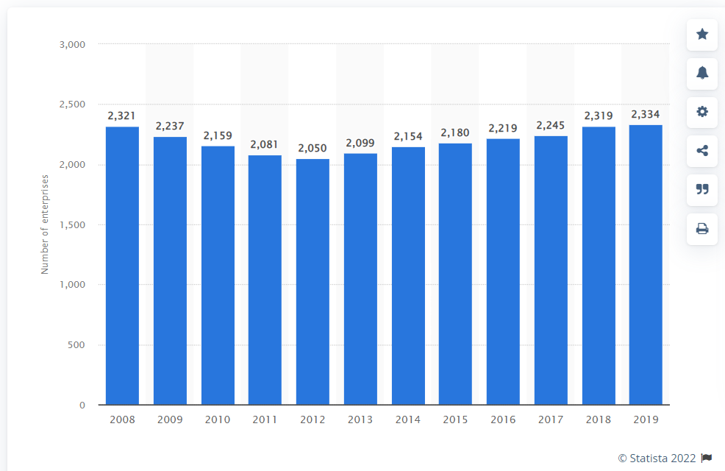
Figure 4: Number of Enterprises for the wholesale of Fruit and Vegetables in the United Kingdom from 2008 to 2019 (Statista, 2022).

3.2 Buyer bargaining power
Larger companies use the buyer forced application, which obligates the supplier to not sell to another company at a reduced price, so they are not placed at a product cost disadvantage relative to another retailer. Also, exclusive supply agreements deny other companies access to the supplier’s produce, which may allow the company to gain a produce differentiation advantage over its competitors. Businesses buying from the same suppliers make a direct impact on Buyer bargaining power. Intense rivalry between competitors can drive down or elevate costs, this affects the power of buyer’s ability to influence the supplier in terms of the profit margin. Regular buyers incur build-up of credit over time and suppliers are unable to break away from financial obligations. This provides buyers a leverage in exploiting their supplier, through securing financial advantage, this either results in the supplier being financially bonded to them or they cut their losses. However, this questions the buyer’s integrity and overall future sustainability of their company due to lack of trust. However, this is not favourably looked upon in the industry as credibility is required for consistent loyalty within the supply chain.

3.3 Threat of Substitutes
The customers of this industry prefer to buy from ethnic grocery stores, as they have access to various fruits and vegetables under one roof. Larger retail stores such as Tesco’s and Asda have expanded into selling ethnic foods, however their price is higher than the Asian high street grocery stores. Inherently consumers assume that buying fresh fruit and vegetables will provide vitamins and nutrients, however studies conducted have revealed that frozen fruit and vegetable have higher nutritional levels of vitamins and antioxidant compounds after storage (Gray, 2013). Environmental change i.e., Covid, will affect future buying trends which will affect supplier and wholesalers.

3.4 Bargaining power of suppliers
Negotiations between buyers and sellers may not arrive at the equilibrium price that is controlled by supply and demand conditions. Price fluctuates day to day dependant on the supplier’s agricultural climate, price discovery is dependent on quality, which segments into grading. Due to this, bargaining power is limited because there are many agricultural barriers that suppliers face from developing countries such as India, Bangladesh, Thailand, and Malaysia. Fresh fruit and vegetables are highly perishable items and have a limited shelf life. Majority of India’s agricultural economy is made up of small farms, due to credit market constraints, they are unable to exploit the productivity and cost saving by not investing enough in mechanization (Foster & Rosenzweig, 2010). Studies have reflected that factor such as lack of training, finance, policy, infrastructure, and market intervention, directly affect post-harvest loss reduction in South Asia (Stathers at al. 2020). India’s central government are inconsistent in their import export policies impacting famers adversely (Ministry of Agriculture Department of Agriculture and Co-operation Government of India, 2013).

3.5 Rivalry between competitors
Gram Bangla has been effective in maintaining its position in the market, due to being able to sell a variety of produces. Customers are likely to buy from one supplier who can cater for all their demand than buy different produces from separate companies. The large competitors have a greater geographical area to cover, their buying tactic is to bulk buy produce in demand, however they invest less in variety, the difference is made up by buying through other wholesalers (competitors). However, collaboration between competitors is required to sustainability in business. Healthy competition is good for motivation, research has shown that the presence of a competitor increases physical effort over short/ long durations (MiMenichi & Tricomi, 2015)

Gram Bangla has currently changed its market segment strategy by selling the more expensive products. which have a better sales margin, in large quantities i.e., Durian and Jackfruit. They have branched out from their usual Indian, Bangladeshi customers to the Vietnamese community.

- Value Chain

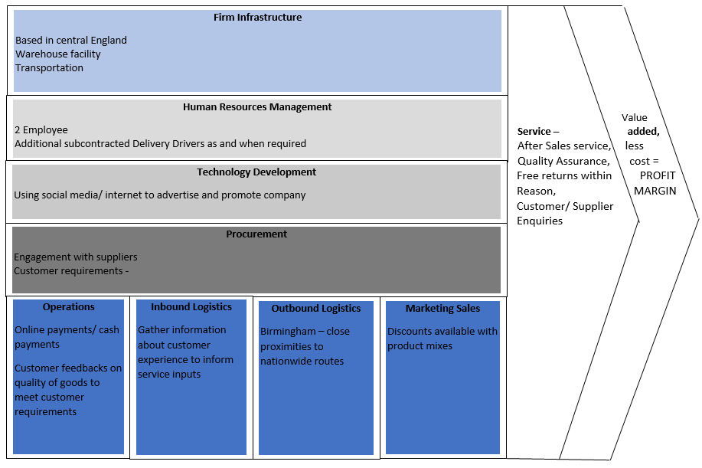

  - Primary Activities

Customer Operations
Each customer is catered for their demands (fig), for time management Gram Bangla obtain payment at the end of the day, when business is less busy. The produce is sold during the duration of the customers business hours, excellent quality produce has longevity and maintains its sale price, however if produce is sold at a lesser price due to quality, Gram Bangla makes good of negotiating a mutually beneficial price at the end of the day, this maintains customer satisfaction.

Inbound Logistics
Customers place orders with Gram Bangla, who purchase directly from Suppliers aboard – India, Bangladesh, Thailand, and Malaysia. This is done once a week for relevant supplier (fig), and this process revolves every week. Once shipment arrives, it is collected and delivered to Gram Bangla’s warehouse.

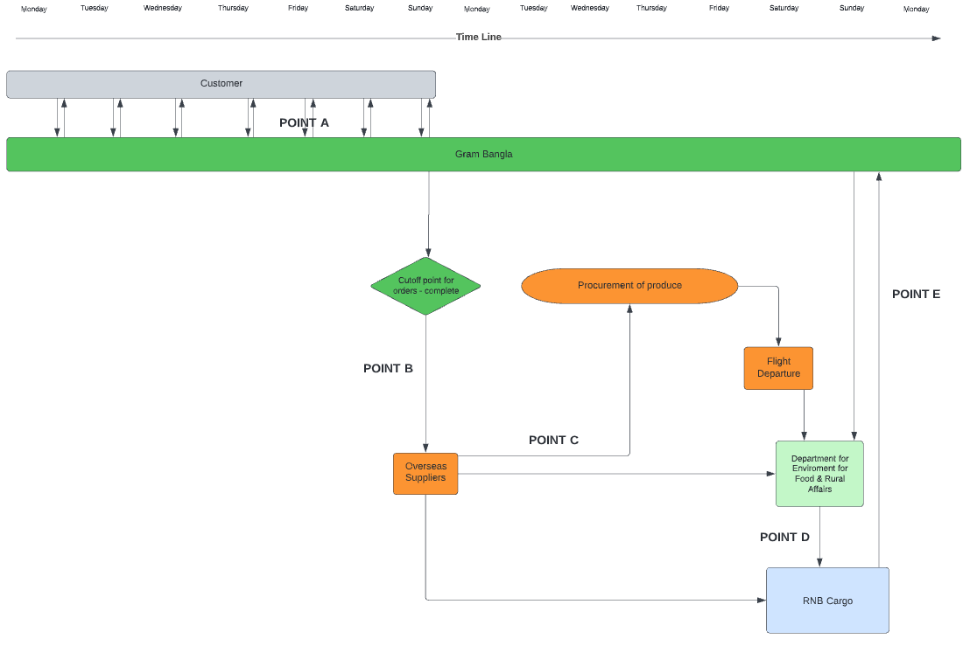
- Point A – WHATSAPP/ PHONE - Order UPDATED each day
- Point B - WHATSAPP Order sent o supplier manager
- Point C - EMAIL - Shipment details to DEFRA and RNB Cargo
- Point D - EMAIL - Cargo checked and released to RNB Cargo
- Point E - WHATSAPP - Release reference sent to GB to pick up from airport and unloaded at Gram Bangla’s Warehouse

Figure 5: Supply chain management

Outbound Logistics
Petrol is filled night before business day. Stores open at 8am, Gram Bangla’s drop off delivery starts at 7.30 and routes are made systematically according to geographical area. GPS is used to navigate through areas of heavy traffic congestion.

Marketing & Sales
Gram Bangla have acquired customers since he was already known in the industry, and they have never advertised or promoted themselves through a social platform. They can create a social media platform to market their business, to further attract customers. however, this can only be done once they increase employees. Gram Bangla has an exceptionally good after care for customers as they cater for each customer’s individual need through negotiation. Gram Bangla differs in negotiation tactics when acquiring new business, here they give more onus on the customers preference in price (within reason).

4.2 Secondary Activities

Firm Infrastructure
1 van and 1 warehouse in central Birmingham, this is very ideal location in terms to nationwide reach. Being central in the UK provides good accessibility to surrounding reach.

Human Resources
Gram Bangla does not have HR policies in place. When recruiting employees, it is not cost effective to use recruitment agencies, so employees are generally recruited through word of mouth, and contacts.

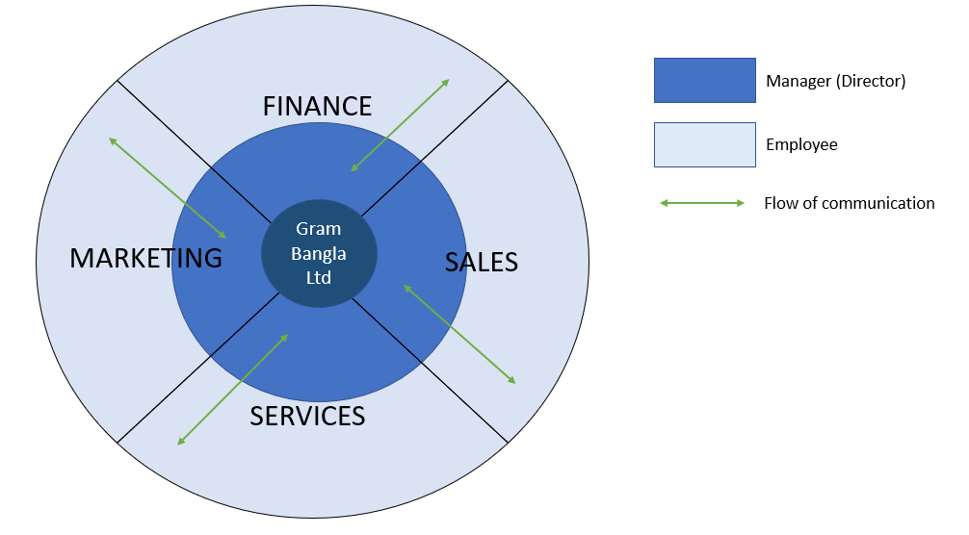
Circular Organisational Structure

Technology Development
Gram Bangla’s use of technology is basic, social app WhatsApp, email and phone, and face to face conversations are the only communication methods used. However, Technological advancement is the future, all industries are using this for innovative ideas, it is not beneficial for Gram Bangla to not make full use of its potential, implementing IT in customer purchase will reduce time and benefit the company. R and D is required to further implement this strategy. It is essential to further develop opportunities considered value for customer needs, than meeting demands (Lynch, 2018). It is mutually beneficial in streamlining customer purchase delivery time through IT innovation.

- Balance Score card
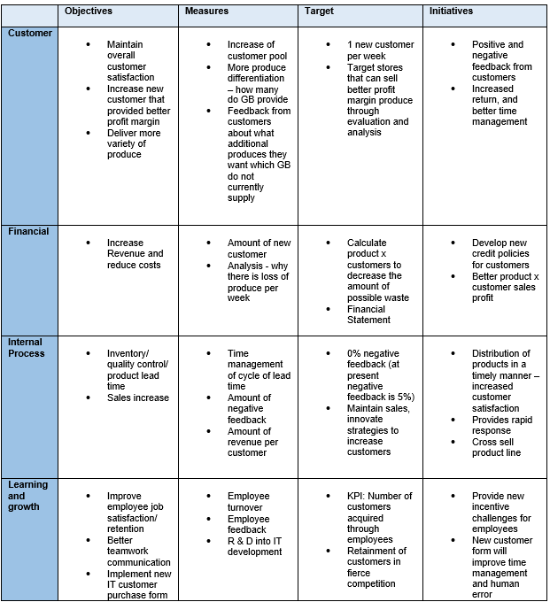

5.1 Analysis – Key Findings
The mission, vision can be interpreted by the customer service that is already provided. The cliental base has been growing steadily through tacit and practical knowledge of the running of the business - supply and demand chain. Customers advise what their requirements are and in turn overseas suppliers are contacted and orders are placed at wholesale prices, at the best possible prices for the stakeholders, so that everyone takes away a positive experience. Mission and Vision (fig 6) are based on the company’s gradual expansion, which are holistically implemented.

As a small business there are advantages in being able to provide customer centricity. A unique approach to each individual customer, having closer customer contact, enables Gram Bangla to take immediate corrective actions. However, this approach will only maintain a level of customer loyalty and does not necessarily increase your sales/ cliental. One approach to increase cliental would be to increase employees. Two employees can only work limited hours, even if you provide great service, you can only achieve a certain amount of productivity. At present Gram Bangla’s employees do everything themselves from purchasing to selling. There is a labour productivity gap, which is detrimental to company growth. Increasing workforce will increase sales and geographical reach.

Figure 6: Vision and Mission

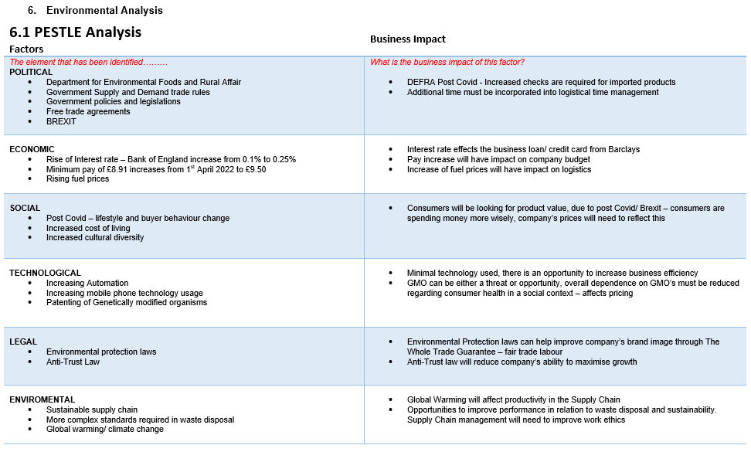
Gram Bangla Wholesale Ltd is a small company and requires a business analysis to ascertain where they are currently are in terms of market growth and where their can extend their profitability to enhance their sustainability within the market. The strengths indicated are viable to any new business in this area however it is how you manage these strengths that provide longevity in the business.

Primary Factors
- Government legislation in trading can change due to the current Covid climate.
- Global warming will affect supply chain - suppliers are from countries where environmental climate impact quality of produce.
- In 2015 UK imported 9.5 million tonnes more products than they exported (fig 7) UK, Russia’s decision to stop petroleum to the UK has surged prices, Gram Bangla will need to better strategize their current routes for optimum logistical efficiency.
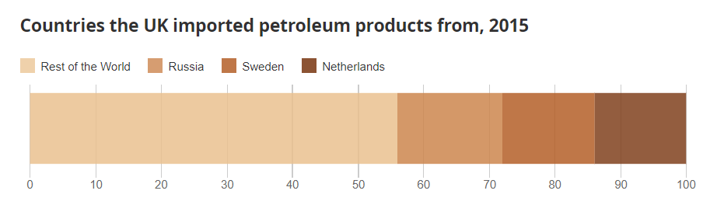
Figure 7: Source: Office for National Statistics, UK Energy: How much, what type and where from? 2016

- The rise of living cost is increasing, this will impact the end consumers, Environmental changes impact consumer buying trends, stock piling has become more common, this may mean, end consumers buying more non-perishable foods, impacting Gram Bangla.

6.2 SWOT Analysis
Weaknesses – Internal
- Products are highly perishable
- Goods that are not sold are either sold at lower cost value or thrown away
- Due to being a small company – competitive edge with larger companies will be limited
- No Social Media Presence
- Produces dependent on seasonality of Fruit and Vegetables sold
- Workforce size is minimal = manpower limited
Threats - External
- Imported products – likeliness to be held in airport to be checked, effects the freshness of produce
- Increase of fuels prices and vehicle maintenance – sustainability
- Customers are not prepared to pay higher prices to support smaller businesses
- Undercut prices from competitors – fierce competitiveness
- Suppliers – quality of produce is dependent on weather – unreliable
- Changes to government requirements on imported produce – Department for Environment, Food and Rural Affairs (DEFRA)
- Threat from Substitutes – Frozen vegetables
Strengths - Internal
- Freshest produce available
- Low start-up cost
- Market size is flexible
- Access to quality products
- Business location – good access to all areas in UK due to being based in Midlands
- “Cost of Goods Sold” is low
- Able to provide customer centricity

Opportunities - External
- Branch out to all seasonal fruit and vegetable
- High demand in exotic produces
- Online retail – free mentoring workshops available
- Expand nationwide
- Provide extra services – sell dry produces in conjunction with fresh produce
- Decrease non-seasonal produce prices, counterproductive with mark up on seasonal produces - so no loss occurs
- Government grants available for small businesses (post Covid)
- Investment in HR, Marketing
- Incorporating IT – performance parameter, traceability, better data visibility, reporting
- Cross collaboration with IT - data can be used to design communications application

Gram Bangla Wholesale Ltd SWOT
Analysis

Advanced SWOT
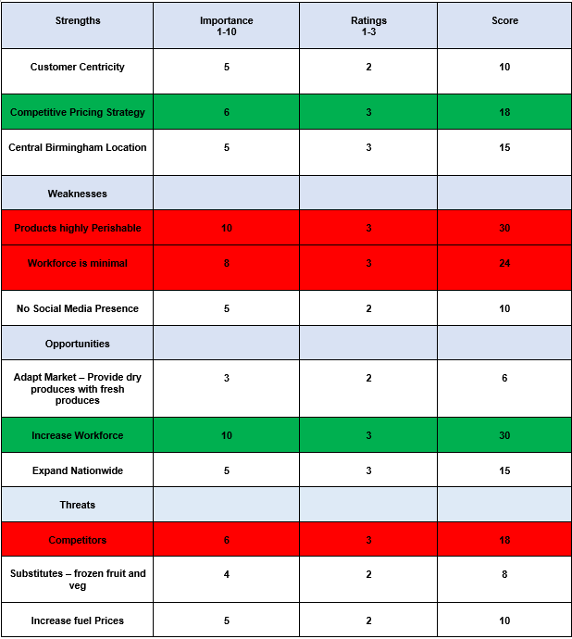
Industry competition is intense, advanced SWOT has identified increasing employees and quality of produce vital for business sustainability. Competitive pricing strategy can only be maintained if your produce is of quality, for optimum price margin. Workforce size is too small to sustain, opportunities can only be implemented if Gram Bangla increase workforce. At present social media is not used as a strength, it has been noted that competitors that have social media presence are not using it as a marketing investment but rather to show presence. They are primarily basic and do not update at all.
6.3 VRIO Analysis
VRIO framework is a tool for internal analysis, it focuses on business resources. It incorporates two theoretical frameworks which are the positioning prospect and the resource-based view (Barney & Hesterly, 2019). This framework helps highlights competitive strengths and weaknesses; it defines 4 attributes (fig 8) that companies must have to sustain competitive advantage.

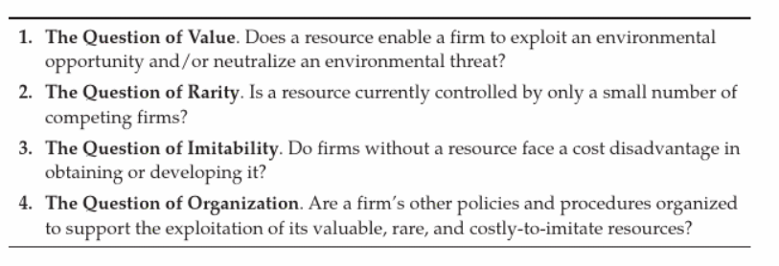
Figure 8 – Source: Barney & Hesterly, 2019, Strategic Management and Competitive Advantage, 6th edition

It has been identified that all competitors in this industry inherently use the same business strategies, customer centricity is what differentiate a company. It has been observed that in the larger companies, due to the having more employees it creates personality clashes amongst themselves.

VRIO
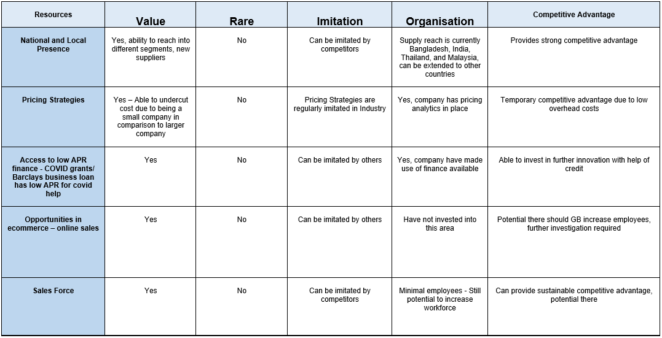

6.4 Ansoff Matrix

The Ansof Matrix is a strategic planning tool for market growth, it helps predict growth through product and market extension (Hussain et al, 2013). It incorporates four key market growth strategies Fig 9),

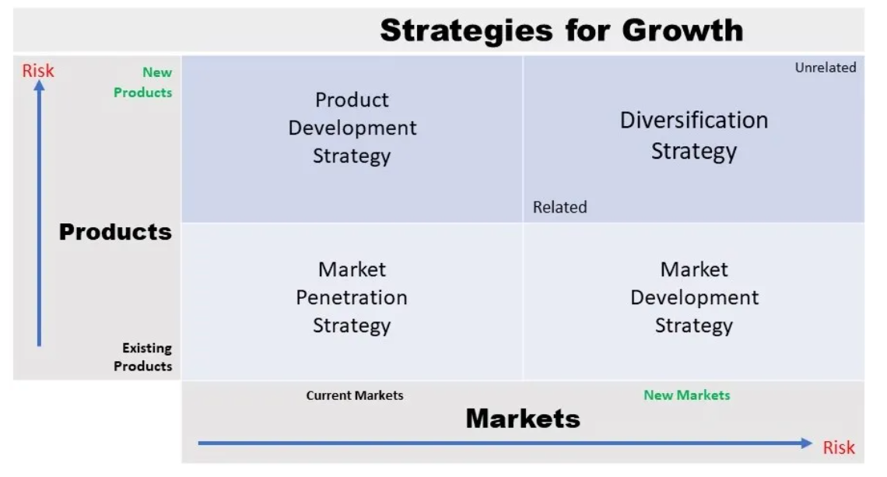

Figure 9: ANSOF Matrix - Product -Market Growth Matrix – Igor Ansoff
Source – Hussain et al, (2022)

Gram Bangla target customers are primarily Indian, Bangladeshi, and Pakistani; however, the produce diversification (products from Thailand/ Malaysia) means that they can sell to other ethnicity i.e., Vietnamese customers. There are many Vietnamese shops within central Birmingham, Gram Bangla have already acquired 3 loyal Vietnamese customers and the profit margin is higher in comparison to their current primary customers. Vietnamese customers are buying the higher priced produce, Durian and Katol which is an expensive fruit, the cost margin of this produce is exceptionally good. Concentrating in this market is beneficial
for Gram Bangla.

- Stake holder Mapping

Stakeholders are individuals/ organisations whose interest and activities strongly affect or are affected by issues concerned, they have information or resources that directly/ indirectly support any changes that a business may make (Aligica, 2006). A stakeholder analysis provides a transparent view of the level of power they hold and how relevant each individual/ organisation is in the success of the company.

The evaluation has ascertained that it is in Gram Bangla interest to closely work with his primary stakeholders: Overseas suppliers are the most important stakeholder to ensure effective produce sustainability, production is maintained. They require RNB Cargo to realise the cargo from the airport. Customer (B2B) are imperative to the business, however end consumers are central in the process, and contribute crucial decisions in the value chain, though they are not the most influential (Akenji and Bengtsson, 2010).

Secondary stakeholders – local wholesalers and direct competitors provide produce when Gram Bangla are out of stock, even in competition, all rival businesses purchase produce from each other when required, so healthy interaction between competitors is essential. Mandatory stakeholders: Government body, DEFRA are required to release cargo shipment at the airport, HMRC for legal governments requirements: tax, NI, and accountants for
effective financial running of the business. Figure 10 shows Gram Bangla’s stakeholders vested interest.

  - Gram Bangla - Stakeholder power/ interest
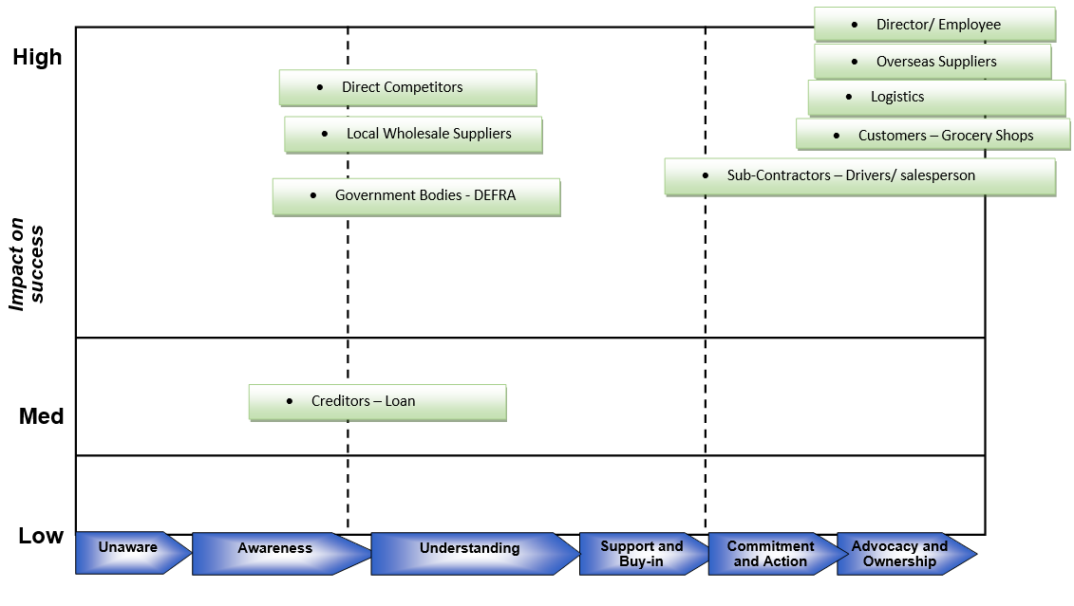
Figure 10: Stakeholders – Vested Interest
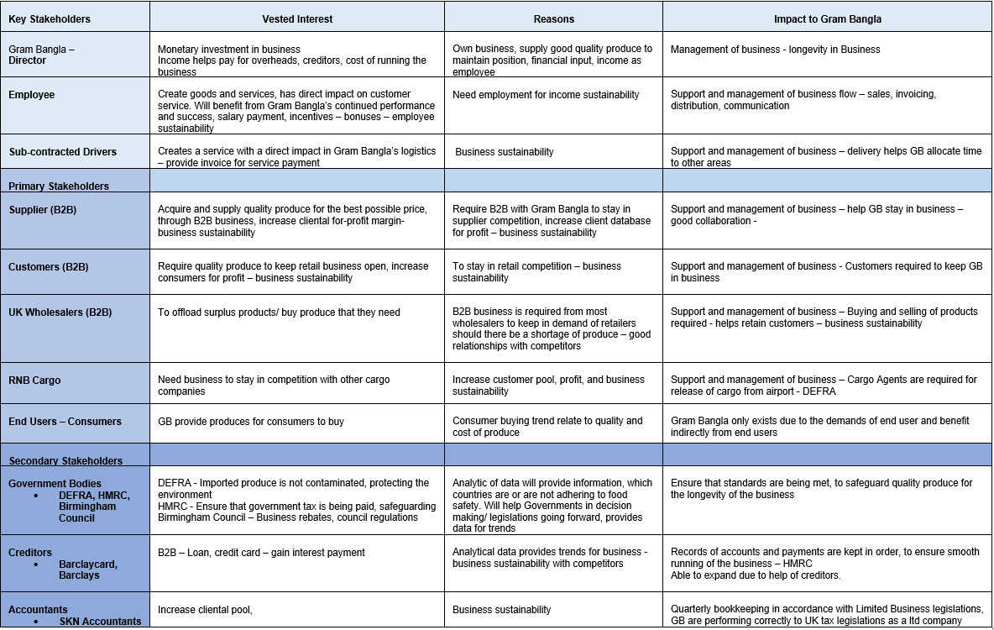
- Strategic Growth Options

8.1 Option 1 - HR and Logistics expansion
Gram Bangla is still in its growth stage, increasing HR will make a positive impact on its strategic growth. At present they outsource (as and when) collection drivers from airport.
Gram Bangla can financially benefit from recruiting permanent employees for this task (fig 11) with this in place and investing in an additional van will increase reach within the geographical area. Recruiting employees is a niche market, due to the cultural aspect of the Asian market, preference is to deal with fellow Asians. There is lack of formal procedures in customer care policies due to the cultural element because they believe “our culture and peer pressure and our values,” permeates throughout their business. Sales employees must have an element of bartering and cajoling clients to make a sale. This belief system extends into recruiting, word of mouth and recommendations of are more the line of recruitment, traditional lines of recruitment i.e., Recruitment agencies are not viable. One key factor in Organizational culture is ethnicity. Ethnical culture in their individual, personal and social sides have a considerable influence on the formation and development of organizational culture of the company (Erastova, A.V. 2016). Considering this recruiting employees through general word of mouth to known employees is the best option.

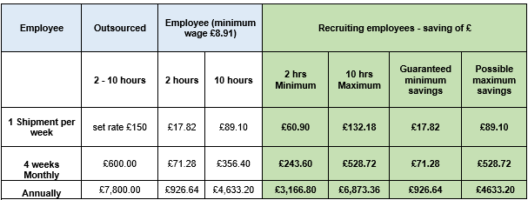
Figure 11: Difference between using outsourced driver and Employee recruitment s

8.2 Option 2 - Cool room investment
For the customer satisfaction service element, it is essential that produce is fresh and of quality. Quality is determined as the most single important economic factor in having a major relationship to customer satisfaction (Agbor, 2011). Any produce that is not of quality due to non-saleability, will be either sold at a discounted price or given away, negatively affecting the profit margin. At present Gram Bangla rent a partial cool room in a grocery store, which is only accessible during opening hours. Incorporating an evaporative cooling system (room) in their warehouse will provide time/ produce value, saving money overall, this will help keep produce fresh and deplete the wastage of any unsaleable produce. Evaporative cooling is an efficient and economical means for reducing temperature and increasing the relative humidity of an enclosure and has been extensively tried for enhancing the shelf life of horticultural produce which is essential for maintaining the freshness of the commodities (Basediya et al, 2011).

8.3 Option 3 - Change customer direction
Gram Bangla have already managed to acquire new Vietnamese customers. Diversification of current produce has shown that there are other consumer areas that are cost affective. It has been observed that dealing with Vietnamese customers is far easier than South Asian customers. Their work ethics is very straight forward, and in line with Gram Bangla's management strategy, the current customers tend to haggle and try and get the best price possible, impacting cost margin. However, Vietnamese customers are noticeably clear and concise in their order and pay promptly on the receiving of goods. Customer feedback has been managed through negotiation where both parties are in profit. It is more lucrative for Gram Bangla to extend into this area; however, they need to implement better marketing strategies if this to work, at present Gram Bangla is only known through word of mouth and direct sales. Gram Bangla needs to implement cognitive mapping to further enhance this direction. Cognitive mapping is a tool that helps define and helps predict the reality of a decision maker perception through understanding, describing, and explaining (Xiang & Formica, 2007).

SAF Matrix
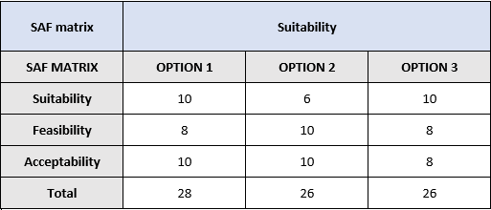
- Developing Business Level Strategies
Analysing all options available to Gram Bangla suggests for sustainability, they need to expand the company. However incremental expansion is more organic for Gram Bangla’s growth, rapid growth can negatively affect the company if operations are not able to cater for demand. For example, the warehouse is right for a certain amount of produce, if they start to expand the warehouse will need to relocate to cater for more produce (Business Expansion, 2022). Once expansion is in progress will open other viable options into business growth.

9.1 Resistance to change

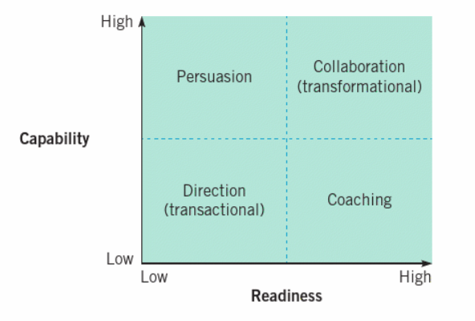
Figure: 12 Source: Exploring Strategy, 2019 (Regner et al, 2019)

When there is a low readiness and capability to change (fig 12), here the leader must adopt the transformational leadership, to be constructive, leaders must be collaborative with employees to enhance active interaction. If capabilities are shown to be high and readiness is low, persuasion will be key to execute the change (Regner et al, 2019).

There are many factors to consider when implementing change (fig 13).

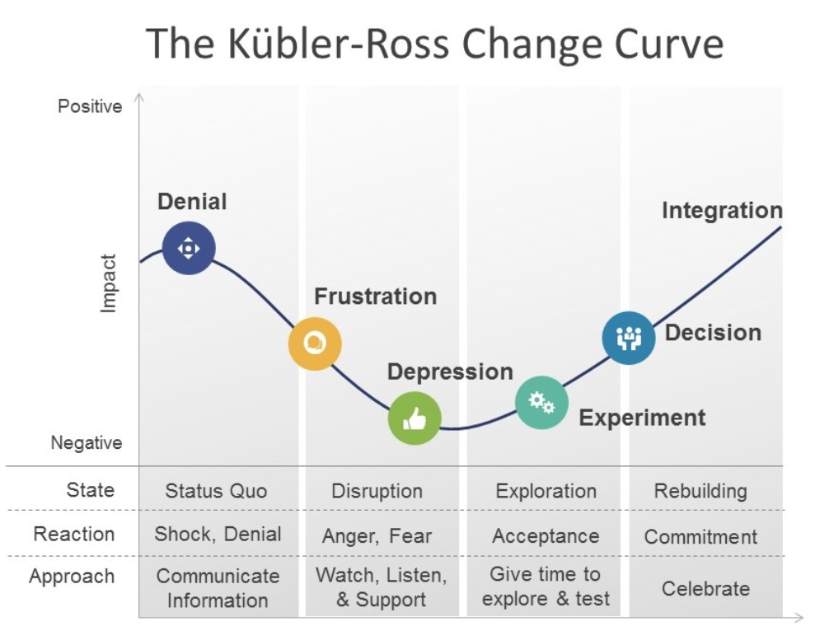

Figure 13: The Kubler-Ross Change Curve, Source – Saboe, D, 2018

The director of Gram Bangla is a key example, his work ethics is very stringent, his leadership style has elements of Autocratic, and micromanages in some areas. This style of leadership leads to conflicts, as the owner he does have influence in how his employees should behave, however there is a line in influencing employees positively and allowing them to have certain authority in decision making. This style has worked well in terms of the size of the business however this will need to change to Democratic leadership if they are to increase and maintain long term employees. The director is aware of this and will need to attend leadership workshops to develop his leadership to become more of a Democratic Leader.

To manage resistance the leader will how show why it is beneficial to expand the company (fig 14).

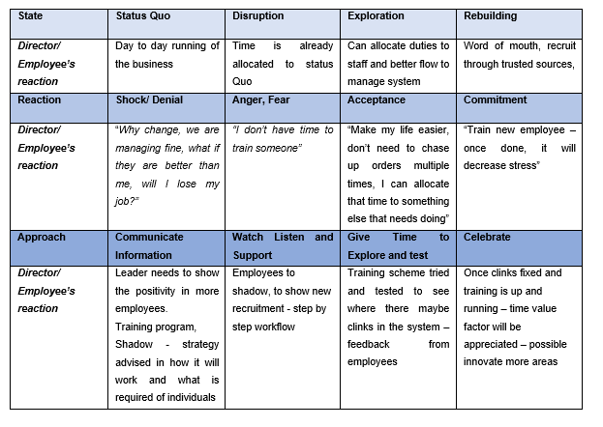
Figure 14: How to manage change

9.2 Human Resource Expansion
Gram Bangla currently is making a profit based on two employees. By increasing employees, the company will have the opportunity to increase sales and geographical reach. At present Gram Bangla is financially independent and have access to funds, to recruit up to two additional employees. The director will need to advertise through word of mouth, through trusted sources, notice boards in high street shops. There are two viable options to recruit -

- Unskilled worker – Due to lack of knowledge, transferable skills must be apparent when interviewing. Employee will be more adaptable, easier to adapt to company culture and work ethics.
- Skilled worker – Has knowledge and skills and own customers contacts (make him more attractive to recruit), this may mean increase in wages overall to maintain existing employees.

- Competitors reaction to Strategic change
The director of Gram Bangla has been an ex-employee of the four direct competitors (fig 15). During his time as an employee has observed each business strategies and has inside acquired knowledge of their working practice. In this industry, business strategies are similar, however it is fundamentally employee’s sales tactic that provides customer sales, so it is important to recruit employees who have this. Due to Gram Bangla company size, there is no immediate threat to competitors, as they all have acquired their own loyal cliental base, however, should Gram Bangla increase their employees which will provide better geographical reach, the competitors threatened.

In this industry it is more gainful to have good relationships with competitors, this promotes networking, equally beneficial as they buy from one another when they have stock shortages. When competitors team up it is beneficial for the consumer, ultimately sharing customers is mutually advantageous, some profit is better than no profit (Hall, 2020).

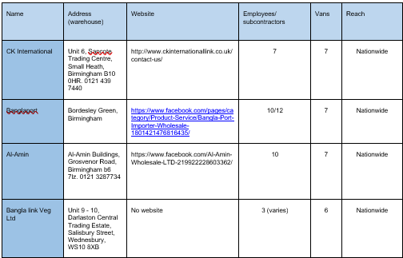
Figure 15: Competitor’s data
- Conclusion

Gram Bangla must expand their business to survive, this should be managed by incremental business expansion. This approach will help sustain change and control the pace, limiting costs.

Increasing workforce
It is imperative to increase employee size for sustainability of the business. By increasing workforce, they will be able to go nationwide and extend their business. This will mean the more people that are available for work the quicker work can be done. This is beneficial because at present each staff is trained to all aspects of work i.e., ordering, delivering, customer service, human error is more likely resulting in customer dissatisfaction, and loss of business. If employees have individual tasks to maintain, workload will be managed more effectively and fairly, providing employee satisfaction and motivation to do well.

Employees that start out in this industry primary are unskilled workers, who have immigrated to the UK and have limited skills and knowledge, manual labour is the easiest to acquire. These individuals are trained into this industry with minimal wages.

However, in all industries recruiting the right staff is hard, Gram Bangla have been unable to maintain staff in the past due to the directors’ strict work ethics of working hard. This can be counteracted with incentives such as bonuses, another option Gram Bangla has, is to go into partnership with someone with the same work ethics. By financially investing, the partner will have the same motivation to make the business succeed.

Sustainability of Produce
Gram Bangla needs to invest in refrigeration to prolong quality of produce, this will enable them to order larger quantities and cater to more customers. However, they must be aware of how they will distribute additional produces, as market fluctuation is very erratic, external environment such as COVID, change of demand, diminishment of quality in cargo journey, are all relative.

- References

- Acharya, S.S., Theme paper: Agricultural marketing in Asia and the Pacific: issues and priorities.
- https://www.fao.org/3/ad639e/ad639e05.htm

- Agbor, J.M., 2011. The Relationship between Customer Satisfaction and Service Quality: a study of three Service sectors in Umeå. Available at: https://www.diva-portal.org/smash/get/diva2:448657/FULLTEXT02.pd (Accessed: 27 April 2022)

- Aligica, P.D., 2006. Institutional and stakeholder mapping: frameworks for policy analysis and institutional change. public organization review, 6(1), pp.79-90.

- Akenji, L. and Bengtsson, M., 2010. Is the customer really king? Stakeholder analysis for sustainable consumption and production using the example of the packaging value chain. Sustainable Consumption and Production in the Asia-Pacific Region: Effective Responses in a Resource Constrained World, 3, pp.23-46.

- Arend, R.J., Zhao, Y.L., Song, M. and Im, S., 2017. Strategic planning as a complex and enabling managerial tool. Strategic Management Journal, 38(8), pp.1741-1752.

- Barney, J.B., Hesterly, W.S., 2019. Strategic Management and Competitive Advantage, Concept and Cases. Available at: https://ebookcentral.proquest.com/lib/trinity/reader.action?docID=5573680 (Accessed: 26 April 2022)

- Basediya, A.L., Samuel, D.V.K. and Beera, V., 2013. Evaporative cooling system for storage of fruits and vegetables-a review. Journal of food science and technology, 50(3), pp.429-442.

- Boyne, G.A., 2010. Strategic planning. Public Service Improvement: Theories and Evidence; Ashworth, R., Boyne, GA, Entwistle, T., Eds, pp.60-77.

- Business Expansion, 2022. Available at: https://www.referenceforbusiness.com/small/Bo-Co/Business-Expansion.html (Accessed: 26 April 2022)

- Erastova, A.V., 2016. The influence of the ethnic culture specifics on the organizational culture of the industrial enterprise. Available at: https://www.ersj.eu/repec/ers/papers/16_3_A_p1.pdf. (Accessed: 27 April 2022)

- Foster, A. and Rosenzweig, M.R., 2010, September. Barriers to farm profitability in India: mechanization, scale, and credit markets. In Conference Agriculture for Development-Revisited, University of California at Berkeley. October (Vol. 24, pp. 1-2).

- Gray, N., 2013. Foodnavigator.com, Frozen fruit and vegetables may be more nutritious than fresh: Research. Available at: https://www.foodnavigator.com/Article/2013/10/11/Frozen-fruit-and-vegetables-may-be-more-nutritious-than-fresh (Accessed: 26 April 2022)

- Hall, J, 2020. Forbes, 4 Reasons Working with your Competitor might be in your best interests. Available at: https://www.forbes.com/sites/johnhall/2020/06/28/4-reasons-working-with-a-competitor-might-be-in-your-best-interests/?sh=b5494cc1ab50 (Accessed: 26 April 2022)

- Hussain, S., Khattak, J., Rizwan, A. and Latif, M.A., 2013. ANSOFF matrix, environment, and growth-an interactive triangle. Management and Administrative Sciences Review, 2(2), pp.196-206.

- Lynch, R., 2018. Strategic Management. Available at: https://ebookcentral.proquest.com/lib/trinity/reader.action?docID=5347868 (Accessed: 20 April 2022)

- MiMenichi, B.C., and Tricomi, E., 2015. The Power of competition: Effects of social motivation on attention, sustained effort, and learning. (Available at: https://www.ncbi.nlm.nih.gov/pmc/articles/PMC4554955/ (Accessed: 27 April 2022)

- Ministry of Agriculture Department of Agriculture and Co-operation Government of India, 2013. ‘Committee of State Ministers, In-charge of Agriculture Marketing to Promote Reforms’ Available at: https://dmi.gov.in/Documents/stminprreform.pdf (Accessed: 24 February 2022)

- Office for National Statistics, 2016. UK Energy: How much, what type and where from? Available at: https://www.ons.gov.uk/economy/environmentalaccounts/articles/ukenergyhowmuchwhattypeandwherefrom/2016-08-15 (Accessed: 26 April 2022)

- Regner, P., Johnson, G., Scholes, K., 2019. Exploring Strategy Text and Cases. Available at: https://ebookcentral.proquest.com/lib/trinity/reader.action?docID=5987036 (Accessed: 27 April 2022).

- Saboe, D, 2018. The Kubler-Ross Change Curve. Available at: https://masteringbusinessanalysis.com/mba154-change-leadership/kubler-ross-change-curve/ (Accessed: 17 April 2022)

- Stathers, T., Holcroft, D., Kitinoja, L., Mvumi, B.M., English, A., Omotilewa, O., Kocher, M., Ault, J. and Torero, M., 2020. A scoping review of interventions for crop postharvest loss reduction in sub-Saharan Africa and South Asia. Nature Sustainability, 3(10), pp.821-835.

- Statista, 2022. Number of Enterprises for the wholesale of fruit and vegetables in the United Kingdom (UK) from 2008 to 2019. Available at: https://www.statista.com/statistics/292430/fruit-and-vegetables-wholesalers-number-of-enterprises-united-kingdom-uk/ (Accessed: 19 February 2022).

- Voloshina, V., 2014. The strategic management tools for higher education institutions. Available at: https://cyberleninka.ru/article/n/the-strategic-management-tools-for-higher-education-institutions/ viewer (Accessed: 13 February 2022).

- Xiang, Z. and Formica, S., 2007. Mapping environmental change in tourism: A study of the incentive travel industry. Tourism Management, 28(5), pp.1193-1202.

