

Student Name: Meetkumar Sureshbhai Vaghasiya
Student ID: 2432237
Module Name: Strategic Management
Module Code: LCMB7003
Title: Report- Spotify
Lecturer’s Name: Amare Desta

Course: MBA
Submission Deadline: 22th December 2025

Table of Contents
1. Introduction 2
2. Benefits and Challenges of International Operations 4
2.1 Spotify 4
2.2 Global Operations 6
2.2.1 Research & Development (R&D) 6
2.2.2 Sourcing & Content Acquisition 6
2.2.3 Platform Development & Engineering 7
2.2.4 Production 8
2.2.5 Global Marketing & Sales 8
2.2.6 Financing & Revenue Models 9
2.3 International Market Entry Modes 11
2.3.1 Dominant Entry Mode 12
2.4 Benefits from International Operations 13
2.4.1 Revenue Diversification 13
2.4.2 Access to Global Talent Pools 14
2.4.3 Economies of Scale 14
2.4.4 Network Effects 14
2.4.5 Content Localisation 14
3. OLI Factors 15
3.1 Ownership Advantages (O) 15
3.2 Location Advantages (L) 16
3.3 Internalisation Advantages (I) 18
3.4 Market Entry Mode Choice 18
4. Cultural Differences 20
4.1 Hofstede Cultural Frameworks 20
4.2 Cultural Distance 20
4.3 Impact on Entry Strategy 21
4.4 Impact on Business 22
5. Recommendations 25
5.1 SOP Adjustment 1 25
5.2 SOP Adjustment 2 26
5.3 SOP Adjustment 3 28
6. Conclusion 31
References 32

1. Introduction
This report examines Spotifys operations in Brazil, a rapidly expanding emerging market, and the United States, a developed and fiercely competitive digital economy. As the top audio streaming service in the world, Spotify routinely outperformed rivals like Apple Music, Amazon Music, and Tencent, holding about 32% of the global subscriber market share in 2023 (Statista, 2025). Despite a stabilizing premium ARPU of four to five euros per person, the platform had more than 670 million monthly active users by late 2024, including more than 260 million paying customers who generate the majority of its revenue.
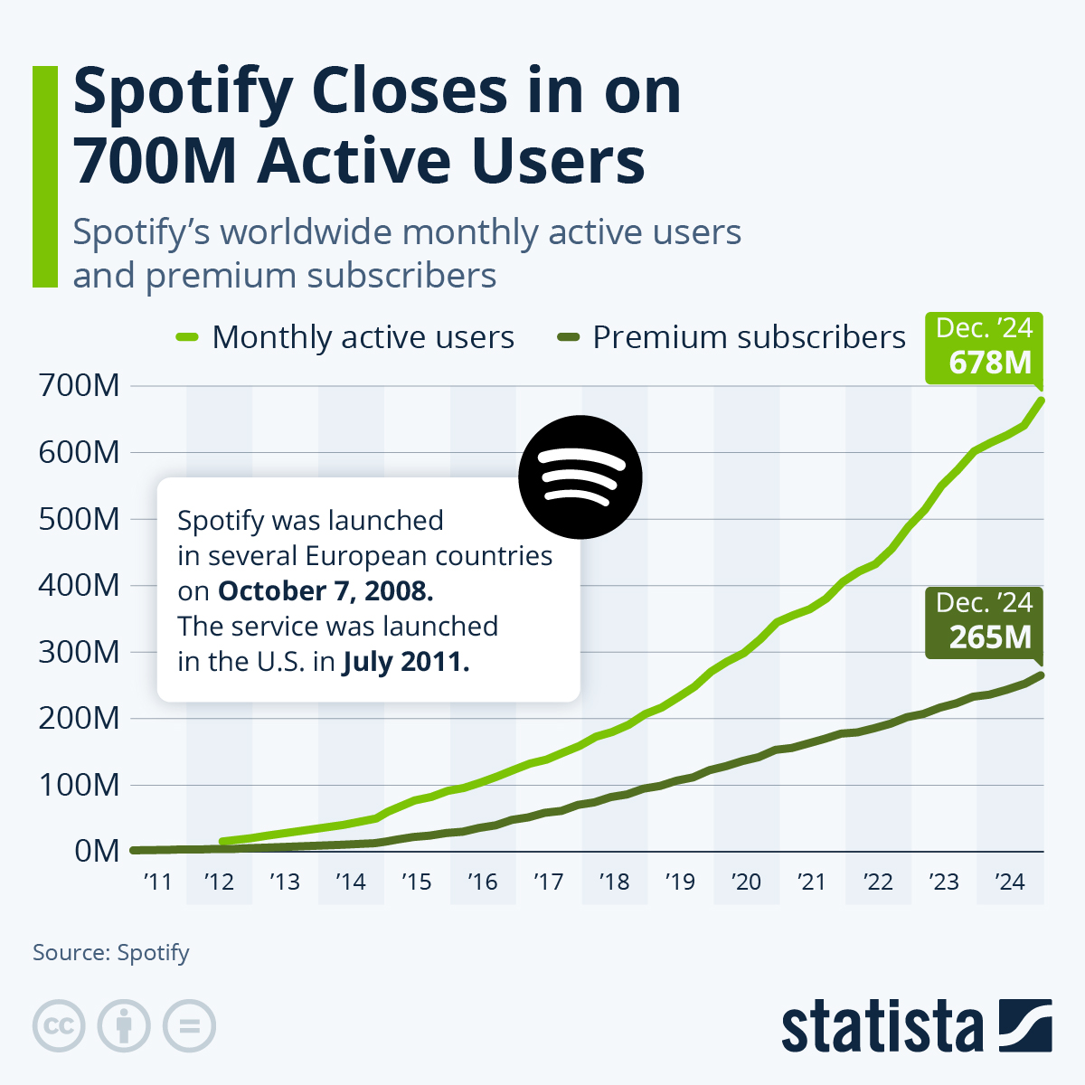
Source: https://www.statista.com/chart/15697/spotify-user-growth/?srsltid=AfmBOooUxp8WS1QIEIMw75lQOG3gZ7cLFVXB8kt7aL9xbA81Y_IzBipS
Strong subscriber growth and growing global audio consumption habits drove Spotify's 2024 revenue of over 15 billion euros and net profit of over one billion euros. As it battles YouTube for supremacy in the spoken-audio market, the corporation keeps making significant investments in R&D, especially in podcasting and video-podcast features (Statista, 2025). In the meantime, Spotify's growing international user base is reflected in the global diversity of music consumption, which ranges from English-language pop to Spanish, Korean, and other international genres. This study assesses Spotify's global operations and offers tactical suggestions to improve its performance in Brazil.

2. Benefits and Challenges of International Operations

2.1 Spotify
Because of the size, organization, and integration of its international operations, Spotify is unquestionably a Multinational Corporation (MNC) and a Transnational Corporation (TNC). As of December 2024, the company's network of fully owned subsidiaries, which includes Spotify USA Inc., Spotify Brasil Serviệ De Música LTDA, Spotify Japan K.K., Spotify India LLP, and several European and Asia-Pacific organizations, supported its operations in 184 countries and territories (Spotify, 2025a). This wide-ranging presence shows not only geographical dispersion but also an organizational strategy designed to handle financing, content distribution, global value creation, and regulatory compliance across several jurisdictions.
Although Spotify's platform is centrally built in Sweden and the US, its content licensing, marketing, pricing, and monetization strategies need to be deeply localized to align with local legislative, cultural, and commercial circumstances. This makes Spotify's business model intrinsically international. In 2024, the company employs 7,691 full-time workers in North America, Europe, Latin America, and Asia, with a sizable workforce in the United States (3,690), Sweden (1,397), the United Kingdom (874), and notable clusters in Brazil, India, Germany, and Mexico (Spotify, 2025a). This illustrates the intricacy of its dispersion of human resources and its dependence on foreign expertise.
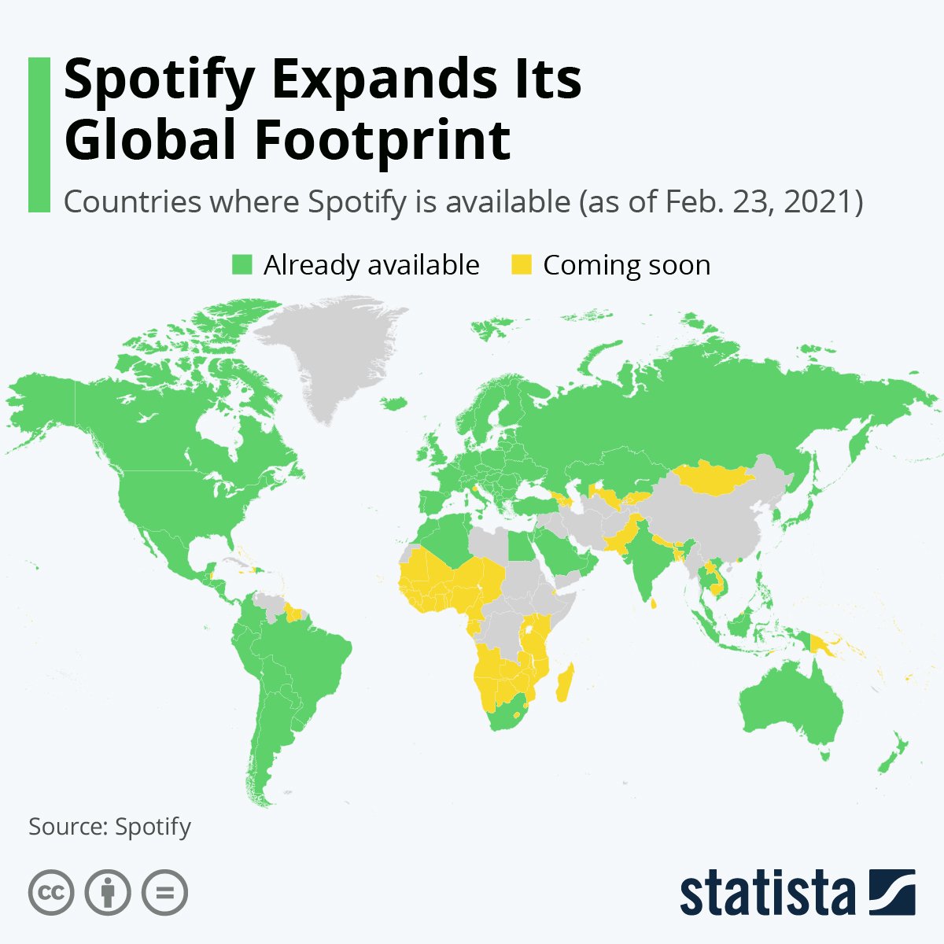
Source: https://www.statista.com/chart/24253/global-availability-of-spotify/?srsltid=AfmBOorm0vemutmAermg1Muc0O-19nOUKktPetQky6YEi_qETbQ8ebRZ
Additionally, Spotify's operations involve significant cross-border flows of intellectual property, payments for content licensing, multicurrency subscription fees, and advertising income from both domestic and international partnerships (Nordea, 2025). Its exposure to international payment networks, regulatory differences, and foreign exchange risks further solidifies its status as a multinational company involved in intricately linked transnational operations. Because of this, Spotify satisfies every conventional requirement for being classified as an MNC or TNC, including global market participation, multinational presence, cross-border revenue dependency, and internationally integrated operations.

2.2 Global Operations

2.2.1 Research & Development (R&D)
The core of Spotify's worldwide value offering is its R&D skills. In addition to maintaining significant product and engineering centres in Stockholm and New York, the firm employs close to 4,000 people in research and development (3,944 in 2024). Spotify Ltd. in the United Kingdom provides further R&D support through contract research and technology development (Spotify, 2025a). Algorithmic search, recommendation systems, AI-powered discovery tools, advertising technologies, infrastructure for audio ingestion and encoding, podcast hosting tools, and audiobook streaming features are the main areas of R&D spending.
Spotify is still making significant investments in new areas of engagement and content discovery. New analytics tools and features for creators, including as dynamic ad insertion, growth analytics, and streaming optimization technologies, had to be developed in order to expand into podcasts and audiobooks (Spotify Advertising, 2023). The strategic significance of R&D is demonstrated by its emphasis on innovation-intensive components like machine learning and platform personalization, which seek to enhance user retention and lengthen platform usage.

2.2.2 Sourcing & Content Acquisition
Another essential component of Spotify's value chain is content acquisition. The business negotiates licensing deals with large international record companies, independent labels, music publishers, publishers of audiobooks, and producers of podcasts. The majority of Spotify's revenue comes from royalties paid to rights holders. Depending on the type of subscription, music royalties are structured around revenue shares or per-user rates, while ad-supported streams adhere to CPM-based revenue sharing agreements (Wondrasek, 2025).
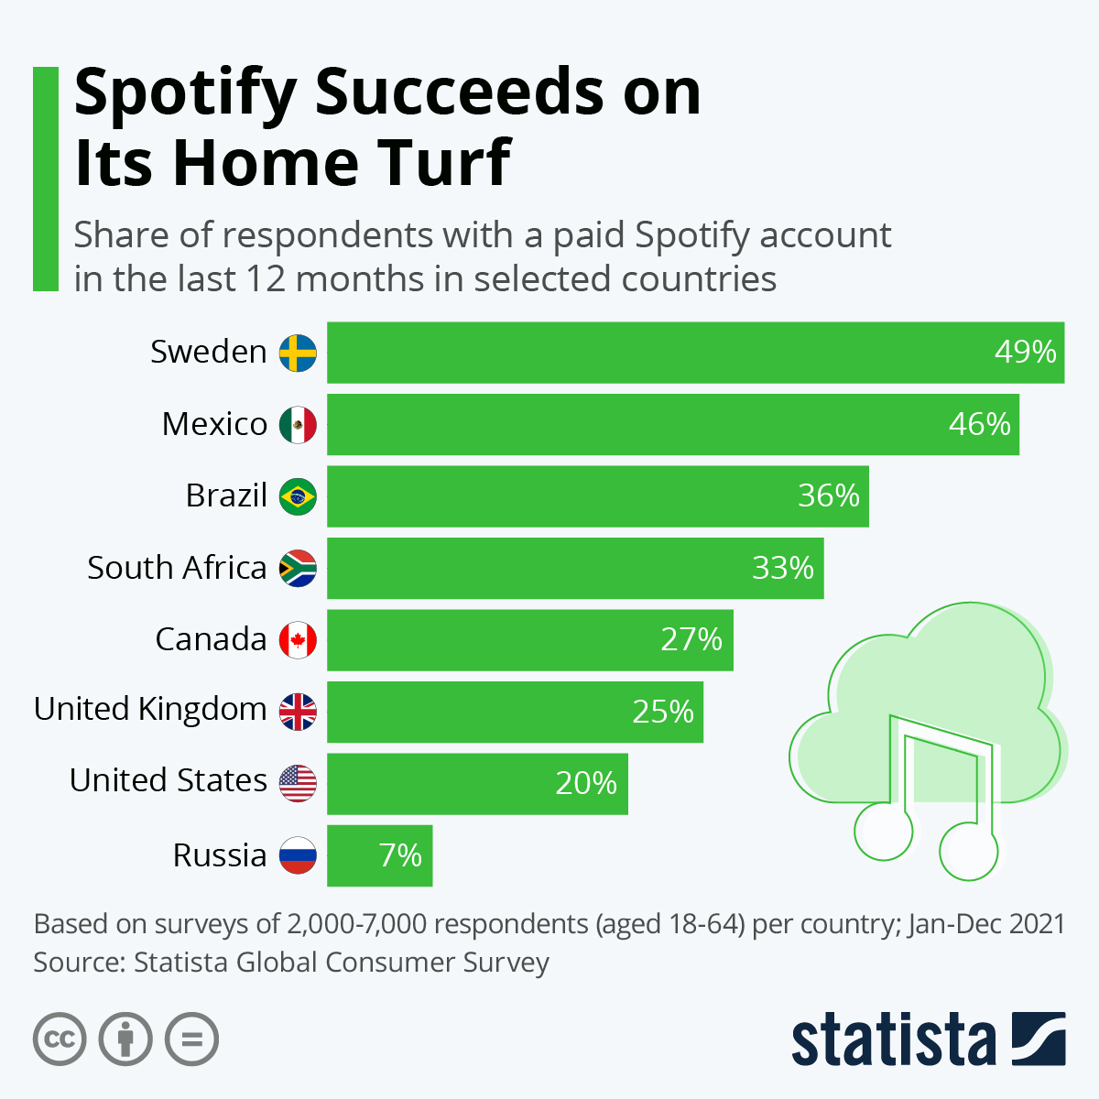
Source: https://www.statista.com/chart/27062/share-of-respondents-in-selected-countries-with-a-paid-spotify-subscription-in-the-last-12-months/?srsltid=AfmBOoobW0sYoYANhHz-N5YOx8M-_AUqrq0kwxawQTwtwgl3w4yezvXh
Additionally, thanks to its purchases of platforms like Megaphone and unique podcast hosting technology, Spotify maintains exclusive content agreements with podcast producers and creators. Additionally, the Spotify Audience Network (SPAN) improves its worldwide inventory and reach by integrating podcast creators and publishers into a single advertising marketplace (Spotify, 2025a).

2.2.3 Platform Development & Engineering
Managing a complicated infrastructure that permits cross-device interoperability across mobile, desktop, web, gaming consoles, home assistants, car interfaces, and televisions is known as platform engineering. Because consumers who access services across many devices show increased engagement and reduced attrition, improving lifetime customer value, Spotify highlights the significance of multi-device access (Renascence, 2024).
Additionally, platform engineering entails creating dynamic ad insertion technologies for podcasts, self-serve advertising tools, and sophisticated advertising capabilities. With 190 billion hours of material streamed by users in 2024, the platform's size is significant and reflects the demand for highly scalable and resilient worldwide cloud infrastructure (Spotify, 2025a).

2.2.4 Production
Although Spotify's product is completely digital and does not require traditional manufacturing, it does require a significant operational infrastructure for data analytics, streaming, content management, rights tracking, and advertising distribution. Global digital production primarily involves (Spotify, 2025a):
- Managing musical and podcast catalogues
- Encoding and distributing content across global data networks
- Ensuring rights compliance across regions
- Delivering personalised algorithmic experiences at scale
Continuous optimization of latency, compression, and server distribution across regional clusters, such as the Americas, Europe, and Asia-Pacific, is necessary for global service delivery (CacheFly, 2024).

2.2.5 Global Marketing & Sales
Through its subsidiaries in the United States, Brazil, Japan, India, Mexico, and Europe, Spotify employs locally specific marketing techniques (Spotify, 2025a). Local customer acquisition, pricing strategies, partnerships, promotional activities, and cultural marketing collaborations are all managed by these subsidiaries.
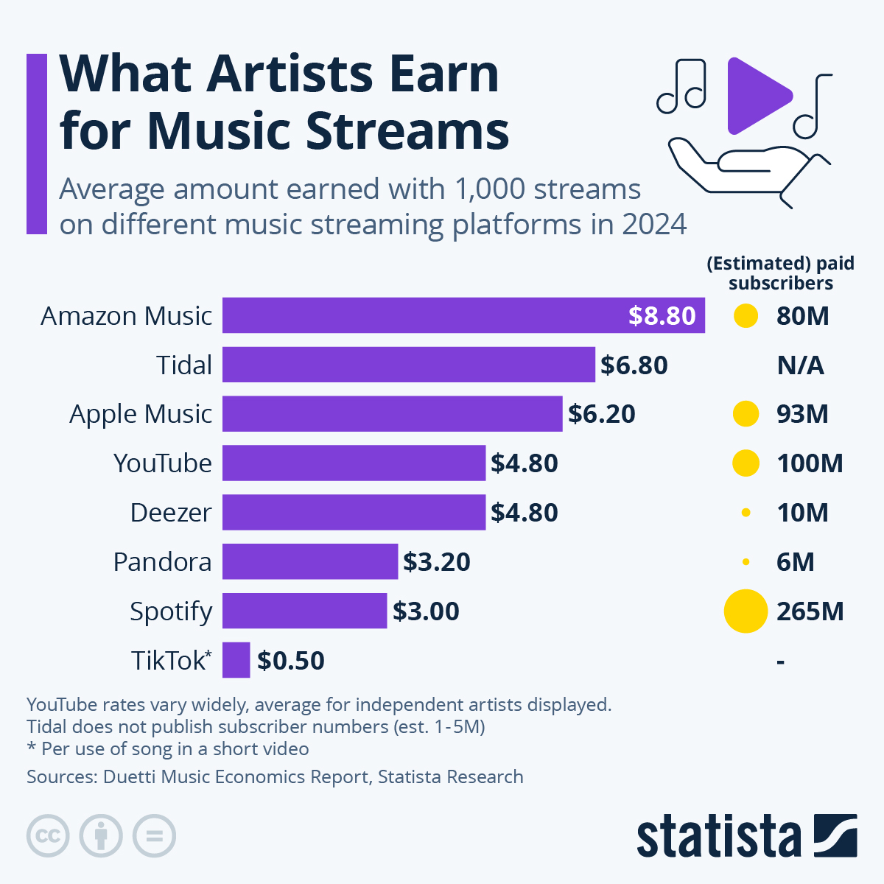
Source: https://www.statista.com/chart/26100/average-amount-of-streams-needed-to-reach-payout-of-dollar1/?srsltid=AfmBOortmKBNWBqYLFnp5PXyl98tKRGBVKUPP_03KnPkpt0naVhj2QCv
In competitive areas like the U.S. and Brazil, where Spotify faces competitors like Apple Music, YouTube, Amazon Music, and regional streaming providers, marketing is essential to preserving leadership (Gandra, 2024). By utilizing data-driven advertising and social media interaction worldwide, Spotify's branding strengthens its cultural positioning.

2.2.6 Financing & Revenue Models
In addition to operating overseas, Spotify also raises and distributes funds abroad. Revenue growth, cash reserves, and financing instruments like its $1.5 billion Exchangeable Notes issued in the U.S. market through Spotify USA Inc., which exhibits excellent global capital management, are how the firm finances its operations (Spotify, 2025a).
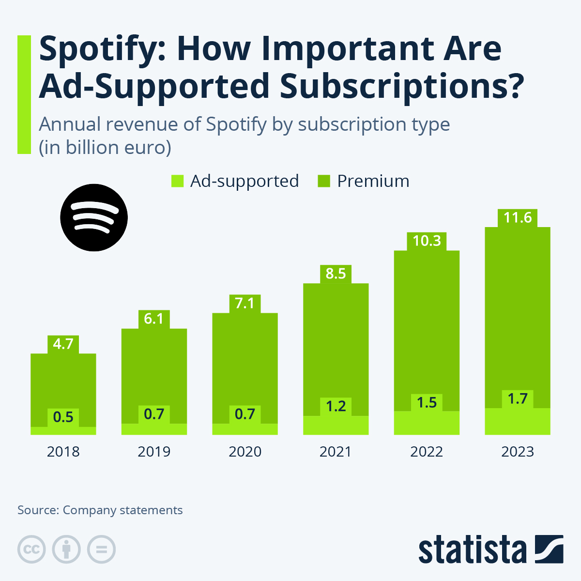
Source: https://www.statista.com/chart/31696/annual-revenue-of-spotify-by-subscription-type/?srsltid=AfmBOorEEt2Lt2JLBTr4oUt6E0uiZxSsihuP8SsgLqOwckieCu2FjLe1
Spotify's revenue model is split between (Spotify, 2025a):
- Premium Subscriptions, its largest revenue driver
- Ad-Supported Revenue, driven by display, audio, and video advertising
- Podcast and audiobooks monetisation, now integrated through SPAN
Because of lower CPM rates and distinct user behaviours, the Ad-Supported model is especially crucial in developing areas like Brazil, where monetization issues still exist in comparison to North America and Europe (Lin, Ke and Whinston, 2012).

2.3 International Market Entry Modes
In addition to licensing deals, local content partnerships, and telecom bundling alliances in particular markets, Spotify's international expansion is distinguished by its predominant dependence on wholly owned subsidiaries as its principal market entry mechanism (Spotify, 2025a).
Spotify has a portfolio of 100%-owned subsidiaries in major international markets, including Spotify USA Inc., Spotify Brasil Servição de Música LTDA, Spotify India LLP, Spotify Japan K.K., Spotify Ltd (UK), Spotify Australia Pty Ltd, and several European and Latin American companies (Spotify, 2025a). This suggests that Spotify favours foreign direct investment (FDI) entry strategies, particularly greenfield totally owned subsidiaries, which give the company complete control over pricing, rights management, and product localization.
Spotify's reliance on content licensing, which serves as an extra entrance route, is a fundamental component of its worldwide entry strategy. Spotify must negotiate complicated licensing deals with international rights holders like Universal, Sony, Warner, and Merlin in order to operate in 184 countries (Spotify, 2025a). Together, these companies accounted for over 71% of all music streams supplied on the site in 2024. Spotify frequently has to bargain directly with local labels and publishers to obtain libraries like Brazilian funk, sertanejo, MPB, or pagode in markets like Brazil, where local material is crucial.
Spotify uses distribution and bundling relationships as a hybrid entry strategy to supplement FDI and licensing in emerging areas. Telecommunications partners frequently sell the Premium Service by bundling Spotify into mobile data plans, collecting payments, and negotiating per-subscriber fees under partner agreements (Lau, 2025). In areas with less developed recurring subscription services, this strategy is particularly crucial.
One obvious example of Spotify's multi-mode entry strategy is Brazil. Spotify has complete control over marketing, pricing, and distribution operations thanks to its completely owned subsidiary, Spotify Brasil Servição de Música LTDA. Local presence is essential for rights management and artist engagement due to Brazil's market dynamics, which include 22.5 million streaming subscribers (Music Ally, 2024).
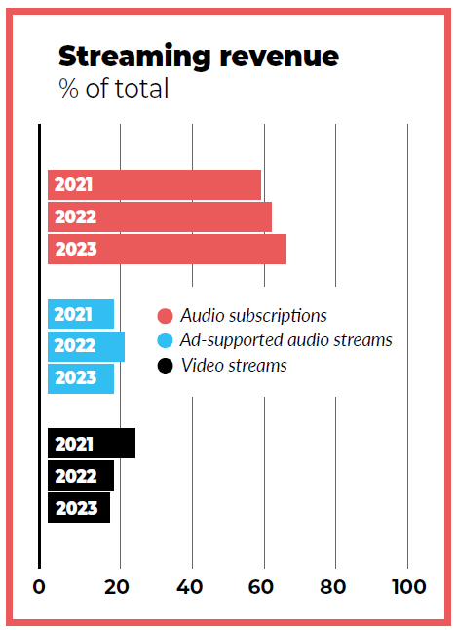
Source: Music Ally (2024)
Over 50 million total streamers, and streaming accounting for 99.2% of all recorded music revenue in the first half of 2024 (Music Ally, 2024). In early 2024, subscription sales increased by 28.4% to R$995 million, while ad-supported revenues increased by 6.6% to R$436 million (Spotify, 2025a). This highlights the importance of localized pricing, partnerships, and ad-selling activities.

2.3.1 Dominant Entry Mode
Wholly owned subsidiaries are the most common entrance strategy in all areas, with telecom bundling alliances in some developing economies and licensing agreements as a universal prerequisite (Spotify, 2025a). This combination enables Spotify to adjust pricing and content to local market conditions while maintaining global strategic coherence.
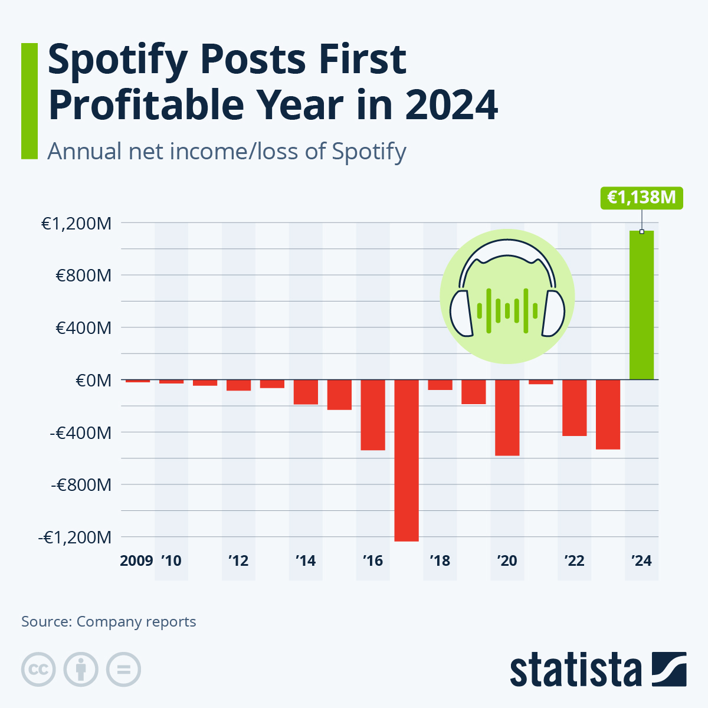
Source: https://www.statista.com/chart/26773/profitability-development-of-spotify/?srsltid=AfmBOoqS1quVsOyQxf2-qSYU0q4oPHi6_IFcVnnE5VIkNhqHeBFCIRP_

2.4 Benefits from International Operations

2.4.1 Revenue Diversification
Spotify's global presence enables a variety of revenue sources in various geographical areas. With 27% of MAUs, Europe continues to be its largest region, followed by North America (17%), Latin America (including Brazil) (22%), and its fastest-growing region (14% annual MAU growth in 2024) (Spotify, 2025a). This geographical dispersion lessens reliance on any one market.

2.4.2 Access to Global Talent Pools
Spotify's dispersed workforce fosters innovation by providing access to commercial, engineering, and creative talent throughout the globe. Its staff is spread across numerous nations, with a focus on R&D and high-value engineering roles in Sweden, the United States, and the United Kingdom, as well as support and sales roles in Latin America and Asia (Spotify, 2025a).

2.4.3 Economies of Scale
Shared R&D expenses, reduced marginal costs per user, and economies in cloud infrastructure and content licensing are all made possible by a global platform. Spotify uses data to improve recommendations, lower attrition, and boost upsell opportunities as more users interact with the service, resulting in scale-driven increases in revenue (Spotify, 2025a).

2.4.4 Network Effects
Strong network effects are produced by Spotify's enormous user base. The platform's ability to draw in additional artists, marketers, and exclusive content partners thanks to its 675 million MAUs and 263 million Premium users strengthens its competitive position (Spotify, 2025a). Because diversified content consumption affects recommendations and discovery worldwide, these network effects are reinforced internationally.

2.4.5 Content Localisation
Spotify must localize its content, price, and marketing tactics in order to operate in developing areas like Brazil. Brazilian funk, sertanejo, and regional pop are examples of local music genres that encourage high engagement and assist greater user retention and cultural relevance (Spotify, 2025b). Spotify can more successfully negotiate with local rights holders and customize products thanks to local subsidiaries.

3. OLI Factors

3.1 Ownership Advantages (O)
Spotify's technological superiority, global reach, proprietary data assets, advanced recommendation algorithms, and well-known brand are the main sources of its ownership advantages. With 675 million monthly active users and 263 million Premium subscribers in 2024, Spotify, the largest music streaming platform in the world, offers a structural advantage in content acquisition, data-driven personalization, and advertising monetization (Spotify, 2025a).
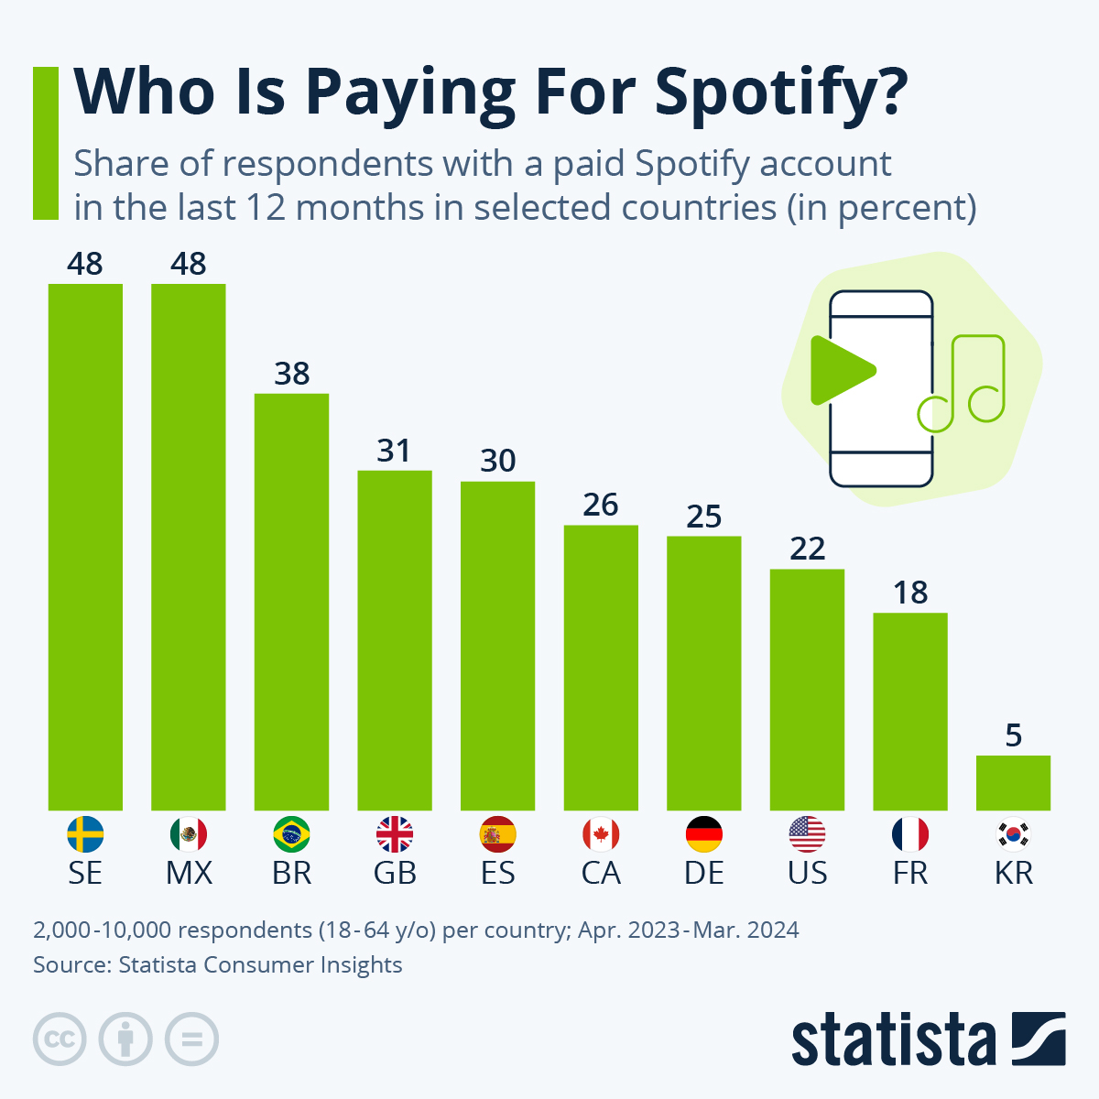
Source: https://www.statista.com/chart/31115/respondents-with-a-paid-spotify-account/?srsltid=AfmBOoqiyht_kjOdSQUClTltCy41bEnjZYpjTuJQS1Ynnlr_Zdq43Eoq
Its possession of cutting-edge machine-learning systems, which maximize user interaction and recommendations, gives it a significant competitive edge. In order to support its growth into podcasts, audiobooks, and sophisticated ad-delivery systems, Spotify made significant investments in algorithmic innovation, according to the Annual Report. The company used roughly 4,000 R&D workers spread throughout Sweden, the United States, and the United Kingdom (Spotify, 2025a).
Spotify's competitive advantage is further reinforced by its possession of exclusive and semi-exclusive arrangements with significant podcast creators. The platform is in charge of the Spotify Audience Network (SPAN), an advertising marketplace that unifies inventory from publishers and creators and allows for dynamic ad insertion and targeted advertising at scale (Spotify, 2025a). This is an advantage that rival platforms in emerging regions cannot replicate.
Additionally, the company possesses advanced worldwide infrastructure for content distribution, rights management, analytics, and multi-device integration, including linked TVs, smart speakers, desktop computers, mobile devices, and cars (Spotify, 2025a). Because of these ownership benefits, Spotify is able to expand its service into new markets at a low marginal cost while keeping a constant level of quality throughout the world.
Moreover, the company's solid financial base, which is based on €15.1 billion in revenue and more than €1 billion in net profit in 2024, permits continued investment in localized market strategies and long-term commitments to artists and rights holders (Spotify, 2025a). Together, these characteristics give Spotify the internal resources and competencies needed to enter Brazil with a high-control entry mode, which is supported by the company's capacity to effectively transfer IP-intensive assets, managerial know-how, and proprietary technology across borders.

3.2 Location Advantages (L)
Brazil provides significant geographic benefits for Spotify's global expansion. Brazil has access to a rapidly expanding young, mobile-first population that is heavily involved with streaming media, making it one of the biggest music marketplaces in the world and the dominating digital entertainment economy in Latin America.
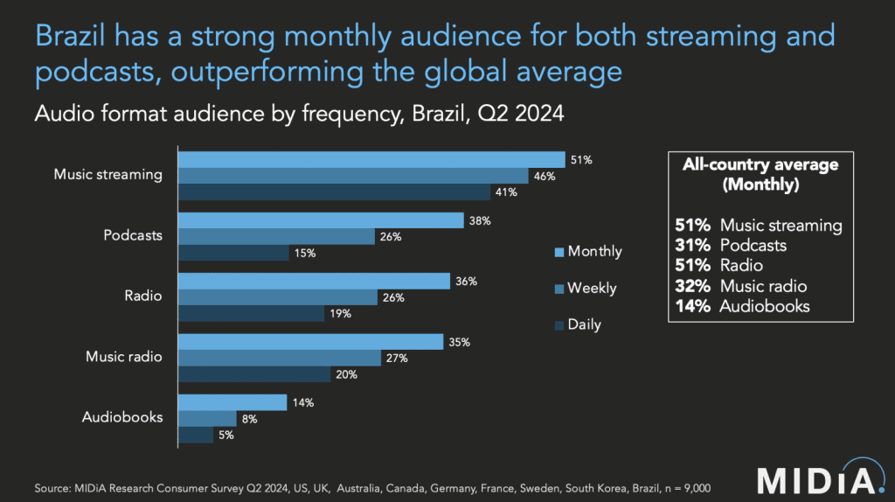
Source: https://www.hypebot.com/hypebot/2024/10/brazil-climbs-the-global-top-10-a-new-era-for-the-music-market-midias-tatiana-cirisano.html
Latin America is the fastest-growing region in the world for recorded music, with 19.4% year-over-year increase, primarily due to Brazil and Mexico (IFPI, 2025). It also highlights a significant shift in consumer preferences toward streaming platforms. Local music genres including sertanejo, Brazilian funk, pagode, and MPB influence Brazil's music streaming market. These genres have a high level of domestic consumption and are ideal for Spotify's localization plans.
High smartphone adoption, extensive usage of prepaid mobile plans, and integration with large telecom companies that facilitate bundled streaming services are other advantages for Brazil. Local billing, Brazilian real currency pricing, and collaborations with operators like Vivo, Claro, and TIM are all made possible by Spotify's subsidiary structure, which enhances customer acquisition and retention. The region's significance within the company's regional portfolio shows that Latin America accounts for 22% of Spotify's entire user base and has had 14% year-over-year MAU growth (Spotify, 2025a).
Furthermore, in comparison to other emerging economies, Brazil has a comparatively favourable regulatory framework for digital services. Brazil's openness to international IT companies and stable intellectual property enforcement lower barriers to entry, despite obstacles like high taxes on digital services and complicated compliance procedures (ITA, 2025). Spotify's choice to create a fully owned subsidiary rather than depend on indirect entry methods is further supported by Brazil's long-standing strong music culture and its close proximity to international rights holders.

3.3 Internalisation Advantages (I)
The necessity to keep control over proprietary technologies, user data, algorithms, and rights-management procedures is what motivates Spotify's internationalization strategy. By reducing the risks associated with local middlemen, such as intellectual property leakage or deterioration of product quality, internalization guarantees that the company maintains control over its fundamental competitive assets (Yan, Li and Zhang, 2021; Mets, Kaarna and Kelli, 2010).
Additionally, a high level of internal control makes it possible to harmonize platform features across regions and maintain consistent global product quality (Aksoy and Aksoy, 2020). To preserve economies of scale in platform engineering and cloud infrastructure, Spotify's digital offering needs to operate consistently across markets. There would be too much danger and variability if these crucial procedures were outsourced or given to regional partners.
Moreover, Spotify's widespread usage of consolidated global subsidiaries contributes to its internalization advantages by enabling the company to manage financial flows, hedge foreign exchange exposures, and adhere to intricate royalty commitments from a centralized structure (Spotify, 2025a). This is especially crucial in Brazil, where varying taxes and exchange rates could otherwise impede operational effectiveness.
Also, Spotify needs complete internal control in order to manage country-specific licensing arrangements and negotiate successfully with global rights holders. The company lowers transaction costs, increases negotiating power, and keeps direct connections with publishers, artists, and business partners by internalizing these services through its Brazilian subsidiary (Spotify, 2025a). Because of these internalization benefits, Spotify prefers wholly owned subsidiaries over joint ventures or franchise arrangements in Brazil.

3.4 Market Entry Mode Choice
Spotify's entry into Brazil through a fully owned local subsidiary is completely consistent with the OLI framework, given the strong ownership advantages, obvious geographical advantages in Brazil, and major internalization imperatives. With a high-control market entrance approach backed by the company's organizational and technology strengths, Spotify Brasil Servição de Música LTDA gives the company complete control over marketing, compliance, talent acquisition, rights negotiations, and local alliances (Spotify, 2025a).
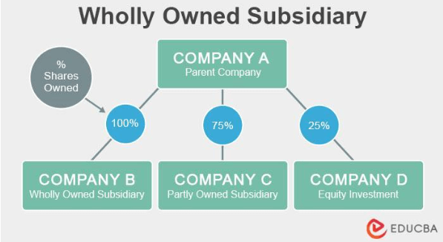
Source: https://www.educba.com/wholly-owned-subsidiary/
Because it allows Spotify to preserve product integrity, protect intellectual property, and carry out quick iterative innovation, all necessary for competing with regional platforms, YouTube Music, and Apple Music, this entrance strategy is beneficial. Spotify's capacity to adjust pricing to local conditions, such as student pricing, discounted prepaid plans, and mobile carrier bundles catered to Brazilian consumer behaviour, is further strengthened by internalizing operations (Spotify, 2025a).
But there are drawbacks to this entrance method as well. Brazil's high digital service taxation, inflation risk, and unstable economy raise operating expenses and limit price options. The administrative load is further increased by the need to adhere to Brazil's complicated labour laws and data privacy legislation (LGPD) (DLA Piper, 2023). Despite these difficulties, the fully owned subsidiary strategy is still the best option because other strategies, including joint ventures or licensing, would reduce Spotify's control over infrastructure, data, and service quality and compromise its worldwide value proposition.

4. Cultural Differences

4.1 Hofstede Cultural Frameworks
A methodical approach to analysing the differences between Spotify's culture in its two main host markets, the United States and Brazil, as well as the consequences for organizational strategy, is offered by Hofstede's cultural aspects framework (Blodgett, Bakir and Rose, 2008). The United States has a modest power distance but high levels of individuality, masculinity, and moderate avoidance of ambiguity. Brazil's large power distance, collectivist inclinations, high uncertainty avoidance, and more relationship-oriented culture set it apart from both nations (TCFG, 2025).
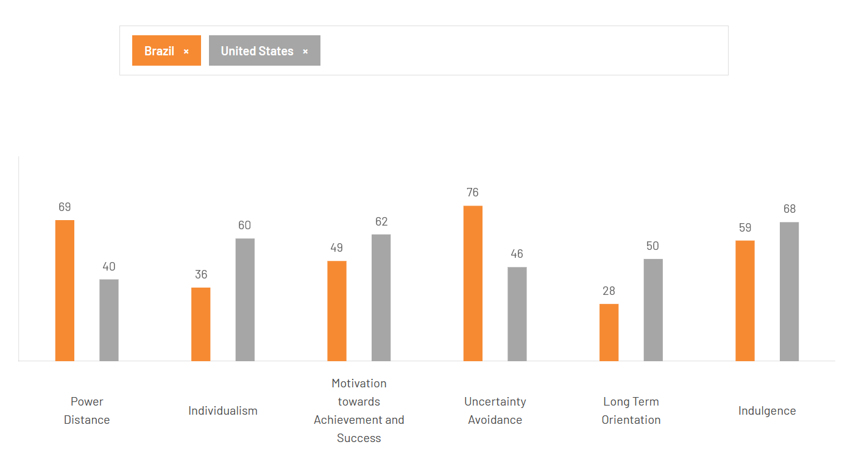
Source: TCFG (2025) https://www.theculturefactor.com/country-comparison-tool?countries=brazil%2Cunited+states
In addition to influencing customer behaviour, these cultural differences also have an impact on organizational procedures, leadership standards, communication methods, and risk tolerance. Given that its digital ecology depends on both local cultural resonance and global standardization, it was crucial for Spotify to understand these differences as it grew outside of its Nordic base.

4.2 Cultural Distance
There is a far greater cultural gap between US and Brazil. Flat hierarchies, informality, consensual decision-making, and great autonomy are characteristics of a American organizational style, which likewise emphasizes individual accountability and direct communication (TCFG, 2025). With a workforce of over 3,690 personnel and considerable R&D, marketing, and commercial capabilities, Spotify's U.S. operations grew into its greatest income source, which can be partially explained by this alignment (Spotify, 2025a).
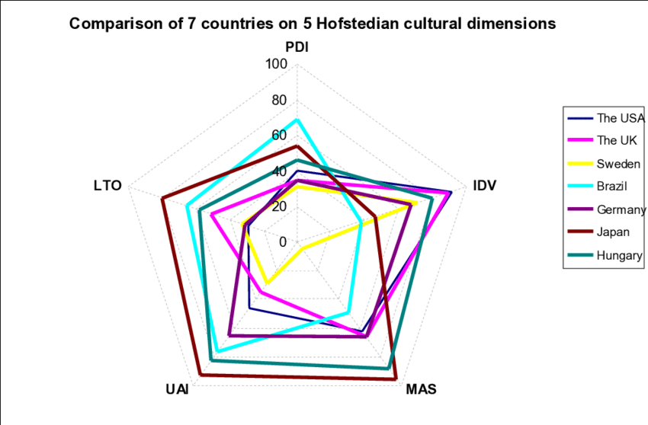
Source: https://www.researchgate.net/figure/The-cultural-profile-of-Japan-Brazil-Sweden-the-USA-Germany-and-Hungary-based-on_fig3_352714983
In contrast, consumers and organizational stakeholders in Brazil frequently anticipate more centralized guidance, formal processes, and authority-based decision styles due to the country's significant power distance (TCFG, 2025). Additionally, relationships, emotional expression, and individualized encounters are highly valued by Brazilian consumers. Spotify's marketing, customer service, artist partnerships, and talent management strategies are all impacted by this cultural divide.
Furthermore, Americas extremely experimental and permissive innovation culture contrasts with Brazil's high uncertainty avoidance, necessitating Spotify to modify not just its product marketing but also its pricing stability, customer service, and partnership-building strategies (TCFG, 2025).

4.3 Impact on Entry Strategy
Spotify decided to develop a real organizational presence in Brazil instead of managing operations remotely due to cultural differences. Spotify can embed local management, work closely with local artists, and negotiate directly with regional rights holders thanks to a wholly owned subsidiary, activities that greatly benefit from cultural proximity. Building local trust is crucial to the company's global artist and creative activities, and in a relationship-oriented culture like Brazil, this is best accomplished through on-the-ground presence (TCFG, 2025).
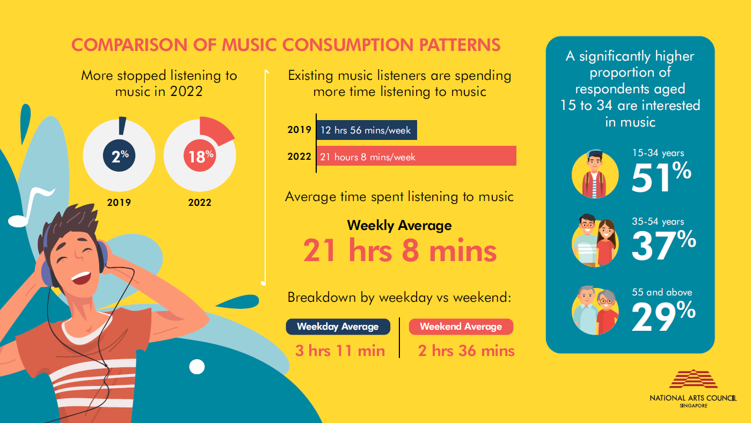
Source: https://www.nac.gov.sg/resources/research/artform-specific/national-music-consumption-survey
Spotify's localization strategy was also influenced by cultural studies. In order to increase cultural relevance, Spotify made investments in country-specific editorial teams, curated playlists like "Top Brasil," and partnerships with local artists after realizing that Brazilians preferred authenticity, emotive storytelling, and social connection (Spotify, 2025a).
Given that the average ARPU in Latin America is substantially lower than in Europe or North America, its pricing strategy demonstrates sensitivity to local expectations for affordability, transparency, and value. Despite lower monetization levels, Latin America is experiencing strong user growth, indicating the need for offers that are both culturally and economically acceptable (Spotify, 2025a).

4.4 Impact on Business
Brazilian users' interactions with Spotify are significantly influenced by cultural differences. Spotify's emphasis on collaborative playlists, social discovery tools, and interaction with social platforms is influenced by Brazil's collectivist mindset, which means that music consumption frequently takes place in shared social situations (TCFG, 2025). Spotify must consistently invest in region-specific curation teams who are aware of local trends and audience feeling due to the popularity of regional genres and the sentimental character of Brazilian music culture.
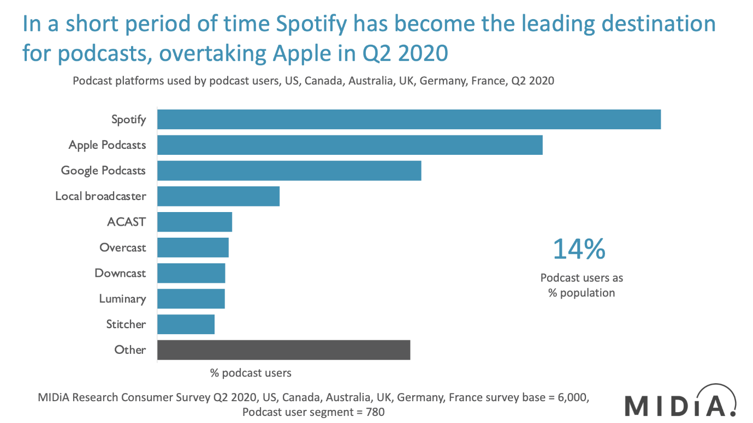
Source: https://www.midiaresearch.com/blog/podcasts-q2-2020-spotify-takes-an-early-lead
In contrast to Sweden's more subdued marketing standards, Brazil's expressive and socially active culture enables Spotify to leverage influencer relationships, live events, and culturally embedded advertising (TCFG, 2025). Operationally, customer service and onboarding must be more transparent and encouraging than in the United States due to Brazil's propensity for structured direction. Additionally, users are more sensitive to platform stability, predictable pricing, and service reliability when uncertainty avoidance is high, which puts pressure on Spotify to maintain consistent performance in spite of regional infrastructure variations.
Partnerships with marketers are also impacted by cultural variations. Compared to clients in the United States, Spotify's advertising clients in Brazil anticipate more consultative engagements and local insights due to the country's high-context communication culture (TCFG, 2025). The local expansion of the Spotify Audience Network necessitates relationship management that is in line with Brazilian expectations for long-term, trust-based engagement as opposed to strictly transactional engagements.

5. Recommendations

5.1 SOP Adjustment 1
The necessity for more thorough localization of content operations, curation workflows, and rights-management procedures in Brazil is the subject of the first significant SOP modification. The OLI analysis showed that the core of Spotify's value proposition is its worldwide ownership advantages, especially its powerful recommendation algorithms, personalization engine, and vast music catalogue (Spotify, 2025a).
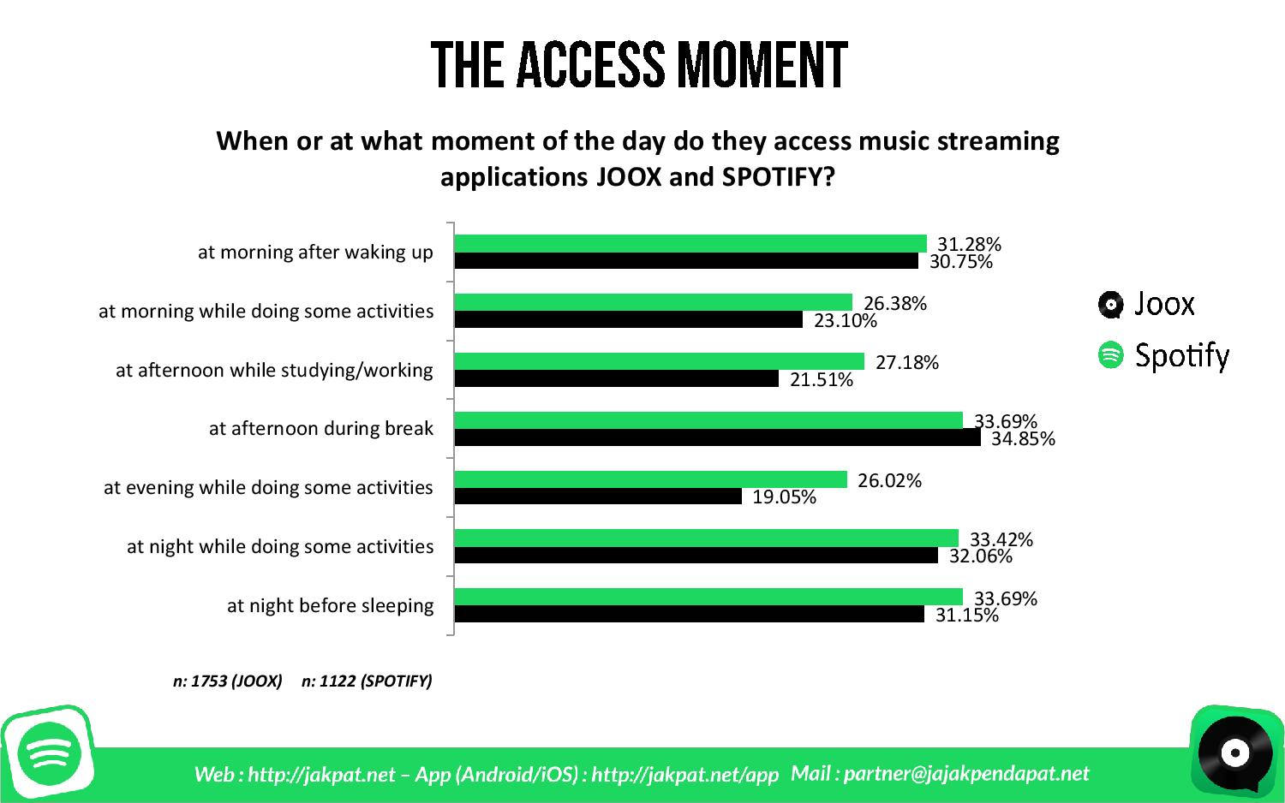
Source: https://insight.jakpat.net/music-streaming-apps-battle-joox-vs-spotify-survey-report/
In contrast to markets like the US, Brazil's highly relationship-oriented, collectivist, and emotionally expressive culture necessitates a bigger local presence in content selection, curation, and partnership management (TCFG, 2025). As a result, Spotify has to formalize and broaden the SOPs pertaining to market-specific content strategy, playlist curation, local artist relationships, and rights-holder agreements.
Domestic genres including sertanejo, funk carioca, pagode, MPB, gospel, and Brazilian trap, which all exhibit strong local involvement and an incredibly devoted fan base, have a major influence on Brazil's music scene. Latin America continues to be the world's fastest-growing recorded music region, with 19.4% year-over-year growth (IFPI, 2025).
This increase is primarily due to local repertoire rather than foreign catalogues. This means that in order to stay competitive with YouTube, which has a high level of video-driven music consumption in Brazil, Spotify needs to promote local creators and increase the number of region-specific playlists (IFPI, 2025).
Additionally, royalties to rights holders, which are structured through usage-based, revenue-share, or minimum guarantee agreements related to subscriber mix and geographic markets, constitute the greatest portion of cost of revenue. Spotify needs extremely effective rights-management operations to guarantee profitability while negotiating fair payments for Brazilian artists because Brazil's ARPU is substantially lower than those of North America and Europe (Antom, 2025).
Therefore, improved protocols for local rights-holder involvement, standardized negotiation playbooks adapted to Brazilian legislation, and expedited processes for licensing domestic catalogues at scale should all be part of the SOP modification. The structural foundation for this deeper localization is provided by Spotify's current Brazilian subsidiary, Spotify Brasil Servição de Música LTDA (Spotify, 2025a).
However, Spotify has to formalize procedures for local talent discovery, community-centric marketing activations, and regionally relevant consumer data, as well as increase the SOPs guiding its editorial and creator-partnership teams, in order to effectively capitalize on Brazil's geographical advantages. In a market where music is intricately linked to social identity and local pride, this operational improvement will assist Spotify in maintaining cultural relevance (IFPI, 2025).

5.2 SOP Adjustment 2
In order to handle Brazil's economic volatility, currency fluctuations, and inherently lower monetization levels, a second crucial SOP modification is updating Spotify's pricing, monetization, and financial-governance practices. Spotify's Latin American users, 22% of all users, contribute considerably to the rise of MAUs worldwide; yet, monetization is still lower than in the US and Europe because of regional purchasing power limitations and lower average CPMs in ad-supported streams (Spotify, 2025a). Spotify must strategically modify its SOPs for risk management, pricing experiments, and financial planning in light of these realities.
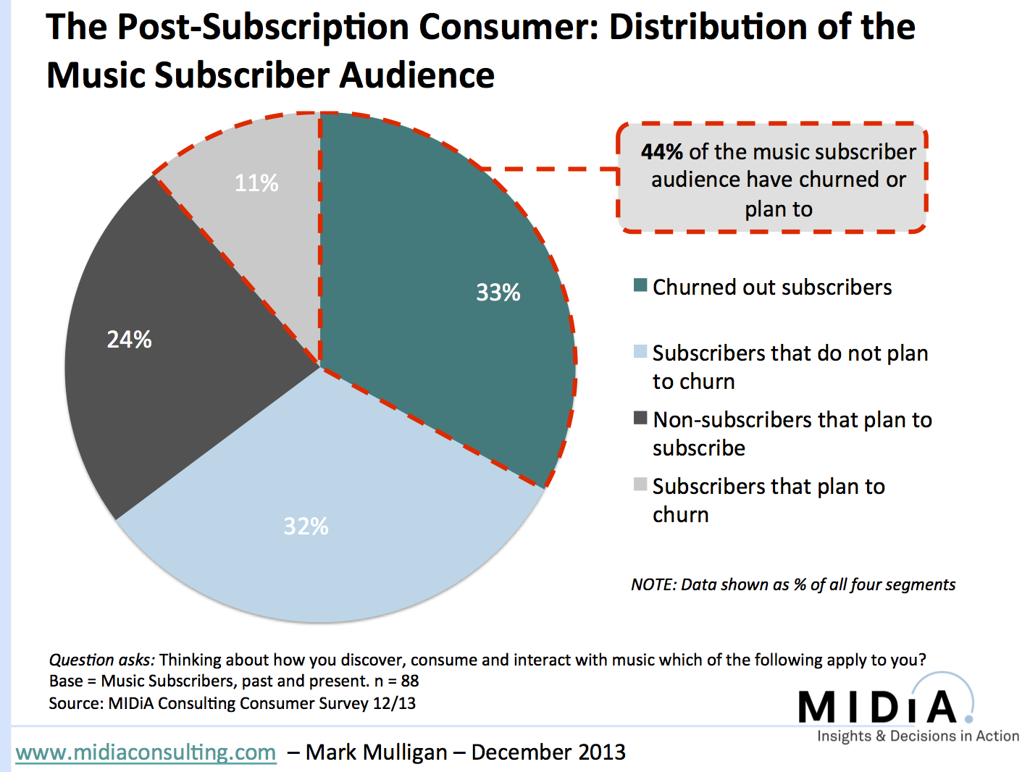
Source: https://musicindustryblog.wordpress.com/tag/music-survey/
Customers in Brazil favour stable, predictable, and transparent pricing systems due to their high level of uncertainty avoidance (IFPI, 2025). This cultural aspect stands in stark contrast to the US's higher receptivity to service innovation and subscription modifications. For Brazilian pricing, Spotify should implement a more structured SOP review cycle that emphasizes long-term stability, fewer price adjustments, and clear communication tactics catered to regional customer preferences.
From an OLI standpoint, Spotify must continue to have direct operational and financial control over its operations in Brazil due to internalization advantages. Given that global rights holders are frequently paid in euros or dollars while subscription revenues in Brazil are collected in reais, Spotify is exposed to foreign exchange risk that has an impact on revenues and royalties (Antom, 2025).
Although these techniques are not always adequate to stabilize profitability in volatile markets, foreign-currency risk is a major operational challenge so might have to use derivative financial instruments to hedge exposures (Spotify, 2025a). Spotify should therefore include Brazil-specific FX-risk procedures in its SOPs, such as improved cash-flow forecasting models, real-time currency-monitoring systems, and emerging-market-specific hedging strategies.
Additionally, structural differences in regional advertising demand reduce the possibility for ad-supported revenue throughout Latin America (IFPI, 2025). This suggests that more robust cross-functional SOPs that incorporate audience-segment optimization, advertiser-relationship management, and local advertising-market knowledge are required.
Particularly as the Spotify Audience Network (SPAN) grows its list of Latin American podcast publishers, Spotify's advertising operations in Brazil need to function with more autonomy and improved SOPs so they can respond to local market signals (Spotify, 2025a). Spotify can make sure that its monetization model is robust in spite of Brazil's macroeconomic swings and decreased income per user by incorporating these modifications.

5.3 SOP Adjustment 3
Spotify's organizational behavior, communication protocols, leadership expectations, and customer experience standards in Brazil are the subject of a third significant SOP modification. Brazil's corporate culture is characterized by high power distance, interpersonal warmth, and relationship-centric commercial interactions, whereas America is characterized by flat hierarchies, consensus decision-making, and great employee autonomy (TCFG, 2025). These cultural differences have a big impact on how teams’ function, how choices are made, and how partners and clients anticipate interacting with service providers.
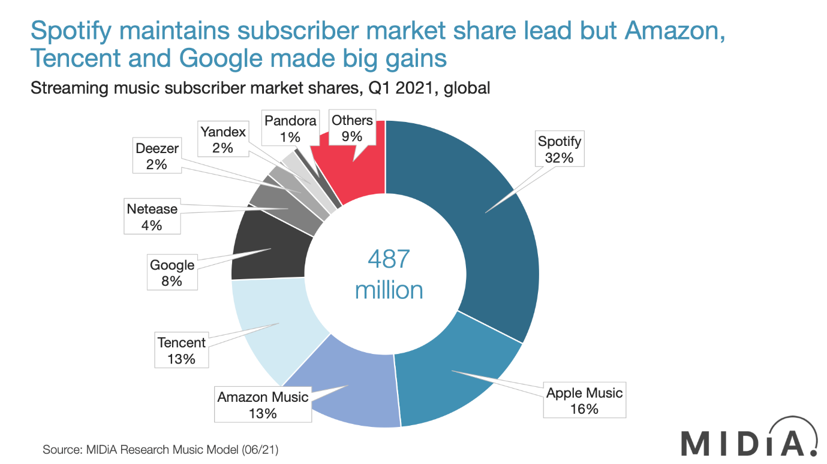
Source: https://musicindustryblog.wordpress.com/tag/music-subscribers/
Spotify's Scandinavian organizational culture, which emphasizes informality, egalitarian structures, and open decision-making, has a significant impact on its global SOPs for team management, internal communication, and customer support delivery. Although this strategy works rather well in the US, where Spotify employs 3,690 people in engineering, commercial, and research and development roles, it is less successful in Brazil (Spotify, 2025a). To avoid uncertainty and guarantee productivity, Brazil's cultural setting necessitates more direct performance-management frameworks, more structured managerial control, and clearer reporting lines.
Customer-experience SOPs are likewise subject to this structural modification. Using multiple devices, having effective onboarding procedures, and having outstanding customer support greatly boost retention and lower attrition. Brazilian users, on the other hand, anticipate greater assurance, more precise instructions, proactive assistance, and quicker service responsiveness due to their high degree of uncertainty avoidance (TCFG, 2025). To help with onboarding and troubleshooting, Spotify must modify SOPs to incorporate enhanced escalation paths, scripted communication standards for customer support agents, and region-specific user education resources.
Additionally, Brazilian high-context communication styles, which place a strong emphasis on human connection, trust, and relational continuity, require that marketing and advertiser-partnership SOPs be modified (TCFG, 2025). Brazilian partners anticipate relational depth prior to making business commitments, in contrast to the United States' penchant for straightforward, succinct conversations. Therefore, relationship-building meetings, customized advertiser consultations, and market-specific storytelling techniques in campaigns should all be formalized in SOPs for commercial teams in Brazil.

6. Conclusion
This study has shown that Spotify's success as a multinational corporation stems from its ownership advantages, wide international reach, and capacity to modify its business practices in response to various cultural and economic contexts. According to the OLI research, Spotify's use of a fully owned subsidiary in Brazil is justified by its technological advantages, strong brand, and centralized platform innovation, allowing the firm to maintain control over intellectual property, data, and service quality.
Significant distinctions between Sweden, the United States, and Brazil were also shown by the cultural research, underscoring the necessity of more thorough localization in organizational communication, pricing strategies, and content strategy. To ensure Spotify's long-term competitiveness in Brazil, the suggested SOP modifications, strengthening local content operations, rethinking monetization and financial-governance systems, and reorganizing communication and customer-experience protocols, are crucial. Spotify can take full advantage of one of the most dynamic developing music markets in the world by institutionalizing these modifications.

References
Aksoy, T. and Aksoy, L. (2020) 'Increasing importance of internal control in the light of global developments, national and international standards and regulations,' Sayıştay Dergisi, (118), pp. 9–40. https://dergipark.org.tr/tr/pub/sayistay/issue/61574/919303.
Antom (2025) 'Brazil’s gaming boom: Unlocking the new frontier of payments opportunities,' Antom, 20 October. https://knowledge.antom.com/brazils-gaming-boom-unlocking-the-new-frontier-of-opportunities (Accessed: December 11, 2025).
Blodgett, J.G., Bakir, A. and Rose, G.M. (2008) 'A test of the validity of Hofstede’s cultural framework,' Journal of Consumer Marketing, 25(6), pp. 339–349. https://doi.org/10.1108/07363760810902477.
CacheFly (2024) The impact of edge computing in music streaming - CacheFly Content Delivery Network. https://www.cachefly.com/news/reshaping-the-soundwaves-how-edge-computing-impacts-music-streaming/ (Accessed: December 11, 2025).
DLA Piper (2023) Data protection laws in Brazil - Data Protection Laws of the World. https://www.dlapiperdataprotection.com/index.html?t=law&c=BR (Accessed: December 11, 2025).
Gandra, A. (2024) Streaming makes Brazil world’s 9th biggest market for music. https://agenciabrasil.ebc.com.br/en/geral/noticia/2024-03/streaming-makes-brazil-worlds-9th-biggest-market-music (Accessed: December 11, 2025).
IFPI (2025) Global Music Report, IFPI. https://gmr.ifpi.org/.
ITA (2025) Brazil - market challenges. https://www.trade.gov/country-commercial-guides/brazil-market-challenges (Accessed: December 11, 2025).
Lau, S. (2025) 'Spotify pricing Strategy explained: The role of bundling and tiered plans - NewswireJet,' NewswireJet, 3 July. https://newswirejet.com/spotify-pricing-strategy/.
Lin, M., Ke, X. and Whinston, A.B. (2012) 'Vertical differentiation and a comparison of online advertising models,' Journal of Management Information Systems, 29(1), pp. 195–236. https://doi.org/10.2753/mis0742-1222290106.
Mets, T., Kaarna, K. and Kelli, A. (2010) 'Intellectual property – lever or barrier to the globalization of knowledgeintensive SMEs of small country origin,' Engineering Economics, 21(4). https://doi.org/10.5755/j01.ee.21.4.11711.
Music Ally (2024) Brazil: Country profiles, Music Ally.
Nordea (2025) Streaming across borders: How Spotify overcomes global currency hurdles. https://www.nordea.com/en/news/streaming-across-borders-how-spotify-overcomes-global-currency-hurdles (Accessed: December 11, 2025).
Renascence (2024) How Spotify Delivers a Unique Customer Experience (CX) with Personalized Music Recommendations. https://www.renascence.io/journal/how-spotify-delivers-a-unique-customer-experience-cx-with-personalized-music-recommendations (Accessed: December 11, 2025).
Spotify (2025) Annual Report 2024. https://investors.spotify.com/financials/default.aspx.
Spotify (2025b) How Spotify continues to supercharge Brazil’s music industry. https://newsroom.spotify.com/2025-05-28/how-spotify-continues-to-supercharge-brazils-music-industry/ (Accessed: December 11, 2025).
Spotify Advertising (2023) Introducing Spotify Ad Analytics. https://ads.spotify.com/en-US/news-and-insights/introducing-spotify-ad-analytics/ (Accessed: December 11, 2025).
Statista (2025) Spotify. https://www.statista.com/topics/2075/spotify/?srsltid=AfmBOoqTmrTs3uD2xtP09I3c7_jfc40E28hXgAQ61G7J4slHNfRMjJry#topicOverview (Accessed: December 11, 2025).
TCFG (2025) Country comparison tool. https://www.theculturefactor.com/country-comparison-tool?countries=brazil%2Cunited+states (Accessed: December 11, 2025).
Wondrasek, J.A. (2025) How Spotify loses money on every stream but grows shareholder value. https://www.softwareseni.com/how-spotify-loses-money-on-every-stream-but-grows-shareholder-value/.
Yan, Y., Li, J. and Zhang, J. (2021) 'Protecting intellectual property in foreign subsidiaries: An internal network defence perspective,' Journal of International Business Studies, 53(9), pp. 1924–1944. https://doi.org/10.1057/s41267-021-00430-5.

