

Student Name: Marco Giordano
Student Number: 1818035
Module Code: BMSW5104
Title: Managing Projects in the Organisation
Module Lecture’s Name: Husam Alharahsheh
Assignment Title: “Managing Projects in the Organisation”

EXECUTIVE SUMMARY
A critical assessment of the usefulness of project management tools and techniques and assess the extent to the company, that proved to be useful in light of the changes that have taken place in the business environment due to the COVID19 pandemic. A plan has been prepared for the implementation of the project and specifies the relevant steps that must be followed and how the plan is going to be implemented. Communication of the project plans with appropriate colleagues and stakeholders. Identification and rationalisation of any pre and post COVID19 changes that have been implemented has also been studied. Evaluation of the ability to manage a project in light with the COVID19 pandemic has undertaken. Feedback from others to evaluate your own ability to plan and implement a project by identifying strengths and weaknesses has been evaluated and a self-development plan to improve the performance in managing projects.

Table of Contents
Introduction 4
Part 1 4
Introduces project management tools and techniques and their usefulness in light of the COVID-19 pandemic 4
Advantages of Project Management tools 6
SWOT Analysis 8
Part 2 11
Project Plan 11
Project Scope 11
Project Timeline 11
Project Budget 12
Risk management map 13
Project Management Goals and Tasks 13
Implementation of a project and the relevant communication strategies 13
Navigate the now while planning for the future 14
Strategy implementation 17
Part 3 19
Self- Development Plan 21
References 22

Introduction
Amazon.com, regardless, suggested as Amazon is an overall American association. The affiliation is in the fundamental occupied with scattered cycle and electronic trade. Jeff Bezos started it on Gregorian schedule month six, 1994. The central command of the affiliation is prepared inside the town, Washington. Jeff Bezos is that the Chairman, President and friends head of the affiliation. Amazon was at first beginnings as a web book place. Following a little low bundle of years, assessment the possibility the affiliation isolated its strategic policies and what's a great deal of began exchange programming, improvements, garments, furniture, gadgets, calf stock, in this manner on the affiliation has changed regions and sells its things from one side of the planet to the back through its objections.
The affiliation has picked objections for the U.S.A.U.S.A., Australia, Canada, Germany, Italy, France, Ireland, European nation, Spain, Japan, China, India, North American country, and Brazil. It outdates Wal-Mart Stores, Inc., in 2020 and was evaluated because of the most crucial retail transporter of America. The affiliation has shown massive progression at some stage in late years as insufficient enhancement resources and everybody out monetary benefit. The unlimited resources remained at $65,444million toward the finish of 2020; the affiliation's monetary benefit remained at $107,006 for vague ads. The affiliation has men of in route more than 183,000 specialists. The load of the affiliation may be a bit of the National Association of Securities Dealers machine-driven Quotations 100 and S&P 500. The ticker picture of the affiliation could be the rudimentary amazon site of the affiliation is. Aitken, R. (April 26, 2020) recommends that "with skilled pertinence appraisals, of 36 merchants found by Thomson/First choice the high fair-minded forward stock is $535 – $89.90 (20.19%) over Friday's finishing esteem."

Part 1

Introduces project management tools and techniques and their usefulness in light of the COVID-19 pandemic

The worldwide COVID-19 pandemic has introduced project supervisors with "obscure questions," which can undoubtedly amend the weather of hazard for the executives. Endeavour chiefs within the business Company ordinarily in command of over every task successively. Company administrators in U. S. and abroad ought to update the endeavour hazard the executives set up of every task in their portfolio. These updates or changes will be subject to the actual company stage but should be created under COVID-19 cataclysm the executive's tips. Task directors can, on these lines, be particularly mindful of the updates concerning the COVID-19 debacle the board tips. U.S.U.S. straight away has 5 degrees of internment and has an alternate arrangement of tips. Tips Company reinvigorated the distinction in each internment level. Chosen project directors in structural coming up with had the choice to figure throughout level four of internment, that finished on thirty one might 2020. In contrast, others within the structure vary. The Company allowed figuring within the excess three levels.
All in all, the endeavour life cycle contains four essential stages: project origination, arranging, execution and conclusion. in an exceeding shell, project origination involves the endorsement of the task sanction, that denotes the presence of the Company, and ordinarily subtleties basic level endeavour stipulations just like the plan, scope, plan, action models and critical dangers. This is often trailed by project composition with an intensive delicate task payment set up, plan, dangers, scope, and a few important highlights. The Company goes to delicate and project execution, which involves executing the task set up.
The last part of the endeavour life cycle is the project conclusion, once it has been finished. Refreshing the endeavour hazard, the executives set up can mean - analyzing the overall impacts of COVID-19 tips on all the task stages. In lightweight of the antecedent mentioned project life cycle stages, there's a great danger of employees catching COVID-19 altogether undertakings that Company currently within the task commencement, composition or execution stages. In any case, finished undertakings at the conclusion stage convey the slightest danger. For homes that were either at project commencement or composition stage toward the beginning of internment in you. s., updated plans that presently fuse current COVID-19 tips even as future guideline suggestions should be thought of. At that time, the Company set up at the execution stage might be reinvigorated, considering the mandatory individual hours, plan, and social separating tips. It tends to be accepted that almost all activities that had found out the execution stage once the internment initiated the Company were presently delayed. Below standard conditions, project slamming and optimizing procedures is utilized to pack project set up exercises to satisfy the overall task fundamental measure. Company smashing alludes to some different assets, for instance, college and equipment, to abbreviate the task set up. Within the business, it's usually accomplished through the extension of the proletariat. Then again, project optimizing suggests that equal or synchronous execution of task exercises might have already been dead consecutively to pack the endeavour timetable and apply to exercises that will be lined. Like task slamming, project optimizing would force many people to be close to executing specific company exercises. Within the current circumstance, each endeavour slamming and optimizing ways repudiate COVID-19 catastrophe the board guidelines' subsections connected with a word connected successfulness and security, for instance, social separating and sign up time wants. During this means, project administrators have very restricted alternatives, forward any, or many probable no decisions to redress internment repercussions connected with the project set up overwhelms. There a positive affiliation between projects set up overwhelms, and project prices invade.
The lot of the endeavour is delayed; the extra cash Company going to be spent on that. Some substances Company is compensating full-time or fleeting agreement employees throughout the internment, whereas the task they were engaged with stayed static. For this purpose, once representatives continue work, they will not end the Company on schedule. During this manner, they infer that they're going to be shrunk to the task for a different timeframe at an additional expense. As a rule, most of the Company's tasks seriously laid low with the worldwide pandemic, and there'll be project set up overwhelms even as payment invades. Inescapably, some activities ought to be finished due to the absence of subsidizing in lightweight of the very fact that COVID-19 contrarily influenced some company backers' wellsprings of account. Hence, project directors, project supporters and specialists ought to re - set up, rethink, re-learn, amendment and fits the various unstable components connected with the COVID-19 pandemic to accomplish project targets.
Company the executive's tools facilitate a personal or cluster to sort out and handle their activities and assignments adequately. The term, as a rule, alludes to project the executives programming you'll be able to get on the net or maybe use for nothing.

Advantages of Project Management tools

1. Easy Planning:
Associate enterprise the executive’s device offers the North American nation the capability to line up a letter of invitation for errands for fulfilment that's eminent and productive.
This makes it heaps less complicated for the workers to play out their work. Since at no matter purpose the cluster chief realizes that steps Company the foremost important, he/she realizes that assignments to hitch to whom this can be a life hack.
2. Trip Management:
Each estimate there's created out of that your workers, or you, ought to finish. Creating notes regarding precisely what your worker's people Company presently doing is unimaginable, particularly once it comes.
This is where the executive’s application is practical: delegate labourers all the elemental errands and track however they Company playacting. Company the board gets less complicated as you'll keep Company with whose that and approach the information occupations. In commonality, teams go through work with the executives. In this manner, accomplishing impacts that Company extraordinary and benefitting business.
3. Actual Project Tracking:
The following time on every endeavour is of excellent price. It licenses you to assemble information regarding people, to grasp their work rate. This can create arrangement occupations less complicated. Time assessments Company often created by the gathering chief. Throughout a Company, a gaggle chief could offer exceptional exercises to workers by the technique of the occasion to seek out their qualities. This produces results that the Company speedier and a lot of noteworthy execution. Moreover, the affordable tools for small to medium organizations Company Indydek's Project Management device. Indydesk devices Company all around planned and straightforward to use for small to medium organizations. this can be one in every of solely a couple few CRM device provider which supplies an option to empower custom highlights for the asking even as the assistance accessible if the requirement arises.
Highlights:
• Account the board
• User Roles
• Notes, Tasks creation, and therefore the board
• Productivity hunter
• Generate each day/week when week/month to month reports in a mere 1-click.
• Task conditions
• Custom stage and Kanab sheets
• Online waterproofing device
• Set cut-off times and updates
• Files and Document sharing
• 1-1/bunch visit
• Enable custom highlights for the asking.
Amazon oversubscribed $94.6 billion value of things online in 2016, taking virtually seventieth of net-primarily based business piece of the pie. Apple came in runner up with $16.8 billion and seven.7% of the trade portion. Orange scrum may be an excellent Project Management and Collaboration tools. This assists you with obtaining sorted outcomes, group, reports and errands at one spot. Orangescrum offers a panoramic see on the advancement of your tasks, the commitment of cluster and overall profitableness to supply you the simplest R.O.IR.O.I. Instantly Orangescrum force small and medium organizations from various companies, not restricted simply to programming/advisor companies. We tend to acknowledge positive inputs as appreciations and, therefore, the others as exercises. We tend to endeavour to boost Orangescrum systematically.
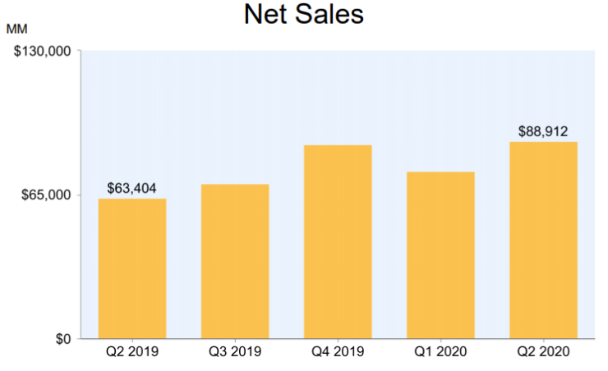

SWOT Analysis
Strengths
Brand Image and Recognition
Everybody worries Amazon. Many beautiful folks have likewise shopped there. It’s a usually recognized name, one that's often talked about getting ready to act as an associate illustration of an unprecedented arrangement someone had the chance to understand on their #1 item. At the tip of the day, it's an entirely positive image and high acknowledgement.
Development and individuation
Consistently, you see new types of things and administrations being value-added to the Amazon stage (commonly through outsider merchants). You likewise see recent fads with stress on straightforward to know utility and unprecedented searching expertise that separates it from contenders – this can be an implausible illustration of Amazon's essential separation.

Weakness
Absence of considerable Physical Presence
This point demonstrates that a solitary issue will set about as each profit associated an obstacle. Whereas the online-generally approach helps the organization save an enormous total in prices, it keeps Amazon from taking advantage of business sectors wherever online business is hitherto associate arising pattern.
Rivalry
Retail organizations Company is developing online and each different day. Anyway, very little regardless, they're Amazon's rivals. Likewise, enormous numbers of them have imitated Amazon's set up of action, removing one in every of its central higher hands. As indicated by the Amazon vision articulation, the organization desires to remain in the 1st spot on the list of most consumer-driven organizations globally.
Opportunities
Market growth
This was recently talked about regarding together of Amazon's qualities. It, during this means, bodes well for it to be an opportunity. Why? Since there Company more business sectors that Amazon will nonetheless enter and cash in on. With associate growth within the net-primarily based selling in agricultural nations, the conceivable outcomes Company unbounded.
Formation of Own business line
One of the first parts of Amazon is to fill in as an internet trafficker for outsiders to sell their things. One thing that will be a lot useful to the organization is that it began creating and marketing its things a lot. This could be worn out a savvy, keyway, even so, to stay it from turning into another fireplace Phone disaster.
Threats
Cybercrime
Cybercrime and data felony Company current crimes that place net purchasers in peril, significantly those who search on the online, there’s associate swollen heedfulness among individuals typically regarding the risks of sharing individual and money balance subtleties over the online nowadays This has forced people to undertake to not search online once they will somewhat.

Expanded Competition
One of the numerous problems that undermine Amazon systematically is that increasingly more online retail locations Company jumping up systematically. Whereas Amazon rules the web business trade by a distinctive edge, a few, if comparatively few, of the novices can systematically have the likelihood to develop at a dramatic rate and leave the undisputed monster (for the time being) behind.
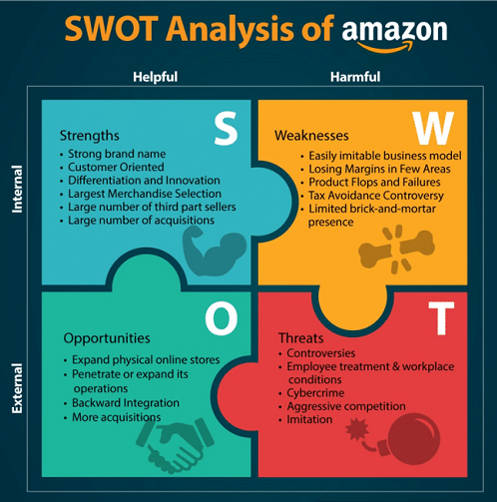

Part 2

Project Plan
Exploring the ramifications of the COVID-19 pandemic is extraordinary. Our significantly else desires Company guaranteeing we're supporting our staff, consultants and customers across the world. As a full-stack innovation and talent helper, we'd like to company our expertise associated supply facilitate in a way to cut back the vulnerability around operating atmosphere administrations support as various organizations shift to an in the main remote working class for an inconclusive timeframe.

Project Scope
The worldwide COVID-19 pandemic has angry organizations to take Company newfound. Briefly, the Company effort stupendous extension of changes to their strategies; they must regulate and keep it up, gaining ground on their distinctive objectives within the long-term.
Fabricate a system for correspondence and business coherence
Most Associations Company will be needed to proceed as they were proceeding the pandemic nonetheless ought to roll in the hay the other means through virtual and distant administration.

Project Timeline
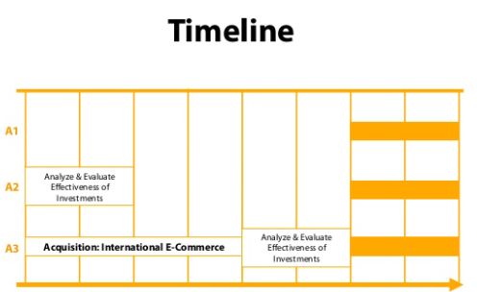
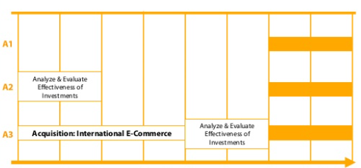

Project Budget
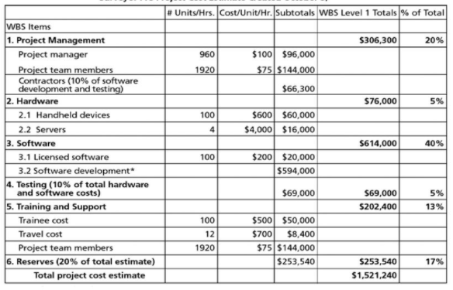
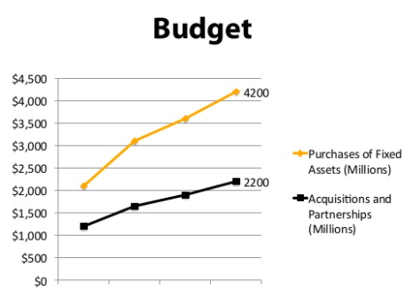

Risk management map
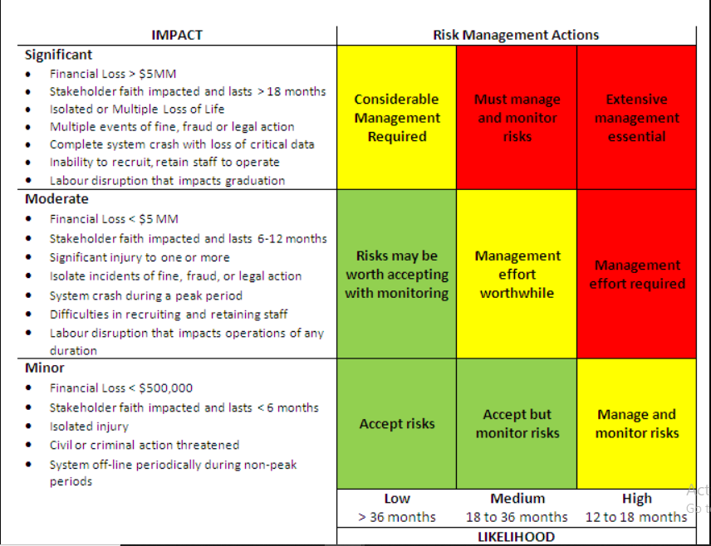

Project Management Goals and Tasks
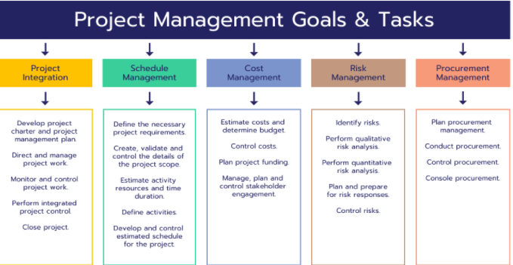

Implementation of a project and the relevant communication strategies
To do this, associations guarantee their business system fuses emergency the executives, catastrophe recovery and hazard the board to regulate and refocus to honest business endeavours. Also, energizing that potency might look unambiguously in distinction to previously—like structure new advancement dashboards or exploitation new coordinated effort tools. Bear in mind that amendment drives Company not no completely different either means. Therefore the methodology got to be elastic and versatile to coordinate with the business's wants. This suggests making sure your Company finishing up O.C.M.O.C.M. exercises that supply the maximum profit and wished results. Utilizing organized amendment, the executive's approaches can facilitate construct amendment attentiveness as your representatives become additional alright with higher approaches for operating, for instance,
• Serving as augmentations of, and associations between, project teams and affected colleagues
• Implementing criticism channels to live correspondences adequacy, appropriation, obstruction and acknowledgement
• Enabling and increasing the use of virtual/far off shows, preparing, instructing and constant improvement with the use of collective apparatuses
• Providing supported facilitate at the friend level
Making associate organized interchanges approach for much off work that upholds representatives can assist them with staying productive in their jobs while not interrupting. This incorporates best observe techniques to ensure representatives and shoppers understand this circumstance, what it means for them, and the new cycles and ways required to manage their responsibilities. Dread of the obscure and vulnerability could be a significant part of people unfit to remain profitable. Any specially appointed ways to take Company of superintending representatives that Company not fastened in or organized won't be viable. Associations that can signally and faithfully convey will wish to assist quiet apprehensions and eventually support business congruousness.

Navigate the now while planning for the future
Temporarily, associations might finally check out business coherence layouts and risk bundles to assist impart to their teams and set cycles set up—all of which can assist with beginning exploring their amendment the executives.
Notwithstanding, it's essential to deem the program and guarantee your program is flexible to your new climate, nonetheless one that's in addition affordable as long as possible—with the capability to advance as enhancements, in any variety of emergency, keep it up evolving. By making and inspiring the conduct changes within a bunch targeted O.C.M.O.C.M. arrange for much off work, representatives can wish to {stay} on sharpening those skills once tasks go back to "typical" and stay adjusted in new limits once back at the geographic point. Staff with no heritable new skills in remote joint effort and self-administration Will be considerably additional viable once placed in extraordinary circumstances past this COVID-19 emergency.
Organizing your O.C.M.O.C.M. arrange during this manner can higher address the concept of your working class so that they become additional versatile, which might improve gain and increment efficiencies. Associations Company will be higher settled to manage comparable emergencies anon, with the capability to extend or down effortlessly.
A couple of tips to assist explore forced amendment the executives and alter business progression plans within the interior of COVID-19:
• Focus on the upper perspective. Methods should be invigorated; nonetheless, remaining fastened on the upper perspective is essential for business execution.
• Adapt to raise approaches for potency. This might bear in mind the collection of new virtual dashboards for Company or cluster progress, small standing gatherings and cluster conferences to develop new concepts or exploitation of distinctive cooperation devices to assist remote correspondences. Regardless of the case—stay elastic and supply facilities to project teams and affected colleagues.
• Clearly and faithfully convey. Creating associate organized interchanges arrangement and setting assumptions for remote work can facilitate keep people engaged and helpful throughout seasons of vulnerability.
• Increase ways that for representatives to administer input and heighten problems or issues. This may assist you in checking correspondences adequacy, choice and opposition.
• Enable consistent improvement. For instance, making ready and advancement, for instance, virtual cluster the executives coaching and joint effort the board will facilitate representatives rotate and embrace higher approaches for operating and work beneficially.
• Build in skillfulness. As you modify your business congruousness plans for the current, guarantee your program is economical as long as possible—with the capability to advance as enhancements, in any variety of emergency, keep it up evolving.
In the quest after wellsprings of manageable favourable position, JEFF BEZOS has understood that business execution depends not simply on arranging and fruitful execution of a given technique but also on the interaction by that serious positions Company created maintained.
(I) Innovation:
The guideline strategy employed by Jeff Bezos is client-targeted on progression. As Pearson and Robinson (2000) battle that "several enterprises guess that it's paid to form progression their tight approach". (Pearson and Robinson 2000). That's the rationalization he had exceptional specialize in the steady flip of events, by orientating new developments with update shopper ability. Since customers expect tenacious change and new things and organizations. Bezos believed in headway as a key to advance and break competitors. In line with (Pearson and Robinson, 2000), "most improvements settled corporations significantly like ought to be innovative" (Pearson and Robinson 2000). As shown by Bob Delaware Wit and Ronley (1998), "headway desires torturous, fiddling, experimentation, testing and ingenuity, as novel issues initial Statevelop and take shape"(Bob First State Wit and Ronley,1998). Steady and relentless improvement within the electronic exchange has been Amazon's inheritance.
(ii) Diversification:
Another strategy Jeff Bezos used for Amazon is rising. He used each issue rising and business enlargement. In some cases, his recognizable new things at a similar time fulfil customer’s desires and desires. That’s why recently, Amazon envelops a large live of consumers. International organization visit the world and satisfy their desires. As incontestable by Pearson and Robinson (2000), "firms looked for balance in their portfolios between current business with lasting arrangements and bought the business with monotonous counter arrangements between high-cash/low chance and low-cash/high chance associations or between commitment-free and significantly used business" (Pearson and Robinson 2000). I trust Pearson and Robinson (2000) since Bezos had seen chance and advancement in new associations e-g, toys, pearls, games, success, and greatness. Subsequently, Bezos is seen appallingly powerful within the business increasing, that affordable from his acclaim of current business position. As Johnson and Scholes (1993) fight, "associations that expand by increasing on their middle business show improvement over people international organization upgrade throughout a disengaged way."
(iii) Human additionally to the method:
Human additionally accepts a crucial part within the accomplishment of a business; as Pearson and Robinson (2000) states that "an associations capability to haul during and resist on in a foothold delegates is vital for its flourishing" (Pearson and Robinson, 2000). Bezos had an extraordinary spotlight in supporting the predominant bunch, and for this, he selected different positioning managers and managers as of currently and once more. Since business framework associated an hour methodology extensively influences the affiliation's show, during this manner to realize tip high, ought to be a linkage between these a pair of procedures. Bezos is seen horrendously productive in doing this.
(iv) Acquisitions
Another framework Bezos used for the occasion of the business is acquisitions. As incontestable by Pearson and Robinson (2000), " the acquisitions of a minimum of one close to corporations filter out competitors and offers the obtaining firm induction to new business areas" (Pearson and Robinson 2000). I trust Pearson and Robinson as Bezos no heritable modified associations to assist journey into the E.U.E.U. business focus. Bezos no heritable shifted distinctive website associations giving numerous types of facilities to its customers. I will be able to fight Bezos. This basic thinking engine helped him alter competitors and make Amazon no one in the world.
(v) Joint undertakings
Jeff Bezos equally used joint undertakings for the augmentation and advancement of his business. As incontestable by Bartlett et al. (2004), "multinationals used joint undertakings freely because the least troublesome manner not completely to research through preventive cycles in any case still get hold of concerning new business areas" (Bartlett et al.,2004). Amazon had joint undertakings with key internet players that offer an enormous shopper base and an opportunity to fill in new business areas. Bartlett et al. (2004) fight that "pioneers rummage around for advancement within the large making business areas, they need associate inclination conventionally to focus in on the elements of the likelihood and what is more the troubles that lie ahead" (Bartlett et al. 2004). I trust Bezos had joint undertakings since he saw an opportunity for advancement.
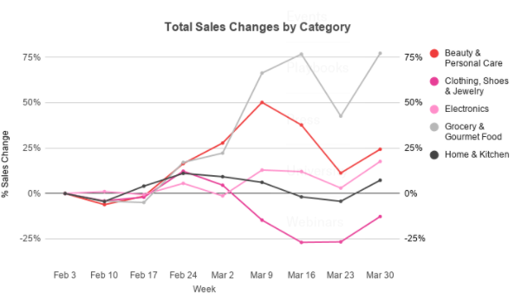

Strategy implementation
"The viable execution of methodology need frequently require some extent of progress within the connection additionally to profile" (Johnson and Scholes, 1993). Jeff Bezos used flip of events and chronic advancement as customary frameworks in his business that he achieved through consistent development improvement and augmentation as acquisitions and joint undertakings. It’s seen that modified frameworks blow as associate aftereffects of nonattendance of the board interest. It’s fundamental that to carry out a productive philosophy, essential resources ought to be disseminated to that, additionally within and out of entryways factors settle for crucial 0.5 inside the accomplishment of the framework. "It isn’t your principal issue, the trail within that you're doing it that is that the problem that gets results" (Anon, 2003). Jeff Bezos is astonishingly productive in touching the ways at the happy time as "the scenario of a system is vital, on the off probability that one is to encourage in before partner resister pay vital time during a market advantage with an analogous idea" (Anon, 2003).
Amazon, the simplest online retail merchant globally, is functioning a lot resolutely to fortify its reality association presence by broadening its scattering association and wandering into new business areas. The money connected Times elaborate. On account of its basic scenario around there, multinationals are great power from all over the world even as U. S., and F.R.G.F.R.G. and subsequently on.
Last year, Amazon added 11 distribution centres to its network, and Goldman Sachs analysts say that all but two were located outside the U.SU.S. According to their research, there were three European, five Chinese and one Japanese opening in 2010. Amazon added an Italian website to the ones it operates in France, Germany and the U.K.U.K., and acquired Spain-based Buy V.I.P.V.I.P. for nearly USD100m (EUR75m).
Amazon is currently boosting labourers numbers in Luxembourg, anyplace its European headquarters are primarily based for the foremost half. The function is checking out consultants in collaborations and conveyance to ensure the easy progression of the enlargement and elevate the adequacy of the diffusion association.

Part 3
The main talents of a task chief incorporate administration, correspondence, time the executives, arranging, cluster the board, and basic reasoning. Moreover, he/she ought to likewise have the choice to remain tuned into the venture the executive’s patterns and utilize the apparatuses they need to their fullest.
Venture the executives could be a drawn-out work joined by numerous errands that project administrators got to do right and project origin, composing and execution, and management and conclusion. What makes it somewhat more testing is that U.N.U.N. agencies are given many objectives, a timetable, and a selected disbursal arrangement once such are appointed to teams. To create matters a smidgeon a lot of convoluted, project supervisors ensured that everything goes simply to ensure a task's prosperity.
Coming up next are in all probability the most effective endeavour the executive’s talents that project supervisors need to have:
1. Leadership
The issue of venture initiative has systematically been and systematically will be a degree of convergence among organizations. This can explain it's while undoubtedly the best purpose of a venture administrator's most vital talents. This experience empowers project administrators to consider company dreams and lead teams adequately. Boosting this ability can hugely improve the endeavour supervisors' professional success.
2. Communication
Correspondence goes inseparably with administration talents. To be a robust pioneer, one should choose to clarify what project teams ought to do. All the same, correspondence is not restricted to the venture cluster; it also applies to all or any partners, as well as merchants, project staff, and shoppers. Such ought to be attainable victimization advances like asserting devices, visit or document sharing. Such devices work with individual-to-individual to individual and gathering correspondence a similar.
3. Risk Management
The multiplication of exceptional ventures has caused project chiefs to obtain a lot of practice at risk on the board. In distinction to traditional tasks that are overtimes revaluated or allotted to less ready venture chiefs, this one in all sort endeavours involve many woolly-headed endeavours that solitary develop project directors are suitable addressing. Having this ability is a sign of getting command over your venture. What is more, it is a palm technique of guaranteeing project supports that their speculations are in good hands.
4. Team Management
Most people from project teams want direction from project directors, and also, the best technique to try to this can be by coaching. Having this ability can empower you to atone for representative deficiencies, such as light venture insight and, consequently, want to coach. What is a lot of?
5. Task Management
A powerful endeavour supervisor needs to likewise be capable at a task the board. This experience includes the capability to concoct task records and representative them whereas keeping expert over the endeavour. To possess the choice to harness this ability, one ought to become acquainted with the means toward creating records. Systems for guaranteeing that one is frequently on prime of such a summary need likewise to be created. This can be well-known to ensure that project result time is systematically on schedule.
To guarantee the workplace and its main goal are running as fruitfully as might significantly be expected, directors got to attract representatives with standard and foreseeable input. Consistent execution observant with traditional, compelling input can deliver ideal results. Positive criticism includes educating someone regarding excellent execution. Create this input ideal, explicit, and constant. Valuable input makes a person tuned in to an area wherever their presentation might improve. Helpful input is not analysis. Giving viable input, kind of like all talents, wants learning, observe and tolerance. Criticism is lauding proper execution and proposing restorative thoughts. Zero in need to be each on what the individual did and the way it had been finished.

Self- Development Plan
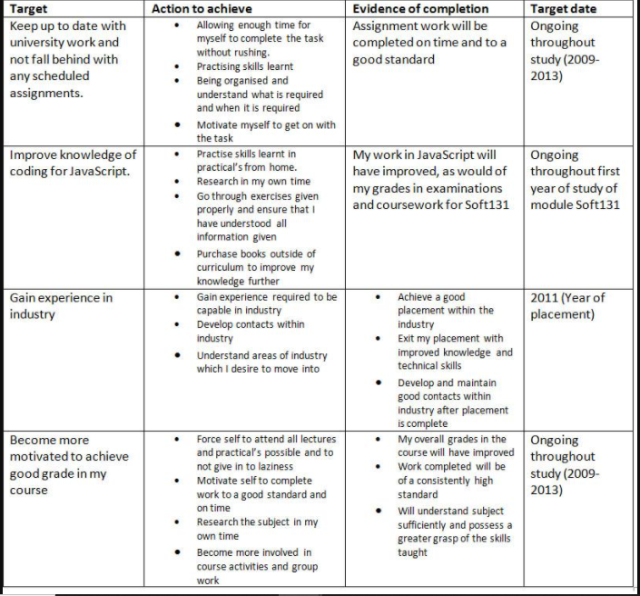

References
Journals
Antunes, A.P., Rebêlo, G.H., Pezzuti, J.C.B., de Mattos Vieira, M.A.R., Constantino, P.D.A.L., Campos-Silva, J.V., Fonseca, R., Durigan, C.C., Ramos, R.M., do Amaral, J.V. and Pimenta, N.C., 2019. A conspiracy of silence: Subsistence hunting rights in the Brazilian Amazon. Land Use Policy, 84, pp.1-11.
Athayde, S., Silva-Lugo, J., Schmink, M., Kaiabi, A. and Heckenberger, M., 2017. Reconnecting art and science for sustainability: Learning from indigenous knowledge through participatory action research in the Amazon. Ecology and Society, 22(2).
Bernalte, E., Arévalo, S., Pérez-Taborda, J., Wenk, J., Estrela, P., Avila, A. and Di Lorenzo, M., 2020. Rapid and on-site simultaneous electrochemical detection of copper, lead and mercury in the Amazon river. Sensors and Actuators B: Chemical, 307, p.127620.
Caballero Espejo, J., Messinger, M., Román-Dañobeytia, F., Ascorra, C., Fernandez, L.E. and Silman, M., 2018. Deforestation and forest degradation due to gold mining in the Peruvian Amazon: A 34-year perspective. Remote Sensing, 10(12), p.1903.
Correa, J., van der Hoff, R. and Rajão, R., 2019. Amazon Fund 10 years later: lessons from the world's most extensive REDD+ program. Forests, 10(3), p.272.
da Silva Júnior, L.A.S., Delgado, R.C., Pereira, M.G., Teodoro, P.E. and da Silva Junior, C.A., 2019. Fire dynamics in extreme climatic events in western amazon. Environmental Development, 32, p.100450.
de Bem, P.P., de Carvalho Junior, O.A., Fontes Guimarães, R. and Trancoso Gomes, R.A., 2020. Change detection of deforestation in the brazilian amazon using landsat data and convolutional neural networks. Remote Sensing, 12(6), p.901.
Delfanti, A. and Frey, B., 2021. Humanly extended automation or the future of work seen through Amazon patents. Science, Technology, & Human Values, 46(3), pp.655-682.
Eisenberg, C.C., Vogt, R.C., Balestra, R.A.M., Reynolds, S.J. and Christian, K.A., 2019. Don't put all your eggs in one basket–Lessons learned from the largest-scale and longest-term wildlife conservation program in the Amazon Basin. Biological Conservation, 238, p.108182.
Fisher, J., Stutzman, H., Vedoveto, M., Delgado, D., Rivero, R., Quertehuari Dariquebe, W., Seclén Contreras, L., Souto, T., Harden, A. and Rhee, S., 2020. Collaborative governance and conflict management: lessons learned and good practices from a case study in the Amazon Basin. Society & Natural Resources, 33(4), pp.538-553.
Gauthier, C. and Moran, E.F., 2018. Public policy implementation and fundamental sanitation issues associated with hydroelectric projects in the Brazilian Amazon: Altamira and the Belo Monte dam. Geoforum, 97, pp.10-21.
Humphries, S., Holmes, T., de Andrade, D.F.C., McGrath, D. and Dantas, J.B.J.B., 2020. Searching for win-win forest outcomes: Learning-by-doing, financial viability, and income growth for a community-based forest management cooperative in the Brazilian Amazon. World Development, 125, p.104336.
Maués, L.M.F., do Nascimento, B.D.M.O., Lu, W. and Xue, F., 2020. Estimating construction waste generation in residential buildings: A fuzzy set theory approach in the Brazilian Amazon. Journal of Cleaner Production, 265, p.121779.
Rauschmayr, N., Kumar, V., Huilgol, R., Olgiati, A., Bhattacharjee, S., Harish, N., Kannan, V., Lele, A., Acharya, A., Nielsen, J. and Ramakrishnan, L., 2021. Amazon SageMaker Debugger: A System for Real-Time Insights into Machine Learning Model Training. Proceedings of Machine Learning and Systems, 3.
Shimabukuro, Y.E., Arai, E., Duarte, V., Jorge, A., Santos, E.G.D., Gasparini, K.A.C. and Dutra, A.C., 2019. Monitoring deforestation and forest degradation using multi-temporal fraction images derived from Landsat sensor data in the Brazilian Amazon. International Journal of Remote Sensing, 40(14), pp.5475-5496.
Stropp, J., Umbelino, B., Correia, R.A., Campos‐Silva, J.V., Ladle, R.J. and Malhado, A.C.M., 2020. The ghosts of forests past and future: deforestation and botanical sampling in the Brazilian Amazon. Ecography, 43(7), pp.979-989.
Uribe, S., 2019. Illegible infrastructures: Road building and the making of state-spaces in the Colombian Amazon. Environment and Planning D: Society and Space, 37(5), pp.886-904.
Urzedo, D.I., Neilson, J., Fisher, R. and Junqueira, R.G., 2020. A global production network for ecosystem services: The emergent governance of landscape restoration in the Brazilian Amazon. Global Environmental Change, 61, p.102059.

Appendices
Appendix 1: Project Management Tool
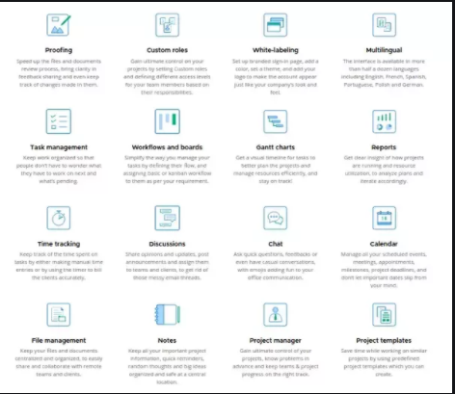
(Source: https://www.quora.com/What-scrum-project-management-tool-does-Amazon-use)

Appendix 2: Corporate Strategy
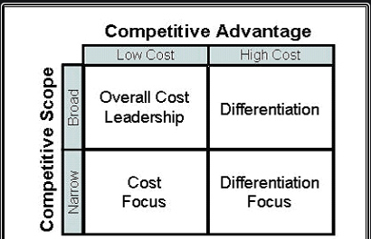
(Source: https://www.managementstudyguide.com/analysis-of-amazon-corporate-strategy.html)

Appendix 3: Marketing Strategy
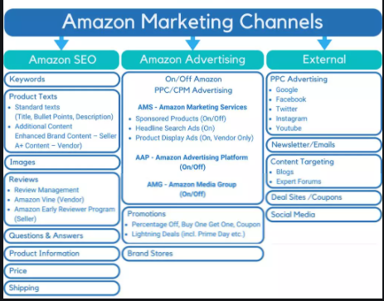
(Source: https://sellics.com/blog-on-amazon-advertising-marketing-overview/)

Appendix 4: Profit Graph

(Source: https://www.statista.com/chart/14887/amazon-quarterly-profit/)

