
Skills for the Workplace
Module Assignment Submission
Student Name: | Martine Kennedy
Student Number: | 2010990
Module No: | BMSK4002
Module Title: | Effective Team Working and Communication  Part 2

Statement of Confirmation of Authenticity
By the act of making this submission, the student declares that this is the work of the student named above. The work has not, in whole or in part, been knowingly presented elsewhere for assessment, or where assessment has been built on a previous assessment, this has been identified. Where materials have been used from other sources it has been properly acknowledged. If this statement is untrue, the student acknowledges that an assessment offence has been committed.
Attention is drawn to the plagiarism and unfair practice policies of both the University and of ILM.

Table of Contents
Part 2 Communication 3
1.0 3
Communication Cycle 3
2.0 5
Assessing Own Communication Skills 5
Gap Analysis 6
PDP 6
References 7
Appendix A 7
Skills You Need Communication Quiz 7
Mind Tools Communication Quiz 9

Part 2 Communication

Prepare a written report on workplace communication with due regard to content, structure, language, levels of formality, modes of communication and regard for audience.
Communication is a fundamental part of how we interact on a daily basis. Effective communication both within the workplace and personally is paramount, as failing to do so can have a severe negative impact in many areas.
Morgan, P (2017), outlines the key elements and states, “the principles are relatively straight forward to understand, of course the challenge comes in applying them to our communication. Unless we think about them, all the processes and issues identified happen unconsciously, but when we do think about them and change what we do as a result, then our communication become much more effective”.
The student totally agrees with this statement. Whether we are communicating verbally or non-verbal, it is how we interact on a daily basis and do not often put much thought into the process.
Technology has advanced immensely in our modern day, and as a result are able to email, text etc. Written communication is widely used across organisations. It is a fast way to send information, in particular for large groups. However, we should consider things such as, the tone of the message, does it need to be formal, informal, how sensitive, time critical, is the information we are relaying. This information translated using this method may be interpreted differently by the recipient and/or not effectively communicated by the sender. This may result in a breakdown of communication. Additionally, will the material be read at different times, or at all.
Verbal communication is where the author prefers to communicate. Whether this be via telephone or face to face. The student feels this is a two-way conversation from the offset where you can pick up on individuals’ tone and body language, opposed to written communication where you are unable to do so. She feels this method is effective but recognises it can also be more time-consuming than the written approach and is guilty of sending a message, rather than verbally, merely as it is quicker.
The student works in an environment where it is purely based on fact to face interaction. On rare occasion her work colleagues communicate via whatsapp. It is a very informal workplace and interacts with her peers as such. However, the student acknowledges that depending on the customer, she adapts to how she interacts. This maybe a difference in her tone or perhaps a more formal approach.
The owner of the business is an ineffective communicator. There is an obvious breakdown of communication when he interacts with the team. The author works within a small team, where collectively they take control of the processes and effectively communicate with each other. The owner of the business acknowledges this is not his strong point and trusts the team to manage his expectations. There is a strong element of trust within the business which is an important element in effective teams and how we interact to reach the main objective.
Whilst many Communication cycles have the option to obtain feedback, without really thinking about the process, we do not always get clarification that the information is understood. We often wait for issues to arise and/or individuals to clarify requirements at a later stage. By following the stages in a preferred cycle, we are more likely to effectively communicate.
There are numerous communication models available on how to effectively communicate.
The Shannon and Weaver communication cycle is broken down into seven steps – see appendix A.
Drew. C (2019), gives an overview of the model,
“1. Sender (Information Source)
The Shannon Weaver model starts with the sender or “information source”. They are the person (or object, or thing – any information source) who has the information to begin with. The information source starts the process by choosing a message to send, someone to send the message to, and a channel through which to send the message.
2. Encoder (Transmitter)
The encoder is the machine (or person) that converts the idea into signals that can be sent from the sender to the receiver. The Shannon model was designed originally to explain communication through means such as telephone and computers which encode our words using codes like binary digits or radio waves.
3. Channel
The channel of communication is the infrastructure that gets information from the sender and transmitter through to the decoder and receiver.
4. Noise
Noise interrupts a message while it’s on the way from the sender to the receiver. It’s named after the idea that ‘noise’ could interrupt our understanding of a message. There are two types of noise: internal and external.
5. Decoder
Decoding is the exact opposite of encoding. Shannon and Weaver made this model in reference to communication that happens through devices like telephones. So, in this model, there usually needs to be a device that decodes a message from binary digits or waves back into a format that can be understood by the receiver.
6. Receiver (Destination)
The receiver is the endpoint of the original Shannon and Weaver model of the technical communication process. This is the step where the person finally gets the message, or what’s left of it after accounting for noise.
7. Feedback
The final step in the Shannon Weaver model is ‘feedback ‘. Actually, the ‘feedback’ step was not originally proposed by Shannon and Weaver in 1948. Norbert Weiner came up with the feedback step.”
It is the authors opinion that although this model was created in 1949, where there were obviously very different methods of communication and technology available, the basis of the concept can easily be applied to our modern day. She recognises that within her workplace this theory is used within the team.
Schramm’s communication cycle is broken down into three area’s – see appendix B.
QS study (2021) highlights Schramm’s theory to be “communication always requires three elements, the source, the message and the destination. Ideally, the source encodes a message and transmits it to its destination via some channels, where the message is received and decoded.
Schramm’s Model of Communication suggests that communication is a two-way process where both sender and receiver take turns to send and receive a message.”
As with any line of effective communication, whether this be verbal or nonverbal, the initial message we convey is the most important factor in the communication process. This is where we set the expectation, requirement which is key.
Management Study Guide (2021) defines Berlo’s model of communication as “it considers the emotional aspect of the message”.
The model is based on various factors, under four key elements, which operates the SMCR model – see appendix C. The theory recognises things such as cultural beliefs, our senses etc as playing an important factor in how we effectively communicate with individuals. It is the opinion of the author that this model is more complexed than the theories, as outlined above. Whilst this would perhaps be better suited to larger organisations, the lack of feedback the model supplies may pose an issue within a workplace environment.

2.0

Evaluate your own communication skill based on feedback and produce a ‘personal development plan’ to address areas for improvement.

The student conducted a “how good are your communication skills test – see appendix D.
Mindtools (2019), summary of the score, “Excellent! You understand your role as a communicator, both when you send messages and when you receive them. You anticipate problems, and you choose the right channel to communicate. People respect you for your ability to communicate clearly and they appreciate your listening skills.”
“The Source – Planning Your Message
Your score is 6 out of 10

Encoding – Creating a Clear, Well-Crafted Message
Your score is 21 out of 25

Choosing the Right Channel
Your score is 15 out of 15

Decoding – Receiving and Interpreting a Message
Your score is 12 out of 20

Feedback
Your score is 9 out of 10”

The student found this test very interesting. Whilst she would say she is an effective communicator, the breakdown of areas for improvement was beneficial. She has compiled a PDP and Gap – see appendix’s E and F.

The decoding stage stood out to the author, as she scored 12 out of 20. Upon reflection she would agree that at times she perhaps focuses on her vocalising her opinion, rather than stepping back and let the other person talk and listen. This is an area she will be mindful in the future, along with the planning stage. She will focus on relaying relevant information opposed to un-necessary contents. Since starting this course, she recognises this is an area that needed improvement and has been working on this.

The lack of confidence with public speaking has been an ongoing area for development for the author. She has been taking steps to improve and will continue in the future.

With a view to establish her work colleagues, effectiveness on communicating, the student asked them to complete the “how good are your communication skills test – see appendix G. What was interesting about the results is that both the owner and Manager both scored within the 15-35 category. Whilst the other team members scored in the higher brackets.

The author also asked her team members how effective they feel her communication is within the workplace – see appendix H. The results came back as she does communicate well within work.

The student also conducted an Interpersonal Skills Self-Assessment, which the results are as follows:

Score - 77%
Skills you need (2019), summary is as follows: “Based on the answers you provided you have above average interpersonal skills. Although your interpersonal skills are good, they can always be improved further, helping you to enjoy even more successful relationships with others, at home, socially and at work or school. Continue to practise your interpersonal skills and improve your understanding of yourself and others.

Listening Skills
Your score: 65% (Average)

Emotional Intelligence
Your score: 77% (Above Average)

Verbal Communication
Your score: 84% (Above Average)”

The author recognises that from both the Communication and Interpersonal evaluations taken, her listening skill are an area for development. This is something the student will be making a conscious effort to improve, moving forward.

Tuckman’s theory is categorised into five elements – see appendix I. Forming, Storming, Norming, Performing and adjourning. The basis of the model is that teams go through the different stages of the process with the end objective of reaching the performing stage. It is recognised that teams may switch from each step, depending on the dynamics of the individuals at that time.
The student conducting a presentation on the model and completed a questionnaire – see appendix J.
The results, of the questionnaire shows she scores highest at the Performing stage, followed by the Norming step. This is positive, as the Norming element is where groups are starting to become a team rather than a group of individuals and the Performing stage indicates an effective team. The author would agree with the findings, as within her workplace she recognises the team to be at the performing stage.
Belbin’s model is based around individual’s behaviour – see Appendix K. The study suggests getting the right balance within a group we are able to achieve a highly effective team. The model is broken down into nine behaviour types, which is divided into three categories of action, people and thought orientated traits.
(Belbin2015) study claims “As the research progressed, the research revealed that the difference between success and failure for a team was not dependent on factors such as intellect, but more on behaviour. The research team began to identify separate clusters of behaviour, each of which formed distinct team contributions or “Team Roles”. A Team Role came to be defined as: “A tendency to behave, contribute and interrelate with others in a particular way.”
The student undertook a Belbin’s test – see Appendix L. The findings were that their behaviour leaned towards a “SH Shaper” and “CO Co-ordinator”
(Belbin2015) defines the “characteristics of a Shaper, as highly strung, outgoing, and dynamic”. Whilst the behaviour of a “Co-ordinator as calm, self-confident and controlled”.
The author agrees with the findings and recognises traits from both areas. She most definitely is confident within herself to verbalise her views, which at times can be deemed as confrontational. However, as mentioned above, when completing a communication and interpersonal evaluation, her ability to always listen effectively is an area of development. She responds to clear, precise, and straight to the point view in all areas, as this is how she applies herself, therefore the student must not overlook the fact that other views are as equally important and does need to make a conscious effort in this area moving forward. Within a work environment she is able to recognise people’s strengths and development areas to reach the main objective.
As part of the assignment, the student was tasked to conduct a presentation on effective teams. She decided to use the Gibbs reflection model – see appendix M.
Reflection
As part of the assignment, I was set the task of compiling and presenting a 10 minute presentation on effective teams. The presentation was to be recorded by myself, through Teams and sent to the tutor, Bob Wilson.
Once I was aware I was required to conduct a presentation I felt extremely anxious. This is an area I am totally not confident, and it was playing heavily on my mind. I had no worries about collating the information, in fact I felt confident in that area, but the presentation made me nervous.
Compiling the presentation and researching the material was an area I felt confident. However, when it came to recording, I was extremely nervous. Although I was on my own, I still found it overwhelming and recorded it many times as I would rush through contents, forget what I was going to say, I felt you could see that I was nervous in my body language.
This is an area of development that I am aware of. Bob Wilson, the Tutor gave positive feedback on the presentation – see appendix N. He states, the information presented was “very good”, clear and precise. That model was linked to my workplace excellently.
Perhaps this is something I have in my mind and more to do with how I feel in these kinds of situations. I am a confident person in other settings.
Bob Wilson, the tutor did offer the platform to go through the presentation with him beforehand. Perhaps this is something I should have accepted, as practising in front of people will perhaps increase confidence.
The lack of confidence with public speaking is an area I have outlined in my PDP – see appendix F. It is an area I have been working on for some time and would expect the more I carry out this task the more confident I will become in this area.

The student applied CRAAP analysis to all resource material, however decided to cover The Business Students Guide to Study and Employability, by Peter Morgan in more detail – see appendix O.

References

Morgan, P. (2017). The Business Students Guid to Study and Employability. London. Sage Publications

Gibbs, G. (1988) Learning by doing; A guide to teaching and learning methods. London: FEU

Drew. C, PhD (2019)
Available at:
https://www.Shannon Weaver Model of Communication - 7 Key Concepts (2021) (helpfulprofessor.com) [Accessed 15/5/21]
Morgan, P. (2017). The Business Students Guid to Study and Employability. London. Sage Publications
MindTools (2019) How good are your communication skills? [online] Available at: https://www.mindtools.com/pages/article/newCS_99.htm Accessed: 15.05.19
Shannon, C. and Weaver, W. (1949) The Mathematical Theory of Communication. Urbana: University of Illinois Press.
Skills You Need (2019) Interpersonal Skills Self-Assessment. [online] Available at: https://www.skillsyouneed.com/ls/index.php/343479 Accessed: 15.05.19
Janse, B. (2019) Schramm Communication Model
Available at:
https://www.toolshero.com/communication-skills/schramm-communication-model/ [Accessed 16/5/21]

Skills You Need (2019) Interpersonal Skills Self-Assessment. [online] Available at: https://www.skillsyouneed.com/ls/index.php/343479 Accessed: 15.05.19
QS Study (2021) Schramm Communication Model
Available at:
https://www.Schramm's Model of communication - QS Study [Accessed:19/5/21]

Tuckman, Bruce W (1965) ‘Developmental sequence in small groups’, Psychological Bulletin, 63, 384-399.

Management study guide (2021) Berlos Model of Communication
Available at:
https://www. Berlo's Model of Communication (managementstudyguide.com) [Accessed 22/5/21]

Belbin2015 [online] Available at:
http://www.belbin.com [Accessed: 20/5/21]

Wageningen University & Research (2012)
Available at:
http://www.Tuckman (forming, norming, storming, performing) | Multi-Stakeholder Partnerships (mspguide.org) [Accessed: 22/5/21]

Bibliography
McGrath, J. and Bates, B (2017) The Little Book of Big Management theories. 2nd edn. Edinburgh Gate, Harlow

Indeed Editorial Team (2021)
Available at:
https:/www.What Are Tuckman's 5 Stages of Group Development? | Indeed.com [Accessed 19/5/21]

Tuckman, Bruce New York: Harcourt Brace Jovanovich. Fifth edition 1999 by Wadsworth. Tuckman, Bruce W. (1979) Evaluating Instructional Programs, Boston: Allyn & Bacon

Emerald Works (2020)
Available at:
https:/www.Forming, Storming, Norming, and Performing – From MindTools.com [Accessed 19/5/21]

Business Balls (2021)
Available at:
https:/www.Tuckman: Forming, Storming, Norming, Performing model (businessballs.com) [Accessed: 19/5/21]

Appendix A
Shannon & Weaver communication model
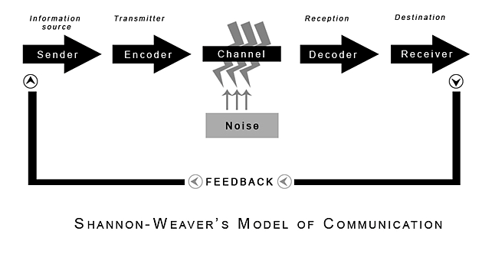
(Shannon and Weaver, 1949)

Appendix B

Schramm communication model
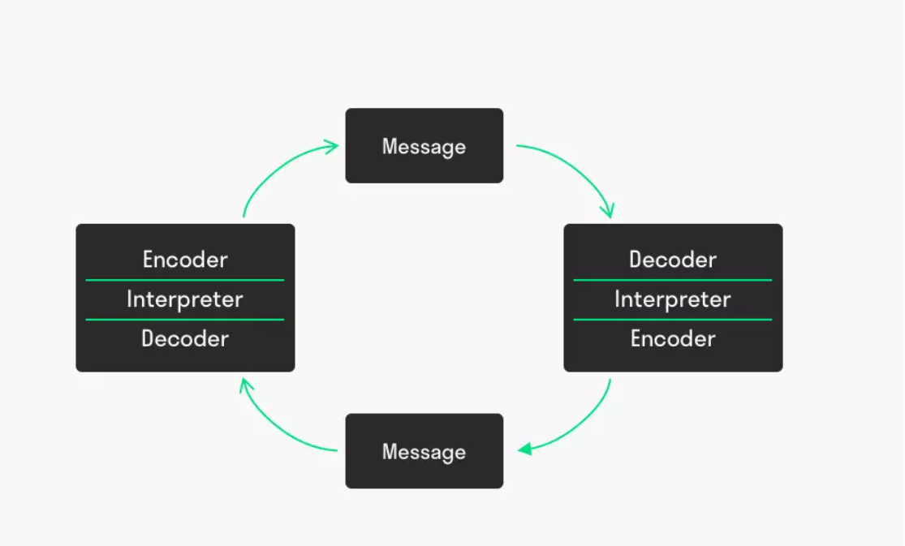

(Schramm, 1959)

Appendix C
Berlo’s communication cycle

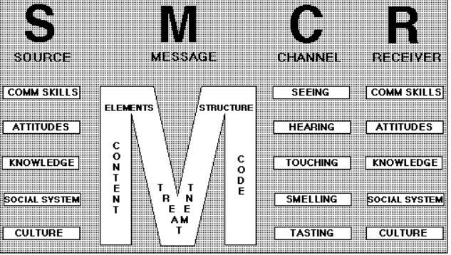

Berlo, (1960)

Appendix D
Martine’s results – “How good are your communication skills”
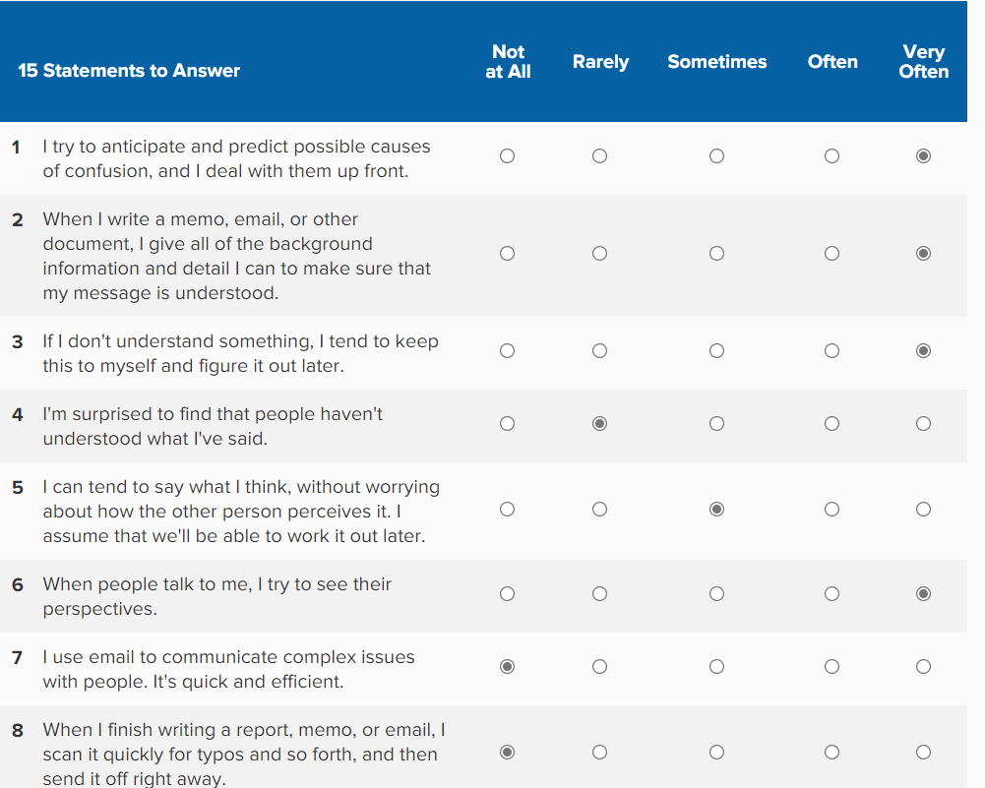

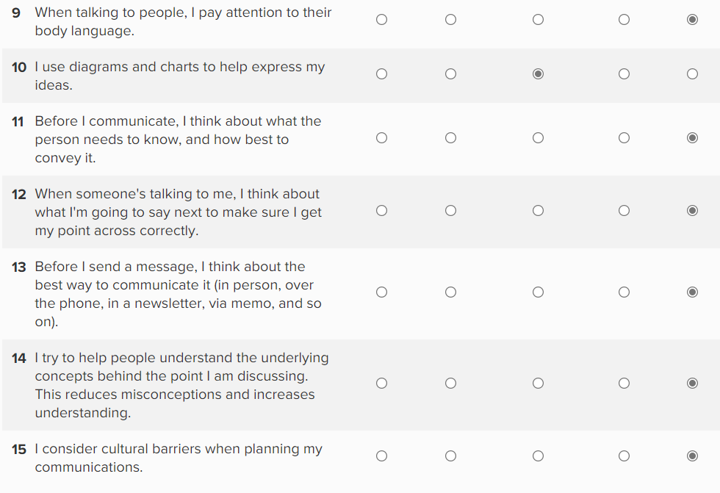

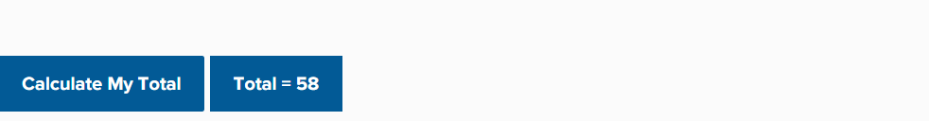

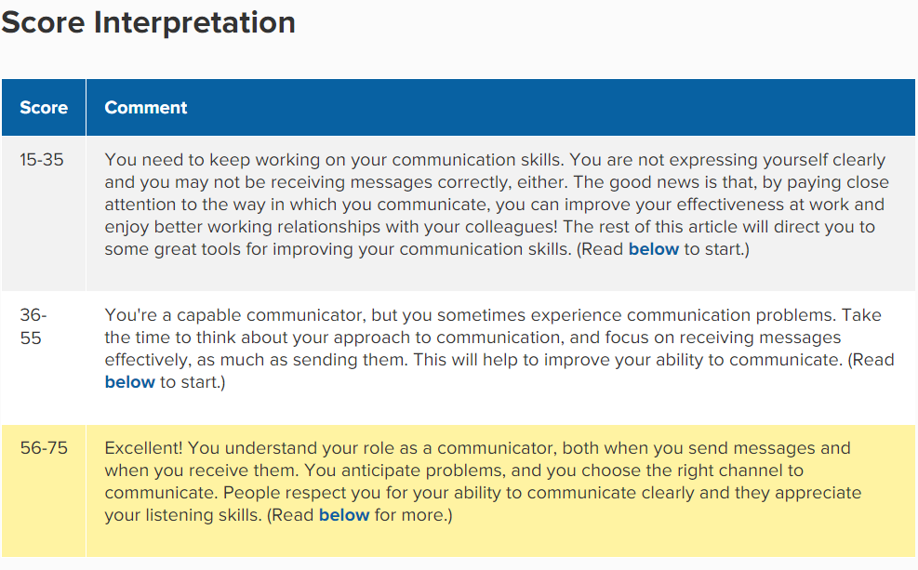

Appendix E

Martine’s Gap Analysis

Objective | Current Position | Deficiency | Actions
What do I want to learn? | What can I already do? | What am I lacking? | How do I fix this?
Successfully complete my first years Higher of Education, Skills for the workplace course | Previous management experience within the workplace | Lack of qualifications | Complete and obtain qualification by 31/9/21
On completion of my first year's course, I will commit to a further two-year study to obtain my BA hours degree | Previous management experience within the workplace | Lack of qualifications | Complete and obtain BA Honours degree by 30/12/23
Focus on becoming an effective, confident public speaker | Hold presentations with confidence around certain people | Confidence with public speaking | Continue to practise presentations for family members and record/review progress by 30/6/21
Increase my knowledge of Microsoft | Basic PC skills | I have become rusty with my computer knowledge, as I do not use a PC on a regular basis. | Continue to use the computer at home frequently and complete a computer training course by 30/6/21
Improve on communication, as outlined in questionnaire – areas as follows:  Decoding  Planning | Able to effectively communicate on many areas | Lack of knowledge these are areas of development. | Make conscious effort to listen more and allow others to speak.  Ensure information supplied when communicating is relevant – review and obtain feedback from colleagues – 30/6/21
Improve on effective time management for  healthy balance of work, family, study, and personal time | Asking and accepting the support from family and friends. | I take on too many tasks/duties | Accept support from family members to assist me with childcare for my daughter to study/work – review monthly 30/6/21
Commit to seeking alternative employment, with a higher salary and a more interesting role | My CV is up to date, along with the skills to successfully search and apply for job vacancies. | Lack of qualifications | Ensure CV is up to date.  Research job vacancies  Complete and pass Level 4, to gain qualification by 31/12/21

Appendix F
Martine’s PDP
Objectives | Tasks | Success criteria | Timeframe | Resources
List your goals | What do you need to do to achieve these goals? | How will you identify your success?  (number Rating 1 poor – 10 excellent) | When do they need to be done by? | Who or what do you need to help you?
Successfully complete my first years Higher of Education, Skills for the workplace course | Complete all assignments and pass to ensure I gain overall marks required | 10 | 31/9/21 | UWTSD Carmarthen University
On completion of my first year's course, I will commit to a further two-year study to obtain my BA hours degree | Complete all assignments and pass to ensure I gain overall marks required | 10 | 30/11/23 | UWTSD Carmathen University
Increase my knowledge of Microsoft | Find a suitable computer course. Continue to practise at home. | 8 | 30/9/21 | External computer training company/college.
Focus on becoming an effective, confident public speaker  Increase my knowledge of Microsoft | Continue to practise presentations for family members and record/review progress | 10 | 30/6/21 | Family/friends
Improve on communication, as outlined in questionnaire – areas as follows:  Decoding  Planning | Make a conscious effort in these points when communicating | 10 | 30/6/21 | Family/friends/  Colleagues
Improve on effective time management for  healthy balance of work, family, study, and personal time | Accept support from family members to assist me with childcare for my daughter to study/work | 8 | 30/6/21 | Family/friends

Appendix G

How good are your communication skills? (Based, on 5 persons)

Appendix H

Based on feedback from four colleagues:

Appendix I
Tuckman’s model:

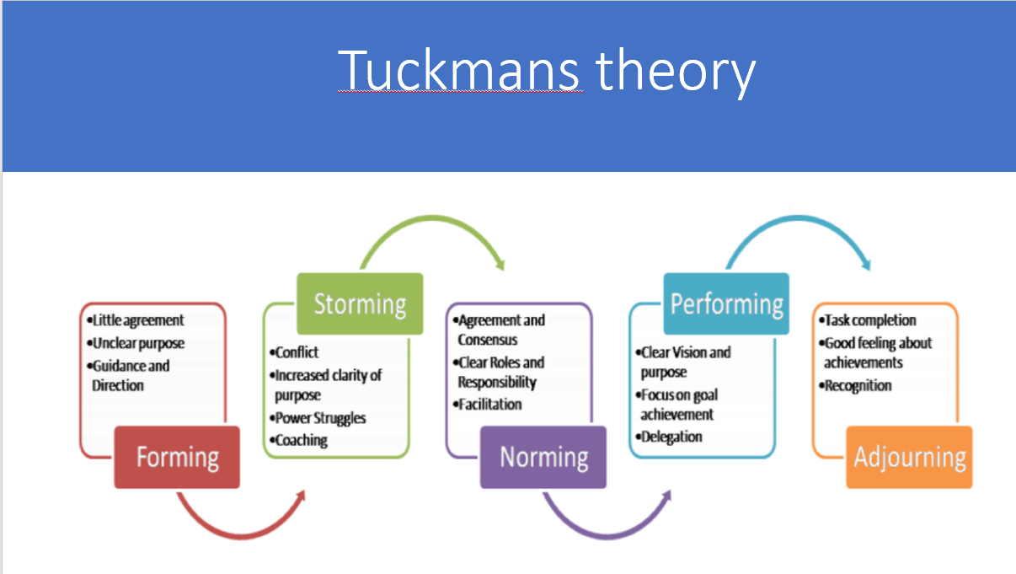

Appendix J

Martine’s Tuckman questionnaire results:

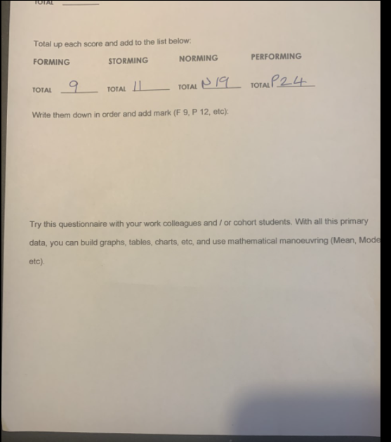

Appendix K
Belbin’s model
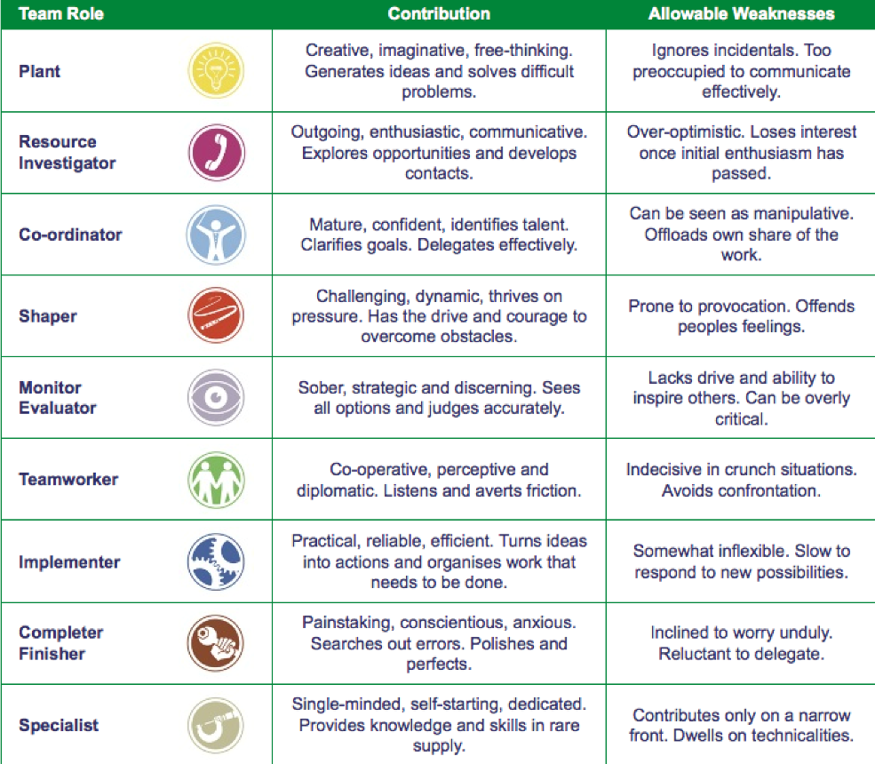

Belbin’s model categorised into three types:
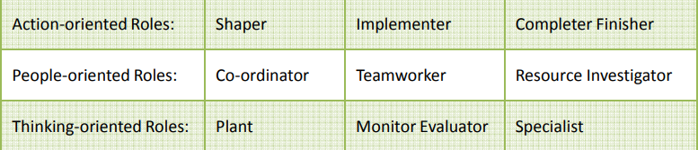

(Belbin, 2015)

Appendix L
Martine’s Belbin questionnaire:
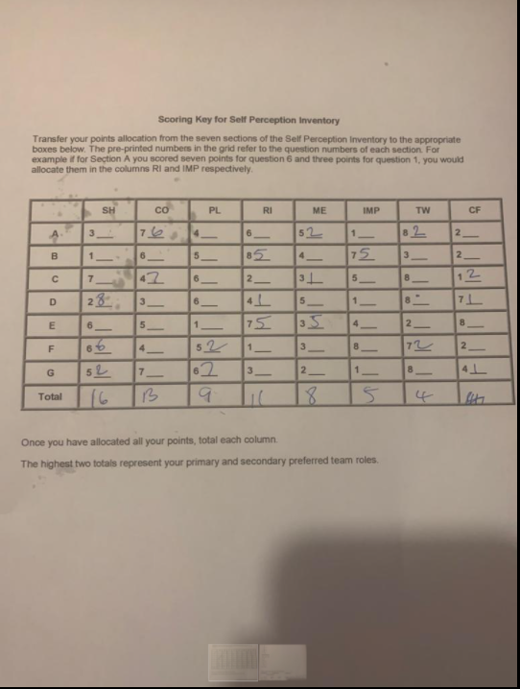

Appendix M
Gibb’s reflection model

Gibbs (1988)

Appendix N

Presentation feedback sheet completed by tutor, Bob Wilson.

Feedback sheet – Effective team working.
Please complete and return to Martine Kennedy via email by 26/5/21
Email: 2010990@student.uwtsd.ac.uk

Did the student, introduce themselves and the topic of discussion?
Very good

How well was the information presented? Did the student speak clearly?
Very good

Did you understand the contents of the presentation?
Yes, it was clear and professionally presented

How well was the presentation compiled visually?
Clear, concise, and easy to follow.

Did the student deliver precise, accurate information on the topic?
Yes, she has obviously researched it well and she linked it excellently to her workplace.

Were there any areas you felt the student could improve?
No real areas for improvement, except there was no collection of data to be able to draw graphs etc.

Appendix O
CRAAP analysis
The information was published 2017 by Peter Morgan. The author commenced his career in 1996 where he obtained his PhD in Occupational Psychology. He has a strong focus on personal development and has been awarded Institutional awards for his teaching. This is a reputable source and has a focus on training/coaching students across the world. The information was easily obtainable.
The information was relevant for my research, which I found informative. The author is non-biased and aims to provide models/processes of what is required to improve personal development relating to the workplace.
Given the authors experience in this field, the information provided is accurate. Whilst there may be differences in opinion with theorist, there is an unbiased tone to the text and presented well.
The authors objective is to enhance the personal development of students, including training relating to the workplace. The point of view appears objective and impartial with no political, cultural, or religious agenda.

