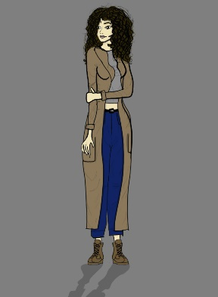
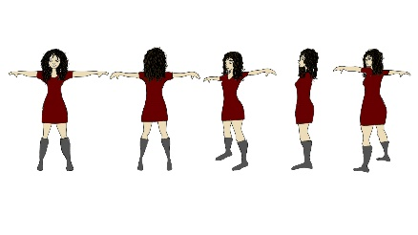
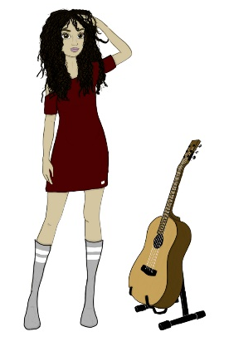
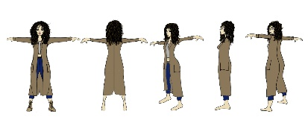
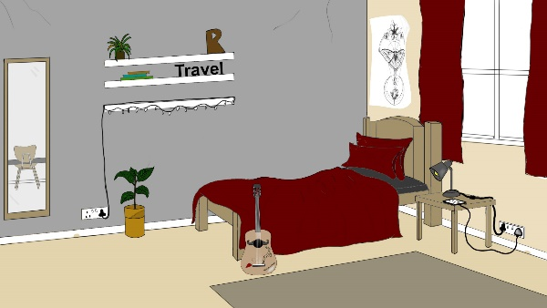

When Riley is not in the bedroom where she is placed,
is where her guitar replaces her with all her
belongings as that’s a huge part of her life.

“It’s okay not to do everything
at once. Take your time.”
(Healthyplace.com,
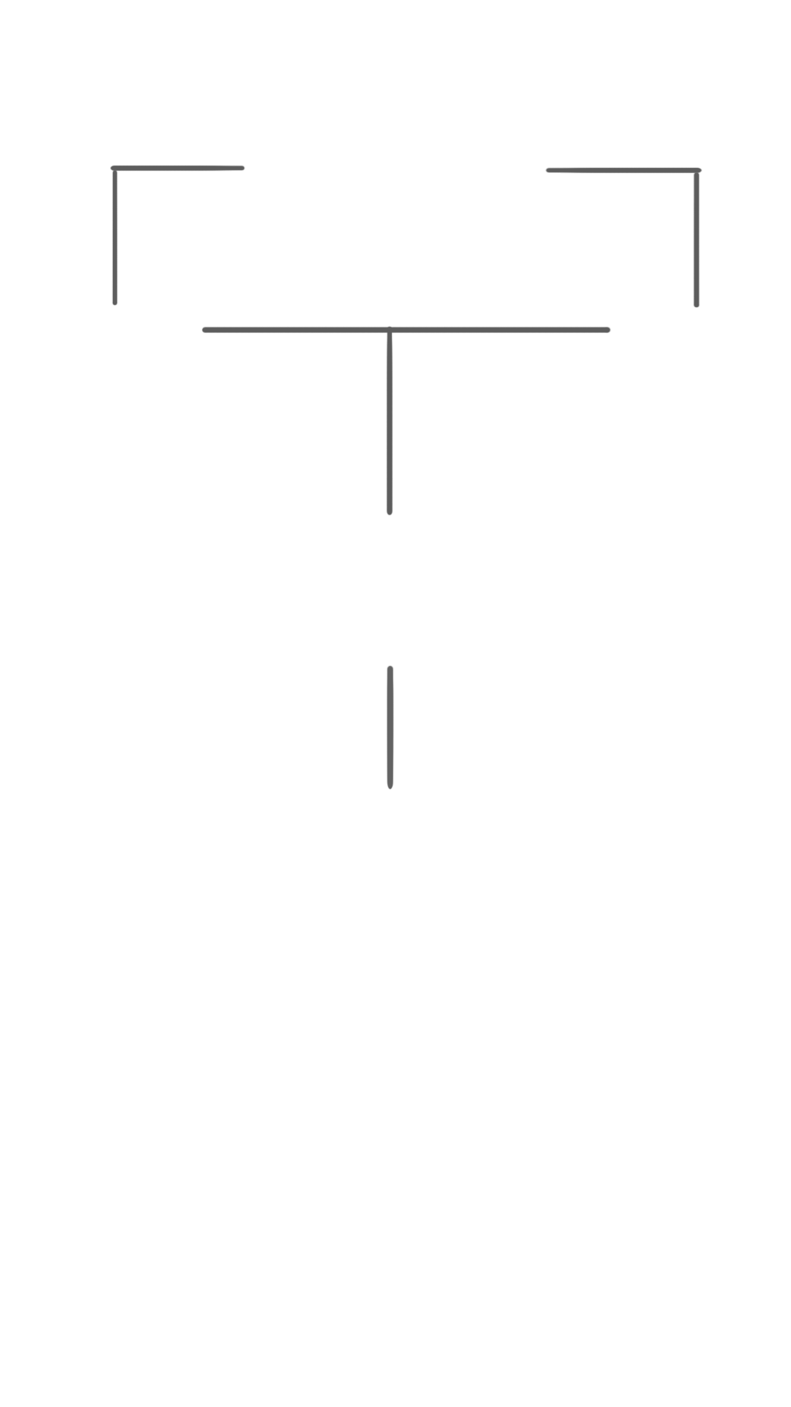

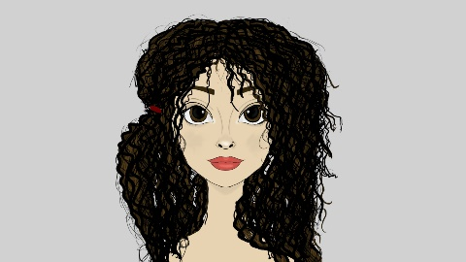

A large part of my project was research for my character getting the right angles and facial expressions a big part of my project as I want to show passion and emotion.

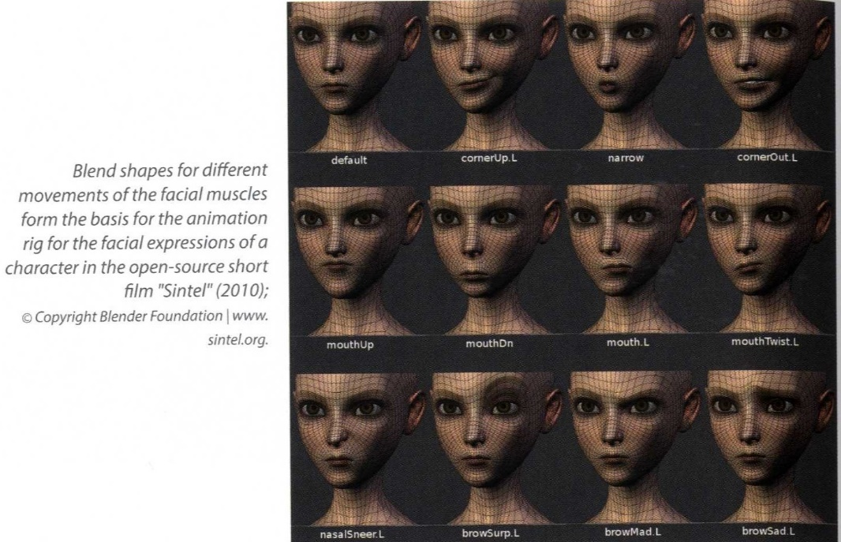

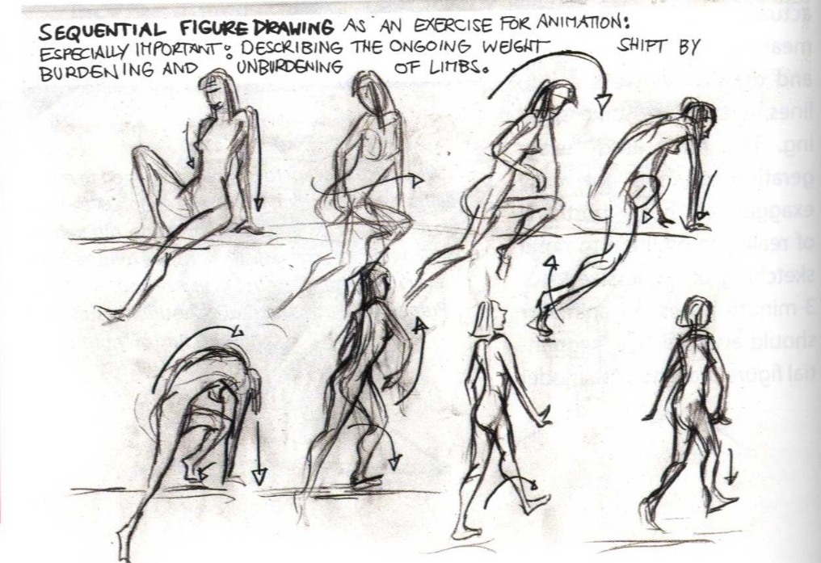

A key aspect of the project is also lighting therefore I found some images that will help me create mood lighting for my scene and how they work around objects and create shadows.

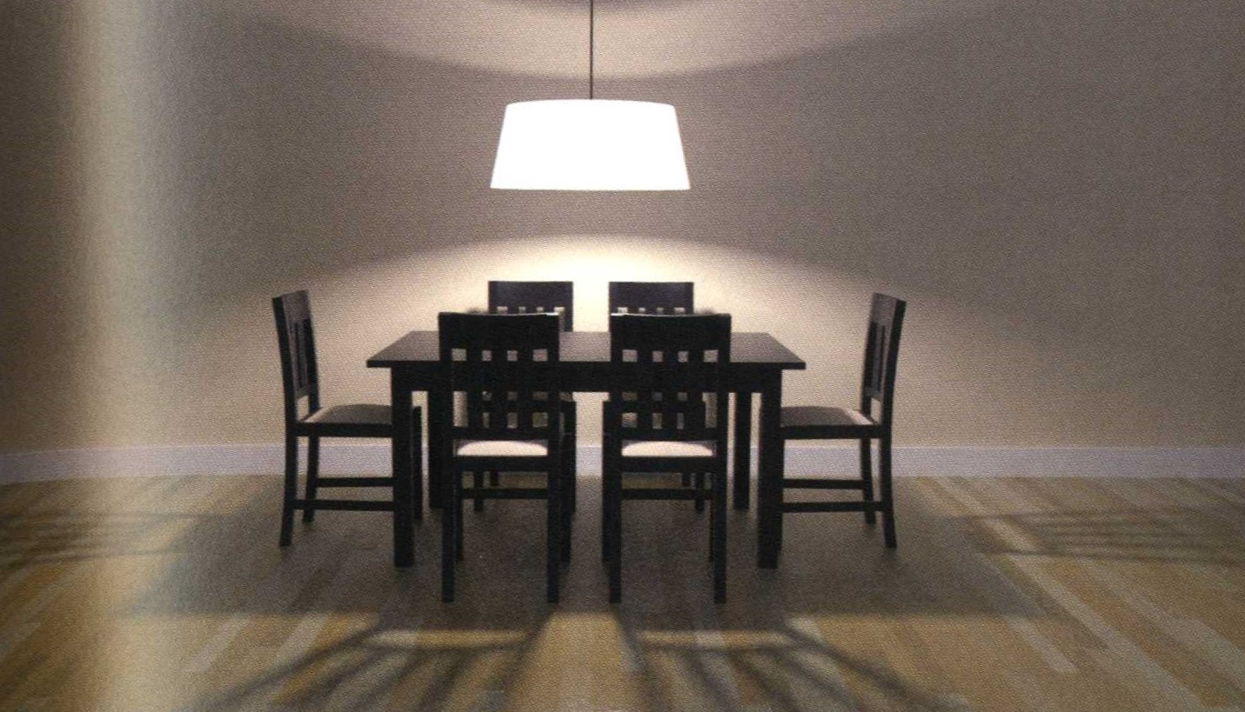

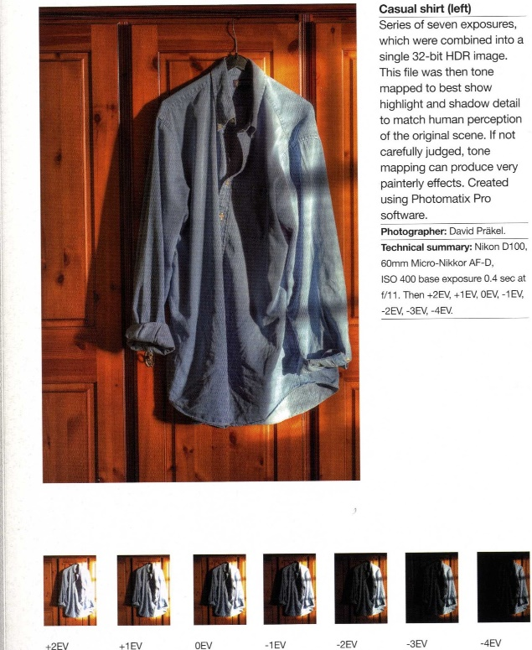
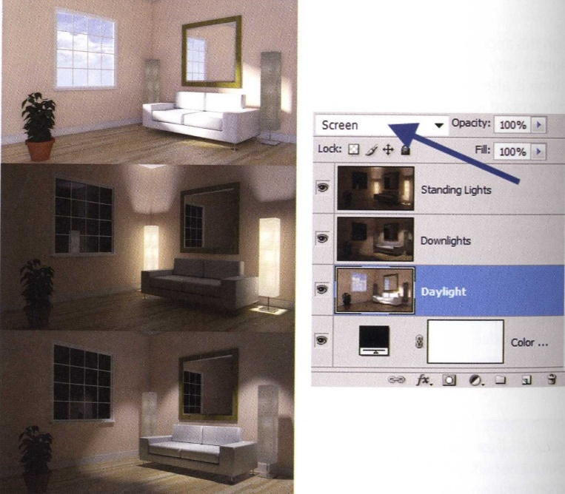

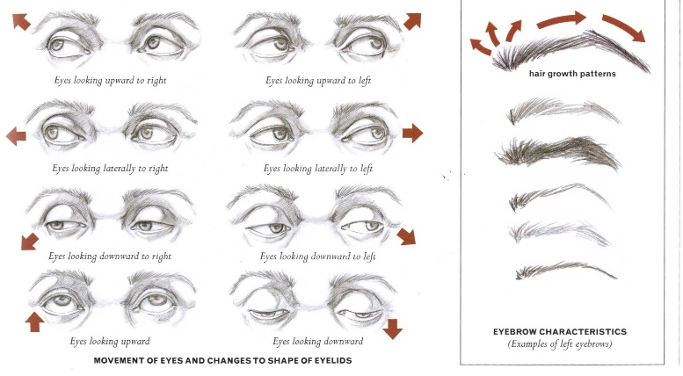

Facial features on a character are very important to help give your character an identity and these images helped me towards my final design for my character.

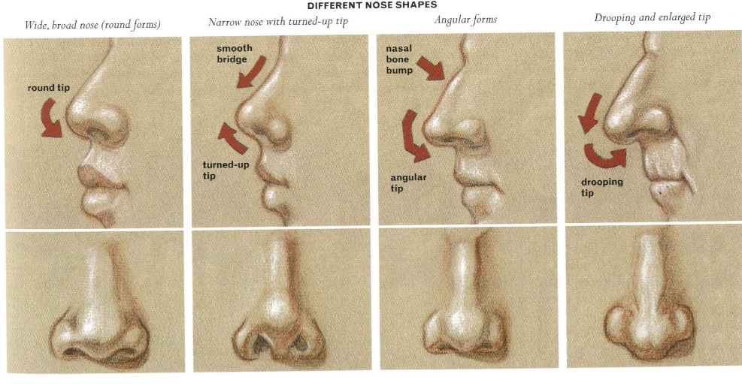

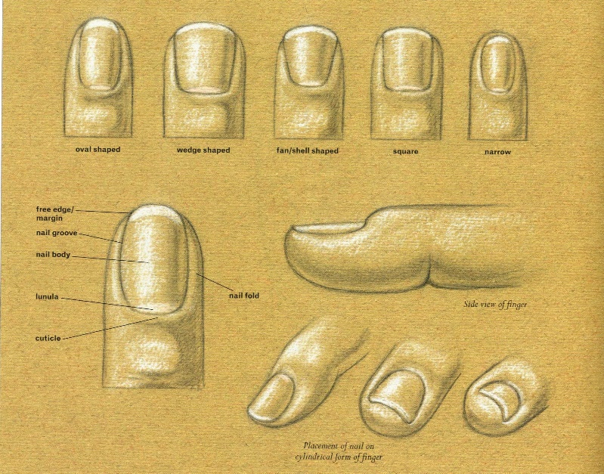

My character’s hair is very much like Merida from the film ‘Brave’ so I did a lot of research on this as it is a difficult process.

More research to be found on dis under Layout > Research

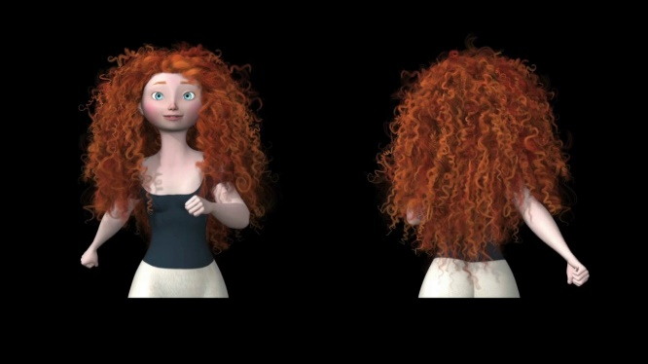

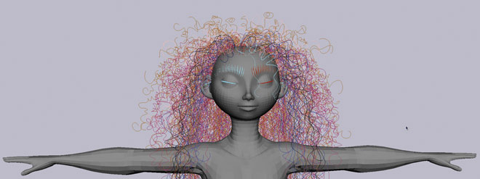
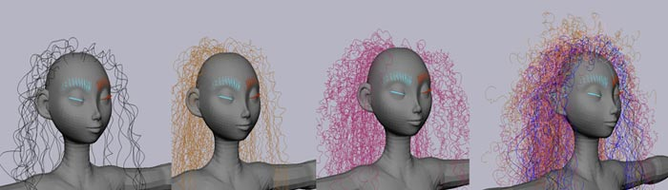

Production book bibliography

RALL, H. (2017). FILM ANIMATION. [S.l.]: CRC PRESS.

Schreyer, A. (2016). Architectural Design with SketchUp: 3D Modeling, Extensions, BIM, Rendering. John Wiley & Sons.

Winslow, V. (2009). Classic human anatomy. New York: Watson-Guptill.

Prakel, D. (2007). Lighting. Lausanne: Distributed in the USA and Canada by Watson-Guptill Publications.

More research references found on disk in Layout > Research

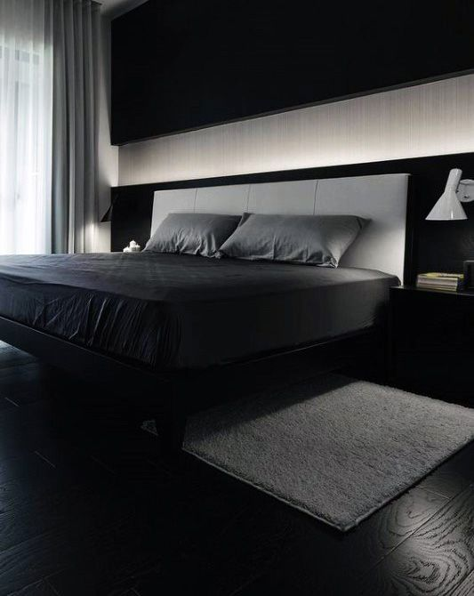
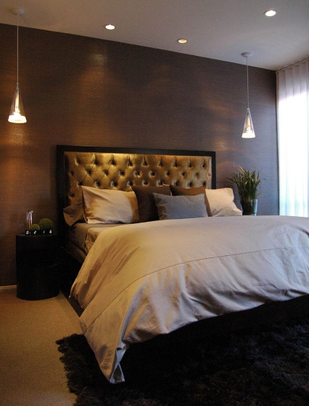
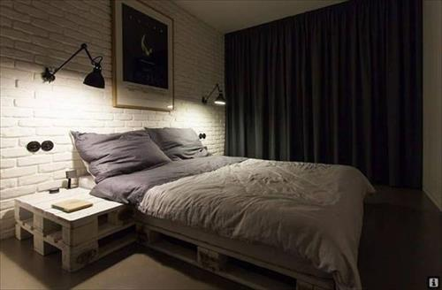
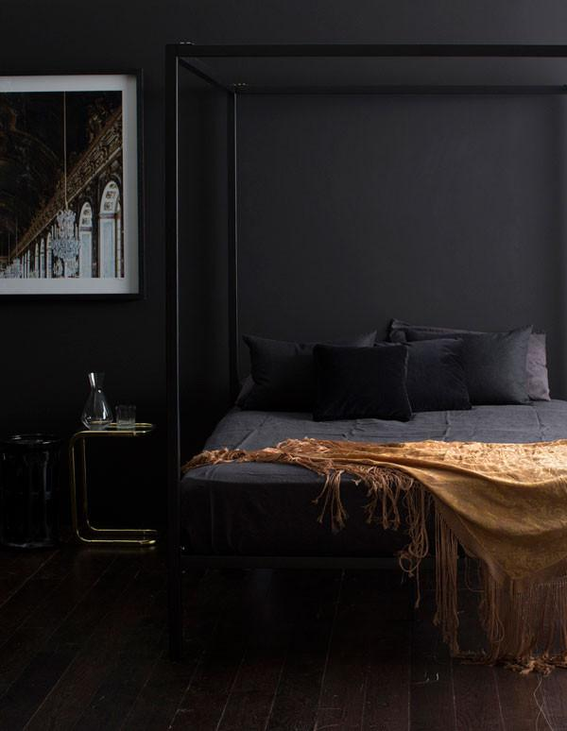
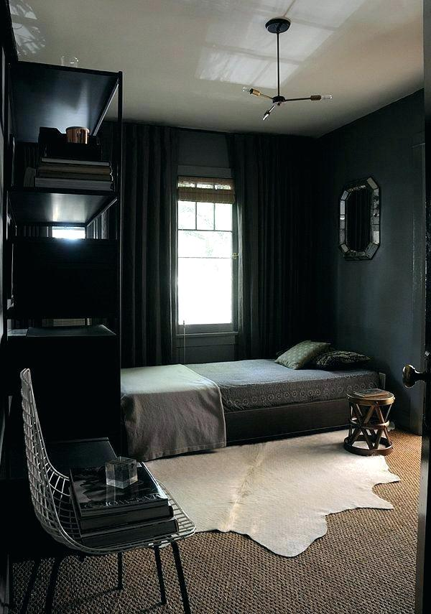

Mood boards are a key aspect for visualising the mood of the environment you are trying to get across. I used these images as they are precisely the mood I want to show in my project.

Using a silhouette design helped me design the basic shape of different guitars, these helped me narrow down my design to take forward and start adding colour and more detail.

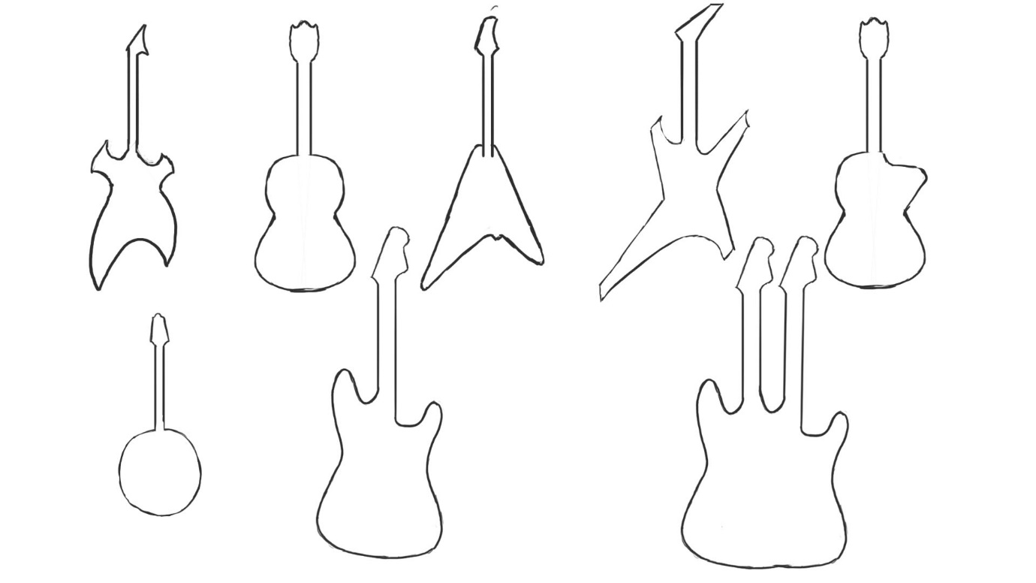

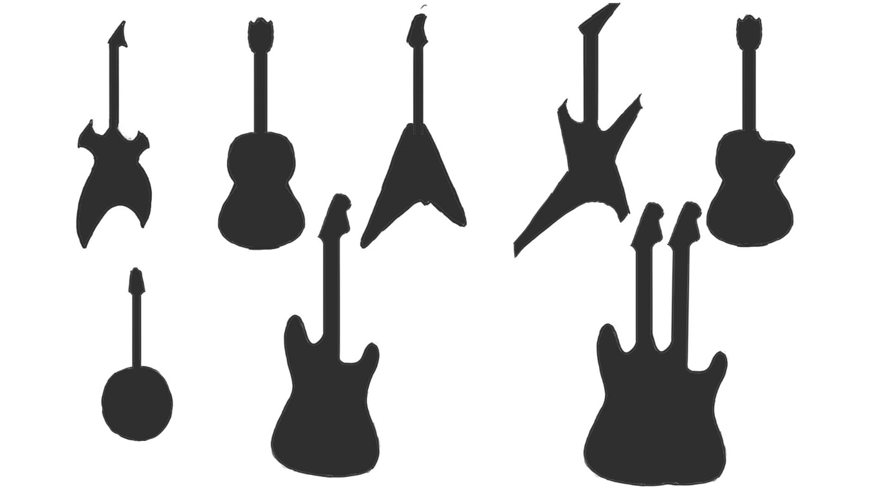

Character Silhouette Designs

Character Silhouette's helped me get the general outline without the design to define which positions my character would be more comfortable in and some clothing design to take forward to develop.

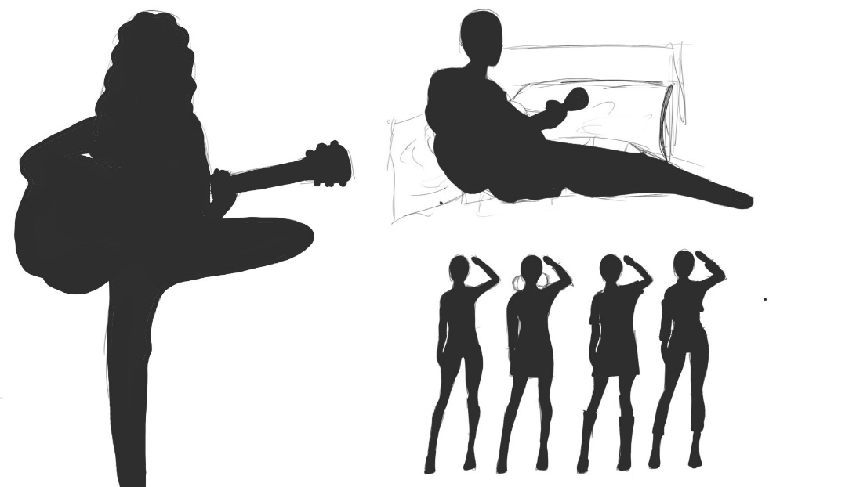

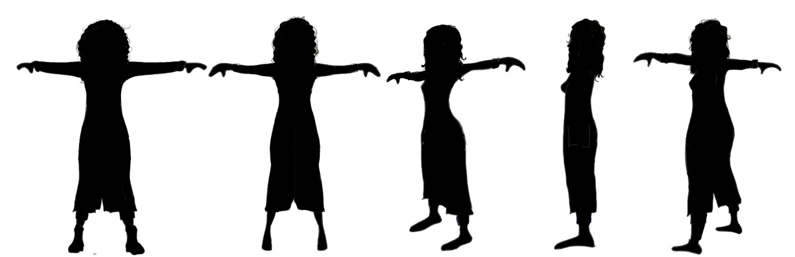

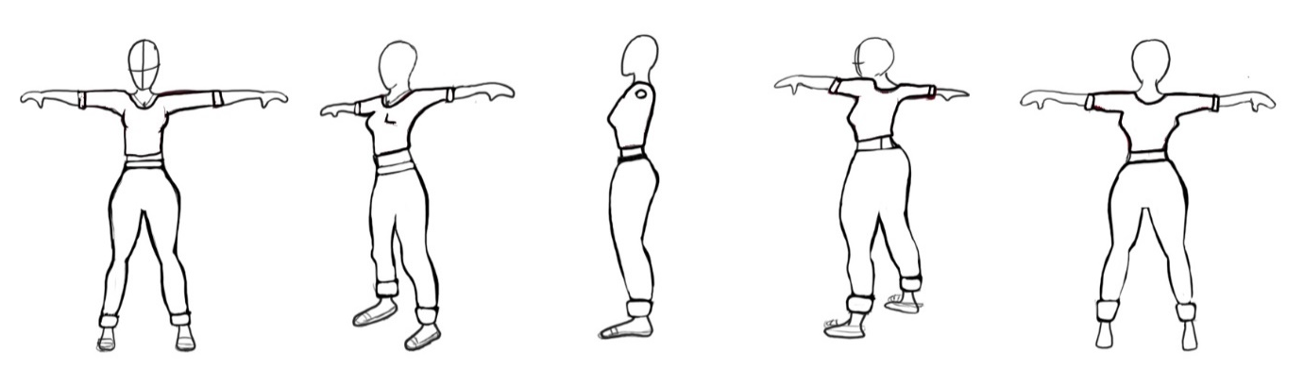
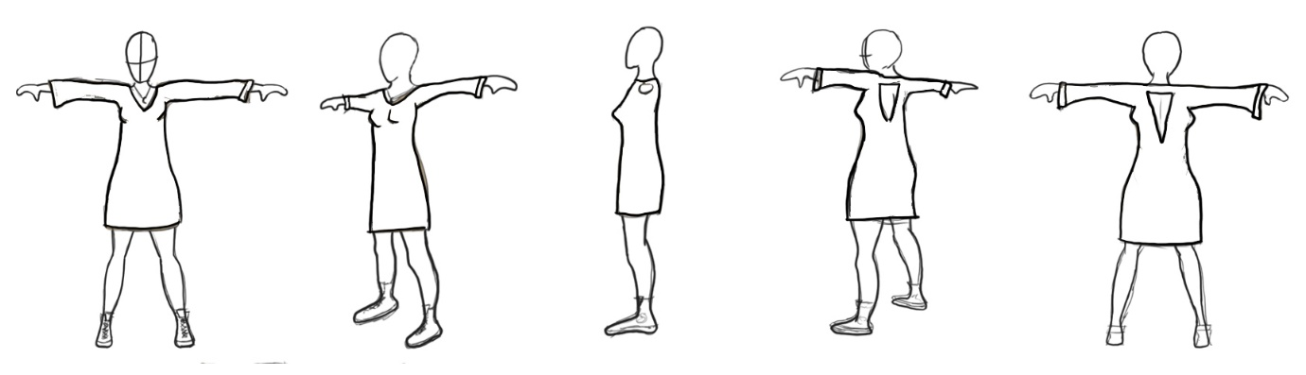
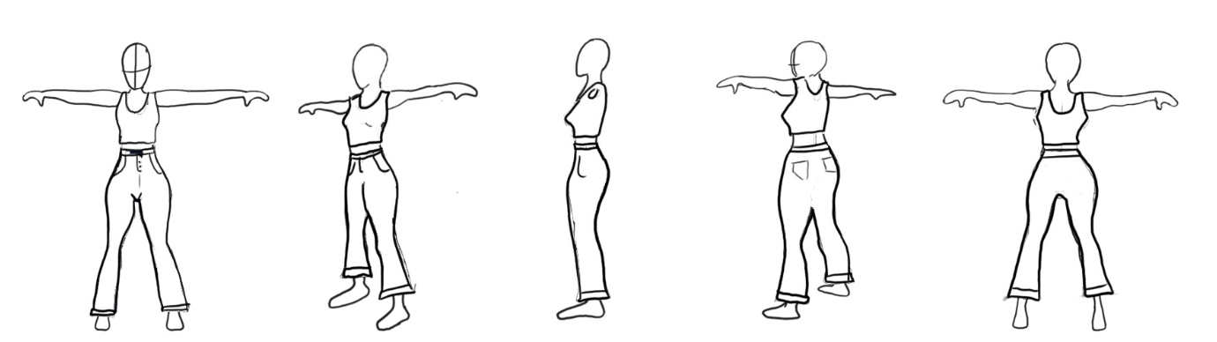

Outfit outlined for better clarity of the clothing.

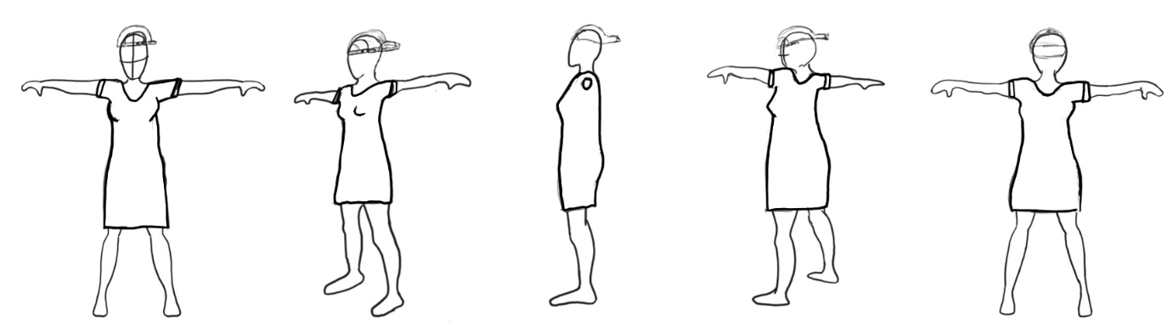
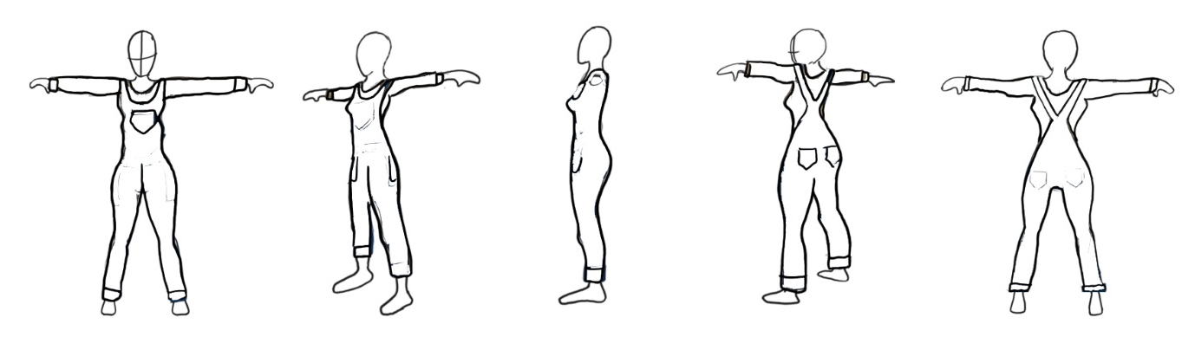
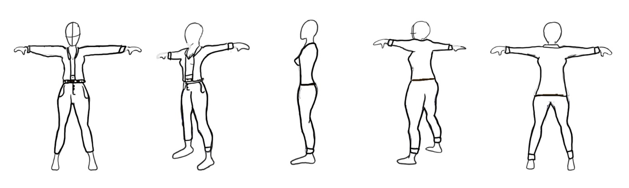

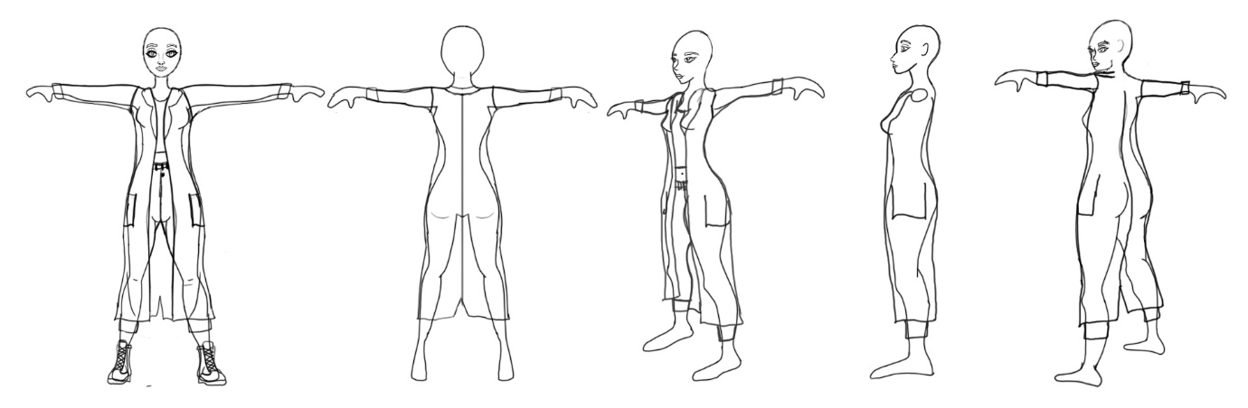
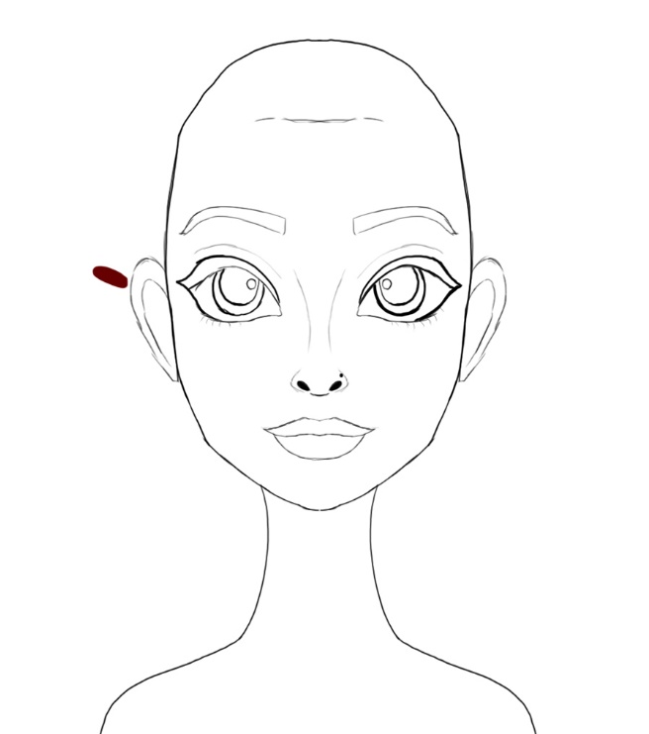

Here is my chosen character design for any outdoor scene.

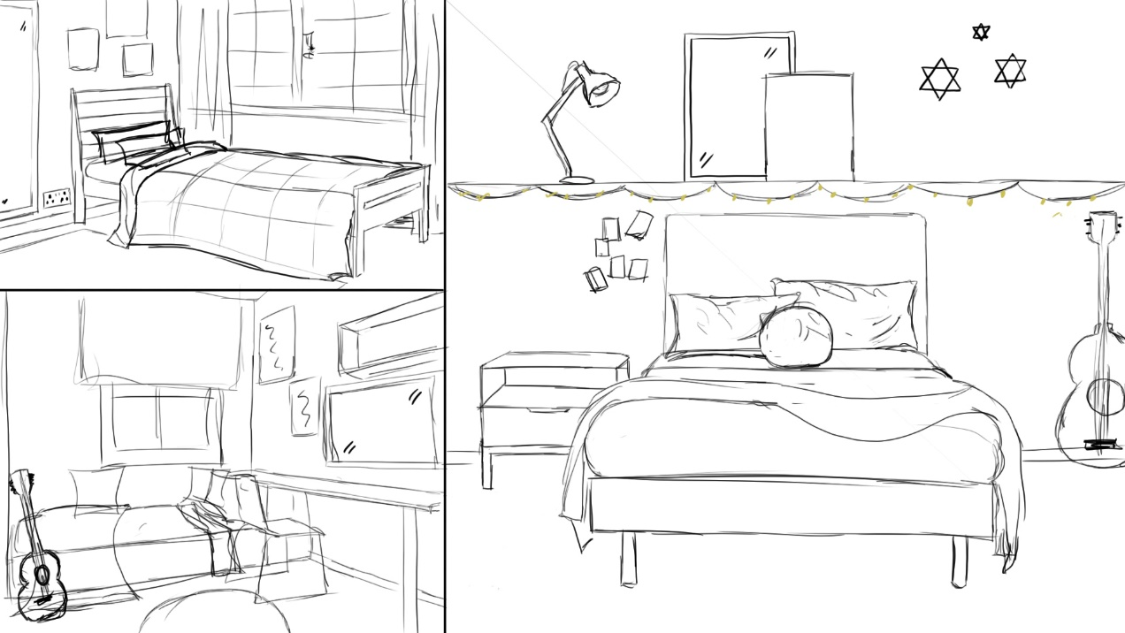
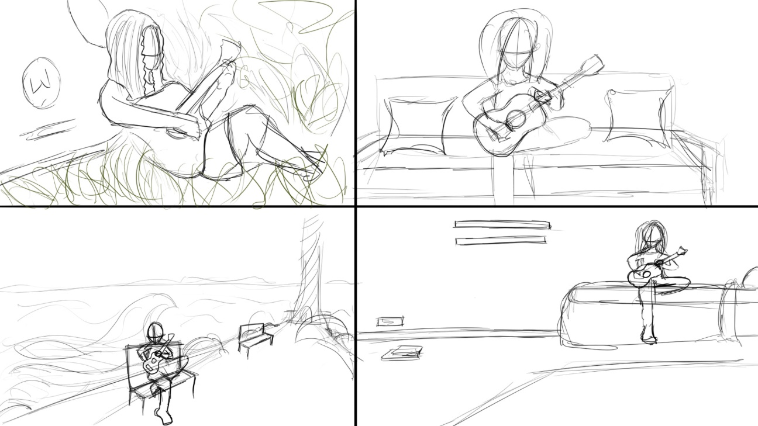

When thinking of the environment I did not know which way to take it therefore I drew some rough area’s where I would have liked my animation to be placed, but I therefore decided to take forward the bedroom design but try out different styles and placements.

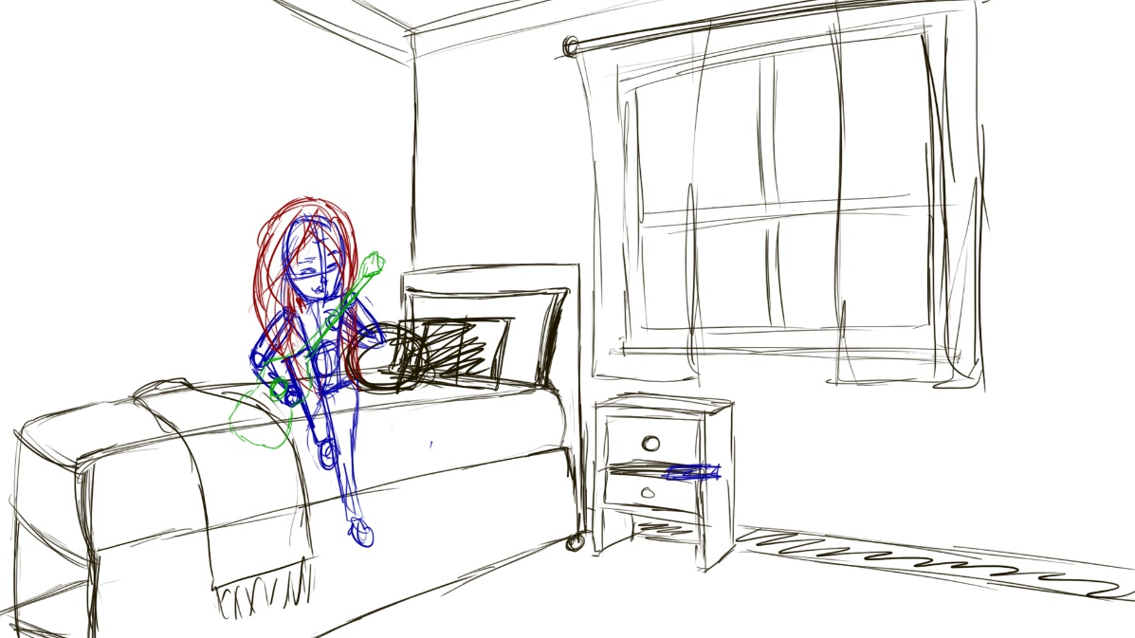
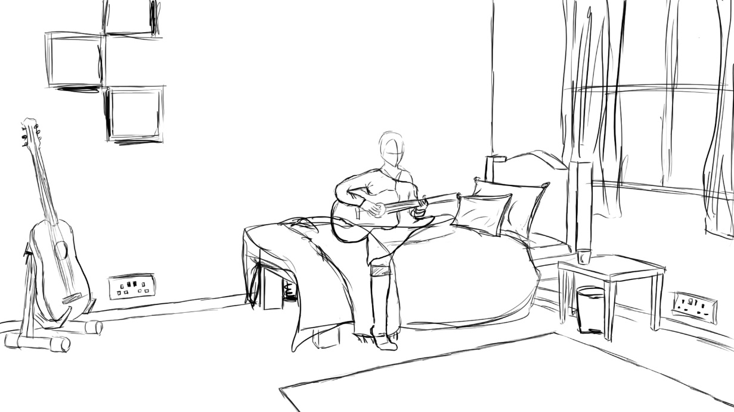

Design 1—Very rough over view of a design to take forward.
Design 2—Work’s better with the rule of thirds as you can see the guitar and window frame the outer sides and the character is in the middle. I improved my perspective drawing skills.

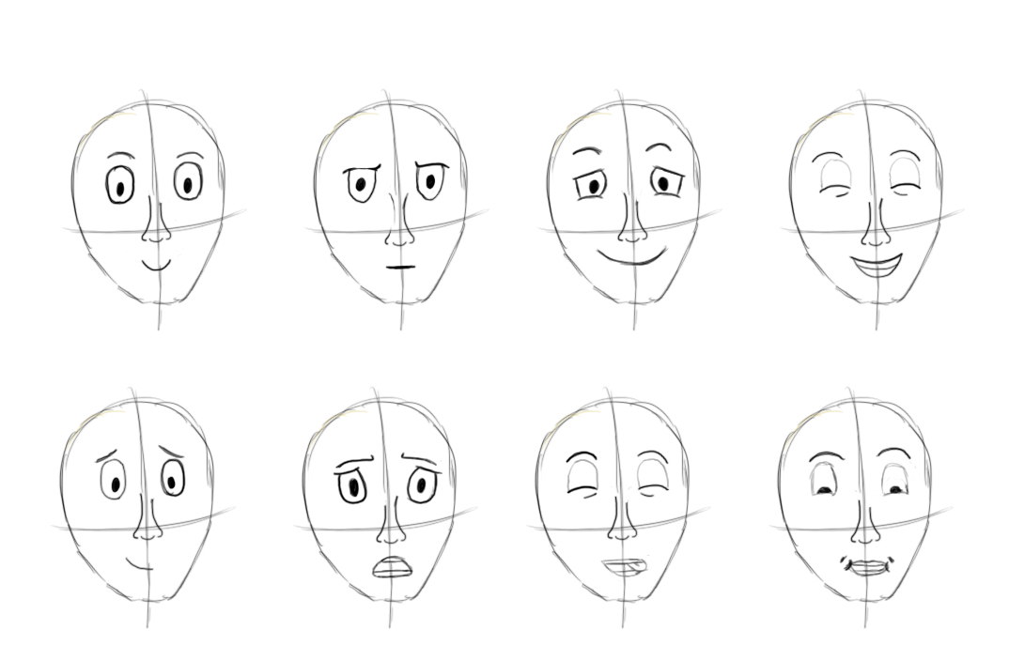
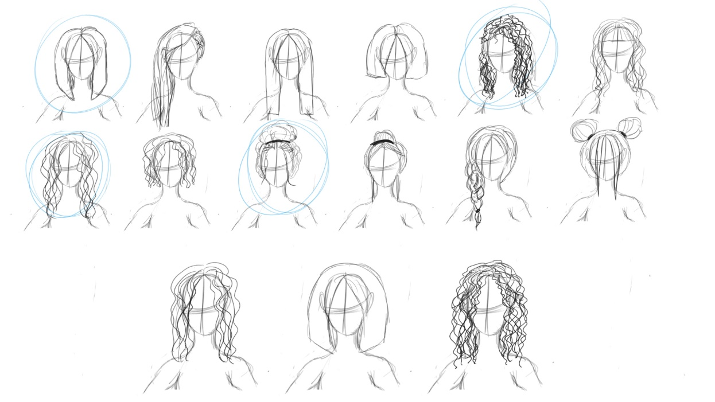

Here are some rough facial expressions to represent my character and her emotions, below this are some rough hair designs I created that I will take forward for development.

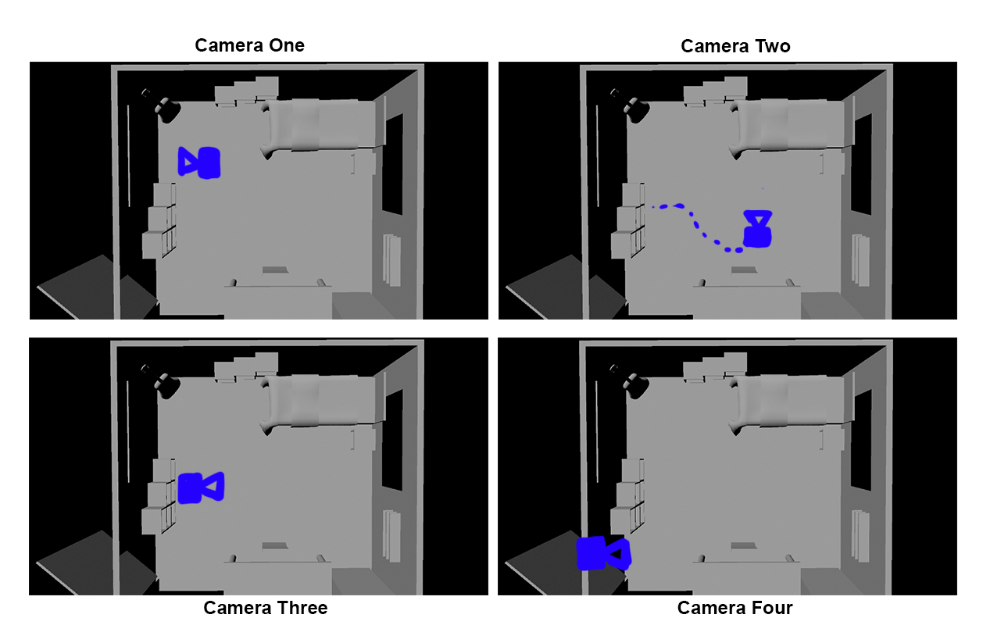
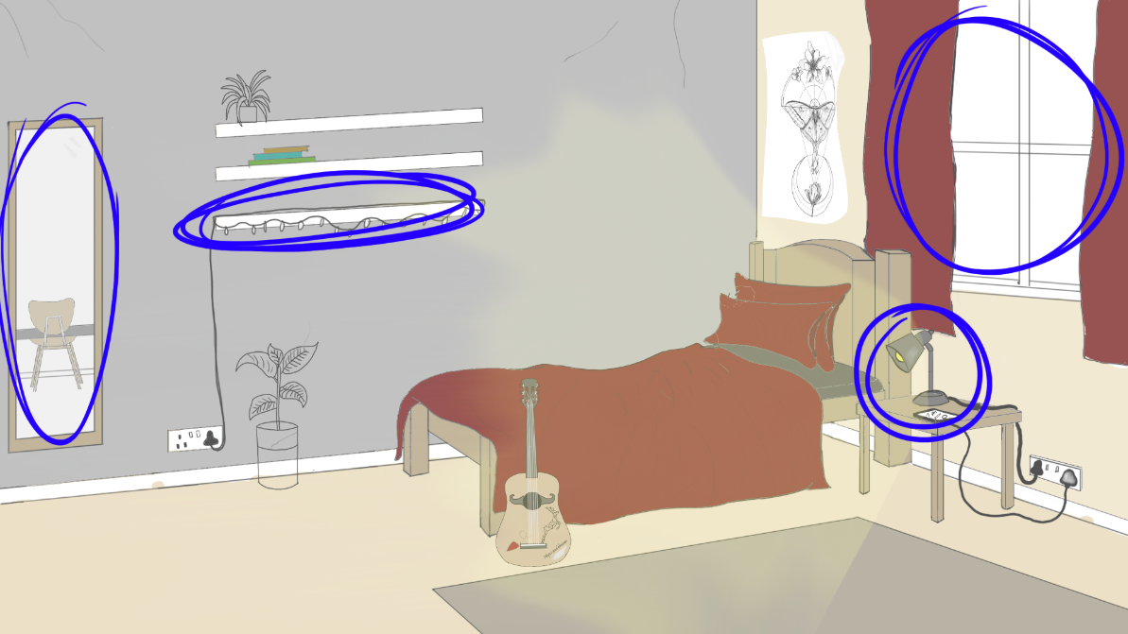

Here is a plan of my camera and lighting source.

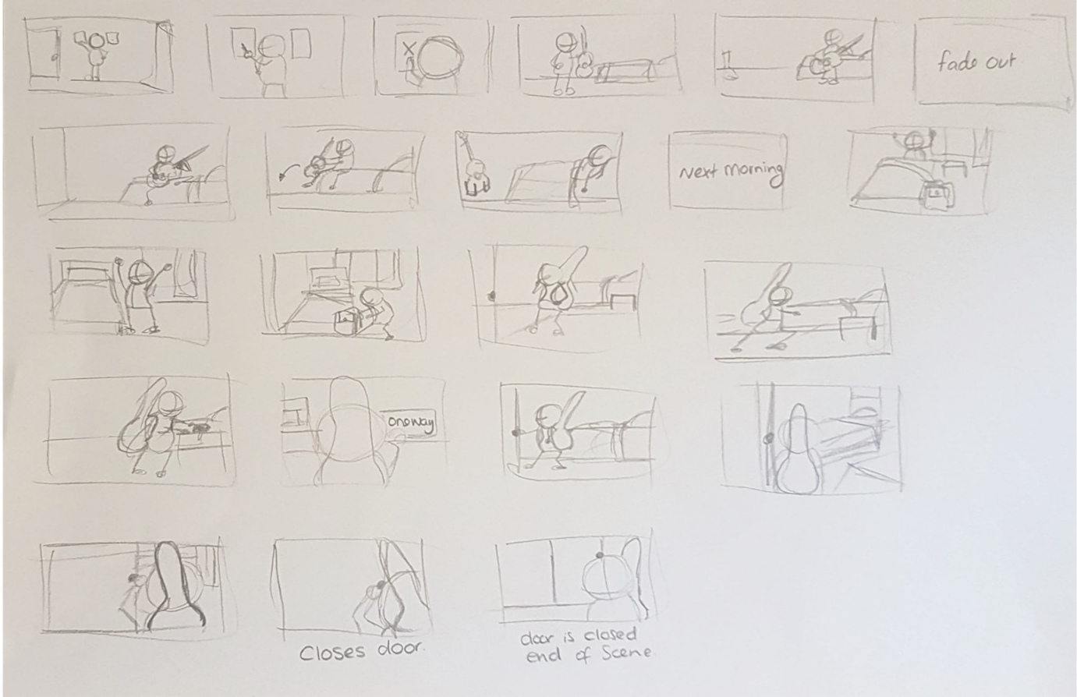

Thumbnails

Here is my first draft of my thumbnail’s.

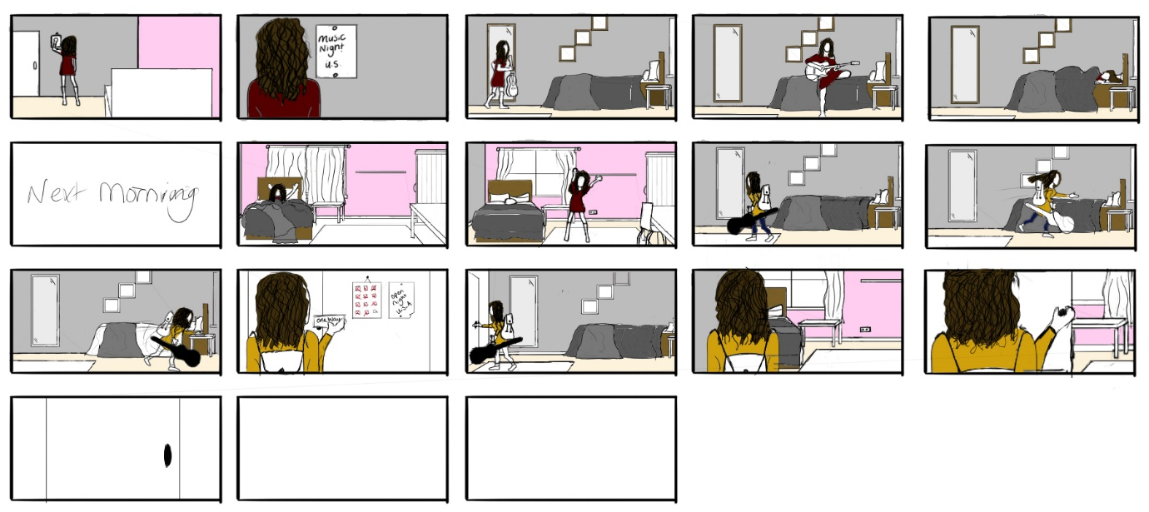

Developed from thumbnails

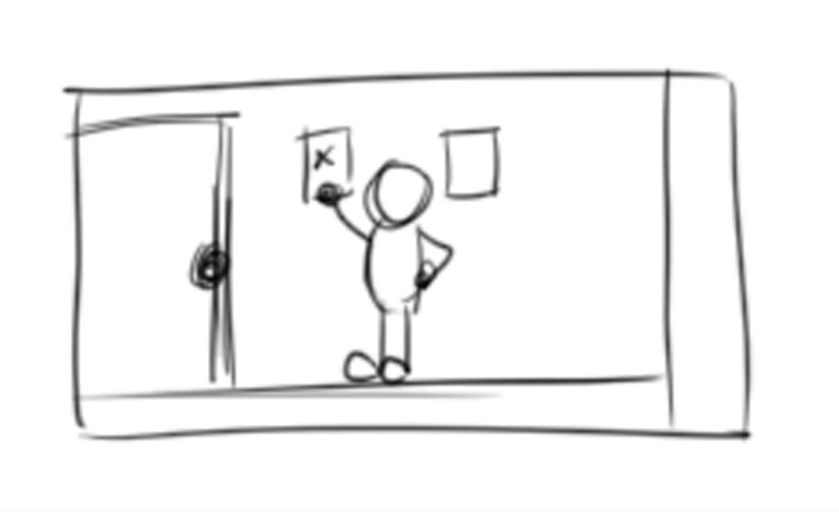

Full Animatic found under Layout > 02 Rough Design > Images.

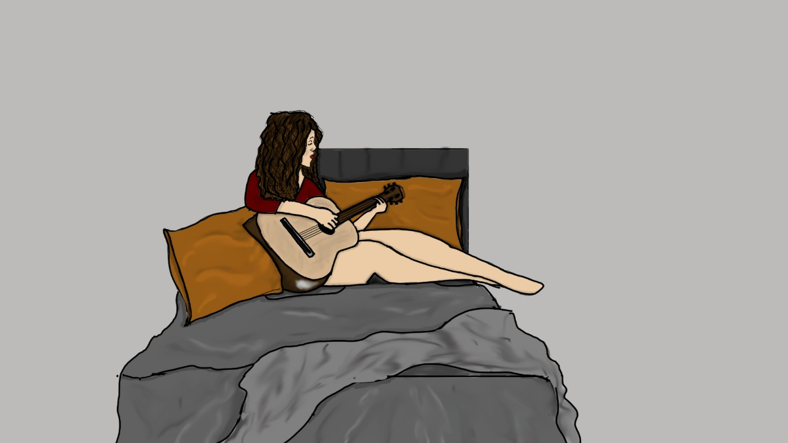
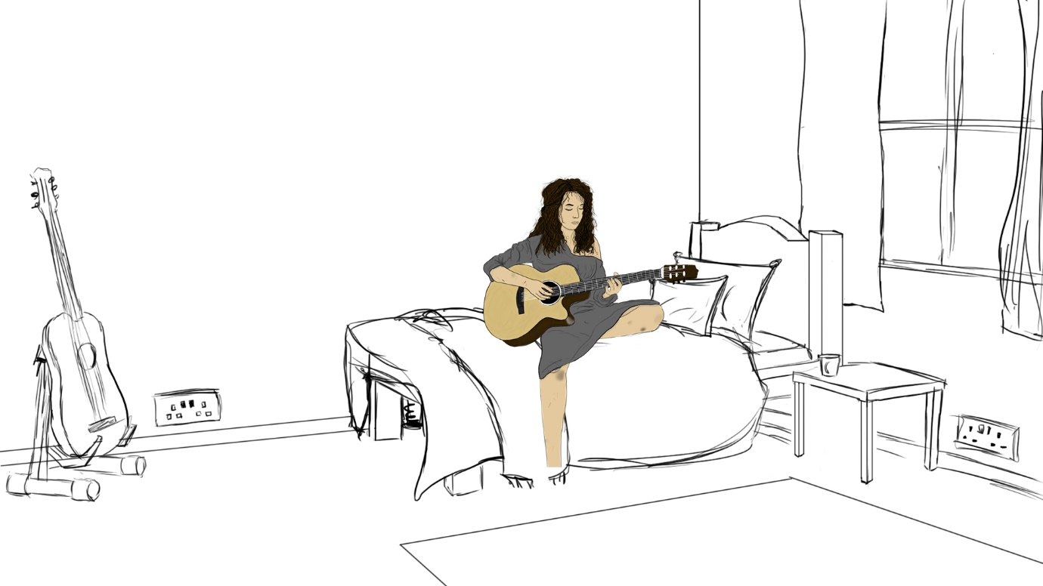

Developed room designs from different angles and brief colour experimentation.

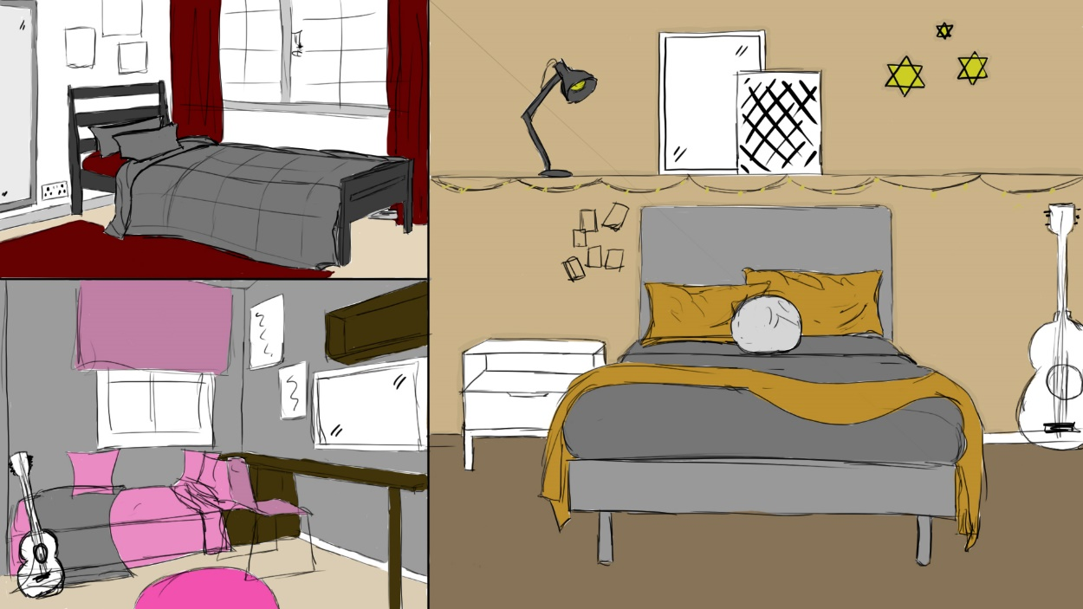
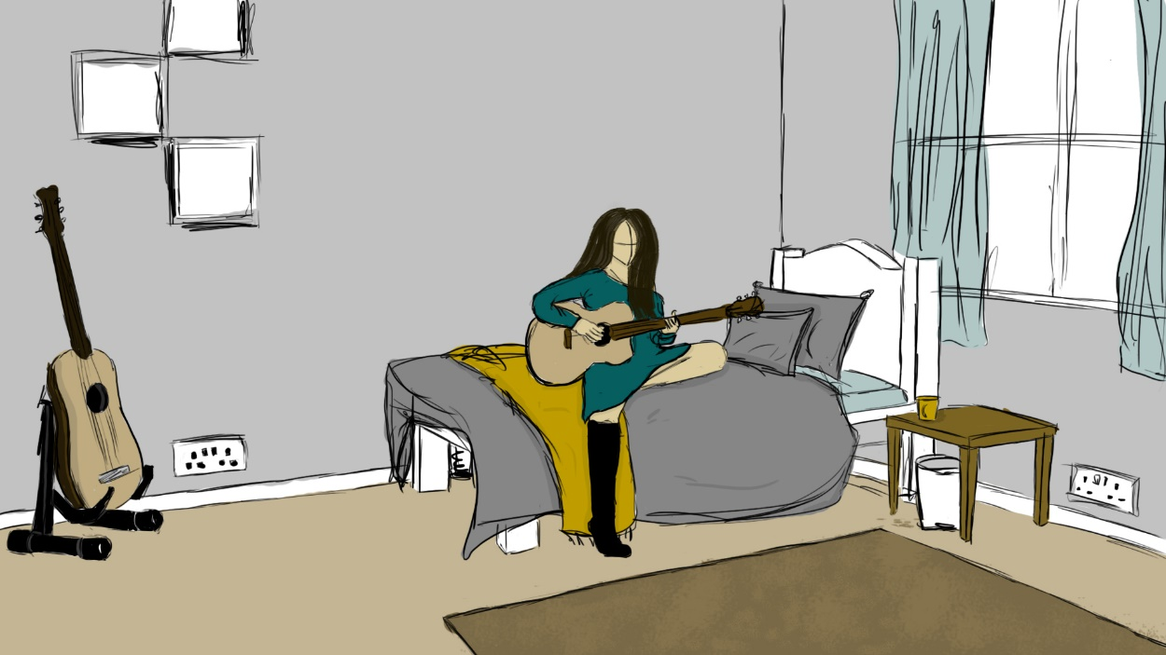

Final room design with developed colour.

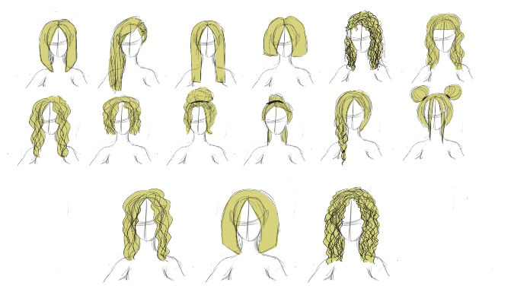
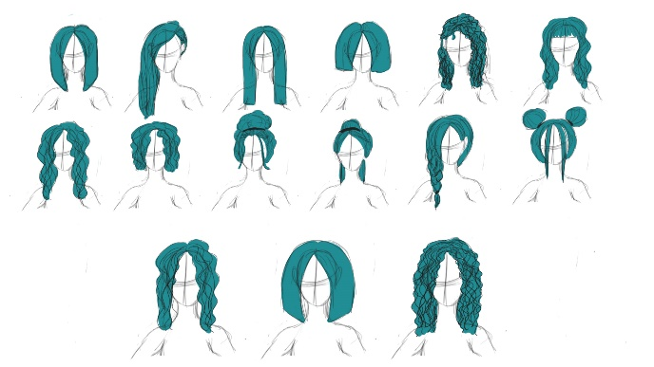
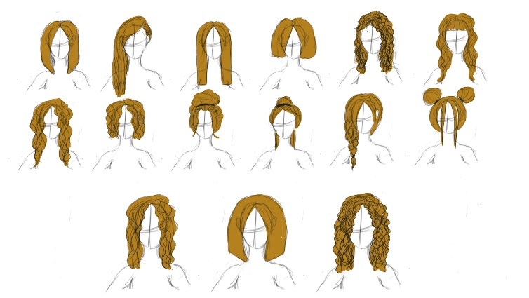
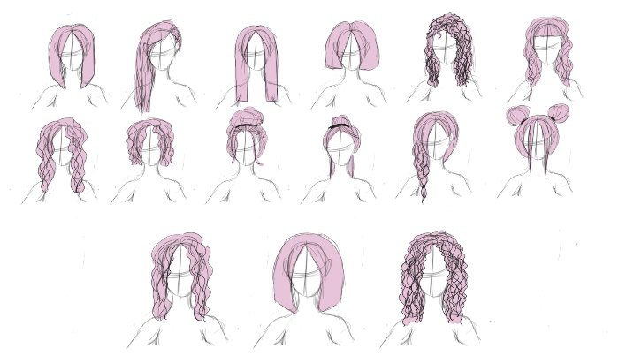
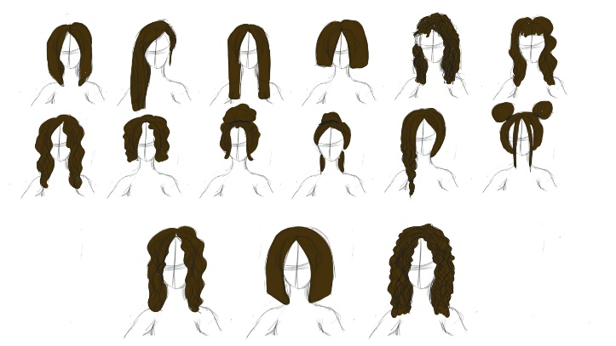

Developed hair colour.
Chosen hair colour highlighted with a red box.

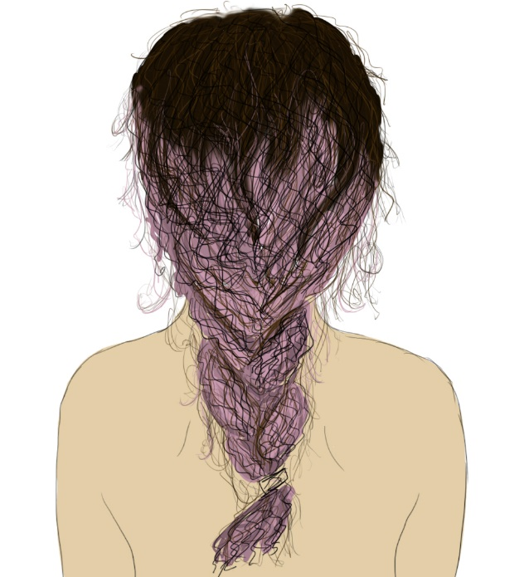
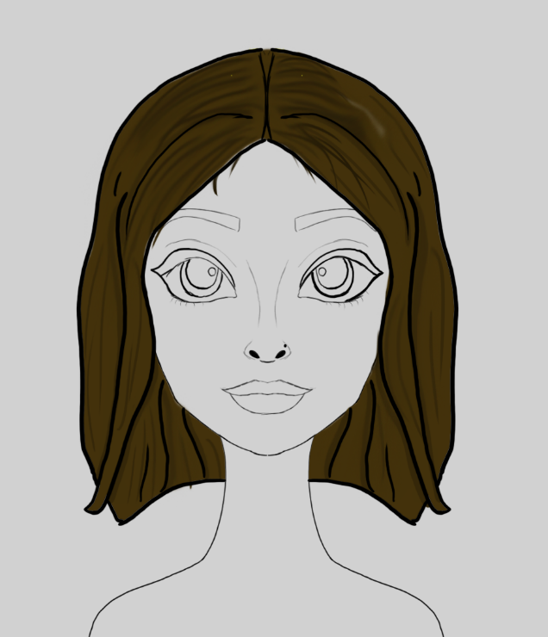
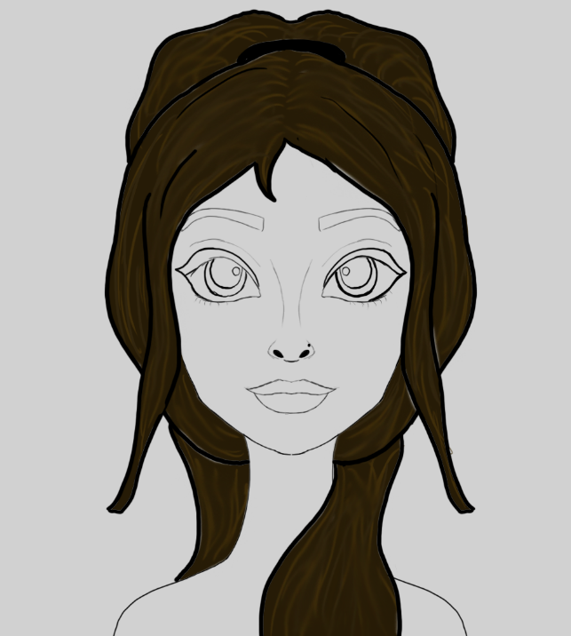
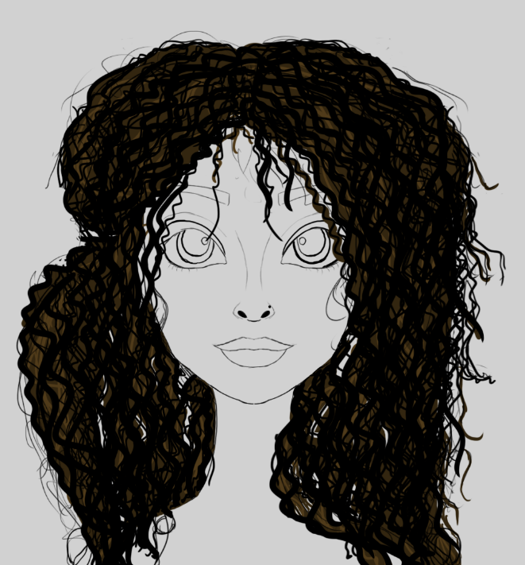

4 chosen Hair design with final hair colour.

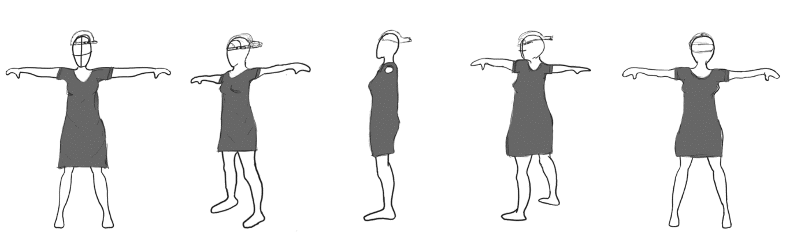
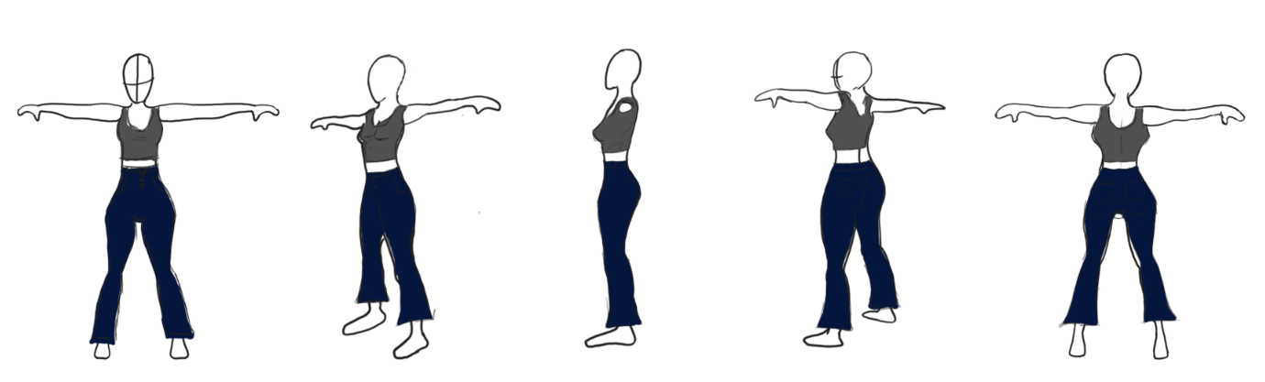
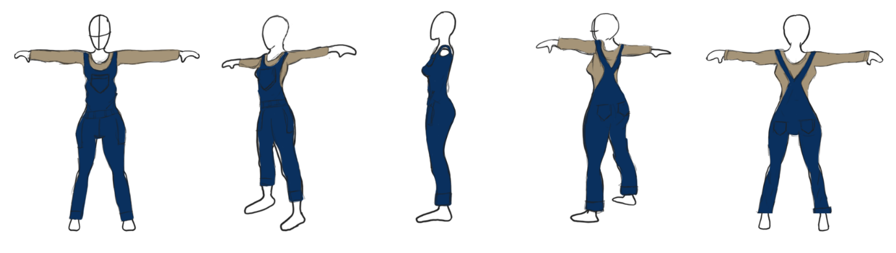

Developed clothing with subtle colours.

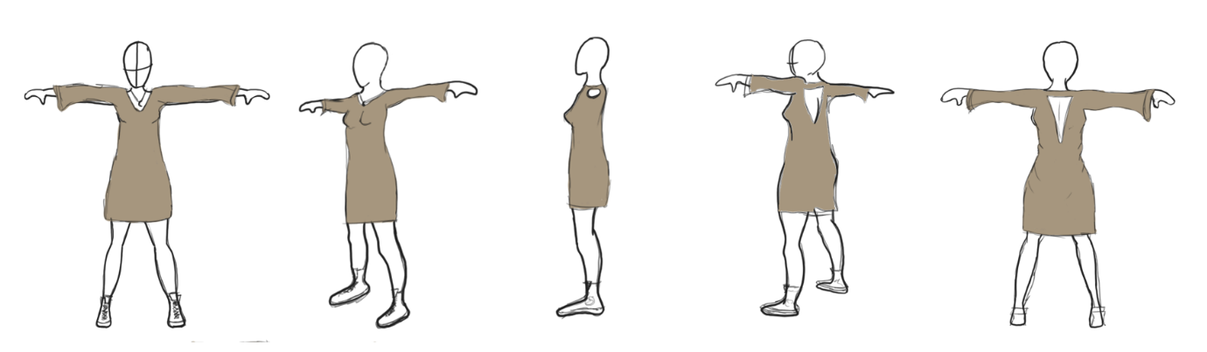
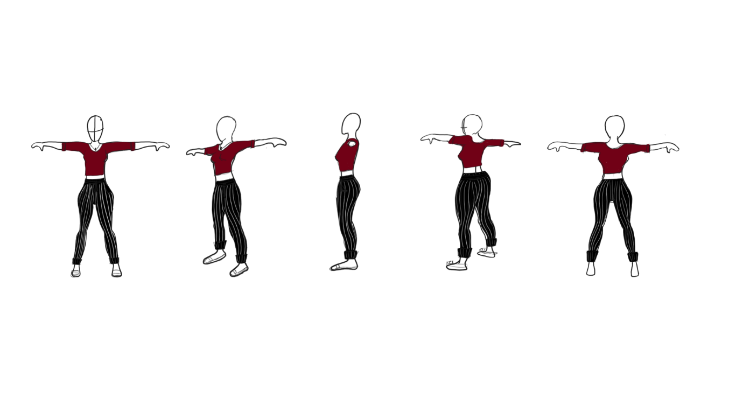
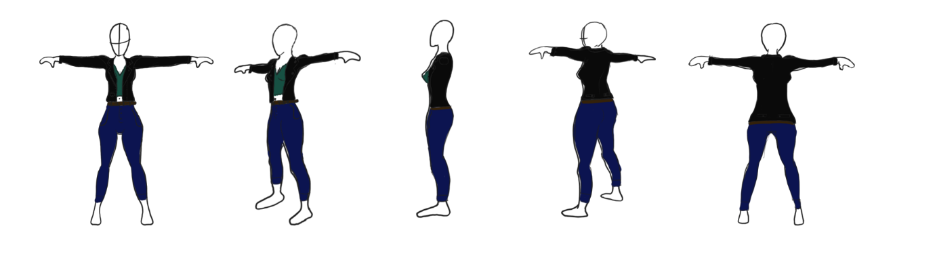

Developed clothing with brighter colours.

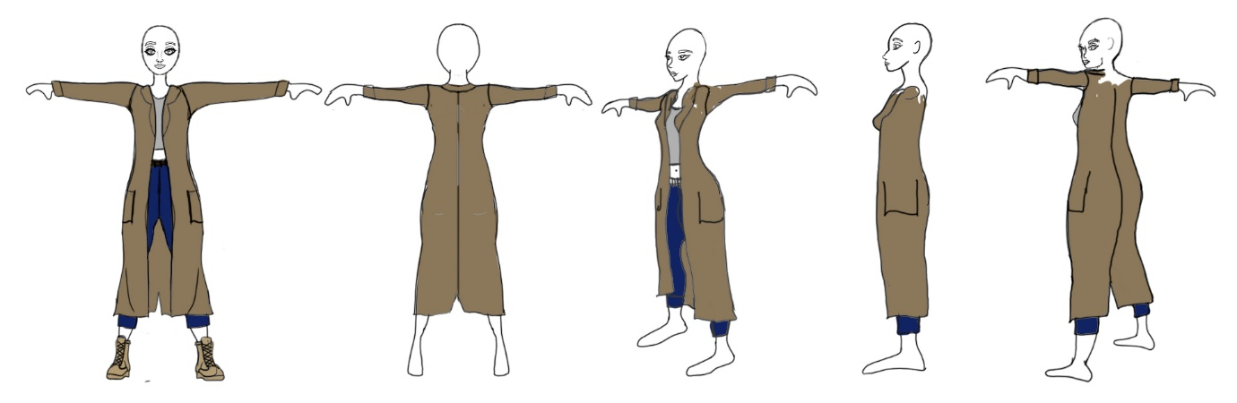
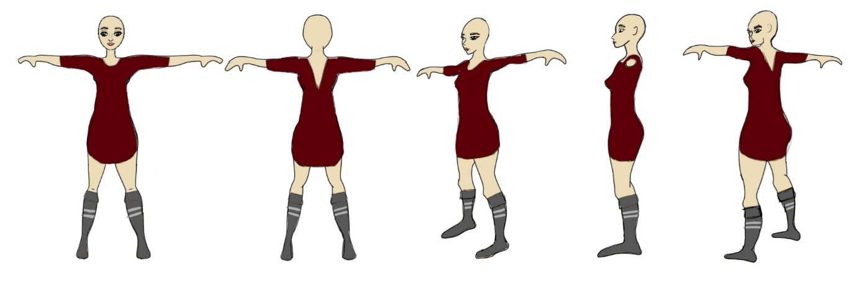
2 final outfit designs were chosen for indoor and outdoor.

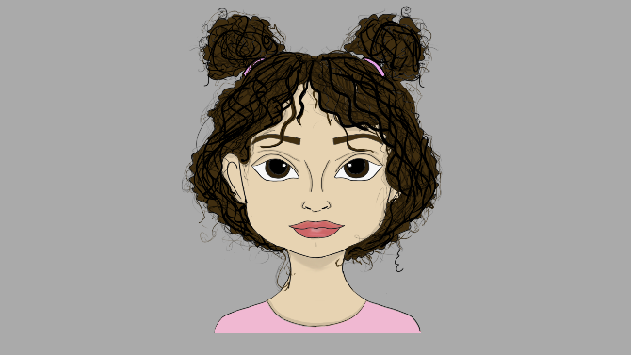

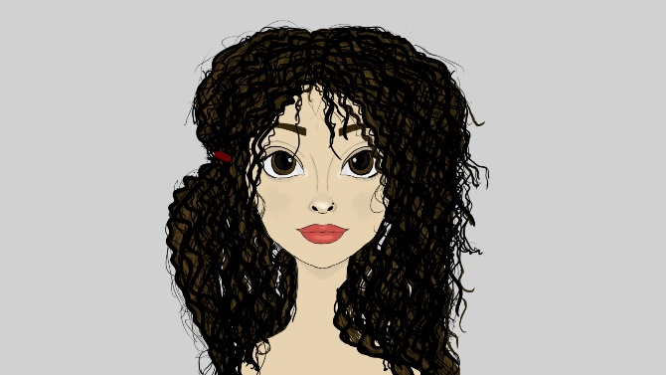

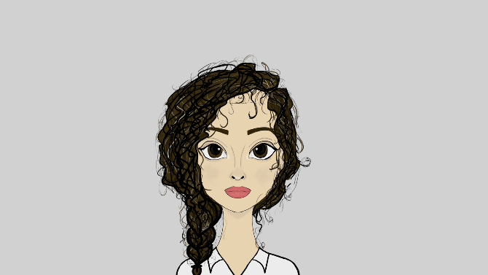

When I was creating my main character aged twenty-one which you will see in part 2 of my production I didn't think it was enough therefore I wanted to show my audience what my character looked like in the past and future.

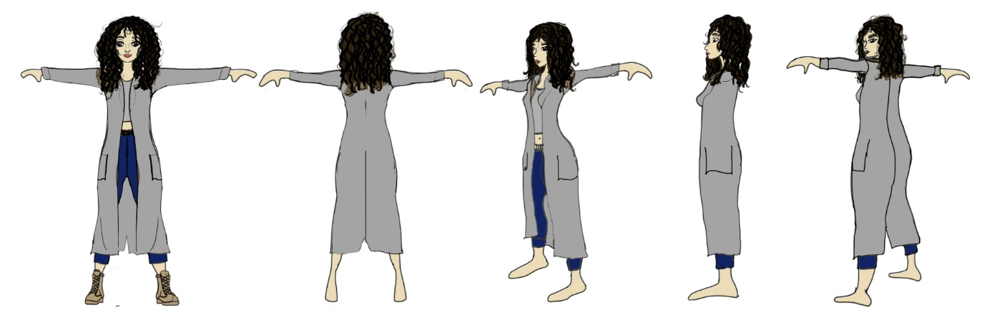
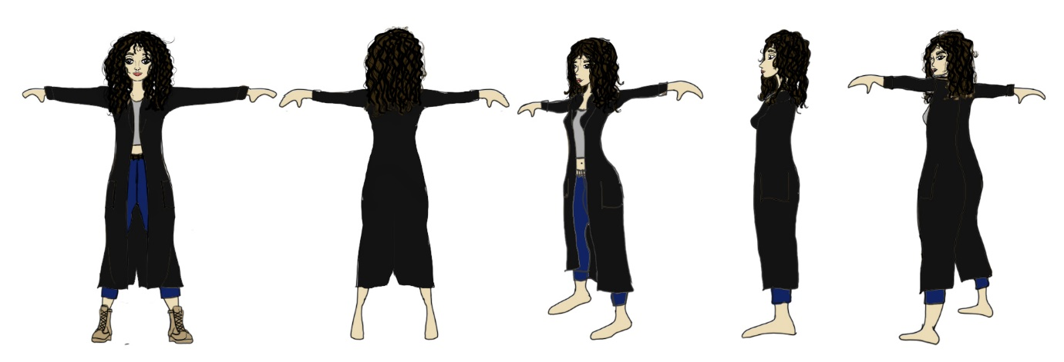

From the chosen final outdoor design, I wanted to experiment with some colour.

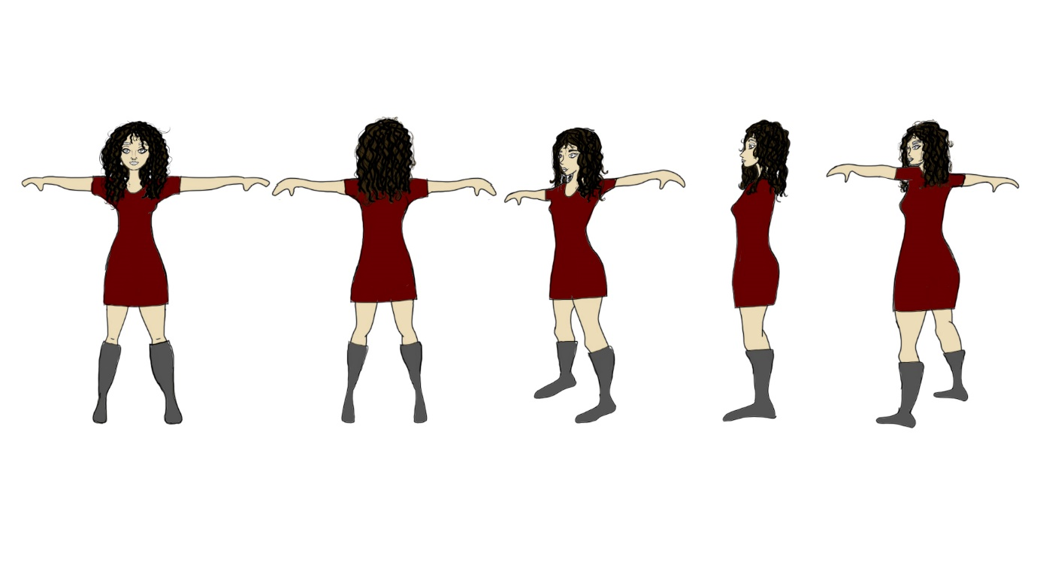
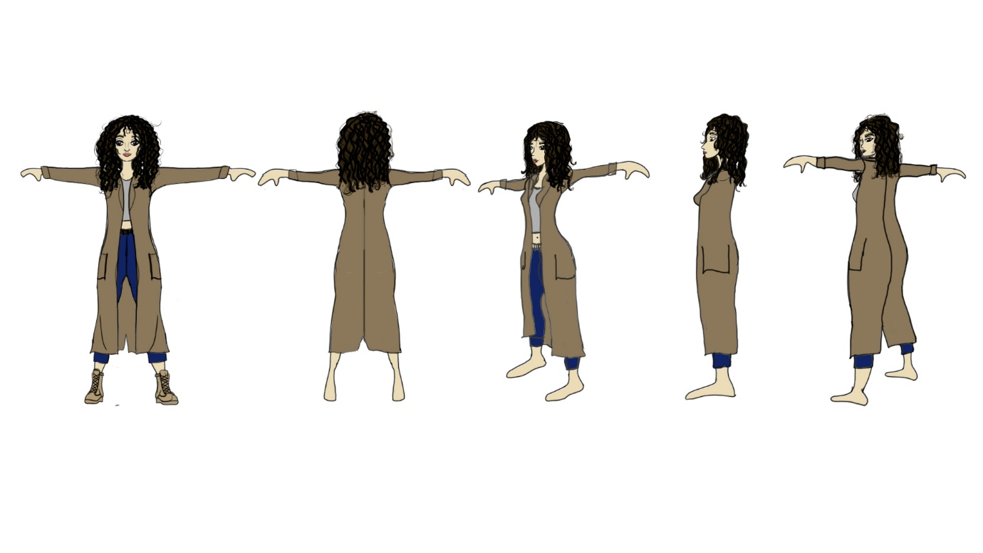
Final Two outfits with colour

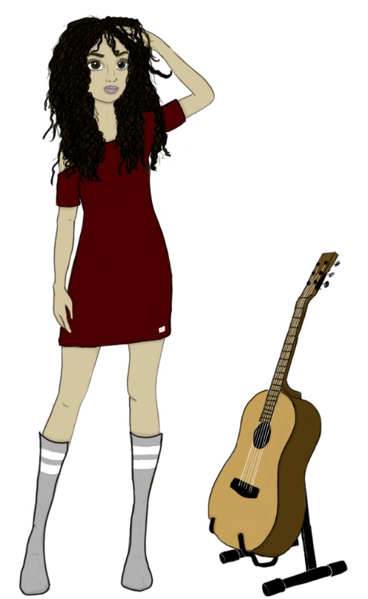
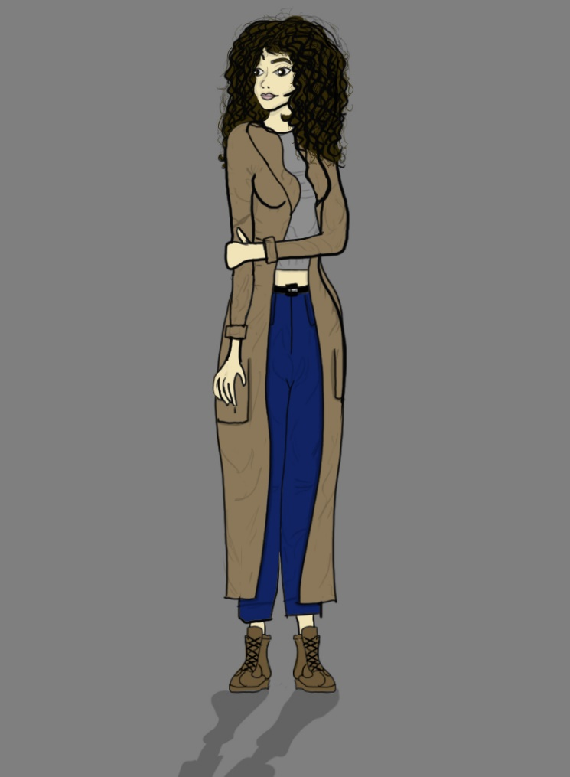

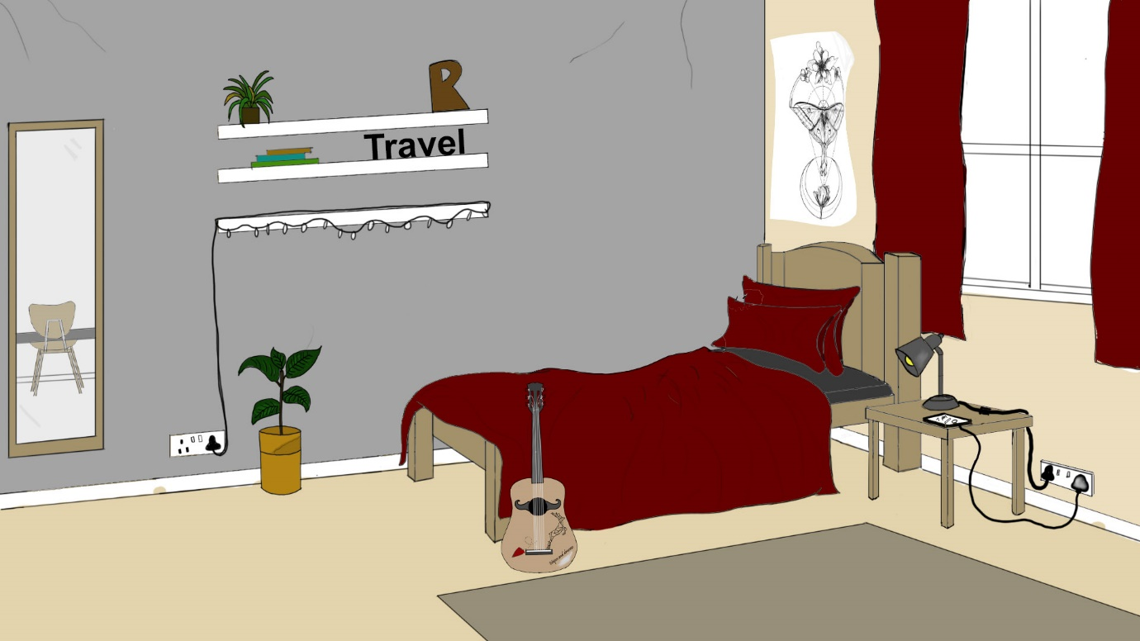
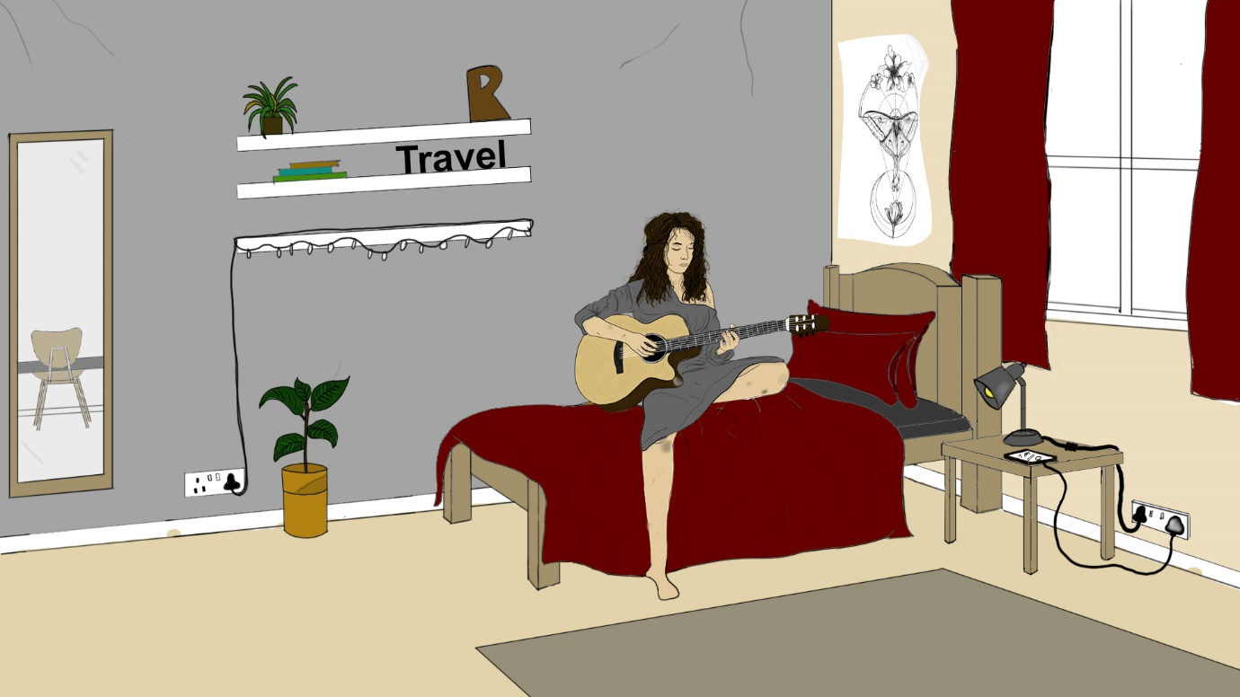
Final room design

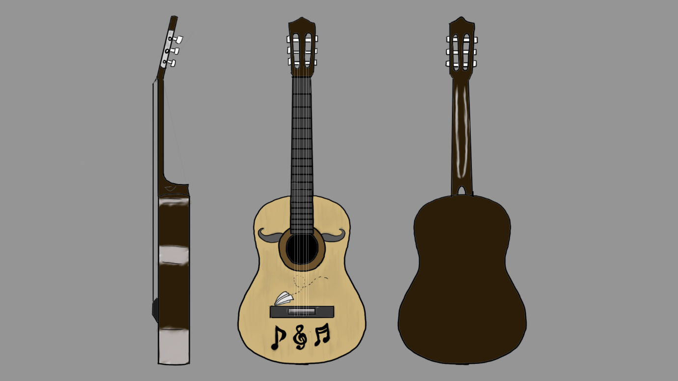
After creating different silhouette designs in development I wanted to look more into my characters choice of guitar as she has a very shy personality I did not want anything too much, therefore I came to the conclusion that choosing a basic acoustic guitar would fit my character the most. How I came to this conclusion was doing a lot of research on the different effects and sounds you can get from the many different guitars that there are.

Final guitar model sheet

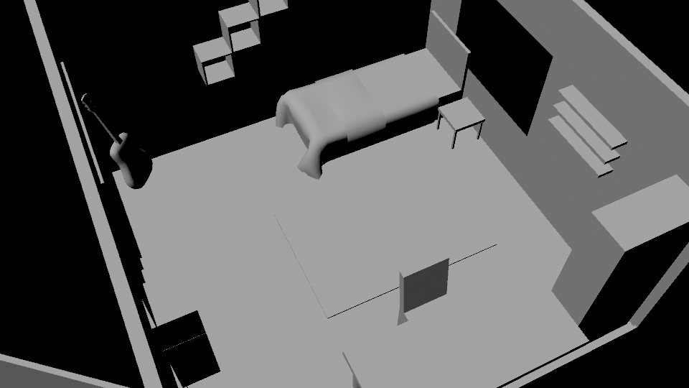
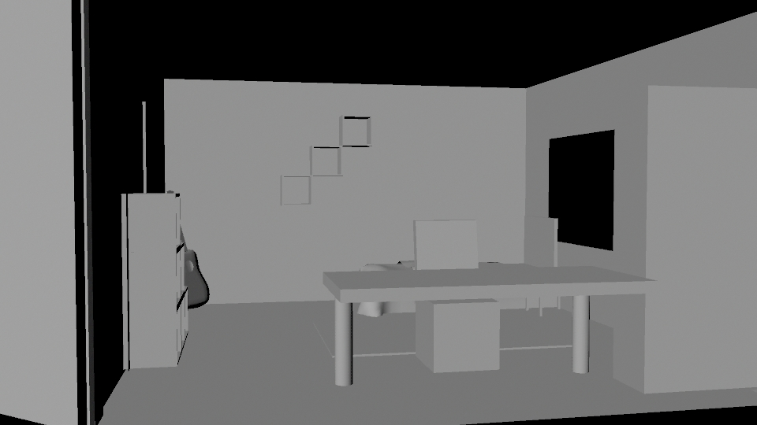

Block Out’s - Room

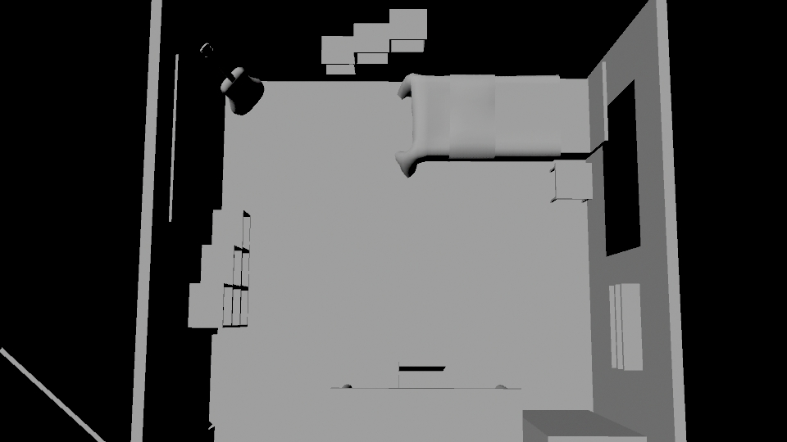

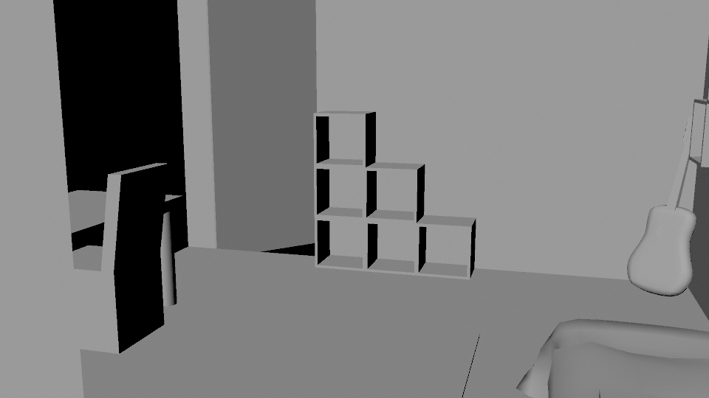

3D Props

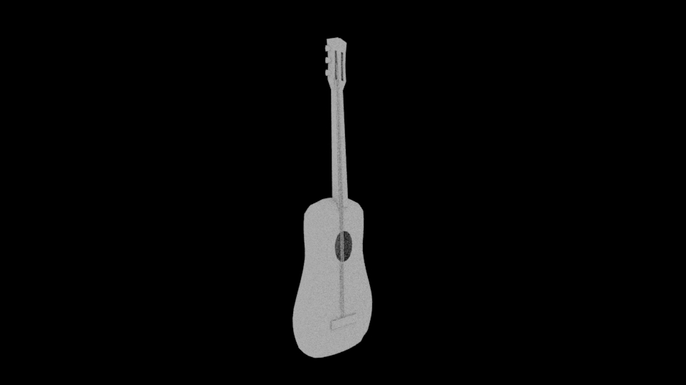

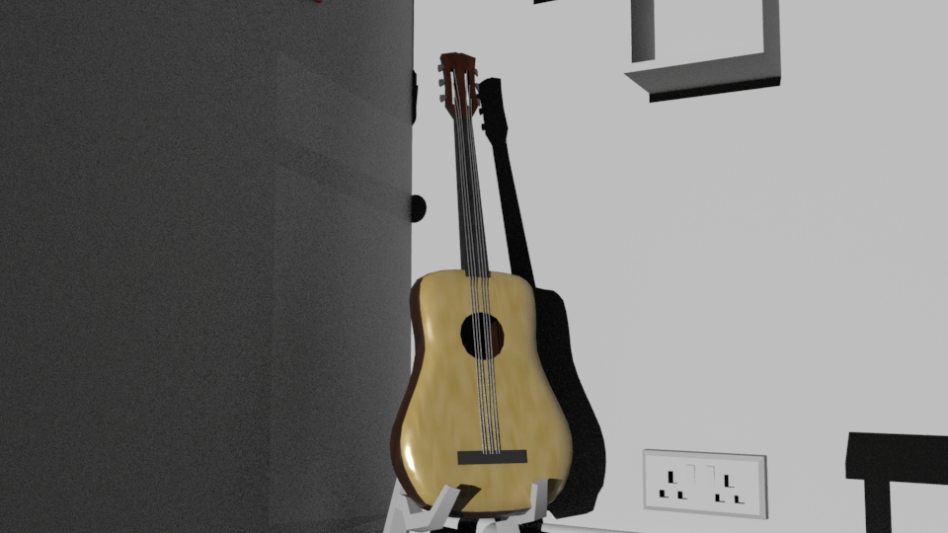

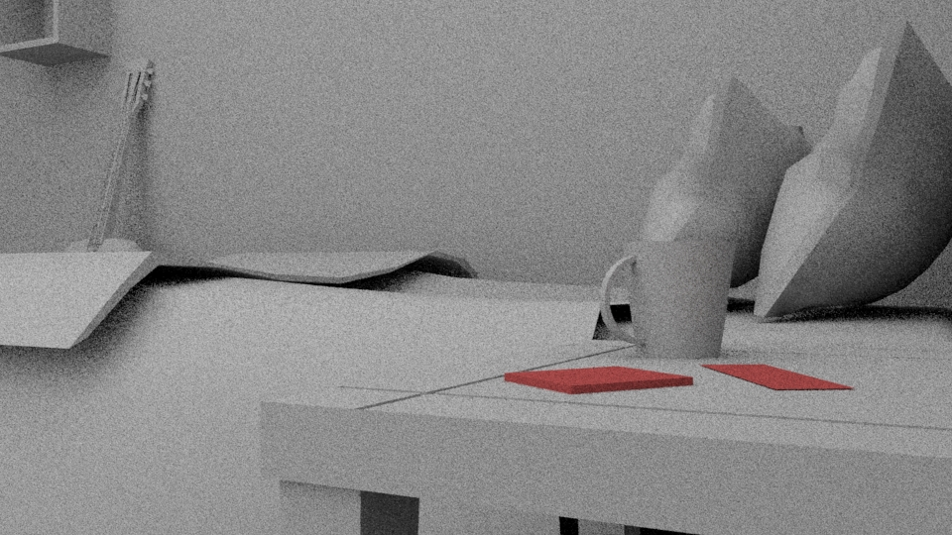
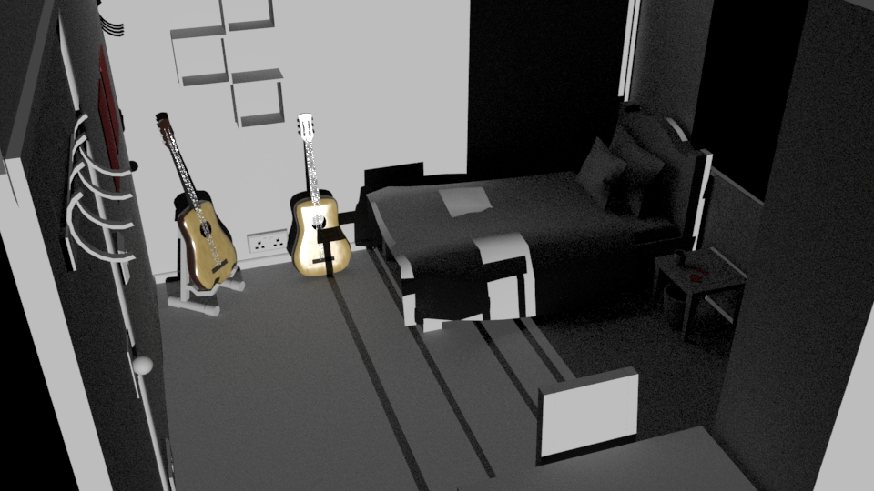

Render Tests

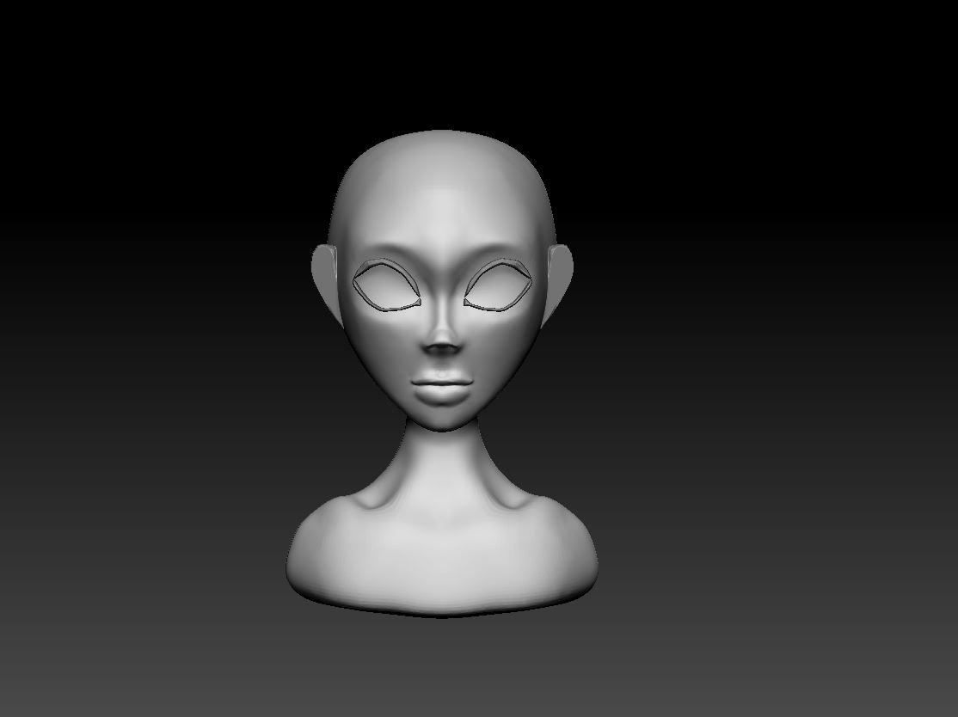
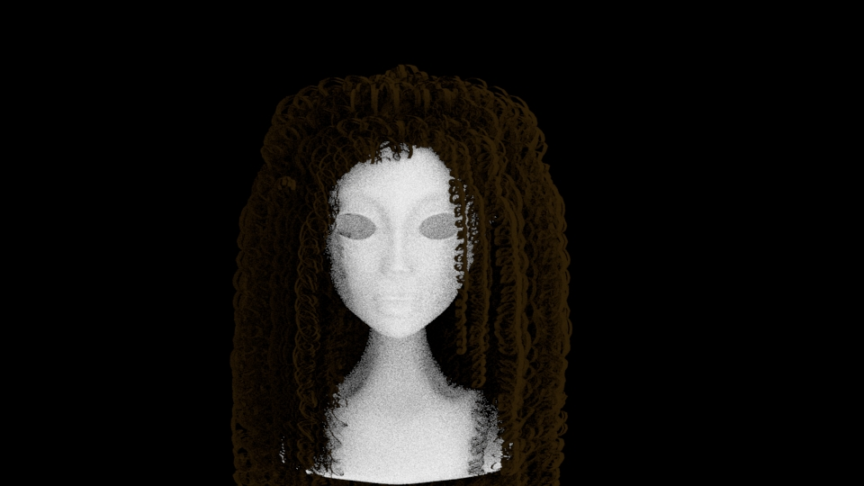

3D Proxy - Riley

Critical analysis

I was tasked with creating a production book for a 3D animated short module, I came up with a project description creating a female character which would be situated in a small space to save time on modelling to be able to output a high quality animation/3D production. The animation should be at least 45 seconds long and I will be aiming for about 1 minute so that I would be able to cute shots if they don’t work in order to meet the requirements of the module. The software I will be using includes but is not limited to Adobe Photoshop, Maya 2018, Zbrush 2018, Substance Painter and the Microsoft Office Suite. Weekly reviews will be held with peers and tutors to gauge if the project follows the S.M.A.R.T format.
I wanted to give my character a backstory so that I could better connect with her and why she does the things she does. My character is called Riley, she is a 21-year-old female with a desire to travel the world and play music ever since she had received the gift of a guitar from her Nan who passed away on Christmas day when Riley was just 6 years old. The passion she had to play music on her guitar was fierce, a burning desire to become what she had wanted to be ever since her Nan had put the guitar in her hands. She wanted to make her Nan proud and would do anything to pursue this as a career. She is quite antisocial when it comes to friends as she would much rather be in her room practising and improving in order to follow her dreams. As she is quite an inverse person, she tends to struggle in large crowd but recently she has a plucked up the courage to get out of her room to achieve her dream. She packed her bag and her guitar and sets out to see the world and perform.
As the process continued, I started doing some research on how to create a certain atmosphere within Riley’s bedroom, the tone I was going for was a dim lighted however with a key light of a lamp placed near her for dramatic effect and to highlight the character in the scene. The reason for the dim lighting is so that with this technique I can focus all the attention on my character so that the animation feels almost personal and close to the audience. I created 3D block outs in order to complete some lighting tests to see if my theory could work, I tweaked some of the lighting sources in order to maximise the effect that I wanted to create. With this lighting test I was also able to double check some camera placements as to test the lighting correctly some cameras would have to be in scene to produce a render.
When designing certain props I wanted to focus on the more important ones within her bedroom the ones she interacts with the most. Her guitar and bed are the things I wanted to focus on the most as they are some of the things she treasures the most, music and the comfort of her bedroom. My main focus for the props was to show how important they were to her and how she uses her space as protection in order to express herself and as a way to achieve her goal. Getting a good angle of Riley is difficult as I want to show as much emotion as possible when she plays music, however also wanting to focus her being very comfortable therefore I wanted to do some silhouette designs in order to quickly determine which poses would be strong enough to show the audience what she's doing without distracting them with a weak silhouette. This is also important to capture the mood of the scene as she needs to display multiple emotions at once in order to portray the story as I want. At the start of the animated short you will see her crossing off a day on the calendar which is right next to her door. She’s counting down the days until she leaves for her dream, having her calendar by her door ensures her that right next to her is the door in where she will be leaving to pursue that dream, so as she crosses it off the calendar the door is a symbolistic reminder that this is everything that she wants in life. All that is needed for her to achieve her goal is to sum up the courage and confidence to pass through this gateway which prevents her from living her dream.

After doing some silhouette guitar designs I wanted to take them forward to develop a unique and personalised acoustic guitar. I wanted to have the basic neutral colours but with some flares on for personalization, the usual personalising of guitar comes in the form of stickers which I could use over the base of the guitar to make a very unique yet familiar look. I wanted to look more into my characters choice of guitar as she has a very shy personality and so I chose the acoustic as this is a very simple and soulful instrument with roots in many . How I came to this conclusion was doing a lot of research on the different effects and sounds you can get from the many different guitars that there are.

When creating the character I didn't know which style specifically to make her so therefore in some drawings you can see a variation of detail and style so that I could experiment and delve into the best style to incorporate into this project. In the end I settled on a stylised version of Riley somewhat similar to Disney which included the big eyes and rounded face for more of a connection to the audience as I would be able to push the emotions that she would be portraying on screen. Therefore I chose that style as a final design to take forward in semester two for creating the 3D animated short. When creating her outfits I wanted one where she is in a very loose shirt and long socks something that she is comfortable in when playing music in her own environment. I wanted her to not really care about looking good in her own home as she could be comforted that she’s in her room and would just focus on the music side of things. Her second outfit would be more covered up and also very dark and neutral colours so that she doesn’t draw that much attention to her self.

When I finished up with the final character design and all her belongings and personality I didn't think it would be enough, so I wanted to take this one step further and design a backstory and future composition of my character to show my audience more about my character. This also helped me gain insight into my characters motivations for her to become what she dreamed about.

When creating and designing the bedroom I wanted to use very subtle and cozy colours to give the room more of a feeling of comfort. I wanted to keep her bedroom as empty as possible as she likes to be able to hear the sound clearly without it bouncing awkwardly off other objects when she is playing music. In terms of the style of the bedroom I wanted to keep things very square and rather simple, not to much pattern as this is not what my character likes, her personality would not reflect a outgoing colour scheme and bold patterns but rather subtle colours and quite simple designs. Where the bed is placed is important as its facing away from the window looking at a corner of the wall where there is minimum lighting this is to reflect that she's excluded herself from the outside world, this is also displayed by the lighting arrangement as it promotes a very close relationship to her guitar as everything else is dimly lighted. When you see her playing she will always have her curtains closed and her just her lamp on to be able to have that barrier between her and the outside world. When she is sleeping she has a photograph of her and her late Nan on the wall above as a symbol she will always be there with her throughout her life to guide and protect her. This is more to show how much Riley looks up to her Nan and wants to make her proud.

There were many difficulties that I had found with this project, this caused me to slow down and focus more on these parts in order to better my skills. The script was a big learning curve as I am not a confident writer and have never really written a script before. I set myself a time limit for this but went over my time a lot this is something that now I have done it the process should be quicker next time and not go too much over the expected duration. I also did a lot of research on hair designs as I really enjoy that process, the tight curled hair suited my character the most but knew this would be a challenge to create. I looked at other hair ideas to take forward to the final design but personally kept coming back to this the tightened curls so I finalised this design. Then after a final decision on this design I decide to do some research on “Brave” and to see how they created the hair and will pursue researching this film to get the best possible outcome.
For semester two continuing on from my pre production I am going to heavily focus on the character and her personality. When I was happy with my final environment design I wanted to visualise it more therefore I created a 3d block out of Riley’s bedroom, along with starting a block out of my character to get a better idea of the final product.
Overall I think the process if creating a production bible went well and I am very happy with the outcome. In future projects I wish to see myself improving on my script knowledge and diving more into symbolism and hinting to meanings beyond just an animation. I made this production bible with this story because I felt like I could show a lot of emotions and no matter your situation you can always chase your dream and pursue them. I am extremely happy with how the bedroom turned out and happy with the final placements as everything has a meaning for the placement of her belongings. Personally I feel I could have dived deeper into colour theory but I always struggle with colour this is why I have stuck to very basic neutral colours. I also feel I could have done some more thumbnail iterations to take forward to get the final story finalised.

