Witness Interview Theft Task Sheet
Scenario 12 Vehicle interference - Witness brief

Witness details: (use your own name)
Witness address: (use your own address)
Location: Kingsway industrial estate carpark, BRIDGEND
Time of the incident: Approx 1 hour before the time of making the statement

You are a self employed electrician for QDL contractors, you have attended at a job today on the KINGSWAY industrial estate and parked your van up in the industrial estate car park. Your van is a Mercedes VITO I/N CN17 NMY. You have returned to you vehicle to find a person looking into the vehicle and as you approached them you have shouted to them

!! Watch the film clip !!

As the suspect ran away out of sight, you saw that they have dropped a screwdriver with a blue handle with paint on it. You have picked up that screwdriver and have put it into a bag and can produce it for the interviewing officer.

You do not recognise this suspect but you will be able to describe them if asked to do so. Use the name provided to you by your trainer.

Aims of the Scenario

- The aim of investigative interviewing is to obtain accurate and reliable accounts from victims, witnesses or suspects about matters under police investigation.
- Investigators must act fairly when questioning victims, witnesses or suspects. Vulnerable people must be treated with particular consideration at all times.
- Investigative interviewing should be approached with an investigative mind-set. Accounts obtained from the person who is being interviewed should always be tested against what the interviewer already knows or what can reasonably be established.
- When conducting an interview, investigators are free to ask a wide range of questions in order to obtain material which may assist an investigation.
- Investigators should recognise the positive impact of an early admission in the context of the criminal justice system.
- Investigators are not bound to accept the first answer given. Questioning is not unfair merely because it is persistent.
- Even when the right of silence is exercised by a suspect, investigators have a responsibility to put questions to them.

Outcome of the Scenario

- Aim: To Provide interviewers with the competence to prepare and plan interviews with suspects.
- Objectives
- Assess information gathered about suspect(s)
- Assess the type and current condition of the suspect to inform the approach to the interview in accordance with legal requirements.
- Establish the correct interview approach utilising the engage and explain phase aide memoir
- Identify the nature of the allegation and identify investigative important information
- Produce a written interview plan that takes account of the suspect assessment , the needs of the investigation and legal requirements
- Select and set up the necessary interview location, resources and personnel.

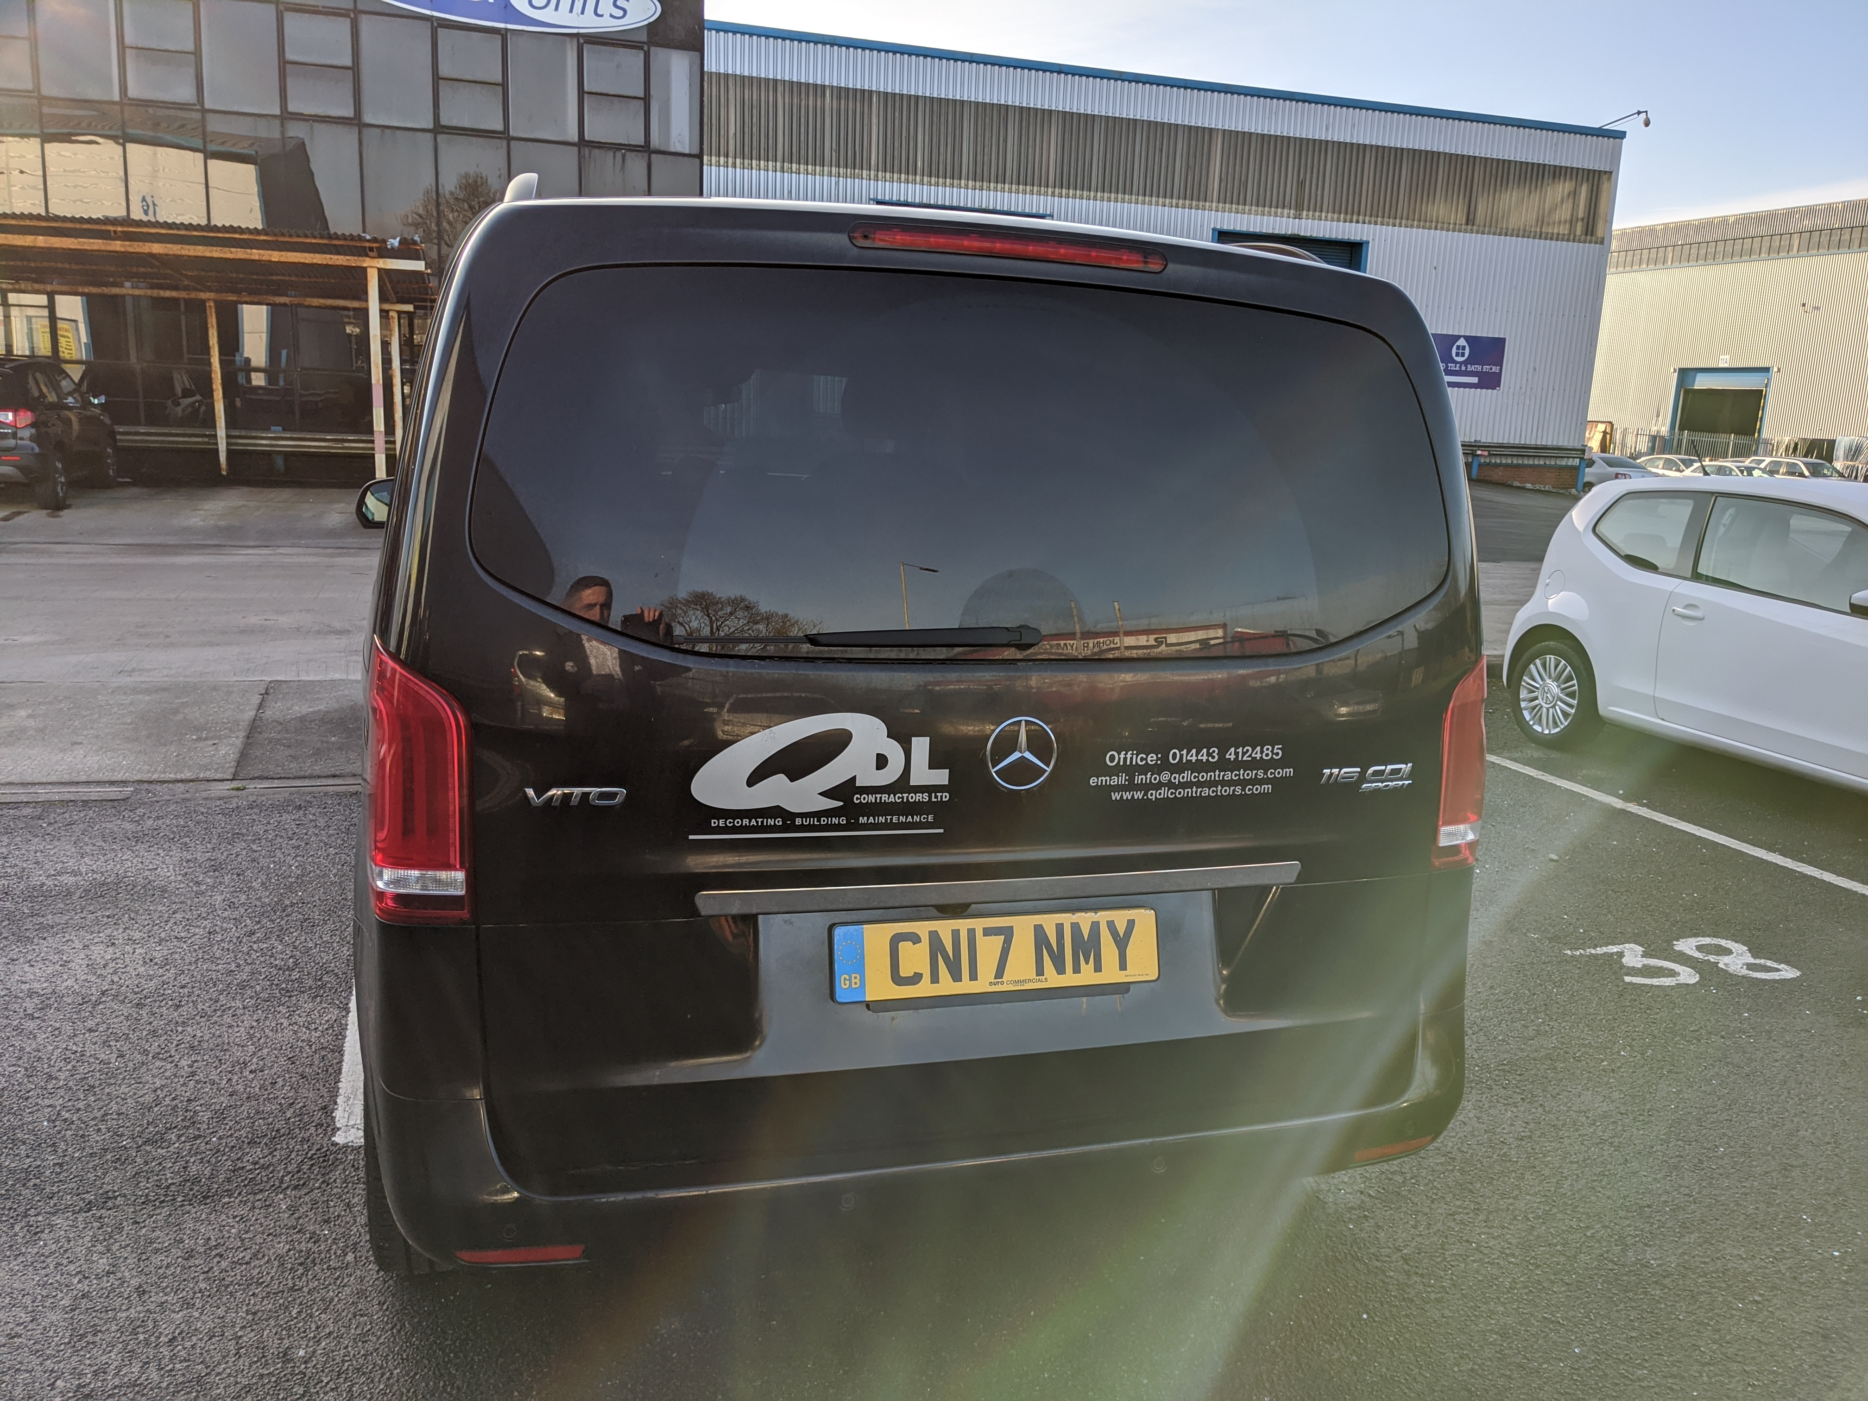

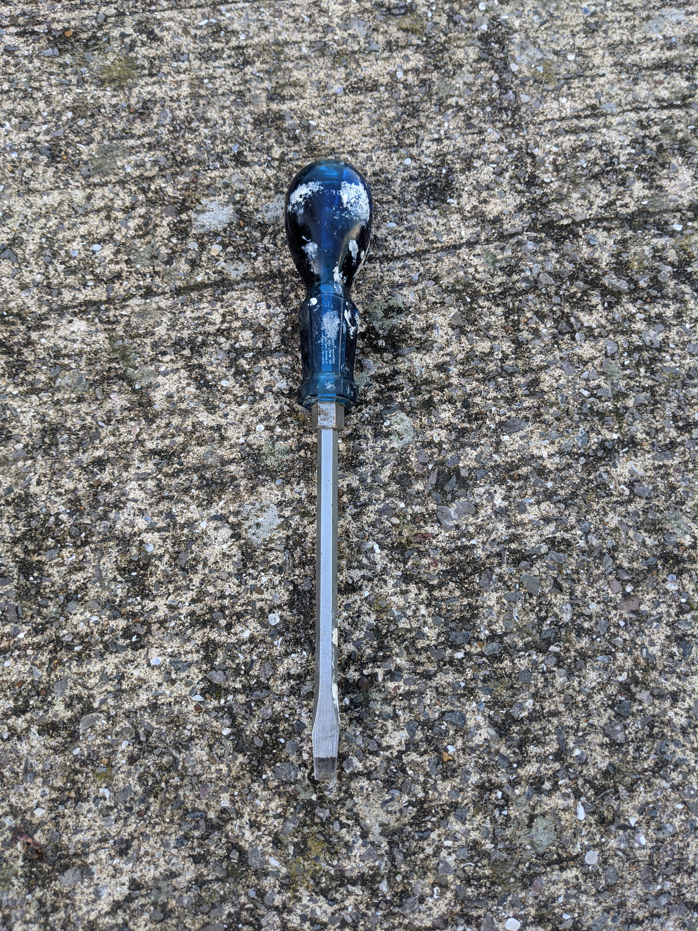

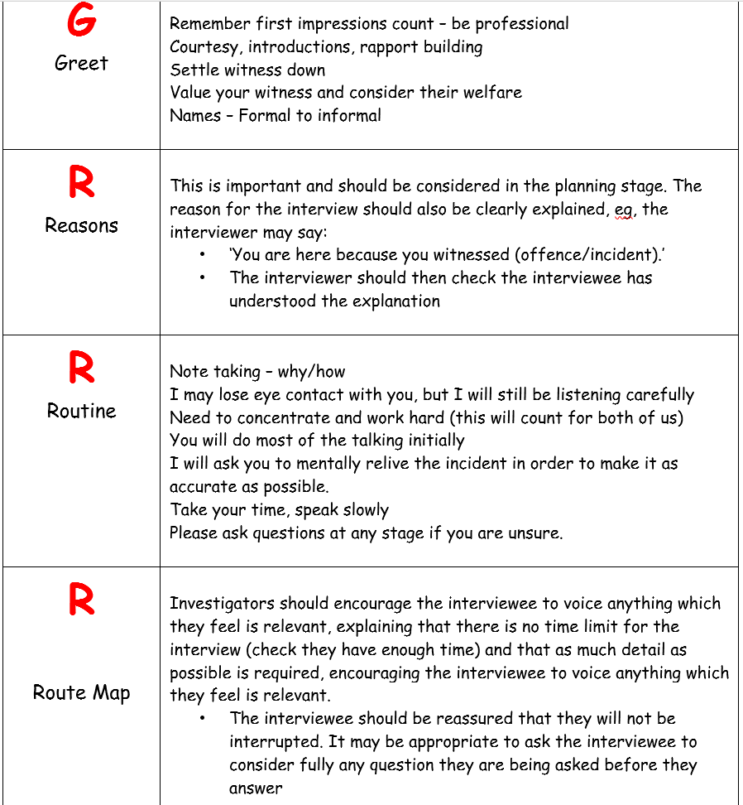

S9 Criminal attempts act 1981

Interference with vehicles.
(1)A person is guilty of the offence of vehicle interference if he interferes with a motor vehicle or trailer or with anything carried in or on a motor vehicle or trailer with the intention that an offence specified in subsection (2) below shall be committed by himself or some other person.
(2)The offences mentioned in subsection (1) above are—
(a)theft of the motor vehicle or trailer or part of it;
(b)theft of anything carried in or on the motor vehicle or trailer; and
(c)an offence under section 12(1) of the M1Theft Act 1968 (taking and driving away without consent);
and, if it is shown that a person accused of an offence under this section intended that one of those offences should be committed, it is immaterial that it cannot be shown which it was.
(3)A person guilty of an offence under this section shall be liable on summary conviction to imprisonment for a term not exceeding three months or to a fine not exceeding [F1level 4 on the standard scale] or to both.
(4). . . . . . . . . . . . . . . . . . . . . . . . . . . . . . . . F2
(5)In this section “motor vehicle” and “trailer” have the meanings assigned to them by [F3section 185(1) of the Road Traffic Act 1988].

