Business Inquiry & Research

QUALITATIVE AND QUANTITATIVE STUDY AND REPORT.

BMSP5007

Zoe Vaughan (2015102)

Qualitative Research - Part 1
Contents Page

1. Introduction
2. Literature Research
3. Procedure
4. Data Analysis Techniques
5. Data Presentation and Findings
6. Conclusion
7. References

1. Introduction
This qualitative study aims to reflect on the participant's views on the benefits they feel they would gain by growing their own fruit and vegetables. Three participants took part in the data gathering. The qualitative interview process was conducted face to face by a semi-structured interview approach.
The ontology of this study is to gain insight from the views, opinions, and feelings of people when recognizing the benefits and importance of growing your own food. This subject I feel is significant to me, and I refer to my positionality where I am currently studying for a business and management degree and hope to set up a business offering a subscription package providing seeds and everything you need to know to understand how to grow. I believe this way of living can improve health in more ways than one such as reducing the risk of obesity, mental health, and of course physical health. Poverty can also be improved and, along the way, bring awareness in reducing carbon footprints by reducing waste and the need for importation. An article by the Welsh Government stated that 1.5 million adults are overweight or obese in Wales alone. This figure is expected to increase to 160,000 adults by 2030.
NatCen Social research Food Security in Wales also stated that a fifth of people in Wales worry about running out of food before receiving money to purchase more. And back in 2017, 14% of people in Wales had run out of food before they could afford to buy more. A study by Benenden Hospital reported that growing your produce can increase a healthy consumption, stating that households who grow their own produce are over three times more likely to consume they're five a day of fruit and veg. (Benenden Hospital).

2. Literature Research
I conducted a Qualitative, subjective interview approach regarding the research process rather than a quantitative approach; this was to understand the phenomenology: the structure of the study and the perception of a person's point of view at that time. The interview was an interactive natural style approach. The information is subjective because it's regarding personal feelings, emotions, and judgments. Quantitative information focuses on numbers and data measured through statistical analyses regarding quantities, identifying facts associated with social Phenomena. (McLeod, S. 2019).
Qualitative data is all based on descriptive results, methodological phenomenon-driven research that's observed by language and can be measured with a concept of understanding and studying human behaviour in natural settings. (McLeod, S. 2019).

The research paradigm regarding the Qualitative approach is largely subjective. The term interpretivist refers to epistemology of a theory for how we can be made aware of feelings. Epistemology is the branch of philosophy concerned with the nature and scope of knowledge, understanding and justified beliefs and gathering qualitative methodology in a semi-structured interview process with an inductive thematic analysis. Qualitative is subjectivist in the research paradigm (a way of looking at the world)—a mapping method for formulating research for an Interpretivist approach. A research paradigm is a multi-method approach based on a naturalistic approach to the interview. (O'Gorman, K,. & MacIntosh, R).

A good qualitative question should describe exactly what the researcher wants to know, a question can shape the way the interview leads. (Aggie, J. 2009).
The research aims to look within the case instead of comparing. The typical case is that the average person within the population has experienced food shortages, poverty, health issues, or obesity. I followed the research paradigm using the thematical framework method because it's a philosophical, social science approach. (Proofed. 2022). The process can apply to both Qualitative and Quantitative research; however, quantitative analysis will be deductive (Improve theory), where Qualitative is an inductive data analytic approach (a new theory).
Braun and Clarke (2006) described the phases of thematic analysis for processing qualitative information; the research usually involves inductive coding from the qualitative data and inferential statistics by looking at themes and relationships. These themes are then grouped into categories where consistent patterns occur to conclude a theoretical explanation of the phenomenon under study. (Chawla, T,. & Wood, J. 2021).

3. Procedure
Once the phenomenon framework (thematical) and methodology were chosen, the systematic research process was carried out by a semi-structured interview type, A qualitative method.
The advantages of a purposive sampling technique (a non-probability sampling method) can help observe patterns and how people react, their behaviour on a matter in question. This technique can be of benefit from its fast and efficient approach. (Dudovskiy, J).

I will identify my participants by pseudonym. Participants were chosen randomly to get a fair analysis, and all were of different ages. I relied on my judgment when choosing participants. The researcher asked the same question to all participants; however, the interview was open to questions for the participants to express their views. I chose the semi-structured interview method because I could prompt by asking my participants to clarify or elaborate on their answers. (Teagan, G. 2022).

My interviewees are familiar with the phenomenological method, and all three interviews were conducted face to face. Each interviewee was fully aware of the process before taking part, and all participants gave consent to the participant agreement and ethics form. I explained to each participant before the discussion began issues regarding ethics and the qualitative interviewing technique. Each interview was 20 minutes and was recorded only for transcription, and responses were analysed using a word document. I followed GDPR by protecting personal details by coding each participant. GDPR (The General Data Protection Regulation) states that when conducting the qualitative research, the below critical points should be considered:

- Requesting only the participant's information that's needed.
- Storing the data for only the required time.
- Using only the information relevant to the subject of study.

For every piece of data collected from a participant, you must get consent. There is a lawful bias for collecting and analysing the data, which is essential for the legit interests of the qualitative researcher. (Transcribe It. 2019).
Discrimination is understood to be any influence made within the interview process which could affect the outcome of results. (Gildas, P. 2017).
All participants consented to the interview, and everyone who took part completed the ethics and participant form.

4. Data Analysis Techniques
Data analytics analysis of raw information enables a researcher to conclude. Data Analysis is crucial in business. (Stevens, E. 2021).
The phases described by Braun and Clarke (2006) of thematic analysis for processing qualitative information are below. (Chawla, T. & Wood, J. 2021).

The process involves:
- Familiarising Data,
- Generating Initial Codes,
- Search for Themes and Patterns
- Review Themes and Patterns
- Produce a Report with a Final Analysation.

Any comments the participants made that were irrelevant to the subject of the interview question, “what benefits do you feel you would gain from growing your fruit and vegetables,” were removed from the transcribed document.

Please see three tables below where the interview data has been gathered in groups. A new group was created regarding any new opinions irrelevant to the previous group.

- The first column – Participant’s views/feelings/opinions
- Middle column – Researcher’s opinion of the Data
- The last column shows the Identification of reoccurring themes and patterns.

5. Data Presentation and Findings
Below is Table 1 of the Qualitative analysis, which has been grouped for reoccurring themes. This data has been analysed from participation's answers and researchers' interpretations.

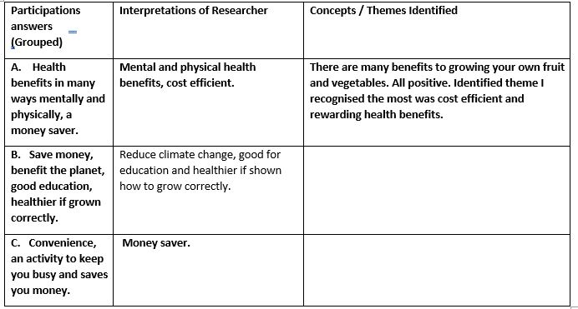
Table 1 above shows a data pattern where all 3 participants identified the benefits of growing their fruit and vegetables. All 3 participants mentioned cost savings as one of the main positives and beneficial health.

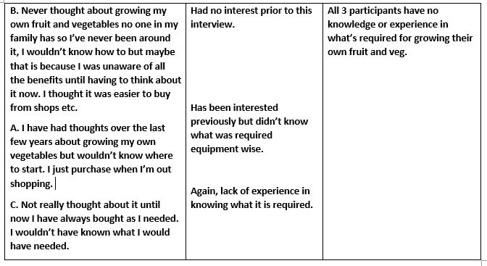
In table 2 above, the second theme identified was that all 3 participants expressed their views that they have no knowledge or experience in what is needed in growing their fruit and vegetables. Participants said they felt it was easier to shop for produce before this interview.
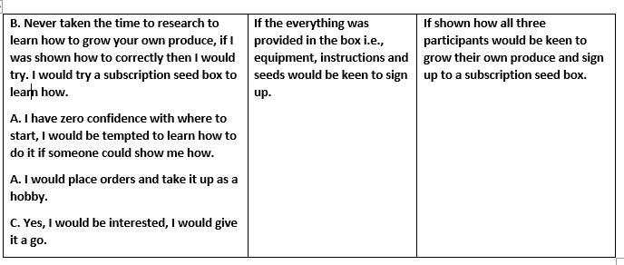
Table 3 above shows patterns that, if shown correctly with given instructions and the seeds needed, all participants would be interested in learning. All three agreed that they would invest and purchase if there was a subscription package available.

6. Conclusion
Data was restricted by the limitations of this study, with only being 3 participants. The Data identified main themes from the semi-structured interview that showed there were valid questions. Qualitative processes like phenomenology with the thematic framework approach allowed the participants to be open and honest and tell a story from an experience or feelings. The themes found within the data have given an insight into the participants' thoughts on the benefits of growing your Fruit and Veg, would your know-how, and would you be interested in purchasing a subscription seed box if you were taught what to do.
My Strengths and weakness in this data research are trial and approach. I would change and tweak the questions on what I would change how I interview in the future. I would slow down on asking questions, and if I had more interviewees to take part, there might have been a broader response. The interview was fair with each participant; I asked the questions in the same manner and tone. I Understand research bias is essential.
I concluded from this study that the participants didn't think or know how to grow their own produce before this interview. All participants recognised the benefits this would provide, and I feel that all participants would be keen to learn how with the correct guidance.

7. References

Aggie, J. (July, 2009). Developing qualitative research questions: a reflective process. https://www.tandfonline.com/doi/full/10.1080/09518390902736512.
Benenden Hospital. Health and wellbeing benefits of growing your own food. https://www.benendenhospital.org.uk/health-news/helpful-tips/health-and-wellbeing-benefits-of-growing-your-own-food/
Chawla, T,. & Wood, J. (2021). ScienceDirect. Thematical Analysis. https://www.sciencedirect.com/topics/nursing-and-health-professions/thematic-analysis.
Dudovskiy, J. Business Research Methodology. Purposive sampling. https://research-methodology.net/sampling-in-primary-data-collection/purposive-sampling/.
Galdas, P. (Dec, 2017). SAGE journals. Revisiting Bias in Qualitative Research: Reflections on Its Relationship with Funding and Impact. https://journals.sagepub.com/doi/full/10.1177/1609406917748992.
McLeod, S. (2019). SimplyPhyscology. What’s the difference between qualitative and quantitative research? https://www.simplypsychology.org/qualitative-quantitative.html.
NatCen Social research that works for society. (March, 2018). Food Security in Wales. https://www.food.gov.uk/sites/default/files/media/document/foodsecurityinwales_0.pdf
O’Gorman, K,. & MacIntosh, R. Mapping research methods. https://www.goodfellowpublishers.com/free_files/xChapter%204%20Mapping%20Research%20Methods-ea47945eed5486d42095459f6812d034.pdf.
Proofed. (March, 2022). Research Paradigms: Explanation and Examples. https://proofed.co.uk/writing-tips/research-paradigms-explanation-and-examples/.
Stevens, E. (March, 2021). The 7 Most Useful Data Analysis Methods and Techniques. https://careerfoundry.com/en/blog/data-analytics/data-analysis-techniques/
Teagan, G. (Jan, 2022). Scribbr. Semi-structured Interview/definition, guide and examples. https://www.scribbr.com/methodology/semi-structured-interview/.
Transcribe It. (April, 2019). What Does GDPR Mean for Qualitative Researchers? https://www.transcribeit.co.uk/gdpr-for-qualitative-researchers/.
Welsh Government. (Oct, 2019). Health Minister launches ambitious new plan to halt obesity rise in Wales. https://gov.wales/health-minister-launches-ambitious-new-plan-halt-obesity-rise-wales.

Quantitative Research - Part 2

Table of Contents

8. Introduction
9. Data Collection
10. Analysis Approach
11. Procedure
12. Analytic Procedure
13. Data Presentation and Findings
14. Cross Tabulation of Results
15. Limitations of Data
16. Conclusion
17. References

8. Introduction
This report examines how confident people feel in growing their own fruit and vegetables. Articles show that the shortage of food could potentially become an issue. I believe that innovating and introducing the idea of being able to provide your own produce could make a difference in already a pressurised world. According to an article by Grocer, only back in Mark 2022, Spanish lorry drivers went on strike, causing significant delays and vast shortages of salads and soft fruits in the UK. A key Spanish supplier who provides for the UK was also struck by the rise in petrol prices, causing catastrophic delays in transportation. A commercial and Marketing Director of the Spain supplier ‘Anecoop’ Scott Porter-Ward commented that they supply the whole of Europe, and the issues with the delays have significantly affected retailers. (Duncan, G. 2022).
The quantitative data in this study will give an insight into how confident people would be growing their own produce. This study was chosen to understand if the idea could be a business and if there is a potential market for it. This study is critical because of the struggles we have and may continue to face. The benefits from growing your own produce can positively impact the world in more ways than one, regarding climate change, pressures on the NHS regarding physical and mental health and the potential shortage of food regarding our reliance on other countries. A story written by Wales online states that research from Weleda revealed that during the lockdown, over 26 million people (just under half of the UK households) resorted to growing their own fruit and vegetables, with 7.4 million from that figure trying for the first time. Weleda also revealed that 62% of people claim connecting with nature positively impacted mental health. (Gibbons, B. 2022).
9. Data Collection
Information was collected from an online questionnaire from a quantitative method to explain the chosen phenomenon. Quantitative research is a Positivist epistemology, a scientific method based solely on facts to make a legitimate claim. Positivists prefer this method because of its structured questions and believe the statistics have reliable results. (Thompson, K. 2015). Quantitative data is related to numbers and is a phenomenon system that gathers information from a wide range of opinions to gather fair results using non-probability sampling methods such as online surveys or questionnaires. The data is analysed by statistics, mathematics, or computer techniques. (QuestionPro).
10. Analysis Approach
Quantitative data can be measured by numbers and collected by measuring variables. (Mills, G, J. 2021). The data is described in variables of quantities i.e., gender and age. (OECD).
Cross tab analysis is usually used in statistical analysis to identify themes or patterns to understand relationships between two or more variables. Categorical data collects information on demographics and cannot belong to more than one category. (Aprameya, A. 2016).
Quantitative research requires a high number of responses the data collection techniques include experiments such as Surveys, questionnaires, longitudinal Studies, Polls, Telephone, and face to face interviews. There are two types of data, descriptive and inferential statistical analysis. Descriptive statistics draws data as a whole and inferential statistics groups and identifies significant differences between data groups. Quantitative questions are usually how questions, and quantitively data is usually a structured approach. (Stevens, E. 2021).

11. Procedure
The data from the survey was used in a descriptive observation research method, a method of descriptive characteristics from the population based on the statistics and numbers. Cross-sectional studies aim to describe a variable, not measure it; in this way, the researcher can look at many characteristics at once. (Simkus, J. 2021).
The survey was created to gain information on how confident people may be in growing their own fruit and vegetables. There were ten questions, and 34 people participated. The questions were closed nominal and ordinal. Nominal questions such as gender, age, i.e., and ordinal questions such as how you would feel, would you ever. The first two questions collected demographic information from the participants, and these themes were then grouped in the analysis. There were multiple response methods such as multiple-choice and yes or no questions.
The survey was online and created from Microsoft forms. The cloud-based software enabled the partakers to answer the survey in their own time in any location where no manipulation or interference could occur. All participants consented to statement via a tick box before the survey began. The participants agreed:
- To understand their participation in the survey is voluntary, and they may wish to withdraw at any time.
- Their identity is not linked to their data, and all information is kept confidential.

12. Analytic Procedure
OneDrive forms and SPSS software Statistical Package for Social Sciences were used to process and identify themes within the data. An ID was assigned to all participants to ensure their data remained confidential and protected. The coding frame was used where labels were given that correlated with the multiple-choice questions. Variables were entered and made to be either nominal, scale, or ordinal.
Results were input into the SPSS software. Some variables were entered in the numeric form to aid analytics and match the assigned labels. The data was scanned ensuring there were no errors in the findings.

13. Data Presentation and Findings

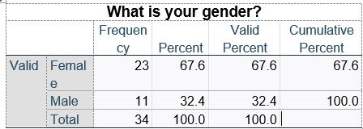
Q1.

The data above identifies that the survey shows that more females participated in this survey than males.

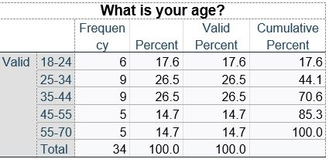
Q2.

The data above from this question shows the age group of the participants who took part. Every age category has data; however, participants aged between 25 and 44 show the majority showing 9 from each category.

Q3. Do you have outside space/garden?
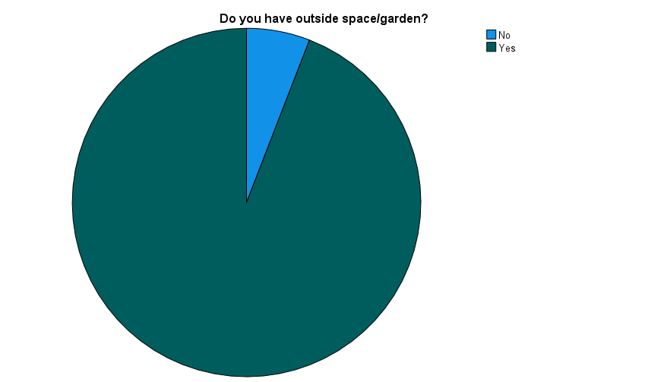

The data above shows that majority of the participants who took part in the survey have outside space or a garden.

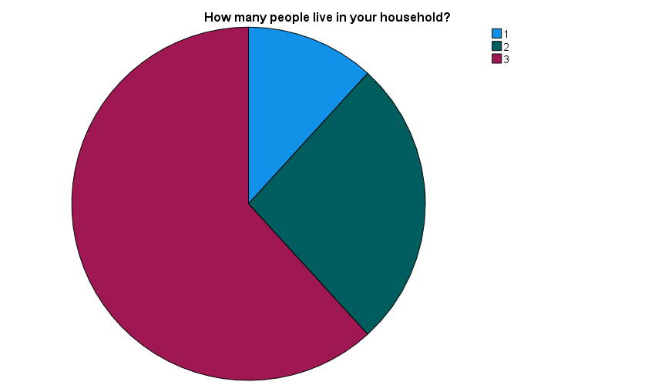
Q4. How many people live in your household?

The chart above identifies that just over half of households have 3 or more people living in their home, which would make it beneficial to grow their own food.

Q5. Roughly how much money do you spend a week on fruit and vegetables?
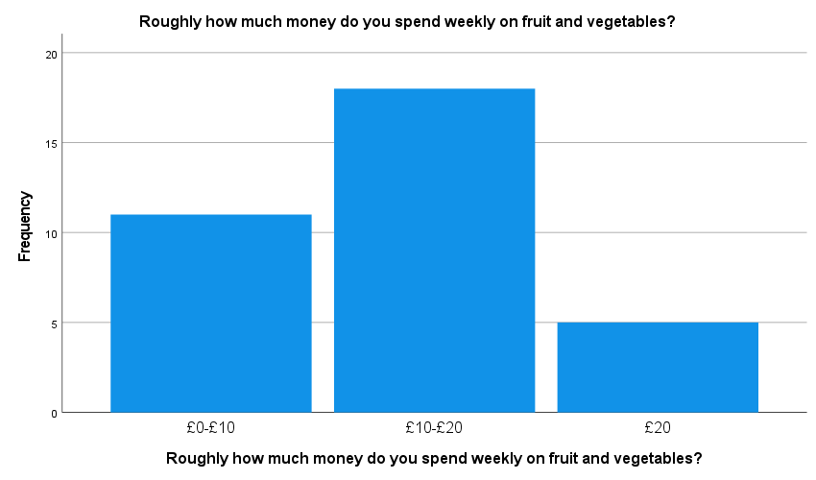

The graph above shows that the average amount of participants who had taken place in the survey spent £10- £20 a week on Fruit and Vegetables.

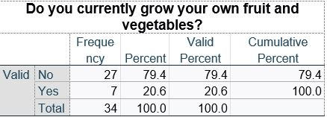
Q6.

The data shows that only 7 people out of 34 grow their own produce, with the majority (79.4%) that don't.

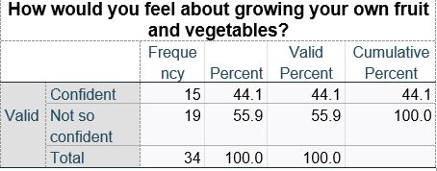
Q7.

The data shows that 55.9% of participants would not be confident in growing their own produce.
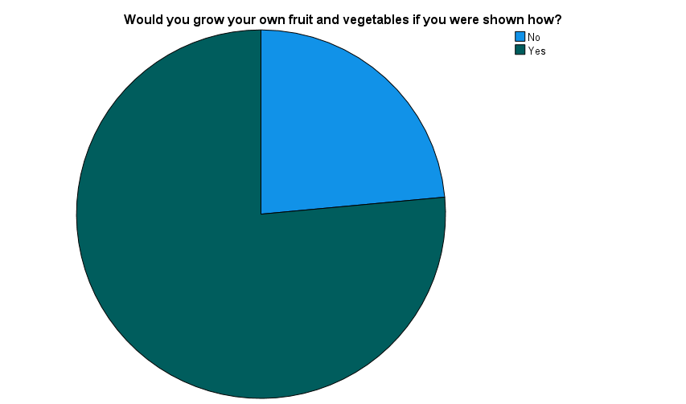
Q8. Would you grow your own fruit and vegetables if you were shown how?

The pie chart shows from the question that just over 75% of participants would grow their own produce if they were shown how.

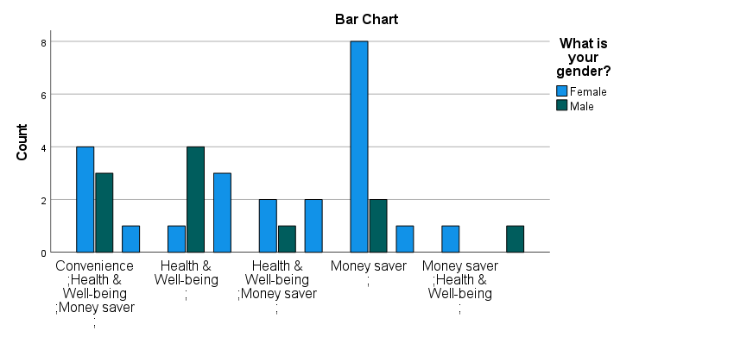
Q9. What benefits do you feel you would gain from growing your own fruit and vegetables?
This bar chart data shows the participants said the potential money savings was the most significant benefit. Most of these respondents were female.

Q10.
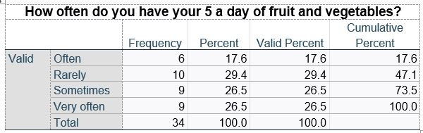

The data shows above that only 26.5% eat they’re five a day very often, whereas 29.4% rarely do.

14. Cross Tabulation of Results

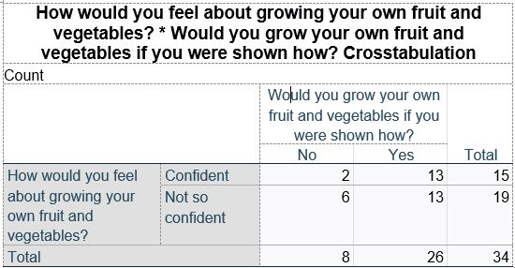
The table above shows that 19 people are not confident in growing their own fruit and veg; however, 26 participants out of 34 would develop their own fruit and vegetables if they were shown how to.

Chi Square test

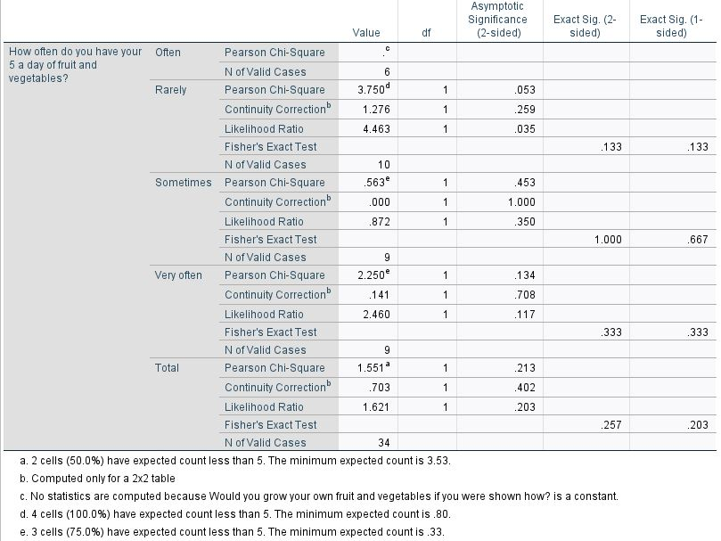

Chi-Square tests are a way to show if there are any relationships between two categorised variables. There are two types of variables, numerical (countable) and non-numerical (categorical). The test shows a single number which tells how much difference there is between the observed counts and counts you would expect if there was no relationship. (Glen, S).
The p-value refers to something that is to have happened at random. If the p-value is below 0.05, the null hypothesis is rejected as there's no difference (no relationship) between the means. The smaller the p-value, the more substantial the null hypothesis's evidence is of becoming rejected. (Mcloed, S. 2019).

15. Limitations of Data
I found the limitations of the data were the limited outcomes from structured closed questions, which limited the response options. I feel gathering quantitative data is time-consuming and more complex for social science and psychology. (Chetty, P. 2016).
Future research would require a larger scale of varied age ranges to get a more precise representation of the opinions of how people feel about growing their own food. A random probability sampling technique would give a more varied set of responses. It would be interesting to research how young adults feel about this new way of living and if a trend can be established for the next generation to follow.

16. Conclusion
To conclude, I feel the data gathered shows a small amount of the population interested and if shown how would grow their own fruit and veg. I believe that introducing this new way of living can benefit many people's lives and benefit the planet. I think there is a business in this area, although further research studies should be carried out for a broader accurate response.

17. References

Aprameya, A. (Jan, 2016). Humans of Data. Cross Tabulation: How It Works and Why You Should Use It. https://humansofdata.atlan.com/2016/01/cross-tabulation-how-why/
Chetty, P. (Sept, 2016). Project Guru. Limitations and weakness of quantitative research methods. https://www.projectguru.in/limitations-quantitative-research/.
Duncan, G. (March, (2022). The Grocer. Spanish strikes cause fruit and veg shortages in UK supermarkets. https://www.thegrocer.co.uk/fruit-and-veg/spanish-strikes-cause-fruit-and-veg-shortages-in-uk-supermarkets/666130.article.
Gibbons, B. (April, (2022). Wales Online. Millions get planting to grow their own fruit and veg during lockdown. https://www.walesonline.co.uk/whats-on/food-drink-news/millions-planting-grow-fruit-veg-20488817.
Glen, S. Statistics How to. Chi Square Statistic: How to calculate it / Distribution. https://www.statisticshowto.com/how-to-find-a-critical-chi-square-value/.
Mills, G, J.(Sept, 2021). Supersurvey. Quantitative Data. https://www.supersurvey.com/Data#What.
Mcloed, S. Simply Psychology. (2019). What a p-value tells you about statistical significance. https://www.simplypsychology.org/p-value.html
OECD. Glossary of Statistical Terms. Quantitative Data. https://stats.oecd.org/glossary/detail.asp?ID=2219
Question Pro. Quantitative Research: Definition, Methods, Types and Examples. https://www.questionpro.com/blog/quantitative-research/.
Simkus, J. (Dec, 2021). Simply Psychology. How Does the Cross-Sectional Research Method Work? https://www.simplypsychology.org/what-is-a-cross-sectional-study.html
Stevens, E. (Sept, 2021). Career Foundry. What is Quantitative data? https://careerfoundry.com/en/blog/data-analytics/what-is-quantitative-data/.
Thompson, K. (May, 2015). Revise Sociology. Positivism and Interpretivism in Social Research. https://revisesociology.com/2015/05/18/positivism-interpretivism-sociology/.

