Programme: Master of Business Administration
Module: Marketing Management
Module code: LCMB7024
Assignment Title: Marketing Environment Analysis
Lecturer: Laila Maazouz Taonga Kaonga Sobere Snithers
Student Name: Vahora Saniyaben Sirajbhai
Student ID: 2541192
Word Count: 2676
Submission Date: 24 July, 2026

Table of Contents
Task 1: Marketing Environment Analysis 5
1.1 Overview of BHP: Scale, Carbon Footprint, and Net-Zero Commitment 5
1.2 The Natural Environment as a Core Marketing Environment Actor 6
1.2.1 Climate Change and Physical Risks 6
1.2.2 Resource Depletion and Responsible Mining 6
1.2.3 Decarbonisation and Greenhouse Gas Reduction 7
1.2.4 Circular Economy and Critical Minerals Demand 8
1.2.5 Critical Evaluation of the Natural Environment 9
1.3 Regulators and Government Publics as External Marketing Environment Actors 10
1.3.1 Australian Safeguard Mechanism 10
An additional key regulatory guidance with regard to BHP's decarbonisation journey is the Australian Safeguard Mechanism (ASM) which requires a staged emission reduction from large industrial plants (Leandro, 2024). A key regulatory policy that impacts BHP's decarbonisation strategy is the Australian Safeguard Mechanism, which applies to large industrial facilities that release over 100,000 tonnes of CO₂-e per year, and requires them to remain within declining baselines (DCCEEW, 2026). The facility baselines remain flat at standard levels from 2026–27 (4.9% annual reduction), spurring the adoption of technologies and investments in renewable energy and operational efficiencies. 10
1.3.2 Science-Based Targets Initiative (SBTi) and Net-Zero Standards 10
1.3.3 Australian Government Future Made in Australia Policy 10
1.3.4 International Sustainability Regulations 11
1.3.5 Critical Evaluation of Regulatory Pressures 11
Task 2: Strategic Growth and Competitive Positioning 12
2.1 Application of the Ansoff Matrix 12
2.2 Competitive Advantage through Low-Carbon Mining: 14
2.3 Critical Recommendation 15
Task 3: Critical Reflection on AI Usage 17
3.1 Tool Disclosure 17
3.2 Critical Evaluation of AI Output 17
AI was only used for proofreading and to correct the grammar using Grammarly to make this report easier to read. Grammarly was used to spot grammatical mistakes and make suggestions on sentence structure and word usage. Each of the suggestions I have considered, as best I might. Some suggestions were made as they clarified but did not alter the meaning. However, I turned down some of the proposals that changed the significance or diluted the academic strength of the original text. No evidence of plagiarism will be found anywhere in the report, which I undertook to analyse, interpret and apply marketing framework(s) and recommendations in a manner that is my own work. 17
3.3 Contribution Analysis 17
3.3.1 AI Contribution 17
3.3.2 Original Contribution 18
3.4 Ethical and Professional Reflection 18
References 19

Task 1: Marketing Environment Analysis

1.1 Overview of BHP: Scale, Carbon Footprint, and Net-Zero Commitment
BHP Group Limited is a leading global diversified mining company operating in Australia, Chile, Canada, and other global locations with a leadership position in iron ore, copper, nickel and potash. BHP has reached its peak production with 291.2 million tonnes of iron ore mined from its WA operations, strengthening its market position globally for iron ore (Reuters 2026). The company has a net zero commitment for operational (Scope 1 + Scope 2) emissions by 2030, and aims to work with customers and suppliers to lower Scope 3 (BHP, 2026a). The marketing strategy is based on sustainability, which reinforces the trust of stakeholders, promotes responsible mineral production and increases competitiveness in the low-carbon economy.
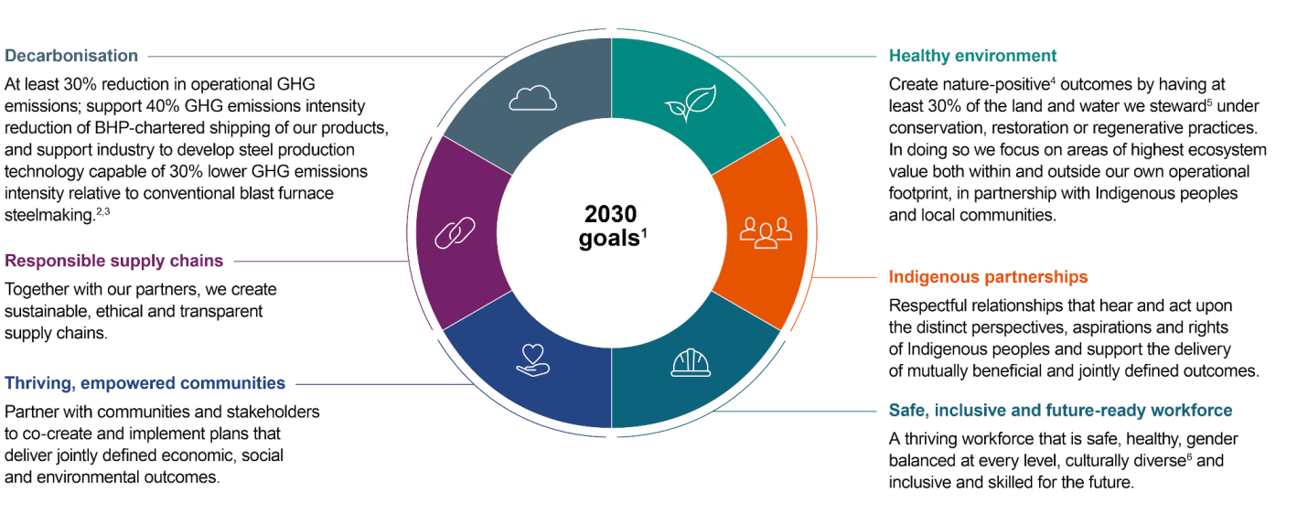
Figure 1: BHP 2030 Goals’
(Source: BHP, 2026)

1.2 The Natural Environment as a Core Marketing Environment Actor

1.2.1 Climate Change and Physical Risks
Climate change stresses BHP’s mining operations, putting infrastructure under threat, adding to safety risks, and causing disruption caused by heatwaves, floods, water shortages, and tropical cyclones. In its actions to adapt and mitigate risks, BHP's climate hazard information has expanded to cover over 20 climate-related hazards for the operated asset base and key locations in its value chains, to enhance resilience (BHP, 2026b). Such actions help ensure continuity of production, alongside strengthening BHP's sustainable and responsible market position in the global mining sector.
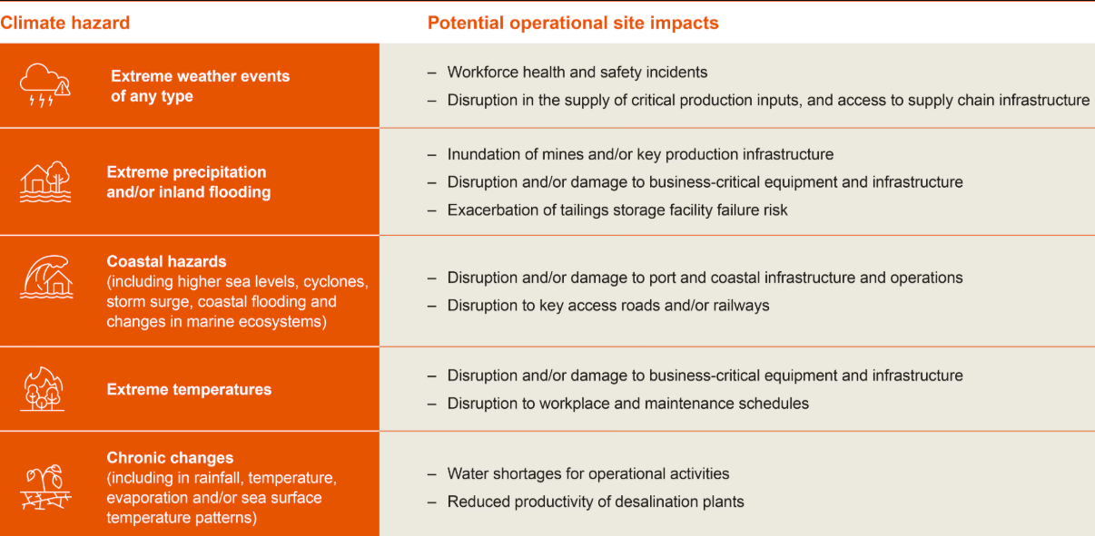
Figure 2: Potential physical climate-related risks at BHP-operated assets and in their value chains
(Source: BHP, 2026b)

1.2.2 Resource Depletion and Responsible Mining
In an age where mineral resources are finite, it is important for BHP to ensure it can sustain extraction operations, which also helps to conserve biodiversity and manage water use efficiently. Conservation, restoration and regenerative approaches will increase on the land and in water whose care BHP takes, with a commitment towards at least 30% to achieve nature-positive outcomes by 2030, whilst continuing to operate responsibly as a miner (BHP, 2026c). This commitment improves the security of long-term resources and BHP's environmental standards and market profile as a sustainable business.

1.2.3 Decarbonisation and Greenhouse Gas Reduction
BHP is fast-tracking decarbonisation by decarbonising Scope 1, 2 and 3 emissions and using renewable electricity, electrifying mines and low-carbon technologies. The company will continue to work towards net zero operational (Scope 1 and 2) greenhouse gas (GHG) emissions, which are projected to be cut by at least 30% from FY2020 by FY2030, and promote renewable power purchase agreements and battery-electric mining equipment (BHP, 2025). These efforts give BHP its competitive long-term future and fortify BHP's low-carbon operations.
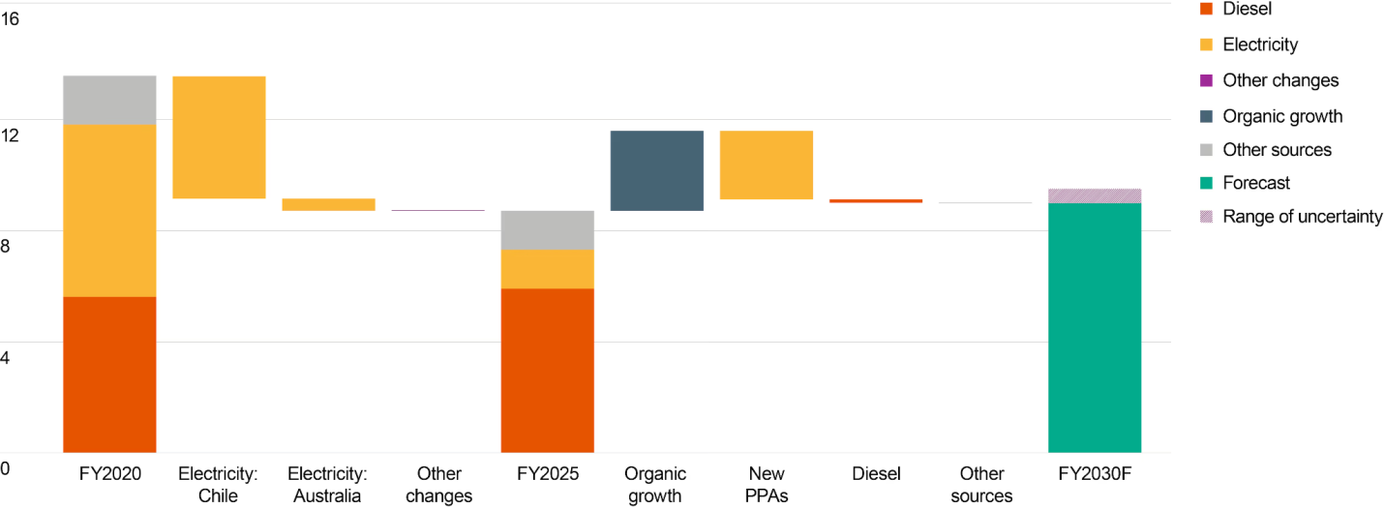
Figure 3: Operational GHG emissions
(Source: BHP, 2025)
Global money invested in clean energy grew more than 200% in 2025 to $2.155 trillion (Stille, 2026). Thus, implying that mining companies have to trade off the growth in production and environmental protection.
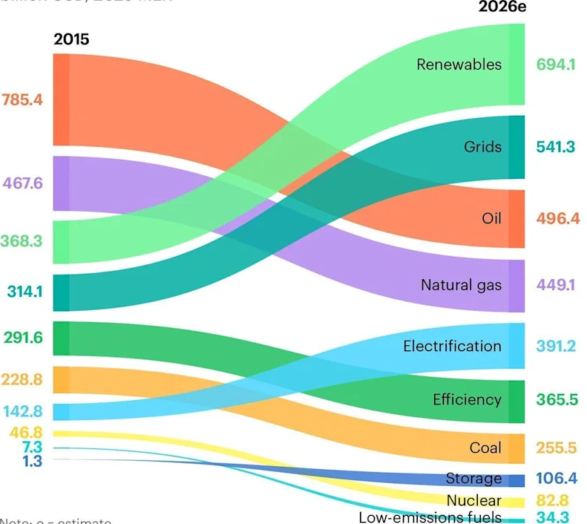
Figure 2: Global energy investment
(Source: Stille, 2026)

1.2.4 Circular Economy and Critical Minerals Demand
An increase in demand for BHP's critical minerals, such as copper for renewable energy, nickel for electric vehicle batteries and potash for sustainable agriculture through their transition to the circular economy, is escalating. The IEA (2026) forecasts that global copper demand in clean energy technologies will grow by approximately 50% by 2040 in the framework of the announced policies. The move bolsters the strategy of BHP delivering responsibly sourced minerals to support the global transition to energy.
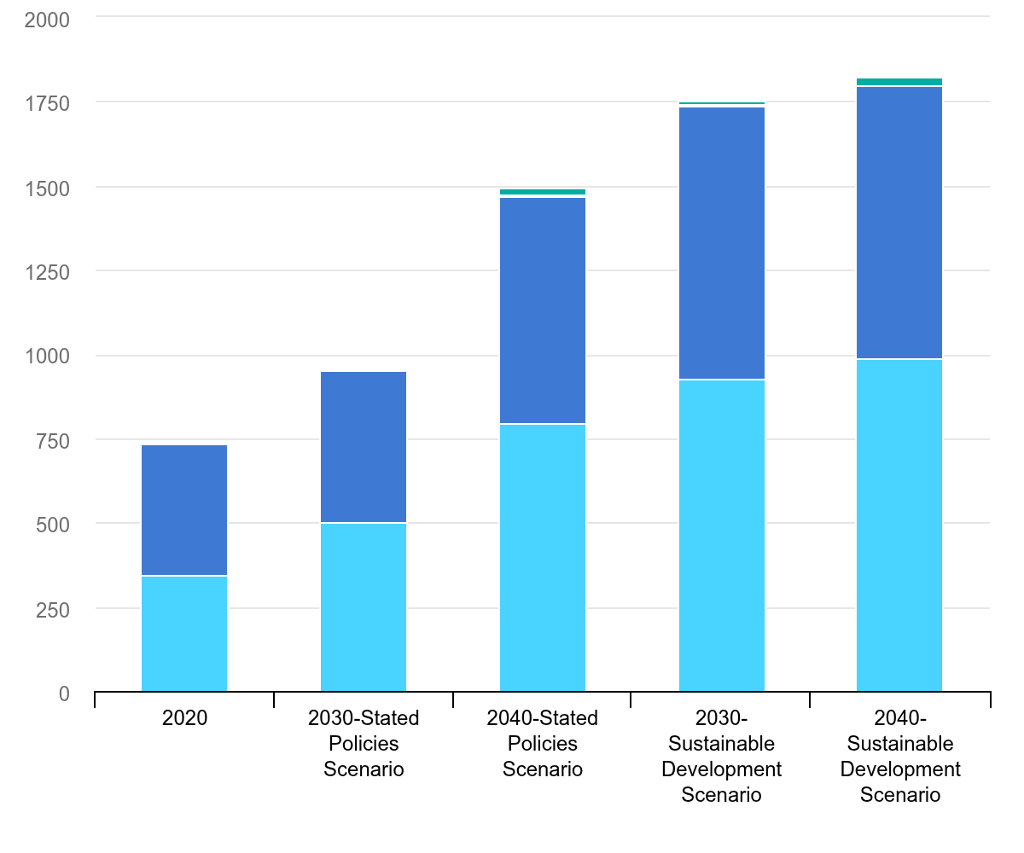
Figure 4: Mineral demand from solar PV by scenario, 2020-2040
(Source: IEA, 2026)

1.2.5 Critical Evaluation of the Natural Environment
BHP has an opportunity and a risk in the natural environment. Low-carbon minerals are in growing demand, which improves market opportunities, while climate change, resource scarcity, and rising environmental demands put climate actions at risk and hence drive up compliance costs. In a marketing aspect, good sustainability results boost the reputation of companies, confidence from investors and trust from customers (Yan et al., 2022). As such, incorporating the company's environmental responsibility into its business strategy further enhances BHP's competitiveness and capability to differentiate in the global mining industry.

1.3 Regulators and Government Publics as External Marketing Environment Actors

1.3.1 Australian Safeguard Mechanism

An additional key regulatory guidance with regard to BHP's decarbonisation journey is the Australian Safeguard Mechanism (ASM) which requires a staged emission reduction from large industrial plants (Leandro, 2024). A key regulatory policy that impacts BHP's decarbonisation strategy is the Australian Safeguard Mechanism, which applies to large industrial facilities that release over 100,000 tonnes of CO₂-e per year, and requires them to remain within declining baselines (DCCEEW, 2026). The facility baselines remain flat at standard levels from 2026–27 (4.9% annual reduction), spurring the adoption of technologies and investments in renewable energy and operational efficiencies.

1.3.2 Science-Based Targets Initiative (SBTi) and Net-Zero Standards
For the Science Based Targets initiative (SBTi), a European initiative provides standards that support companies like BHP to set targets to reduce greenhouse gases in line with climate science and the Paris climate agreement (Bjørn et al., 2022). Science Based Targets initiative (SBTi) alignment boosts transparency, accountability and stakeholder confidence. The SBTi Corporate Net-Zero Standard Version 2.0 was published in 2026, which is an updated global science based target setting framework (SBTi, 2026). BHP believes alignment is a key contributor to improved ESG performance, investor confidence and sustainable market competitiveness.

1.3.3 Australian Government Future Made in Australia Policy
The Future Made in Australia policy in Australia helps BHP grow through clean energy investment, critical mineral investment, and low-carbon manufacturing (Clarke et al., 2022). The Future Made in Australia policy bolsters resilient supply chains, domestic value and the clean envelope industry. The Australian Government 2026–27 Australian Budget proposes a funding cap of $1 billion for the project to promote 'facilitate lower emissions metals production through investment in sustainable mining and critical minerals' (Australian Government, 2026). This will see BHP gain opportunities to grow responsibly sourced mineral output and further boost competitiveness.

1.3.4 International Sustainability Regulations
BHP is under pressure to do more to foster transparency around climate and environmental performance with the introduction of international sustainability regulations. The EU Carbon Border Adjustment Mechanism (CBAM) becomes transitional and includes financial obligations on companies importing emission-intensive goods from 1 January 2026 (ALS Customs Services, 2026). The regulations promote BHP to report and reduce emissions, improve sustainability performance and access to international markets, alongside the ISSB climate disclosure standards and global ESG reporting requirements.

1.3.5 Critical Evaluation of Regulatory Pressures
BHP is facing the added stresses of regulatory pressures, which offer challenges as well as opportunities. EDTs and costs of complying to climate and ESG regulations. Transparent sustainability practices help build investor confidence, robustify brand value and help unlock access to global markets where customers and governments are increasingly prioritising minerals with low carbon footprints and responsibly sourced (Deshmukh and Tare, 2023). Thus, a proactive approach to regulatory compliance helps to ease BHP out of the business of long-term sustainability and competitive advantage.

Task 2: Strategic Growth and Competitive Positioning

2.1 Application of the Ansoff Matrix
Market Penetration
BHP can further enhance its market presence as a result of greater sales volumes of its current iron ore and copper products, while applying sustainable mining methods and developing improved customer relationships. Total copper production was of 1.953 million tonnes, as per BHP's FY2026 Operational Review (LME Insight 2026). Production reliability ensures long-term contracts and customer confidence and strengthens BHP's competitive position in mineral markets.
Market Development
BHP has a chance to grow its low-carbon mineral supply in Europe, India and Southeast Asia, regions with growing demand for sustainable resources. BHP Chemicals also conducted a reassessment on Jansen Stage 2 in June 2026, which has resulted in a significant uplift in the size of the project, from a former estimate of US$4.9 billion to US$6.9 billion, furthering future global market expansion and long-term growth prospects (BHP, 2026d).
Product Development (Recommended Strategy)
BHP should aim at product development by introducing and developing low-carbon products like green iron feedstocks, low-carbon copper, sustainable nickel, potash for sustainable agriculture and digital carbon-transparency services (Adey et al., 2022). The company BHP has announced that its operational GHG emissions are down 36% since FY2020 (Knaus and Morton, 2026). These innovations meet the increasing demand by customers for responsibly sourced minerals, improve sustainability leadership, produce higher value minerals and boost BHP's competitiveness in the global energy-transition market.
Diversification
BHP can diversify through an increased investment in future-focused critical minerals and increasing investments in renewable energy partnerships to shift the world to a zero-carbon energy future. In July 2026, BHP announced approval for its South Australian Oak Dam copper project, which enhanced its future copper portfolio and paved the way for long-term growth opportunities in clean energy and electrification markets (Department for Energy and Mining, 2026).

Justification
Product development fits best as an effective tool for BHP to develop new innovative products that would meet the increase demand from customers for low-carbon minerals (Sharma et al., 2024). Green iron feed stocks, low-carbon copper and sustainable nickel serve to reinforce competitiveness, improve ESG performance, strengthen a premium market positioning and long-term growth of the global energy transition economy.

2.2 Competitive Advantage through Low-Carbon Mining:
Porter's Generic Strategies Perspective
Apply Differentiation Strategy
BHP's sustainable competitive advantage strategy can be attained by a differentiation strategy by providing quality low-carbon minerals in which sustainability is incorporated throughout the value chain. BHP is not primarily competing on cost it is competing to provide responsibly sourced iron ore, copper, nickel and potash that is supporting the global energy transition. This helps the business achieve the best value possible for customers looking for more responsible raw materials for sustainable steel, EVs and renewable energy infrastructure.
Being a leader for sustainability has become stronger for BHP with investments in renewable-powered mining, operational decarbonisation and digital innovation. Digital technologies like real-time emission monitoring or carbon transparency help to make supply chains more transparent and allow customers to quantify the environmental footprint of the minerals they buy, thereby strengthening trust and long-term relationships (Ameh, 2024). Also, the strong ESG performance can draw in investors, build stakeholder trust and help adherence to a set of sustainability standards that are in constant evolution globally.
During FY2026, BHP's Western Australia Iron Ore (WAIO) operations reached a record-high production of 291.2 million tonnes, while continuing its dedication to sustainability and operations (Gate.com, 2026). What is more, Escondido in Chile produced a record 1.261 million tonnes of copper in FY2026, whilst the global demand for copper for renewable energy applications and electric vehicles (EVs) keeps growing (LME Insight, 2026). Such accomplishments underscore BHP's capacity to supply dependable minerals which are responsibly produced, while also setting itself apart from rivals. Therefore, through Porter's different approach of differentiation strategy, BHP can be able to build a value and thus a reputation of its brand name, achieve a premium market position and thus long run competitive advantage while competing in the world of the global mining industry.
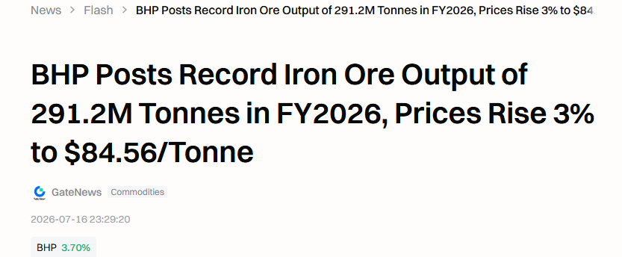
Figure 5: BHP's production report
(Source: Gate.com, 2026)

2.3 Critical Recommendation
BHP needs to step up its efforts on low-carbon minerals and consolidate its leadership position in the energy transition. The growth in production of low-carbon copper, nickel and potash will allow the company to satisfy the growing needs of the renewable energy, electric vehicle and sustainable agriculture industries, and also bring new value for customers. Financial support should be channelled in renewable energy-driven mining operations such as solar energy, wind and battery storage to minimise emissions during the mining operations and enhance cost efficiency in the long run (Dikgwatlhe et al., 2026).
Further, BHP should increase strategic collaboration with green steel manufacturers and technology providers with an aim to help in the commercialisation of green steel. Innovation and business relations along the value chain will benefit from working with customers (Fianko et al., 2023). The company should also enhance ESG reporting and carbon transparency by leveraging cutting-edge digital solutions for reliable emissions data and transparent supply chain tracking, driving greater trust and compliance. Additionally, companies need to continue to invest in strategic minerals, key for the global energy transition, such as those in BHP's case. Nickel supply is anticipated to stay steady throughout the forecast period, simply as the nickel spot price fell to USD 17,224 per tonne as of March 31, 2026, indicating cooling market sentiment amid ongoing demand (Seeking Alpha, 2026).
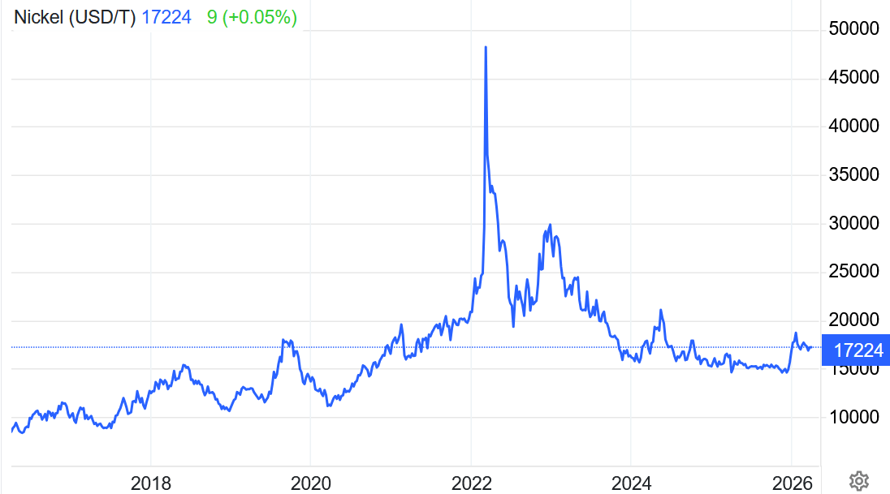
Figure 6: Nickel spot price 10-year chart—current price = USD 17,224/t
(Source: Seeking Alpha, 2026)
Further, South Flank has also been bolstering BHP's iron ore production capacity and showcased robust operational capabilities, underscoring BHP's commitment to sustainable growth (Tan et al., 2024). The strategic investments will strengthen BHP's competitive position and bolster the Company's leadership in sustainability and long-term profitability in the rapidly changing minerals industry.

Task 3: Critical Reflection on AI Usage

3.1 Tool Disclosure
The author has used Artificial Intelligence (AI) tools to get help in proofreading, grammar corrections, sentence refinements and style improvements for academic writing in this report. The report text was not generated by AI, and nor it was used to research, analyse or develop critical arguments or recommendations. A literature review, an analysis of BHP's marketing environment, the application of the Ansoff Matrix and Porter's Generic Strategies, critical analysis and conclusions were each compiled individually, drawing on credible publications from academic institutions, industry reports and BHP official publications, in line with the institution's Academic Integrity policy.

3.2 Critical Evaluation of AI Output

AI was only used for proofreading and to correct the grammar using Grammarly to make this report easier to read. Grammarly was used to spot grammatical mistakes and make suggestions on sentence structure and word usage. Each of the suggestions I have considered, as best I might. Some suggestions were made as they clarified but did not alter the meaning. However, I turned down some of the proposals that changed the significance or diluted the academic strength of the original text. No evidence of plagiarism will be found anywhere in the report, which I undertook to analyse, interpret and apply marketing framework(s) and recommendations in a manner that is my own work.

3.3 Contribution Analysis

3.3.1 AI Contribution
The AI has only been used for proofreading, grammatical corrections, and enhancing academic writing clarity as mentioned earlier. The research, literature selection, data collection, statistical interpretation, critical analysis, application of marketing frameworks, as well as the findings and recommendations, were done independently by the author. AI was not used to generate ideas, analyse evidence or develop arguments. The final report is an original piece and has been collated with original understanding and assessment, with employability of academic integrity and full compliance with the assessment requirements of the institution.

3.3.2 Original Contribution
This report is the original work to be presented to the academic world and the independent understanding of concepts in marketing theories and analysis. I chose the company, collected information from relevant and trusted academic, industry and official sources, analysed the information collected and drew out all substantial arguments and recommendations. The use of the marketing environment analysis, Ansoff Matrix and Porter's generic strategies is the output of my own analysis and judgment and has been done as per the academic integrity requirements, which display my contribution and ethical transparency to the report.

3.4 Ethical and Professional Reflection
AI tools were used in that report to just improve the clarity, readability and professionalism of that report and not to any degree of altering the originality of the report. It Help to pinpoint language errors and to advance sentence structure to help in effective academic communication. All research, analysis and recommendations were done on its own terms, thus ensuring the ethical use of AI and preserving personal accountability for the content of the report.
The misuse of AI can result in plagiarism, misinformation and diminish critical thinking, impacting academic integrity. To mitigate these ethical issues, in this report, AI was used solely for proofreading and grammar correction. All research, analysis, interpretation and recommendations were undertaken in an original and independent way, observing the originality, transparency and abstention from violations of the institution's ethical and/or academic rules.

References
Adey, P., Pink, S., Raven, R., Hadfield, P., Badger, A., Strengers, Y., Sharp, D., Bock-Brown, O., Lyall, B., Martin, R. and Wright, S. (2022) Just transitions in Australia: moving towards low carbon lives across policy, industry and practice. Monash University. Available at: https://research.monash.edu/files/630694855/556685537.pdf
ALS Customs Services (2026) CBAM is live: what changed on 1 Januar 2026?. Available at: https://www.als-cs.com/news/detail/cbam-is-live-what-changed-on-1-january-2026/
Ameh, B. (2024) ‘Digital tools and AI: Using technology to monitor carbon emissions and waste at each stage of the supply chain, enabling real-time adjustments for sustainability improvements’, International Journal of Science and Research Archive, 13(1), pp. 2741–2754. Available at: https://www.researchgate.net/profile/Blessing-Ameh-2/publication/385382826_Digital_tools_and_AI_Using_technology_to_monitor_carbon_emissions_and_waste_at_each_stage_of_the_supply_chain_enabling_real-time_adjustments_for_sustainability_improvements/links/6750c7ae359dcb4d9d51f28b/Digital-tools-and-AI-Using-technology-to-monitor-carbon-emissions-and-waste-at-each-stage-of-the-supply-chain-enabling-real-time-adjustments-for-sustainability-improvements.pdf
Australian Government (2026) Security and investment: Budget 2026–27. Available at: https://budget.gov.au/content/06-security-and-investment.htm
BHP (2025) Operational GHG emissions. Available at: https://www.bhp.com/sustainability/climate-change/operational-ghg-emissions
BHP (2026a) Sustainability. Available at: https://www.bhp.com/sustainability
BHP (2026b) Physical climate-related risk and adaptation. Available at: https://www.bhp.com/sustainability/climate-change/physical-climate-related-risk-and-adaptation
BHP (2026c) Environment. Available at: https://www.bhp.com/sustainability/environment
BHP (2026d) Update - Jansen Stage 2 Potash Project. Available at: https://www.bhp.com/news/media-centre/releases/2026/06/update---jansen-stage-2-potash-project
Bjørn, A., Tilsted, J.P., Addas, A. and Lloyd, S.M. (2022) ‘Can science-based targets make the private sector Paris-aligned? A review of the emerging evidence’, Current Climate Change Reports, 8(2), pp. 53–69. Available at: https://link.springer.com/article/10.1007/s40641-022-00182-w
Clarke, D., Baldwin, K., Baum, F., Richardson, S., Godfrey, B., Robin, L. and Vivoda, V. (2022) Australian energy transition research plan: transition dynamics. ACOLA Research Briefing Paper, Australian Council of Learned Academies. Available at: https://www.researchgate.net/profile/Vlado-Vivoda/publication/362709069_Australian_Energy_Transition_Research_Plan_Transition_Dynamics_ACOLA_Research_Briefing_Paper_Australian_Council_of_Learned_Academies/links/62fb2edeeb7b135a0e3ba256/Australian-Energy-Transition-Research-Plan-Transition-Dynamics-ACOLA-Research-Briefing-Paper-Australian-Council-of-Learned-Academies.pdf
Department for Energy and Mining (2026) Oak Dam. Government of South Australia. Available at: https://energymining.sa.gov.au/industry/minerals-and-mining/mining/major-projects-and-mining-activities/developing-projects/oak-dam
Department of Climate Change, Energy, the Environment and Water (DCCEEW) (2026) Safeguard mechanism. Available at: https://www.dcceew.gov.au/climate-change/emissions-reporting/national-greenhouse-energy-reporting-scheme/safeguard-mechanism
Deshmukh, P. and Tare, H. (2023) ‘Green marketing and corporate social responsibility: A review of business practices’, Multidisciplinary Reviews, 7(3), pp. 1–9. Available at: https://pdfs.semanticscholar.org/9378/a207efa8e3122792b9364f0ba31c9d80cd76.pdf
Dikgwatlhe, I., Mushwana, T., Chiloane, N.M., Mndawe, N. and Chimwani, N. (2026) ‘A Review of the Integration of Clean Energy Technology in the Mining Industry: Challenges and Opportunities’, International Journal of Energy Research, 2026(1), p. 9939005. Available at: https://onlinelibrary.wiley.com/doi/abs/10.1155/er/9939005
Fianko, A.O., Essuman, D., Boso, N. and Muntaka, A.S. (2023) ‘Customer integration and customer value: contingency roles of innovation capabilities and supply chain network complexity’, Supply Chain Management: An International Journal, 28(2), pp. 385–404. Available at: https://www.emerald.com/scm/article/28/2/385/342119
Gate.com (2026) BHP posts record iron ore output of 291.2M tonnes in FY2026, prices rise 3%. Available at: https://www.gate.com/news/detail/bhp-posts-record-iron-ore-output-of-2912m-tonnes-in-fy2026-prices-rise-3-to-22645432
International Energy Agency (IEA) (2026) The role of critical minerals in clean energy transitions. Available at: https://www.iea.org/reports/the-role-of-critical-minerals-in-clean-energy-transitions/mineral-requirements-for-clean-energy-transitions
Knaus, C. and Morton, A. (2026). Revealed: The internal BHP memo that slammed the brakes on world’s biggest miner’s climate push. [online] The Guardian. Available at: https://www.theguardian.com/world/ng-interactive/2026/may/25/bhp-files-internal-memo-revealed
Leandro, A. (2024) Achieving the transition to net zero in Australia. OECD Economics Department Working Papers. Available at: https://search.proquest.com/openview/e5af1dc714611e81243d34dd65cc93dc/1?pq-origsite=gscholar&cbl=54478
LME Insight (2026) BHP flags deeper copper decline as Escondida grades slide even as iron ore hits record. Available at: https://www.lmeinsight.com/bhp-flags-deeper-copper-decline-as-escondida-grades-slide-even-as-iron-ore-hits-record/
Reuters (2026) BHP misses quarterly copper output estimates, flags lower Chilean production, 15 July. Available at: https://www.reuters.com/business/energy/bhp-misses-quarterly-copper-output-estimates-flags-lower-chilean-production-2026-07-15/
Science Based Targets initiative (SBTi) (2026) The Corporate Net-Zero Standard V2.0 is here: what comes next. Available at: https://sciencebasedtargets.org/blog/the-corporate-net-zero-standard-v2-0-is-here-what-comes-next
Seeking Alpha (2026) Nickel Miners News For The Month Of March 2026. Available at: https://seekingalpha.com/article/4887810-nickel-miners-news-month-of-march-2026
Sharma, S., Singh, R.K., Mishra, R. and Subramanian, N. (2024) ‘Developing climate neutrality among supply chain members in metal and mining industry: natural resource-based view perspective’, The International Journal of Logistics Management, 35(3), pp. 804–832. Available at: https://www.emerald.com/ijlm/article/35/3/804/1227181
Stille, L. (2026). The World’s Biggest Energy Bet Is No Longer on Fossil Fuels. [online] Yahoo Finance. Available at: https://finance.yahoo.com/energy/articles/worlds-biggest-energy-bet-no-210000953.html
Tan, J., Melkoumian, N., Harvey, D. and Akmeliawati, R. (2024) ‘Evaluating Swarm Robotics for Mining Environments: Insights into Model Performance and Application’, Applied Sciences, 14(19), p. 8876. Available at: https://www.mdpi.com/2076-3417/14/19/8876
Yan, X., Espinosa-Cristia, J.F., Kumari, K. and Cioca, L.I. (2022) ‘Relationship between corporate social responsibility, organizational trust, and corporate reputation for sustainable performance’, Sustainability, 14(14), p. 8737. Available at: https://www.mdpi.com/2071-1050/14/14/8737

