

MODULE CODE: Digital Skills for Personal Development and Business Growth BMSW4008

ASSESSMENT COMPONENT: PORTFOLIO

STUDENT NAME: ALEXANDRA-MARINA MANDOIU

STUDENT NUMBER:2524588

LECTURER: PHILIPPA FITZGERALD

DEADLINE DATE:16th of MARCH 2026

Contents

Assessment of Digital Skills 2
REFERENCES………………………………………3
Task 2 4
LinkedIn Learning Certificates for Office365 4
TASK 3……………………………………………….6
Essay on Relevance of Excel in professional and personal life. 6
Task 4 9
7 Minute Reflective Presentation
References

I acknowledge the use of Canva on 10 March 2026 to use the template provided from it using the prompt:
‘’ generate a template that contains the keyword Digital skills’’
I acknowledge the use of Copilot for proofreading and grammar checking.

Assessment of Digital Skills

Alexandra Marina Mandoiu (2524588)
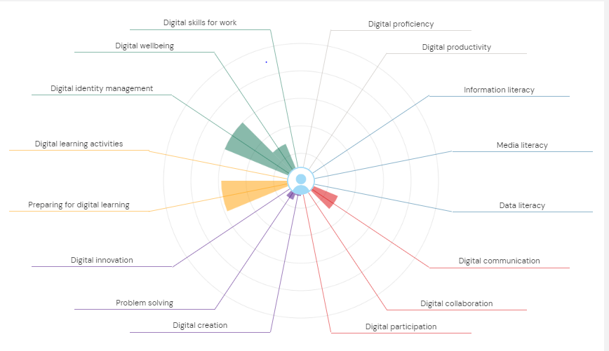

Task 1
Assessment of Digital Skills
The Jisc digital capability results give a useful overview of current strengths and areas that still need improvement. In higher education, digital skills are important because students are expected to find information online, use virtual learning environments, complete coursework electronically and communicate in appropriate ways through digital tools. Jisc’s framework is helpful because it divides digital capability into clear areas, including information and media literacies, digital learning, digital creation, and communication (Jisc, 2022). This makes it easier to understand which skills are already developed and which need more attention. Based on these results, two strengths are finding information and resources and managing digital learning. Two weaker areas are digital creativity and problem solving and digital communication and collaboration.
The first strength is finding information and resources. This is important because university students need to search for books, journal articles and reliable websites when completing assignments. If a student can search effectively and select appropriate sources, the quality of their academic work is likely to improve. Selwyn (2022) explains that technology in education is not simply about access to information, but also about how learners use information in thoughtful and informed ways. In this case, a strong result in finding information suggests a good starting point for academic study because it supports research, independent learning, and better preparation for coursework.
The second strength is managing digital learning. This includes using online learning systems, opening lecture materials, checking deadlines, and submitting work through university platforms. These are now normal parts of student life and are essential for staying organised. Sweeney (2024), in a study of university students’ use of educational technology, found that students use digital tools in separate ways depending on their learning context and confidence. This suggests that being able to manage digital learning is an important strength because it helps students keep up with tasks, access support, and use digital systems more confidently as part of everyday study.
However, the results also show that digital creativity and problem solving is a weaker area. This means using technology in flexible and creative ways, such as creating presentations, trying unfamiliar tools, or choosing the best digital method for a task. A lower score in this area may show that basic digital use is secure, but there is less confidence when moving beyond routine tasks. Sharpe, Bennett, and Varga-Atkins (2022) explain that digital higher education involves more than simple technical ability, because students are also expected to engage, create and adapt within changing learning environments. Improving this area would therefore be useful for both university work and future employment.
Another weakness is digital communication and collaboration. This includes using shared documents, joining online discussions, and working with others through digital platforms. These skills matter because university study often includes group work and online interaction. The Office for Students (2022) states that students need sufficient support to develop the skills required for effective digital learning and highlights the importance of collaborative learning within blended education. A lower result in this area may mean that more practice is needed in working with others online and communicating clearly in digital spaces.
To improve these weaker areas, a SMART plan has been created. First, to improve digital creativity and problem solving, I will complete LinkedIn Learning courses in PowerPoint such as Learning PowerPoint 2021 and Excel Online tips and Tricks (Microsoft 365) by 30 April 2026. This goal is specific because it focuses on two named applications, measurable because I can record course completion, achievable because the training is already available, relevant because both programmes are widely used in education and employment, and time bound because I have set a clear deadline. Second, to improve digital communication and collaboration, I will take part in one shared digital activity each week for six weeks, such as editing a shared document, joining an online discussion, or helping with a group presentation. Bancroft, Challen and Pearce (2024) show that digital confidence is closely linked to how students experience and develop their digital abilities in higher education. This means that regular practice should help build confidence as well as skill.
Overall, the Jisc results show a balanced picture of digital capability. Finding information and managing digital learning are clear strengths and give a good foundation for university study. However, digital creativity, problem solving, communication and collaboration still need development. The SMART plan is realistic and directly linked to the weaker areas, so it should help improve confidence and digital skills over time.

References
1.Bancroft, R., Challen, R. and Pearce, R. (2024) ‘Searching for a shared understanding of digital confidence in a tertiary context: a scoping review’, Journal of Learning Development in Higher Education, 30. Available at: https://doi.org/10.47408/jldhe.vi30.1061 (Accessed 7 March 2026).
2.Jisc (2022) Individual digital capabilities. Available at: https://digitalcapability.jisc.ac.uk/what-is-digital-capability/individual-digital-capabilities/ (Accessed: 5 March 2026).
3.Office for Students (2022) Online and blended learning. Available at: https://www.officeforstudents.org.uk/for-students/teaching-and-studying/online-and-blended-learning/ (Accessed: 6 March 2026).
4.Selwyn, N. (2022) Education and Technology: Key Issues and Debates. 3rd edn. London: Bloomsbury Academic.
5.Sharpe, R., Bennett, S. and Varga-Atkins, T.(eds) (2022) Handbook of Digital Higher Education. Cheltenham: Edward Elgar Publishing
6.Sweeney, D.M. (2024) ‘Students experiences of educational technology use to facilitate university learning: factors influencing their mediation of learning’, Research in Learning Technology, 32, 3193. https://doi.org/10.25304/rlt.v32.3193 (Accessed: 9 March 2026)

Task 2

LinkedIn Learning Certificates for Office365



Task 3

Essay on Relevance of Excel in professional and personal life.
Introduction
Microsoft Excel is one of the most useful digital tools in education, work, and everyday life. It allows users to organise information, carry out calculations, present data clearly and support decision-making. In higher education, digital capability includes using productivity tools confidently and applying them to practical tasks (Jisc, 2022). Excel is relevant because it helps students and employees work with numbers in a structured and accurate way. It can be used for data analysis, budgeting, reporting, and decision-making, which makes it valuable in both personal and professional contexts.
Main body
One reason Excel is important is that it helps with data analysis. Data analysis means looking at information so that totals, differences, and patterns can be understood more easily. In Excel, numbers can be entered into rows and columns and then analysed using simple formulas. This saves time and reduces mistakes because the software performs calculations automatically. Sharpe, Bennett, and Varga-Atkins (2022) explain that digital higher education increasingly requires students to engage with data and digital tools in practical ways. Excel supports this because it helps users move from raw figures to clear information that can be interpreted.
Excel is also extremely useful for budgeting. Money Helper (2025) explains that a budget should show both income and spending so that a person can understand what is left at the end of the month. This is clearly shown in Alexandra’s household income and expenditure spreadsheet. The spreadsheet records monthly income from Wage 1 (£5,000), Wage 2 (£1,000), Universal Credit (£400), Student Finance (£1,000), and other income like Child Benefit (£311). It also records spending such as rent (£1,320), council tax (£195), electricity (£300), gas (£100), food (£1,200), fuel (£400), childcare (£600) and loans or credit cards (£1,000). Using the SUM function, the spreadsheet gives a total monthly income of £7,711 and a total monthly expenditure of £5,610. A subtraction formula can then show a monthly surplus of £2,101. This is a good example of how Excel can support financial planning in daily life.
Another reason Excel is relevant is that it improves reporting. Reporting means presenting information clearly and easy to understand. A spreadsheet can be formatted effortlessly and then turned into charts so that important patterns can be seen more quickly. In Alexandra’s spreadsheet, a column chart could compare total income and total expenditure, while a pie chart could show which spending categories take the largest share of the household budget. Hjelle, Mikalef, Altwaijry and Parida (2024) found that the format and completeness of visual information can improve decision quality. This is relevant because Excel charts turn a list of figures into a visual summary that is easier to read and explain.
Excel is also important for decision-making. Good decisions are usually based on clear information rather than guesswork. Tawil, Mohamed, Schmoor, Vlachos and Haidar (2024), in a study of 85 UK small and medium-sized enterprises, found that data-driven decision-making supports productivity, innovation and performance. Although Alexandra’s spreadsheet is a simple household example, the same principle applies. If the spreadsheet shows that rent, food, and debt repayments accept most of the budget, the household can decide whether spending needs to be reduced in other areas. In a workplace, managers can use Excel in a similar way to compare costs, monitor performance, and plan future action.
A further strength of Excel is that it supports organised working practices. Data can be labelled clearly, arranged into sections, and checked more easily when it is displayed in a structured table. The spreadsheet for this task already separates income from expenditure, which makes the information easier to follow. It can also be formatted as an Excel table to improve readability and review. The Office for Students (2022) found that students develop data skills most effectively when these skills are taught in practical and relevant contexts. Creating a household budget in Excel is therefore a useful activity because it links digital skills to a realistic task.
Excel also supports confidence and employability. Sweeney (2024) found that students use educational technology in separate ways depending on the task and their confidence. This suggests that repeated use of Excel for real tasks can improve both technical ability and confidence. Bancroft, Challen and Pearce (2024) argue that digital confidence is an important part of student development in higher education. When students learn how to use formulas, tables, and charts, they are likely to feel more capable when using other digital tools as well.
Selwyn (2022) argues that technology in education should support meaningful activity rather than simple technical use. Excel fits this idea well because it is not valuable only because it is digital. It is valuable because it helps people solve problems, organise information and communicate results clearly. For Alexandra, learning Excel is useful not only for this assignment, but also for future study and employment where spreadsheet skills are often expected.
In conclusion, Microsoft Excel is a highly relevant tool for both personal and professional life. It can be used for data analysis, budgeting, reporting, and decision-making, which makes it useful in education, workplaces, and everyday financial management. Alexandra’s spreadsheet demonstrates this clearly by showing how formulas can calculate totals, how charts can make information easier to understand and how tables can improve organisation. The spreadsheet shows a monthly income of £7,711, monthly expenditure of £5,610 and a surplus of £2,101, which gives a clear picture of the household’s financial position. Overall, Excel is important because it helps users work accurately, understand data more clearly and make better decisions.

References
1.Bancroft, R., Challen, R. and Pearce, R. (2024) ‘Searching for a shared understanding of digital confidence in a tertiary context: a scoping review’, Journal of Learning Development in Higher Education, 30. Doi: https://doi.org/10.47408/jldhe.vi30.1061 ( Accessed: 14 March 2026)
2.Hjelle, S., Mikalef, P., Altwaijry, N. and Parida, V. (2024) ‘Organizational decision making and analytics: an experimental study on dashboard visualizations’, Information and Management, 61(6), 104011. Doi: https://doi.org/10.1016/j.im.2024.104011 (Accessed:10 March 2026)
3.Jisc (2022) Building digital capability. Available at: https://www.jisc.ac.uk/building-digital-capability (Accessed: 12 March 2026).
4.Money Helper (2025) Budget planner. Available at: https://www.moneyhelper.org.uk/en/everyday-money/budgeting/budget-planner (Accessed: 12 March 2026).
5.Office for Students (2022) Evaluation of National Data Skills pilots: final report. Available at: https://www.officeforstudents.org.uk/publications/evaluation-of-national-data-skills-pilots-final-report/ (Accessed: 12 March 2026).
6.Selwyn, N. (2022) Education and Technology: Key Issues and Debates. 3rd edn. London: Bloomsbury Academic.
7.Sharpe, R., Bennett, S. and Varga-Atkins, T. (eds) (2022) Handbook of Digital Higher Education. Cheltenham: Edward Elgar Publishing.
8.Sweeney, D.M. (2024) ‘Students’ experiences of educational technology use to facilitate university learning: factors influencing their mediation of learning’, Research in Learning Technology, 32. Doi: http://dx.doi.org/10.25304/rlt.v32.3193
9.Tawil, A.-R.H., Mohamed, M., Schmoor, X., Vlachos, K. and Haidar, D. (2024) ‘Trends and challenges towards effective data-driven decision making in UK small and medium-sized enterprises: case studies and lessons learnt from the analysis of 85 small and medium-sized enterprises’, Big Data and Cognitive Computing, 8(7), 79. Doi: https://doi.org/10.3390/bdcc8070079

Excell embedded in following link:https://tinyurl.com/37dczfx9

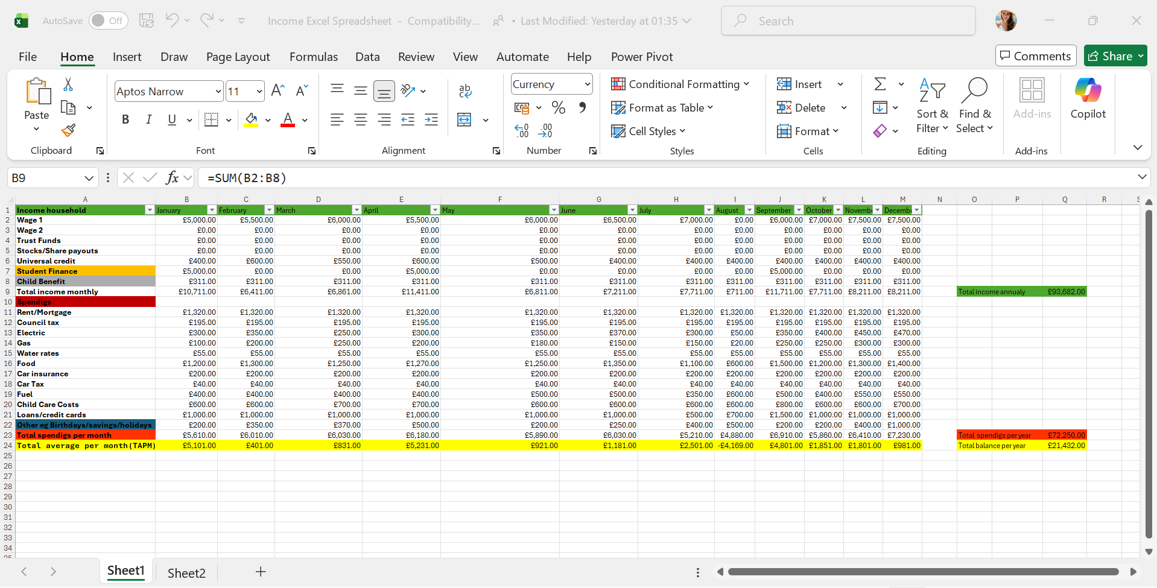
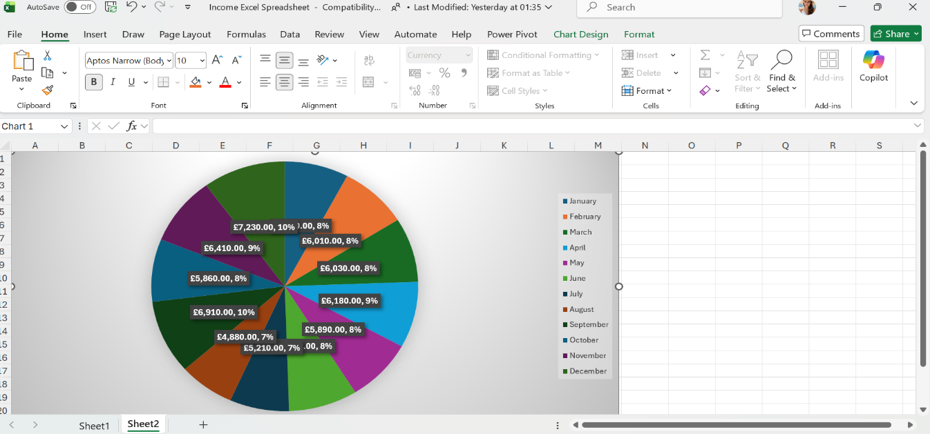

Task 4

References
1.Bancroft, R., Challen, R. and Pearce, R. (2024) “Searching for a shared understanding of digital confidence in a tertiary context: a scoping review”, Journal of Learning Development in Higher Education, 30.
2.Jisc (2022) Individual digital capabilities. Available at: digitalcapability.jisc.ac.uk.
3.Office for Students (2022) Online and blended learning. Available at: officeforstudents.org.uk.
4.Selwyn, N. (2022) Education and Technology: Key Issues and Debates. 3rd edn. London: Bloomsbury Academic.
5.Sharpe, R., Bennett, S. and Varga-Atkins, T. (eds) (2022) Handbook of Digital Higher Education. Cheltenham: Edward Elgar Publishing.
6.Sweeney, D.M. (2024) “Students’ experiences of educational technology use to facilitate university learning: factors influencing their mediation of learning”, Research in Learning Technology, 32, 3193.

