3/24/2025 LDE Assignment 1

E-Portfolio
Module Name: Learning In the Digital Era Module Code: ACCA 4025

Student Name: Archana Gurudas Salgaocar
Student ID: 2514522
Group: 3

Lecturer’s Name: Koushik Modak

E-Portfolio Link: https://sites.google.com/view/archana-e-portfolio/welcome

University of Wales Trinity Saint David
LONDON CAMPUS

Table of Content
Introduction 3
Task 1: Essential Academic and Employment Skills 3
a) Report on Essential Academic and Employment Skill 3
b) Evaluation of Task 1(a) based on Similarity report 4
Task 2: Collaborative Mind Map and Individual Poster 5
Mind Map 6
Poster 7
Task 3: Virtual Collaboration and MyBib 7
Report on Virtual Collaboration 8
Task 4 9
A) E-Portfolio Creation and Evaluation 9
B) Illustrative Review of E-Portfolio tool Selection. 10
Conclusion 10
References 10
References for Task 1 10
References for Task 3 10
E- Portfolio 11
Task 1: 11
Task 2: 11
Task 3: 13
Task 4: 13

Introduction
This assignment to the CertHE Computing Skills for Workplace module is developed to create and showcase the necessary academic, professional, and digital skills needed to succeed both academically and professionally and in their careers. It combines four connected activities that develop the knowledge, practical skills, and digital competency. Task 1 is devoted to defining the necessary academic and work-related skills, showing that such competencies as communication, problem-solving, and digital literacy can be used to help an individual and improve his/her career. Task 2 focuses on working as a team, where the collaborative mind map and an A3 poster are used to demonstrate the main aspects such as trust, communication, leadership, and accountability in the context of effective collaboration in an academic and workplace setting. The importance of academic integrity and research skills can be also evidenced by the use of an automatic referencing tool (MyBib) to handle citations in the proper way as it is seen in Task 3. Task 4 is the last task, which brings all the work to an online e-portfolio, organizing, being available, and reflectively practicing in a digital format. The combination of these activities gives a systematic, applied method of acquiring those skills that result in life-long learning and professional achievement.

Task 1: Essential Academic and Employment Skills

a) Report on Essential Academic and Employment Skill
Obtaining the necessary academic and professional skills is key for success in college and the workplace. Some of the most important skills include communication, critical thinking, and teamwork, problem-solving and time management. These are skills that do not only enhance education but also make individuals to compete effectively in various work environments.
Effective communication is imperative to enable the learners and employees to work together and effective communications with both each other and in written forms to clearly express ideas [1]. Critical thinking makes it possible to arrive at logical conclusions, evaluate evidence and debate information [2]. Cooperation, flexibility, and respect for other viewpoints are all encouraged by teamwork and are critical in today's workplaces [3]. Like how time management enables people to prioritize work, fulfil deadlines, and maintain balance, problem-solving enables people to approach issues creatively and confidently [4].
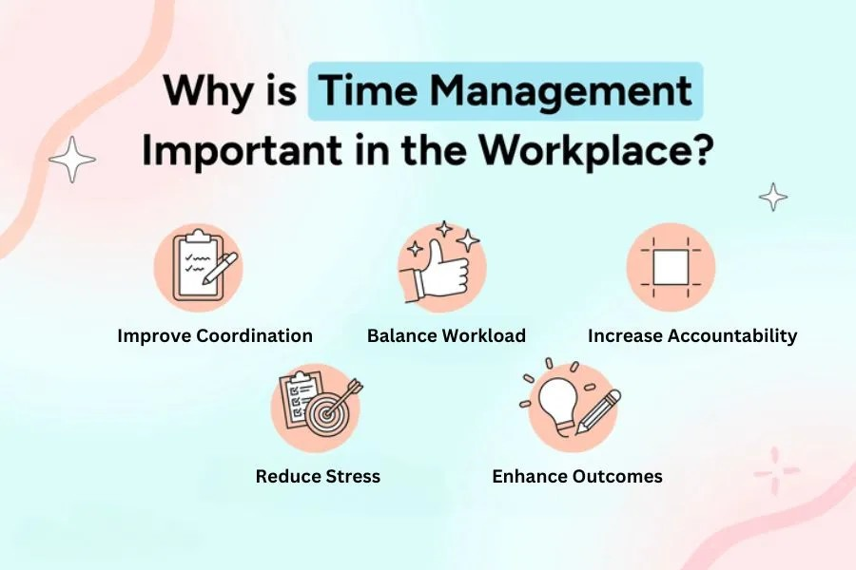
These abilities are very useful in my chosen field of business management. Effective decision-making will be driven by critical thinking and problem-solving skills, while strong communication and teamwork will enable me to lead projects and inspire others. Meeting deadlines and maintaining organization are made possible by effective time management. I will be more equipped to handle obstacles at work and succeed in my career in the long run if I keep honing these skills.

b) Evaluation of Task 1(a) based on Similarity report
I obtained 10% similarity score after submitting my summary to Turnitin, indicating that while the majority of my work is original, there is some properly cited material. I will focus on improvement of paraphrasing and using ideas in my own language in a manner that will not compromise academic honesty next time to increase my score. According to the Generic Assessment Criteria I would rate myself at 85%. The synopsis has been written in a proper way, arranged and referenced. To better it, however, I need to provide more detailed examples and consider more closely how these skills apply to real business scenarios.
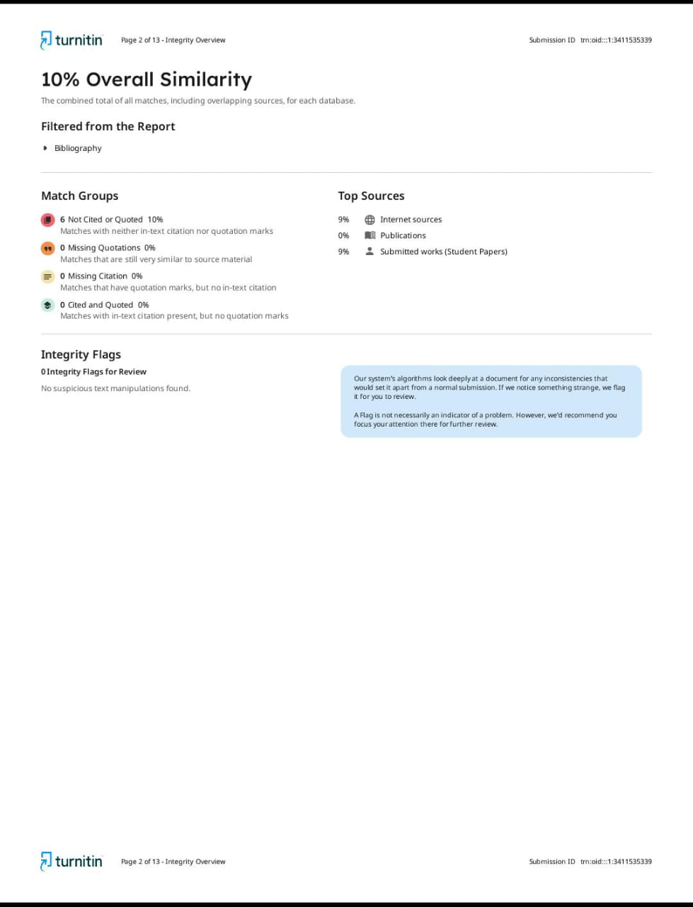

Task 2: Collaborative Mind Map and Individual Poster

Mind Map

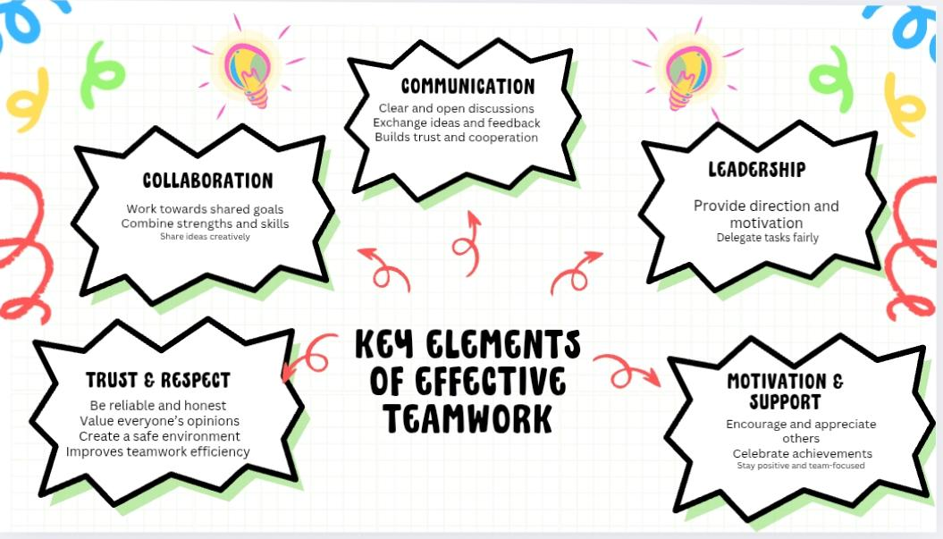

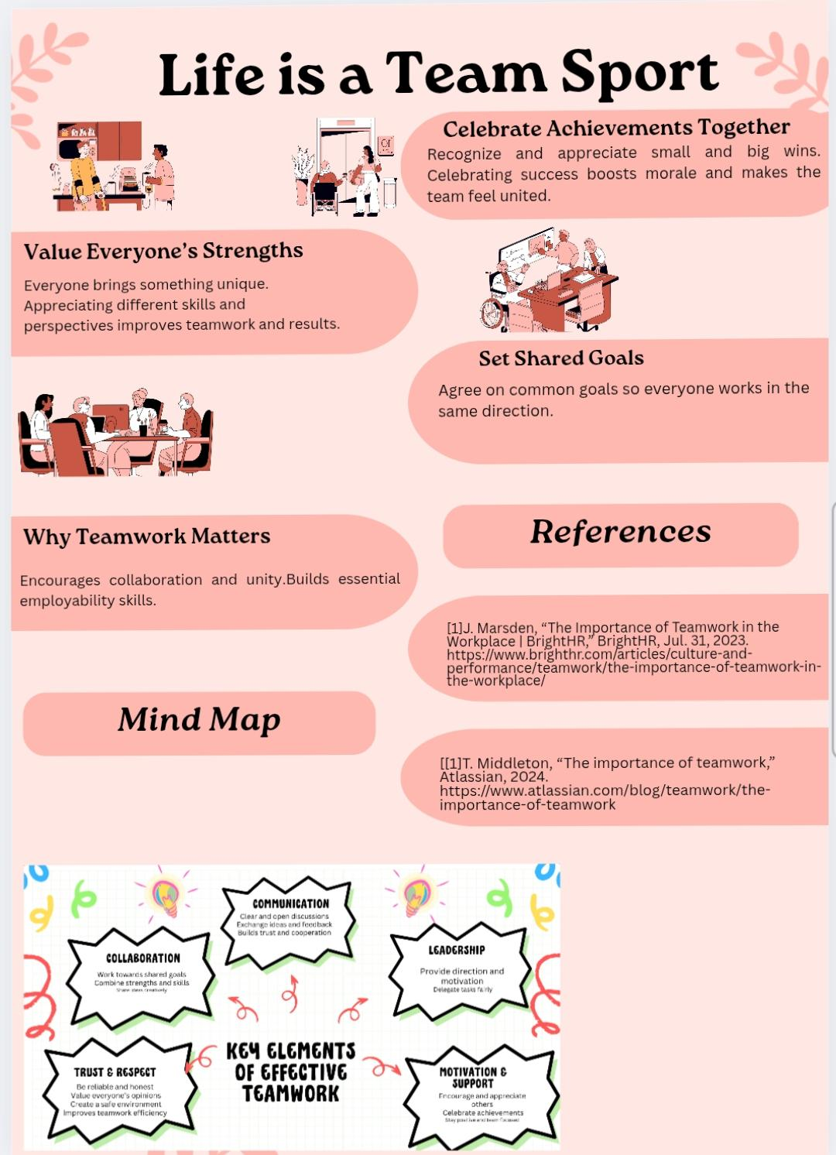
Poster

Task 3: Virtual Collaboration and MyBib

Report on Virtual Collaboration

Summary
Virtual collaboration implies the use of online tools (e.g., Microsoft Teams, Zoom, Slack) to organize geographically dispersed teams and to make them communicate, share resources, and coordinate their work. They enable communication in real-time and on-demand basis, and students and professionals can work together regardless of time zones or institution limitations, which was accelerated during the pandemic and currently became a part of the hybrid approach to education and work [5].
These possibilities are increased accessibility and inclusiveness (participants contribute on different locations), increased resource-sharing (shared documents and shared boards) and reflective learning chances in the educational process with structured online interactions. It was found that with the help of online learning with a collaborative approach, a stronger knowledge base, intercultural competence may be achieved in case the properly designed activities are implemented [6].
Nonetheless, virtual collaboration also presents its challenges: the lack of social cues may make it harder to establish trust, technical difficulties may impose a cognitive load on certain learners, and inadequately designed tasks may limit the engagement. The best practices that can reduce these problems are the assignment of clear roles, the presence of scheduled synchronous check-ins and asynchronous workspaces, facilitation techniques used to promote participation, and intentional trust-building exercises. Online group work and incorporation of multimedia resources have been suggested by educational research to enhance interaction and learning transfer in online group work [7].
It is important to select the right tools: Microsoft Teams can be used as a single application with integrated chat, meetings, file and channel sharing, which will be useful in formal instruction and work projects; Trello/Asana will be used to keep track of the work, and Google Docs will be used when you need to work with others in real-time. Effective virtual teams match the appropriate tools with clear norms (channels of communication, response times, and version control) and leadership behaviors that promote a sense of accountability and psychological safety.
Overall, virtual collaboration may contribute greatly to learning and workplace productivity, but it requires a deliberate choice of the technology and design of activities based on clear roles in facilitation and scaffolding to facilitate interaction and trust [8].

Step-by-step process of using MyBib with visuals
Step 1: I opened the MyBib IEEE Citation Generator to automatically create accurate references for my assignment.

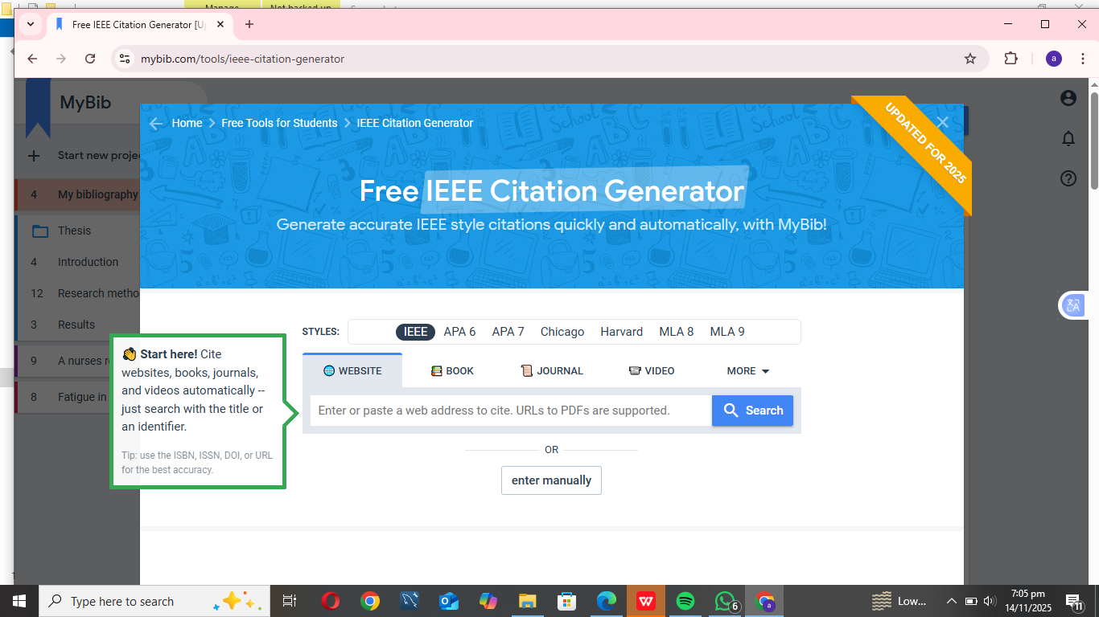
Step 2: The tool generated the full IEEE reference format for me, which saved time and ensured accuracy.

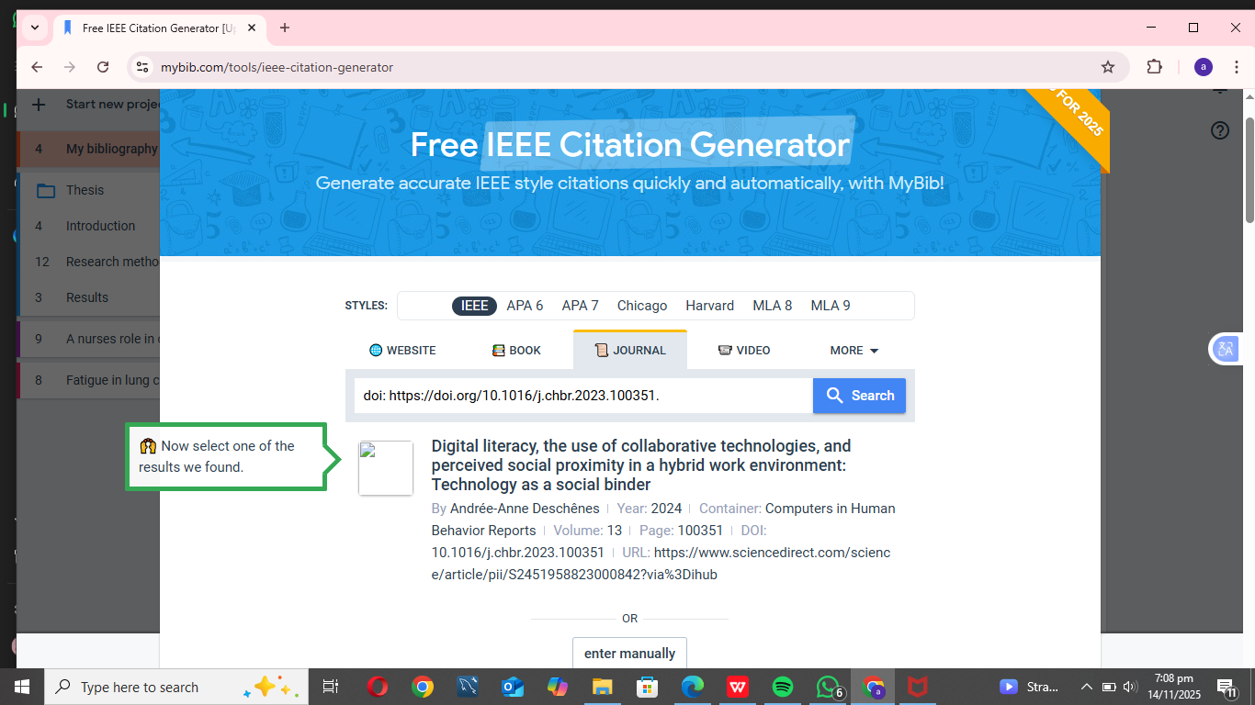

Task 4

E-Portfolio Creation and Evaluation
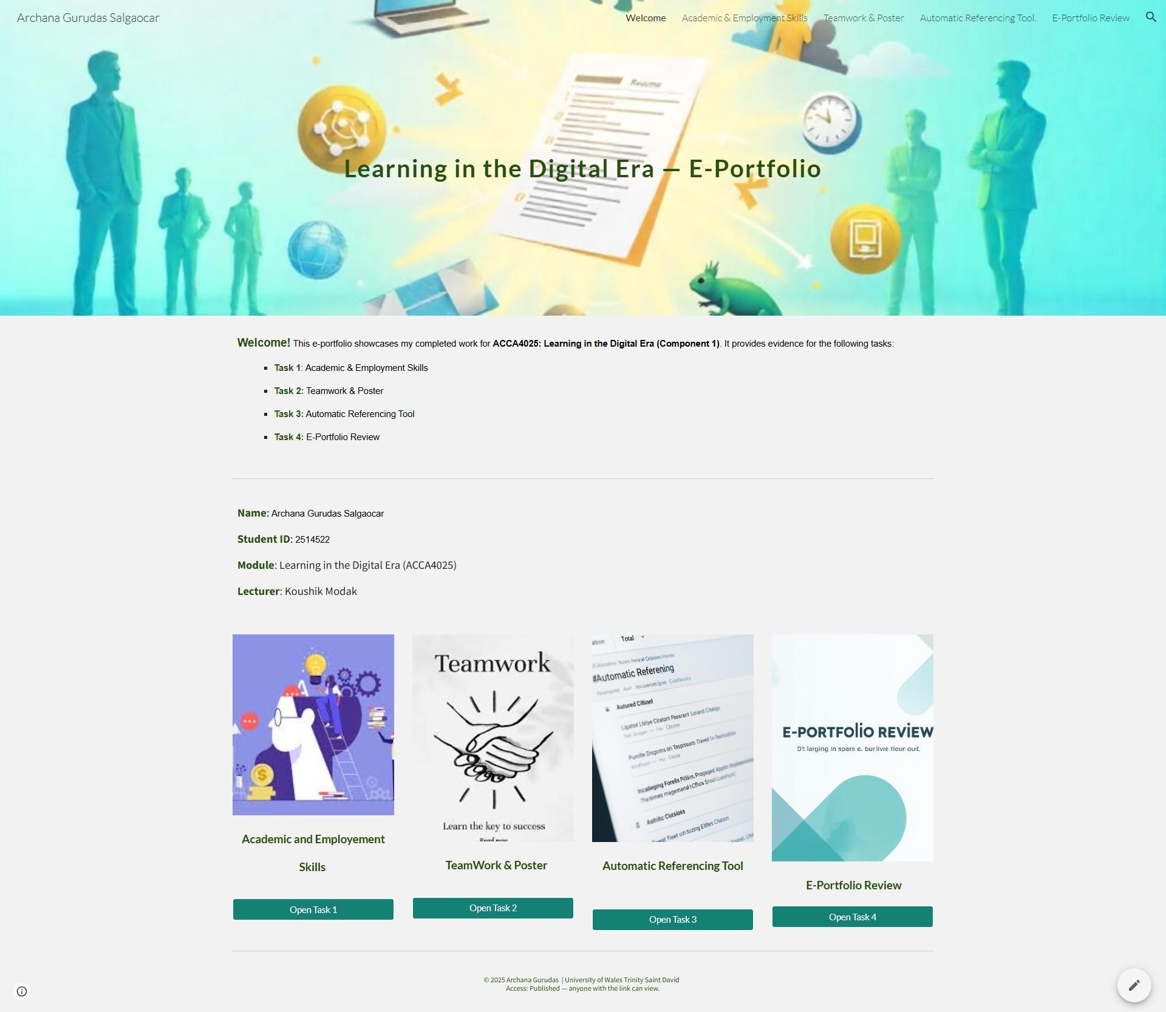

B) Illustrative Review of E-Portfolio tool Selection.
For my e-portfolio, I choose to utilize Google Sites because it is cloud-based, free, and incredibly user-friendly—all without requiring any coding knowledge on my part. It was simple to include images, screenshots, and documents into each assignment using Google Sites because it is interoperable with other Google apps like Drive and Docs. The pre-existing templates gave all of the assignments a professional and consistent appearance, and the drag-and-drop framework let me vividly arrange the content of tasks 1-4. When it came to building an academic e-portfolio to showcase my digital talents and learning accomplishments, Google Sites was hands-down the best and most convenient solution.

Conclusion
This project shows the process of combining the academic, professional, and digital skills by means of practical and reflective tasks. Task 1 promoted awareness of important study and employment skills, and served to relate learning to future career aspirations. Task 2 emphasized importance of teamwork, collaboration and leadership, based on poster and mind map and the importance of collectivism in performance and learning. Task 3 also supported digital literacy and academic honesty by way of using MyBib to reference and cite properly. Task 4 involved gathering of all work in online e-portfolio that demonstrated organization, accessibility, and the capability to present work in a digital format in an effective way. On the whole, the project demonstrates that structured learning exercises, group work, and technology may help to increase academic competence, professional readiness, and confidence in task management both in the educational and professional context.

References

References for Task 1

[1] | M. Cottrell, The Study Skills Handbook, London: Macmillan, 2019.
[2] | P. Facione, "Critical Thinking: What It Is and Why It Counts," Insight Assessment, https://www.insightassessment.com, 2020.
[3] | J. Katzenbach and D. Smith, The Wisdom of Teams: Creating the High-Performance Organization, Boston: Harvard Business Review Press, 2015.
[4] | S. R. Covey, The 7 Habits of Highly Effective People, New York: Simon & Schuster, 2020.

References for Task 3

[5] | A.-A. Deschênes, "Digital literacy, the use of collaborative technologies, and perceived social proximity in a hybrid work environment: Technology as a social binder," Computers in Human Behavior Reports, vol. 13, 2024.
[6] | S. Alkoud, D. Zainudin and S. M. Sarif, "Challenges, Barriers, and Obstacles Facing Virtual Teams: a Conceptual Study," International Journal of Academic Research in Business and Social Sciences, vol. 13, no. 4, 2023.
[7] | "What Are The Benefits of Online Collaboration in Education?," Digital Products, 2024. [Online]. Available: https://www.digitalproductsdp.com/blog/benefits-of-online-collaboration-in-education.
[8] | S. Hackett, J. Janssen, P. Beach, M. Perreault, J. Beelen and J. V. Tartwijk, "The effectiveness of Collaborative Online International Learning (COIL) on intercultural competence development in higher education," International Journal of Educational Technology in Higher Education, vol. 20, no. 1, 2023.

E- Portfolio

Task 1:

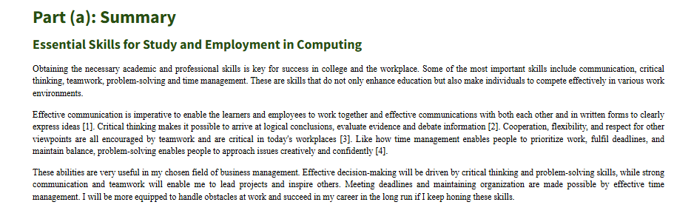

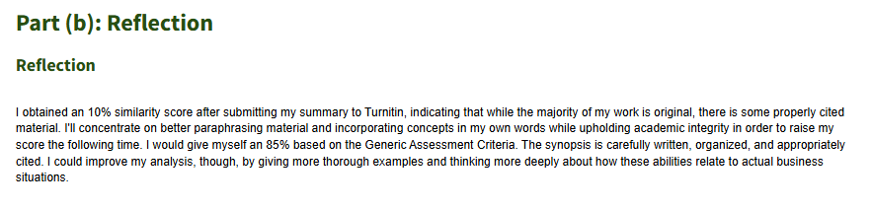

Task 2:
MIND MAP:
https://uowtsd-my.sharepoint.com/:i:/g/personal/2514522_student_uwtsd_ac_uk/IQAxcp7LfWhUR6GQUPAK1vlBAUpelyBmTuoDgogv7Wkt0WI?e=j27XUb
POSTER:
https://uowtsd-my.sharepoint.com/:i:/g/personal/2514522_student_uwtsd_ac_uk/IQAxcp7LfWhUR6GQUPAK1vlBAUpelyBmTuoDgogv7Wkt0WI?e=j27XUb

Task 3:
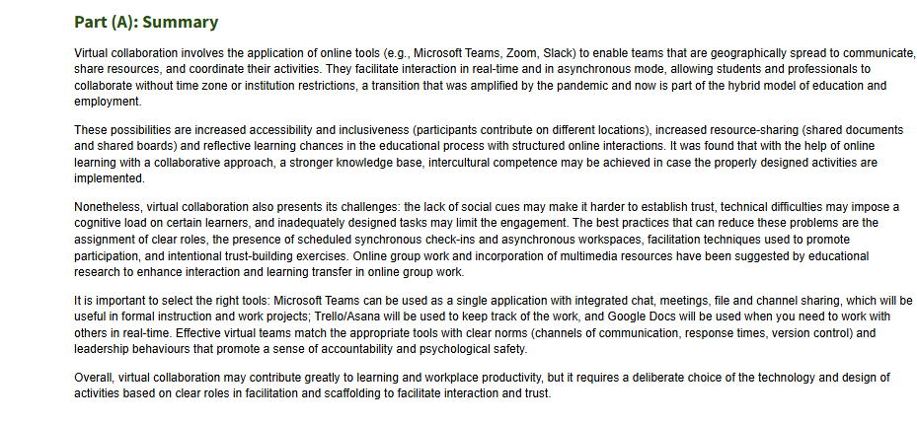

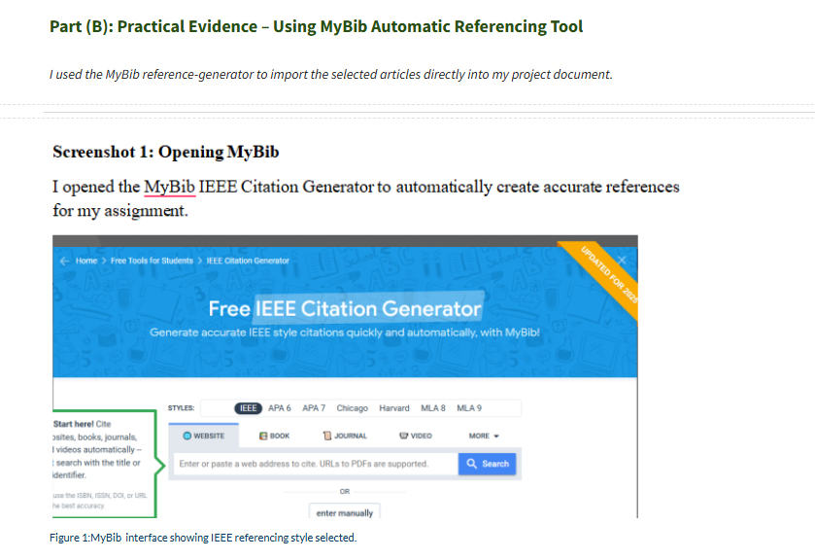

Task 4:
E-PORTFOLIO REVIEW

Task 1:

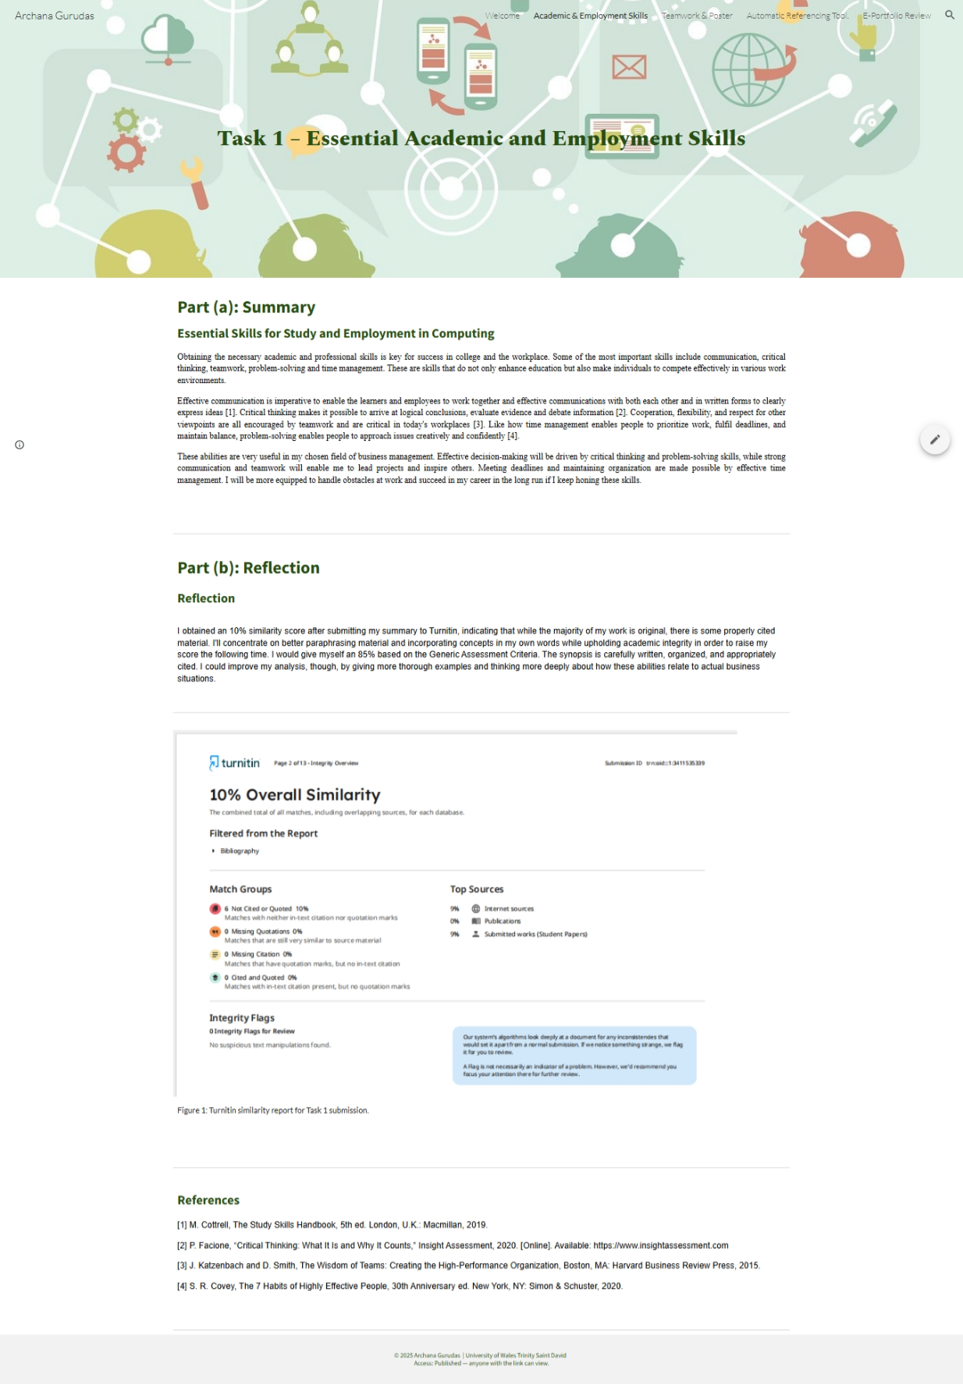

Task 2:

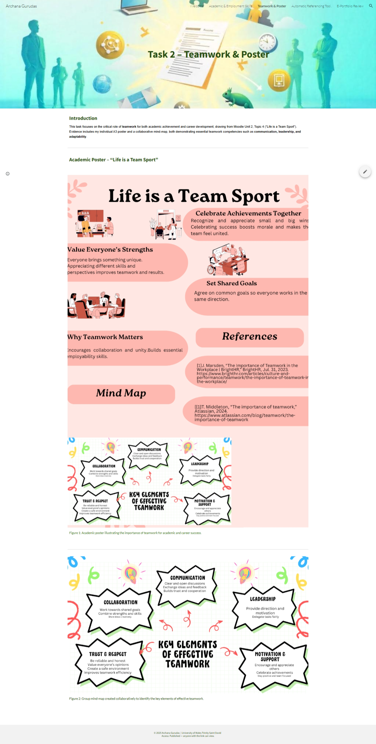
Task 3:

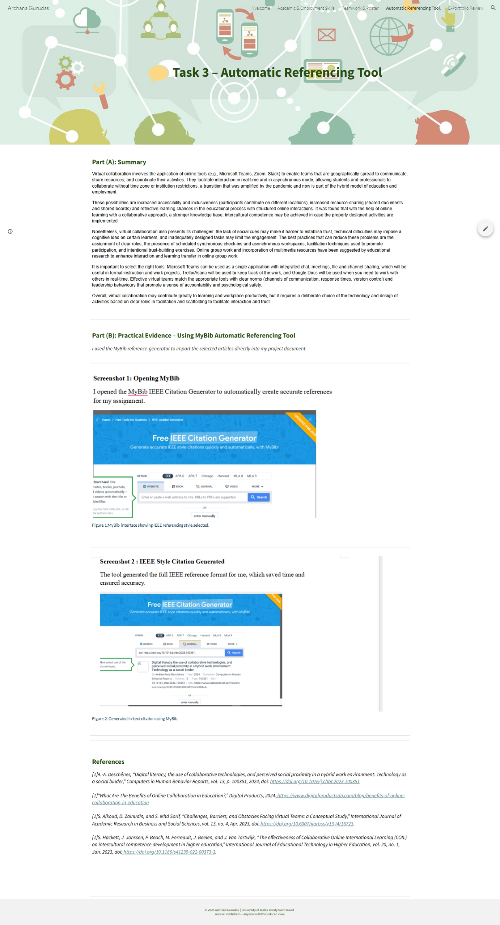

Task 4:



