Matthews House

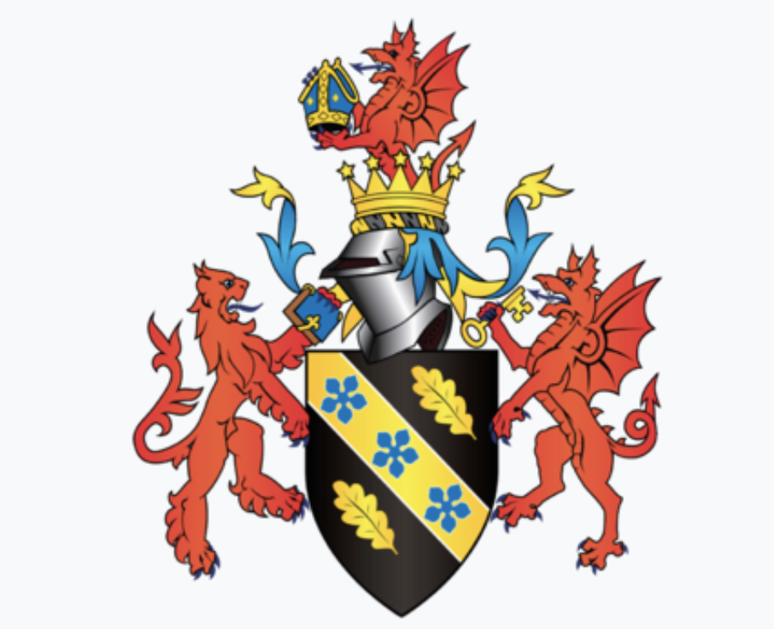

December 2017

Introducing the modern workplace

Nia James

1705762

This assignment describes the culture and structure of the organisation called Matthews House. Culture is an abstraction, yet the forces that are created in social and organisational situations that derive from culture are powerful (Schein, 2006). Structure is the relationship among people within an organisation that give rise to patterns of action which can be known as a ‘transitory social structure’ (Mullins, 2005). Without structure within a business there may be no sense of direction which could lead to a business failing, for example, if Matthews House had no structure then they may not be able to meet their aims and objectives.

Johnson (1987) states that the culture web is a means of analysing culture. The cultural web expresses the behavioural, physical and symbolic manifestations of a culture that inform and are informed by the taken-for-granted assumptions or paradigm. The paradigm is the core of the web, the core also has different assumptions which include stories, symbols, power structures, control systems, routines and rituals, and finally, organisational structure.
The stories told by the members within an organisation can act to embed the present in its organisational history and also identify the important events and personalities. The stories are mainly to do with successes and disasters within the organisation which also then highlights the importance of the organisation (Johnson, et al, 2015). Thom is very ambitious, he decided to quit his high paid job in Tata Steel for a not-for-profit job within Matthew’s House as he wanted to help the vulnerable of Swansea.
Symbols are objects, events, acts or people that convey, maintain or create meaning over and above their functional purpose (Johnson, et al, 2015). For example, Thom being the leader of Matthews House is a symbol of his functional purpose and also signals about his status and hierarchy. Many elements of the web are symbolic, meaning routines, control and reward systems and structures are both functional and symbolic. Matthews House also has a wall of pictures of the people who come and use the service so that they feel valued. The organisation doesn’t have a till in the café area which allows service users to pay as they please, this proves that Matthews House is helping the communities most vulnerable as they are allowing them to eat with whatever money they have.
Power structures are the most powerful groupings. They are commonly closely associated with the core assumptions and beliefs. In some organisations, it is not unusual to identify powerful executives who have long association with long-established ways of doing different things (Johnson, et al, 2008). Thom is known to have the most operational power as he is the organisations leader, even though trustees have power as well, he is the only paid person so is the one who will take criticism and ideas from volunteers but he will be also the person to finalise whether it’s beneficial or not. For example, a volunteer may suggest investing in a ‘Matthews House Doctor’ to come every so often, but as Thom has the main power, he will decide whether or not it’s realistic or not, he can figure this out by checking the finances for example.
According to (Johnson, et al, 2008), control systems, measurements and reward systems emphasise the importance within an organisation to monitor certain things that the organisation leader wants to monitor. Some organisations can be accused of being concerned with stewardship of funds instead of the quality of the service meaning money is more important than quality of the service the organisation provides. The trustees within Matthews House are rewarded daily as they get to receive positive fulfilment as they are helping the vulnerable of Swansea. After speaking with Thom, he doesn’t think money he thinks ensuring the service users are fully satisfied after every visit to Matthews House because otherwise this organisation wouldn’t be doing its job.
Routines and rituals are the work processes that go on day-to-day within an organisation. Rituals are ‘how things are done around the organisation’ and routines are a more in-depth level of rituals, so these are the corporate events that reinforce the behaviour demonstrated in the rituals (Thomas, 2005). There are many different ‘things done around the organisation’ such as Tuesday and Monday lunch, Friend Friday, and Super Sunday. This allows service users to plan around the business and know exactly when it’s accessible for them, they will also be able to know exactly when they can receive food and shelter.
Organisational structures are determined by the authority which are apparent to the organisation. Either if the organisation has a tall or flat hierarchical structure, it will influence the overall culture of the firm (Robinson, 2009) Matt’s Café which is in Matthews House offers to help the Local Swansea City of sanctuary. On their website they state ‘It is wonderful to see that a hot meal is available every day of the week throughout our city’ (SwanseaCityofSancuary.com 2017). This proves that Matthew’s House is massively helping the Swansea community. There’s a large pay out for the organisation but it doesn’t matter to Thom because he’s so happy and the community are helping him out, especially the volunteers as they’re not paid.
Culture can change depending on many different aspects such as leaders, managers and the environment. Thom is having a great impact on the organisation because he is setting different aims and objections and for the past 6 months that the organisation has been running he has already met a vast majority of them. The environment is a huge impact on cultural change, as Mullins (2005) outlines, ‘climate can be said to relate to the prevailing atmosphere surrounding the organisation, to the level of morale, and to the strength of feelings or
belonging, care and goodwill among members.’ This shows that the weather can depend on the demand of Matthews House, for example, if it’s raining really bad then the individuals that are homeless are going to need to rely on this organisation for their shelter.

The structure of an organisation reflects the pattern of relationships between all individuals within the organisation. Although, the structure needs to also reflect the nature and diversion of the work that is conducted by the individuals. This then needs to be established to make sure that they can achieve their aims and objectives of the organisation, they will do this with careful co-ordination and direction in the organisation (Sutherland and Canwell, 1997).
There are three different types of organisations, functional, matrix and project. As Sutherland and Canwell (1997) describe the matrix, they state that matrix relationships are based on different levels of authority and multiple support systems, the matrix structure was evolved in the aerospace industry to facilitate control of certain projects. This means there are three different sets of relationships, the first is between the project manager and the functional and product manager, the second is the relationship between the functional and product managers who share a number of subordinates, and finally the third is between the subordinates and their different managers. Matthews House is a project organisation because every day runs the same way, as Thom is able to ask volunteers to do a certain task. For example, the volunteered cook will do this job each time she comes to help out. This prevents anyone from feeling unhappy as these volunteers can come to work every and know exactly what they are going to do.
As Mullins (2016) outlines, there is a clear relationship between strategy and structure, this is due to the organisations structures goals and objectives being attained. Lynch (2012) suggests that the nature of this relationship is not clear, whether or not the structure follows strategy or strategy follows structure. Over the past thirty years there has been a debate over the relationship between the strategy and structure of the organisation. In the past it was known to be strategy first then structure second, but recently research questioned this approach and thought that structure and strategy are interrelated so now they are considered with each other. Matthews House most definitely benefits from this theory because they have set themselves many different aims and objectives since the business first set up and throughout the past six months they have already accomplished so many of these.
Mullins (2016) states that structure is ‘clearly important for any organisation, whatever the size’. He says in smaller organisations, like Matthews House, there are likely to be fewer issues. The distribution of certain tasks the definition of authority and responsibility, and the relationship between members within the organisation can be highlighted onto a personal and informal basis. He also describes that there is a need for a formal organisational structure and continual review of the structure to make sure it’s the most appropriate for the certain organisation, and also to maintain growth and development. It can also make effective management possible due to the performance improving, this should then also increase moral and job satisfaction of colleagues which will then facilitate the attainment of aims and objectives. On the other hand, a badly designed structure can have a number of effects, it can also be seen as cruel by members of staff as they may feel they are being treated unfairly, also it’s inefficient but a good structure can be due to effective communication and task completion. Structure is important for Matthews House as well due to the fact that they have many different opportunities coming their way to help raise money towards the organisation, without a good structure Thom wouldn’t be able to plan as efficiently meaning certain task may never get done. Because they are so organised and have a good structure, Thom has been able to do so much for the short time they can been live, such as the half marathon, Thom organised this by creating sponsorship forms, getting his volunteers involved, and spreading awareness to people who don’t even use the service. This then resulted in them raising enough money to refurbish their café area.
In an organic structure, an individual in a certain role is assigned to a task or set of tasks. Although, they will not be restricted from learning new skills they will still be open to new ones. An organic structure is a fluid structure that is known for changing conditions and it always has joint specialisation (Aquinas, 2008). A mechanistic structure on the other hand, is a person within a role specialised towards a specific task or set of tasks. Within a mechanic structure, it’s primarily hierarchical in nature, interactions and communications are sometimes vertical and their instructions come from the boss. They are designed so people behave in a predicable manor, they also can’t deal with rapid change (Aquinas, 2008). Matthews House has an organic structure due to the fact that Thom welcomes in any volunteers to help him, he doesn’t require any certain skills from anyone. He also allows all volunteers to switch roles so that they can learn new skills, for example, when he allowed the Matts Café cook to work for him he didn’t ask for a catering qualification, he also allows her to do other jobs around the House such as greeting service users and having a chat with them so they feel welcome.
Span of control, span of responsibility and span of supervision, all come down to the number of employees who report directly to a given manager or team. An appropriate span of management is important for 2 reasons, one is because it affects the efficient utilisation of managers and the effective performance of their subordinates. And the other is because there is a relationship between the span of management and organisational structure. If it’s too narrow then the managers will be underutilised and their subordinates will be over controlled, resulting in communication and cost problems (Tripathi and Reddy, 2008). Matthews House have a sound span of management due to Thom taking control, taking responsibility and supervising his volunteers and organisation. 12 volunteers are working for him at the moment and their relationships are strong due to them also being friends outside of the organisation, this allows positivity and no confrontation as the volunteers should feel able to talk to Thom if they have an issue rather than keeping it to themselves and feeling de-valued.
The essence of structure is the division of work among members of the organisation and the co-ordination of jobs and activities. In 1996 Donaldson came up with a theory that there is a single organisational structure that is highly effective to all kinds of organisations (Bacher, 2005). According to Aquinas (2008) he says Donaldson insisted that the contingency approach is the essence of organisation theory.

Culture and structure overlap due to organisations needing a certain amount of culture for each structure. Matthews House is a very strong and secure organisation as everything discussed has been positive and there has been no highlight of mishaps. Thom has a huge responsibility towards his organisation and he has good structure within this for many different reasons, one being the fact that his relationship is strong with his volunteers and another reason being himself having so much control and responsibility as he has not failed the organisation.

References

Aquinas. P G, (2008), Organisation Structure and Design applications and challenges: Organisation and Design, 1st edition, chapter 9, Anurag Jain, New Delhi, pp. 208-211.
Bacher. C, (2005), Contingency Theory, Definition and Development, Auflage, Germany, pg. 2.
Food and Friendship in Swansea, Available at https://swansea.cityofsanctuary.org/2017/08/17/food-and-friendship-in-swansea. Accessed 13th of November 2017.
Johnson, G. Strategic Change and the Management Process, (1987), and G. Johnson, ‘Management strategic change: strategy, culture and action’, Long Range Planning, vol. 25, Blackwell, no. 1 (1992), pp. 28-36.
Johnson, Whittington, Scholes, et al, (2015), Fundamentals of Strategy: chapter 4, 4.6.5 Analysing Culture – the cultural web, third edition, Pearson Education: London, UK, pg. 98.
Johnson, Whittington, Scholes, et al, (2008), Exploring Corporate Strategy: chapter 5, 5.4.6 Culture and Strategy - What is culture and why is it important, 8th edition, Pearson Education: London, UK, pg. 199.
Lynch, R. (2012), Strategic Management, sixth edition, Pearson Education, pg. 7.
Mullins, J. Laurie, (2016), Management and Organisational Behaviour: chapter 11, part 4, Organisation Structure and Design, the purpose and importance of structure, Pitman, London, UK, pg. 395.
Mullins, J. Laurie, (2005), Management and Organisational Behaviour: chapter 3, Part 1 Approaches to organisation and management, 7th edition, David Preece, London, UK, pg. 87.
Mullins, J. Laurie, (2005), Management and Organisational Behaviour: chapter 22, Part 8 Improving Organisational Structure: Organisational Climate, 7th edition, David Preece, London, UK, pg. 899.
Mullins, J. Laurie, (2016), Management and Organisational Behaviour: chapter 14, part 4, Structure Strategy and Effectiveness, the importance of strategy, Pitman, London, UK, pg. 504.
Robinson, P. (2009), Operations Management in the Travel Industry: chapter 1, 6.10 Strategic Implementation, 1st edition, CAB International, Wolverhampton, UK, pg. 131.
Schein, H. (2006) Organizational Culture and Leadership, third edition, Jossey – Bass: San Francisco, CA. pg. 4.
Sutherland. J, Canwell. D, (1997), Organisational Structures and Processes, Section 1, 1.1, Identifying Structures: types of organisation and associated structures, Pitman, London, UK, pg. 3.
Sutherland. J, Canwell. D, (1997), Organisational Structures and Processes, Section 1, 1.1, Identifying Structures: types of organisation and associated structures, matrix relationships, Pitman, London, UK, pp. 30-31.
Thomas. J, Stephen, (2005), Improving Maintenance and Reliability Through Cultural Change: chapter 2, 2.5 The Elements of Culture, 1st edition, Copyright by Industrial Press Inc.: New York, USA, pg. 24.
Tripathi. P C, Reddy. P N, (2008), Principles of Management: Business Forecasting and Operations Research, Span of Management, chapter 6, Tata McGraw-Hill, New Delhi, pg. 103.

