Internet protocols
University of Wales
Saint David
BSc Cloud Computing
by Nikolay Balkanski
student – 1909874

Table of Contents

Introduction IPv6…………………………………………………………………………………………1
IPv6 Addressing and expressions………………………………………………………………..2
Address Types of IPv6………………………………………………………….………………….....3
Unicast………………………………………………………………………………………………………..4
Global Unicast Addresses…………………………………………………………………………….5
Link – local addresses………………………………………………………………………………….6
Unique local addresses……………………………………………………………………………....7
Loopback addresses…………………………………………………………………………………….8
Unspecified addresses………………………………………………………………………………...9
Embedded addresses…………………………………………………………………………….…..10
Multicast………………………………………………………………………………………………….…11
Anycast…………………………………………………………………………………………………….…12
Conclusion…………………………………………………………………………………………………..13
Special addresses……..…………………………………………………………………………………14
IP addressing scheme………………………………………………………………………………….15
IPv6 Servers………………………………………………………………………………………………..16

Task 1

Introduction

In today’s dynamic world in which technologies are changing every day, network technologies have to offer speed, scalability and easy of management, that World need today. IPv4 has only about 4.3 billion addresses available in the theory, and we know that we don’t even get to use most of those. There are about 7 billion people in the world, and it is estimated that just over 10% of the population is currently connected to the Internet.
When for a first time IP and IPv4 has been used in the network “The advance research project Agency Network” switch packets and later tcp/ip protocol become one of the common connection in the network. And ipv4 addresses start run out.
Why do we need IPv6, because World technology is changed rapidly an increasingly more people every day connected to the Internet, so very soon the recent IPv4 protocol will run out of addresses that’s why world need to switch to new IPv6. It’s not brand new IPv6 it has been created/design it/ in December 1998. IPv6 is 128 bit and will give us more addresses rather than recent IPv4 32 bit- address. 128 - bit address will give us 2^128 or approx. 3.4 X 10^38 addresses, us you can see on the picture.

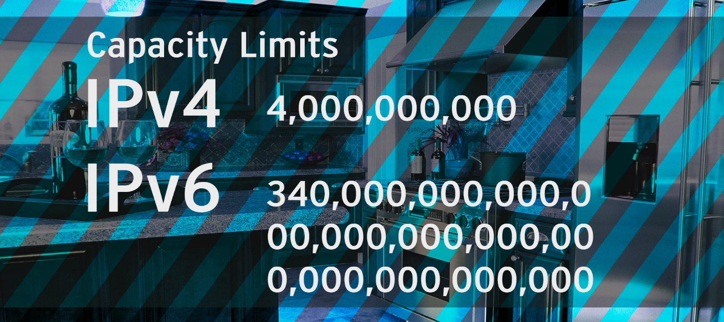

IPv6 Addressing and Expressions
We already know about the fact that 128 bits IPv6 address is, and is much longer the than IPv4 address is. We all of us probably guessing that IPv6 will be more complicated to manage. But good news is there is something can help us to sort it this monster address to a smaller pieces and will be much easier to configure the address but we need to follow just simply rules any zero each block can be omitted, we can use numbers from 0 to 9 as well as letters from “a” to” f” this special types can help to reduce the lent of the address and to convert to smaller bits as well as can be much easier to simplify or understandable for the human brain as well.

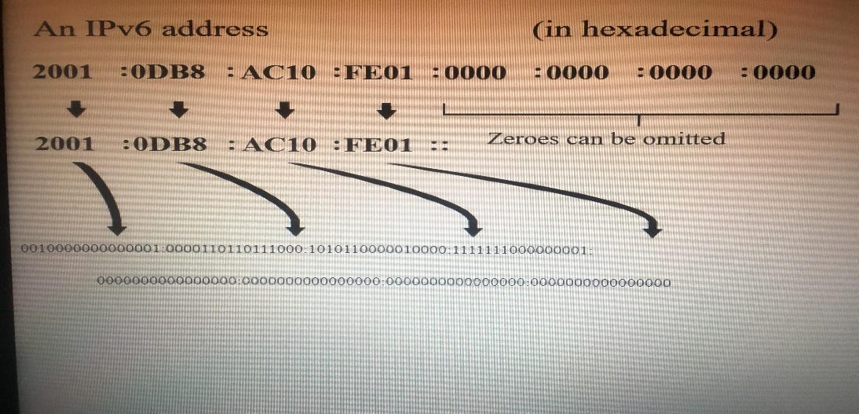

We can change double zero blocks:
2002:0000:0000:0011:0000:0000:3214:86ac
2002::11::3214:56ac

Because it is represented in 8 groups in 16-bit hexadecimal colon. On the picture you can see broken down IPv6 address into sections, such as Global prefix 64 bits included 16 bits of Subnet and 64 bits of Interface.

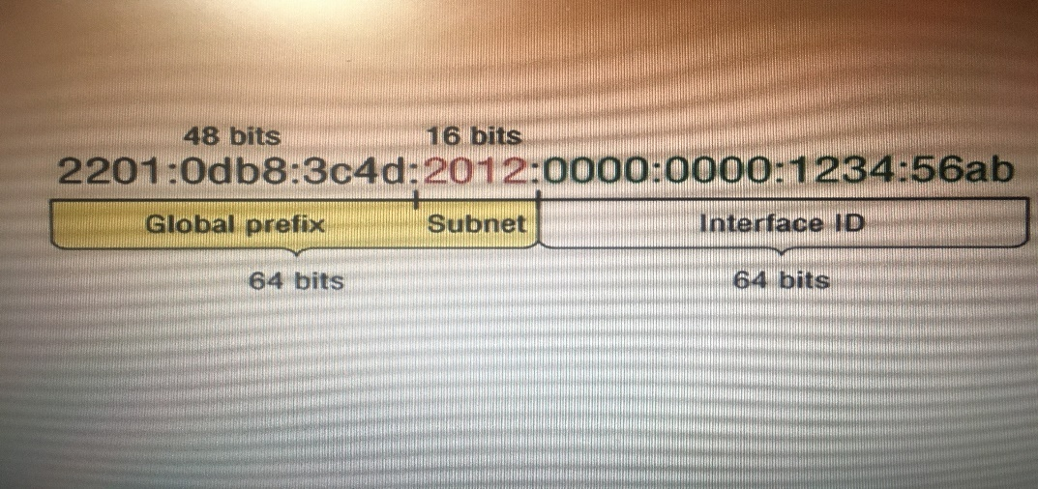

When we use web browser to get HTTP connection in IPv6 device, have to type the address into browser whit brackets around literal address. That is a good example:
http://[2002:1db9:3c4d:0012:0000:0000:32134:85ab]

Addresses types of IPv6

1 Unicast – IPv6 unicast use “ONE to ONE” association between
two individual devices, packet communication to unicast address delivery
Information to single destination across internet(network)
Examples from web server to client or host PC. Communications,
2004, vol.87(8)

1.1 Loopback addresses – Loopback addresses is pretty the same as UNA again all dresses are 0 but the last numeral is created to 1, it looks like that.
0000:0000:0000:0000:0001 and omitted is 0:0:0:0:1
Also can’t be assigned to do physical interface but can send can send packet to itself in IPv6.

1.2 Link local addresses – (APIPA) Automatic Private IP Addresses, in IPv6 start whit FE80::/10, the link-local addresses is the Unicast and it is in single subnet. Also addresses can be manually configure In the prefix FE80::/10. Perspective,2016, Vol.25
1.3 Unspecified addresses – It is the same like Unique local addresses all the addresses is 0, used to be assigned absence of the address, also not assigned to the interface.

1.4 Global unicast addresses – Thera are publicly routable and reachable addresses, there are absolutely identical whit IPv4. GUAs begin from ( 2000::/3) prefix ISP will give us – 48 network ID, 64 bits is for the router addresses, and the last 64 bits is for the host.(IANA,2019)
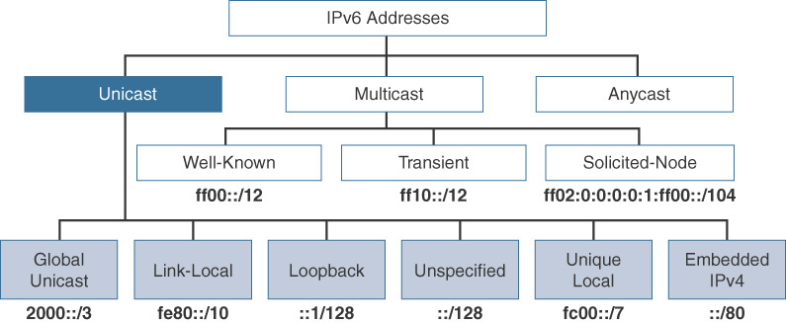

1.5 Unique local addresses – Every Each address is 0, what I mean
0000:0000:0000:0000:0000:0000 or if it’s omitted it looks like that, 0:0:0:0:0:0, So as we can see All the addresses is 0. Start whit (FC00::/7) non routable over the internet. Unique local addresses are designed to replace site local addresses, basically do almost the same what IPv4 private addresses do. CCNA book

1.6 Embedded addresses IPv4 – is design to mapped IPv4 addresses, it’s a special technique to communicate host via the routers and represent IPv4 to IPv6 addresses.
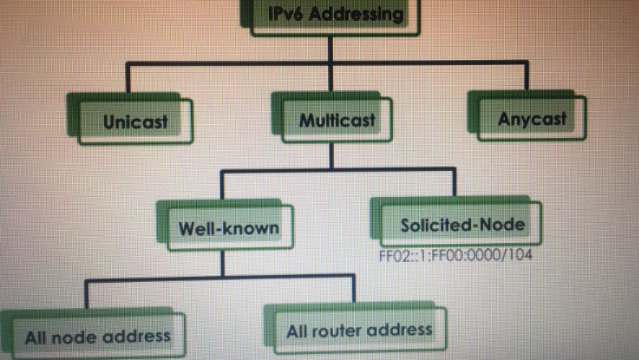

In IPv4 version all host need a broadcast communication when it does not know the receiver’s address. In IPv6 version there is no broadcast/domain. So IPv6 version use MULTICAS.

Multicast – It is a special technique “one to many” packets addresses for communication addressed to a multicast address and delivered to all interfaces. Multicast is design to replicate unicast and transmit only single copy of any packets. IPv6 Multicast address used prefix FF00::/8, just to simplify to be understandable to equivalent IPv4 is 244.0.0.0/4 . CCNA (router and switching) book. RFC 2375, IPv6 Multicast Address Assignments, R. Hinden, Ipsilon Networks, July 1998.

Well – known – well known multicast addresses are reserved for (all nodes address) use FF02::1 and (all router addresses) use FF02::2. So all Routers in LAN segment can hear Multicast messages. CCNA book,1999

Solicited – Node - addresses are created not manually, automatically prepending this Multicast use FF02::1:FF00:0000

Anycast – Like multicast addresses but delivery packets to only one device, it’s 3rd model of IPv6 communication and is classify as a “one to nearest” addresses. Delivery only to one device like Router but never to the host. Most not used as the source address.
When you send the packet in the group means send it to the closest one/router/.RFC 2526, Reserved IPv6 Subnet Anycast Addresses, D. Johnson, Carnegie Mellon University, March 1998.

Special and reserved addresses in IPv6:
They all a special and reserved for specific use and every one address is unique and internal encrypted.
2000::/3 - global unicast address range,
FC00::/7 - unique local unicast range,
FE80::/10 – link local unicast range,
3FFF:FFFF::/32 – reserved for documentation
2002::/16 – tunnelling IPv4 to IPv6 or also transmittion of packet whitout
Configure.
RFC 4291, IP Version 6 Addressing Architecture, R. Hinden, Nokia, February 2006.

Conclusion,
IPv6 has received strong support over the past few years in the computer technology world. IPv6 entry, however slow coming in the year will the best for the World today because of the huge range of the address space. IPv6 is better equipped and prepared to face up in the real World today and in the future. Entering IPv6 from parts will remove NAT (Network Address Translation) and won’t need to use it for hidden IP addresses. Perhaps Nat will remain for network protection. Ipv6 is managed by IANA (Internet Assigned Numbers Authority). IPv6 is better version of IPv4 whit much more solution space whit huge IP range spaces and will solve the problem in the future and running out of addresses on IPv4. Internet of things also becoming increasingly popular for home appliances required IP addresses and without IPv6 would be very difficult and impossible. Internet Protocol Version 6 addresses (IPv6 addresses) is a Numeric authentication address for a server, network device. The address must be connected to the worldwide network for executing information packets. IPv6 is vital in the World where everyone uses computers, laptops and tablets.

TASK 2

School of Applied Computing – Network Address: 170.70.0.0/22- 255.255.252.0
Rooms Network Address Subnet mask First IP Address Last IP Address |  |  |  |  | Broadcast
Open Access (245)Dev. and 5 printers | 171.70.0.0/24 | 255.255.255.0 | 171.70.0.1 | 171.70.0.254 | 171.70.0.255
Test C (20)pcs IP phone, a printer | 171.70.3.64/27 | 255.255.255.224 | 171.70.3.65 | 171.70.3.94 | 171.70.3.95
Lab301 (60) pcs | 171.70.2.0/26 | 255.255.255.192 | 171.70.2.1 | 171.70.2.62 | 171.70.2.63
Lab302 (30) pcs | 171.70.3.96/27 | 255.255.255.224 | 171.70.3.97 | 171.70.3.126 | 171.70.3.127
Lab303 (36) pcs | 171.70.2.64/26 | 255.255.255.192 | 171.70.2.65 | 171.70.2.126 | 171.70.2.127
Lab304 (45) pcs | 171.702.128/26 | 255.255.255.192 | 171.70.2.129 | 171.70.2.190 | 171.70.2.191
Lab306 (40) pcs | 171.70.2.192/26 | 255.255.255.192 | 171.70.2.193 | 171.70.2.254 | 171.70.2.255
Lab308 (140)pcs | 171.70.1.0/24 | 255.255.255.0 | 171.70.1.1 | 171.70.1.254 | 171.70.1.255
Lab309 (50) pcs | 171.70.3.0/26 | 255.255.255.192 | 171.70.3.1 | 171.70.3.62 | 171.70.3.63
Lab310 (18) pcs | 171.70.3.128/27 | 255.255.255.224 | 171.70.3.129 | 171.70.3.158 | 171.70.3.159
Staff (20) pcs | 171.70.3.160/27 | 255.255.255.224 | 171.70.3.161 | 171.70.3.190 | 171.70.3.191
Required host | 711

School of Automotive Engineering – Network Address: 171.70.4.0/23 – 255.255.254.0
Rooms | Network address | Subnet mask | Firs IP Address | Last IP Address | Broadcast
Staff lab (25) pcs | 171.70.3.192/27 | 255.255.255.224 | 171.70.3.193 | 171.70.3.222 | 171.70.3.223
Lab101 (40) pcs | 171.70.4.0/26 | 255.255.255.192 | 171.70.4.1 | 171.70.4.62 | 171.70.4.63
Lab102 (25) pcs | 171.70.5.64/27 | 255.255.255.224 | 171.70.5.65 | 171.70.5.94 | 171.70.5.95
Lab103 (35) pcs | 171.70.4.64/26 | 255.255.255.192 | 171.70.4.65 | 171.70.4.126 | 171.70.4.127
Lab205 (40) pcs | 171.70.4.128/26 | 255.255.255.192 | 171.70.4.129 | 171.70.4.190 | 171.70.4.191
Lab206 (48) pcs | 171.70.4.192/26 | 255.255.255.192 | 171.70.4.193 | 171.70.4.254 | 171.70.4.255
Lab301 (50) pcs | 171.70.5.0/26 | 255.255.255.192 | 171.70.5.1 | 171.70.5.62 | 171.70.5.63
CAD Lab (20) pcs | 171.70.5.96/27 | 255.255.255.224 | 171.70.5.97 | 171.70.5.126 | 171.70.5.127
Required hosts | 283

School of Engineering – Network Address: 171.70.6.0/23 – 255.255.254.0
Room | Network address | Subnet mask | First IP Address | Last IP Address | Broadcast
Staff (18) pcs | 171.70.3.224/27 | 255.255.255.224 | 171.70.3.225 | 171.70.3.254 | 171.70.3.255
Lab201 (20) pcs | 171.70.5.128/27 | 255.255.255.224 | 171.70.5.129 | 171.70.5.158 | 171.70.5.159
Lab 202 (80) pcs | 171.70.6.0/25 | 255.255.255.128 | 171.70.6.1 | 171.70.6.126 | 171.70.6.127
Lab203 (65) pcs | 171.70.6.128/25 | 255.255.255.128 | 171.70.6.129 | 171.70.6.254 | 171.70.6.255
Lab205 (25) pcs | 171.70.5.160/27 | 255.255.255.224 | 171.70.5.161 | 171.70.5.190 | 171.70.5.191
Lab404 (45) pcs | 171.70.7.128/26 | 255.255.255.192 | 171.70.7.129 | 171.70.7.190 | 171.70.7.191
Lab408 (28) pcs | 171.70.5.192/27 | 255.255.255.224 | 171.70.5.193 | 171.70.5.222 | 171.70.5.223
Lab409 (80) pcs | 171.70.7.0/25 | 255.255.255.128 | 171.70.7.1 | 171.70.7.126 | 171.70.7.127
Lab410 (45) pcs | 171.70.7.192/26 | 255.255.255.192 | 171.70.7.193 | 171.70.7.254 | 171.70.7.255
Required hosts | 406

Server | IPv6
MP | 0:0:0:0:0:ffff:ab46:0
DNS | 0:0:0:0:0:ffff:ab46:5e1
Finance | 0:0:0:0:0:ffff:ab46:5e2
Email | 0:0:0:0:0:ffff:ab46:5e3
File | 0:0:0:0:0:ffff:ab46:5e4
Registry | 0:0:0:0:0:ffff:ab45:5e5
Print | 0:0:0:0:0:ffff:ab45:5e6

