Kyle Lovell
1802143@student.uwtsd.ac.uk
EIGP 2 – Individual Report
ACDA5003

Introduction
In this report, the author will document their contributions to their group project, “Go Go Cook”. The contributions they have made come under two categories: Development, and Tech Start-Up.

Development of App

Creation of Assets
Before development of the app could begin, Kyle worked with artist Daniel O’Dwyer to create the assets needed for the app. This included buttons and visual aids, as well as text for the tutorials and ingredients lists. During the development of the app’s assets, Kyle would instruct Daniel on what would be needed, Daniel would then create said assets, and Kyle would edit them by resizing images, removing backgrounds etc. Team Leader and Voice Actor of Henry, Rhys Lewis, also helped with editing the assets.

Navigation System

Scene-to-Scene
Once this was done, Kyle created a C# method that, when connected to a button, would allow the program to open and close scenes, allowing the user to traverse the app at their leisure. This method was named “Go” and stored in the “NavigationButtons” script. An example of NavigationButtons.Go’s usage would be the “Back” button in the “VegCurry” scene which, when pressed, would take the user back to the “RecipesMenu” scene. Another example would be the “Start” button on the “StartMenu” scene, which will take the user to the “HomeMenu” scene. The reason this method was included in the app was to give the user an intuitive method of navigating the app.
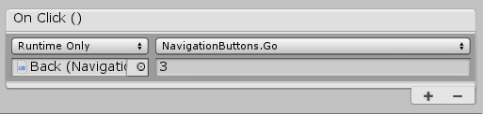
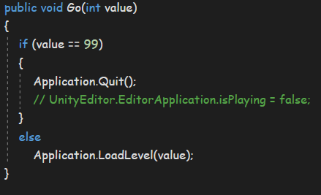
Figure 2: 'Go' Method connection
Figure 1: 'Go' Method code

Camera Movement
The second method created for the navigation system was “MoveCamera”, which is stored in the “NavigationButtons” script. This method, which is passed the value “noOfScenes”, works out the next position of the camera and, if the next position is a “legal” position, translates the camera by the designated amount. An example of NavigationButtons.MoveCamera’s usage would be the “NextRecipe” button in the “RecipesMenu” scene, which alters the camera’s position in the x axis by +12.5 (5 * 2.5) each time it is pressed. Another example would be the “PrevStep” button in the “CottagePie” scene, which alters the camera’s position in the x axis by -12.5 (5 * -2.5) each time it is pressed. The reason this method was included was to allow all recipe select screens to be kept in a single scene, decreasing app load times and storage space requirements.
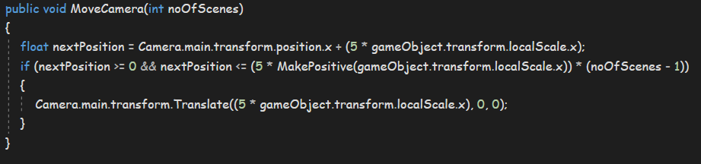
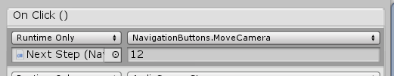
Figure 3: 'MoveCamera' Method code
Figure 4: 'MoveCamera' Method connection

Select Recipe
The third method created for the navigation system was “SelectRecipe”. This method starts by disabling all buttons in the current scene. The reason for this is, due to the button playing audio before switching scenes, the user had enough time to press one of the “MoveCamera” buttons, resulting in the program taking the user to a different recipe than the recipe they selected with the “SelectRecipe” button. The method then sets the float value ‘time’ to 0, and the Boolean value “isPlaying” to true (continued in ‘Update’ method). An example of NavigationButtons.SelectRecipe’s usage would be the “Select Recipe” button in the “RecipesMenu” scene, where if the camera’s position in the x axis was 12.5, the button would take the user to the “CottagePie” scene. The reason this method was included was to stop the user from activating a known bug within the code.

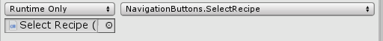
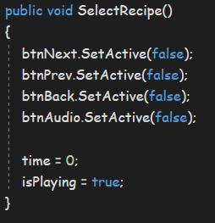
Figure 6: 'SelectRecipe' Method connection
Figure 5: 'SelectRecipe' Method code

Update
The update method is called every frame that the program is active. Every frame, Update increments the float value “time” and, if the Boolean value “isPlaying” has been set to true, checks if the value of “time”’ has surpassed the length of the audio clip currently playing. If true, Update opens the correct new scene.
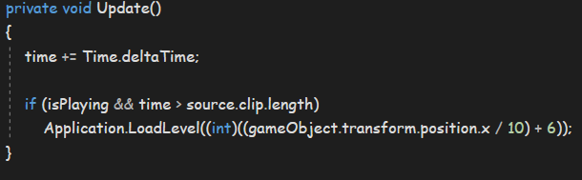
Figure 6: 'Update' Method code

Audio

Play Audio
Next, Kyle worked with Rhys Lewis, the Group Leader and Voice Actor of Henry, to create a C# method that would work out the camera’s current position in the X axis and use this value to play a specific audio clip. They called this method, “PlayAudio” and saved it in the “AudioOutput” script. An example of AudioOutput.PlayAudio’s use would be the following: For the “SelectRecipe” button, if the camera position is 10, “PlayAudio” would play Henry’s ‘cott_intro.mp3’ audio file. Another example would be if the user were to click on Henry at step 7 of the Vegetable Curry recipe, the camera’s position in the x axis would be 75, and so the “PlayAudio” script would play the ‘vegcur_step7.mp3’ audio file. The reason this method was included in the app was to give the app an audial aspect, so that partially-sighted / blind users could still follow the recipe instructions.
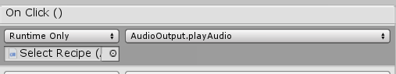
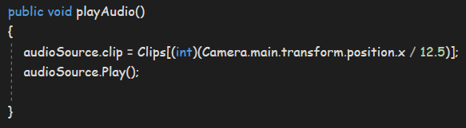
Figure 8: 'playAudio' Method connection
Figure 7: 'playAudio' Method code

Other

Victory Button
Each time the “Next Step” button in any of the recipe tutorials is pressed, it calls the “ShowVictory” method, stored in “NavigationButtons”. For the most part, this method has no effect on the app. However, when the user reaches the final step of the recipe (For example, Step 12 for Spaghetti Bolognese), the method causes the “Victory” button to appear in the top left of the screen. It does this using the “setActive()” method and passing it the Boolean value “true”. The reason why Kyle stopped the user from interacting with the “Victory” button was because, if the user could interact with it at, for example, step 3 of the recipe, the user could skip to the victory scene without actually completing the recipe, nullifying the point in the app.
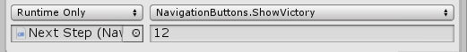
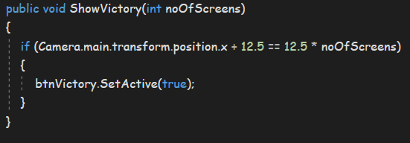
Figure 10: 'ShowVictory' Method connection
Figure 9: 'ShowVictory' Method code

Kyle’s Contributions

Tech Start-Up
Aside from the general development of the GoGoCook mobile app, Kyle also worked on the Trading Name of the company, the legal classification of the company, and the start-up description.

Trading Name
The trading name of the company is ‘TsunamiSoft’. After some research, the group found that this name was not being used by any person or company.
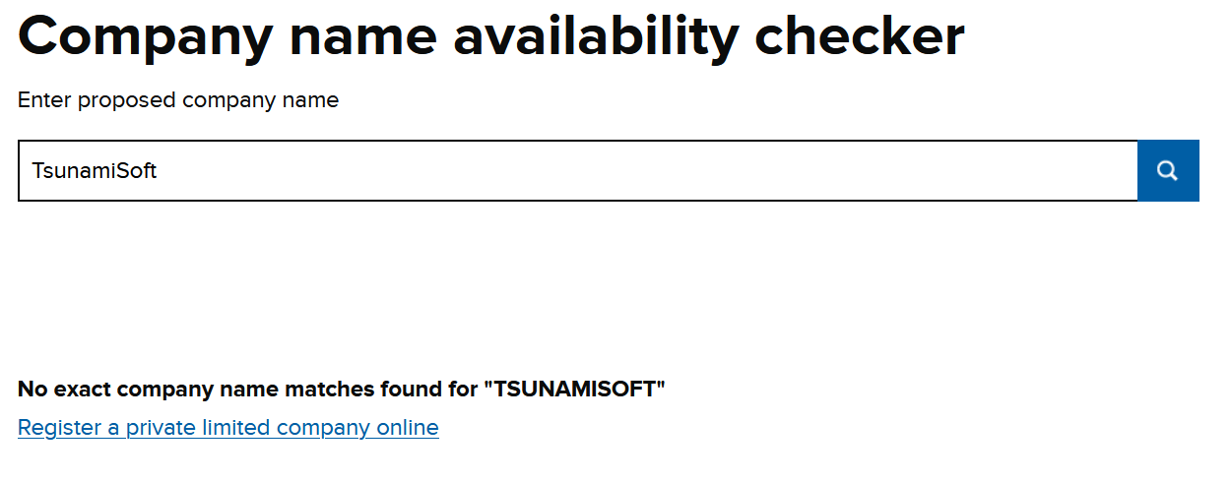

Legal Classification
The legal classification of TsunamiSoft is a “Private Limited Company” (LLC). This means that the company “is legally separate from the people who run it” and “has separate finances from your personal ones” [1]. The reason why the group chose this legal classification is, due to the small size of the business, and relative neophytic nature of the group, not needing much start-up capital is a major advantage.
Brief Start-Up Description
The name for our company is “TsunamiSoft”, which we agreed upon as a team. The logo used depicts a rising wave, our slogan is “making waves”. The company logo, slogan and name all centre around waves and ocean themes, it relies on puns for a bit of light-hearted humour. TsunamiSoft specialises in software and games tech. We are a small team of seven individuals who all study games development, we all share a great passion for coding and are proud of our work and company.

Appendix

Reflection
At the start of the project, Kyle wasn’t fully confident in his ability to create an app in Unity due to his lack of experience in designing and coding function UI. During the course of the project, Kyle developed both his coding ability, and his artistic creativity. This was due to his learning of different coding techniques in C#, and his working with group artist Daniel O’Dwyer to create the design of GoGoCook.

Team Progress Sheets

Week 1
------------------- TEAM PROGRESS SHEET -------------------------
Team Name: Tsunami Soft.
Team Member Names & Roles:
RL - Rhys Lewis - Team Leader / Audio Technician / Actor
DD - Daniel O’Dwyer - Graphics / Animations Designer
KL - Kyle Lovell - Chief Coder/Programmer
AH - Adam Whoreton - Weighing Scale Designer / Builder
MK - Mariusz Kalasz - Weighing Scale Designer / Builder
BK - Ben Kiddie - Social Network Integration
BG - Bartosz Galantowicz - Weighing Scale to Mobile App Connection

Weekly Progress report:
Week 1:
Date: 30/10/2019
In Attendance: RL, KL, AH, MK, BK.
Apologies: DD.
Absent: BG.

Team Goals:
Developing Project sheet & Discussing Project scope.
> Individual Updates:
RL - Planned and discussed potential Weighing Scale connection methods. Created Template for all Team Progress Sheets.
BK - Discussed project scope
MK/AH - Went over with basic ideas and concepts of the weighing scale
KL - Spelling / Grammar-checked Team Progress Sheet.

> Team discussion:
Developing Project sheet & Discussing Project scope.
> Individual Actions For Upcoming Week:
RL - Plan potential sound effects for the game, write a script based on potential menu options (Must discuss with Dan).

BK - Research how to integrate Facebook, Twitter and Instagram

MK / AH - Make a list of needed components and the total costs ready for order and find out if the facilities in uni can be used to further help with the construction and design.

Week 2
------------------- TEAM PROGRESS SHEET -------------------------
Team Name:
Team Member Names & Roles:
RL - Rhys Lewis - Team Leader / Audio Technician / Actor
DD - Daniel O’Dwyer - Graphics / Animations Designer
KL - Kyle Lovell - Chief Coder/Programmer
AH - Adam Horton - Weighing Scale Designer / Builder
MK - Mariusz Kalasz - Weighing Scale Designer / Builder
BK - Ben Kiddie - Social Network Integration
BG - Bartosz Galantowicz - Weighing Scale to Mobile App Connection

Weekly Progress report:
Week 2:
Date: 6th of November
In Attendance: BK, MK, DD, AH. RL.
Apologies: KL.
Absent: BG.

Team Goals:
Complete a PoC Survey. Have an app, logo and Mascot prepared.
> Individual Updates:
RL - Considered potential recipes
DD - Designed Mascot
KL - Researched minimal viable product
AH - Researching Scale Connectivity
MK - Researching Scale functionality
BK - Researching social media integration / further discussed project scope
BG - No information given
> Team discussion:

> Individual Actions For Upcoming Week:
RL - Take PoC survey
DD - Illustration of Menus, logo and Mascot
KL - Contemplating MVP and organising prototype priorities.
AH - Design Weighing scale and discuss functionality
MK - Design Weighing scale and discuss functionality
BK - Design MVP and decide initial priorities
BG - Requires further discussion

Week 3
------------------- TEAM PROGRESS SHEET -------------------------
Team Name:
Team Member Names & Roles:
RL - Rhys Lewis - Team Leader / Audio Technician / Actor
DD - Daniel O’Dwyer - Graphics / Animations Designer
KL - Kyle Lovell - Chief Coder/Programmer
AH - Adam Horton - Weighing Scale Designer / Builder
MK - Mariusz Kalasz - Weighing Scale Designer / Builder
BK - Ben Kiddie - Social Network Integration
BG - Bartosz Galantowicz - Weighing Scale to Mobile App Connection

Weekly Progress report:
Week 3
Date: 13/11/19
In Attendance: RL, DD, KL, AH, MK, BK, BG.
Apologies: N/A.
Absent: N/A.

Team Goals:
Complete PEST Analysis, Competitor analysis, email potential partners and finalise equipment needed for scales.
> Individual Updates:
RL - Completed survey
DD - Designed game menus
KL - Completed a Minimal Viable Product document
AH - Began writing component list for scale
MK - Began writing component list for scale
BK - Completed an Initial Requirements Specification document
BG -
> Team discussion:
Discussing the beginning of product development and app features.
> Individual Actions For Upcoming Week:
RL - Email potential partners, discuss recipes with Dan.
DD - Complete Competitor analysis, discuss recipes with Rhys.
KL - T+Ec of PESTLEc analysis
AH - Complete component list
MK - Complete component list
BK - Work on environmental and social research for PESTLE analysis
BG - Political + Legal - PESTLE analysis

Week 4
------------------- TEAM PROGRESS SHEET -------------------------
Team Name:
Team Member Names & Roles:
RL - Rhys Lewis - Team Leader / Audio Technician / Actor
DD - Daniel O’Dwyer - Graphics / Animations Designer
KL - Kyle Lovell - Chief Coder/Programmer
AH - Adam Horton - Weighing Scale Designer / Builder
MK - Mariusz Kalasz - Weighing Scale Designer / Builder
BK - Ben Kiddie - Social Network Integration
BG - Bartosz Galantowicz - Weighing Scale to Mobile App Connection

Weekly Progress report:
Week 4
Date: 20/11/19
In Attendance: All
Apologies: N/A
Absent: N/A

Team Goals:

> Individual Updates:
RL - Attempted to contact potential partners
DD - Completed a competitive analysis
KL - [N/A] Took the week off for health
AH - Finalised the component list and found out how to build the scale
MK - Finalised the component list and found out how to build the scale
BK - Worked on the social & environmental sections of the PESTLE analysis
BG - Finished P&L analysis
> Team discussion:

> Individual Actions For Upcoming Week:
RL - Hand out completed survey and process results
DD - Design a recipe completion screen, animate mascot and buttons, Task 3.
KL - Fill in PESTLE Analysis (Technological + Economical)
AH - Finalise initial idea for scale and researched designs of competitive scales for additional ideas.
MK - Start planning on ordering the parts and make blueprints
BK - Finish developing social & environmental factor analysis (include justifications or citations where relevant), research social media implementation (look at how to post to media in app, display media content, filters for displayed content)
BG - Create a mission, objectives and values

Week 5
------------------- TEAM PROGRESS SHEET -------------------------
Team Name:
Team Member Names & Roles:
RL - Rhys Lewis - Team Leader / Audio Technician / Actor
DD - Daniel O’Dwyer - Graphics / Animations Designer
KL - Kyle Lovell - Chief Coder/Programmer
AH - Adam Horton - Weighing Scale Designer / Builder
MK - Mariusz Kalasz - Weighing Scale Designer / Builder
BK - Ben Kiddie - Social Network Integration
BG - Bartosz Galantowicz - Weighing Scale to Mobile App Connection

Weekly Progress report:
Week 5
Date: 27/11/19
In Attendance: RL, DD, KL, AH, MK, BK
Apologies: BG
Absent: N/A
Team Goals:
Finalise group presentation.
> Individual Updates:
RL - Planned presentation, began Gantt chart
DD - Completed finish recipe screen, excel spreadsheet for survey results, Company description.
KL - Filled in PESTLE Analysis (Technological + Economical)
AH -finalised initial idea for scale and researched designs of competitive scales for additional ideas.
Also expanded upon the initial outcome of the scale to include additional features / clients
MK - Finalised the Part list and sent the parts for order.
BK - Refined environmental & social factors, further research of social media implementation
BG - Created a mission, objectives and values
> Team discussion:
Discussion of Gantt chart
> Individual Actions For Upcoming Week:
RL - Finalise presentation and Gantt chart, write script.
DD - Finalize assessment, write script.
KL - Finish PowerPoint presentation, including market research and unity app research
AH - finish P.P and ensure correct resources are available for final design of scale.
MK - Finish the powerpoint presentation, with details of research, the most important parts and how the scale will be created and using what.
BK - Work on powerpoint for initial pitch, continue research of social media
BG - Work on Powerpoint assignment

Week 6
------------------- TEAM PROGRESS SHEET -------------------------
Team Name:
Team Member Names & Roles:
RL - Rhys Lewis - Team Leader / Audio Technician / Actor
DD - Daniel O’Dwyer - Graphics / Animations Designer
KL - Kyle Lovell - Chief Coder/Programmer
AH - Adam Horton - Weighing Scale Designer / Builder
MK - Mariusz Kalasz - Weighing Scale Designer / Builder
BK - Ben Kiddie - Social Network Integration
BG - Bartosz Galantowicz - Weighing Scale to Mobile App Connection

Weekly Progress report:
Week 6:
Date: 4/12/19
In Attendance: All.
Apologies: N/A.
Absent: N/A.

Team Goals:
Perform Assignment Presentation
> Individual Updates:
RL - Finalised Presentation
DD - Finalised Presentation
KL - Finalised Presentation
AH - Finalised Presentation
MK - Finalised Presentation
BK - Finalised Presentation
BG - Finalised Presentation

> Individual Actions For Upcoming Week:
RL - Perform Assignment Presentation
DD - Perform Assignment Presentation
KL - Perform Assignment Presentation
AH - Perform Assignment Presentation
MK - Perform Assignment Presentation
BK - Perform Assignment Presentation
BG - Perform Assignment Presentation

Week 7
------------------- TEAM PROGRESS SHEET -------------------------
Team Name:
Team Member Names & Roles:
RL - Rhys Lewis - Team Leader / Audio Technician / Actor
DD - Daniel O’Dwyer - Graphics / Animations Designer
KL - Kyle Lovell - Chief Coder/Programmer
AH - Adam Horton - Weighing Scale Designer / Builder
MK - Mariusz Kalasz - Weighing Scale Designer / Builder
BK - Ben Kiddie - Social Network Integration
BG - Bartosz Galantowicz - Weighing Scale to Mobile App Connection

Weekly Progress report:
Week 7:
Date: 11/12/2019
In Attendance: BK, RL, MK, AH.
Apologies: N/A
Absent: BG, DD, KL.

Team Goals:

> Individual Updates:
RL - Planned for beginning of production
DD - Supplied kyle with assets for game menus
KL - No information given
AH - reviewed the progression of the parts being delivered and began forming an initial start-up of the build of the weighing scale.
MK - Ordering of the final part
BK - Outlined steps to research on social media integration of Facebook
BG - Research on Arduino

> Individual Actions For Upcoming Week:
RL - Write script with Dan and record Voiceover for character voice
DD - Write script with Rhys
KL - Requires further discussion
AH - Begin the build of the weighing scale and ensure we as a team meet the correct targets at the given times or before hand for additional testing and earlier completion.
MK - Begin the build and coding of the scale
BK - Outline steps for implementation of other social media
BG - Creating a prototype for network connection tests

Week 8
------------------- TEAM PROGRESS SHEET -------------------------
Team Name:
Team Member Names & Roles:
RL - Rhys Lewis - Team Leader / Audio Technician / Actor
DD - Daniel O’Dwyer - Graphics / Animations Designer
KL - Kyle Lovell - Chief Coder/Programmer
AH - Adam Horton - Weighing Scale Designer / Builder
MK - Mariusz Kalasz - Weighing Scale Designer / Builder
BK - Ben Kiddie - Social Network Integration
BG - Bartosz Galantowicz - Weighing Scale to Mobile App Connection

Weekly Progress report:
Week 8:
Date: 18/12/2019
In Attendance:N/A
Apologies: N/A
Absent: BK, RL, MK, KL, AH, BG, DD.

Team Goals:
Continue Development of App
> Individual Updates:
RL - On break for Christmas period
DD - On break for Christmas period
KL - On break for Christmas period
AH - On break for Christmas period
MK - On break for Christmas period
BK - On break for Christmas period
BG - On break for Christmas period

> Individual Actions For Upcoming Week:
RL - On break for Christmas period
DD - On break for Christmas period
KL - On break for Christmas period
AH - On break for Christmas period
MK - On break for Christmas period
BK - On break for Christmas period
BG - On break for Christmas period

Week 9
------------------- TEAM PROGRESS SHEET -------------------------
Team Name:
Team Member Names & Roles:
RL - Rhys Lewis - Team Leader / Audio Technician / Actor
DD - Daniel O’Dwyer - Graphics / Animations Designer
KL - Kyle Lovell - Chief Coder/Programmer
AH - Adam Horton - Weighing Scale Designer / Builder
MK - Mariusz Kalasz - Weighing Scale Designer / Builder
BK - Ben Kiddie - Social Network Integration
BG - Bartosz Galantowicz - Weighing Scale to Mobile App Connection

Weekly Progress report:
Week 9:
Date: 22/12/2019
In Attendance:RL, KL, BK.
Apologies: N/A
Absent:MK, AH, BG, DD.

Team Goals:
Continue Development of App and prepare for assessment
> Individual Updates:
RL - Assisted with testing of early prototype
DD - On break for Christmas period
KL - Assisted with testing of early prototype
AH - On break for Christmas period
MK - On break for Christmas period
BK - Assisted with testing of early prototype
BG - On break for Christmas period

> Individual Actions For Upcoming Week:
RL - Oversee progress
DD - On break for Christmas period
KL - Finalise early prototype
AH - On break for Christmas period
MK - On break for Christmas period
BK - Begin integration of Social media
BG - On break for Christmas period

Week 10
------------------- TEAM PROGRESS SHEET -------------------------
Team Name:
Team Member Names & Roles:
RL - Rhys Lewis - Team Leader / Audio Technician / Actor
DD - Daniel O’Dwyer - Graphics / Animations Designer
KL - Kyle Lovell - Chief Coder/Programmer
AH - Adam Horton - Weighing Scale Designer / Builder
MK - Mariusz Kalasz - Weighing Scale Designer / Builder
BK - Ben Kiddie - Social Network Integration
BG - Bartosz Galantowicz - Weighing Scale to Mobile App Connection

Weekly Progress report:
Week 10:
Date: 29/12/2019
In Attendance:RL, BK, MK, AH, DD.
Apologies: KL.
Absent: BG.

Team Goals:
Prepare for prototype demonstration assessment
> Individual Updates:
RL - Updated Gantt chart
DD - Updated Gantt chart
KL - Further developed early prototype
AH - Finalised parts for scale
MK - Finalised parts for scale
BK - Continued social media implementation
BG - On break for Christmas period

> Individual Actions For Upcoming Week:
RL - Prepare for assessment
DD - Prepare for assessment
KL - Prepare for assessment
AH - Prepare for assessment
MK - Prepare for assessment
BK - Prepare for assessment
BG - Prepare for assessment

Week 11
------------------- TEAM PROGRESS SHEET -------------------------
Team Name:
Team Member Names & Roles:
RL - Rhys Lewis - Team Leader / Audio Technician / Actor
DD - Daniel O’Dwyer - Graphics / Animations Designer
KL - Kyle Lovell - Chief Coder/Programmer
AH - Adam Horton - Weighing Scale Designer / Builder
MK - Mariusz Kalasz - Weighing Scale Designer / Builder
BK - Ben Kiddie - Social Network Integration
BG - Bartosz Galantowicz - Weighing Scale to Mobile App Connection

Weekly Progress report:
Week 11:
Date: 5/1/2020
In Attendance: RL, BK, MK, AH, DD, KL.
Apologies:N/A
Absent: BG.

Team Goals:
Prepare for prototype demonstration assessment
> Individual Updates:
RL - Updated Gantt chart
DD - Updated Gantt chart
KL - Further developed early prototype
AH - Began production of scale
MK - Began production of scale
BK - Continued social media implementation
BG - Researched scale connection

> Individual Actions For Upcoming Week:
RL - Prepare for assessment
DD - Prepare for assessment
KL - Prepare for assessment
AH - Prepare for assessment
MK - Prepare for assessment
BK - Prepare for assessment
BG - Prepare for assessment

Week 12
------------------- TEAM PROGRESS SHEET -------------------------
Team Name:
Team Member Names & Roles:
RL - Rhys Lewis - Team Leader / Audio Technician / Actor
DD - Daniel O’Dwyer - Graphics / Animations Designer
KL - Kyle Lovell - Chief Coder/Programmer
AH - Adam Horton - Weighing Scale Designer / Builder
MK - Mariusz Kalasz - Weighing Scale Designer / Builder
BK - Ben Kiddie - Social Network Integration
BG - Bartosz Galantowicz - Weighing Scale to Mobile App Connection

Weekly Progress report:
Week 12:
Date: 12/1/2020
In Attendance: RL, BK, MK, AH, DD, KL.
Apologies: N/A
Absent: BG.

Team Goals:
Prepare for prototype demonstration assessment
> Individual Updates:
RL - Preparing for other assessments
DD - Preparing for other assessments
KL - Preparing for other assessments
AH - Preparing for other assessments
MK - Preparing for other assessments
BK - Preparing for other assessments
BG - Preparing for other assessments

> Individual Actions For Upcoming Week:
RL - Preparing for assessment
DD - Preparing for assessment
KL - Preparing for assessment
AH - Preparing for assessment
MK - Preparing for assessment
BK - Preparing for assessment
BG - Preparing for assessment

Week 13
------------------- TEAM PROGRESS SHEET -------------------------
Team Name:
Team Member Names & Roles:
RL - Rhys Lewis - Team Leader / Audio Technician / Actor
DD - Daniel O’Dwyer - Graphics / Animations Designer
KL - Kyle Lovell - Chief Coder/Programmer
AH - Adam Horton - Weighing Scale Designer / Builder
MK - Mariusz Kalasz - Weighing Scale Designer / Builder
BK - Ben Kiddie - Social Network Integration
BG - Bartosz Galantowicz - Weighing Scale to Mobile App Connection

Weekly Progress report:
Week 13:
Date: 19/1/2020
In Attendance: RL, BK, MK, AH, DD, KL.
Apologies: N/A
Absent: BG.

Team Goals:
Prepare for prototype demonstration assessment
> Individual Updates:
RL - Finalised Gantt chart
DD - Finalised Gantt chart
KL - Continued app development
AH - Worked on construction of scale
MK - Worked on construction of scale
BK - Continued development of social media integration
BG - Prepared for assessment

> Individual Actions For Upcoming Week:
RL - Prepare for prototype demonstration assessment
DD - Prepare for prototype demonstration assessment
KL - Prepare for prototype demonstration assessment
AH - Prepare for prototype demonstration assessment
MK - Prepare for prototype demonstration assessment
BK - Prepare for prototype demonstration assessment
BG - Prepare for prototype demonstration assessment

Week 14
------------------- TEAM PROGRESS SHEET -------------------------
Team Name:
Team Member Names & Roles:
RL - Rhys Lewis - Team Leader / Audio Technician / Actor
DD - Daniel O’Dwyer - Graphics / Animations Designer
KL - Kyle Lovell - Chief Coder/Programmer
AH - Adam Horton - Weighing Scale Designer / Builder
MK - Mariusz Kalasz - Weighing Scale Designer / Builder
BK - Ben Kiddie - Social Network Integration
BG - Bartosz Galantowicz - Weighing Scale to Mobile App Connection

Weekly Progress report:
Week 14:
Date: 26/1/2020
In Attendance: RL, BK, KL.
Apologies: MK, AH, DD
Absent: BG.

Team Goals:
Prepare for prototype demonstration assessment
> Individual Updates:
RL - Completed 2nd Recipe
DD - Completed 2nd Recipe
KL - Continued app development
AH - Worked on construction of scale
MK - Worked on construction of scale
BK - Continued development of social media integration
BG - Researched data transfer methods

> Individual Actions For Upcoming Week:
RL - Work on 3rd recipe
DD - Work on 3rd recipe
KL - Continue App Development
AH - Continue development of scale
MK - Continue development of scale
BK - Continue App Development
BG - Continue research into data transfer

Week 15
------------------- TEAM PROGRESS SHEET -------------------------
Team Name:
Team Member Names & Roles:
RL - Rhys Lewis - Team Leader / Audio Technician / Actor
DD - Daniel O’Dwyer - Graphics / Animations Designer
KL - Kyle Lovell - Chief Coder/Programmer
AH - Adam Horton - Weighing Scale Designer / Builder
MK - Mariusz Kalasz - Weighing Scale Designer / Builder
BK - Ben Kiddie - Social Network Integration
BG - Bartosz Galantowicz - Weighing Scale to Mobile App Connection

Weekly Progress report:
Week 15:
Date: 5/2/2020
In Attendance: RL, BK, KL, DD, AH
Apologies: MK, BG
Absent: N/A

Team Goals:
Prepare for prototype demonstration assessment
> Individual Updates:
RL - Began 3rd recipe
DD - Began 3rd recipe, Added new art assets
KL - Continued app development
AH - Worked on construction of scale & supplier of 3D Ink.
MK - Worked on construction of scale
BK - Continued development of social media integration
BG - Researched data transfer methods

> Individual Actions For Upcoming Week:
RL - Work on 3rd recipe
DD - Work on 3rd recipe
KL - Continue App Development
AH - Continue development of scale & buy necessary Ink needed for the 3D printer
MK - Continue development of scale
BK - Continue App Development
BG - Continue research into data transfer

Week 16
------------------- TEAM PROGRESS SHEET -------------------------
Team Name:
Team Member Names & Roles:
RL - Rhys Lewis - Team Leader / Audio Technician / Actor
DD - Daniel O’Dwyer - Graphics / Animations Designer
KL - Kyle Lovell - Chief Coder/Programmer
AH - Adam Horton - Weighing Scale Designer / Builder
MK - Mariusz Kalasz - Weighing Scale Designer / Builder
BK - Ben Kiddie - Social Network Integration
BG - Bartosz Galantowicz - Weighing Scale to Mobile App Connection

Weekly Progress report:
Week 16:
Date: 12/2/2020
In Attendance: BK, MK
Apologies: MK, BG, RL, KL, DD, AH
Absent: N/A

Team Goals:
Prepare for prototype demonstration assessment
> Individual Updates:
RL - Finished 3rd Recipe
DD - Finished 3rd Recipe
KL - Continued app development
AH - Worked on construction of scale & supplier of 3D Ink.
MK - Further researched on the arduino
BK - Began research for further options to the user regarding social media
BG - Researched data transfer methods

> Individual Actions For Upcoming Week:
RL - Test 3rd Recipe
DD - Test 3rd Recipe
KL - Test 3rd Recipe
AH - Continue scale build
MK - Continue to research the arduino IDE
BK - Continue research of social media options
BG - Research data transfer methods

Week 17
------------------- TEAM PROGRESS SHEET -------------------------
Team Name:
Team Member Names & Roles:
RL - Rhys Lewis - Team Leader / Audio Technician / Actor
DD - Daniel O’Dwyer - Graphics / Animations Designer
KL - Kyle Lovell - Chief Coder/Programmer
AH - Adam Horton - Weighing Scale Designer / Builder
MK - Mariusz Kalasz - Weighing Scale Designer / Builder
BK - Ben Kiddie - Social Network Integration
BG - Bartosz Galantowicz - Weighing Scale to Mobile App Connection

Weekly Progress report:
Week 17:
Date: 19/2/2020
In Attendance: BK
Apologies: RL, DD, KL, AH, MK, BG
Absent: N/A

Team Goals:

> Individual Updates:
RL - Tested 3rd Recipe
DD - Tested 3rd Recipe
KL - Continued app development
AH - Continued construction
MK - Continued construction
BK - Researched various social media options to the user
BG - Researched methods

> Individual Actions For Upcoming Week:
RL - Implement audio
DD - Global support
KL - Continue app development
AH - Continue construction
MK - Continue construction
BK - Begin implementing a ‘Stay Logged In’ feature
BG - Continue Research methods

Week 18
------------------- TEAM PROGRESS SHEET -------------------------
Team Name:
Team Member Names & Roles:
RL - Rhys Lewis - Team Leader / Audio Technician / Actor
DD - Daniel O’Dwyer - Graphics / Animations Designer
KL - Kyle Lovell - Chief Coder/Programmer
AH - Adam Horton - Weighing Scale Designer / Builder
MK - Mariusz Kalasz - Weighing Scale Designer / Builder
BK - Ben Kiddie - Social Network Integration
BG - Bartosz Galantowicz - Weighing Scale to Mobile App Connection

Weekly Progress report:
Week 18:
Date: 26/2/2020
In Attendance: BK, MK
Apologies: RL, DD, KL, AH, BG
Absent: N/A

Team Goals:

> Individual Updates:
RL - Record and edit script for recipe 3
DD - Created art assets
KL - Continued app development
AH - Continued scale development
MK - Arduino research
BK - Continued development of app
BG - Continued Research methods

> Individual Actions For Upcoming Week:
RL - Global Assistance
DD - Implement Camera function
KL - Continue app development
AH - Continue construction
MK - Continue construction
BK - Continue app dev
BG - Continue Research methods

Week 19
------------------- TEAM PROGRESS SHEET -------------------------
Team Name:
Team Member Names & Roles:
RL - Rhys Lewis - Team Leader / Audio Technician / Actor
DD - Daniel O’Dwyer - Graphics / Animations Designer
KL - Kyle Lovell - Chief Coder/Programmer
AH - Adam Horton - Weighing Scale Designer / Builder
MK - Mariusz Kalasz - Weighing Scale Designer / Builder
BK - Ben Kiddie - Social Network Integration
BG - Bartosz Galantowicz - Weighing Scale to Mobile App Connection

Weekly Progress report:
Week 19:
Date: 26/2/2020
In Attendance: BK, MK
Apologies: RL, DD, KL, AH, BG
Absent: N/A

Team Goals:

> Individual Updates:
RL - Global Assistance
DD - Worked on Implementing Camera function
KL - Continued app development
AH - Continued construction
MK - Continued construction
BK - Continued development of app
BG - Continued Research methods

> Individual Actions For Upcoming Week:
RL - Global Assistance
DD - Implement Camera function
KL - Continue app development
AH - Continue construction
MK - Continue construction
BK - Continue app dev
BG - Continue Research methods

Week 20
------------------- TEAM PROGRESS SHEET -------------------------
Team Name:
Team Member Names & Roles:
RL - Rhys Lewis - Team Leader / Audio Technician / Actor
DD - Daniel O’Dwyer - Graphics / Animations Designer
KL - Kyle Lovell - Chief Coder/Programmer
AH - Adam Horton - Weighing Scale Designer / Builder
MK - Mariusz Kalasz - Weighing Scale Designer / Builder
BK - Ben Kiddie - Social Network Integration
BG - Bartosz Galantowicz - Weighing Scale to Mobile App Connection

Weekly Progress report:
Week 20:
Date: 4/3/2020
In Attendance: BK, MK, RL, AH, DD
Apologies: KL
Absent: BG

Team Goals:
Finish App Development
> Individual Updates:
RL - Created Audio script for App
DD - Worked on Implementing Camera function, Creation of new art assets
KL - Continued app development
AH - Continued construction
MK - Continued construction
BK - Continued development of social media systems
BG - Continued Research methods

> Individual Actions For Upcoming Week:
RL - Report completion
DD - Implement Camera function
KL - Continue app development
AH - Continue construction
MK - Continue construction
BK - Continue Facebook integration
BG - Continue Research methods

Week 21
------------------- TEAM PROGRESS SHEET -------------------------
Team Name:
Team Member Names & Roles:
RL - Rhys Lewis - Team Leader / Audio Technician / Actor
DD - Daniel O’Dwyer - Graphics / Animations Designer
KL - Kyle Lovell - Chief Coder/Programmer
AH - Adam Horton - Weighing Scale Designer / Builder
MK - Mariusz Kalasz - Weighing Scale Designer / Builder
BK - Ben Kiddie - Social Network Integration
BG - Bartosz Galantowicz - Weighing Scale to Mobile App Connection

Weekly Progress report:
Week 21:
Date: 11/03/2020
In Attendance: MK, BK, AH, KL.
Apologies: RL, DD.
Absent: BG.

Team Goals:

> Individual Updates:
RL - Finalising app development
DD - Finalising app development
KL - Finalising app development
AH - Worked on scale
MK - Caught up with the development with Bartosz and working on a solution for data transfer via WiFi
BK - Integrated a basic twitter composer
BG - Finished scale programming

> Individual Actions For Upcoming Week:
RL - Finalising app development
DD - Finalising app development
KL - Finalising app development
AH - Finish scale
MK - Working on the solution and report, possibly making a 3D model for the scale shell
BK - Working on the report
BG - Finish Scale

