Project Initiation DOCUMENT (PID)

Student name/P-number: Alexander Hall (P151746)

Course Title: Project Management

Course Lecturer: Susan Maw

Course code:M5X00615

  - Group project: Products for the E-Bike market, including hall-effect indicators.

Section 1: what is the Project?
Background
The project that the group Swansea Cycle Electronics (SLE) has picked is a project to improve the quality of electronics that are part or are connected to Electric bikes (E-Bikes) so that consumers have the best experience when buying or using their electric bikes, the specific idea that one of the team members has is to produce a set of indicators that can be bought and connected to a consumers e-bike.
Purpose: This project was chosen mainly as the field of electronics that are associated with electric bikes needs improvement when it comes to the consumer market.
Objectives: The main objectives that the group members hope to achieve during this project are:
- Produce electronic products for electric bikes.
- Develop products that are straightforward to use by consumers.
- Supply consumers with a product that is of exceptional quality.
- Improve understanding of how to prepare/perform a satisfactory project.
The success of these objectives will be determined by the outcome quality of the assorted products made by the group.
Scope: The main type of work that will be carried out is the designing/manufacturing of the group’s specified products, there is also the task of researching into the various products to make sure they completely satisfy the objectives mentioned above, the main client for the project is the consumer market, the other client that could be concerned is any stakeholders as they want the project to go smoothly.
Deliverables: The group hopes to deliver four products, those products being a GPS tracker unit, a headlight for the front and back of an electric bike, an hall-effect indicator system and a smart lighting system for the e-bike, each of the products should have a small report on their features and how they were designed and constructed.
Constraints: The main constraint that the group has is the timeframe as it is vitally important to stick to a timeframe, so that the products produced can be shown to any person who has an interest in the project such as consumers, companies and any internal contributors, there are other constraints such as sourcing materials for the projects and any changes that might be demanded from the projects key stakeholders.
Assumptions: The Assumptions that the group have at this stage of the project are that by the end of April 2018 there will be four working products, the project schedule will be followed by all members to increase the success of the group’s project, all products will satisfy any of the needs of all the consumers or stakeholders and these assumptions should be verified by the end of the project’s timescale.
Section 2: Why is the project being done?
Benefits: This project is being carried out as the current electronics within the e-bike market are viewed as being unsatisfactory to the members of the group, therefore the benefits that are hoped to be achieved by the group is to construct products that are cheap, efficient and highly useful for consumers.
The measurement of the benefits above will be the overall cost of product and the overall satisfaction of consumers and internal stakeholders.
Options: The alternate options for the indicator product was to use either an accelerometer or an Optical sensor to feedback motion data to a PIC microcontroller, neither was used as the use of a hall effect sensor was both cheaper to source and easier to implement into the product.
Cost and Timescale: The costs of the project will be dependent on how much the electronic parts will be for each individual product within the group, during the initial research the cost of parts for the bike indicator product have been found to be quite cheap, the main cost of most of the other products should be the time taken for each member of the project to learn how to use the programming and designing languages, mainly Proteus and CCS.
The timescale of all the products will mainly vary for each team member, All the products are expected to be finished for a deadline of the end April 2018.
Project Risk analysis
Risk identification: There are a couple of risks that the group are expected to run into during the project including:
- Over costing of electronic parts within the manufacturing of the specified products.
- Group members going over the anticipated timescale.
- Stakeholders losing interest in the project.
- Group members might change their chosen product specifications.
- Communication between members of the project group.
Risk prevention: The group hopes to prevent the risks mentioned above by sticking rigidly to their proposed costings, conforming to the timescale outlaid within the project plan mentioned later within this document, keeping stakeholders up to date with all developments that arise when carrying out the project, the members of the group will research their chosen product so that they know everything that is needed of them which will in turn minimize the amount of changes they need to complete their projects and meetings will be held on a regular basis to make sure that everyone within the group knows what they are doing, what everyone else in the group is doing.
Risk management: If any risks materialize during the project that cannot be prevented, a meeting is to be held between all the project members and any stakeholders, so that the risks can be dealt with efficiently and a plan can be put in place to overcome the risk posed.
Risk monitoring: All the risks must be monitored so that the project can run as planned, a system can be implemented so that at every major milestone of the project, an analysis must be covered either by each team member on their products or the group as a whole on all of the products this way the risks can be seen and prioritized so the risk is reduced.
Section 3: Roles within the Project
Roles and Responsibilities
Project organization chart: Here is a simple diagram of who informs who within the project group and/or Stakeholders/Sponsors: -

There are two sponsors for this project: -
Susan Maw- Lecturer at University Trinity saint David (UWTD), covers the Project Management course and develops student’s skills in how to manage and implement a project.
Gareth Jones – Lecturer at University Trinity saint David (UWTD) who covers the Group Project course and oversees all the group’s projects.
Project manager- The project manager will change on a weekly basis so that all four group members have a chance at a high authority role, their role is to ensure that every group member is staying on task and is following the project plan so that all the products succeed.
Group Members- There are Four group members that work within this project, they will report to the project manager with all information regarding their products and any problems that have occurred: -
Alexander hall – His product is an indicator system that will be connected to the electric bike that utilizes a hall effect sensor, a permanent magnet and a PIC microcontroller.
Robert Lucas – His Product is lighting system that will be able to detect whether it is dark or light and will be controlled with a PIC microcontroller.
Nathan Davies- His product is a GPS tracker that connects to the electric bike, this product will also use a PIC microcontroller to control his electronic device.
Michael Edwards- His product is a smart lighting system for an E-bike, this product will be managed by the employment of a PIC microcontroller.
Section 4: The project plan

Initial project plan: - Below is a Gantt chart that shows all major and minor stages/milestones: -
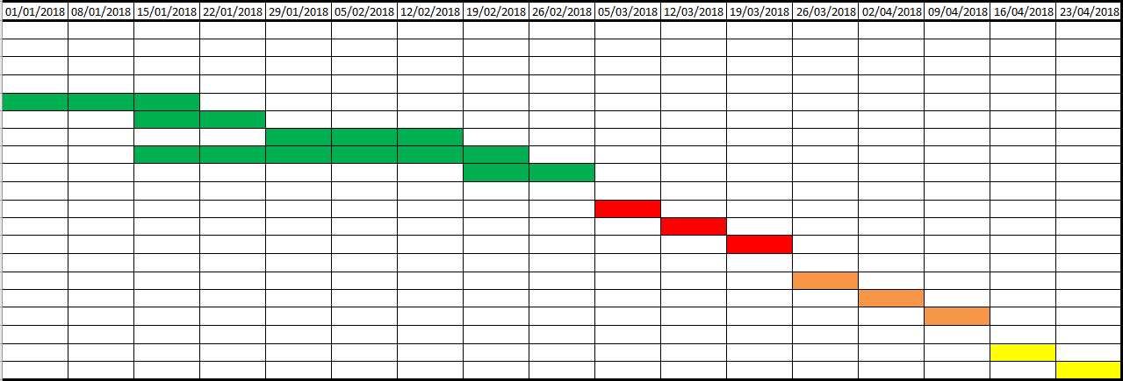
Major milestones
There are four major milestones during this project: -
- Testing of Proteus design and code – This is vital as it shows whether the design will work in reality and if the code will perform to carry out all the tasks necessary of each of the members products.
- Ordering parts- This is a major milestone for the project because it shows that the products are becoming attainable and are ready to be assembled for the first time as a practical prototype.
- Testing evaluation- This an integral milestone as it demonstrates whether the team members products have met they’re and the projects sponsors expectations and also shows that their products work as they are intended to.
- Project write up- The project write-up is crucial to the successful outcome of the group members products as it shows the amount of work that has been undertaken by them to create a cheap and efficient product.
Project control- Each member of the Project group will monitor their own products and will convey the development of their products to the project manager, the project manager at the time will receive all information on how all the products are progressing and will then correspond with the project sponsors to make sure they are up to date with all matters that arise.
Quality control- Quality control checks will be carried out by each of the project’s members after every minor milestone to confirm that the products they make are of a satisfactory standard.

