Naim Chowdhury
1811558
BMSK6002:

Developing Innovation and Creativity for Business Advantage

Table of Contents
Introduction 3
Business Innovation 3
Innovation concept 3
Significance of Innovations 3
Types of Innovation 4
Business Innovation Models 5
Third generation-coupled innovation model 6
5th generation-network system model 7
Differences in the innovation models 8
Business Creativity 10
Definition of creativity 10
Types of creativity 11
Effective use of creativity 12
Factors that contribute to creativity 12
Foster a creative culture in the workplace 13
Definition of culture 14
Elements of culture 14
Effective use of culture 15
Factors that contribute to culture 15
Importance of creativity and culture to the organization 16
Conclusion 18
References 19

Introduction
Business innovation and creativity are the two major issues that have influenced the functional activities of business organizations. This study reflects how Tesco has used innovation models and how creative practices help to flourish in this competitive environment. This study, at first, reveals the concept of innovations, the importance of innovations, and the types of innovations used in organizations. Then, this study shows some innovative strategies and innovation models including technology push, market pull, combined model, integrated network, open innovation model. Furthermore, the study shows the differences among the innovation models. After that, the study describes creativity and culture and how effectively Tesco has used creativity and culture in its organization. Moreover, it unfolds the effectiveness of creativity and cultural influences on the performance of Tesco.

Business Innovation
Innovation concept: Innovation is a process in which individuals or organizations implement the ideas practically that result in introducing new processes, new products, and services or developing new offerings to the markett (Dearing and Cox, 2018). Therefore, business innovation is the practical implementation of ideas of the entrepreneurs of the organizations to promote new offerings to the market and fulfill the requests and demands of the customers. Moreover, innovations in the business refer to a method through which business organizations can manipulate existing inventions or introduce new processes that turn the products or services. Consequently, innovation is sometimes new that is vital for organizations to survive in the market. Most organizations have used multifarious innovations to introduce new processes or new workflows or capturing the new market and so on (Ramdorai and Herstatt, 2015). In the modern competitive business environment, to stay in the business without innovations is quite impossible because the customers are finding something new and innovative. Moreover, the competitors cannot give space to stay in the market. As a result, it is important to value the business innovations and practically implement them whenever the situation demands the business. World's top giant companies such as Apple, Microsoft, Amazon, UBER, Unilever, Walmart, and others have maintained innovations whenever they need them; consequently, they can continue their business from the '90s and today's world (Kumaraswamy, Garud and Ansari, 2018). In 1990, Apple incorporation went through bankruptcy problem and wanted to sell its business to Microsoft. However, the deal was not done because Apple incorporated the invented iMac that innovation saved them and helped it to move on. Like that, Apple incorporation launched iPhone in 2007 because the market needed a branded phone and Apple incorporation used the opportunity and launched iPhone. As a result, Apple incorporation is the biggest tech company in the world.
Significance of Innovations: As the global market is competitive and unpredictable day by day, the organizations of the world can stay with the existing products or services for more. From that, the importance of innovations is felt and the global organizations try to follow the trending (Vossen, 2008). Innovations are the required and survival tool in the competitive business environment. The significance of innovations are given the following:
To grow the organizations: The formula to make the organizations more profitable and more growing in the market, innovation is the pivotal tool through which organizations of the world can innovate their processes, workflows, and products offerings and expand their businesses across the nations (Kleinknecht, 2010). For example, Microsoft, Unilever, Walmart have grown their businesses by innovating new things in their businesses. As a result, they move to top-ranked corporations in the world.
To survive in the market: Adaptation is the most pivotal part for organizations in the world. Today, the use of technology has changed everything and the taste and demands of the people have changed with time. Therefore, organizations need to understand the needs of customers and take innovations to satisfy them (Nooteboom, 2004). Therefore, survival is not easy if the organizations continue innovations. For example, Nokia cannot survive in the business environment as it ignores the needs of customers and is unable to follow innovation trends.
To differentiate the offerings: Differentiation is one of the recognized strategies of businesses in the world. There are two types of differentiation including cost reduction and product innovation and differentiation. Now, the world's top organizations differentiate their products or service to capture the brand value of those organizations (Popa, Preda and Boldea, 2010). For example, Apple incorporation and Unilever have differentiated their products and offerings; consequently, they easily improve the market and keep their brand value.
Types of Innovation: In the business world, four types of innovation are being used by organizations. Innovations are seen from two dimensions including technology and market that make differentiate the innovations. The four types of innovations are given the following:
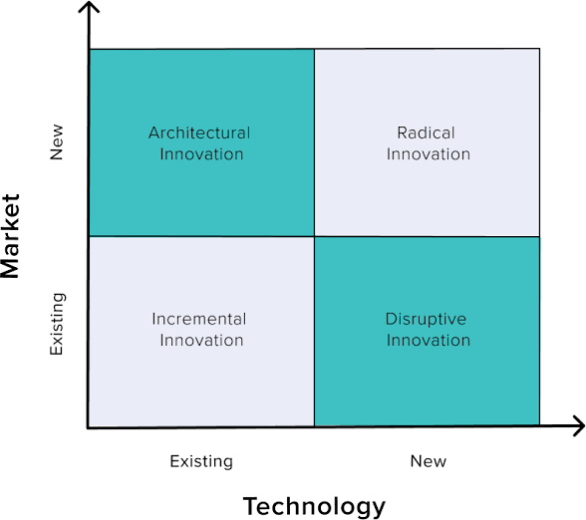
Figure 01: Types of Innovations.
Source: (Blok and Lemmens, 2015).
Incremental Innovation: Incremental innovation is the widely used innovation that is used by most of the organizations in the world. In this innovation, organizations use the existing technology in the existing market. Moreover, this innovation can add or remove the features and designs of the existing products and deliver them to the existing market (Haner, 2002). Therefore, organizations can alter any changes according to the needs and demands of the existing customers.
Disruptive Innovation: In disruptive innovation, the organizations use the new technology within the current market. In this innovation, organizations add new types of technology in which new processes, new types of equipment are added and apply these technologies into the current market (Marinova and Phillimore, 2003). For example, Apple incorporation has used disruption innovation in which it has introduced iPhone as new technology to the new markets. Therefore, it can expand its business to the world.
Architectural innovation: Architectural innovation is the opposite of disruptive innovation. In this innovation, organizations use the current skills and knowledge of the technology in the new market (Hobday, 2005). However, this innovation bears some risks of failure in the new markets. Therefore, architectural innovation is a risky and uncommon innovation strategy that is hardly used by organizations in the world.
Radical innovation: The purest form of innovation is radical innovation. In this innovation, organizations start new industries in new markets and use the latest revolutionary technology to capture the customers and survive in the market. For example, the airplane industry was the first mode of transportation that was used this innovation to make a radical change in the industry.
In sum, these four types of innovations are widely used in organizations to keep their momentum and stay in the competition.
Business Innovation Models: In business, there have been some innovation models that are used by organizations. Furthermore, business innovation models offer a complete framework to identify and implement the ideas into action. These innovation models help to grow the organizations and expand their businesses in this competitive environment (Brem and Voigt, 2009). The innovation business models include 1st generations technology push model, 2nd generation-market pull model, 3rd generation-coupling method model, 4th generation-integrated model, 5th generation-network model, 6th generation-open innovation model (Di Stefano, Gambardella and Verona, 2012). Among the innovation models, the 3rd generation-coupled or balanced innovation model and the 5th generation-network model are more effective in businesses.
Third generation-coupled innovation model: The 3rd generation model is the combination of the linear model of the 1st generation model describing the technology push and the 2nd generation model describing the effects of market pull. In this model, the combination of market and technology is used together and shows the combined effects.
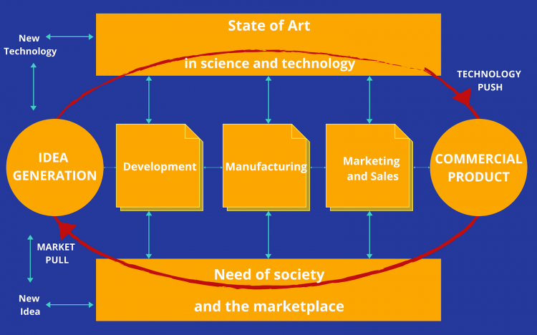
Figure 02: Combined innovation model.
Source: (Rothwell, 2002).
The combined innovation model has removed the restrictions of the 1st and 2nd generation innovation model. This innovation model is applicable in the time of high inflation in the country. Though it is not a linear model, its effects are quite impressive to introduce new products to the markets. The most influential factor of this innovation model is that it reduces the total operating costs of the organizations. This innovation model follows some sequential steps. The steps are given the following:
Idea generation: Idea generation is the first step of the model. Organizations of the world, at first, think about the needs and tastes of the customers of the society and use the science and art technology for generating new ideas that are effective with the combination of new technology and new market (Chesbrough, 2012). As a result, organizations will be able to generate potential ideas that fulfill the requirements of customers as well as the technological and market needs.
Idea development: After generating new ideas, organizations need to develop the ideas and examine the viability of the ideas that can satisfy the needs of all the stakeholders of the organizations and the marketplace. Idea development must be done with the synchronization of the existing technology and the market. Then, an effective idea can be developed and ensure the viability of the idea. Therefore, organizations can implement the ideas into action and try to go to the next phase of the innovation model.
Manufacturing: After developing the viable idea, organizations can manufacture the implementation of the ideas. In this step, organizations go for production and try to satisfy the market needs with the help of the technology push along with market pull. This step is the implementation of the ideas that are generated keeping the needs of the marketplace (Basadur, 2007). In this step, the effects of technology are immense as technology speeds up the manufacturing activities of the organizations.
Marketing and sales: As the organizations complete the manufacturing activities, they need to promote their products and services to potential customers. For that reason, they need to use marketing tools including myriad strategies including differentiation, cost reduction, and so on. Marketing is the prime need for promoting the products of the organizations because customers can perceive the detailed information of the products and services through marketing (Andersen and Kragh, 2013). Therefore, organizations can start their sales directly to the customers.
Commercial products: Products commercialization is the last step of the innovation model. Through the technology push, organizations can easily adapt to the market and offer the customers their products and services. Consequently, organizations can able to deliver their products and services to their targeted customers and ultimately commercial products successfully.
Finally, organizations that can assess the needs and tastes of the marketplace easily implement the innovation process through the third generation- combined innovation model.
5th generation-network system model: At present, the world is triggered by the changes of ICT. As a result, the business world is also following the patterns of the technological changes in every activity (Jolly, 2003). Among the innovation models, the 5th generation model is the model that integrates the network of the processes in the innovation model.
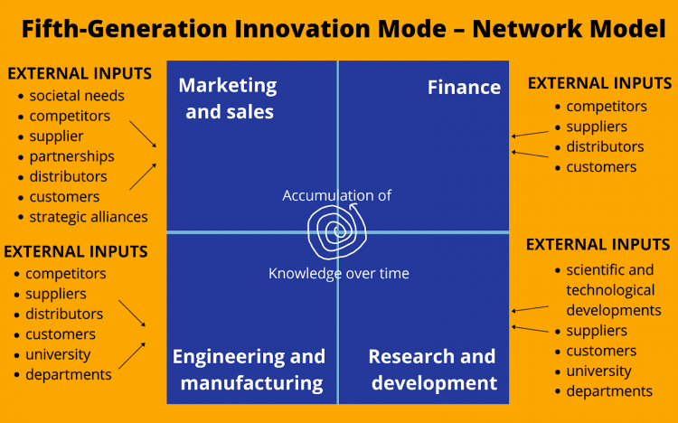
Figure 03: 5th generation innovation model.
Source: (van Knippenberg, 2017).
In this model, organizations can emphasize the distribution of network processes and increase flexibility along with process speed. Furthermore, this innovation model reflects and integrates the internal and external factors to process the model. This innovation model has four steps to complete. The steps are given the following:
Research and development: This innovation model values the external stakeholder's suggestions and considers them. The external stakeholders such as suppliers, customers, universities, and departments give suggestions to innovate. Moreover, the R&D section of the organizations gives the internal ideas to generate innovations (Badran, 2007). Therefore, the 5th generation model, at first, takes the suggestions of both external and inter stakeholders to generate ideas.
Finance: Today, financing is the key part of the innovation process because innovation needs finance to operate properly. Financing ideas can be gathered from different stakeholders including competitors, customers, suppliers, and others. By gaining the financing ideas, this step helps to manage to finance the organizations properly and execute the model with the help of ICT.
Marketing and sales: Marketing and sales are the most pivotal part of the innovation model as this innovation model's success is mostly dependent upon marketing and sales step. To go for marketing and sales, organizations must consider society's needs, competitor's signal, supplier's capacity, distributes ability, partnership opportunities, and so on (Pitta, Wood and Franzak, 2008). After considering the external inputs and internal inputs, organizations can go for marketing and sales for innovative products and services.
Manufacturing: Manufacturing is the key stage of this innovation model in which organizations finally manufacture their innovative products and try to make the promotion of their products and services. Manufacturing depends upon the actions of the R&D section and their appropriate idea generation (Sherman, 2006). If idea screening is well, the innovation model works more relevantly.
Therefore, the 5th generation-integrated network model reveals how the innovation process has occurred and how the organizations can use this model to innovate their ideas.
Differences in the innovation models: Innovation models, the detailed framework of innovation processes, are the driving forces to make innovations in the organizations. As organizations need to choose which types of innovation models they need and which innovation model suits the innovation process for the innovation. Therefore, organizations need to compare the issues and differentiate issues among the innovation models. As differences reveal the strengths, weaknesses, relevancy, resources, and so on, organizations must find out the differences among the innovation models (Miller and Brankovic, 2010). The key differences of 1st generation-technology push, 2nd generation-market pull, 3rd generation-combined model, and 5th generation-network model are given the following:
Technology push model | Market pull model | Combined model | Integrated network model
This model reflects the technological push to innovation. | This model reflects the market pull to innovation. | This model jointly reflects the combination of market pull and technology push to innovation. | This model reflects the distribution of network systems among the processes to innovation (Van de Ven and Rogers, 2004).
This model is linear. | It is also linear. | This model is not linear rather flexible. | This model is flexible.
It is the first generation model for innovations. | It is the second generation model for innovations. | It is the third generation model for innovations. | It is the fifth-generation model for innovations.
This model is appropriate when the existing market is still booming. | This model is appropriate when new markets are increasing. | This model is suitable for organizations that are following incremental innovation strategies (Damanpour and Gopalakrishnan, 2010). | This model is suitable for organizations that have complex processes.
This model is adopted by small organizations. | This model is adopted by small organizations. | This model is adopted by the medium type of organizations. | This model is adopted by large corporations.
This innovation model takes less time to complete. | This innovation model also takes less time to complete. | This model takes more time than the technology push and technology pull model. | This model takes more time than the combined innovation model as it has long processes to complete (Damanpour, Sanchez‐Henriquez and Chiu, 2018).
This innovation model emphasizes more on R&D. | This model emphasizes more on marketing segments. | This model emphasizes more integrating marketing segments and R&D (Kim and Chung, 2017). | This innovation model emphasizes more on external linkages and gaining knowledge along with connecting the systems networks among the processes.
The key driving force of this model is to develop ideas for innovations. | The key driving force of this model is the cost-benefit analysis (Brown, 2011). | The key driving force of this model is to reduce operational costs. | The key driving force of this model is to maintain a unique distribution network of processes.
The limitation of this model is ignoring the market needs. | The limitation of this model is ignoring the technological advantage. | The limitation of this model is ignoring the external factors. | The limitation of this model is ignoring the sequences of the processes.

Based upon the differences among the innovation models, it is apparent that the fifth-generation model is the most suitable in this modern world. Therefore, organizations can assess all the above innovation models, evaluate their effectiveness relying upon strengths, weaknesses and choose the best innovation models that suit the most.

Business Creativity
Definition of creativity: Creativity is the process through which individuals, organizations can generate ideas, possibilities, and alternatives that are used in solving problems (Sargent, 2014). Furthermore, creativity is the capability to come up with new ideas to adjust and solve instant situations. Tesco has used the creativity concept in its entire journey. In a broad sense, creativity refers to generating new ideas and beliefs that are used in the realm of businesses. Creativity has few significant features that are given the following:
Multiple perspectives: Creativity is the process through which individuals think and find new ideas to meet up the existing problems. Moreover, various people give different advice and think differently (Eirich, 2020). Therefore, multiple perspectives are one of the features of creativity. Tesco has used creativity to solve the existing problems by consulting with the top managers of the organization.
Flexibility: Flexibility is the features in which new ideas can be modified according to the situation's demands. Flexibility helps to adapt ideas into action. As a result, new ideas can be applied properly.
Multiple solutions: New ideas are generated by the process of creativity. Creativity triggers the organization to find out myriad solutions to the problem. Therefore, flexibility makes multiple solutions for organizations.
Types of creativity: Four types of creativity are used in organizations. They are given the following:
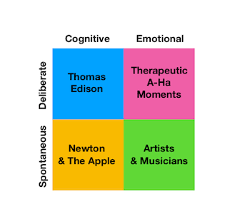
Figure 03: Types of creativity.
Source: (Thissen, Zwijnenberg and Zijlmans, 2013).
Deliberate and cognitive: This type of creativity was seen in the work of Thomas Edison who invented the electric light bulb for using the required information and took more time. In this creativity, the thinker needs to have more knowledge about the issue and has a lot of time to work on it.
Deliberate and emotional: In this creativity, the thinker has to deal with emotions and feelings and takes more time to work on them.
Spontaneous and Cognitive: In this creative process, the thinker needs to take a break to move away from the conscious part of the brain from the problems and gives the unconscious part of the brain to work on it. In this process of creativity, Newton enabled to make creativity (Carroll, 2014).
Spontaneous and emotional: This type of creativity occurs in the mind of artists, painters, and musicians who see the problems differently and give solutions to the problems (Popov, 2003). Therefore, this process of creativity cannot be gained as artists possess this skill.

Effective use of creativity: Tesco, one of the retailers in the UK, has been working for a long in the market of the UK. Tesco has appreciated creativity and its significance in the business. For that reason, Tesco has recently appointed a chief creative officer for maintaining the creative works. Today, creativity is pivotal to determine what the customer needs and customers need new things. Therefore, most of the organizations in the world rely upon creativity. As the customers choose low-cost products along with high quality, the creative team of Tesco has to think from various perspectives and try to generate ideas. After that, screening out the best ideas to solve the problems, and finally, they successfully solve the problems. Furthermore, the creative team of Tesco is involving in differentiating the existing products and find new products for the customers. It is important to keep the conditions of the customer's needs and take according to that. The creative team of Tesco has tried to find opportunities in the market to launch new products for meeting up the tastes of the customers (Steiner, 2007). Therefore, it is seen that the creative team of Tesco has successfully used the creativity and apply it in its organization properly.
Factors that contribute to creativity: Creativity is an art that is affected by some influential factors. The factors directly or indirectly influence the contributions of creativity to business. Factors can be at a different level including individual level, team, and organizational level. The factors of creativity are given the following:
Organization level
Resource: Resources are the primary assets for organizations. If organizations have enough resources, they can think about keeping a mind about the resources. The creative team of Tesco has made creative actions while thinking about the resources they have (Ramdorai and Herstatt, 2015). Therefore, resources are playing a significant role in the development of creativity in organizations.
Pressure: In organizations, the creative team can feel the pressure from different ways; consequently, they cannot give attention to creative actions. In Tesco, the organizational pressure is not high that forces the team to think in a quick moment and give ideas to solve any problems. Therefore, pressure can either speed up the actions of creativity or demotivates the actions of creativity.
Group encouragement: Brainstorming is a process in which the group members think individually about a given problem and they give various ideas from a different perspective. As a result, creative ideas come out and solve the problem (Vossen, 2008). Like that, group encouragement can motive to generate creative ideas for organizations. In Tesco, the creative team is greatly encouraged by the organization. Therefore, they motivate to generate new ideas.
Organizational barriers: Every organization has some barriers that create impediments to generate ideas for the organization. In Tesco, some barriers impede the organization to move forward. Therefore, organizational barriers have significant influences on creativity.
Work environment: The work environment is the key to grow a good culture for nurturing creativity. Tesco has provided a good working environment that helps to nurture creativity for the organization.
Individual-level
Enough knowledge: For the individual level, the chief creative officer needs enough information regarding the problems. If he has enough knowledge, he can easily generate ideas to solve problems. So, the creative officer must gain enough information to think about the problems (Kim and Chung, 2017).
Enough time: Time is a big factor because the creative officer needs more time to think and deliver new ideas. If he gets enough space and time for thinking, he will deliver new ideas for the organization.
Tolerance: Failure is common while thinking solutions for problems. For that reason, tolerance is a must to contribute to creativity. Failure of patience is a factor that impacts creative actions.
Environment: At the individual level, the environment is also a factor that can influence the contribution to creativity. As a result, the environment helps to develop new ideas at the individual level.
Experience: Personal experiences assist the individual to assess and evaluate the conditions and take appropriate strategies to develop new ideas (Miller and Brankovic, 2010). Therefore, the creative officer who has enough experience can develop ideas easily.
Personality: Personality reflects the cognitive and emotional traits of persons. Therefore, personality impacts the creative process of the individual. If a person has a strong personality, he can relate to creativity.
Foster a creative culture in the workplace: The workplace is the place where the employees engage in working together to achieve the targets of the particular organization. Creative culture means a culture in which the practice of creativity is nurtured and encouraged by the environment of that culture (Blok and Lemmens, 2015). Therefore, organizations that ensure a culture in which creativity is given priority and employers motivate the employees to generate new and innovative ideas by thinking well. In Tesco, the creative culture is seen and it gives every necessary resource to build a creative environment. For that reason, Tesco has appointed the chief creative officer who is responsible for growing the creative culture in that organization. Furthermore, the chief creative officer nurtures the teammates to develop a culture of creativity. As creativity is an influential tool for organizations, they can solve any problems by thinking creatively. For that reason, most of the organizations including Apple incorporation, Microsoft, and Dell have nurtured creativity culture to meet up the unpredictable problems as well as unprecedented issues (Eirich, 2020). In sum, creativity is the only solution to meet unprecedented problems for organizations. Therefore, Tesco has established a creative culture in its organization.
Definition of culture: Culture is the ways and manners of life that have characteristics of a particular group. Culture is all about how a particular group of people behaves and leads life. Furthermore, it shows different elements including language, belief, religion, social norms, social ways, arts, values, and so on (Damanpour and Gopalakrishnan, 2010). Therefore, culture refers to particular norms, values, ways, customs of a particular group for a specific one. In businesses, the impact of culture is immense because various organizations have a multifarious culture that reflects the characteristics of those organizations. For example, Unilever has different ways to motivate employees, Apple incorporation motivates its employees in other ways. So, every organization has a different culture that makes. Likewise, a culture of growing up trust among the colleagues and develop trust bonding. Therefore, this culture has changed the ways of employees thinking as they find it comfortable to work for building up Tesco (Brown, 2011).. This is the power of an organization's culture.
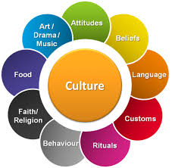
Figure 04: Elements of culture.
Source: (Basadur, 2007).
Elements of culture: Culture encompasses some elements. The elements of culture are given the following:
Attitudes: One of the key elements of culture is attitudes that reflect the ways of doing things. Therefore, attitudes can develop a well-structured culture.
Beliefs: Various organizations have various beliefs that make differentiation among the culture of the organizations. Beliefs can have both positive and negative impacts on organizations.
Language: Language also represents the culture of a particular geographical location. It can not influence the culture properly.
Customs: Customs mean multifarious ways of doing the same thing. Customs play a significant role in the organizational culture.
Rituals: Rituals represent the manners and ways of thinking and doing the activities of the organizations. Therefore, rituals have immense impacts on the culture.
Behavior: The ways of behavior also include in the culture. Different cultures have different ways of behavior towards others (Damanpour, Sanchez‐Henriquez and Chiu, 2018). For example, there are differences between Arabs and European behaviors. Therefore, behavior has reflected the culture.
Faith: Faith is another element of culture. Though faith is an element of the culture, it can not impact the organization's culture.
Food: Food habits are different in various cultures. European culture has different food habits when Asian has multifarious food habits.
Art: Art and music also represent the culture. They reflect the ways culture nurture and promotes art and music.
Effective use of culture: The effective use of culture determines the satisfaction of the employees; consequently, employees work to achieve the goals of organizations (Van de Ven and Rogers, 2004). In Tesco, the culture is impressive and adapts to new employees. Tesco has introduced a culture in which it has rewarded the employees for achieving the milestones. Furthermore, it offers a positive working environment where employees trust other colleagues and create bonding. These cultural aspects of Tesco have immensely impacted the missions and visions of the organization. As employees feel comfortable and relaxed, they can deliver good works and try to develop their skills (Thissen, Zwijnenberg and Zijlmans, 2013). As a result, Tesco has improved in retail supermarkets in the UK. For posing a good and positive working environment to the employees, Tesco has enabled to possess the top-ranked retail shop in the UK. Tesco has successfully used the culture properly.
Factors that contribute to culture: Some factors can influence the contributions to culture. The factors can develop or decline the contribution to culture if the factors are not used properly. The factors of culture are given the following:
Material culture: Material that is available in culture is satisfying the people of the culture by materials. The physical object that influences the culture is material culture (Haner, 2002). In organizations, physical resources that satisfy the stakeholders of the organization can be influenced by this culture.
Cultural preferences: In a culture, organizations give prioritizes something. Preferences can have positive or negative impacts on the organization. Tesco has some preferences that have positively influenced the working conditions and the outputs of the organization. Therefore, cultural preference can significantly affect the culture of organizations.
Language: Language in the culture of organizations impact a little bit as modern time language cannot be a barrier for the growth of the culture of organizations. Therefore, language has a little bit impact on the culture of organizations.
Education: Educational qualification is the parameter to measure the skills of the culture. Graduates can easily join the organizations and change the entire paradigm in a very short time. Therefore, education can influence the culture of the organization properly.
Social organization: As social organizations are the role models to spread out the norms, customs, and rituals, employees and customers have a good sense of social rules (Brem and Voigt, 2009). As a result, employees of that culture have good knowledge and working sense. Therefore, social organizations can impact the contributions to the culture of organizations.
Ethical values: Ethical values are the most influential factors that present a well-structured culture. In this culture, both the customers and employees have ethical values and they respect each other. Furthermore, they do not involve in cheating or deceiving anyone for many purposes. Therefore, ethical values have immensely influenced the culture of organizations (Hobday, 2005). Those who have good ethical culture can go a long way in the future.
Economy: Strong economy signifies the developed nations. The economy has significant influences on the culture. As strong economical culture can develop the organization, organizations can fulfill its demands. Moreover, the economy benefits the culture by providing strong infrastructure and developed financial systems.
Geography: Geographical locations also contribute to developing the culture. If the culture belongs to well-equipped positions, it has a positive impact on it. However, it can have a negative impact if the culture belongs to disadvantageous geographical locations (Nooteboom, 2004). Therefore, geographical locations can influence the contribution to culture.
Importance of creativity and culture to the organization: The combination of creativity and culture can change the paradigm of the organization. Both creativity and culture have reshaped the activities of Tesco and they both have laid a good foundation upon the functional activities of Tesco (Chesbrough, 2012). As a result, Tesco has created a culture where creativity can be practiced and show their performance them. The importance of creativity and culture are given the following:
Create brand image: As creativity and cultural practices enhance the activities of Tesco, the brand image has been increased immensely. Consumers have a firm belief in Tesco because it has practiced a creative culture for the employees (Andersen and Kragh, 2013). Consequently, employees of Tesco have delivered new offerings. Therefore, the brand value of Tesco has increased.
Facilitate healthy competition: Creative culture triggers and facilitates healthy competition among the competitors. Tesco has successfully promoted healthy competition.
Survive in the competition: Without creativity, no organization can survive in this corporate business environment (Sargent, 2014). Therefore, the creative culture of Tesco helps to survive in the competitive environment.
Enjoy environment: If stakeholders find themselves comfortable in creative culture, they will do their best to improve the conditions. In Tesco, the stakeholders enjoy a good working environment.
Common platform: Creative environment gives an equal and common platform for the stakeholders of Tesco. Therefore, creative culture is important for Tesco.

Conclusion
In sum, the study uncovers the applicable two innovation models including the combined innovation model that is 3rd generation based, and the integrated network innovation model. Furthermore, this study shows the significance of creativity and culture that reshape and upgrade the activities of Tesco. In this study, it is observed that creativity is the most influential tool to meet the needs and demands of customers. Therefore, Tesco has recruited a chief creative officer to continue the creativity in the organization.

References
Andersen, P.H. and Kragh, H. (2013) Managing creativity in business market relationships. Industrial Marketing Management, 42(1), pp.82-85.
Badran, I. (2007) Enhancing creativity and innovation in engineering education. European Journal of Engineering Education, 32(5), pp.573-585.
Basadur, M. (2007) Needed research in creativity for business and industrial applications. Frontiers of creativity research: Beyond the basics, pp.390-416.
Blok, V. and Lemmens, P. (2015) The emerging concept of responsible innovation. Three reasons why it is questionable and calls for a radical transformation of the concept of innovation. In Responsible innovation 2 (pp. 19-35). Springer, Cham.
Brem, A. and Voigt, K.I. (2009) Integration of market pull and technology push in the corporate front end and innovation management—Insights from the German software industry. Technovation, 29(5), pp.351-367.
Brown, J. (2011) Innovation for excellence. Lanham, MD: University Press of America.
Carroll, J. (2014) Innovative Practices in Teaching Information Sciences and Technology. Cham: Springer International Publishing.
Chesbrough, H. (2012) Open innovation: Where we've been and where we're going. Research-Technology Management, 55(4), pp.20-27.
Damanpour, F. and Gopalakrishnan, S. (2010) The dynamics of the adoption of product and process innovations in organizations. Journal of management studies, 38(1), pp.45-65.
Damanpour, F., Sanchez‐Henriquez, F. and Chiu, H.H. (2018) Internal and external sources and the adoption of innovations in organizations. British Journal of Management, 29(4), pp.712-730.
Dearing, J.W. and Cox, J.G. (2018) Diffusion of innovations theory, principles, and practice. Health Affairs, 37(2), pp.183-190.
Di Stefano, G., Gambardella, A. and Verona, G. (2012) Technology push and demand pull perspectives in innovation studies: Current findings and future research directions. Research policy, 41(8), pp.1283-1295.
Eirich, R. (2020) Organization design and its impact on the digital innovation process and the digital innovation outcome. Wiesbaden: Springer Gabler.
Haner, U.E. (2002) Innovation quality—a conceptual framework. International Journal of Production Economics, 80(1), pp.31-37.
Hobday, M. (2005) Firm-level innovation models: perspectives on research in developed and developing countries. Technology analysis & strategic management, 17(2), pp.121-146.
Jolly, A. ed. (2003) Innovation: harnessing creativity for business growth. Kogan Page Publishers.
Kim, J.S. and Chung, G.H. (2017) Implementing innovations within organizations: A systematic review and research agenda. Innovation, 19(3), pp.372-399.
Kleinknecht, A. (2010) Indicators of manufacturing and service innovation: their strengths and weaknesses. In Innovation systems in the service economy (pp. 169-186). Springer, Boston, MA.
Kumaraswamy, A., Garud, R. and Ansari, S. (2018) Perspectives on disruptive innovations. Journal of Management Studies, 55(7), pp.1025-1042.
Marinova, D. and Phillimore, J. (2003) Models of innovation. The international handbook on innovation, 1.
Miller, P. and Brankovic, A. (2010) Building a" creative culture" for sustainable innovation (No. D/879). IESE Business School.
Nooteboom, B. (2004) Innovation and diffusion in small firms: theory and evidence. Small business economics, 6(5), pp.327-347.
Pitta, D.A., Wood, V.R. and Franzak, F.J. (2008) Nurturing an effective creative culture within a marketing organization. Journal of Consumer Marketing.
Popa, I.L., Preda, G. and Boldea, M. (2010) A theoretical approach of the concept of innovation. Managerial Challenges of the Contemporary Society. Proceedings, p.151.
Popov, O. (2003) Creative and innovative network management. Amsterdam: IOS Press.
Ramdorai, A. and Herstatt, C. (2015) Disruptive innovations theory. In Frugal Innovation in Healthcare (pp. 27-38). Springer, Cham.
Rothwell, R. (2002) Developments towards the fifth generation model of innovation. Technology Analysis & Strategic Management, 4(1), pp.73-75.
Sargent, M. (2014) The Innovation Process. Cork: BookBaby.
Sherman, A. (2006) Toward a creative culture: Lifelong learning through the arts. Generations, 30(1), pp.42-46.
Steiner, G. (2007) The creative organization. Chicago: University of Chicago Press.
Thissen, J., Zwijnenberg, R. and Zijlmans, K. (2013) Contemporary culture. Amsterdam: Amsterdam University Press.
Van de Ven, A.H. and Rogers, E.M. (2004) Innovations and organizations: Critical perspectives. Communication research, 15(5), pp.632-651.
van Knippenberg, D. (2017) Leadership and creativity in business. In Handbook of research on leadership and creativity. Edward Elgar Publishing.
Vossen, R.W. (2008) Relative strengths and weaknesses of small firms in innovation. International small business journal, 16(3), pp.88-94.

