

Svitlana Kyrnychna- 2542903
Assessment 1 – Reading Task Template
PART 1: Upload your photo of your A3 in-class notes here:
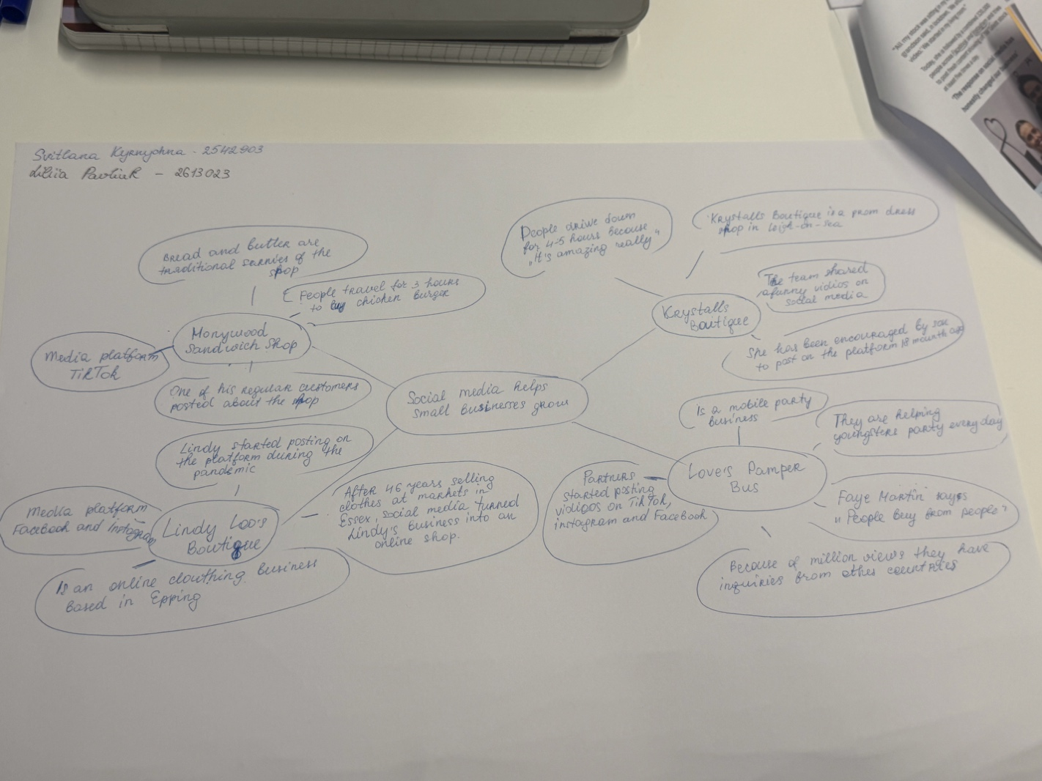

PART 2:
- Answer every question below in 1-3 full sentences.
- Use your own words. Do not use generative AI to answer these questions.
- Include a specific detail from the text when asked.
REMINDER
- The main idea is the overall message of the whole text.
- A key point helps to explain the main idea.
- A specific detail or example from the text shows that the key point is true.

- What is the main idea of the whole text?
I think the main idea of the text is that business owners explain how social media helped them grow their businesses, both online and in their shops.

- What is one key point that supports the main idea, and which specific example from the text shows this?
The key point is posts and videos on social media. For example, in one story, a regular customer shared a video about Honywood Sandwich Shop. Because of this video, many people found out about the shop. Some people travelled more than 3 hours just to try their chicken burger.

- What is a different key point that supports the main idea, and which specific example from the text shows this?
For example, the key moment for Lindy Loo’s Boutique was the start of the pandemic. During this time, she started posting about her clothing business on social media. Later, she moved from selling clothes at the market to selling them in an online shop.

- Which part of the text do you think is most important, and why?
I can’t choose only one important part of the text because every story shows how social media helped small businesses grow.

Reflection:
- What did you find difficult in this task (including in-class components), and why was it difficult?
I don’t think the task was difficult because I could understand and find all the answers in the text and in each business story.

- What helped you with this difficulty, and how did it help you?
Working in pairs helped me with the task. My partner and I shared our ideas. We both had good ideas and helped each other. Together, we chose the most important points. It was great!

